Automatic report for a 2-factor factorial

International Potato Center

June 26, 2018

Table of Contents

# 1. Model specification and data description

The data frame has two factors with 2 and 46 levels. The experimental design is a randomized complete block design with 3 blocks. The statistical model is

$$y_{ijk}=μ+α_{i}+β_{j}+(αβ)_{ij}+γ_{k}+ϵ_{ijk}$$

where

* $y_{ijk}$ is the observed response with level $i$ of factor A, level $j$ of factor B, and block $k$.
* $μ$ is the mean response over all levels of factor A, factor B, and blocks.
* $α_{i}$ is the effect for level $i$ of factor A.
* $β_{j}$ is the effect for level $j$ of factor B.
* $(αβ)_{ij}$ is the interaction effect between level $i$ of factor A and level $j$ of factor B.
* $γ_{k}$ is the effect of block $k$.
* $ϵ_{ijk}$ is the error term.

In this model we assume that the errors are independent and have a normal distribution with common variance, that is, $ϵ_{ijk}∼N(0,σ_{ϵ}^{2})$.

# 2. Analysis for trait Marketable tuber yield no adjusted-t/ha-CO_330:0000330

There are no missing values for this trait; the design is balanced.

## 2.1. Descriptive statistics

### 2.1.1. Means by factor A levels

## 1 2   
## 27.90036 28.33601

### 2.1.2. Means by factor B levels

## CIP392797.22 CIP700234 CIP700313 CIP700787 CIP701165   
## 16.49500 24.76833 30.82500 27.62167 30.55667   
## CIP701273 CIP701515 CIP701675 CIP701997 CIP702363   
## 27.24500 26.00833 31.09333 24.92500 23.45167   
## CIP702395 CIP702453 CIP702464 CIP702736 CIP702815   
## 27.31500 26.47000 29.70000 32.60667 28.64333   
## CIP703168 CIP703197 CIP703264 CIP703265 CIP703268   
## 31.39333 29.96333 24.02000 29.10833 25.70833   
## CIP703274 CIP703287 CIP703291 CIP703312 CIP703317   
## 24.45500 33.97833 22.59667 27.36833 27.35667   
## CIP703352 CIP703421 CIP703488 CIP703741 CIP703768   
## 28.05833 26.50167 25.15667 26.03000 32.82667   
## CIP703825 CIP703831 CIP703844 CIP703899 CIP703985   
## 30.50667 33.18000 30.57333 28.84500 31.73833   
## CIP704022 CIP704058 CIP704143 CIP704327 CIP704393   
## 29.59500 24.54167 26.28000 30.73500 32.83167   
## CIP704481 CIP705009 CIP705280 CIP705543 CIP706191   
## 29.80167 19.86667 31.48833 31.64667 29.90833   
## CIP707135   
## 29.65167

### 2.1.3. Means by factor A and factor B levels

## CIP392797.22 CIP700234 CIP700313 CIP700787 CIP701165 CIP701273 CIP701515  
## 1 15.81333 24.07000 31.11667 27.14000 29.82333 27.52333 25.58667  
## 2 17.17667 25.46667 30.53333 28.10333 31.29000 26.96667 26.43000  
## CIP701675 CIP701997 CIP702363 CIP702395 CIP702453 CIP702464 CIP702736  
## 1 31.61333 24.25667 23.05000 26.92667 25.77333 29.67333 32.93000  
## 2 30.57333 25.59333 23.85333 27.70333 27.16667 29.72667 32.28333  
## CIP702815 CIP703168 CIP703197 CIP703264 CIP703265 CIP703268 CIP703274  
## 1 28.20333 31.46667 30.20333 23.55333 29.16000 25.28333 23.67333  
## 2 29.08333 31.32000 29.72333 24.48667 29.05667 26.13333 25.23667  
## CIP703287 CIP703291 CIP703312 CIP703317 CIP703352 CIP703421 CIP703488  
## 1 34.18667 22.56000 28.00667 26.29000 27.39333 26.59333 24.26667  
## 2 33.77000 22.63333 26.73000 28.42333 28.72333 26.41000 26.04667  
## CIP703741 CIP703768 CIP703825 CIP703831 CIP703844 CIP703899 CIP703985  
## 1 24.87667 32.28667 30.19333 32.85667 29.50333 28.32667 32.08667  
## 2 27.18333 33.36667 30.82000 33.50333 31.64333 29.36333 31.39000  
## CIP704022 CIP704058 CIP704143 CIP704327 CIP704393 CIP704481 CIP705009  
## 1 30.25667 24.81333 26.54333 30.76 31.97333 29.33000 19.66000  
## 2 28.93333 24.27000 26.01667 30.71 33.69000 30.27333 20.07333  
## CIP705280 CIP705543 CIP706191 CIP707135  
## 1 32.68333 32.16000 29.95333 29.01667  
## 2 30.29333 31.13333 29.86333 30.28667

## 2.2. ANOVA

### 2.2.1. Checking assumptions

As it was stated in section 1, it is supposed that the error has a normal distribution with the same variance for all the combinations among the levels of both factors. The following plots help to evaluate this assumptions:

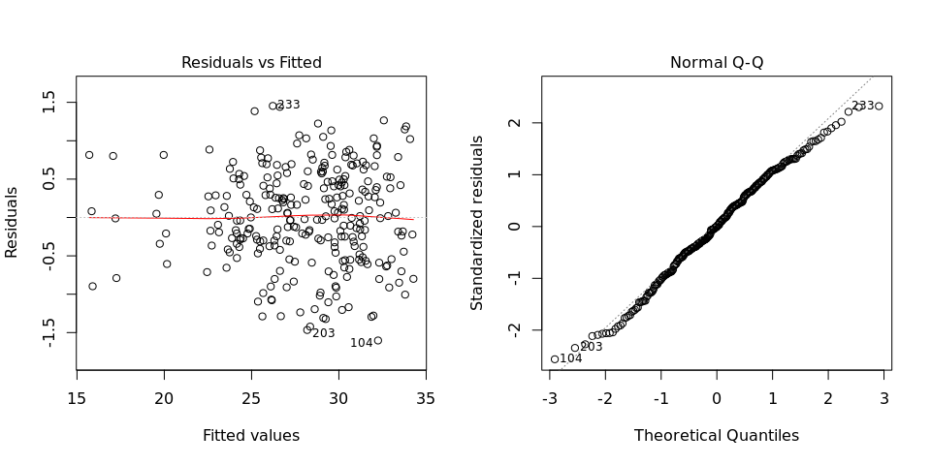

Funnel shapes for the first plot may suggest heterogeneity of variances while departures from the theoretical normal line are symptoms of lack of normality.

### 2.2.2. ANOVA table

## Analysis of Variance Table  
##   
## Response: "Marketable tuber yield no adjusted-t/ha-CO_330:0000330"  
## Df Sum Sq  
## Land levellingTotal number of levelling passes 1 13.1  
## VARIETIES 45 3515.3  
## BLOCK 2 1.8  
## Land levellingTotal number of levelling passes:VARIETIES 45 75.8  
## Residuals 182 108.1  
## Mean Sq F value  
## Land levellingTotal number of levelling passes 13.096 22.0584  
## VARIETIES 78.117 131.5797  
## BLOCK 0.887 1.4934  
## Land levellingTotal number of levelling passes:VARIETIES 1.685 2.8389  
## Residuals 0.594   
## Pr(>F)   
## Land levellingTotal number of levelling passes 5.195e-06 ***  
## VARIETIES < 2.2e-16 ***  
## BLOCK 0.2273   
## Land levellingTotal number of levelling passes:VARIETIES 4.989e-07 ***  
## Residuals   
## ---  
## Signif. codes: 0 '***' 0.001 '**' 0.01 '*' 0.05 '.' 0.1 ' ' 1

# 3. Analysis for trait Marketable tuber weight-kg/plot-CO_330:0000308

There are no missing values for this trait; the design is balanced.

## 3.1. Descriptive statistics

### 3.1.1. Means by factor A levels

## 1 2   
## 51.67196 37.37384

### 3.1.2. Means by factor B levels

## CIP392797.22 CIP700234 CIP700313 CIP700787 CIP701165   
## 54.61833 51.64500 28.69500 39.48333 35.29167   
## CIP701273 CIP701515 CIP701675 CIP701997 CIP702363   
## 55.75333 53.23833 38.00167 54.45333 63.85333   
## CIP702395 CIP702453 CIP702464 CIP702736 CIP702815   
## 41.91167 56.81833 61.08333 32.46833 43.65000   
## CIP703168 CIP703197 CIP703264 CIP703265 CIP703268   
## 36.54333 41.63167 41.22833 38.59500 54.61833   
## CIP703274 CIP703287 CIP703291 CIP703312 CIP703317   
## 56.14500 28.76833 82.74333 31.39500 36.68833   
## CIP703352 CIP703421 CIP703488 CIP703741 CIP703768   
## 45.78500 42.92833 43.72000 49.62167 33.34500   
## CIP703825 CIP703831 CIP703844 CIP703899 CIP703985   
## 45.71000 30.35333 30.60333 34.49167 33.78167   
## CIP704022 CIP704058 CIP704143 CIP704327 CIP704393   
## 22.31000 71.28167 54.57667 44.75500 83.77000   
## CIP704481 CIP705009 CIP705280 CIP705543 CIP706191   
## 31.37667 70.96333 30.28833 25.09000 25.71833   
## CIP707135   
## 38.26167

### 3.1.3. Means by factor A and factor B levels

## CIP392797.22 CIP700234 CIP700313 CIP700787 CIP701165 CIP701273 CIP701515  
## 1 61.26333 62.55 31.86 40.40000 57.37000 50.74667 47.39000  
## 2 47.97333 40.74 25.53 38.56667 13.21333 60.76000 59.08667  
## CIP701675 CIP701997 CIP702363 CIP702395 CIP702453 CIP702464 CIP702736  
## 1 39.23000 58.09000 59.69667 43.83333 63.89333 69.07333 43.96333  
## 2 36.77333 50.81667 68.01000 39.99000 49.74333 53.09333 20.97333  
## CIP702815 CIP703168 CIP703197 CIP703264 CIP703265 CIP703268 CIP703274  
## 1 46.39 59.20667 40.63333 38.11333 40.65 52.76000 69.03667  
## 2 40.91 13.88000 42.63000 44.34333 36.54 56.47667 43.25333  
## CIP703287 CIP703291 CIP703312 CIP703317 CIP703352 CIP703421 CIP703488  
## 1 30.83667 108.3567 37.67333 39.24000 56.21333 51.18667 43.31333  
## 2 26.70000 57.1300 25.11667 34.13667 35.35667 34.67000 44.12667  
## CIP703741 CIP703768 CIP703825 CIP703831 CIP703844 CIP703899 CIP703985  
## 1 64.86000 56.86 60.72667 48.54667 47.07667 39.44333 41.86667  
## 2 34.38333 9.83 30.69333 12.16000 14.13000 29.54000 25.69667  
## CIP704022 CIP704058 CIP704143 CIP704327 CIP704393 CIP704481 CIP705009  
## 1 33.10333 65.86000 59.25667 51.93 105.07 50.14000 73.15000  
## 2 11.51667 76.70333 49.89667 37.58 62.47 12.61333 68.77667  
## CIP705280 CIP705543 CIP706191 CIP707135  
## 1 43.91000 28.80667 25.54333 37.79000  
## 2 16.66667 21.37333 25.89333 38.73333

## 3.2. ANOVA

### 3.2.1. Checking assumptions

As it was stated in section 1, it is supposed that the error has a normal distribution with the same variance for all the combinations among the levels of both factors. The following plots help to evaluate this assumptions:

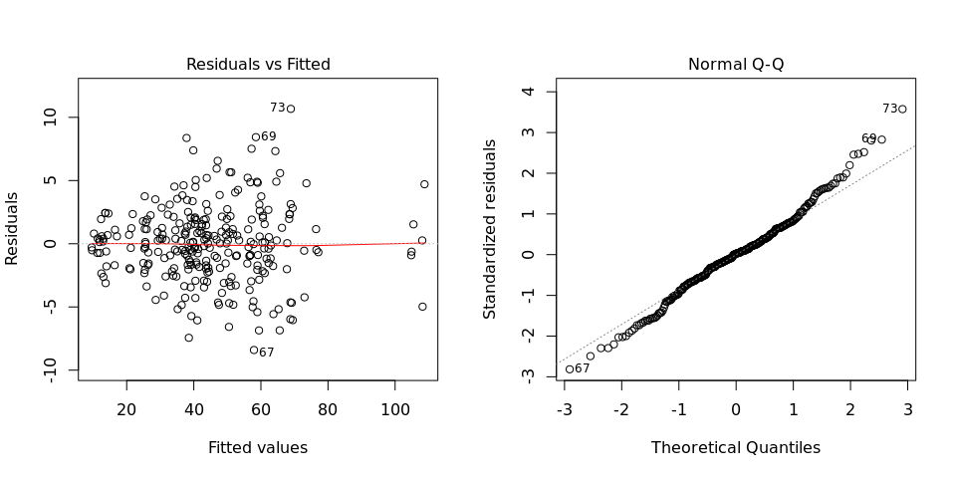

Funnel shapes for the first plot may suggest heterogeneity of variances while departures from the theoretical normal line are symptoms of lack of normality.

### 3.2.2. ANOVA table

## Analysis of Variance Table  
##   
## Response: "Marketable tuber weight-kg/plot-CO_330:0000308"  
## Df Sum Sq  
## Land levellingTotal number of levelling passes 1 14106  
## VARIETIES 45 57422  
## BLOCK 2 24  
## Land levellingTotal number of levelling passes:VARIETIES 45 19037  
## Residuals 182 2459  
## Mean Sq F value  
## Land levellingTotal number of levelling passes 14106.1 1044.1843  
## VARIETIES 1276.0 94.4571  
## BLOCK 12.2 0.9035  
## Land levellingTotal number of levelling passes:VARIETIES 423.0 31.3148  
## Residuals 13.5   
## Pr(>F)   
## Land levellingTotal number of levelling passes <2e-16 ***  
## VARIETIES <2e-16 ***  
## BLOCK 0.407   
## Land levellingTotal number of levelling passes:VARIETIES <2e-16 ***  
## Residuals   
## ---  
## Signif. codes: 0 '***' 0.001 '**' 0.01 '*' 0.05 '.' 0.1 ' ' 1