Automatic report for a Completely Randomized Design (CRD)

International Potato Center

March 14, 2019

Table of Contents

# 1. Model specification and data description

There are data from 4 treatments evaluated using a completely randomized design. The statistical model is

$$y_{ij}=μ+τ_{i}+ϵ_{ij}$$

where

* $y_{ij}$ is the observed response with treatment $i$ and replication $j$.
* $μ$ is the mean response over all treatments and replications.
* $τ_{i}$ is the effect for treatment $i$.
* $ϵ_{ij}$ is the error term.

In this model we assume that the errors are independent and have a normal distribution with common variance, that is, $ϵ_{ij}∼N(0,σ_{ϵ}^{2})$.

# 2. Analysis for trait Wheat_Grain_Fresh weight_g

There is at least one treatment without data. The table below shows the frequencies of valid data for each treatment . The analysis cannot be produced if there are treatments without data.

##   
## gauvar_Conventional till gauvar_Reduced till   
## 0 0   
## rajkumar_Conventional till rajkumar_Reduced till   
## 0 0

# 3. Analysis for trait Wheat_Total biomass (including all roots and spikes)_Dry matter yield_kg/ha

## 3.1. ANOVA

You have fitted a linear model for a CRD. The ANOVA table for your model is:

## Analysis of Variance Table  
##   
## Response: "Wheat_Total biomass (including all roots and spikes)_Dry matter yield_kg/ha"  
## Df Sum Sq Mean Sq F value Pr(>F)   
## TREATMENT 3 126150 42050 16.82 0.009864 **  
## Residuals 4 10000 2500   
## ---  
## Signif. codes: 0 '***' 0.001 '**' 0.01 '*' 0.05 '.' 0.1 ' ' 1

The coefficient of variation for this experiment is 3.396%. The p-value for treatments is 0.009864 which is significant at the 5% level.

## 3.2. Assumptions

Don’t forget the assumptions of the model. It is supposed that the errors are independent with a normal distribution and with the same variance for all the treatments. The following residuals plots must help you evaluate this:

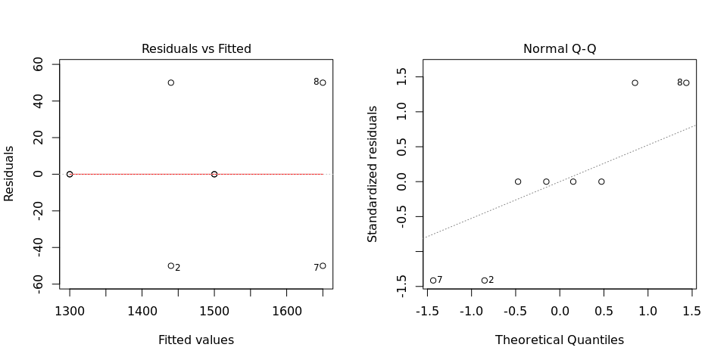

Any trend in the residuals in the left plot would violate the assumption of independence while a trend in the variability of the residuals –for instance a funnel shape– suggests heterogeneity of variances. Departures from the theoretical normal line on the right plot are symptoms of lack of normality.

## 3.3. Treatment means

Below are the sorted means for each treatment with letters indicating if there are significant differences using the multiple comparisons method of Tukey at the 5% level.

## dfr[, traits[i]] groups  
## gauvar_Reduced till 1650 a  
## gauvar_Conventional till 1500 ab  
## rajkumar_Conventional till 1440 b  
## rajkumar_Reduced till 1300 b

It is always good to have some visualization of the data. Because the number of treatments in your experiment is not so big, we can plot the data for each treatment:

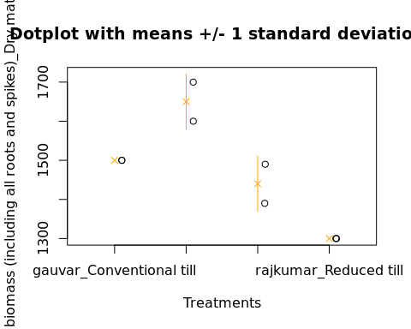

## 3.4. Variance components

Below are the variance components for this model, under the assumption that treatments are random. Here the model is fitted using REML.

## Variance Std.Dev.  
## TREATMENT 19775.013 140.62366  
## Residual 2499.999 49.99999