Automatic report for a Completely Randomized Design (CRD)

International Potato Center

March 14, 2019

Table of Contents

# 1. Model specification and data description

There are data from 6 treatments evaluated using a completely randomized design. The statistical model is

$$y_{ij}=μ+τ_{i}+ϵ_{ij}$$

where

* $y_{ij}$ is the observed response with treatment $i$ and replication $j$.
* $μ$ is the mean response over all treatments and replications.
* $τ_{i}$ is the effect for treatment $i$.
* $ϵ_{ij}$ is the error term.

In this model we assume that the errors are independent and have a normal distribution with common variance, that is, $ϵ_{ij}∼N(0,σ_{ϵ}^{2})$.

# 2. Analysis for trait [:blank:]

## 2.1. ANOVA

You have fitted a linear model for a CRD. The ANOVA table for your model is:

## Analysis of Variance Table  
##   
## Response: "[:blank:]"  
## Df Sum Sq Mean Sq F value Pr(>F)  
## TREATMENT 5 2294.4 458.89 0.5975 0.703  
## Residuals 12 9216.7 768.06

The coefficient of variation for this experiment is 9.021%. The p-value for treatments is 0.703 which is not significant at the 5% level.

## 2.2. Assumptions

Don’t forget the assumptions of the model. It is supposed that the errors are independent with a normal distribution and with the same variance for all the treatments. The following residuals plots must help you evaluate this:

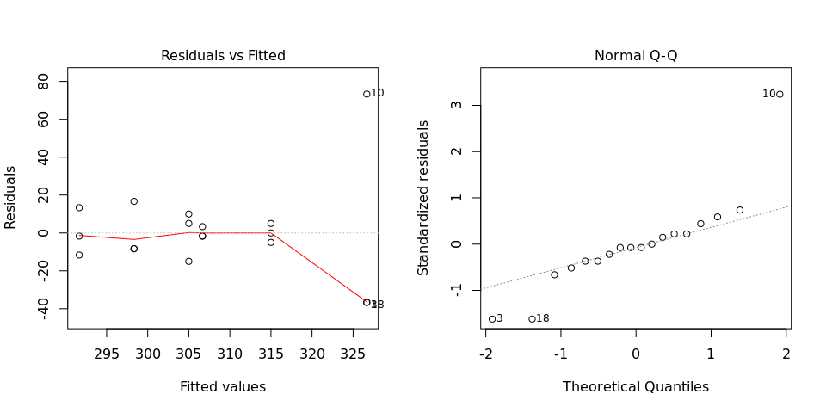

Any trend in the residuals in the left plot would violate the assumption of independence while a trend in the variability of the residuals –for instance a funnel shape– suggests heterogeneity of variances. Departures from the theoretical normal line on the right plot are symptoms of lack of normality.

## 2.3. Treatment means

The means of your treatments are:

## 2_Gaurav 2_Kisan2 2_Rajkumar 4_Gaurav 4_Kisan2 4_Rajkumar   
## 315.0000 326.6667 291.6667 306.6667 298.3333 305.0000

It is always good to have some visualization of the data. Because the number of treatments in your experiment is not so big, we can plot the data for each treatment:

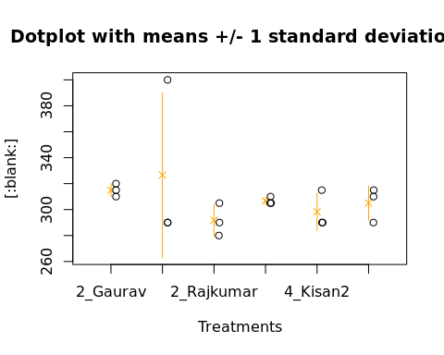

## 2.4. Variance components

Below are the variance components for this model, under the assumption that treatments are random. Here the model is fitted using REML.

## boundary (singular) fit: see ?isSingular

## Variance Std.Dev.  
## TREATMENT 0.0000 0.00000  
## Residual 677.1242 26.02161