Automatic report for a factorial experiment

International Potato Center

August 14, 2019

Table of Contents

# 1. Model specification and data description

The data frame has two factors with 3 and 3 levels. The experimental design is a randomized complete block design with 2 blocks. The statistical model is

$$y_{ijk}=μ+α_{i}+β_{j}+(αβ)_{ij}+γ_{k}+ϵ_{ijk}$$

where

* $y_{ijk}$ is the observed response with level $i$ of factor A, level $j$ of factor B, and block $k$.
* $μ$ is the mean response over all levels of factor A, factor B, and blocks.
* $α_{i}$ is the effect for level $i$ of factor A.
* $β_{j}$ is the effect for level $j$ of factor B.
* $(αβ)_{ij}$ is the interaction effect between level $i$ of factor A and level $j$ of factor B.
* $γ_{k}$ is the effect of block $k$.
* $ϵ_{ijk}$ is the error term.

In this model we assume that the errors are independent and have a normal distribution with common variance, that is, $ϵ_{ijk}∼N(0,σ_{ϵ}^{2})$.

# 2. Analysis for trait Sweetpotato_Storage_roots_Fresh_weight_g__1

There are no missing values for this trait; the design is balanced.

## 2.1. Descriptive statistics

### 2.1.1. Means by individual factor levels

## variety1 variety2 variety3   
## 6.245000 6.250000 6.083333   
## 0.36 m2 0.66 m2 0.94 m2   
## 6.150000 6.211667 6.216667

### 2.1.2. Means by factor levels combinations

## 0.36 m2 0.66 m2 0.94 m2  
## variety1 6.45 6.035 6.25  
## variety2 6.40 6.350 6.00  
## variety3 5.60 6.250 6.40

## 2.2. ANOVA

### 2.2.1. Checking assumptions

As it was stated in section 1, it is supposed that the error has a normal distribution with the same variance for all the combinations among the levels of the factors. The following plots help to evaluate this assumptions:

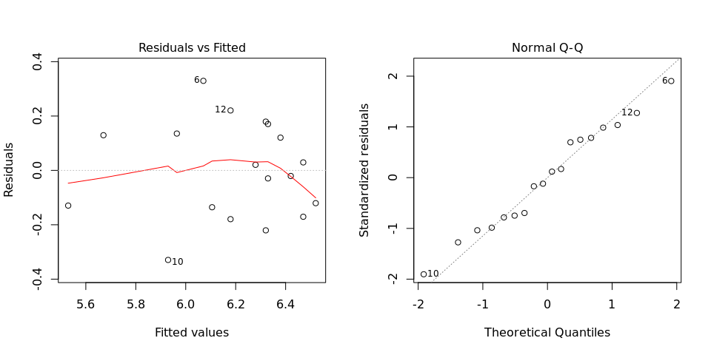

Funnel shapes for the first plot may suggest heterogeneity of variances while departures from the theoretical normal line are symptoms of lack of normality.

### 2.2.2. ANOVA table

## Analysis of Variance Table  
##   
## Response: Sweetpotato_Storage_roots_Fresh_weight_g__1  
## Df Sum Sq Mean Sq F value Pr(>F)  
## Crop_variety_f1 2 0.10788 0.053939 0.8008 0.48193  
## Plot_area_harvested_f2 2 0.01654 0.008272 0.1228 0.88606  
## BLOCK 1 0.08961 0.089606 1.3303 0.28204  
## Crop_variety_f1:Plot_area_harvested_f2 4 1.06909 0.267272 3.9681 0.04615  
## Residuals 8 0.53884 0.067356   
##   
## Crop_variety_f1   
## Plot_area_harvested_f2   
## BLOCK   
## Crop_variety_f1:Plot_area_harvested_f2 *  
## Residuals   
## ---  
## Signif. codes: 0 '***' 0.001 '**' 0.01 '*' 0.05 '.' 0.1 ' ' 1

The coefficient of variation for this experiment is 4.191%.