Automatic report for a Completely Randomized Design (CRD)

International Potato Center

September 30, 2019

Table of Contents

# 1. Model specification and data description

There are data from 16 treatments evaluated using a completely randomized design. The statistical model is

$$y_{ij}=μ+τ_{i}+ϵ_{ij}$$

where

* $y_{ij}$ is the observed response with treatment $i$ and replication $j$.
* $μ$ is the mean response over all treatments and replications.
* $τ_{i}$ is the effect for treatment $i$.
* $ϵ_{ij}$ is the error term.

In this model we assume that the errors are independent and have a normal distribution with common variance, that is, $ϵ_{ij}∼N(0,σ_{ϵ}^{2})$.

# 2. Analysis for trait 1:Maize_Grain_Fresh_weight_g

## 2.1. ANOVA

You have fitted a linear model for a CRD. The ANOVA table for your model is:

## Analysis of Variance Table  
##   
## Response: "1:Maize_Grain_Fresh_weight_g"  
## Df Sum Sq Mean Sq F value Pr(>F)  
## TREATMENT 15 139783 9318.9 0.9222 0.551  
## Residuals 30 303165 10105.5

The coefficient of variation for this experiment is 434.6%. The p-value for treatments is 0.551 which is not significant at the 5% level.

At the subsample level, the ANOVA table is:

## Analysis of Variance Table  
##   
## Response: "1:Maize_Grain_Fresh_weight_g"  
## Df Sum Sq Mean Sq F value Pr(>F)  
## TREATMENT 15 419349 27957 0.8607 0.6120  
## Exp. Error 16 519713 32482 1.1042 0.3607  
## Sampling Error 106 3118208 29417

The p-value for the experimental error is non significant which implies that plot to plot variation is low. Thus, fewer plots with more subsamples could be used.

## 2.2. Assumptions

Don’t forget the assumptions of the model. It is supposed that the errors are independent with a normal distribution and with the same variance for all the treatments. The following residuals plots must help you evaluate this:

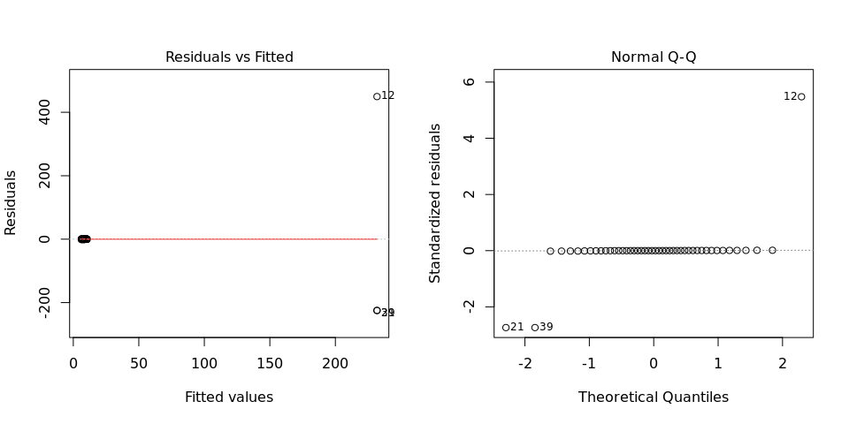

Any trend in the residuals in the left plot would violate the assumption of independence while a trend in the variability of the residuals –for instance a funnel shape– suggests heterogeneity of variances. Departures from the theoretical normal line on the right plot are symptoms of lack of normality.

## 2.3. Treatment means

Because the effect of treatments was not significant in the ANOVA, multiple comparison tests are not presented. The means of your treatments are:

## v1_Irrigation sprinkler system_200mm_0 cm_2019-04-08   
## 7.222222   
## v1_Irrigation sprinkler system_200mm_0 cm_2019-05-08   
## 8.666667   
## v1_Irrigation sprinkler system_200mm_10 cm_2019-04-08   
## 7.333333   
## v1_Irrigation sprinkler system_200mm_10 cm_2019-05-08   
## 6.222222   
## v1_Irrigation sprinkler system_300mm_0 cm_2019-04-08   
## 10.000000   
## v1_Irrigation sprinkler system_300mm_0 cm_2019-05-08   
## 10.222222   
## v1_Irrigation sprinkler system_300mm_10 cm_2019-04-08   
## 8.777778   
## v1_Irrigation sprinkler system_300mm_10 cm_2019-05-08   
## 8.666667   
## v2_Irrigation sprinkler system_200mm_0 cm_2019-04-08   
## 8.333333   
## v2_Irrigation sprinkler system_200mm_0 cm_2019-05-08   
## 8.222222   
## v2_Irrigation sprinkler system_200mm_10 cm_2019-04-08   
## 6.888889   
## v2_Irrigation sprinkler system_200mm_10 cm_2019-05-08   
## 231.777778   
## v2_Irrigation sprinkler system_300mm_0 cm_2019-04-08   
## 10.333333   
## v2_Irrigation sprinkler system_300mm_0 cm_2019-05-08   
## 10.444444   
## v2_Irrigation sprinkler system_300mm_10 cm_2019-04-08   
## 8.555556   
## v2_Irrigation sprinkler system_300mm_10 cm_2019-05-08   
## 8.833333

## 2.4. Variance components

Below are the variance components for this model, under the assumption that treatments are random. Here the model is fitted using REML.

## boundary (singular) fit: see ?isSingular

## Variance Std.Dev.  
## TREATMENT 0.000 0.00000  
## Residual 9843.291 99.21336