Automatic report for a Randomized Complete Block Design (RCBD)

International Potato Center

September 30, 2019

Table of Contents

# 1. Model specification and data description

There are data from 16 treatments evaluated using a randomize complete block design with 3 blocks. The statistical model is

$$y_{ij}=μ+τ_{i}+β_{j}+ϵ_{ij}$$

where

* $y_{ij}$ is the observed response with treatment $i$ and block $j$.
* $μ$ is the mean response over all treatments and blocks.
* $τ_{i}$ is the effect for treatment $i$.
* $β_{j}$ is the effect for block $j$.
* $ϵ_{ij}$ is the error term.

In this model we assume that the errors are independent and have a normal distribution with common variance, that is, $ϵ_{ij}∼N(0,σ_{ϵ}^{2})$.

# 2. Analysis for trait 1:Maize_Ear_Moisture_content_%

## 2.1. ANOVA

You have fitted a linear model for a RCBD. The ANOVA table for your model is:

## Analysis of Variance Table  
##   
## Response: "1:Maize_Ear_Moisture_content_%"  
## Df Sum Sq Mean Sq F value Pr(>F)   
## TREATMENT 15 568.55 37.904 2.6113 0.01369 *  
## BLOCK 2 38.82 19.412 1.3374 0.27878   
## Residuals 28 406.42 14.515   
## ---  
## Signif. codes: 0 '***' 0.001 '**' 0.01 '*' 0.05 '.' 0.1 ' ' 1

You have some missing values (4.17%) and they have been estimated before running ANOVA.

The coefficient of variation for this experiment is 5.682%. The p-value for treatments is 0.01369 which is significant at the 5% level.

## 2.2. Assumptions

Don’t forget the assumptions of the model. It is supposed that the errors are independent with a normal distribution and with the same variance for all the treatments. The following plots must help you evaluate this:

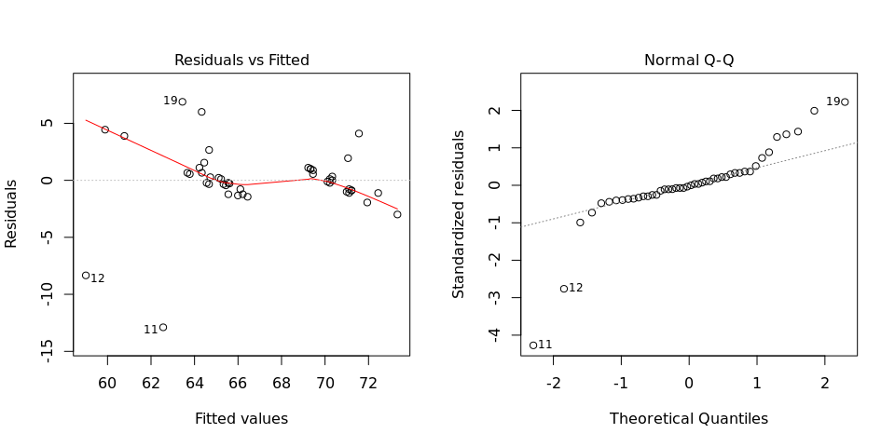

Any trend in the residuals in the left plot would violate the assumption of independence while a trend in the variability of the residuals –for instance a funnel shape– suggests heterogeneity of variances. Departures from the theoretical normal line on the right plot are symptoms of lack of normality.

## 2.3. Treatment means

Below are the sorted means for each treatment with letters indicating if there are significant differences using the least significance difference method and the multiple comparisons method of Tukey, both at the 5% level.

### 2.3.1. LSD test

## means groups  
## v2_Irrigation sprinkler system_300mm_10 cm_2019-04-08 72.44444 a  
## v2_Irrigation sprinkler system_300mm_10 cm_2019-05-08 70.86508 ab  
## v1_Irrigation sprinkler system_300mm_10 cm_2019-04-08 70.33333 ab  
## v1_Irrigation sprinkler system_300mm_10 cm_2019-05-08 70.33333 ab  
## v1_Irrigation sprinkler system_300mm_0 cm_2019-05-08 70.22222 ab  
## v2_Irrigation sprinkler system_300mm_0 cm_2019-04-08 70.22222 ab  
## v2_Irrigation sprinkler system_300mm_0 cm_2019-05-08 70.11111 ab  
## v2_Irrigation sprinkler system_200mm_0 cm_2019-04-08 65.55556 bc  
## v2_Irrigation sprinkler system_200mm_0 cm_2019-05-08 65.33333 bc  
## v1_Irrigation sprinkler system_200mm_10 cm_2019-04-08 65.22222 bc  
## v2_Irrigation sprinkler system_200mm_10 cm_2019-04-08 65.11111 bc  
## v1_Irrigation sprinkler system_200mm_10 cm_2019-05-08 64.66667 bc  
## v1_Irrigation sprinkler system_200mm_0 cm_2019-04-08 64.55556 bc  
## v1_Irrigation sprinkler system_200mm_0 cm_2019-05-08 64.53175 bc  
## v1_Irrigation sprinkler system_300mm_0 cm_2019-04-08 63.44444 c  
## v2_Irrigation sprinkler system_200mm_10 cm_2019-05-08 59.88889 c

### 2.3.2. Tukey test

## means groups  
## v2_Irrigation sprinkler system_300mm_10 cm_2019-04-08 72.44444 a  
## v2_Irrigation sprinkler system_300mm_10 cm_2019-05-08 70.86508 ab  
## v1_Irrigation sprinkler system_300mm_10 cm_2019-04-08 70.33333 ab  
## v1_Irrigation sprinkler system_300mm_10 cm_2019-05-08 70.33333 ab  
## v1_Irrigation sprinkler system_300mm_0 cm_2019-05-08 70.22222 ab  
## v2_Irrigation sprinkler system_300mm_0 cm_2019-04-08 70.22222 ab  
## v2_Irrigation sprinkler system_300mm_0 cm_2019-05-08 70.11111 ab  
## v2_Irrigation sprinkler system_200mm_0 cm_2019-04-08 65.55556 ab  
## v2_Irrigation sprinkler system_200mm_0 cm_2019-05-08 65.33333 ab  
## v1_Irrigation sprinkler system_200mm_10 cm_2019-04-08 65.22222 ab  
## v2_Irrigation sprinkler system_200mm_10 cm_2019-04-08 65.11111 ab  
## v1_Irrigation sprinkler system_200mm_10 cm_2019-05-08 64.66667 ab  
## v1_Irrigation sprinkler system_200mm_0 cm_2019-04-08 64.55556 ab  
## v1_Irrigation sprinkler system_200mm_0 cm_2019-05-08 64.53175 ab  
## v1_Irrigation sprinkler system_300mm_0 cm_2019-04-08 63.44444 ab  
## v2_Irrigation sprinkler system_200mm_10 cm_2019-05-08 59.88889 b

## 2.4. Variance components

Below are the variance components for this model, under the assumption that treatments and blocks are random. Here the model is fitted using REML and missing values are not estimated.

## Variance Std.Dev.  
## TREATMENT 7.7446733 2.782925  
## BLOCK 0.2002715 0.447517  
## Residual 14.4670486 3.803557