A PRELIMINARY DESK REVIEW of
URBAN POVERTY IN THE
EAST ASIA REGION:
with particular focus on
31421
v. 1
INDONESIA, THE PHILIPPINES,
AND VIETNAM

East Asia Urban Development Division

VOLUME 1: MAIN REPORT

Final Draft
September, 2002

TABLE OF CONTENTS

Foreword vii
Executive Summary 1
Part One: Background 14
A. Purpose and Approach of this Review 14
B. The context of urban demographics 15
The urban transition 15
The size and growth of urban areas 20
Migration and urban growth 23
C. The urban economic context 24
Changing economic activities 24
Increased concentration in extended peri-urban areas 26
Susceptibility to macroeconomic shocks 28
D. Implications of demographic and economic changes for urban poverty 29
Is poverty urbanizing? 29
How important is migration to poverty? 32
What are the trends in the incidence of poverty, and especially of urban poverty, in the Region? 33
Implications of urban development for poverty reduction 37
Part Two: Assessing Urban Poverty in the Focus Countries—What we know from available quantitative and qualitative information 40
A. A conceptual framework for urban poverty 40
B. Methodological issues in the quantitative assessment of urban poverty 42
Limitations of national household (living standards) surveys from the urban perspective 43
C. Demographic Profile of the Urban Poor 45
Age, gender, household size and composition 45
Migration Status 46
D. Labor and Human Capital Assets 48
Education Status 48
Health Status 49
Employment status and types of work 51
E. Physical Assets: Housing, Land and Infrastructure 53
Housing and land tenure 53
Electricity and durable consumer assets 56
Water supply 56
Sanitation 59
Transport 62
F. Insecurity and urban poverty 64
Insecurity of home and place 64
Personal insecurity 64
Financial insecurity 65
G. Empowerment, Social Capital and Urban Poverty 66
Relations with government 66
Social networks among the urban poor 67
Part Three: Implications of Urban Poverty Findings for Policy, Institutional Development, and Research in the Region 69
A. Summary of key points about urban poverty in the EAP Region 69
B. Policy and institutional implications of urban poverty 71
C. Suggested priorities for research into urban poverty in the Region 73
Technical Annex – Developing better sampling designs and questionnaires to assess the living conditions of the urban poor 76
Bibliography 81

Table I.1: Total and Urban Population, East Asia and Pacific Region 15
Table I.2: Historic and Recent Trends in Urbanization: East Asia and Other Countries Compared 16
Table I.4: In both the Philippines and Vietnam, income (expenditure) poverty has declined by standard measures in both rural and urban areas 35
Table I.5: Indonesia: Different poverty measurement techniques yield large differences in rural/urban comparisons 36
Table I.6: Cumulative distribution function of per capita expenditure, by type of settlement (Indonesia) 37
Table II.1 Health Indicators by Urban-Rural Residence 50

Figure I.1: The rate of urbanization is starting to taper off in the Philippines, still increasing in Indonesia, and poised to take off in Vietnam 18
Figure I.2: Urban growth is still significant in the Philippines and Indonesia, and picking up in Vietnam 19
Figure I.3 City size patterns differ between the East Asian subregions, and compared to other developing countries 22
Figure I.4 Urban’s share of the total poverty is growing in East Asian countries 32
Figure II.1 Indonesia – Urban household demographics: Female-headed and elderly households are not generally poor – but large families are 47
Figure II.2 Philippines – Urban household demographics: Female and elderly headship is more common among mid- to upper-expenditure households 47
Figure II.6 Vietnam – Urban source of drinking water: Unprotected sources predominate among the lower expenditure deciles 58
Figure II.7 Philippines – Urban access to “own faucet” rises sharply with per capita expenditure status 58
Figure II.8 Indonesia – Urban sanitation (final disposal): About a third of lower-to middle-income residents use unsafe methods 61
Figure II.9 Vietnam – Urban type of toilet: Half or more of lower-expenditure households lack access to protected facilities 61

Box I.1 Why East Asia shows little relationship between urbanization and industrialization 27
Box: II.1 The costs of inadequate sanitation in Indonesian cities 60

Acronyms

ADB Asian Development Bank
BPS Badan Pusat Statistik
DHS Demographic and Health Surveys
EAP East Asia and Pacific
FIES Family Income and Expenditure Survey
GDP
GRP
IN Indonesia
LSMS
LSS Living Standards Survey
PA poverty assessment
PH Philippines
PPA participatory poverty assessment
PRA participatory rapid appraisal
PRSP
NGO non-governmental organization
SUSENAS
SWRS Social Weather Report Survey
TA Technical Annex
UIP Urban Indicators Program
UN United Nations
UNCHS United Nations Centre for Human Settlements (Habitat)
UNDP United Nations Development Programme
VLSS Vietnam Living Standards Survey
VN Vietnam
WDI World Development Indicators
WDR World Development Report
WUP World Urbanization Prospects

Foreword

  - The aim of this study is to interpret much of the available information on urban poverty in three countries of the East Asia and Pacific (EAP) Region—Indonesia, the Philippines and Vietnam—in order to identify main issues and trends, and thereby inform the World Bank’s dialogue with these countries. This effort is motivated by the problem that the nature and dimensions of urban poverty in the Region have not been subjected to much direct or systematic analysis, either quantitative or qualitative; therefore, discussions of overall poverty in the Region tend to gloss over its urban manifestations, while urban operations suffer from the lack of a strong grounding in relevant poverty knowledge. Most available poverty assessments (PA) in EAP and in many other parts of the developing world have focused heavily on the still-predominant problem of rural poverty and identified issues of most relevance to the rural context. The existing poverty surveys and analyses in the Region have examined urban poverty to a quite limited extent, as a special issue (e.g. profiling one city) or at a rather general level. The urban poverty components of PAs typically do not include sufficient observations or detail on urban poor populations (representative of different types and sizes of urban areas, and by location within urban areas) to permit conclusions to be drawn about the factors defining and affecting urban poverty and its changing dimensions, or about the need for tailored actions. This study provides a preliminary analysis of available quantitative and qualitative information as a step towards identifying and motivating further work on urban poverty in the Region

  - This study was Task Managed by Aniruddha Dasgupta, under the overall guidance of Keshav Varma. Michael Lokshin and Vijayendra Rao carried out the analysis of urban data from the living standards surveys for the three focus countries. Christine Kessides drafted the main report. Shareen Joshi contributed to the literature review and background data collection. Laura de Brular and Barbara Gregory assisted with the preparation of graphics and tables, and Vernetta Hitch with document production.

  - The work has benefited from the comments of Peer Reviewers (Judy Baker, Marianne Fay, Jesko Hentschel, Kinnon Scott), written comments from Bhuvan Bhatnagar, Edward Dotson, Teresa Ho, Tamar Manuelyan Atinc, Menno Prasad Pradhan, Rob Swinkels and Carolyn Turk, and views expressed by participants at a World Bank review meeting on October 17, 2001, chaired by Homi Kharas. The Executive Summary was presented to participants (including 11 mayors and other officials from Indonesia, the Philippines and Vietnam, as well as Cambodia, China, and Mongolia) at an Urban Poverty Learning Workshop held in Singapore on June 10-11, 2002.

Executive Summary

Purpose and approach

This study reviews much of the available quantitative and qualitative information on urban poverty issues and trends in the East Asia and Pacific (EAP) Region, with particular focus on Indonesia, the Philippines, and Vietnam. This effort is motivated by the concern that much of the overall poverty analysis undertaken in the Region does not adequately represent the urban dimensions, while urban operations suffer from the absence of a strong grounding in relevant poverty knowledge. The aim of this preliminary assessment is to contribute to a fuller and more accurate understanding of urban poverty and how it is evolving in the Region (especially, in these large countries), in order to inform the Bank’s work in operations and research and to enhance our dialogues with the local and national clients on poverty reduction strategies.

The review is a desk study—that is, it is limited to material accessible to the Bank in Washington, drawing mainly on existing field work and other published and unpublished papers. The empirical analysis focuses on the household poverty surveys and Bank-sponsored “poverty assessments”, which are the main data sources used by the Bank and by the national governments in designing poverty-related activities. The three countries were chosen because each of them has had a recent Bank-assisted poverty assessment exercise, and an active dialogue with the Bank on urban strategy and operations. The report identifies certain shortcomings and gaps in the conventional poverty measurement approaches, and recommends refinements and priorities for further work.

Part One: The context of urban poverty

Trends in urban demographics

The urban population of the East Asia and Pacific Region will almost double between 2000-2030, from 0.7 billion to 1.2 billion. The annual rate of increase in the last 25 years (3.75 percent) is exceeded only by that in Sub-Saharan Africa. The urban increment will account for 130 percent of total population growth in the Region over the next generation.

Vietnam, Indonesia and the Philippines are at distinctly different points in their urban transitions – according to the official indicator of urbanization, the Philippines appears at upper-middle rank, Indonesia in the middle group, and Vietnam in the low category among other countries of the Region. However, in many countries of the Region the measurement of what is “urban” is distorted by the failure to count extensive peri-urban areas which are in fact the fastest growing areas of settlement.

Urban growth results from a combination of natural increase in the urban population, net migration from other areas of the country, and reclassification of rural areas as urban. Rural-to-urban migration appears to be the major factor explaining urban growth in the least urbanized countries (e.g. Vietnam), but becomes much less important than natural increase and reclassification at higher urbanization levels, such as in the Philippines.

Countries facing rapid urban growth, whether due to natural increase or in-migration, confront rising demands for housing, land, and urban services—and the residents least able to compete for constrained supplies are the poor. A distinctive phenomenon in Southeast Asia in recent years is migration not to the city cores but rather to peri-urban areas (zones beyond and not necessarily adjacent to the existing city boundaries) as these have attracted much new investment. The exclusion of these residents from existing local government jurisdictions restricts their access to social services and creates poverty risks even in the midst of a relatively strong local economy. The transition countries in the region, notably China and Vietnam, have pursued policies of strictly controlling rights to reside in the major cities (although this is no longer effectively enforced in China); such measures exacerbate hardships for poor migrants who remain illegal “unregistered” residents for many years.

The absolute size of urban areas is dramatic in EAP. The population of cities in the Region with over 1 million residents will increase by half, from 330 million to almost 500 million, between 2000-2015; that of “mega cities” (over 10 million residents) will increase similarly, from about 80 to 120 million. The Eastern Asian countries show population more evenly spread across city-size categories than is typical in the developing world, but with cities of 1-5 million residents being slightly dominant. Southeastern Asia, by contrast, has population heavily clustered in the below-500,000 residents category, and relatively more in the 10-plus million range than other countries. The Southeastern Asia subregion thus faces a particular challenge of managing the very high growth continuing in the largest cities.

Size of cities is not in itself a development issue, although size combined with rapid growth clearly presents a serious challenge to manage. The key to welfare outcomes is the city’s capacity (financial and managerial) to ensure the provision of essential services and to prevent or counteract the crippling land costs and negative externalities such as traffic congestion, pollution or crime that often worsen as cities grow. The poor are highly vulnerable to such problems and less able than higher-income groups to compensate by finding alternative sources of service and protection, or to negotiate with authorities and service providers.

The urban economic context

Along with the urban transition the Region is experiencing a structural transformation of its economy. These changes can be seen best within a broad spatial perspective encompassing not only the “city proper”, but rather city-regions. While economic development proceeds through shifts in production and employment from largely rural-based agriculture to largely urban-based industry and services, this transformation extends into hinterland areas before they are officially classified as urban. Traditional manufacturing progressively shifts to the outskirts of large cities and to smaller cities to find cheaper land. At the same time, the more information- and technology-intensive industry and services remain in the central cities and metro areas (and in some new extended periurban areas), as required skills, infrastructure and amenities become more important factors for these producers than land costs.

For many unskilled workers and for most of the poor, the small scale and “informal sector”, including activities of infrastructure and other services, construction, trade and small scale manufacturing, and urban agriculture, are the main source of income and exploit the multiplier effects of the registered “formal” economy. Similarly diverse economic activities are increasingly important in rural areas too, and such nonfarm employment generally benefits from proximity to urban areas (as does agricultural production) because of access to markets, information, and infrastructure.

The framework of economic policies and the business environment affecting incentives for investment and private enterprise are clearly very important for countries to realize the potential productivity advantages of large urban labor markets. The Region’s macroeconomic-financial crisis of the late-1990s demonstrated that while urban areas are generators of economic activity, they are also very subject to ripple-through effects of cyclical and other macroeconomic shocks which are particularly hard on the residents living at the margin of poverty.

One result of the prevalance of extended periurban development in the Region is that the cities “proper” do not contain a wide range of formal sector jobs across skill levels in both manufacturing and services. Manufacturing is increasingly locating outside the city limits while “high end” modern services (and very low end, informal sector production and services) remain as the officially-recognized urban economy. An implication is that the urban poor may have less occupational mobility within the cities than has been available to urban residents in other countries. Policies to ensure a well-integrated internal labor market ( with ease of migration and internal mobility) are one important conditon to avoid spatial segmentation of population and of jobs. The peri-urbanization phenomenon also calls for realistic urban management policies that integrate zones outside the cities and provide them with adequate urban services.

The urbanization of poverty

How the trends in urbanization and economic activity in the EAP countries will affect the magnitude and proportion of poverty in urban places is not simple to predict. Growth in the share of the total population that is urban should be associated with a reduction in total poverty in a country over the medium-term, as urbanization is highly correlated with increasing national income, greater market depth, and other development indicators. Increasing urbanization therefore allows incomes to grow for the urban residents and for migrants from other regions to the cities. Over time it should have the same effect for the remaining rural population, by relieving pressure on rural land, enlarging markets for rural goods, and providing savings for public and private transfers to rural areas. However, this process does not ensure that the pace of income growth in the urban and rural areas will remove income inequalities between them. Indeed, the urban-rural gap may widen in the medium term, especially with respect to rural areas that are intrinsically under-resourced (in natural or human capital), or if governments do not introduce effective transfer policies and well-integrated financial markets.

While increasing urbanization should reduce both total and urban poverty over the medium term, the processes of this transition—influx of migrants and other factors creating new demands on cities for services, jobs, housing, infrastructure, etc.—could induce urban poverty in the short term. Even with good conventional urban management, cities may confront a more deep-seated phenomenon of poverty that can be exacerbated by high urban growth, but is more a manifestation of social, political, and institutional issues that become visible in new ways in the urban context. These kinds of problems are revealed where:
- there are deep divisions between social groups (e.g., “legal” and “nonlegal” residents);
- certain settlements within the city are spatially segregated from others, leaving residents burdened with persistent multiple disadvantages, including risk of eviction and social stigma;
- access to “normal” political voice and legal redress remains weak or lacking for many people; or
- certain vulnerable groups are insufficiently protected by social networks and other institutions of the society.
Such structural determinants of poverty require more fundamental reforms in governance, both locally and nationally, than mere financial resources. Poverty could therefore both be created faster, and resolved faster, in urban areas, depending on the nature of the poverty and of the responses to it.

With respect to the conventional income or consumption (expenditure) measures of poverty, the share of urban within the total poor population of developing countries, including of the EAP Region, is projected to increase significantly over the coming years. Conservative assumptions would indicate that urban poverty as a share of total poverty in the Region overall would average about 40 percent in 2025, up from about 25 percent in 1998. (Hentschel and Bump, 1999) The share could range from over half (Indonesia and the Philippines) to less than a fifth in China and Vietnam—although figures for China, especially, vary greatly with assumed poverty income thresholds and definitions of what is the “urban” population.

Although it is sometimes considered that rural-urban migration shifts poverty from rural to urban areas, migrants are not necessarily motivated by poverty nor languishing among the poor in cities. How government policy and the incumbent population treat the migrants is critical to their welfare and their ability to integrate themselves into city life.

The incidence of urban poverty—the share of poor people within the urban population

In both the Philippines and in Vietnam, income or expenditures poverty has declined over the 1990s for both urban and rural populations, whether measured as the basic “headcount” or as depth (severity) of poverty. The urban poverty headcounts as cited in the recent poverty assessments (16 percent of urban population in Indonesia, 12 percent in the Philippines and 9 percent in Vietnam) remain well below those for rural. However, measurements of urban poverty are subject to important caveats, as discussed further below. Correcting for the omission of unregistered migrants, for example, could raise the urban poverty headcount in Vietnam to possibly 15 percent. For Indonesia, differences in the measurement methodology have an enormous impact on the ratios of poverty headcounts between rural and urban populations. The low and improving indicator of poverty depth implies that the urban population is close to the poverty line. Therefore, changes in estimations about this line—as well as real adverse events that create income shocks—can have a large (statistical or real, respectively) impact on the numbers of individuals falling into poverty.

Inequality is higher in urban than in rural areas for all three focus countries, and in the Philippines and Vietnam, urban inequality is worsening. This intra-urban inequality is also evident from much of the data on access to basic services and welfare status (across housing, land tenure, water and sanitation, and transport). Possibly reflecting the limitations of official income-based measurements of poverty as well as the evidence of real inequalities, the urban population in the Philippines rates their own poverty status well above official estimates and above ratings by rural respondents.

Implications of urban development for poverty reduction

It is of interest to this review to determine what factors are associated with, or contribute to, increases or decreases in overall poverty (and of course, in particular to urban poverty) in the Region. Causality of change and implications for poverty strategies are not easy to identify. In all three countries, the agricultural population has the highest incidence of poverty and the highest share of the total poor. Both the Philippines and Vietnam poverty assessments conclude that given the continuing preponderance of the poor in agricultural occupations, better growth performance in agricultural is crucial for poverty impacts, along with a structural shift of the population out of agriculture into higher productivity activities. The key questions are then: in what locations do the high productivity activities (including high-value agriculture) take place and what are the conditions that best support them?

Within all three countries, the regions with highest poverty incidence tend to remain those that are remote from population centers and, especially, those with relatively poor natural resources but dependent on agricultural-based activities. The less well-off regions therefore have less access to the economies of agglomeration, which are based on proximity to markets for goods and labor, to infrastructure that reduces production costs, and to networks for exchange of information and technology. Even within rural areas of Vietnam, for example, both nonfarm employment and agricultural activities benefit from proximity to sources of urban demand; living standards are higher (and poverty lower) in the periphery of cities and towns. The urban characteristic of relatively dense and larger scale settlement also permits activities with high fixed costs ( increasing returns to scale) to be provided more efficiently—activities such as secondary and tertiary education and health services, and network infrastructure. In short, the common observation that more urbanized regions (e.g. the Red River Delta, South East and Mekong Delta in Vietnam) have lower poverty incidence should not be attributed merely to chance or unfair policy advantage. Such outcome can also result because the intrinsic elements of the (general) urban context make some growth-promoting and poverty-reducing actions have lower cost and higher return than in the (general) rural context. This is true not only of public investment in infrastructure, for example, but also for much private investment, for which the physical proximity of other producers, workers, consumers and suppliers confers a real productivity advantage.

But there is nothing about the theory of agglomeration economies that guarantees that population concentration alone will achieve economic growth or poverty reduction. What matters is whether producers and workers are able to respond to opportunities that urban marketplaces can bring. How well urban growth is managed in the EAP countries in the coming years will therefore matter greatly not only for poverty within the cities, but even more for how much the urban areas contribute to the economy and the prospects for poverty reduction in the rural areas. Correspondingly, strategies for national and rural poverty reduction need to draw on the productivity-enhancing potential of urban agglomerations. This is acknowledged quite explicitly in the Vietnam and the Philippines poverty assessments, and in the latest national plan for China. Policies and investments that strengthen the ability of the rural population to shift to higher return activities and/or to move to locations offering greater opportunity, along with increasing the effectiveness of cities and towns in providing jobs and services, all need to be integral ingredients of the national poverty strategies in countries of the Region.

part two: Observations concerning urban poverty in the focus countries

Methodological approach and issues

The present review employs a broad definition of poverty reflecting the multiple dimensions of opportunity and capability, security, and empowerment. (WDR 2000/01) Three particular aspects of urban life affect directly how poverty is manifested (Moser, Gatehouse and Garcia, 1996):
- the characteristic reliance on cash income for all necessities (“monetization”);
- environmental hazard, stemming in particular from the relative density of urban habitation; and
- social fragmentation or “churning”. Although urban social networks can be strong and highly functional, they are different from those in rural areas. The larger turnover and absence of many social (especially, familial) support structures relative to rural areas can contribute to urban social stress.

To incorporate the dynamic and contextual nature of urban poverty, it is also necessary to account for vulnerability to risks and the corresponding importance of various assets, both formal and informal—labor, human capital, natural capital, physical productive assets, household relations, and social capital—determining households’ ability to manage risks. (Moser, 1998) Evidence of how the poor cope with risks reveals that in the presence of shocks and crises they employ a wide range of such assets as best they can, but many also cut back expenditures for food. Urban populations face a high covariance of risks to the household, when income-earning opportunities are lost (because of the need for cash income to access essential services), as well as risks to the neighborhood community, from the threat of forced eviction when tenure is insecure.

For the present study the living standards survey databases for Indonesia, the Philippines and Vietnam were broken down to extract the responses from the urban and rural population samples. Respondents were classified according to expenditure deciles (and in some cases, poor and nonpoor groupings) and their survey responses were then compared accordingly.

There are several important caveats about these (and most) living standards surveys that limit the picture they can convey about urban poverty, for several methodological reasons:
- they may fail to capture fully the mixed sources of livelihoods (drawing from both rural as well as urban activities and assets) of many households, regardless of where they live;
- the samples are typically too small to permit disaggregation among and within urban areas (i.e., different cities cannot be compared, and neighborhoods within cities cannot be distinguished);
- the sampling frames may be outdated given the rapid changes in urban population; and
- the survey instrument is often insensitive to the peculiarities of urban life.
More is said about the last two points further below.

Findings from the quantitative and qualitative analyses reviewed

Despite these caveats the following preliminary observations can be made from the survey data, supplemented by the limited review of qualitative studies in the three focus countries. This analysis identifies both what can be known and what cannot be known from these sources:

Characteristics of the income-poor people and their location
- The living standards survey data reveal that the poor and poorest among the urban populations of Indonesia, the Philippines and Vietnam are not the usually expected “vulnerable groups” (i.e., not female-headed households nor the elderly), but they do include large families. Private transfers (of urban origin) may be one main reason why these groups escape poverty.
- The migrants surveyed are not less well off than longtime residents, although a major shortcoming of the Vietnam survey is its failure to capture the nonregistered migrants who suffer official exclusion from services and benefits.
- While indicators improve generally with increasing size of settlements, the largest urban areas (Manila and Jakarta) are not necessarily most favored. In some respects (e.g., water and sanitation in Jakarta), the poor residing there are worse off than in other types of settlements.

Housing, physical assets and services
- The housing status of the urban poor is marked by a high degree of crowding and by tenure insecurity (risk of forced eviction). There is a large quality differential across urban income groups, although housing conditions are surprisingly poor even for the urban middle class in the Philippines.
- Although access to education, health facilities, water and sanitation is predictably higher in urban than rural areas overall, a breakdown of both effective access (and quality of service) and of outcomes is needed—across income groups, zones of the city, and among urban localities—to determine accurately the welfare status of different groups (in absolute or relative terms). Such disaggregations are not feasible from most of the survey databases.
- Sources of water supply and quality of sanitation are highly divergent across income groups in urban areas. The poor are more likely to pay for water than the rich in Jakarta and Manila. The large share of the urban poor without basic sanitation or safe waste disposal in Vietnam and Jakarta pose major health risks for them and for the entire city populations.
- The high density of East Asian cities has historically permitted use of nonmotorized transport and walking for a large share of transport needs, but this is changing with urban growth The mobility and accessibility of the poor are affected by problems in public transport, increased traffic congestion and accidents, ground level pollution, and transport-related crime, although these factors were not observable from the available information.

Characteristics relative to opportunity and capability
- The urban poor are not necessarily the unemployed according to the surveys. The survey instruments are not well suited to capture the vagaries of urban earnings patterns, especially in the informal sector.
- From the information available, it is evident that there are large disparities in educational attainment among the urban population. Intermediate levels of education do not necessarily translate into higher incomes in the urban setting.
- Health status in urban areas is deleteriously affected by behaviors, multiple stresses and environmental risks. Infant and child mortality are higher for the urban poor than the rural poor in the Philippines. (Health outcomes have been found to vary even more across zones of a city where this has been studied elsewhere, although the available living standards surveys examined here do not permit this analysis for the focus countries.) Undernutrition and hunger are evident in some urban areas of the Philippines and Vietnam. Risky behaviors (e.g., smoking), disaster-prone living conditions, incidence of crime, violence, and HIV-Aids, and traffic accidents can further affect mortality and morbidity in urban areas, especially among the poor, although these impacts could not be observed from the data studied.

Characteristics affecting empowerment and security
- The urban poor experience a covariance of threats to their personal, financial and communal security stemming from uncertain tenure status, macroeconomic shocks (affecting earnings and prices), crime and other social pathologies (such as drugs).
- Private financial transfers play a larger role than public transfers in mitigating financial risks of the poor.
- Despite their physical proximity to seats of political power, the urban poor report having little influence on policies or programs affecting them unless they organize. Generally the urban poor perceive themselves to be excluded by government, yet highly vulnerable to official corruption.
- The urban poor have many complex social networks that serve multiple functions of social integration, mutual support, labor market facilitation, and collective action to obtain services and housing. This social capital, which is highly diversified, is more important for the urban poor than their formal relations with government in helping them cope with and manage urban life.

Policy and institutional implications

There is an element of urban poverty that could be considered a function of temporary mismatch between the supply and demand for jobs and services, especially in the presence of rapid in-migration. If institutions are basically responsive and efficient this kind of poverty could be addressed by applying more resources to the provision of services and removing any specific bottlenecks, such as undue regulatory barriers. But in the three focus countries viewed here, and arguably in many other countries, much of the poverty appears due to deepseated political and institutional factors that prevent certain groups from obtaining the opportunities and protections they should be able to expect from either markets or from government. The empirical finding that inequalities are deep and pervasive in the urban areas suggests that this more fundamental rooting of poverty in the structures of governance is the main issue to be addressed.

For the former type of poverty—which may be characterized as “waiting in a queue” that moves by fair, well-known and accepted rules—governments and external donors can accelerate the queue by applying additional financial resources and helping to identify measures that would accelerate supply (e.g., frameworks to facilitate private sector provision), or sharpen the expression of demand for services, such as by providing information. Much of the government attention to policy reform and improved investment in infrastructure, and to private sector development, is very relevant to this process. This effort remains a priority in the Region, particularly if it focuses on regulatory or other disincentives to the provision of services to low income users. Support to municipalities in removing policy-induced barriers to land development and undertaking flexible urban planning, to steer new development in ways that can forestall future slum creation with population growth, are also high priorities.

To get at the deeper problems that prevent the urban poor from taking advantage of improved opportunities and disempower them, it is necessary to act more directly on underlying institutional issues of governance. The insecurities of housing and land tenure, livelihood insecurity and physical insecurity to which low income urban residents are vulnerable call for policies and programs to strengthen legal protections and rights (especially for tenure), to reduce corruption and arbitrary administrative actions, and to foster the communities’ own social capital. Community-driven slum upgrading programs, which improve a wide range of physical and communal services in neighborhoods with the active involvement of the residents, would have broad benefits in reducing multiple sources of vulnerability—provided the local and national government are committed to the program as part of a framework of better governance (recognizing the residents as full citizens with rights and responsibilities) rather than an isolated action. Similarly, measures to raise the capacity of local governments to carry out all of their basic functions in a more responsive, transparent and accountable manner, and to undertake participatory strategic planning of their investments and other activities, would help change the relationship between the local government and citizens.

The process of urban transition and the potential economies of agglomeration can raise the productivity for both rural and urban residents, but only if the basic mechanisms—a well integrated internal market for labor and goods, with ease of movement and good information flows, and lowered production costs from shared infrastructure—are actually working. Reform of policies and programs that make the urban economies function efficiently and raise the returns to private investment there would be good value to the nation as a whole.

Such policies and programs would, for example:
- be positive towards internal migration—certainly remove residence restrictions where they linger, and facilitate urban-rural remittances as a main source of private transfers;
- favor domestic markets for goods and services (aided by transport and telecommunications improvements); and
- correct distortions or missing segments of financial markets (especially credit and savings for the poor).

Greater attention to housing sector reforms and to urban transport needs is especially crucial in the Region. The widespread inadequacies in housing and transport, which affect many urban residents but are especially debilitating to the poor, should be among the highest priority concerns of governments and the Bank as these failures undercut the very essence of the urban economy, which is a fluid labor market.

Finally, the findings on urban poverty and inequality argue for the development of more detailed information on impact and targeting within the urban population. Nationally representative household surveys will not be able to provide the necessary spatial disaggregation and special purpose surveys will be needed that are capable of producing panel data. Similarly, public expenditure analysis needs to go beyond aggregate attributions to “rural” or “urban” beneficiaries, to determine more accurately the distributional reach within the urban population and in different urban areas.

Suggested priorities for research into urban poverty in the Region

The present analysis raises important issues about the common methods of empirical poverty research (living standards surveys) that are ill-suited to the context of urban poverty, and therefore unlikely to reveal correctly its nature and relevant distinctions with respect to rural poverty. Potentially the most serious problems stem from the fact that the research methodology, which has been developed and applied most extensively in rural settings and reflects rural notions of life, carries a bias inherent in the sampling design and in the construction of survey instruments that tends to work against an accurate representation of the urban poor.

Because urban populations are constantly changing, homes often contain several families, and unregistered migrants are not counted as urban residents, decennial census-based sampling frames become nonrepresentative within a short time and are especially likely to miss those who are transient or without a fixed address. There are known techniques to ensure more accurate sampling, but best practices are not always applied.

The national survey instruments and methods are typically designed for rural households, work, and living conditions, and are usually not adapted adequately to capture the complexities of urban livelihoods and social relationships, or the multi-spatial nature of households rooted in both places. Combining qualitative and quantitative methods and information sources is important to overcome the limitations of each. Alternative approaches to sampling and to survey design may need to be tested and applied.

With better methods of obtaining a more complete and accurate picture of urban poverty, a number of specific issues and questions need to be explored. Based on the preceding review some priority research topics are suggested here:

- The role of interspatial mobility (migration and multi-spatial livelihoods) in affecting poverty in both rural and urban areas. This would include looking at circular and temporary rural-to-urban migration as well as longer-term movement, and would examine both the role of private transfers transfers and mechanisms by which rural migrants become integrated into the urban society and economy.
- The dynamics of informal employment in urban areas—the quality of livelihoods and patterns of occupational mobility in the context of policy and institutional conditions.
- How social networks among the urban poor function to help members cope with poverty and its various dimensions; these networks often include linkages with rural residents.
- A disaggregated analysis of health outcomes by zones within some major cities and comparison among different cities (with different sizes, growth rates, and degrees of service provision), to map health-related poverty in greater geographic and socio-economic detail than is currently available.
- Evaluation of the impact of specific interventions or packages of interventions, such as neighborhood infrastructure improvements and tenure security, on the well-being of low income residents. The role of social capital and how it affects or is affected by residents’ participation in such interventions would be a further question for such research.

Urban Poverty in the East Asia Region: A Preliminary Desk Review
(with particular focus on the Philippines, Indonesia, Vietnam)

Part One: Background

A. Purpose and Approach of this Review

  - The present work aims to begin filling gaps in the Bank’s understanding of urban poverty in East Asia by surveying as much as possible of the quantitative and qualitative work that is currently available through a desk review, in particular by extracting urban details from existing poverty surveys, to suggest implications for policy, external assistance and research. Given resource and time constraints the present study is focused on three countries—Indonesia, Philippines and Vietnam— because each of them has had a recent Bank-assisted poverty assessment exercise, and an active dialogue with the Bank on urban strategy and operations. The present report looks at the three countries, and some selected evidence on others, to illustrate urban poverty developments within East Asia and the Pacific but does not attempt to generalize to the entire Region.

  - The present study is therefore a preliminary effort to extend our knowledge on: the extent and nature of urban poverty in the three countries, on apparent contributing or associated factors, and on possible approaches for country policy and donor assistance to tackle these poverty issues. In addressing these questions, the study compares and contrasts the findings on poverty in urban areas with those pertaining to rural areas where this can help to clarify the distinctive nature of urban poverty. Such comparisons can illuminate similarities and differences in policy or operational assistance for different spatial contexts, and potential synergies in urban and rural poverty reduction efforts. By its design the present study raises more questions and hypotheses than conclusive answers, thereby suggesting directions for future work.

  - The remainder of this section outlines briefly the demographic and economic context of urban development, and the overall pattern of urban and total poverty, in East Asia and the Pacific. (Readers familiar with this Regional background may wish to skip this section.) Section II begins with a conceptual framework to view urban poverty, and some methodological issues; it then reviews the empirical survey evidence on the three focus countries, supplemented by qualitative studies and illustrations from other countries in the Region where possible, to gain a preliminary picture of urban poverty in its multiple dimensions. The last section recapitulates the main elements of urban poverty that emerge from this evidence and outlines some priorities for policy and program responses and for future research.

B. The context of urban demographics

The urban transition

  - The urban population of the East Asia and Pacific will almost double between 2000-2030, from 665 million to 1.2 billion, according to the UN (Table I.1). The urban increase will account for more than the total net increase in national populations because of absolute decline in the population counted as rural.

Table I.1: Total and Urban Population, East Asia and Pacific Region

EAP Region | 2000 m | 2030 m | Increase m | % increase
Total Pop | 1877.0 | 2301.9 | 424.9 | 22.6
Urban Pop | 664.8 | 1230.1 | 565.3 | 85.0
Rural Pop | 1212.5 | 1071.8 | (-140.7) | (-11.6)
Urban/Total | 35.4% | 53.4%

East Asia and Pacific (EAP) Region combines Southeastern Asia and Eastern Asia, less Japan.
Excludes Melanesia, Micronesia and Polynesia
Source: UN, World Urbanization Prospects (WUP), 1999 Revision.

Table I.2: Historic and Recent Trends in Urbanization:
East Asia and Other Countries Compared

 | Developed Countries | All Developing Countries |  | East Asia and Pacific Region
Year | 1900-1925 | 1975-2000 | 2000-2025 | 1975-2000 | 2000-2025
Share Urban (%) (beginning - end of period) | 26-40 | 27-40 | 40-53 | 20-35 | 35-51
Urban pop growth over 25-year period % | 90 | 140 | 82 | 151 | 75
Growth Rate % p.a.:
Urban | 2.57 | 3.56 | 2.43 | 3.75 | 2.25
Rural | 0.05 | 1.12 | 0.20 | 0.60 | -0.32
Total | 0.87 | 1.92 | 1.23 | 1.45 | 0.74
Contribution of urban to total pop growth - % | 96 | 62 | 92 | 71 | 130

Developed country data from Brockerhoff and Brennon, 1998; Other data UN, WUP 1999 Revision. All averages weighted by population.

  - Table I.2 shows that the East Asia and Pacific Region has urbanized more rapidly over the past 25 years than have the developing countries overall; it also far exceeded the pace of the currently developed countries when they passed through a similar stage of their urbanization in the 1900-25 period. The developing countries have urbanized with much higher overall population growth than the industrial countries experienced. This has been particularly true in EAP, which has witnessed 3.75 percent annual growth of the urban population over the past 25 years, a pace exceeded only by Sub-Saharan Africa. This rate is projected to decline sharply over the next period along with falling population growth, but the urban increment will account for a historically unprecedented 130 percent of total population growth over the next generation.
Table 1.3: Comparative Structural Indicators of Urban and Economic Development, by Country and Subgroups

 | % Urban |  | # Urban Pop,  millions |  | % Growth  Rate of  Urban  Pop, | Population in Largest City,  % Urban Pop | Gross National Income*  per capita, |  | Value Added  % of GDP, |  |  | % Average Annual Growth of Output,
 |  |  |  |  |  |  | $ | Ave. Ann.  Growth  Rate | Agric | Mfg | Services | Agric | Mfg | Services
Current Level of Urbanization | 2000 | 2030 | 2000 | 2030 | 2000-05 | 2000 | 1999 | 1997-98 | 1999 | 1999 | 1999 | 1990-99 | 1990-99 | 1990-99
High
Republic of Korea | 81.9 | 90.5 | 38.4 | 47.9 | 2.67 | 26 | 8,490 | -7.5 | 5 | 32 | 51 | 2.1 | 7.1 | 5.8
Medium
Mongolia | 63.5 | 76.0 | 1.7 | 2.9 | 2.28 | .. | 390 | 1.9 | 32 | .. | 39 | 3.1 | .. | 1.3
Philippines | 58.6 | 73.8 | 44.5 | 84.1 | 3.14 | 25 | 1,050 | -2.1 | 18 | 21 | 52 | 1.4 | 2.9 | 4.0
Malaysia | 57.4 | 72.7 | 12.8 | 23.7 | 2.83 | 10 | 3,390 | -8.0 | 11 | 32 | 43 | 0.2 | 9.7 | 8.0
Lower Medium
Indonesia | 40.9 | 63.5 | 86.8 | 179.9 | 3.57 | 13 | 600 | -18.0 | 19 | 25 | 37 | 2.3 | 7.6 | 4.0
China | 32.1 | 50.3 | 410.0 | 752.1 | 2.34 | 3 | 780 | 6.4 | 18 | 38 | 33 | 4.3 | 13.9 | 9.2
Myanmar | 27.7 | 46.6 | 12.6 | 28.0 | 2.86 | 33 | .. | .. | 60 | 7 | 31 | 4.9 | 6.7 | 6.6
Low
Laos | 23.5 | 42.6 | 1.3 | 4.5 | 4.87 | .. | 290 | 1.4 | 53 | 17 | 25 | 4.6 | 12.6 | 6.5
Vietnam | 19.7 | 33.7 | 15.7 | 38.0 | 2.86 | 30 | 370 | 4.3 | 25 | 18 | 40 | 4.9 | .. | 8.1
Thailand | 21.6 | 39.1 | 13.3 | 29.0 | 2.19 | 56 | 2,010 | -8.6 | 10 | 32 | 50 | 2.5 | 6.7 | 4.4
Cambodia | 15.9 | 31.9 | 1.8 | 5.5 | 4.16 | 51 | 260 | -2.3 | 51 | 6 | 35 | 2.1 | 8.2 | 6.9
Papua New Guinea | 17.4 | 33.0 | 0.8 | 2.6 | 4.01 | .. | 810 | 0.0 | 30 | 8 | 24 | 4.4 | 6.3 | 3.3
Regional Averages
Eastern Asia | 38.5 | 54.6 | 571.7 | 933.0 | 1.90
Southeastern Asia | 37.2 | 55.9 | 192.7 | 397.4 | 3.17
Total EAP Region |  |  |  |  |  | 10 | 1,010 | -2.6 | 14 | 33 | 41 | 3.3 | 10.2 | 6.5
Group Averages
More Developed | 76.0 | 83.5 | 903.0 | 1,009.8 | 0.50 | 17 | 26,440 | 0.9 | .. | .. | .. | .. | .. | ..
Less Developed | 39.9 | 56.2 | 1,942.1 | 3,879.6 | 2.70 | 16 | 1,980 | -1.3 | 10 | 25 | 54 | 2.0 | 6.3 | 3.7
Least Developed | 26.0 | 44.5 | 167.4 | 527.2 | 4.49 | 18 | 420 | 1.8 | 26 | 19 | 44 | 2.5 | 2.7 | 4.7

* formerly gross national product
** WDI. Latest available year
.. data not available

Source: Population Division of the Department of Economic and Social Affairs of the United Nations Secretariat, World Urbanization Prospects: The
1999 Revision. Part 1: Urban and Rural Areas (POP/DB/WUP/Rev.1999/1), data set in digital form.
World Bank, World Development Indicators (WDI) 2000 and 2001.

  - For the purposes of the present study, it is noteworthy that Vietnam, Indonesia and the Philippines are at distinctly different points in their urban transition (defined here as urbanization, the shift in population shares between rural and urban areas). Table I.3 presents the countries of the East Asia Region (excluding the small Pacific islands) grouped by level of urbanization, with the Philippines at upper-middle rank, Indonesia in the middle group, and Vietnam in the low category. For the most part these urbanization rankings correlate with levels of economic development according to the well-known log-linear relationship, although there are clear anomalies in the Region—Mongolia is highly urbanized for its per capita income and economic structure, and Thailand appears very much less so. Indonesia is still at the steep slope of its urbanization curve (indicating relatively high annual increase in the rate of change of urbanization), while Vietnam is just heading into it and the Philippines’ pace of urbanization is starting to taper off. (Figure I.1) All three countries are experiencing urban growth (i.e., annual increase of the urban population) around 3 percent per annum, with Vietnam’s poised to accelerate in the coming decade. (Figure I.2)

Figure I.1: The rate of urbanization is starting to taper off in the Philippines, still increasing in Indonesia, and poised to take off in Vietnam

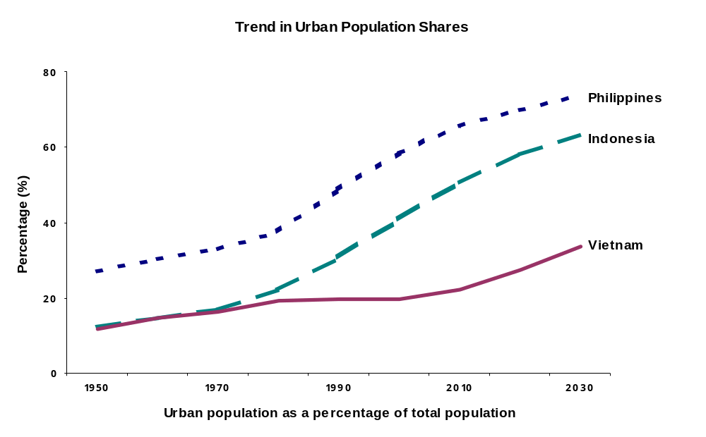

Figure I.2: Urban growth is still significant in the Philippines and Indonesia, and picking up in Vietnam

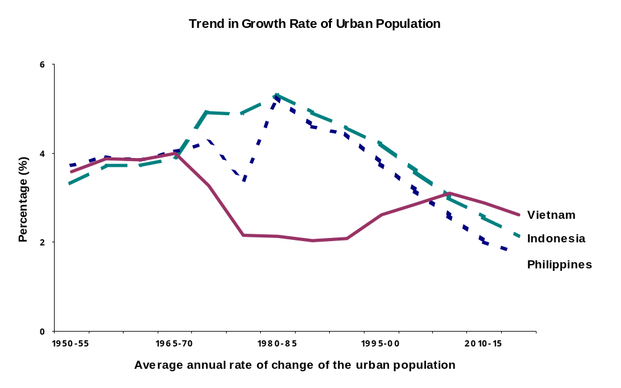
Source: Population Division of the Department of Economic and Social Affairs of the United Nations Secretariat, World Urbanization Prospects: The 1999 Revision. Part 1: Urban and Rural Areas (POP/DB/WUP/Rev.1999/1), data set in digital form.

  - Characterizations of “urban” populations are of course subject to definitional issues and differ across countries and even in the same country over time. For example, China reset its urban threshold causing a discontinuous jump in registered urban growth between 1985-90. Vietnam counts an area as urban if a settlement has at least 4000 residents and at least 60 percent of the population is engaged in nonagricultural activities; this is a rather conservative definition that gives added weight to rural areas. In many countries especially in East Asia, a major factor obscuring the measurement of urbanization is the failure to count peri-urban areas (discussed further below) as urban. While UN data record Thailand’s population as only 22 percent urban in 2000 and official government statistics report 30 percent, the Thai planning ministry (NESDB) acknowledges that a more accurate figure taking account of peri-urban settlement would be about 40 percent.

  - Households often depend on very diverse economic livelihoods, combining agricultural-based, manufacturing, commerce and other services, either in their existing location (urban or rural), through seasonal or other temporal migration, and/or through an extended family “portfolio” of economic activities in which different family members engage across different locations. Hence, to fully understand the economic circumstances and prospects of the poor whether counted as urban or rural, it is necessary to have a disaggregated picture of their livelihoods and their interactions outside of their main geographic area.

The size and growth of urban areas

  - As countries go through the urban transition that all experience with development, the rate of growth of the urban population has particular relevance to urban poverty. Urban growth results from a combination of natural increase in the urban population, net migration from other areas of the country, and reclassification of rural areas as urban. Countries facing rapid urban growth, whether due to natural increase or in-migration, confront rising demands for housing, land, and urban services, and the residents least able to compete for constrained supplies are the poor.

  - The absolute size of urban areas is dramatic in EAP. The population of cities in the Region with over 1 million residents will increase by half, from 330 million to almost 500 million, between 2000-2015; that of “mega cities” (over 10 million residents) will increase similarly, from about 80 to 120 million. While in 1950 only three of the world’s 30 largest cities were in the developing countries of East Asia (all in China and averaging 3.9 million residents), by 2015 there will be seven (Bangkok, Jakarta, Metro Manila, and Seoul along with the original Beijing, Shanghai and Tianjin) with average size of 17.1 million. (UN, 2000)

  - But size of cities is not in itself a development issue—big is not bad, and there is evidence that large urban areas, when well managed, are more spatially efficient than smaller ones. (Prud’homme 1994) The key is the city’s capacity (financial and managerial) to ensure the provision of essential services and to prevent or counteract the crippling land costs and negative externalities such as traffic congestion, pollution or crime that are often associated with large cities—and to which the poor are most vulnerable. In most developing (and developed) countries, about half of the urban population resides in cities of less than half a million residents and another quarter in cities of the 1-5 million range. (Figure I.3) Growth rates are quite dispersed across the size ranges but tend to be highest in the cities of 1 million plus. The city size distribution is quite distinct from these international tendencies for both Eastern Asia and Southeastern Asia, in quite different ways. The Eastern Asian countries show population more spread across the size categories but with cities of 1-5 million being slightly dominant. Southeastern Asia, by contrast, has population heavily clustered in the below-500,000 category, and relatively more in the 10-plus million range than other countries. The Southeastern Asia subregion thus faces a particular challenge of managing very high growth continuing in the largest cities.

Figure I.3 City size patterns differ between the East Asian subregions, and compared to other developing countries
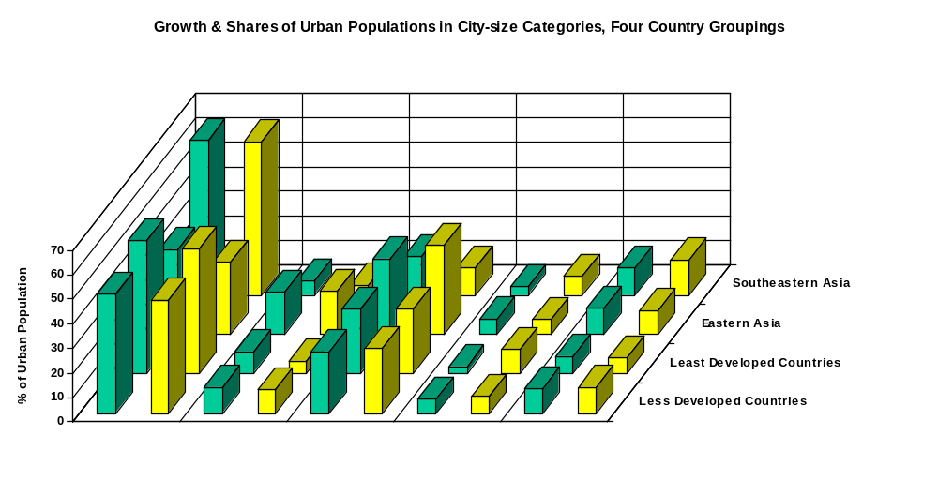
Fewer than
500,000
500,000 –
1 million
1 –5
million
5 – 10
million
10
million +
City Size Categories
(Number of Residents)
- 2000
- 2015

Source: Population Division of the Department of Economic and Social Affairs of the United Nations Secretariat, World Urbanization Prospects: The 1999 Revision. Part 2: Urban Agglomerations (POP/DB/WUP/Rev.1999/2/F16), data set in digital form. According to the UN WUP, Eastern Asia comprises China, Hong Kong, DPR Korea, Japan, Macau, Mongolia and Republic of Korea. Southeastern Asia includes Brunei Darussalam, Cambodia, East Timor, Indonesia, Laos, Malaysia, Myanmar, Philippines, Singapore, Thailand and Vietnam.

  - Research on a large sample of cities of different size categories across all developing regions has revealed that the combined effects of city size and high growth rates are unfavorable to infant mortality rates, an indicator of residents’ basic welfare. At city growth rates above 3 percent per annum, agglomerations above 1.5 million show no greater deleterious effects (odds ratios) on infant mortality than cities in the 750,000-1.5 million size range. However, the negative effects increase considerably with higher growth rates for each city size range. The concern for policy is to address the challenges of urban growth where it is occurring by improving the management of cities in order to protect and promote the welfare of the residents, especially the poor.

  - Another important structural urban characteristic is the concentration of the urban population in one dominant (“primate”) city, or a very few cities. The EAP Region features a lower average rate of urban primacy than other developing countries but also a very wide range, from China at 3 percent to Thailand at 56 percent. (Table I.3) Recent international research has revealed that urban concentration is related to economic efficiency (Henderson, 1999). The evidence suggests a “best” degree of national urban concentration that increase sharply as income rises up to a per capita income threshold (about $5000 in PPP) then declines modestly, and the “best” degree of concentration also declines with country scale. Of the East Asian countries studied, Korea and Thailand are seen to have “excessive” urban concentration (at least according to official urban statistics), Malaysia’s is below the estimated optimum for its income level, and China’s is about right (given its size). It is also likely from this analysis that the Philippines is nearing an excessive concentration in Metro Manila. The economic costs of concentration rates that exceed or fall far short of the estimated best level are considerable according to this research, in terms of foregone economic growth. The factors affecting primacy are complex: history, openness to trade, degree of fiscal (de)centralization, extent of interregional transport infrastructure. The research finds that increasing road density significantly reduces urban concentration, and the effect rises with national income. What is of interest from this analysis for the present review is the confirmation that the process of urbanization (agglomeration of economic activities, population and markets) is important to economic growth but that imbalances in urban development have high costs to the country. Ensuring that cities and towns are well managed and integrated to subregions throughout the country should be a deliberate element of strategies for national growth and poverty reduction.

Migration and urban growth

  - The significance of internal migration to urban growth is difficult to assess accurately because in census data migration cannot be separated from the reclassification of formerly rural areas as urban. However, it can safely be said that rural to urban migration represents a dominant factor in the growth of urban areas for countries at relatively low levels of urbanization, but at higher levels of urbanization and of income (up to a threshold of about US$4000 (1985 prices), internal natural increase in the cities becomes the main source of their growth (Lucas, 1999). Rural to urban migration is seen as explaining the bulk of urban population growth in Vietnam, for example, (Lim et al, 2000), which is at an early stage in its urban transition. In analysis of 26 developing countries in the 1980s, net migration plus reclassification explained 40 percent of urban population growth; however, in a broader sample of 46 developing countries over 1960-90, the average contribution of migration and reclassification appeared highest in East and South East Asia.

  - Internal migration tends to take many diverse patterns (including rural-rural and urban-urban) as development proceeds. Even some urban-rural migration, at least temporarily, is observed in times of macroeconomic crisis such as East Asia experienced in 1998-99. A distinctive phenomenon in Southeast Asia in recent years is migration not to the city cores but rather to peri-urban areas (zones beyond and not necessarily adjacent to the existing city boundaries) as these have attracted much new investment. As already noted, the increased populations of these peri-urban areas are not necessarily counted as urban in the censuses. The fact that the residents fall outside local government jurisdictions may restrict their availability to social services and create poverty risks even in the midst of a relatively strong local economy.

  - The transition countries in the region, notably China and Vietnam, have pursued policies in the past of strictly controlling rights to reside in the major cities. In Vietnam, as noted further below, such measures have restricted access to employment and services and exacerbated hardships for poor migrants who remain illegal “unregistered” residents for many years. The household registration system in China, created in the early 1950s to limit residency and employment in cities, is now starting to be relaxed in some provinces, and some flexibility in enforcement is also evident in parts of Vietnam.

  - Considerable flows of international migration also occur to the peri-urban and urban areas of East Asia (such as Burmese workers in Thailand, and Indonesian and Philippino workers in Malaysia and Singapore). These individuals, an increasing share of whom are women, often suffer the lowest legal and social status, and the worst living conditions. (Webster, 2001)

C. The urban economic context

Changing economic activities

  - As has been documented in many countries, urban areas, especially large cities, contribute more than their population share to the national economy. For example, the three major cities of Vietnam (Ho Chi Minh City, Hanoi and Haiphong), with a combined official population of 12 percent of the national total in 1990, produced 19 percent of gross domestic product; by 1995, with their population share largely unchanged, these cities generated nearly 30 percent of the national output. Counting their surrounding provinces (the Mekong and Red River Deltas), the combined city-regions produce more than 70 percent of national output with half of national population.

  - Taking account of the broader regions surrounding urban centers is important because while economic development proceeds through shifts in production and employment from largely rural-based agriculture to largely urban-based industry and services, this transformation often extends into hinterland areas before they are officially classified as urban. Traditional manufacturing progressively shifts to the outskirts of large cities and to smaller cities to find cheaper land, while the more information- and technology-intensive industry and services remain in the central cities and metro areas, or new peri-urban areas, since skilled labor, infrastructure and amenities are more important productive factors for them than land costs. For many unskilled workers and for most of the poor, the small scale and “informal sector”, including informal infrastructure and other services, construction, trade and small scale manufacturing, and urban agriculture, are the main source of income and exploit the multiplier effects of the registered “formal” economy. Similarly diverse economic activities are important in rural areas, e.g., among villages of Thai Binh province in Vietnam (Red River delta), 52-64 percent of income is earned in services and small businesses. Such “nonfarm employment” generally benefits from proximity to urban areas (as does agricultural production) because of access to markets, information, and infrastructure. According to many studies, migration of workers into both formal and informal urban-based activities is also more common from regions located relatively near to the migrant’s destination (i.e., migration behavior weakens with distance) , which further suggests that the domestic influence of an urban economy needs to be considered beyond the formal city boundaries.

  - What are the most vibrantly growing economic activities in the focus countries, and how do these relate to the urban demographics? Output and employment growth has been much stronger in industry and especially services than agriculture in Vietnam in 1993-98, as expected at its early stage of structural transformation. Ironically, employment growth in “nonfarm” activities has been higher in rural areas of Vietnam than in urban in the same period. This may reflect the incomplete state of reforms (doi moi) continuing to constrain private sector commerce and manufacturing relatively more in urban areas. Vietnam’s rate of growth of wage employment (considered in the Vietnam Poverty Assessment as synonymous with “formal sector”) was only half of what Indonesia achieved in the first half of the 1990s after it embarked on a similar reform program. Of course, wage jobs and reported unemployment affect a small share of the labor force even in urban areas. There is a strong duality in the labor force (little movement from the informal to formal sector employment), possibly more so than in the more fully market-oriented countries in the Region because of Vietnam’s relatively underdeveloped private enterprises. Job growth has been most dramatic in labor intensive light manufacturing, largely export oriented, in the main cities (e.g., shoe production in and around Haiphong and Ho Chi Minh City), especially for young female workers, many of whom are migrants.

  - In the Philippines there has been little additional shift in employment from agriculture to industry and services since the mid-1980s. Although labor productivity (output per worker) in industry is about five times that of agriculture (and for services, about two times), labor productivity has deteriorated in industry and stagnated in the other sectors since 1984 with a decline in capital intensity. Therefore, while there is considerable scope for future sectoral shifts in employment to secure income gains, this may not happen automatically without better economic management.

Increased concentration in extended peri-urban areas

  - Industrial relocation and new investment is most apparent in the “extended urban regions” (peri-urban areas) outside major cities in East Asia. This spatial trend will account for 40 percent of urban population growth in the Region over the coming 20-25 years—specifically, 53 percent of demographic growth in the extended Bangkok region, 70 percent for Jakarta’s extended urban region, and about 40-60 percent for major Chinese cities. Peri-urban regions can be defined by their underlying process characteristics: that is, they demonstrate an ongoing shift from an agricultural-based to manufacturing-dominated economy, corresponding change in employment structure, rapid population growth and urbanization, and changing spatial development and rising land costs. These peri-urban regions are becoming home to most large manufacturing investment and to foreign direct investment, in industrial estates that provide large perimeter structures and infrastructure networks along with access to a major city for higher level services. Their workers are not commuters but residents, often migrants from other urban areas (both highly qualified and less skilled workers) and rural areas, attracted both to the core formal sector jobs and to the spin-off demand for other services. (See Box I.1)
Box I.1 Why East Asia shows little relationship between urbanization and industrialization

Box I.1 Why East Asia shows little relationship between urbanization and industrialization

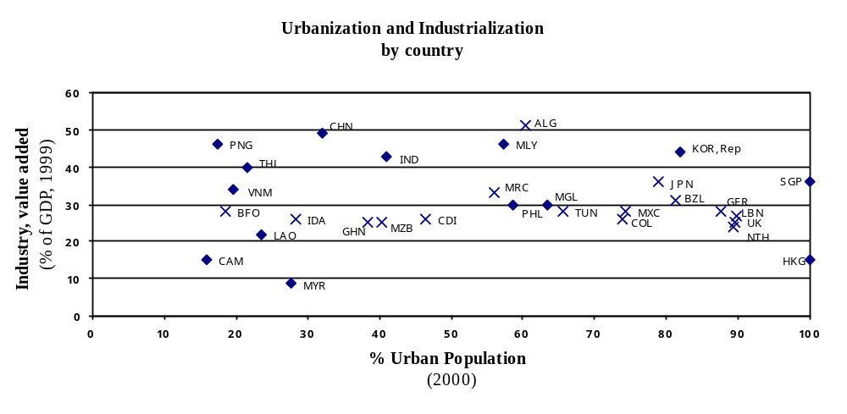

Source: Population Division of the Department of Economic and Social Affairs of the United Nations Secretariat, World
Urbanization Prospects: The 1999 Revision. Part 1: Urban and Rural Areas (POP/DB/WUP/Rev.1999/1),
data set in digital form. World Bank, World Development Indicators (WDI) 2001.

There is a well-known linear relationship between urbanization levels and per capita income, which represents the robust correlation between economic development and increasing shares of urban population both across countries and over time. Since the process of economic development involves a shift of output and employment from agriculture towards industry and then later services, there is a less straightforward relationship between urbanization and industrialization. Rich countries such as the Europeans, and even Japan, have shed industry, so their industrialization levels are declining even though they are already highly urbanized. But it would be expected that countries in the low-to-middle range of urbanization have correspondingly rising levels of industrialization.
In the East Asian Region, however, industrialization appears to rise very sharply at low levels of urbanization as measured in official statistics. As the figure shows, China, Thailand, Indonesia and Malaysia are now the foundries of the world, the Manchesters of the 21st century. In every one of these countries (though perhaps less pronounced in Indonesia), industry is not locating in cities but in peri-urban areas. Yet, in many cases, e.g., Thailand and China, these places are not being defined officially as urban.
The other factor skewing the urbanization-industrialization relationship across the East Asian region is the widespread practice of urban de-industrialization. For example, virtually every Chinese city (right down to the cities of 800,000 and smaller such as Kunming) has a policy, which has been very successfully implemented in almost all cases, to deindustrialize the city. (Even without the policy, as seen in Southeast Asia and other market economies, the market would have done the same thing in China over time.) Bangkok and Kuala Lumpur, and dozens of other Southeast Asian cities have similar policies, which have been implemented successfully, that are reinforcing market forces. The result is that officially non-urban areas such as Thailand’s Eastern Seaboard (the industrial heartland of Southeast Asia) and Chinese peri-urban zones, especially in the Lower Yangtze and Lower Pearl River regions, have regional economies with manufacturing GRP shares of 60-70 percent (the highest in the world), while the cities, such as the Bangkok Metropolitan Area, have manufacturing shares of under 30 percent and falling. Meanwhile, the share of services in cities (measured in terms of GRP) such as Bangkok is over 50 percent and rising. In summary, urbanization in East Asia is increasingly highly correlated with service activities (the more developed the country, the more higher-level services predominate), and increasingly inversely correlated with industrial activities which market forces and national and local policies are moving out of cities.
Of course, the above has enormous implications in terms of poverty. Many of the jobs accessible to rural-urban migrants and those with modest education (high school or less) are found outside, but within 200 kms of, the city limits. The cities themselves are often less effective mechanisms for providing such individuals a foothold on the economic ladder as they offer mainly either very high end jobs or very low (often informal sector) jobs. (The city proper of Shanghai epitomizes this duality.) The cities of the Region are increasingly lacking the equivalent of the solid blue collar jobs which helped so many urban and migrant households in North America to get ahead.
Source: Dr. Douglas Webster, Stanford University and the Asia-Pacific Research Center

.

- East Asia Pacific Countries
- Non-EAP Countries

  - A result of this pattern of peri-urban development is that the cities “proper” do not contain a wide range of formal sector jobs across skill levels in both manufacturing and services, since the manufacturing is increasingly locating outside the city limits while “high end” modern services (and very low end, informal sector production and services) are remaining as the officially-recognized urban economy. An implication is that the urban poor may have less occupational mobility within the cities than has been available to urban residents in other countries at other times (e.g. in U.S or Europe during the last century). Policies to ensure a well-integrated internal labor market are necessary at minimum, to avoid spatial segmentation of population and of jobs. Such policies would permit workers to migrate without administrative restrictions within the country and ease physical mobility (which depends further on land tenure, housing, and urban and inter-urban transport). The peri-urbanization phenomenon also calls for realistic urban management policies that integrate zones outside the cities and provide them with adequate urban services.

Susceptibility to macroeconomic shocks

  - The urban economies and their residents in East Asia have been particularly vulnerable to macroeconomic shocks such as the financial crisis that occurred in 1997-98. The impact hit urban areas through price increases of imported goods and food products (the latter also due to coinciding effects of El Nino), job losses (initially in the high-end services such as finance and construction), and resulting reductions in demand for other urban-based output and services such as transportation, hotels and restaurants, entertainment, domestic help, etc. Losses in real earnings therefore affected the poorer workers more as second-order effects, while higher income earners experienced the initial job cuts more directly.

  - In Indonesia, the financial crisis was estimated to affect the urban economy (especially in the largest cities) more than the rural sector, with urban-based GDP declining by 18 percent versus 14 percent for the entire economy in 1998. Urban households reduced real spending on food by 28 percent (compared to 8 percent for rural households) between 1997-98. While all regions of Indonesia experienced an increase in poverty incidence between February 1996 and February 1999, the relative increase was much higher in urban areas than in rural areas (the urban poverty rate rose by 126 percent, almost double the increase of rural areas). Similarly, the indices of poverty headcount, poverty gap, and poverty severity in Indonesia increased by 152 percent, 184 percent, and 202 percent, respectively, between 1996-99, well over twice the increases seen for rural.

  - In the Philippines, the labor market shock (job or earnings loss) was found to have had a more negative impact on relatively commercially-developed communities (in effect, those with more urban characteristics). The Philippines poverty assessment (PA) did not analyze survey data on the impact of the crisis separately for urban and rural households but concluded that “the labor market shock affected the relatively better-off wage earners more severely, while the impact of the drought (from El Nino) was heavier on the relatively poorer agriculture-based households”. However, since many urban poor are not earning wages but are subject to second-order reductions in demand for their labor, and they are vulnerable to inflation due to both the drought and macro/financial instability, it is highly likely that the urban poor were harshly affected.

  - The macroeconomic-financial crisis in 1997/98 sharply raised income poverty in other countries of the Region as well (notable Korea and Thailand). Poverty has since declined, although not recovering entirely to pre-crisis levels by 2000 in Indonesia. The Region’s economic crisis demonstrated that while urban areas are generators of economic activity, they are also very subject to ripple-through effects of cyclical and other macroeconomic shocks. The urban economies can sometimes spring back fairly rapidly from shocks, but the setback may be more serious and lasting for residents living at the margin of poverty.

D. Implications of demographic and economic changes for urban poverty

Is poverty urbanizing?

  - How the trends in urbanization and economic activity in the EAP countries will affect the magnitude and proportion of poverty in urban places is not simple to predict. Growth in the share of the total population that is urban would be expected to be associated with a reduction in total poverty in a country over time, as urbanization is highly correlated with increasing national income and other development indicators. This would occur because: (i) labor productivity is in general higher in secondary and tertiary activities, which become more dominant in the urbanized economy, than in primary production; (ii) the agglomeration economies associated with concentration of population and economic activity in urban areas permit more efficient use of (increasing returns to) labor, land and capital; and (iii) the resulting urban economic growth generates fiscal revenues that can be used for equalizing transfers. Increasing urbanization therefore allows incomes to grow for the urban residents, for migrants from other regions to the cities, and (by relieving pressure on rural land and providing savings for public and private transfers) in the rural areas themselves. However, this process does not ensure that the pace of income growth in the urban and rural areas will remove income inequalities between them; indeed, the urban-rural gap may widen in the medium term, especially with respect to rural areas that are intrinsically under-resourced (in natural or human capital), or if governments do not introduce effective transfer policies.

  - While increasing urbanization should reduce both total and urban poverty over time, the processes of this transition—influx of migrants and other factors creating new demands on cities for services, jobs, housing, infrastructure, etc.—can appear to be poverty-inducing in the short- to medium-term. Urban growth itself creates a challenge to manage what could be considered “frictional” poverty—that is, the transitional task of settling-in new arrivals or integrating residents at the expanding borders of the urban area. This kind of poverty (in principle) can be corrected as fast as these demands can be met, which depends on the size of the backlog and pace of new growth. And since the numbers are so large both of backlog and new residents, cities and countries need to innovate and adapt flexible approaches such as public-private partnerships for service delivery, liberalize conditions for private enterprise and business development, facilitate private sector provision of housing, land development and infrastructure, and so on, to deal with these growing demands.

  - But even with good conventional urban management, cities may also confront a more deep seated phenomenon of “structural” poverty, which can be exacerbated by high urban growth but is more a manifestation of social, political, and institutional issues that become visible in new ways in the urban context. These kinds of problems, which are evident even in many rich cities, are revealed where there are deep divisions between social groups (such as “legal” and “nonlegal” residents); where certain settlements within the city are spatially segregated from others, leaving residents burdened with persistent multiple disadvantages including risk of eviction; where access to “normal” political voice and legal redress remains weak or lacking for many people; and where certain vulnerable groups are insufficiently protected by social networks and other institutions of the society. These structural determinants of poverty require more fundamental reforms in governance, both locally and nationally, than mere financial resources.

  - Poverty could therefore both be generated, and resolved, in urban areas, depending on the nature of the poverty and the institutional responses to it. Definitions of urban poverty and details for the focus countries will be discussed further below.

  - With respect to the conventional income or consumption (expenditure) measures of poverty, and with due caveats about estimations and projections, it is fair to say that the share of urban within the total poor population of developing countries, including of EAP Region, will increase significantly over the coming years with rising urbanization. Ravaillion (2000) shows that, under reasonable theoretical assumptions and tested with data on 39 developing countries, the urban share of the total number of poor is a strictly increasing and convex function of the urban share of the total population. That is, as a country urbanizes, urban poverty rises relative to the national mean, and the poor urbanize faster than the population as a whole. The cross-country data suggest that the urban share of the total number of poor would reach 50 percent by 2035 when the urban population share reaches 60 percent. This simple analysis implies that as countries urbanize (at least up to some threshold), the share of the urban poor will increase both within the urban population and within the population at large.

  - Hentschel and Bump (1999), starting from UN urbanization projections and current estimates of the incidence of rural and urban poverty for each Region, project the share of total poor living in urban areas by 2025 according to three possible assumptions: that the ratio of urban to rural poverty headcount rates remains the same as in 1998 (base case), or that the ratio increases (deemed least likely), or decreases. The range thus obtained for the East Asia Region overall indicates that the urban share of total poverty would reach 35 to 50 percent in 2025 with a midpoint of 40 percent, in contrast to about 25 percent in 1998. A similar projection for six East Asian countries, taking just the base case (no change in the current ratio of urban and rural poverty headcount rates), shows that by 2030 urban areas would account for more than half of total poverty in Indonesia and the Philippines, 35 percent in Cambodia, but still less than a fifth in China and Vietnam. (Figure I.4) Thus there is sufficient evidence for the present analysis that growth in income poverty in urban areas is a secular trend that merits increasing attention from policy makers and other stakeholders, including the Bank. Beyond the income measurement of poverty, the vulnerability of much of the urban population, both in material and nonmaterial terms, living near the poverty line is a further cause for concern as discussed in Part Two.

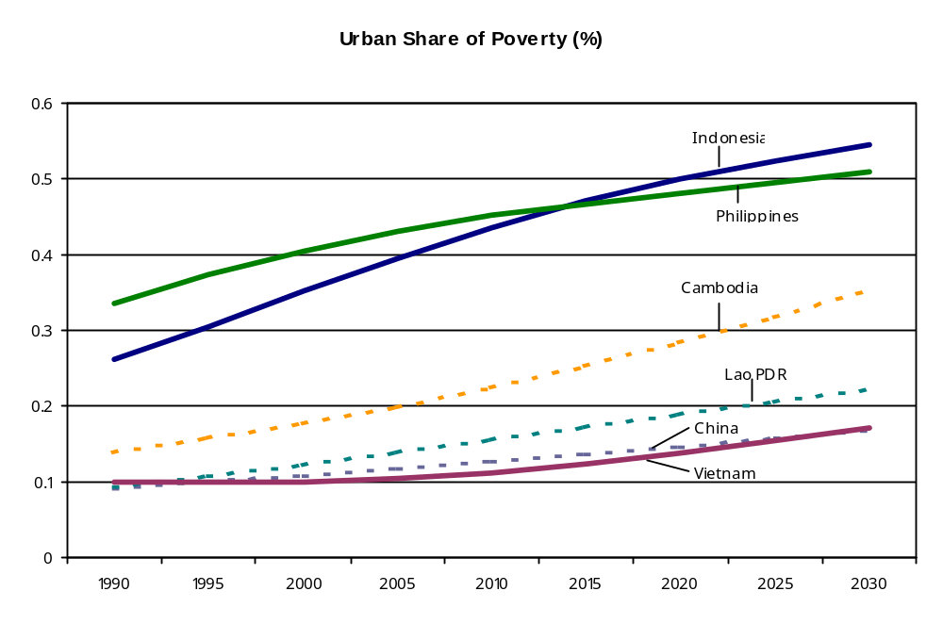Figure I.4 Urban’s share of the total poverty is growing in East Asian countries

Source: Population projections from UN, WUP, 1999 Revision. Urban and rural poverty headcount rates are for latest year available from World Bank, WDI 2000. Projection assumes that ratio of urban to rural headcount rates remains unchanged from base year.

How important is migration to poverty?

  - Although it is often believed that migrants to cities remain at the margin of the urban labor force for a long time, that is not a valid generalization in EAP or elsewhere. Observations from many developing countries have revealed that migrants, whether coming from other urban areas as is often the case or from rural areas, initially earn less than comparable natives of the city and may make their start in the informal sector, but the earnings gap tends to close within a few years and can even reverse. Migrants are typically quite well informed about the labor market at their destination through informal networks, although these networks by their nature are not available to all potentially interested candidates, and so limited information and lack of facilitating social connections no doubt constrain some would-be migrants.

  - Individuals move to urban areas for both economic (better living conditions and earnings potential) and other reasons (for marriage, schooling, to rejoin family). In Indonesia, on average across all regions only 40 percent of migrants from rural to urban areas report that seeking employment is their main reason. A survey of migrants to Ho Chi Minh City in Vietnam found that slightly over half of males and only a third of females reported moving for economic reasons; those respondents tended to come from the poorer provinces, while migrants with non-economic motivations moved from the nearby Mekong Delta and Southeast regions and had strong family networks. Other research on migrants in Vietnam found that employment and economic factors influence interprovincial migration at least indirectly, since there was a larger volume of net migration to the more urbanized and industrialized areas.

  - How government policy and the receiving population treats the migrants is critical to their welfare and their ability to integrate themselves into the city life. The Vietnam Poverty Assessment finds that “While…most of the migrants to urban areas fare well and add to the prosperity…the plight of a particular group of poor migrants was highlighted …these are migrants to urban areas who have not secured permanent registration….this group of the urban poor face difficulties in accessing public services and may also be socially marginalized.” (p. vii) Although controls have recently been relaxed, it still can take a migrant a decade to move from “category 4” (illegal, without residency papers) to “category 2 or 1” (with full urban citizenship). Migrants can also be subjected to very poor living standards even if they acquire a decent livelihood, to the extent that they settle in zones of the city that lack basic services and availability of secure tenure (such as in peripheral slums), either because this is where labor-intensive manufacturing is relocating (as a result of high land costs within the city) or because of shortage of affordable housing in the central areas.

What are the trends in the incidence of poverty, and especially of urban poverty, in the Region?

  - The East Asia and Pacific Region has experienced by far the most dramatic reduction in the numbers and percentage of poor people (measured by the international income poverty threshold of $1/day) in the 1987-98 period among all regions of the developing world (with only the Middle-East and North Africa Region also showing a decline). The share of the population living on less than one dollar a day fell from 26.6 percent in 1987 to 15.3 percent in 1998 (23.9 to 11.3 percent excluding China)—a drop of fully one-third, or 139 million persons (of whom 90 million in China). Even relative income poverty (share of population living on less than one-third of average national consumption) has fallen in the EAP Region over the period, from 33 to 19.6 percent (from 45 to 25 percent excluding China).

  - For most of the countries poverty reduction paralleled their economic growth trend, though with different degrees of elasticity (responsiveness of poverty to changes in income). From about the mid-80s to mid-90s, China led the Region in economic growth but achieved a relatively low reduction in poverty because of worsening inequality. Poverty reduction in the Philippines was also somewhat low for its economic growth performance, relative to other countries in the region. In Vietnam there could have been a greater impact on poverty reduction if the benefits of economic growth had been more evenly spread between urban and rural areas. Thailand demonstrated a particularly high poverty reduction elasticity, followed by Indonesia and Malaysia. Such differences correspond to the degree to which each country’s growth was “pro-poor”, but changes in inequality do not show a strong correlation with growth overall in EAP or elsewhere.

  - In both the Philippines and in Vietnam, income or expenditures poverty has declined over the 1990s for both urban and rural populations, whether measured as basic headcount or depth of poverty. (Table I.4) Urban poverty continues to be well below that of rural; however, measurements of urban poverty are subject to important caveats, as discussed further in Part Two. The Vietnam sampling frame is believed to have excluded migrants who do not have permanent residency permits, and hence left out what are likely the poorest people; it is estimated that correcting for this oversight could raise the urban poverty headcount from 9 to possibly 15 percent. For Indonesia, differences in the measurement approach (based on assumptions about consumption baskets and poverty lines) have an enormous impact on the ratios of the poverty headcount between rural and urban populations. (Table I.5) These statistical and survey issues underscore that differences in measured income or expenditure poverty between rural and urban areas “are possibly as much an artifact of method and assumptions as they are a finding of ‘fact’—the poverty line is higher because it is assumed to be higher”, and should not be interpreted too precisely. Likewise, the low and improving “depth” indicator of poverty, while favorable, also means that the population is close to the poverty line and so changes in estimations about this line—as well as real adverse events that create income shocks—can have a large (statistical or real, respectively) impact on numbers of individuals falling into poverty.
Table I.4: In both the Philippines and Vietnam, income (expenditure) poverty has declined by standard measures in both rural and urban areas

1985 1991 1997

The Philippines

Total Population
Poverty Incidence (%) 40.9 34.3 25.1
Depth (%) 13.2 10.6 6.4
Inequality (Gini) 0.412 0.428 0.427
Rural
Poverty Incidence (%) 53.1 48.6 36.4
Depth (%) 17.8 15.6 9.8
Inequality (Gini) .352 .359 .352
Urban
Poverty Incidence (%) 21.7 20.1 11.9
Depth (%) 5.9 5.7 2.6
Inequality (Gini) 0.410 0.421 0.425

1993 1998
Vietnam

Total Population
Poverty Incidence (%) 58 37
Depth (%) 18.50 9.50
Inequality (Theil Index) .177 .201
Gini .33 .35
Rural
Poverty Incidence (%) 66 45
Depth (%) 21.50 11.60
Inequality (Theil Index) .128 .126
Urban
Poverty Incidence (%) 25 9
Depth (%) 6.40 1.70
Inequality (Theil Index) .187 .197

Source: The Philippines Poverty Assessment, Tables 4 and 6, Volume I, Main Report;
Vietnam: Attacking Poverty, Figures 1, 2 and 1.3, pages 12-13.
Note: “Depth” of poverty refers to distance below the respective poverty line.
For both Gini and Theil indices, increasing value indicates greater inequality.

Table I.5: Indonesia: Different poverty measurement techniques yield large differences in rural/urban comparisons

Poverty Incidence (%)
February 1999

Indonesia Iterative Method BPS Method

Total Population 27.1 23.6
Rural 34.1 25.9
Urban 16.3 20.0
Urban Head Count as % Rural 47.8 77.2

Source: Pradhan, et al. (2000), Table 2. See paper for explanation of methods. The Indonesia Poverty Assessment (World Bank, September 2000 draft) uses the “iterative” method estimates. BPS method is that of Badan Pusat Statistik, Jakarta.

  - In China, for example, using the $1/day international standard of absolute poverty is questioned by many analysts as irrelevant to urban poverty because of the much higher living costs in cities. By this measure only 1.7 percent of the urban population was poor (5 million people) in 1998. Raising the threshold to $1.50/day yields an urban poverty headcount rate of 10.1 percent, more than a five-fold increase; and $2.00/day implies a 24.4 percent headcount rate, or total numbers of urban poor of 31 and 75 million, respectively.

  - Inequality is shown to be higher in urban than in rural areas for all three countries (e.g., a Gini coefficient of .266 for the rural population and .328 for urban in Indonesia in 1999—see Table I.6). In Indonesia, inequality declined by about the same degree for urban and rural households between the pre-crisis (1996) and post-crisis (1999) periods, but urban Ginis remained consistently higher than rural. In the Philippines and Vietnam, urban inequality as shown in Table I.4 is worsening, a pattern found in many other developing countries as well. Analysis in Vietnam indicates that the national increase in inequality is due primarily to a growing rural-urban gap in incomes, however, which outweighs the diverging trends in inequality within the rural and urban settings.

Table I.6: Cumulative distribution function of per capita expenditure,
by type of settlement (Indonesia)

Gini | Rural | Urban – by size of settlement
Gini | Rural | <250K | 250-500K | 500K-1M | 1M-2M | >2M | All Urban
Total  Population | 0.2662 | 0.3014 | 0.3257 | 0.3448 | 0.3168 | 0.3367 | 0.3282
Lowest  quintile | 0.1366 | 0.1304 | 0.1294 | 0.1576 | 0.1622 | 0.1688 | 0.1453

Source: SUSENAS 1999 household survey.

Implications of urban development for poverty reduction

  - It is important to this review to determine what factors are associated with, or contribute to, increases or decreases in overall poverty, and of course in particular to urban poverty. The poverty assessments for the three focus countries analyze the regional and sectoral breakdown of poverty trends, which gives some insight into the urban and rural phenomena although none of these reports explores urban poverty directly nor the interlinkages between rural and urban livelihoods. Causality of change and implications for poverty strategies are not as easy to identify.

  - Certain observations are worth making. In all three countries, the agricultural population has the highest incidence of poverty and the highest share of the total poor. Only Vietnam achieved a relatively greater reduction of poverty in the agricultural than in other sectors, reflecting both positive achievements in agricultural productivity (which have a high poverty impact given the large share of the population depending on agriculture) and the relatively weak employment growth in the industrial sector. In the Philippines, poverty reduction was much faster in nonagricultural activities (industry and services) than agriculture from 1985-97 and the occupational distribution of the population shifted in favor of those sectors that were showing the rapid declines in poverty—although this move was not sufficient to change the sectoral (occupational) composition of the poor. Both the Philippines and Vietnam poverty assessments conclude that given the continuing preponderance of the poor in agricultural occupations, better growth performance in agricultural is crucial for poverty impacts, along with a structural shift of the population out of agriculture into higher productivity activities.

  - The key questions are then: in what locations do the high productivity activities (including high-value agriculture) take place and what are the conditions that best support them? The regional breakdowns of poverty and growth within the focus countries show, first, that spatial variations are quite sharp and durable. The Philippines PA notes that “there is no strong evidence for convergence of poverty levels” among provinces of the country between 1988 and 1997. In all three countries, the regions with highest poverty incidence tend to remain those that are remote from population centers and especially those with relatively poor natural resources but dependent on agricultural-based activities. The less well-off regions therefore have less access to the economies of agglomeration (which are based on proximity for producers to markets for goods and labor, to infrastructure reducing production costs, and to networks for exchange of information and technology). The fact that the more urbanized regions (such as the Red River Delta and South East in Vietnam) have lower poverty incidence is probably a reflection of their benefitting from agglomeration economies permitting higher, and faster increasing, productivity which provide conditions permitting poverty to be reduced.

  - While the functioning of these agglomeration economies and their impact on poverty reduction within their areas of reach cannot be confirmed rigorously and empirically in the sense of causality (at least by the present study), there is ample evidence of association. Nonfarm employment, which as noted in the Vietnam PA is critical for future poverty reduction, as well as the higher value agricultural and livestock activities, require a buoyant source of demand. The PA reports note, for example, that high value agriculture is more successful closer to urban sources of demand. The market impetus is very important to poverty reduction in general, and the liberalization of internal trade is cited in the Indonesia PA as one of the factors that have contributed to pro-poor growth in the country. The Vietnam (Interim) PRSP points out that rural living standards have improved most in the periphery of cities and towns, and a poverty mapping analysis has shown that rural poverty is less prevalent or severe in provinces that are closest to the major urban centers. Even within the poorest provinces, the urban areas have lower poverty headcounts than the neighboring rural zones; and the more prosperous provinces, e.g. in the South East, have achieved a relatively small rural-urban poverty gap indicating some economic spillovers. Education is also most strongly related to income in the two urban regions with major cities (Red River Delta and South East), suggesting that returns to education are also greater where there are more opportunities for nonfarm employment.

  - Such differences are often interpreted as demonstrating that urban areas simply enjoy a favorable policy and political environment, endowing them with more than their proportional share of tax revenues and public investment, high wage protection, favorable prices, and a stronger overall safety net. While some such policies have been maintained in many countries at times (e.g. the “iron rice bowl” policies of China up to the 1980s), it is surely a leap of faith to assume that deliberate policy has been designed and implemented effectively, even in the more urban parts of rural areas, to account for the better urban performance in so many circumstances. There are elements of the (generic) urban context that make some growth-promoting and poverty-reducing measures have lower cost and higher return than in the (generic) rural context. While this is generally the case with public investment in major infrastructure (characterized by high fixed costs and increasing returns to scale), it is also true of much private investment, for which the physical concentration of other producers, workers, consumers and suppliers in spatial proximity provides a real economic advantage.

  - But there is nothing about the theory of agglomeration economies that guarantees that population concentration alone will achieve economic growth or poverty reduction—what matters is how well producers and workers are able to respond to opportunities that urban marketplaces can bring. Therefore when regulatory constraints impede entrepreneurial action, when other policies such as excessive or unpredictable taxation raise risks to investment, or weak governance and inefficient urban management fail to deliver services demanded, the mere growth of urban places will not bring about the promise of economic welfare improvement for any but a few people. In such circumstances growing urbanization does less than it could for the country’s development. People still come to cities with hope for more opportunity, but face undue constraints on their ability to improve their incomes or living conditions. Private investment then focuses on the surest quick-return and low risk activities. And public resources are unlikely to be allocated in ways consistent with the potential areas for broad-based growth.

  - How well urban growth is managed in the EAP countries in the coming years will therefore matter greatly not only for poverty within the cities, but even more for how much the urban areas contribute to the growth of the economy and the prospects for poverty reduction in the rural areas. Correspondingly, strategies for national and rural poverty reduction need to draw on the dynamics of economic agglomeration. This is acknowledged quite explicitly in the Vietnam and the Philippines poverty assessments, and the latest national plan for China incorporates the urban transition as a deliberate feature of strategy to combat poverty in the western regions that have missed out on economic growth. Growth of rural nonfarm employment and of urban employment are presented as two elements of an integrated regional development approach in the Vietnam PA. The stated priority to develop nonfarm production to raise and diversify rural incomes will require increased public investment in rural areas, but this investment will need to be planned with a view to where such activities can be best connected to upstream and downstream markets, in a broad spatial vision. Policies and investments that strengthen the ability of the rural population to shift to higher return activities and/or to move to locations offering greater opportunity, along with increasing the effectiveness of cities and towns in providing jobs and services, all need to be integral ingredients of the national poverty strategies in countries of the Region.

Part Two: Assessing Urban Poverty in the Focus Countries—What we know from available quantitative and qualitative information

A. A conceptual framework for urban poverty

  - It is now widely accepted internationally that understanding poverty requires looking beyond traditional definitions related to income, expenditure or consumption. The WDR 2000/01 expressed this consensus that poverty has multiple dimensions: lack of opportunity (including access to markets and assets, and to the conditions affecting the returns to assets); low capabilities (due to low achievement in human development—health, education and nutritional status); a state of insecurity (exposure to risk and income shocks, whether as an individual/household or as part of a larger group); and disempowerment (because of social or political barriers). These dimensions are equally relevant to urban and to rural poverty, but the manifestations differ by spatial context. In the urban setting, markets and certain productive assets (e.g. infrastructure facilities) are often more available than in the rural areas as observed earlier, but institutional failures can mean that the urban poor do not have effective access. For example, lack of public transport can prevent the poor from moving from the only residential areas they can afford to the locus of jobs in a large city; services such as piped water supply may be nominally provided but of such low quality and reliability that the poor have to seek their own, higher cost sources of supply. And while urban residents live in closer proximity to government agencies, this does not ensure the urban poor a political voice but in fact can subject them to direct and frequent costs of police harassment and corruption.

  - There are three particular aspects of urban life that affect directly how poverty is manifested: first, “commoditization”-- the reliance on cash income for food, housing, transportation and other essential goods/services. Second, environmental hazard due to negative externalities--the relative density of urban settlement means that behaviors and environmental sanitation have an immediate and widespread impact on human health and amenities of public space. Asian cities have the highest density (inhabitants per hectare) in the world. And third, social fragmentation--the mix and churning of population is particularly intense in urban areas by their nature, even when natural growth or internal migration are relatively slow. The social implications of this third characteristic are complex. That is, the constant transformations of the urban population can be accompanied by breakdown in traditional social patterns and networks as well as by the creation and reinforcement of different ones—but it is likely that sources of social support in cities are subject to stronger forces of change and stress than in rural areas, which partially explains different rates of crime, substance abuse, and other social pathologies.

  - To better incorporate these contextual characteristics and the dynamic nature of poverty, some urban poverty research has used an “asset vulnerability” framework. (Moser, 1998) This captures the view of poverty as a state of heightened risk; that people move in and out of poverty based on their exposure to hazards and shocks; and that their ability to cope and adapt depends on use of multiple assets. These assets include labor, human capital (qualified by health and education status), productive assets (including housing, which in the urban context is often a locus of informal employment as well as source of rental income), household relations (mutual reliance for pooling income and sharing consumption), and social capital (reciprocity and trust between households). Other analysts may describe or group the relevant assets somewhat differently but the main components are these; and in the rural context, natural capital would obviously be counted as well. De Soto (2000) further stresses the importance of informal assets held by the poor and the benefits they can gain once these assets can be collateralized and used to generate liquidity.

  - Combining qualitative and quantitative methods of inquiry permits an assessment of the poor’s effective stock of assets and how they manage them, for example to cope with macroeconomic crisis; such analyses are cited below. What is found is that faced with economic stresses the urban poor both cut back expenditures, frequently by reducing or substituting food intake (which is often 60 percent or more of the total household expenditures), and mobilize their various assets--increasing work by family members including children, using the home as a source of income, increasing reliance on extended family support, and on community networks (e.g. for informal credit). Qualitative studies of poor households also reveal that their liabilities as well as assets affect their capacities to cope; important liabilities include debt and social obligations (e.g. to send money to rural relatives).

  - Focusing on the assets of the poor and their vulnerability to risk further highlights the particular aspects of the urban context and relevant distinctions with the rural. For example, while the rural population faces a high covariance of risks stemming from climatic shocks, livestock and crop diseases which can undermine an entire farming community, the urban population suffers covariance as well at the household and community levels, but with different characteristics. The need for cash for all essentials in urban areas means that the loss of income impacts the effective consumption of food, education, health and transport services, i.e. numerous dimensions of welfare, and may lead to accumulation of debt. The threat of eviction from illegal housing or “slum” settlements and forced resettlement is a shared risk to low income communities and its occurrence is devastating to their income, sense of security and social networks.

  - While the “asset vulnerability” perspective lends itself well to qualitative studies of poverty, the concept of vulnerability in income terms can be measured quantitatively as “the standard deviation of intertemporal changes in expenditures”, thus capturing the notion of variability or transient states of poverty. Applying this measure to expenditures data from Indonesia surveys shows that while headcounts of poverty and of income vulnerability are higher for rural than urban respondents, the ratio of the “income vulnerable” to the “poor” is substantially higher for the urban population (3.67 vs. 2.05), and similarly higher for individuals occupied in trade and services (averaging 3.33 vs. 1.95) than in agriculture. The finding indicates that even where the incidence of poverty does not appear a major issue for an urban population at one point in time, this status is highly unstable because their expenditures are so variable—as typical of urban informal sector workers such as petty traders and scavengers.

  - The inequality, vulnerability and multiple dimensions of poverty enter into individuals’ own assessments of whether they are poor. The Philippines has conducted surveys of self-rated poverty which place poverty incidence more than twice the official estimates for 1997-99 reported in Table I.4. There is also a very high urban-rural differential in these self-ratings, 2 to 5 times higher than the cost of living differential implied by the official or basic needs poverty lines. Urban respondents judged poverty incidence to be 55 percent as against 70 percent reported by the rural respondents (compare to the measured headcount above at 12 percent urban versus 37 percent rural). These self-ratings may represent the higher expectations of the urban residents in the face of stark inequalities in welfare, but they also suggest that the official poverty measurements do not successfully capture the full measure of absolute hardships of urban life for many people.

  - The next section reviews some of the quantitative and qualitative findings on urban poverty in the focus countries, including perspectives on the various assets which are pertinent to avoiding, or coping with, poverty. Since the empirical analysis conducted here of the survey databases breaks down respondents by income-poverty status (or expenditure deciles), the following discussion does not provide a separate quantitative evaluation of the survey samples according to other (non-income) dimensions of poverty—such as by education, health or housing status.

B. Methodological issues in the quantitative assessment of urban poverty

- For the present report the poverty survey databases used for the Bank’s poverty assessments in Indonesia, the Philippines and Vietnam were analyzed to extract whatever information they contained about the urban population and the urban poor in particular. For the Philippines, the 1997 Family Income and Expenditure Survey (FIES) dataset contains information about 38,000 households in 81 provinces and 16 regions; 47 percent of the total sample are urban households. For Vietnam, the 1998 Household Living Standards Survey (VLSS) was used, containing 6000 households of which 1730 (29 percent) are urban. The Indonesia poverty assessment is based on the SUSENAS 1999 dataset of 205,700 households (approximately 800,000 individuals), 31 percent of which are urban. Each survey provides for both relative comparison of income and non-income characteristics across per capita expenditure deciles, and absolute measures of the poor/non-poor, based on poverty lines established by the surveys separately by region and by rural and urban zones within the regions.

Limitations of national household (living standards) surveys from the urban perspective

- Several caveats should be emphasized about these surveys that also apply to most other nationwide living standards surveys (LSS) of similar type. These caveats imply that the LSS cannot be used to cover all the dimensions and population breakdowns that would be needed to accurately assess urban poverty, hence additional, special -purpose surveys may be required.

- Spatial attribution. First, all distinguish between rural and urban settlement according to the countries’ own conventions, with the usual inherent problems of defining this boundary. The main practical problem is that households are therefore classified as wholly urban or wholly rural, without accounting for multi-spatial households or mutual dependencies among them.

- Cost of living and consumption differences. Second, how well the price adjustments and consumption baskets differentiate between actual cost of living (and costs of avoiding poverty) in the different settlements, and especially between large cities and smaller urban or rural areas, remains an underlying issue for surveys of this type. For example, the “urban” poverty line is based on cost of living estimates in the more urbanized regions, which probably underestimates the costs pertaining to major cities.

- Aggregation. Third, although the databases for the three countries contain a good proportional coverage of urban households, the absolute size of the surveys is either too small, or the data are otherwise unable to be broken down, to produce representative samples for different sizes of urban areas, or even in most cases for specific cities. The Philippine survey provides a representative look at Metro Manila, but the data do not permit a comparison with other distinct urban areas. A poverty mapping exercise has been done with the VLSS and subsequent 1999 Population and Housing Census which provided considerable regional differentiation, but only the combined Hanoi/Ho Chi Minh City on the one hand, and other urban areas as a group, can be broken out. For the present study, the Indonesia LSS data were subjected to an approximate disaggregation by size of locality. Even this very limited analysis reveals that Metro Manila offers worse living conditions to the poor than other regions, and that larger cities in Indonesia have higher levels of inequality (Gini coefficient for lowest quintile rising from 0.130 to 0.169 from small to large settlement size categories, with Jakarta being the most unequal—see Table I.6).

- Locational detail within urban areas also cannot be obtained from any of these surveys as typically designed, which is a serious omission since analysis elsewhere indicates that living standards can vary greatly across neighborhoods of the same city. A participatory poverty assessment carried out in Ho Chi Minh City as part of the national Poverty Assessment confirmed that this largest city in the wealthiest region has pockets of severe poverty.

- These and similar income or expenditure-based poverty surveys that are derived from rural research can have two additional shortcomings from the urban perspective, that of sampling design and the survey instrument (questionnaire) itself. (See Technical Annex.) Both sampling and survey problems would tend to understate the extent of urban poverty and not capture its complexities well. Design techniques exist to correct for these problems but are not always applied.

- Outmoded sampling design. Poverty estimates are usually calculated from surveys of large nationally representative samples drawn from sampling frames based upon decennial censuses. In other words, the samples assume that populations are stable over a ten year period. In rural areas this is normally not a problem, since rural populations tend to be quite stable so that samples drawn from censuses collected every ten years are unbiased and representative.

- The urban situation is quite different, however. Urban populations, particularly the urban poor, are characterized by high levels of mobility, poorly defined property rights, and fluid family and social structures. The poorest of the poor, in particular, tend to be squatters living in temporary settlements that are subject to demolition, with poorly defined addresses and high probability of changes in residence, and even homelessness. Thus, the poorest and especially new migrants, tend to be particularly mobile. The problem is compounded in those countries where residents need to be “registered” and thus new migrants are automatically excluded from the urban census and from the samples based upon them unless special provision is made to capture them. Furthermore, urban homes often have multiple families resident in them, both because migrants may be sheltered by existing residents and because young households “nest” within extended families for economic reasons. Census-based sampling frames are consequently out of date almost the moment that they are tabulated, and surveys based on them, unless adequately corrected and updated to reflect current residential patterns, are very likely to miss the poorest among the urban poor and to underestimate the extent of urban poverty.

- Inappropriate survey design. A further shortcoming of many livings standards surveys concerns the questionnaire instrument, which is typically geared to agricultural-based activities and village lifestyles but less well designed to capture the particularities of urban life. As noted above, the urban poor face risks and insecurities especially regarding property rights for housing and employment . The nature of urban occupations, especially the functioning of the informal sector, is typically not captured by national surveys where questions on income and occupation tend to be based on agricultural and salaried categories. Urban social relationships are often characterized by unconventional connections peculiar to urban communities where individuals from diverse ethnic and economic backgrounds live together in the same space. These networks are often directed to finding income opportunities and are part of social protection strategies among the poor. At the same time, the urban population and especially migrants are heavily interconnected to rural family and community. Survey instruments need to be made both more sensitive to the complexities of the urban experience, as well as capture the rural-urban interlinkages at the household level. This can be done by including modules on non-farm businesses in the surveys, and by combining quantitative with qualitative methods of inquiry. Combining different techniques such as participatory poverty assessments, focus groups, etc. is especially relevant for diagnostic purposes and to test the relevance of a formal survey.

- With these due qualifications, a preliminary picture of the urban poor in the three focus countries is summarized below from the survey data, supplemented by more textured information from other studies drawing on focus groups and case study interviews. City-specific data from other sources (e.g. UNCHS (Habitat) Urban Indicators Program) are also referred to where available, and some relevant indicators summarized in Annex tables A1-A5. The findings are presented according to the main asset categories: labor resources and quality of human capital, housing and infrastructure (physical capital), security, social capital and empowerment. (Country specific tables referred to below can be found in the Annex (Volume 2) to this Report.)

C. Demographic Profile of the Urban Poor

Age, gender, household size and composition

- There is not a strong difference in age composition of rural and urban households in the three countries. Larger families tend to be poorer (and clustered in the lowest expenditure decile) in both localities, and there is not a significant spatial difference in the size structure of families (Figure II.1). For Indonesia, household headship by a single parent is more common among the poor in urban than in rural areas. The elderly are not especially poor in either location—nor are female-headed households. (Table IN2)

- In the Philippines, female headship is more an urban than rural phenomenon (18 percent of households vs. 12 percent rural), but female headed households and the elderly are over-represented among the higher deciles in both areas. (Figure II.2 and Tables PH1,2)

- On average, urban households in Vietnam are smaller and have fewer children than rural, across across all deciles. Female headed households, as well as the elderly, are also more common in urban areas and are not particularly poor (Table VN1)—although they do represent a larger share of the urban poor than rural poor. (Table VN2). Only in Vietnam did the survey include ethnicity. Ethnic groups other than native Vietnamese (Kinh) are almost nonexistent in the urban population and especially among the urban poor—which indicates either that the others do not migrate or that they have not been enumerated in the survey. (Table VN3).

Migration Status

- Migration status is usually captured in living standards surveys through questions on place of origin or length of residency. In the Vietnam survey (the only one including this topic), 63.7 percent of all urban respondents said they were born in their current locality, while 74 percent of the urban poor reported the same. (Table VN4) This confirms that the long-standing residents surveyed are not necessarily much better off than the migrants (at least, those with legal status who were enumerated) and many may be worse off—although a true comparison is not possible due to the noncoverage of unregistered migrants. This tentative interpretation is consistent with many other migration studies that indicate that migrants do eventually do as well or better than the native residents. The unregistered migrants, however, are not entitled officially to social services or formal employment, cannot register the births of their children and enter them into regular public school, and have virtually no legal identity. (Lim et al, 2000) These unregistered migrants are estimated to number 1.5-2.5 million in Vietnam cities, of whom 10-50 percent are poor.

Figure II.1 Indonesia – Urban household demographics: Female-headed and elderly households are not generally poor – but large families are
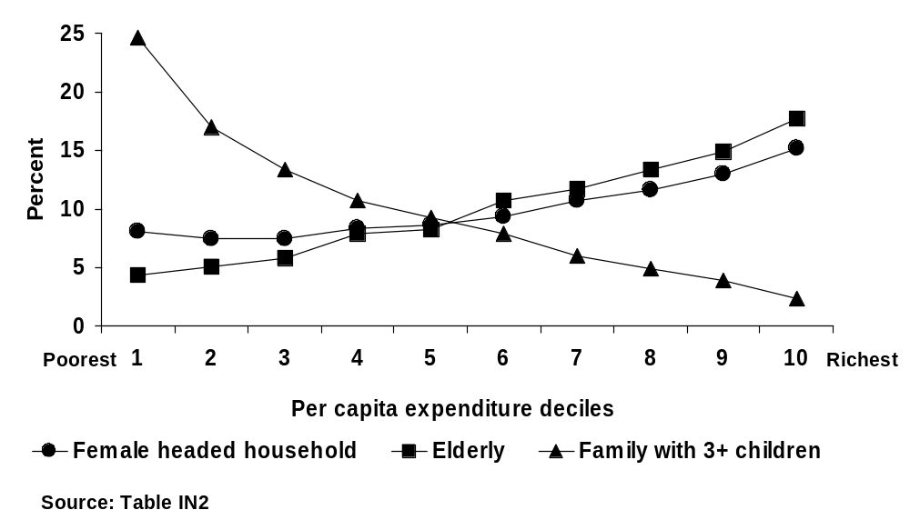

Figure II.2 Philippines – Urban household demographics: Female and elderly headship is more common among mid- to upper-expenditure households
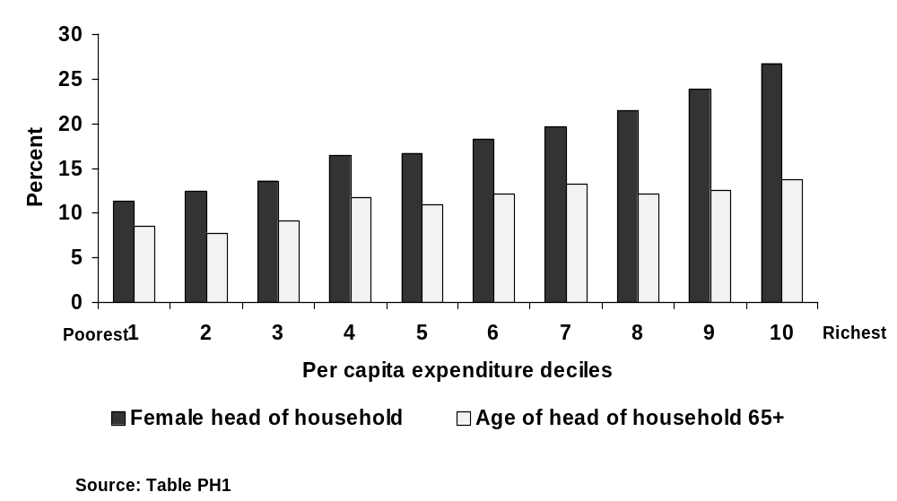

D. Labor and Human Capital Assets

Education Status

- Access to schooling and educational attainment are usually reported to be higher for urban than rural populations because of ease of provision (e.g., lower per capita fixed costs) in denser settlements, and this is evident in the three country databases. Differentials in education status can also reflect the influx of the better educated among the rural population to the urban areas. In Indonesia, urban households are on average better educated than rural, although urban areas are characterized by sharper differences in educational level between the rich and the poor. The proportion of individuals without completed primary school education is almost four times higher among the urban poor than among the urban rich, compared to only a two-fold difference in rural areas. (Table IN3) Rates of school participation and literacy are highest in Jakarta and lowest in rural areas, but do not uniformly decline with declining settlement size. In fact, illiteracy is more concentrated among the lowest decile in several of the city size categories than in rural areas. (Tables IN4,5)

- In Vietnam, the urban poor do have much higher literacy rates than their rural counterparts: 75 percent of individuals in the lowest expenditure decile in urban areas can read versus 49 percent of their rural counterparts. The urban poor are better educated than the rural poor; however, the differences in education levels among urban income deciles are more dramatic than rural:urban differences among the poor. (Tables VN1,5) In the country overall, the education of the household head is related to per capita expenditure, but not too closely. Households whose head has completed primary or lower secondary do not have higher expenditure than those whose head has not completed primary school; however, higher levels of education are associated with significantly higher earnings. These findings are true both in the major cities (Hanoi and Ho Chi Minh) and other urban areas. Families with unskilled heads are clearly the worst off. The education of the spouse is a better predictor of household expenditure in urban than in rural areas, suggesting perhaps that members have more attractive earning options in the cities.

- The Philippine LSS does not provide education or literacy data. School related expenditures can be considerable for the urban poor and are often sacrificed as a coping strategy (e.g., 12 percent of the lowest decile in the Philippines reported removing children from school, at least temporarily, during the recent crisis compared to 6 percent for the total population), although many households also strive to protect their children’s schooling for longer term advancement. The economic returns to education would be expected to be higher in urban areas where the labor market is larger and better able to absorb and reward workers for each level of attainment, especially those at the higher levels. However, actual employment experience does not always match the theory because of differences in individuals’ own expectations and macro- or microeconomic factors even in the large urban areas that impede labor utilization. (The present desk review does not cover labor market issues, which can be quite important in explaining poverty.)

Health Status

- While indicators of access to health facilities are normally better for urban than for rural populations (as would be expected given the greater ease of servicing denser, more accessible settlements), the actual health outcomes may not show the same differential because of many intervening factors including environmental health and sanitation (discussed further below), and behaviors. Averages on reported availability of facilities or services for urban or rural aggregates can mask issues of effective access (e.g., lack of transport) and quality especially for the poor. Studies that have broken down the data on both health care and health outcomes within urban areas (e.g. in slum neighborhoods) have often found results that are no more favorable, and sometimes much worse, than those in rural areas. Health problems such as low nutrition and mental illnesses, related to economic and life stresses, are growing in urban areas among the poor in particular.

- The national Demographic and Health Surveys (DHS) in Indonesia and the Philippines (Table II.1) reveal that the infant mortality rate and under-5 mortality rate of the second poorest income quintile are significantly higher in urban than rural areas of Indonesia; the same is true in the Philippines even at the middle quintile. This disparity in mortality outcomes may reflect higher urban environmental health risks. The DHS surveys also show surprisingly lower immunization coverage (for measles and diptheria/polio/tetanus3) in urban areas relative to rural for most quintiles in the Philippines, and a similar situation for contraceptive use in Indonesia—indicating that an urban advantage in access to services cannot be taken for granted.

Table II.1 Health Indicators by Urban-Rural Residence

Indonesia 1997
Indicators | URBAN  Income Quintiles |  |  |  |  | RURAL  Income Quintiles
Infant Mortality Rate  Under 5 Mortality Rate | Poorest  (46.5)  (102.3) | Second  75.3  112.8 | Middle  43.3  56.5 | Fourth  34.9  44.7 | Richest  25.6  31.3 | Poorest  78.9  109.1 | Second  55.5  72.8 | Middle  54.0  73.5 | Fourth  42.2  56.0 | Richest  18.5  24.6

Phillippines 1998
Indicators | URBAN  Income Quintiles |  |  |  |  | RURAL  Income Quintiles
Infant Mortality Rate  Under 5 Mortality Rate | Poorest  49.7  70.5 | Second  40.1  62.9 | Middle  37.6  57.9 | Fourth  24.8  33.2 | Richest  17.7  26.9 | Poorest  48.7  81.2 | Second  38.7  59.2 | Middle  28.4  38.8 | Fourth  25.1  33.7 | Richest  (35.5)  (39.8)

Infant Mortality Rate: Deaths under age 12 months per thousand births
Under 5 Mortality Rate: Deaths under 5 years per thousand births

Source: Demographic and Health Surveys. Figures in parenthesis indicate large sampling errors due to small number of cases.

- The Philippines Poverty Assessment also found that while health indicators vary predictably by income status, the rural/urban differences are small, and both infant and child mortality are actually somewhat worse for urban than rural populations at the lower quintiles. While access to medically trained personnel is better in urban areas and immunization rates show a slight advantage for the poorest urban residents, health outcomes are not commensurate. Fees for health care, as for education, in the Philippines create a significant strain on urban households. Survey data of the poor in Naga City found that 68 percent of respondents described health and sanitation as a problem for them, greater than housing (57 percent). Noncommunicable diseases (cardiovascular, cancers, asthma) and traumatic injury are reportedly on the rise among the urban poor, possibly indicating increased effects of pollution and the pressures of urban survival.

- The health outcomes, especially for young children, may also reflect issues of food affordability and undernutrition, which became most apparent during the financial crisis. The Philippines Social Weather Report Survey in June 1999 found that 20 percent of the extremely poor in urban areas said they had experienced hunger in the last three months, and 11 percent said they felt hunger “always”. Across all urban areas except Luzon, 19-40 percent of respondents had experienced hunger “often”. In Vietnam, as of 1994 over one million (9 percent) of the total urban population could not meet the basic requirement of 2100 calories daily food consumption. About one-fourth of the children who were determined to be malnourished live in the major cities such as Ho Chi Minh City and Hanoi.

- The living standards survey data examined for this report do not permit within-city disaggregation of the urban samples. Health indicators are only included for Vietnam and Indonesia. The Indonesian data show virtually no pattern in 16 categories of health complaints across deciles or settlement sizes. For Vietnam, the urban population overall reported a lower incidence of sickness (38 percent) than their rural counterparts (43 percent); however, the urban poor were more often sick that the rural poor (46 versus 42 percent incidence). (Table VN6) The urban population engages in damaging behavior (smoking) at a greater rate than rural, and the poor more than the nonpoor; in fact, the share of poor urban females who smoke (83 percent) rivals that of the men. (Table VN7) The urban poor spend almost as much on healthcare as the nonpoor, even though the poor would be expected to rely more on free public services, and both groups spend a proportion of their income double that of the rural population. (Table VN4) Sexually-transmitted diseases, including HIV-Aids, are increasing rapidly in urban areas, in particular among sex workers in Ho Chi Minh City. The higher prevalence of HIV-Aids in large urban areas compared with smaller urban and rural areas is apparent in many countries.

Employment status and types of work

- Employment status as reported in the surveys is not very indicative of the actual situation of the urban population, for reasons discussed earlier—e.g., questions asking “have job/no job” are not very relevant to the fluid informal sector, especially. As would be expected, unemployment is reported to be higher in urban areas than in rural areas, but employment status alone is not a good predictor of income (nor a useful poverty targeting criterion) in any of the three countries.

- In the Philippines, reported unemployment of the household head is twice as high in urban than in rural areas, although this may imply that urban residents have higher expectations of what constitutes a “job”, e.g. a formal sector or regular activity. The lower deciles report unemployment much less frequently than do the better-off households, whether urban or rural—presumably because the poor cannot afford to remain inactive. (Table PH3)

- However, in Indonesia by contrast, the urban poor report consistently higher rates of “Not working” than the nonpoor, and the same pattern appears when the question regards officially-defined unemployment, across all urban size categories. The share of women claiming to not work is almost twice that of men in all settlements including rural—which is curious, considering that female-headed households are not particularly poor as noted earlier. (Tables IN6). Since women do not more often claim to be officially unemployed, it is possible that women do not consider their types of work to be recognized formally as such. (Table IN7) It is also possible that many of the relatively well-off female-headed households are single women migrants, e.g. those with jobs in the new manufacturing industries. In Vietnam, female unemployment rates have remained about two-thirds those of men from 1993-98.

- The unemployment rate is reported to be slightly higher in Metro Manila than in other urban areas of the Philippines; 21 percent of household heads claim to be unemployed in Manila versus a 19 percent overall urban average. (Table PH4) Similarly in Indonesia, the unemployment rate tends to increase, for both poor and nonpoor, with increasing settlement size: e.g., 12.6 percent of the poor males and 10 percent of poor females claim to be unemployed (officially) in the largest urban category (2 million-plus residents—essentially, Jakarta), compared to 8.5 and 6.7 percent, respectively, in the urban areas below 250,000 population. (Table IN7) These results for what are by far the largest cities of these two countries is somewhat surprising, in that demand for all types of workers should be the strongest there; however, the influx of aspiring workers to these metropoles, and their expectations for formal sector employment, may be greater as well.

- To get a fuller and perhaps more accurate picture of the urban poor, it is necessary to acquire more information about underemployment (defined as “employment that doesn’t pay enough to meet the basic needs, so workers must search for additional sources of income”), and about work in the informal sector. In the newly developing peri-urban zones of the Philippines, Thailand and other East Asian countries, poverty is characterized by “the working poor”—i.e., jobs are abundant but not providing an adequate earnings level for the cost of living. In both Indonesia and the Philippines, estimates of underemployment from national labor force surveys indicated an increase in the numbers and shares of workers (particularly in manufacturing) that were on the job less than fulltime, during and after the macroeconomic crisis—a trend that may have pushed some marginal earners to seek informal sector work, or even to fall below the poverty line. Among poor households, individuals work longer hours as a reflection of underemployment, and in times of crisis mobilize more family members, especially secondary school age children. In Vietnam, 33 percent of the urban employed worked over 50 hours/week in 1998 (17 percent over 60 hours), in contrast to 20 (and 9) percent, respectively, of the rural labor force. Thus simply comparing urban household earnings to rural can overestimate the hourly pay differential.

- The informal sector, which is said to employ 60-80 percent of the working poor in most developing countries, represents a very wide range of activities and degrees of productivity. Earnings from petty trade in urban areas such as sidewalk sales of prepared foods, in-home piecework, domestic service, or rental of housing space can fluctuate greatly and also tend to be adversely affected by general economic declines.

- The participants in informal sector employment lack the basic protections of formal jobs but even worse, are often vulnerable to official harassment and intrusive regulations that undermine legitimate work. In Vietnam, for example, a recent decree has made it illegal for street vendors to retain a fixed place on the pavements, under threat of confiscation of their wares, which adds to the instability of their business. Similarly, cyclo drivers have been banned from the main streets of Ho Chi Minh City and some of the main routes in Hanoi, thus cutting into their market. In the Philippines informal urban labor is less organized than the poor in rural areas have traditionally been, and so have not made effective claims for social protection.

E. Physical Assets: Housing, Land and Infrastructure

Housing and land tenure

- Housing for the urban poor represents not merely shelter but also a workplace and source of rental income. In a well functioning real estate market, households can choose where they wish to live by balancing values such as convenience of access to jobs and services against other amenities such as living space, and trade-off transport costs against housing costs. But in many developing country cities, including those of East Asia, poor households especially are faced with only choices that leave them with low welfare. They must often accept living in a location that provides access to their employment options but with little tenure security and unsafe environmental conditions, so that both their health, financial assets, and earnings are put at risk. The financial costs of such housing to the family can still be substantial, especially when the associated nonmonetary costs (requirements for alternative infrastructure service provision, absence of public transport, exposure to pollution, etc) are taken into account.

- The living standards survey data for Vietnam generally confirm that the quality of housing for the urban poor is low, and only modestly better than that of the rural poor. Almost half of the urban poor live in the temporary housing versus 10.6 percent of urban non-poor and 38 percent of rural poor. (Table VN10) Housing for the urban poor also presents a wide range of qualities, with half of the lowest decile reporting brick or stone walls but 17 percent having only leaves or branches (Table VN11). Their roofs are similarly varied—half have tile or iron, but 20 percent only straw or leaves. (Figure II.3 and Table VN12) Urban housing offers more space per person than rural, which is not generally expected given higher land costs in cities. But the urban poor have the least space: 8.85 m2/person compared to 11.4 for the rural poor. (Table VN13) Since the nonregistered migrants are not included in this sample the quality of their housing would probably lower the urban averages. Participatory poverty assessments in Ho Chi Minh City and Haiphong found that the location of housing, in particular sites in areas scheduled for clearance or off main alleys (farther from commercial activity), is considered a signal of poverty status.

- As with Vietnam, the survey instrument for Indonesia is not very sensitive to the kinds of housing status and characteristics that would be most meaningful in the urban context. In Indonesia the share of the population at all deciles owning their houses is predictably much greater, and renting/leasing much less, in rural than urban areas (Figure II.4). (Table IN9) The share of the urban poor in “free” housing (presumably squatters) is 6.4 percent (and 5.4 percent of the nonpoor), although even some of the 77 percent of the urban poor who own their housing and of the 14 percent who rent or lease may lack secure tenure. (Table IN8) The share of the lowest expenditure decile in “free” housing is highest in settlements of 500,000-1 million (9 percent). The rural housing has slightly more space than the urban, including for the poor: 34.5 percent of the urban poor have less than 40 m2 floor area, compared to 29.4 percent of the rural poor. (Table IN8) Surprisingly, the urban poor have larger houses than the urban nonpoor; however, the differential in quality across urban income groups is considerable (e.g. 9 percent of the poorest decile have bamboo walls compared to 0.7 percent of the richest), and more pronounced than for rural housing. (Table IN9)

- In the Philippines, about half of the lowest urban expenditure decile owns their house and lot, which is close to the urban average (60 percent). (Table PH5) There is a wide diversity of formal and informal (“with charge”/ “without charge”) housing arrangements reported by the poor, although actual tenure status is difficult to determine from the survey instrument. The proportion of the households that live in the lowest quality houses (“improvised”) is five times as high among urban than among rural households. Almost 10 percent of the poorest urban decile lives in such housing (and 21 percent in Manila), compared to 2.7 percent as the urban average (Figure II.5). (Tables PH6,7) The use of salvaged building materials for roof and walls is much more predominant among the poorest urban decile than for any other groups, but is also quite prevalent among the lower-middle income groups in urban areas, indicating possibly a poorly functioning construction market. (Tables PH8,9) The share of the poorest decile living in houses of salvaged materials is almost twice as high in Manila as in all urban areas, and ownership less common for all income groups (only 40 percent of the poorest decile in Manila report full ownership of house and lot). (Tables PH10,11) As acknowledged in the Philippines Poverty Assessment, housing is a problem for the population as a whole in the country—the prevalence of illegally occupied housing is highest for those in the middle of the income distribution and occurs even among the wealthy—indicating fundamental problems of the housing market (possibly including corruption and bad regulation), in which the urban poor are the most disadvantaged.
Figure II.3 Vietnam – Urban type of housing: Temporary structures are
most common among the poorest households
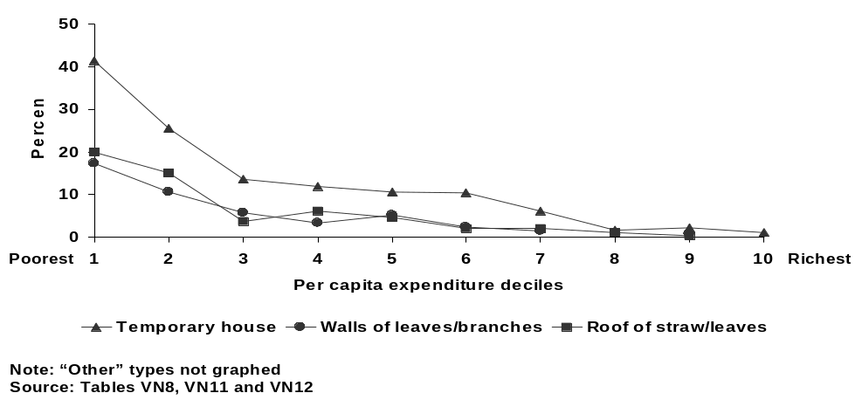

Figure II.4 Indonesia – Urban housing status: Private ownership is the
most common arrangement, especially among the poor
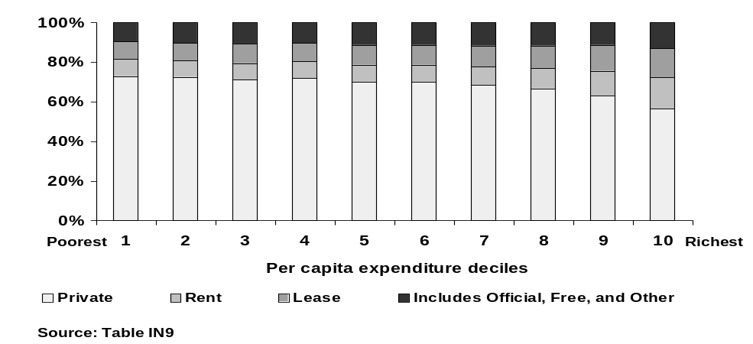

Figure II.5 Philippines and Manila – Urban housing quality is worst for
poor and lower-middle income groups in Manila
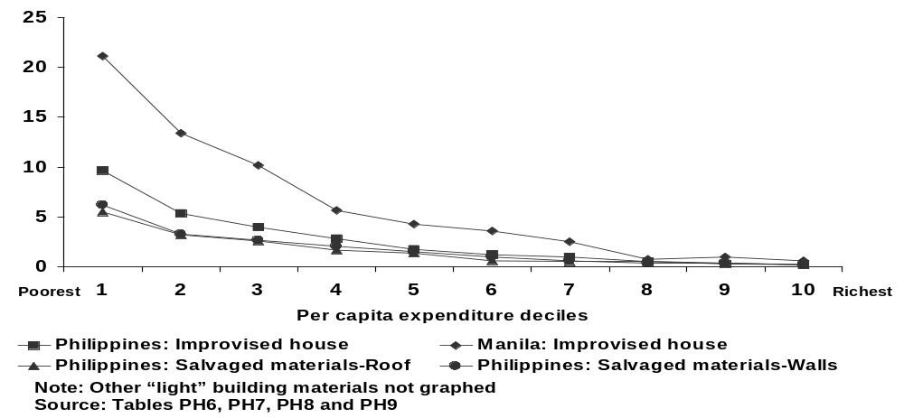

Electricity and durable consumer assets

- The Philippine living standards survey reveals that electricity is almost twice as available “in their building” in urban as rural areas (90 vs. 52 percent), and even 71 percent of the poorest urban decile has such access. (Table PH12) Rural access varies much more sharply with income distribution, which may reflect the costs and difficulty of connecting more remote (often poorer) rural areas compared to the low unit costs of providing service in denser settlements. Electrification is universal for all income groups in Manila. (Table PH14) Reliability, e.g., frequency of outages, is not measured in the survey data. Partly due to differences in service, the urban poor report more ownership of electrical appliances than the rural poor, but not a very high ownership outside Manila of any but radio (which is widely available to all income groups in both areas) and television (owned by a third of the urban poor). (Table PH13)

- Vietnam has a higher rate of electrification than the Philippines, both for the total rural population (71 percent) and for the lowest urban decile (94 percent), despite a much lower per capita electricity consumption. (Table VN14) In Vietnam television ownership is one of the strongest predictors of per capita expenditure in both urban and rural areas, and radio ownership somewhat less so. Vietnam has a higher ownership of television (battery-operated Chinese-made) than of radios, even in rural areas, and higher than in the Philippines. Availability of electricity does not extend to its use for heat or cooking by low income groups, who rely primarily on heavily polluting coal or wood.

Water supply

- Access to reliable, safe water and sanitation is particularly important in urban areas because the density of settlement limits the availability of water from private wells, and the public health risks from inadequate sanitation (disposal of liquid and solid waste) are correspondingly greater. The poor who often reside in low-lying areas prone to flooding are particularly vulnerable to water-borne diseases. Thus even while urban access is usually reported to be higher than for rural populations, there remain serious issues of service reliability, quality and affordability for many poor urban residents. Unfortunately the available living standard surveys do not delve into these questions.

- The Indonesian living standards survey data confirm that a higher share of urban households than rural consume tap water (46.6 percent versus 11 percent) and the rural are more likely to use unprotected water sources (spring, river, rain water). (Table IN10) Half of all urban dwellers (and 42 percent of the poor) purchase water, compared to only 15 percent of the rural population, attesting that water access requires a cash outlay in urban areas. Urban households rely more on “private” drinking water facilities (in-house or -yard taps)—66 percent for urban versus 48 percent for rural—and even 55 percent of the urban poor do so. These gross comparisons of rural and urban areas are as expected. However, it is less evident from standard poverty analyses that the inequalities in sources of drinking water are sharper between urban poor and rich than across rural income groups. For example, while twice as many poor as rich drink from unprotected water sources in rural areas, the urban poor are five times more likely to use unprotected wells and to rely on public (communal) drinking water facilities than the urban rich. In the largest urban area (Jakarta), the poor are even more likely than the rich to purchase water. (Table IN11) As other studies have documented in cities in Indonesia and elsewhere in the developing world, the poor tend to pay higher unit prices and even higher shares of their income for water than the rich, while consuming much smaller quantities and less safe quality. Overall the nonpoor in Jakarta have less advantage in sources of water supply than their counterparts in the smaller urban settlements despite the capital city status. In such circumstances, the sector failures have widespread impacts on all groups but especially on the city’s poor.

- In Vietnam there are sharp disparities in water sources between rural and urban areas, with rural having negligible use of tapwater compared to 53 percent on average for urban residents. However, the disparities across urban income groups are also deep. Only 16 percent of the urban poor have an indoor or outdoor tap compared to 57 percent of the nonpoor, and 64 percent of the poor rely on informal sources (hand dug well, rainwater, surface water, or other) versus 25 percent of the nonpoor. (Table VN15) The inequalities are even sharper, of course, across the extremes of the urban expenditure distribution. (Figure II.6 and Table VN16)

- In the Philippines the inequalities in use of different water sources are not very great between urban and rural households overall, apart from “own faucet” which is clearly more an urban asset (used by 37 percent of urban versus 7 percent of rural). (Table PH15) However, large gaps appear again across the urban expenditure distribution: e.g., 66 percent of the rich have such a facility versus 11.5 percent of the poorest group. (Table PH12) (Figure II.7) Shared facilities and nonprotected sources are used by 75 percent of the urban poor compared to 41 percent of the urban nonpoor. (Table PH15) The most striking feature in Manila is that “peddlers” are relied on twice as much by all residents there as in other cities (10.3 vs. 5.3), and four times as much by the poorest (20.6 percent of the bottom decile). Even though faucet water is modestly more available to the poor in Manila, one would expect that this major city would have a much greater reliance on formal water provision even for the poor than other urban areas. (Table PH14) It is possible that even the poor find the quality and reliability of formal supplies inadequate, resulting in their greater reliance on peddlers.

Figure II.6 Vietnam – Urban source of drinking water: Unprotected sources predominate among the lower expenditure deciles
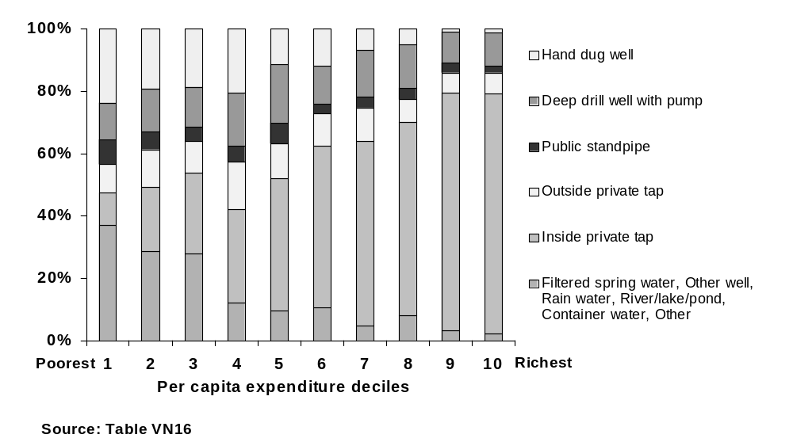

Figure II.7 Philippines – Urban access to “own faucet” rises sharply with per capita expenditure status
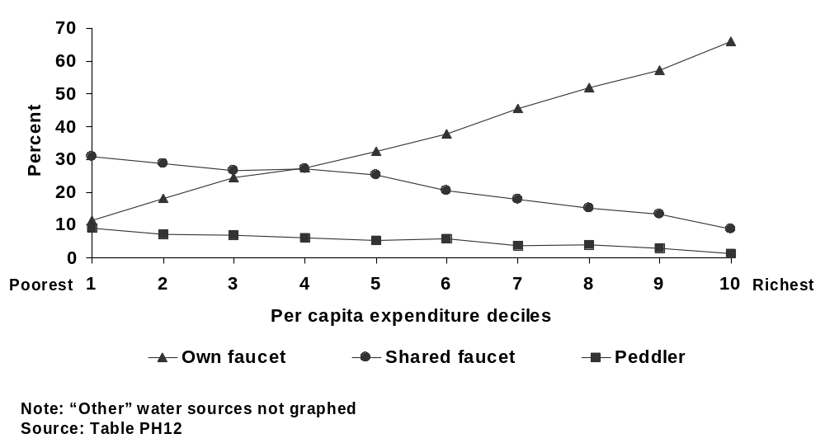

Sanitation

- In Indonesia the form of toilet facility (private or shared) does not vary greatly between rural and urban, or even across the expenditure deciles, except for public facilities which in urban areas are almost exclusively used by the poorest deciles. (Table IN12) Squatter toilets are clearly the type preferred by the better-off population both in urban and rural areas, and even by 60 percent of the urban poor, while dry latrines are the poor person’s alternative (used by 16 percent of the poorest versus 2 percent of the rich in urban areas). The use of squatter and throne toilets by the poor is more common in the larger urban areas. (Table IN13) Safe waste disposal (through septic tank) is twice as available in urban than in rural areas (73 vs. 32 percent), but the bottom third of the urban expenditure distribution relies on discharge to open field, ground hole or water bodies to an alarming degree (about 40 percent using these methods) which risks contamination of the surface and groundwater in dense urban areas. (Figure II.8) (See Box II.1) Even in Jakarta, 30.3 percent of the poor discharge their waste directly into water bodies. (Table IN13) Government statistics confirm that in DKI Jakarta, the water source of 30 percent of households surveyed is within six meters of a source of contamination such as sewage discharge outlet.

Box: II.1 The costs of inadequate sanitation in Indonesian cities

Indonesia has one of the lowest rates of urban sewerage coverage in Asia. This causes widespread contamination of surface and ground waters all across the country. As a result there have been repeated local epidemics of gastrointestinal infections, and high incidence of typhoid (Foley, Soedjarwo, and Pollard, United Nations Development Program, 2001). Economic losses attributed to inadequate sewerage are conservatively estimated at US $4.7 billion per year, and 2.4% of 1997 GDP—roughly equivalent to US $12/household/month (Asian Development Bank, 1999). The low coverage is partly a result of the Government of Indonesia policy, which assigns the responsibility for sanitation to households (World Bank, 1993). This policy--which is a result of the poor past performance of large centralized sewer systems—has inhibited the evolution of effective local governmental institutions for the planning,, implementing and operating of sewer systems. Currently 73% of urban households have on-site sanitation through septic tanks. The partially-treated, or untreated, effluent from these facilities typically flows into soils, open drains, or directly into water bodies. Proper disposal of human waste, either sewage or sullage, is a rare exception. Given the scale of the problem, interest in neighborhood or community-based sewer systems is increasing. One of the more recent successes of the latter approach in Malang, Indonesia, is summarized in Foley, Soedjarwo, and Pollard (United Nations Development Program, 2001).

Source: Shareen Joshi, “Urban Poverty in East Asia”, Draft literature review-background paper, Yale University, May 2001.

- In Vietnam, the highest form of sanitation (flush toilet with septic tank) is, predictably, overwhelmingly available in urban rather than rural areas (62 versus 4 percent), but only 26 percent of the poorest urban decile have this facility. (Tables VN17, 18) The poorest urban residents report less availability of a “simple toilet” than does the rural population, and a disturbing 31 percent report having no toilet at all. (Figure II.9) This figure is equivalent to that of the poorest rural decile, but the environmental health implications can be much worse in denser settlements. The gradient of access to sanitation facilities across the expenditure deciles in urban areas is much steeper than in rural areas, again confirming the large overall urban inequality even without taking account of the nonregistered migrants.

- In the Philippines the urban poor are better served with toilet facilities than the rural poor, but certainly not adequately from an environmental health perspective. Only about half (52 percent) of the poorest urban decile has use of a water-sealed toilet, and 33 percent use an open pit, pile or “no toilet”. (Table PH16) Again, the dispersion of access to different types of toilet is wider in the urban than in the rural context: twice the share of poor than nonpoor use open pit or no toilet in rural areas, compared to a ratio of 4-to-1 in urban areas. (Table PH17) In Manila the poorest group has considerably better access to water sealed or closed pit toilets, and relies less on unsafe disposal, than in other urban areas (Table PH18)

Figure II.8 Indonesia – Urban sanitation (final disposal): About a third of lower-to middle-income residents use unsafe methods
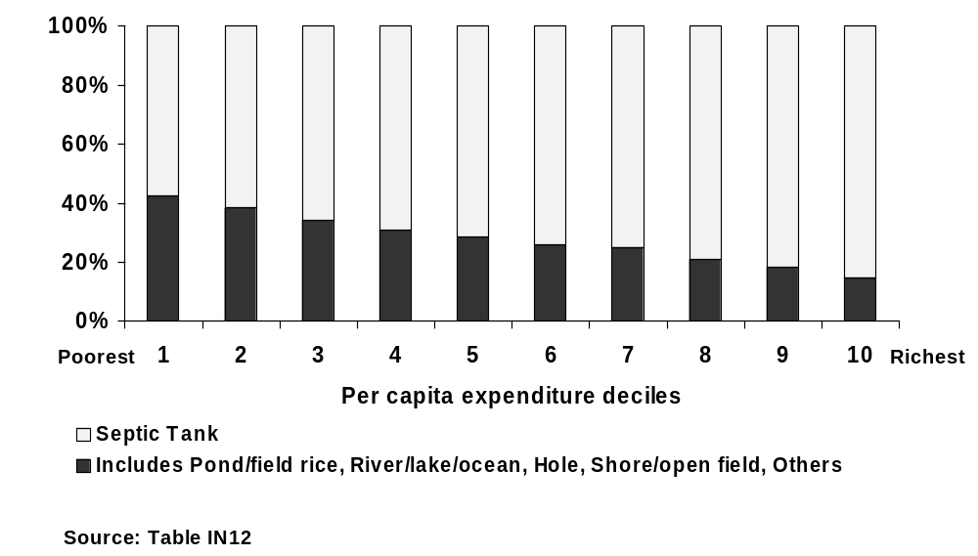

Figure II.9 Vietnam – Urban type of toilet: Half or more of lower-expenditure households lack access to protected facilities
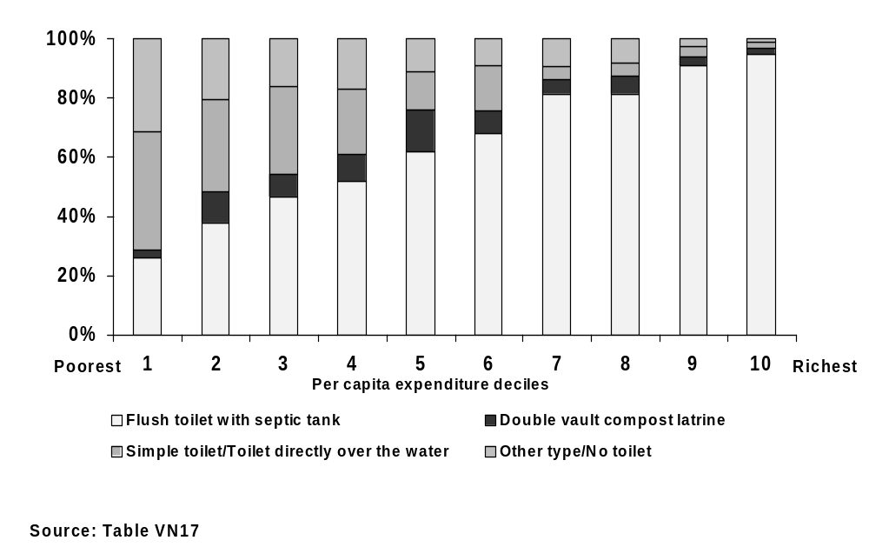

- The living standards surveys do not investigate solid waste disposal, but this also represents a serious environmental health hazard in urban areas. Typically not more than half of household trash is collected in urban areas; one random sample survey in kampungs of Indonesia found that only a quarter of poor households have such service. What trash is collected, often by informal private agents, is usually dumped in unprotected sites, including drains and canals, rather than in regulated landfills. Alternatively, it is burned, thus adding to ground level air pollution. The dire situation in Manila became international news in July 2000 when a literal mountain of refuse in the city’s largest dumpsite (Payatas) collapsed on squatters’ houses, killing dozens of people. Discharge of untreated or toxic industrial waste without proper regulation in urban areas is also common and the poor often live in or near the areas of impact.

Transport

- East Asian cities are experiencing a rapid increase in motorization and they vary greatly in their efforts to manage the use of transport modes to balance the demands of economic and demographic growth, consumers’ rising expectations for travel, and the environmental costs. Experience across the world has shown that inadequate policy attention to public transport, land and housing policies that discourage in-fill development, and unrestrained use of motor vehicles contributes to geographic spread of urban areas, inefficient land use, and excessive separation of residential sites and workplaces. The low income cities of East Asia have developed a legacy of high density, mixed-use urban form based on nonmotorized transport, buses and “jitneys”, and this structure is generally hospitable to the needs of the poor residing throughout the cities. But this land use pattern is changing, as increased public and private investment favoring motor vehicles extends commutes and heightens congestion within the cities, worsening both access and mobility for the poor especially. The high density of Asian cities means that even at existing levels of motorization, pollution emissions are very high on a per hectare basis and the local impacts are particularly severe on the urban poor who are least able to protect themselves.

- According to the UNCHS Urban Indicators Program (UIP) database, the Asia/Pacific cities on average spend longer to reach work (42 minutes) than urban residents in any other region, because of higher use of nonmotorized transport (walking and bicycles) which accounts for 23 percent of work trips—more than in any other region besides Africa. Travel times to work remain relatively low (half-hour) in cities of Indochina and Mongolia where urban growth is still light, and most East Asian cities experience travel times that parallel those of South Asian and Latin American cities. (Annex Table A5) Bangkok’s average time, at 60 minutes, may foreshadow the future for many cities, however; Metro Manila’s average travel speed at 10 km/hour is only slightly faster than that of Bangkok. Private motorized transport already accounts for well over half of travel in some Indonesian, Thai and Vietnamese cities. Public transport is the dominant mode in Singapore, Seoul, Ulaanbaatar, Penang, and Yangon (Myanmar). Walking and bicycles, along with other nonmotorized carriage, are major alternatives in some countries (especially China) but the sheer size, geographic spread, and congestion of many of the cities make these modes impractical and unsafe as long term solutions even for the poor. In major urban areas of Vietnam, motorcycles have taken over both bicycle and public transport use (accounting for 80 percent of central area traffic in Ho Chi Minh City), which adds to congestion and compromises road safety and the environment.

- Lower income groups are the main users of public transport and nonmotorized alternatives. In Metro Manila, socio-economic class is strongly associated with forms of transport, and over 80 percent of the poor and poorest strata depend on public transit for work trips. According to the living standards survey examined here, half of the richest decile in Manila own a motor vehicle or motorcycle compared to one percent of the poorest; in all urban areas the ratio of motor ownership between nonpoor and poor is 13:1. (Tables PH13,19) When low income communities are dispersed throughout the city as in Manila, public transport networks need to be dense and widespread to meet their requirements.

- In most cities, the majority of all trips by lower income groups are on foot, which effectively limits their overall mobility for all purposes. In low income cities, vulnerable road users (pedestrians, bicyclists and motorcyclists), among whom the poor are disproportionately represented, comprise a high proportion of road fatalities. Women are particularly disadvantaged by inadequate public transport and their mobility is hampered by infrequent service provision and transport-related crime. In Bangkok, evening buses for women-only have been instituted in response to their demands for safer means of travel. Men often control most of the family’s transport resources and in some countries women are not sanctioned even to ride bicycles, although women have multiple needs for travel to school, health care, shopping, etc. for the family, even if not for work outside the home. Information on household expenditure for transport was not available from the surveys reviewed here, and would be necessary for a fuller analysis of the poor households’ transport problems.

F. Insecurity and urban poverty

- As noted earlier, poverty is also characterized by a state of insecurity and vulnerability to risks—personal, communal and financial—which undermine the asset base of the poor as well as their ability to manage and cope.

Insecurity of home and place

- The major source of insecurity to the urban household and community is lack of recognized tenure, and the resulting risk that dwellers of informal or illegal settlements will be evicted forcibly with little notice, losing their home, belongings, and connections to work and neighbors. In squatter areas of Metro Manila, official evictions are one threat but private developers and contractors are also known to set fires (“hot demolition”) to clear out shanties and open rights of way. As noted above, a detailed breakdown of de facto and de jure tenure status was not available to this desk study but would be critical to a more thorough urban poverty analysis.

- A second major source of insecurity is natural disasters, to which low income settlements built on flood-prone land, hillsides, or near factories are particularly vulnerable. The very dense and haphazard layout of such neighborhoods, without storm drainage, access roads or cadastres, makes emergency evacuation and service by emergency vehicles slow and difficult and raises the human toll of natural disasters and industrial accidents. In a 1999 survey of communities and specifically, of the “Class D and E” (poor and poorest) residents, in several urban areas of the Philippines, problems of the water system, drainage and floods, or roads ranked in the top five concerns cited even in the midst of a macrofinancial crisis.

Personal insecurity

- In the urban context personal insecurity stems from health and traffic risks described earlier, and from crime. In surveys of poor urban communities the vast majority of residents report feeling unsafe and subject to crime, violence, and harassment, much of it drug- and gang-related. In the same Philippine survey mentioned above, drug addiction ranked first or second (following only unemployment) as major concerns, and robbery entered among the top five problems in two of the communities. Slum dwellers are not only the victims of violent crimes, which tend to be geographically concentrated in poorer neighborhoods of cities, but also of the negative stereotypes attributed to their neighborhoods and by association, to residents in them. Crime therefore adds to the exclusion and marginalization of the urban poor.

Financial insecurity

- Financial risks for urban populations arise from their dependence on cash income and expenditure, which are sensitive to vagaries of the economy at all levels. Formal safety nets are the main solutions in developed countries, and microcredit programs can be important in low and middle income countries. However, reliance on informal private transfer mechanisms as a supplementary source of income is widespread for the urban as well as for rural households in East Asia as elsewhere in the developing world, especially when times are difficult. Mutual financial support among families and communities, including informal credit groups, also may decrease on such occasions as reported from household interviews in Jakarta.

- A study of private financial exchanges in Vietnam found that virtually all of the cash transfers were reported to be sent to family members, and 70 percent are sent from a city/large town to a small town/rural area. An urban survey in the Philippines found that nearly 40 percent of respondents send money to their rural kin but only 6 percent reported receiving any financial transfers (from other urban areas or abroad). The individuals providing remittances reported that unavoidable social obligation to support the extended family even in times of economic pressure make it difficult for them to save. The Philippine Poverty Assessment determined that the relatively low poverty incidence for three categories of the population normally considered vulnerable—female-headed households, the elderly and the unemployed—is due to the significant receipt of cash transfers, almost all of which are from private sources. Transfers are large and increasing in the Philippines, accounting on average for 13 percent of pre-transfer household incomes in 1997. Just over half (57 percent) of the transfers originate from abroad, with the remainder mainly from domestic urban areas. These transfers are found to be highly progressive—benefiting more households with low levels of pre-transfer income.

- A multi-country study by the ADB also found that during the recent financial crisis private transfers constituted a much more important safety net than public programs. In a sample of Indonesian communities surveyed, of the 44 percent of respondents who reported receiving cash transfers, 20 percent was obtained from the government and NGOs while 80 percent was from family and friends, and the better-off families received more of the public funds. It is evident that the flow of funds from (mainly) urban to other urban and rural households through private transfers constitute a valuable and well-targeted mechanism to fight poverty and financial insecurity. While financial risk-sharing through social and family networks is evidently important for the urban poor, it is also an urban-based strategy for reduction of poverty throughout the country.

G. Empowerment, Social Capital and Urban Poverty

- It is often argued that the urban population is favored by better access to channels of influencing government decisions and obtaining favors, relative to the rural population. Below this superficial generalization the reality of relations with government and political voice is much more complex, especially for the urban poor, who express a sense of exclusion and powerlessness in their status as much as do the rural poor. The urban poor therefore rely heavily on their own social organizations and networks, and on informal mechanisms of service provision, to meet many of their needs. While this reliance has many positive aspects it is also a response to government’s failure to recognize the urban poor and treat them fairly in its own backyard.

Relations with government

- Living in geographic proximity to seats of government, the urban poor may have higher expectations than do the rural poor. Participatory poverty assessments among the urban poor often reveal expressions of exclusion from information about government, distrust or unawareness of its intentions, and a widespread experience of the most negative official behavior, corruption. In a “Consultations with the Poor” study of both rural and urban populations in Indonesia, respondents rated institutions (including government, religious, private commercial, and NGO) in terms of their effectiveness and ability to engender trust. No government services or programs, nor any NGOs (which tend in many countries to be rural-based) appeared among the top five institutions that the urban poor selected on the criteria of importance, effectiveness, trustworthiness, and openness to community influence. Both men and women in both rural and urban areas agreed that they could not influence government programs at all.

- Even in the Philippines, which has had a longer democratic and decentralized orientation than Indonesia, the urban poor are disillusioned with government as unhelpful and even harmful to their interests, despite the physical proximity of its agents. The failures of government programs to deliver as promised, such as land tenure through the Urban Housing Act, leads to an expressed sense of suspicion and betrayal. The demands of the poor may in some respects be unrealistic, but it is not clear that the government has tried effectively to educate the population as to what they should expect from it. One study of the urban poor in Naga City in 1998 found that 74 percent were unaware of government programs intended to help them, and almost all were unaware of the pertinent urban development and housing legislation.

- The broader SWRS survey cited earlier of several urban populations, including specifically the poor, indicated that they overwhelmingly expect from government “economic services” (provision of jobs, credit, lower prices, higher wages, projects for the poor), and to a lesser extent infrastructure, social services, and public order. The relatively low listing of the latter elements, which should be government’s main role, may reflect past populism which offered job programs or controlled prices rather than reformed the underlying capacity of agencies to deliver core public services. The same survey respondents perceived that local, not national, government was mainly responsible for local problems, but about as many expressed the view that the government was not doing anything about them, as gave it credit for “probably doing something”. The survey revealed fairly high regard for the then-Administration’s “readiness to cooperate with the poor to fight poverty”. Respondents rated the national government’s performance on housing programs overall as unsatisfactory, which is consistent with data on their regressive impact; however, the Community Mortgage Program, which is well-targeted and efficient in helping the poor acquire land and improve their housing, is held in much higher esteem.

- Corruption is widely perceived as an impediment to the population’s ability to obtain government services and benefits fairly and efficiently. In the above Philippine survey, only the very poor respondents expressed overall confidence that the national administration was trying to eradicate corruption (possibly reflecting faith in Estrada in particular). In areas of Jakarta, local corruption was found to interfere with an emergency rice subsidization program funded by the World Food Program at the height of the financial crisis, but residents were able to mobilize a boycott and force correction.

Social networks among the urban poor

- The social interactions and relationships among urban households are more significant than their dealings with government or other institutions in helping them cope with and manage urban life. A large literature on developing countries has established that households devise various strategies of collaborating with others, both within and outside the family, to pool risk. This research on risk, insurance, and uncertainty has been based largely on studies of rural households because little such work on urban poverty exists. Risk sharing, however, is likely to be a central feature of the behavior of poor urban households, as Cox and Jimenez (1998), in a study of the Philippines, demonstrate. Several qualitative studies already cited here have highlighted the importance of networks in helping urban households cope with risks in cities around the world, and particularly in East Asia.

- As discussed in Section I, the risks faced by the urban poor tend to very different—more based on insecure property rights, environmental health, and unemployment than on climate and natural resources—from the risks faced by the rural poor. Like their rural brethren, the urban poor cope with these diverse types of shocks by using their social networks in conjunction with their personal assets. As Jellenik (1991) in her superb ethnography of a Jakarta slum points out, these social networks are likely to consist both of relatives and friends. Urban slum living is very dense with multiple families often living in the same house. This density tends to move social relationships away from the traditional forms that characterize village networks. Marriages are much less stable and both women and men are more likely to engage in serial monogamy and consequently have a several circles of relatives. Relationships are forged more on the basis of the quality of reciprocal links between individuals and friends rather on familial obligations. These reciprocal connections consist of mutual relationships built on helping people obtain housing and jobs, and coping with illness and credit problems.

- Networks in urban areas are not just an asset for coping with shocks, they are also an important source of mobility. Typically, individuals who migrate to the city come knowing a friend or relative with whom they can stay and who may help them find a job or connect them with other people who can potentially help. These social networks are central to improving the living standards of the poor. In the extended peri-urban areas outside East Asian cities, the torrent of new workers into a relative social vacuum means that community networks are weaker and thinner than in longer-established core urban settlements, and so channels for informal housing, credit and other services are more lacking. A poor migrant’s social networks, however, are not only in the city but also in the village. S/he often supports parents, spouses and other relatives in the village. When the migrant is successful in the city this can represent improvements in his or her family’s living standards in the village as well. On the other hand, during periods of adversity, a migrant’s rural-based family may help with gifts of food and money.

- The nature of community in urban areas is also very different from village life. While recent poor migrants may live in recently settled squatter settlements, they may retain a strong sense of community. They often reside within enclaves populated by people from their home village, or live with relatives who have developed strong ties within a more diverse community. Slum communities usually have well-defined leaders who mediate the relationship of the families in the slum to the State. As in rural areas, the ability of urban communities to engage in collective action may play a very important role in determining the extent to which they can obtain and access public services. This is particularly true in capital cities such Jakarta or Manila, where the urban poor – because of their numbers and the relative ease with which they can be organized --are a very important part of the political culture. In a survey of poor people in Naga City in the Philippines, households reported a 91 percent participation rate in various organizations (averaging 1.4 members per household); of these, 71 percent belong to organizations specifically of the poor. This willingness of a community to engage in collective action can be mobilized by community leaders to obtain services for slum communities. It can also be manipulated for private gain or unofficial corruption. Among squatter communities in Manila, it has been reported that “toughminded syndicates often organized the occupation of such land and distributed sites for a price and monthly fees”. One resident’s mafia may be another’s service provider.

- Note that networks are not always good things. The ability of a community to engage in collective action can also make it very effective as a source of political violence. The obligations required to maintain social networks often have high costs that the poor, who are constrained for time, may not desire to expend. Moreover, mobility can reduce the need to rely on old friends and relatives which means that these webs of obligation can often be lost when a lucky member of the community moves ahead and cuts ties with his or her roots. Networks can be a means of inclusion as well as exclusion. In Vietnamese cities the government’s harsh policy towards unregistered migrants makes them outcasts to the poor residents as well, so that it becomes more difficult for both groups to organize together around common issues of poverty.

- In short, urban social networks are not necessarily any less central to the survival of the urban poor than of the rural residents. The urban social fabric may be more varied in texture and color, more easily torn and rewoven to fit changing needs, but still indispensable as a basic shield and safety net for the urban poor.

Part Three: Implications of Urban Poverty Findings for Policy, Institutional Development, and Research in the Region

A. Summary of key points about urban poverty in the EAP Region

- This review of living standards survey data and other evidence points to some clear observations, and some preliminary conclusions, concerning the directions and magnitudes of urban poverty issues and trends at least in three major countries of the Region. These findings suggest recommendations about relative priorities and potential focus areas for policy and institutional follow-up, and for further research that would sharpen and deepen understanding in the Bank and among clients and partners.

- The main points drawn from the preceding analysis can be summarized as follows:

- The countries of the Region have reduced urban poverty along with overall poverty (in income/expenditure terms) over the past decade, but the urban poor are poised to increase in magnitude and share of the total over the medium term. Income inequality is relatively high (higher than rural) and rising in urban areas; large intra-urban inequities in access to basic services and welfare status (across housing, land tenure, water and sanitation, transport) are also evident from numerous sources.
- Income or expenditure-based measurements of urban poverty are highly subject to the assumptions used, and much of the urban population is close to the estimated poverty line. The recent macro-financial crisis demonstrated this, as it hit urban populations particularly hard and sent many into poverty status at least temporarily. Possibly reflecting the limitations of income-based measurements, the self-ratings of poverty status are especially high among urban populations.
- Further caveats about the living standards surveys limit the picture they can convey about urban poverty, for several methodological reasons: they do not fully capture the mixed livelihood sources (rural plus urban) of many households, the samples are typically too small to permit disaggregation among and within urban areas, sampling frames are often outdated given the rapid changes in urban population, and the survey instrument insufficiently tailored to the peculiarities of urban life.
- The living standards survey data reveal that the poor and poorest among the urban populations of Indonesia, the Philippines and Vietnam are not the usually expected “vulnerable groups” (i.e., not female-headed households nor the elderly), but they do include large families. Private transfers (of urban origin) may be one main reason why these groups escape poverty.
- The migrants surveyed are not less well off than longtime residents, although a major shortcoming of the Vietnam survey is its failure to capture the nonregistered migrants who suffer official exclusion from services and benefits.
- The urban poor are also not necessarily unemployed, although the survey instruments are often unsuited to capture the vagaries of urban earnings patterns, especially in the informal sector. Due to the commoditization of urban life (expenditure required for all essential goods and services), a stable source of cash income is essential to avoiding poverty.
- While indicators improve generally with increasing size of settlements, the largest urban areas (Manila and Jakarta) are not necessarily most favored and in some respects (e.g., water and sanitation in Jakarta), the poor residing there are worse off than in other types of settlements. The theoretical economic advantages of agglomeration can be lost in practice due to bad urban management.
- The housing status of the urban poor is marked by a high degree of crowding, tenure insecurity and risk of forced eviction. There is a large quality differential across urban income groups, although housing conditions are surprisingly poor even for the urban middle class in the Philippines.
- Although access to education, health facilities, water and sanitation is predictably higher in urban than rural areas overall, a breakdown of both effective access (and quality of service) and of outcomes is needed—across income groups, zones of the city, and among urban localities—to determine accurately the welfare status of different groups (in absolute or relative terms). Such disaggregations are not feasible from most of the survey databases.
- From the information available, it is evident that there are large disparities in educational attainment among the urban population. Intermediate levels of education do not necessarily translate into higher incomes in the urban setting.
- Health status in urban areas is deleteriously affected by behaviors, multiple stresses and environmental risks. Infant and child mortality are higher for the urban poor than the rural poor in the Philippines. Health outcomes have been found to vary even more across zones of a city where this has been studied, although the available living standards surveys examined here do not permit this analysis. Undernutrition and hunger are evident in some urban areas of the Philippines and Vietnam. Risky behaviors (e.g., smoking), disaster-prone living conditions, incidence of crime, violence, and HIV-AIDS, and traffic accidents are all affecting health in urban areas, especially among the poor.
- Sources of water supply and quality of sanitation are highly divergent across income groups in urban areas. The poor are more likely to pay for water than the rich in Jakarta and Manila. The large share of the urban poor without basic sanitation or safe waste disposal in Vietnam, and in Jakarta, pose major health risks for them and for the entire city populations.
- The high density of East Asian cities has historically permitted use of nonmotorized transport and walking for a large share of transport needs, but this is changing with urban growth The mobility and ease of access for poor urban residents are most likely to suffer from deteriorating public transport and increased traffic congestion. Their welfare is also harmed by their susceptibility to traffic accidents, ground level pollution, and transport-related crime.
- The urban poor experience a covariance of threats to their personal, financial and communal security stemming from uncertain tenure, macroeconomic shocks (affecting earnings and prices), crime and other social pathologies (e.g., drugs). Private financial transfers play a larger role than public transfers in mitigating financial risks of the poor.
- Despite their physical proximity to seats of political power, the urban poor have little influence on policies or programs affecting them unless they organize; generally the urban poor perceive themselves to be excluded by government, yet highly vulnerable to official corruption.
- The urban poor have many complex social networks that serve multiple functions of social integration, mutual support, labor market facilitation, and collective action to obtain services. This social capital, which is highly diversified, is more important for the urban poor than formal relations with government in helping them cope with and manage urban life, although maintaining networks can also be costly or perverse in effects on individuals.

B. Policy and institutional implications of urban poverty

- The preceding desk analysis is largely limited to describing the correlates of urban poverty in the focus countries, rather than the causes, which would require deeper investigation. The review is also mainly limited to identifying the urban poor in per capita income or expenditure terms, since the data sources provide less detailed markers of nonincome poverty. An overall picture emerges of vulnerability as a key characteristic of urban poverty. Important underlying contributing or causal factors requiring further study may include tenure insecurity, problems of governance, dysfunctionality of labor and land markets, or issues in the investment climate that impede growth of employment providing good livelihoods. Key policy and institutional dimensions such as the incidence of public expenditure, the effectiveness and efficiency of formal safety net programs, systems of political representation and legal protections, public access to information, as well as sectoral policies governing education, health, housing, and basic infrastructure services all need to be explored in further work to identify approaches that may alleviate and reduce poverty in its multiple dimensions. But even the narrow confines of this desk study suggest some of the factors that may be driving urban poverty and would need to be addressed.

- As discussed in section I.(D), there is an element of urban poverty that could be considered a function of temporary mismatch between the supply and demand for jobs and services, e.g. in the presence of rapid in-migration. If institutions are basically responsive and efficient this kind of poverty could be addressed by applying more resources to the provision of services and removing any specific bottlenecks such as undue regulatory barriers. But in the countries viewed here, and arguably in many places elsewhere, the larger part of poverty appears due to deep seated political and institutional factors that prevent certain groups from obtaining the opportunities and protections they should be able to expect from either markets or from government. The empirical finding that inequalities are deep and pervasive in the urban areas indicates that this more fundamental rooting of poverty in the structures of governance is the main issue to be addressed.

- For the former type of poverty—which may be characterized as waiting in a queue that moves by fair, well-known and accepted rules—external assistance can accelerate the queue by applying additional financial resources and helping to identify measures that would accelerate supply (e.g., by better frameworks to facilitate private sector provision) and sharpen the expression of demand for services, such as by better pricing, improved information, etc. Much donor assistance for infrastructure policy reform and improved investment, and for private sector development, is very relevant to this process and remains a priority in the Region, particularly if it focuses on constraints to the provision of services to low income users (such as tariff structures or regulations that create disincentives or obstacles to connecting such consumers). Assistance to municipalities in removing policy-induced barriers to land development, and undertaking flexible urban planning to steer new development in ways that can forestall future slum creation with population growth, are also high priorities.

- To get at the deeper problems that prevent the urban poor from taking advantage of improved opportunities and make them disempowered and vulnerable, it is necessary to act more directly on underlying governance issues in the choice and design of policies and programs. The insecurities of housing and land tenure, livelihood insecurity and physical insecurity to which low income urban residents are subjected call for policies and programs to strengthen legal protections and rights (especially for tenure), reduce corruption and arbitrary administrative actions, and foster the communities’ own social capital. Community-driven slum upgrading programs, which improve a wide range of physical and communal services in neighborhoods with the active involvement of the residents, would have broad benefits in reducing multiple sources of vulnerability—provided the local and national government are committed to the program as part of a framework of better governance (e.g., recognizing the residents as full citizens with rights and responsibilities) rather than an isolated action. By the same token, interventions to raise the capacity of local governments to carry out all of their basic functions in a responsive, transparent and accountable manner, and to undertake participatory strategic planning of their investments and other activities, would be important to help change the relations and rules of the game between the local government and citizens.

- As also noted in section I (D), how well urban growth in the Region is managed in the coming decades will have a large impact not only for urban poverty, but even more for how well the urban areas can contribute to the growth of the national economy and to the prospects for poverty reduction in rural areas. The process of urban transition and the potential economies of agglomeration can raise the productivity for both rural and urban residents, but only if the basic mechanisms—a well integrated internal market for labor and goods, with ease of movement and good information flows, and lowered production costs from shared infrastructure—are actually working. Donor support to policies and programs that make the urban economies function efficiently and raise the returns to private investment there would be good value to the nation as a whole.

- Such policies and programs would, for example, be positive towards internal migration—and certainly remove residence restrictions; they would facilitate urban-rural remittances as a main source of private transfers however appropriately; favor internal marketing (aided by transport and communications improvements where needed); and correct distortions or missing segments of financial markets (especially credit and savings for the poor). Particular attention to housing sector reforms and to urban transport needs are especially crucial in the Region. The widespread inadequacies in housing and transport, which affect many urban residents but are especially debilitating to the poor, should be among the highest priority concerns of governments and donors as these failures undercut the very essence of the urban economy, which is a fluid labor market.

- Finally, the findings on urban poverty and inequality suggest that any policy or program interventions, but especially those intended to be poverty-focused, should be designed with more detailed information on impact and targeting among the urban population. Similarly, public expenditure analysis needs to go beyond aggregate attributions to “rural” or “urban” beneficiaries to determine more accurately the distributional reach within the urban population and in different urban areas

C. Suggested priorities for research into urban poverty in the Region

- The present analysis raises important issues about the common methods and sources of empirical poverty research (such as living standards surveys) that are often not well suited to the context of urban poverty, and therefore unlikely by themselves to reveal correctly its nature or relevant distinctions with respect to rural poverty. Because the research methodology of living standards surveys has been developed and applied most extensively in rural settings, the sampling design and in the construction of survey instruments tend to be based upon rural notions of life.

- The implications of both of these problems were discussed in section II (A). Because urban populations are constantly changing, homes often contain several families, and unregistered migrants are not counted as urban residents, decennial census-based sampling frames quickly become non-representative and, unless frequently updated, are likely to miss the poorest residents. The survey instruments and methods are designed from rural experience with the nature of households, work, and living conditions, and are often not adapted adequately to capture the complexities of urban livelihoods and society, or the multi-spatial nature of households rooted in both places.

- There are known techniques to ensure more accurate sampling and to design well-tailored survey instruments, but best practices are not always applied. Some suggested alternative approaches to sampling and to survey design are outlined in an attachment to this report. In particular, conducting special-purpose surveys to supplement national living standards surveys, acquiring panel data, and combining quantitative and qualitative information will be necessary to delve into many of the issues and dimensions of urban poverty more adequately, with sufficient detail across and within urban areas.

- With appropriate methods of obtaining a more complete and accurate picture of urban poverty, a number of specific issues and questions need to be explored. Based on the preceding review some priority research topics are suggested here:

- The role of interspatial mobility (migration and multi-spatial livelihoods) in affecting poverty in both rural and urban areas. This would include looking at circular and temporary rural-to-urban migration as well as longer-term movement, and would examine both the role of private transfers and mechanisms by which rural migrants become integrated into the urban society and economy.
- The dynamics of informal employment in urban areas—the quality of livelihoods and patterns of occupational mobility in the context of policy and institutional conditions.
- How social networks among the urban poor function to help members cope with poverty and its various dimensions; these networks often include linkages with rural residents.
- A disaggregated analysis of health outcomes by zones within some major cities and comparison among different cities (with different sizes, growth rates, and degrees of service provision), to map health-related poverty in greater geographic and socio-economic detail than is currently available.
- Evaluation of the impact of specific interventions or packages of interventions, such as neighborhood infrastructure improvements and tenure security, on the well-being of low income residents. The role of social capital and how it affects or is affected by residents’ participation in such interventions would be a further question for such research.

Technical Annex – Developing better sampling designs and questionnaires
to assess the living conditions of the urban poor

By Vijayendra Rao (DECRG)

- We know much less about the urban poor than we know about the rural poor. The primary reason for this is that the analysis of risk and poverty has focused more on rural areas because the preponderance of the poor are in rural areas. As demonstrated above, however, this is rapidly changing and poverty is increasingly acquiring an urban face. But the rural bias has resulted in a limited understanding of the urban experience of poverty. This bias results from both sampling design problems and from the construction of survey instruments both of which tend to be based upon rural notions of life. This Annex first outlines the nature of the problems and then sketches possible solutions to them.

a) Sampling Design

The Problem:

- Poverty estimates are usually calculated from surveys of large nationally representative samples. These samples are typically drawn from sampling frames based upon decennial censuses (e.g.: Surbakti, 1995, World Bank 2001). In rural areas this is usually not a problem. Rural populations tend to be quite stable with families that have lived several generations in the same village on ancestral land with well defined addresses and property rights. Family structures also tend to be relatively stable and mobility is low. Consequently a ten year update on the sampling frame is adequate to track important changes in the size and composition of the population. Since the populations are relatively stable, samples drawn in subsequent years from this sampling frame are unbiased and representative.

- The urban situation is quite different. Urban populations, particularly the urban poor, are characterized by high levels of mobility, unstable and poorly defined property rights, and fluid family and social structures. The poorest of the poor, in particular, tend to be squatters living in temporary settlements that are subject to high risks of demolition. Thus, the poorest tend to be particularly mobile. Census based sampling frames are consequently out of date almost the moment that they are tabulated. Squatters are the most likely to be excluded from these sampling frames because of poorly defined addresses and the high probability of changes in residence. New migrants, who are often homeless and live on the streets, are also unlikely to be captured within the sampling frame. Consequently a sample constructed on the basis of census based sampling frame is very likely to miss the poorest among the urban poor and underestimate the extent of urban poverty.

- Furthermore, urban homes often tend to have multiple families resident in them since new migrants typically reside with friends and relatives while they find a place to live. Thus, even if a household was picked up in the census, it is likely that there are now two or more households resident in the same space once again resulting in an undercount of the poor in the sample.

- The problem is compounded in those countries where governments require citizens to register in order to be considered “legitimate” residents of a town or village. New migrants and the poor tend to be unregistered which leads to their automatic exclusion from censuses, and from the samples based upon them. This is a problem that is widespread in East Asia with both the Vietnam LSMS (World Bank, 2001) and the China Household Survey (China National Bureau of Statistics, 1999) reporting that their urban samples suffer from the problem.

One Possible Solution:

- Urban sampling frames need much more frequent updating than rural sampling frames. While it would expensive to conduct a complete household listing prior to conducting a household survey, various statistically valid procedures can be employed to reduce the extent of bias. One possibility is to conduct a stratified random sample where sectors within a city are first selected - employing census based information on population and housing to construct a community level sampling frame.

- Then these sampled neighborhoods can be mapped to identify new squatter settlements, and to incorporate changes in the size and structure of neighborhoods. Following this a PRA (participatory rapid appraisal) or PPA (participatory poverty assessment) exercise can be conducted within these neighborhoods to obtain rough estimates of population size, housing quality, ethnic composition and other such broad indicators that will help determine the next stage of sampling and stratification. Once this information is obtained, the samples can be collected by randomly choosing neighborhoods from the updated list stratified by appropriate criteria. Once the neighborhood sample is chosen, household within them can be systematically listed to obtain a complete sampling frame for the subset of neighborhoods included in the multi-stage sample. Households can then be randomly chosen from this sampling frame. A sample conducted on the basis of this method is less likely to be biased against new migrants and the poor.

- This method is just one way of attempting to improve the coverage of the urban poor in sample surveys. While there may be other methods, any technique employed will have to tackle the problem of updating the sampling frame to include transients and new migrants, and multiple households. The problem of the homeless is more difficult to deal with. To begin with it may be important to conduct a case-study of homelessness in major metropolitan areas to understand the magnitude of the problem and develop ways of including the homeless in surveys of the urban poor.

b) Survey Instruments

The Problem:

- The experience of poverty in urban areas is quite different from that of rural areas. Risks suffered by the urban poor are very different. For instance the urban poor are plagued by insecure property rights in housing. This causes households to constantly cope with the possibility of eviction or demolition. While rainfall risks may dominate the lives of agricultural households, the urban poor are more likely to face macro-economic shocks which have a direct effect on urban employment. This is particularly true of East Asian countries who faced the recent economic downturn.

- While it is well-known that urban occupations of the poor tend to be in the informal sector, it is less well-known that the informal sector can also be highly organized. For instance, the sale of cooked food is a disciplined occupation that depends crucially on social ties and inter-connections between grocers, cooks, and sellers ( Jellinek, 1991). Occupational structures in urban areas are, therefore, very different from those in rural areas. The risks faced by these occupations are thus not very well understood. For instance, garbage pickers dependent upon recycling plastic bags found in the trash may lose a lot of income if new environmental regulations banning plastic bags are instituted. The peculiar nature of urban occupations are typically not captured by national surveys where questions on income and occupation tend to be based on traditional agricultural and salaried categories.

- Urban social ties are also different from the rural. While urban social groups sometimes import pre-existing relationships from the village, more often urban social relationships are based upon unconventional connections peculiar to urban communities where individuals from diverse ethnic and economic backgrounds may live together in the same space. It is therefore not uncommon to observe marriage patterns in urban areas that are very different from those observed in rural areas. Typically, the lack of an extended family also makes life for young urban families much more dependent upon their own initiative rather than on the endowments of social and cultural capital they obtain from their parents. All of these affect how urban households cope with risk – their coping mechanisms depend much more on friends, co-workers, employers and less on close relatives as in rural areas.

- The life of urban migrants, however, remains closely linked to the family they leave behind in the village. This migrant is often the rural family’s most important form of support, while the rural family in turn might provide help with food and grain during periods of crisis, and help with marriage, pregnancy and other life events. The inter-connectedness between the rural and urban branches of a family are important enough that it is difficult to argue that there is a clear distinction between the rural and urban poor. Rural and urban poverty are closely connected and this inter-connectedness needs to better taken into consideration when formulating policy which tends to see rural and urban populations as distinct. Urban migration provides rural households with a ticket to mobility and many urban migrants, therefore, spend as much effort on trying to “get ahead” as they do on “survival.” Urban social networks are thus as geared to finding income earning opportunities as they are part of social protection strategies among the poor. Urban households, to coin a phrase, constitute the branch offices of their rural brethren.

- National surveys typically do not take account of the complexities of urban life. The substantial differences between rural and urban household in their occupational composition, sources of risk, the nature of networks call out for very different survey instruments. On the other hand the close links between rural and urban households require a more integrated approach to survey design. While the rural experience of poverty is usually well-covered in questionnaires with several questions on agricultural occupations, investments and coping strategies against climate related shocks, the urban poor tend to not have their experience of poverty measured or understood.

Possible Solutions:

- While qualitative and case-study research has substantially expanded our knowledge of urban poverty, the nature of risks, social networks, occupations, etc. may differ substantially from country to country and even from region to region. In order to develop survey instruments that are able to uncover some of the complex social and economic relationships outlined above, we need a method that first uncovers the phenomena experienced by the urban poor and then tries to formulate structured questions that can measure then in the context of a survey instrument.

- One method that can be employed to undertake this is to combine qualitative and quantitative techniques (Rao, 2001). Once the sampling frame has been constructed on the basis of the multi-stage method outlined above, a sub-sample of communities selected for the quantitative questionnaire can be the focus of an intensive qualitative investigation. This would involve a combination of focus group discussions, Participatory Poverty Assessments at the community level, combined with in-depth interviews at the level of households. Community level investigations should be conducted with sub-groups stratified into relevant categories – such as men and women, working age, students and the elderly. Participants in these discussions should as far as possible be randomly selected. Simultaneously a small random sample of households can be administered open-ended in-depth interviews. The subject matter of the focus group discussions, PPAs and in-depth interviews should be kept as general as possible in order to allow new findings to be uncovered and digested by the research team. Structured questionnaires often pre-suppose a lot of knowledge on the part of the researcher and when the subject matter is relatively less understood – as in the experience of urban poverty – it is best to allow the poor to take the lead in informing researchers about the issues that they confront them in order to make the process more consultative. This qualitative information should be recorded and the team that is conducting the interviews should ideally meet at the end of every day to cross-check and dissect their findings.

- For instance, the urban poor tend to engage in occupations that are sometimes not easy to predict or classify – such as organized panhandling, or street performance, or recycling discarded copper wire. Standard questionnaires would classify these either as “other” or as “self-employed.” However, both of these categories do not do justice to the complexity of the occupation which may be quite formally organized and more in the nature of piece-work than self-employment. A consultative process of questionnaire development could obtain a comprehensive list of the types of occupations engaged in the slum. A focus group would be very helpful in classifying these as wage related, or self-employed. This focus group information could then be incorporated in the questionnaire which would then be able to better reflect the reality of occupational patterns among the urban poor, rather than preconceptions about what they might be.

- Another example of the usefulness of this technique is to understand the role of networks – who do people seek help from and for what purpose? Do new migrants access a different set of networks than older migrants? How do urban household interact with their rural families? How do they interact with the slum leadership and agents of the State? Qualitative work can provide insights into how these issues are best incorporated into the questionnaire – whether they should have a separate module for instance or folded in to modules on labor supply and housing.

- The method by which the qualitative information in incorporated into the questionnaire is best done by bringing in the views of all the field staff. This is best done soon after the end of the qualitative field work which can take from a week to several months depending upon the size and experience of the team, and the complexity of the field site. The team should then have a conference to devise a structured quantitative questionnaire that emerges directly from the field experience. One way of doing this efficiently is to begin with a prototype survey instrument such as the LSMS or some other well-known household survey. Then each module in the questionnaire can be analyzed by the field team to examine how closely it fits what they learned in the field. The facilitator can attempt to direct the discussions towards specific structured questions that can be used to modify the prototype module. This process can be followed to develop an entirely new questionnaire that is informed by the field team’s contributions. Once the new questionnaire is developed, it is important that is be pre-tested and refined before being finally administered.

- This mixed method approach provides one solution towards developing survey instruments that are attuned to the experience of urban poverty. It may mean that national surveys would have three modules – one that is common to all communities in the sample and one each for rural and urban households that include questions on the inter-connections between rural and urban life.

Bibliography

Ahuja, V., B. Bidani, F. Ferreira, and M. Walton. 1998. Everyone's Miracle? Revisiting Poverty and Inequality in East Asia. The World Bank, Washington, D.C.

Anh, Truong Si, Patrick Gubry, Vu Thi Hong, and Jerrold W. Huguet. 1996. “Migration and Employment in Ho Chi Minh City.” Asia-Pacific Population Journal. Vol. 11, No. 2, 3-22.

Asian Development Bank. 2001. Cities Data Book: Urban Indicators for Managing Cities. Manila. April Draft.

Asian Development Bank. 2000. “Fighting Poverty in Asia and the Pacific: The Poverty Reduction Strategy”. available at: http://www.adb.org/Documents/Brochures/Fighting_Poverty

Asian Development Bank. 1999. “Towards a Community Based Environmental Sanitation Program for Indonesia”. Dillion Consulting and PT Dacrea Design and Engineering, for Asian Development Bank. (TA No. 2805-IN)), Jakarta, Indonesia.

Barter, A. Rahman Paul. 1998. “Transport and Urban Poverty in Asia: A Brief Introduction to the Key Issues”, UNCHS (Habitat) Regional Symposium on Urban Poverty in Asia, Fukuoka, 27-29 October.

Besley, Timothy. 1995. “Savings, Credit and Insurance,” Chapter 36 in Handbook of Development Economics, Vol. 3A, Jere Behrman and T.N.Srinivasan (editors), Amsterdam: Elsevier.

Betcherman, G., and R. Islam, 2000. East Asian Labor Markets: Impacts, Responses and Lessons. The World Bank, Washington D.C.

Brockerhoff, Martin and Ellen Brennan. 1998. “The Poverty of Cities in Developing Regions”, Population and Development Review, 24(I):XX-XX (March)p. 1-40.

Campbell, Tim. 2001. “A Tale of Two Cities in Vietnam: Towards a Strategy for Growth, Poverty Reduction, and Environmental Quality in the Cities and Regions of Vietnam”, World Bank.

China National Bureau of Statistics. 1999. “A brief introduction of urban household survey”. Memorandum.

Coate, Stephen and Martin Ravallion. 1993. “Reciprocity Without Commitment: Characterization and Performance of Informal Insurance Arrangements,” Journal of Development Economics, 40: 1-24.

Cox, Donald and Emmanuel Jimenez. 1998. “Risk Sharing and Private Transfers: What About Urban Households?” Economic Development and Cultural Change, Volume 46, No. 3.

Cox, Donald, Emanuela Galasso, Emmanuel Jimenez. 2001. "Private Transfers in a Cross Section of Developing Countries". The World Bank.

Craig, Mary, Alejandro de la Fuente Meraz, Simin Ho, Hanayo Kuroda, Fredric Gilles Serpoul, Stephen Sokol, Jocelyn Songco. 2001. “Krisis: How the Urban Poor Cope”, Columbia University School of International and Public Affairs, Economic and Political Development Concentration, SIPA/World Bank Report, May.

Cour, Jean-Marie. 2001. “Vietnam: Migrations, urbanisation, and changes in the rural world,” Paper prepared for the Franco-Vietnamese Economic and Financial Forum, May.

Dang, Ahn, Sidney Goldstein, and James McNally. 197l. “Internal Migration and Development in Vietnam.” Center for Migration Studies of New York.

Esguerra, J., A. Balisacan, and N. Confessor. 2000. “The Philippines: Labor Market Trends and Government Interventions following the East Asian Financial crisis”. in East Asian Labor Markets and the Economic Crisis: Impacts, Responses and Lessons, Edited by G. Betcherman, and R. Islam.

Fan, Shenggen, Cheng Fang, Xiaobo Zhang. 2001. “How Agricultural Research Affects Urban Poverty in Developing Countries: The Case of China”, Paper presented at International Food Policy Research Institute, Washington, D.C., June 18, 2001.

Fang, Cheng, Shenggen Fan, Xiaobo Zhang. 2001. “Emergence of Urban Poverty and Inequality in China: Evidence from Household Survey”. Paper presented at International Conference on Urbanization in China: Xiamen, Fujian Province, China, June 26-28, 2001.

Foley, S., A. Soedjarwo, and R. Pollard. 2001. “Case Study: Of the People, By the People, For the People: Community-Based Sewer Systems in Malang, Indonesia”. Water Sanitation Program for East Asia and the Pacific.

de Haan, Arjan. 2000. “Livelihoods and Poverty: the Role of Migration”, Presentation at World Bank, March 9, 2000.

Hamid, Naved and Mildred Villareal, editors. 2001. Asian Cities in the 21st Century: Contemporary Approaches to Municipal Management. Volume V: Fighting Urban Poverty. Asian Development Bank Institute and Asian Development Bank. Manila.

Henderson, Vernon. 1999. “The Effects of Urban Concentration on Economic Growth”, Brown University working paper, December draft.

Hentschel, Jesko and Jesse Bump. 1999. “Urban Poverty Dimensions – Some Cross-Country Comparisons”, World Bank, December draft.

Hugo, G. 2000. “The Crisis and International Population Movements in Indonesia”. Asian and Pacific Migration Journal, Vol. 9 (1), 93-129.

Islam, R, Bhattacharya, G, Dhanani, S, Iacono, M, Mehran, F, Mukhopadhyay, S, and Thuy, P. 2000. “The Economic Crisis: Labor Market Challenges and Policies in Indonesia”. in East Asian Labor Markets and the Economic Crisis: Impacts, Responses and Lessons, Edited by G. Betcherman, and R. Islam.

Jellinek, Lea. 1991. The Wheel of Fortune: The History of a Poor Community in Jakarta. University of Hawaii Press.

Jones, G.W. 1998. “Urbanization Trends in Southeast Asia: Some Issues for Policy,” Journal of Southeast Asian Studies, March.

Joshi, Shareen. 2001. “Urban Poverty in East Asia: A Literature Review”, Yale University, Background paper prepared for East Asia Region Urban Development Division (EASUR) Poverty Study, World Bank. June draft.

Joshi, Shareen. 2001. “Urbanization and Migration in East Asia : A Literature Review”, Yale University, Background paper prepared for East Asia Region Urban Development Division (EASUR) Poverty Study, World Bank. May 2 draft.

Lim, Liza, Wilfredo F. Arce, and Mary Racelis. 2000. “Urban Poverty from the Perspectives of the Urban Poor in Vietnam”. Ateneo de Manila University. Draft Background Paper prepared for East Asia Region Urban Development Division (EASUR), The World Bank.

Lindfield, M. and A. Lanyon. 2000. “Community Upgrading and Poverty Alleviation.” Presentation to World Bank Seminar on Upgrading Projects, Jakarta, Indonesia.

Luan, Trihn Duy, Nguyen Xuan Mai, and Vu Tuan Anh. 1999. “Poverty and Social Issues in Haiphong City: A Report on Socio-Economic Survey”, Haiphong and Hanoi, March.

Lucas, Robert E.B. 1999. “Internal Migration and Urbanization: Recent Contributions and New Evidence”, Background Paper for World Development Report 1999/2000.

Minot, Nicholas and Bob Baulch. 2001. “The Spatial Distribution of Poverty in Vietnam and the Potential for Targeting,” DFID Poverty Trust Fund and World Bank Development Economics Research Group, Revised April 18.

Moser, Caroline O.N. 1998. “The Asset Vulnerability Framework: Reassessing Urban Poverty Reduction Strategies”. World Development, 26(1): 1-19.

Moser, Caroline. 1996. Confronting Crisis: A Comparative Study of Household Responses to Poverty and Vulnerability in Four Poor Urban Communities. Environmentally Sustainable Development Studies and Monographs Series No. 8. The World Bank. Washington, D.C.

Moser, Caroline, Michael Gatehouse and Helen Garcia. 1996. “Urban Poverty Research Sourcebook Module II: Indicators of Urban Poverty”, UNDP/UNCHS (Habitat)/World Bank, Urban Management Program Working Paper No. 5, September.

Ogawa, N.. 1985. "Urbanization and Migration in Selected ASEAN Countries: Trends and Prospects", in Urbanization and Migration in ASEAN Development, edited by M., Hauser, D. B. Suits and N. Ogawa, National Institute for Research Advancement, Tokyo.

Pernia, Ernesto M. 1994. Urban Poverty in Asia: A Survey of Critical Issues. Hong Kong: Oxford University Press, 1994.

Phan, Anbinh. 2001. “Peri-urbanization in Vietnam and Thailand”, Unpublished thesis, Pomona College, California.

Popkin, B.M. 1999. « Urbanization, lifestyle changes and the nutrition transition,.” World Development, 27(11): 1905-1916.

Pradhan, Menno, Suryahadi, Asep, Sudarno, Sumarto, and Pritchett, Lant. 2000. “Measurements of Poverty in Indonesia : 1996, 1999 and Beyond”, Social Monitoring and Early Response Unit (SMERU) Working Paper, Jakarta, Indonesia.

Pritchett, Lant, Asep Suryahadi, Sudarno Sumarto. 2000. “Quantifying Vulnerability to Poverty: A Proposed Measure, with Application to Indonesia.” SMERU Working Paper, Revised May.

Prud’homme, Remy. 1994. “On the economic role of cities”. In Joint OECD-Australian Government Conference: Cities and the New Global Economy, Melbourne, November 20-23.

Racelis, Mary. 2000. “Urban Poverty from the Perspectives of the Urban Poor in the Philippines,” Draft background paper prepared for East Asia Region Urban Development Division (EASUR), The World Bank.

Rao, Vijayendra. 2001. “Potters and Slums: Two Qualitative/Quantitative Projects in India”, in Ravi Kanbur, Editor, Qual-Quant: Qualitative and Quantitative Poverty Appraisal--Complementarities, Tensions and The Way Forward – Contributions to a Workshop Held at Cornell University, http://www.people.cornell.edu/pages/sk145/papers/QQZ.pdf, March 2001.

Ravallion, Martin. 2000. “On the Urbanization of Poverty”, World Bank Development Research Group Working Paper.

Reyes, C.M., Manasan, R.G., Orbeta, A.C. and de Guzman, G.. 1999. “The Social Impact of the Financial Crisis in the Philippines—Working Paper No. 5,” Asian Development Bank.

Rosenzweig, Mark and Oded Stark. 1989. “Consumption Smoothing, Migration and Marriage: Evidence from Rural India”. Journal of Political Economy , 97(4): 905-927

Ruel, Marie T., Lawrence Haddad and James L. Garrett. 1999. “Some Urban Facts of Life: Implications for Research and Policy”, World Development, Vol 27. No. 11, 1917-1938.

Ruel, M.T., L. Haddad and J. L. Garrett. 1999. “Are Urban Poverty and Undernutrition Growing: Some Newly Assembled Evidence”, World Development, Vol 27, No. 11, pp.1891-1905.

Save the Children (UK). 1999. Ho Chi Minh City: A Participatory Poverty Assessment. Hanoi: World Bank.

de Soto, Hernando. 2000. The Mystery of Capital : Why Capitalism Triumphs in the West and Fails Everywhere Else. New York: Basic Books.

Stephens, Carolyn, Marco Akerman, Sebastian Avle, Paulo Borlina Maia, Paulo Campanario, Ben Doe and Doris Tetteh. 1997. “Urban equity and urban health : using existing data to understand inequalities in health and environment in Accra, Ghana and Sao Paulo, Brazil.,” Environment and Urbanization, Vol. 9, No. 1, April.

Strassman, P. and A. Blunt. 1993. “Land, income, mobility and housing, the case of metro Manila”. Journal of Philippine Development, 36, XX, No. 1.

Surbakti, Panjung. “Indonesia’s National Socio-Economic Survey”. Central Bureau of Statistics, Jakarta-Indonesia, 1995.

Suryahadi, Asep, Sudarno Sumarto, Yusuf Suharso, and Lant Pritchett. 2000. “The Evolution of Poverty during the Crisis in Indonesia, 1996-1999 (Using Full Susenas Sample),” SMERU Working Paper, Revised March.

Thomas, D. 2001. "Education in Crisis", Presentation at the Economic Trade and Development Workshop, Yale University.

UNCHS (Habitat). 2001a. Cities in a Globalizing World: Global Report on Human Settlements 2001. United Nations Center for Human Settlements (Habitat). London: Earthscan Publications Ltd.

UNCHS (Habitat). 2001b. The State of the World’s Cities 2001. Nairobi, Kenya.

UNCHS (Habitat). 2001c. The Global Urban Observatory Databases (CD-ROM). http://www.unhabitat.org/programmes/guo/guo_databases.asp

United Nations. 2000. World Urbanization Prospects: The 1999 Revision. Part 1: Urban and Rural Areas (POP/DB/WUP/Rev.1999/1), United Nations Secretariat, Population Division of the Department of Economic and Social Affairs. Data set in digital form.

Government of Vietnam-Donor-NGO Poverty Working Group Joint Report. 1999. Vietnam: Attacking Poverty, Vietnam Development Report 2000, December.

Webster, Douglas R.. 2001. “On the Edge: Shaping the Future of Peri-Urban East Asia”, Discussion Paper prepared for East Asia Region, Urban and Water Division, World Bank. June draft.

Wegelin, Emiel. 2001. “Urban Sector Profile for Indonesia”. Asian Development Bank. Draft.

The World Bank. 2002. World Development Report 2003: Sustainable Development in a Dynamic Economy. The World Bank and Oxford University Press.

The World Bank. 2001. “Vietnam Living Standards Survey (VLSS) 1997-98”. Poverty and Human Resources Division, April.

The World Bank. 2001b. World Development Report 2000/2001: Attacking Poverty. New York: Oxford University Press.

The World Bank. 2001c. “World Bank Project Appraisal Document for Metro Manila Urban Transport Integration Project”, Report No. 20767-PH, Transport Sector Unit, East Asia and Pacific Region, May 23, 2001.

The World Bank. 2000. Philippines Poverty Assessment, Poverty Reduction and Economic Management Unit, East Asia and Pacific Region, The World Bank, Report No. 20498-PH, June 14.

The World Bank. 2000. “Poverty Reduction in Indonesia: Constructing a New Strategy,” Poverty Assessment, The World Bank, September draft.

The World Bank. 2000. World Development Indicators (WDI).

The World Bank. 1999. Gender Dimensions of the East Asia Crisis. Washington, D.C.

The World Bank. 1999. Vietnam Moving Forward: Achievements and Challenges in the Transport Sector. Transport Sector Unit, East Asia and Pacific Regional Office, Report No. 18748-VN.

The World Bank. 1993. “Indonesia: Urban Public Infrastructure Services”. Report No. 12154-IND Washington, DC.

For the Philippines, the 1997 Family Income and Expenditure Survey (FIES) dataset contains information about 38,000 households in 81 provinces and 16 regions; 47 percent of the total sample are urban households. For Vietnam, the 1998 Household Living Standards Survey (VLSS) was used, containing 6000 households of which 1730 (29 percent) are urban. The Indonesia poverty assessment is based on the SUSENAS 1999 dataset of 205,700 households (approximately 800,000 individuals), 31 percent of which are urban. Each survey provides for comparison of income and non-income characteristics across per capita expenditure deciles and across poor/non-poor groupings; it also breaks down the characteristics within each decile or grouping. Poverty lines are established by the surveys separately by region and by rural and urban zones within the regions.
The finding that larger households have higher poverty risk was not checked against alternative assumptions about economies of scale in household consumption.
Mongolia is similar in this respect to many other countries in transition from Soviet-style socialism. Thailand followed deliberate decentralization policies through its national plans for many years. Vietnam’s early urbanization trend was influenced by war up to the early 1970s, then was curbed sharply by policies of rural resettlement into “new economic zones” through the early 1980s and urban residency controls.
Most countries follow a UN or other standard statistical convention to define residents as urban (or rural) if more (or less) than a threshold level live in a single agglomeration. Besides population concentration, urban definition may take account of criteria such sectoral shares of employment, “contiguous built-up area”, and administrative designation.
In China, a place needs about 50,000 residents to qualify as urban, compared to 10,000 in the Canadian or U.S. definition. The Chinese urbanization level would be well over 50 percent if the latter threshold were used.
Campbell (2001), p. 19.
Communication with Dr. Douglas Webster (Stanford University), July 2001.
Brockerhoff and Brennan (1998), p. 1-40. Conclusions apply to sample including East Asian cities, although results for the latter not separately identified.
A 1985 cross-country study found the contribution to urban population growth of net migration plus reclassification to be about 61 percent for Thailand, 55 percent for Indonesia, and 40 percent for the Philippines, consistent with their relative levels of urbanization. Ogawa, 1985, cited in Shareen Joshi, 2001.
Ibid. In China, the number of towns more than quadrupled between 1982-90 due to reclassification. In Indonesia, net rural-urban migration is estimated to account for 25-30 percent of urban population growth, with 30-35 percent attributed to reclassification of settlements and the remaining 40-45 percent due to natural increase. Wegelin, 2001, p. 4.
Females such as domestic servants in Malaysia (mainly from Indonesia) now outnumber males among official overseas migrant workers, although males still dominate the larger population of illegal and undocumented workers. Hugo, 2000, cited in Joshi, May 2001.
Campbell, op cit., p. 21. Recently the South East Region alongside Ho Chi Minh City has demonstrated dynamic enterprise development and structural economic transformation more dramatic than that of the Mekong Delta; compared to the Mekong Delta, the South East accounts for a much larger share of private sector employment (especially manufacturing). (Comments by Carolyn Turk and Rob Swinkels, EACVF)
Survey of 45,000 families from 1999 agricultural publication, cited in Ibid., p. 19
See Chapter 5 of 2003 World Development Report: Sustainable Development in a Dynamic Economy. The World Bank and Oxford University Press, 2002.
Lucas, op cit., updated at presentation at World Bank, March 2000.
Vietnam Attacking Poverty, tables 3.1 and 3.2.
However, the differential between urban and rural incomes continues to increase because the urban-to-rural productivity differential is high and growing (from a ratio of 2.4 in 1986 to 4.2 in 1998), due to the rising ratio in nonagricultural-to-agricultural productivity (from 4.4 to 7.3), and the ratio of informal sector productivity to primary sector productivity (from 4.0 to 4.5) over the same period. Jean-Marie Cour, 2001.
Vietnam: Attacking Poverty, Vietnam Development Report 2000, Joint Report of the Government of Vietnam-Donor-NGO Poverty Working Group, December 1999, p. 47. (Hereafter referred to as “Vietnam Poverty Assessment or PA”).
Campbell, op cit.
“Philippines Poverty Assessment”, Vol. II, Chapter 2, Fig. 2.13.
Webster, op cit., p. 1.
Wegelin, op cit, p. 8.
Ibid., p. 108.
Pradhan et al., 2000.
Suryahadi, Sumarto, Suharso and Pritchett (2000), Table 8.
Philippines PA, Vol. II, Chapter 5, p. 99.
WDR 2000/01, p. 26.
Lucas, op. cit.; de Haan (2000).
Wegelin, Table A.7. from SUPAS census, 1995.
Dang et al., 1997 and Anh et al, 1996, cited in Phan, 2001.
J-M. Cour, 2001.
WDR 2000/2001, Tables 1.1 and 1.2.
WDR 2000/01, Figure 3.4. Largely similar comparisons emerge from the Philippines PA, Volume 1, Figure 1, and from Vietnam PA, Table 6.3.
Termed the “current consumption expenditures deficit”, the most common quantified definition of poverty. Pradhan op cit. Sometimes referred to simply as “income poverty” or “expenditure or comsumption poverty”; these terms are used interchangeably here.
These poverty rates cited in the Bank’s PA for the Philippines are substantially below the official estimates (e.g. 36.8 percent in 1997 compared to 25.1 percent in the Table above), due to higher official poverty lines. (Philippines PA, Chapter 1).
Vietnam PA, Box 1.4. The China annual household surveys also exclude the “floating population” (nondocumented urban residents), who are counted among the rural population.
Pradhan et al., op cit., p. 16.
The ADB has used both $2 and 3/day as poverty lines for measuring urban poverty in China , according to Fan et al (2001).
Suryahadi et al, March 2000, Table 9.
Vietnam PA, Table 3.7 on rural income sources. There has been much less labor intensive growth of industry in Vietnam than in other more liberalized industrializing countries of the EAP region; the lack of industrial employment growth is attributed to the still small and immature private sector. P. 60
Philippines PA, Vol. I, Main Report, para. 25.
See Chapter 4 in 2003 WDR.
Minot and Baulch, p. 9.
An example is industrial promotion policies. Experience in Malaysia, Taiwan, Korea and the Philippines demonstrates that industrial estates (which are often government funded) are most successful when located in major ports, regional centers or near a natural resource base. Estates intended to facilitate rural development in isolated locations lacking market potential have generally not been sustainable. Jones (1988), cited in Joshi, June 2001. The preferences of investors to cluster in close physical proximity, for both economic reasons and to ease their access to government and to services, is also discussed in Webster, op. cit.
Moser et al, 1996 ; Moser, 1998. Commoditization is Moser’s term but « monetization » may be a more accurate way of conveying her point that the urban livelihoods depend on cash income and expenditure for access to essential goods and services (e.g. self-provision of food, water, housing, transport, and so on is less an option than for the rural population). This may be only a distinction of degree compared to rural poverty in some countries.
The Indonesian living standards survey reveals that among the three lowest expenditure deciles in urban areas, at minimum 60 percent of household expenditure is devoted to food; the shares rise by decreasing size of settlement to 75 percent for the poorest urban decile in towns, which is close to the share for the rural poor. The high shares devoted by the rural population to food (even 66 percent by the richest decile) may indicate that there are fewer claims on household expenditure in rural areas, while the urban population has more requirements (and options) to spend on housing, transport, education, health care, and other goods/services. See Annex Table IN1.
Craig, et al., op cit.
Pritchett et al, 2000. Figures cited are from the mini-Susenas; the same pattern was found in a 100 village survey that included small urban areas.
Philippines PA, Chapter 2.
Minot and Baulch, op cit., p. 7. The census did not permit distinguishing between “other cities” and towns. A Chow test suggests that Hanoi and Ho Chi Minh City differ significantly from other urban areas.
The breakdown by size of locality in Indonesia were calculated using household weights from the survey. For each district were calculated the actual number of the households in the district and then, using the urban/rural variable, the size of the urban locality was calculated. The problem with this approach is that it could categorize some households incorrectly if there are many small towns in the region; in that case, such households would be considered as if they were from a larger city. The category for largest city (plus 2 million population) refers unequivocally to Jakarta.
See references in section on Health. E.g., in Sao Paulo (Brazil), poverty incidence in some parts of the city is more than 40 times higher than in the richest neighborhood (ranging from 1.7 to 77 percent). In Cali (Colombia), a quarter of the poor are concentrated in one of the 20 communes of the city. (Danny Leipziger and Marianne Fay, Presentation to LCR Corporate Day, April 23, 20001)
Note that this finding of more poverty among larger families did not correct for different assumptions about possible economies of scale in household consumption.
The Hoa (Chinese) are the only significant urban ethnic minority in Vietnam.
However, there are several categories of registration which confer different levels of access to services; access can also vary by ward and by availability of ward funds. Children of unregistered migrants may attend evening literacy classes if not the regular schools, and relaxed enforcement of restrictions is seen in some cases.
Vietnam PA, Box 1.4.
Minot and Baulch, p. 9.
Philippines PA, Table 5.8.
E.g., A spatially disaggregated study of morbidity and mortality across zones of Accra (Ghana) and Sao Paulo (Brazil) found that age adjusted death rates are up to three times higher in the most disadvantaged areas of each city compared to those with the best socio-environmental conditions. The death rate differential applies to both diseases of childhood and those of adulthood, and to multiple categories (infectious, respiratory and circulatory) of illness, as well as (in Sao Paulo) to external causes such as traffic accidents and mortality. (Stephens et al, 1997)
“Demographic and health surveys from eleven developing countries show that the ratio of stunting prevalence between poorer vs. wealthier quintiles is greater within urban than within rural areas, and that intra-urban differences between socio-economic groups are greater than urban/rural differences. Urban poor households have worse nutritional status than rural poor households, contributing to greater ill-health related to nutrition. Malnourishment, hunger, dietary problems (and ill health) often coexist in urban populations.” UNCHS (Habitat), 2001a, p. 108, citing study from Popkin, 1999.
The DHS urban sample sizes for Vietnam were too small to permit a similar analysis.
The Philippines PA, Figure 8.
Ateneo Social Science Research Center, 1998, cited in Racelis, 2000.
Racelis, 2000.
International research elsewhere has found that malnutrition in the poorest areas of cities often rivals that found in rural areas. Ruel et al (1999), pp.1891-1905.
Social Weather Report Survey, June 2-16 1999, cited in Racelis, 2000.
Lim et al, citing a UNDP report of 1998.
Poverty experts in the Bank’s Resident Mission in Vietnam dispute the validity of the survey finding of smoking prevalence among women.
Lim et al, 2000
UNCHS (Habitat), 2001a, p. 107.
Vietnam PA, Table 3.6.
Esguerra et al, 2000.
Webster, op cit., p. 50.
Islam et al, 2000.
Thomas, 2001, cited in Shareen Joshi literature review #3.
Vietnam Poverty Assessment, Table 3.5.
Lim et al., 2000.
Vietnam PA p. 10; Luan et al., 1999.
Philippines PA, Chap. 1.
In rural and urban areas, respectively, the 1999 Population and Housing Census found that 46% and 76% of households owned TVs, and 42% and 56% owned radios. Minot and Baulch, p. 19.
Luan, Mai and Anh, op cit., p. 66. Pollution from various sources but in particular from household and industrial energy consumption is reflected in concentrations of total suspended particulates (micrograms per cubic meter) averaging from 200 to well over 500 in a large sample of Chinese cities, 271 in Jakarta, 223 in Bangkok and 200 in Manila, but below 100 in reporting cities of Korea and Malaysia and below 50 in many OECD cities. World Bank, WDI, 1995 data.
Badan Pusat Statistik (BPS), Environmental Statistics of Indonesia, BPS Catalogue 2202, Jakarta. Cited in ADB Urban Chapter p. 12.
Lindfield and Lanyon (2000), cited in Wegelin, 2000, p. 12.
Washington Post, July 11, 2000.
Barter, 1998.
UN-Habitat Global Urban Indicators Database, 1998
UNCHS, 2001b, p. 43. Regional averages should be taken with caution because the UIP database does not contain a representative sample of cities.
World Bank, 1999, p. 6.
Social Weather Station Bulletin 97-22, cited in World Bank, 2001c.
Barter, op cit.
Barter, op cit.
UNCHS (Habitat), 2001a. The service was instituted by the Bangkok Mass Transit Authority in 2000 on a pilot basis.
Racelis, op cit., p. 22. Men surveyed in three communities in Metro Manila reported that they make 60-80 percent of the households’ total expenditures on transportation, about equal to their share for “vices” (alcohol, cigarettes and other).
Racelis, p.
Social Weather Report Survey (SWRS) June 2-16, 1999, covering national capital area (Metro Manila), Luzon, Visayas and Mindanao, cited in Racelis, 2000.
Craig et al., p. 34.
Tabulations from the Vietnam VLSS (1997-98). Cox et al, 2001.
Survey in PNR Bangkal by Schelzig (1999 – incomplete reference) cited in Racelis, 2000.
Reyes et al., 1999, cited in Craig et al., 2001.
Indonesia Poverty Assessment, Box A2.1.
Craig et al, 2001.
Ateneo Social Science Research Center (1998), “Socio-Economic Profile of the Urban Poor in Naga City”, cited in Racelis.
SWRS June 2-16, 1999.
This survey was undertaken during the Administration of former President Enrique Estrada who had campaigned to fight poverty and had strong political support among the urban poor.
SWRS and other studies cited by Racelis 2000; the Bank’s Philippines PA (Chapter 4) documents the regressive incidence of the public housing programs in general (not distinguishing among them).
Craig et al., p. 40.
Such literature includes: Besley, 1995; Coate and Ravallion, 1993; Cox and Jimenez, 1998; Rosenzweig and Stark, 1989.
Moser, 1996; Lim, Arce and Racelis, 2000; Craig et. al., 2001; Jellinek, 1991.
Webster, 2001.
Craig et al., 2001.
Racelis, p. 41.
P. Strassman and Blunt, 1993.
Lim et al, 2000.

