***SALES & PROFIT ANALYSIS***

**NAME : Abir Ghosh**

**EMAIL : abirghosh033@gmail.com**

**PHONE : +919748248459**

**Drive Link for all the files :** [**https://drive.google.com/drive/folders/1dikuzHY9P_ymfxjiOmvj4J8pvGJU22S2?usp=sharing**](https://drive.google.com/drive/folders/1dikuzHY9P_ymfxjiOmvj4J8pvGJU22S2?usp=sharing)

**Github Link of the Project : https://github.com/AGTech27/Sales_Analaysis_JAR__BA_Assignment.git**

**QUESTION 1**

**Part 1: Sales and Profitability Analysis**

**Step 1: Import Libraries and Load Data**

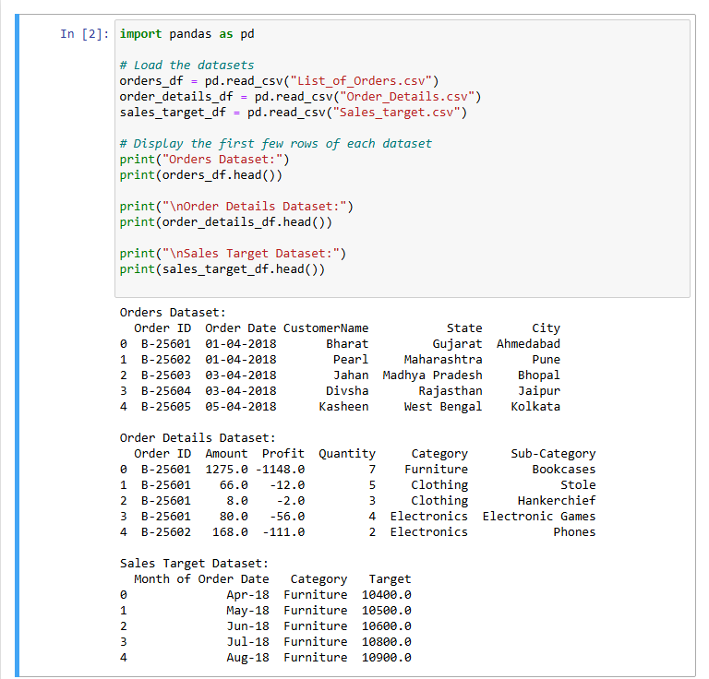

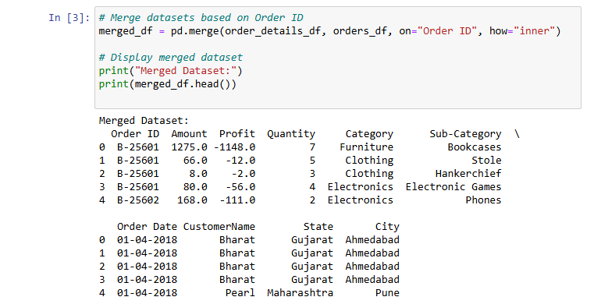**Step 2: Merge Orders and Order Details Datasets**

**Step 3: Sales and Profitability Analysis**

1. 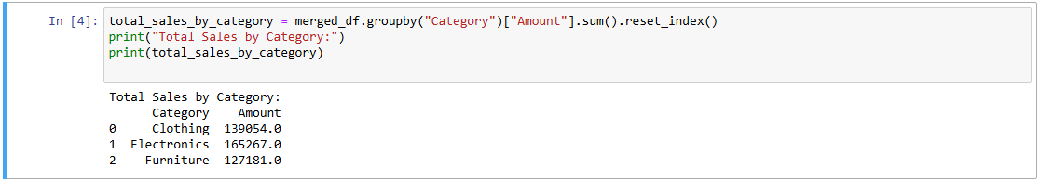**Calculate total sales per category**

**Total Sales by Category:**

* **Clothing: ₹139,054**
* **Electronics: ₹165,267**
* **Furniture: ₹127,181**

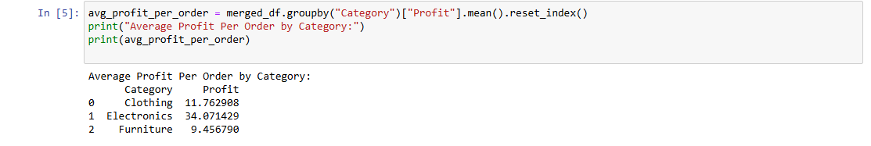**2. Calculate average profit per order**

**Average Profit per Order:**

* **Clothing: ₹11.76**
* **Electronics: ₹34.07**
* **Furniture: ₹9.46**

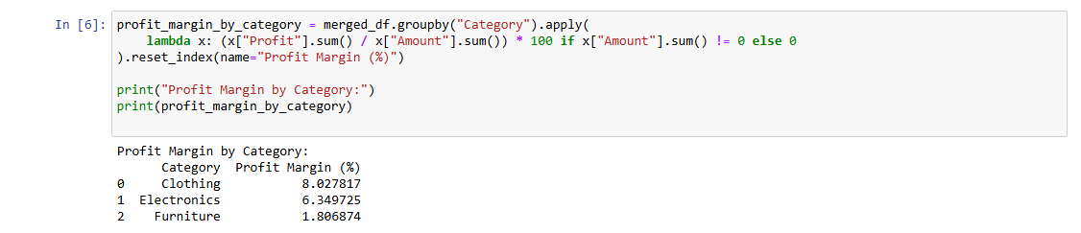**3. Calculate total profit margin (Profit as a % of Amount)**

**Total Profit Margin (Profit as % of Sales):**

* **Clothing: 8.03% (Highest)**
* **Electronics: 6.35%**
* **Furniture: 1.81% (Lowest)**

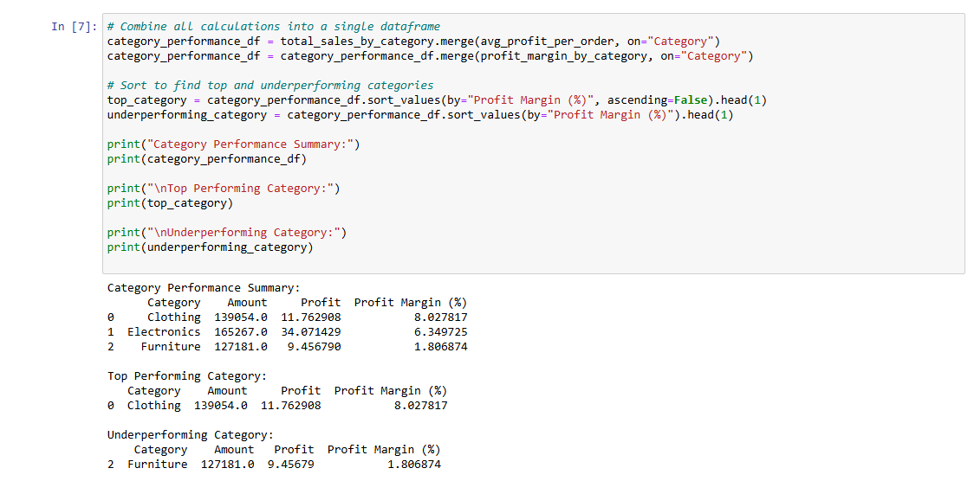**4. Identify top-performing and underperforming categories**

**Top-Performing Category**

* **Clothing** is the best-performing category, with the highest profit margin (**8.03%**).
* Possible reasons:
  + High demand and consistent sales.
  + Better profit margins due to pricing strategies.

**Underperforming Category**

* **Furniture** is the lowest-performing category, with a profit margin of just **1.81%**.
* Possible reasons:
  + High cost of production or logistics.
  + Heavy discounts or lower sales volume.

***VISUALIZATION***

**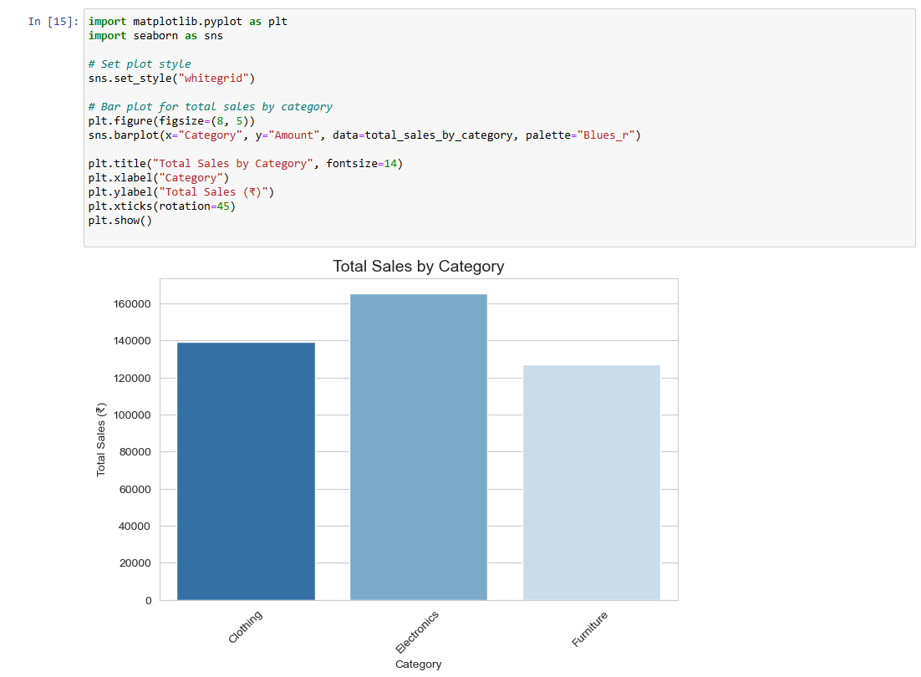*Total Sales by Category:***

***Profit Margin Distribution by Category:***

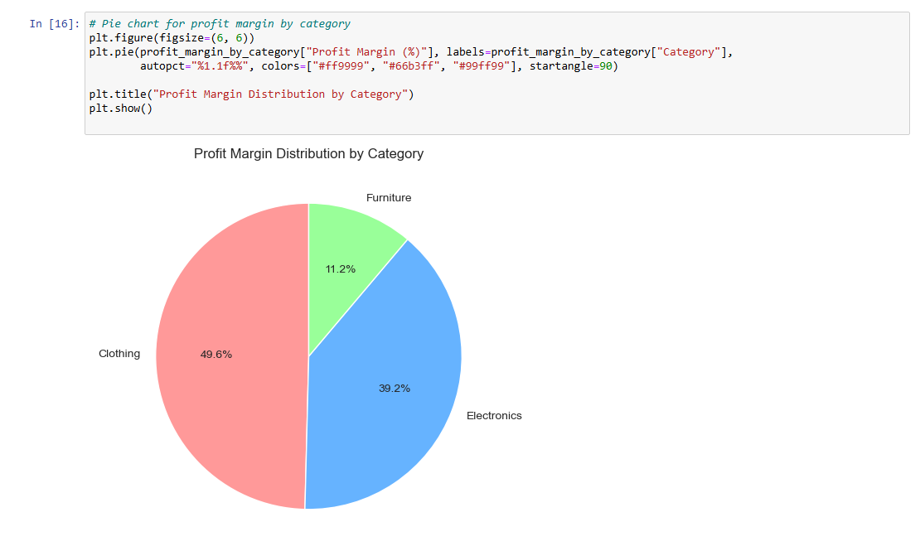

**Part 2: Target Achievement Analysis**

**Step 1: Percentage change in target sales for the Furniture category month-over-month**

**1. Convert Month to Date Format**

**2. Filter for Furniture Category**

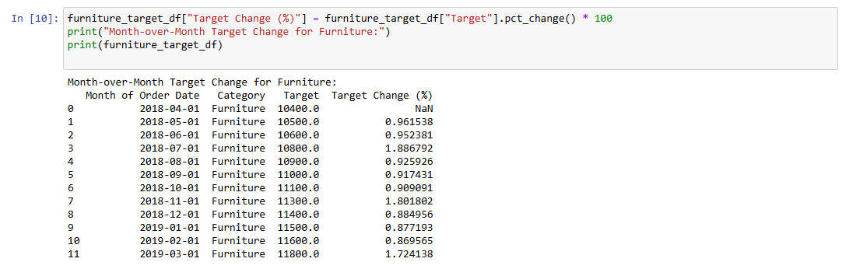**3. Calculate Month-over-Month % Change**

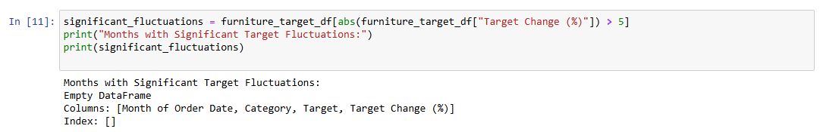**Step 2: Identify Significant Fluctuations**

• **Month-over-Month Target Change (%):**

* The target sales for Furniture increased gradually, with small percentage increases ranging from **0.87% to 1.88%**.
* No significant fluctuations (above ±5%) were observed in the dataset.

• **Insights:**

* The sales target was **incremented in a steady manner**, indicating **predictable demand trends**.
* No major spikes or drops suggest that **sales forecasting was stable**.

• **Strategy Recommendations:**

* To further align targets with actual performance:
  + **Analyze seasonal demand trends** to set dynamic targets.
  + **Introduce promotions during slow months** to boost actual sales.
  + **Review pricing strategies** to improve profit margins.

***VISUALIZATION***

***Month-over-month Target Change for Furniture:***

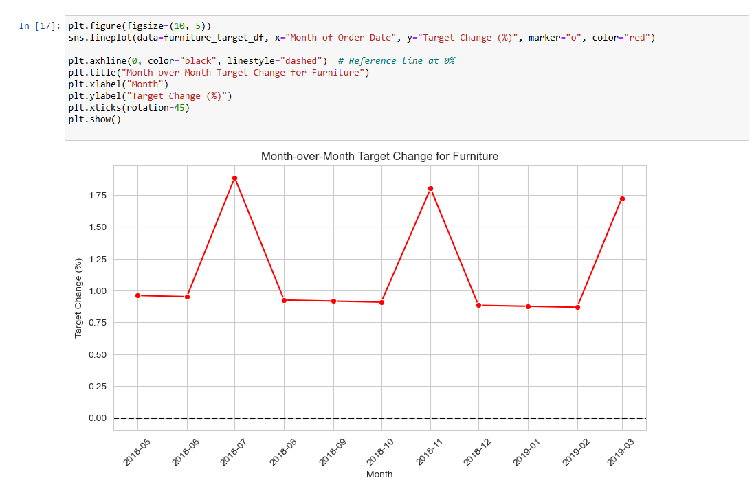

**Part 3: Regional Performance Insights**

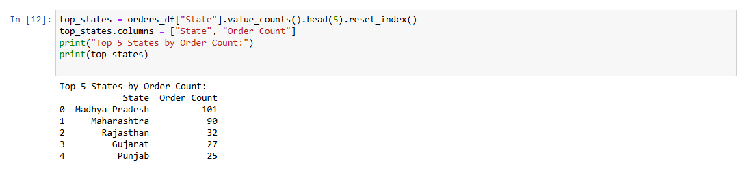**1. Find Top 5 States with Highest Orders**

**Top 5 States by Order Count:**

* **Madhya Pradesh: 101 orders, ₹105,140 total sales, ₹16.33 avg profit**
* **Maharashtra: 90 orders, ₹95,348 total sales, ₹21.30 avg profit**
* **Rajasthan: 32 orders, ₹21,149 total sales, ₹16.99 avg profit**
* **Gujarat: 27 orders, ₹21,058 total sales, ₹5.34 avg profit**
* **Punjab: 25 orders, ₹16,786 total sales, -₹10.15 avg profit (Loss)**

***VISUALIZATION***

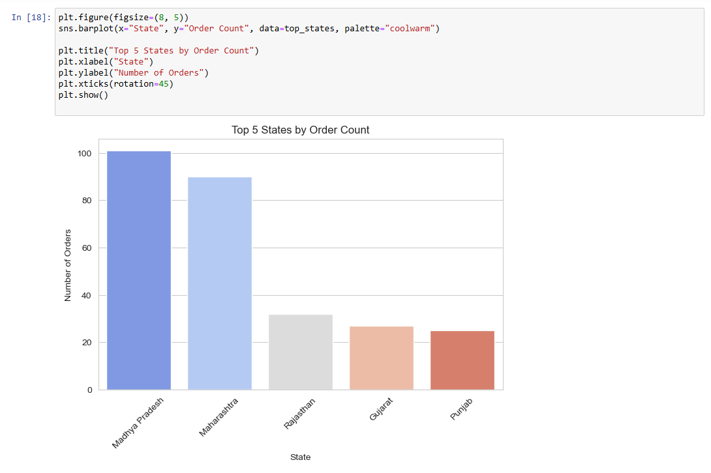***Top 5 States by Order Count:***

**2. Calculate Total Sales and Average Profit per State**

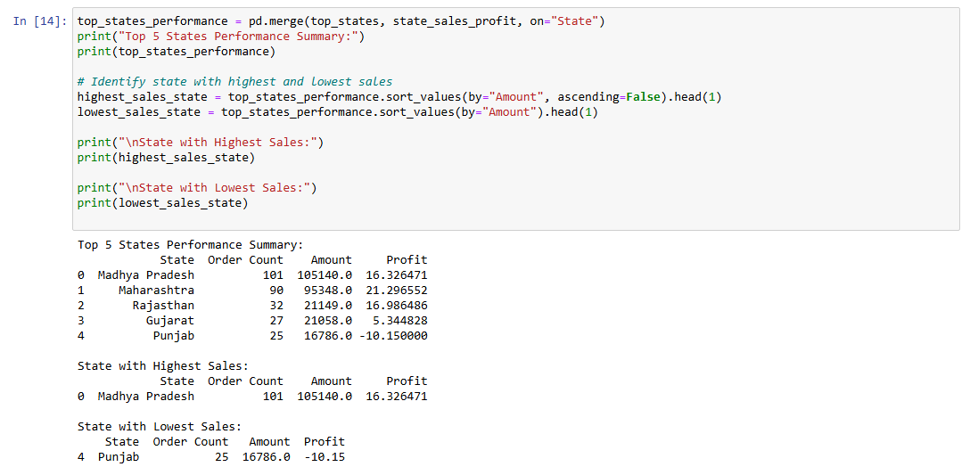**3. Merge Data and Find Disparities**

**State with Highest Sales:**

* **Madhya Pradesh had the highest sales of ₹105,140 with 101 orders.**

**State with Lowest Sales:**

* **Punjab had the lowest sales of ₹16,786 and an average profit of -₹10.15, indicating losses.**

**Regional Disparities & Recommendations:**

* **Punjab is underperforming** with negative profitability. Possible reasons:
  + High costs or low sales volume.
  + Product mismatch with market demand.
  + Higher return rates or discounts.

**Actionable Steps:**

* **Focus on Maharashtra and Madhya Pradesh** (high order count and profitability).
* **Improve marketing & pricing strategies in Punjab** to recover losses.
* **Expand high-performing product categories in top states** to maximize profitability.

***VISUALIZATION***

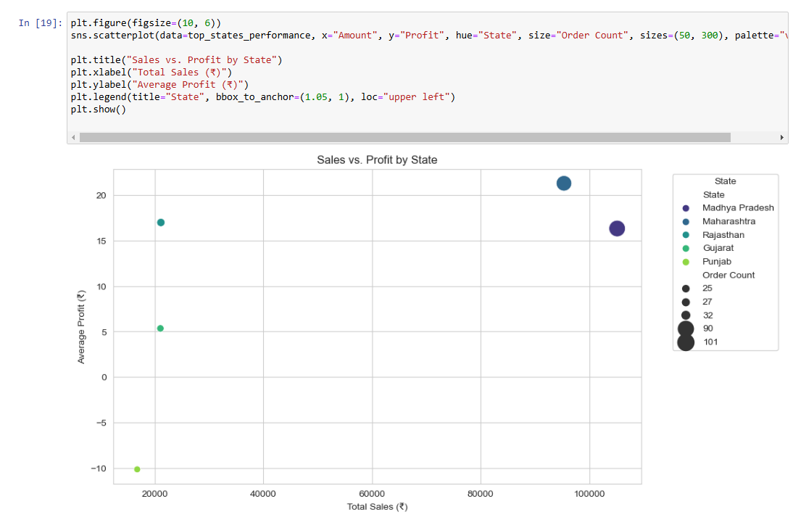***Sales vs Profit by State:***

**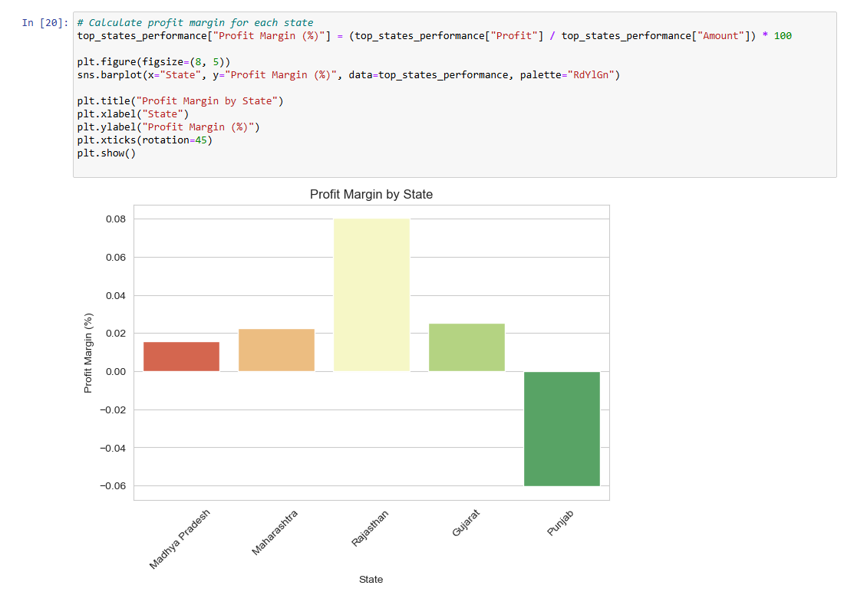*Profit Margin by State:***

***Regional Disparities in Sales & Profitability (City-Level Analysis):***

***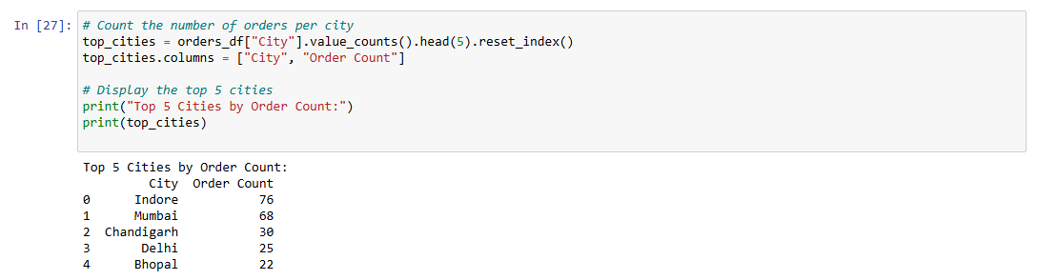*Identify the Top 5 Cities with the Highest Order Count:**

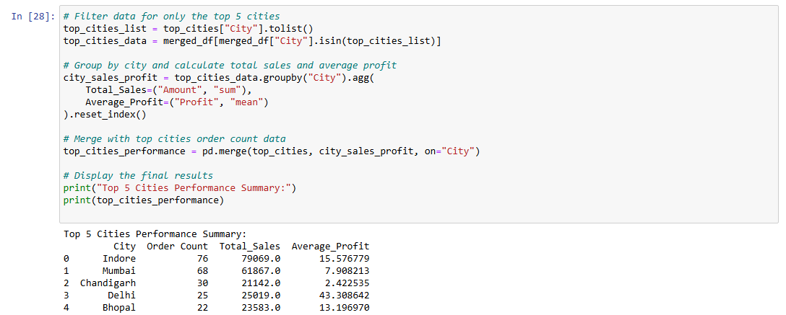**Merge with Order Details & Compute Sales & Profitability:**

***VISUALIZATION***

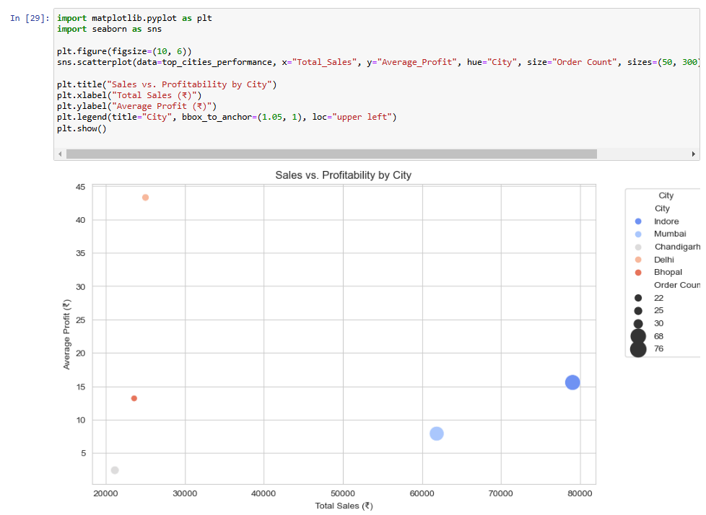**Sales vs. Profitability by City (Scatter Plot)**

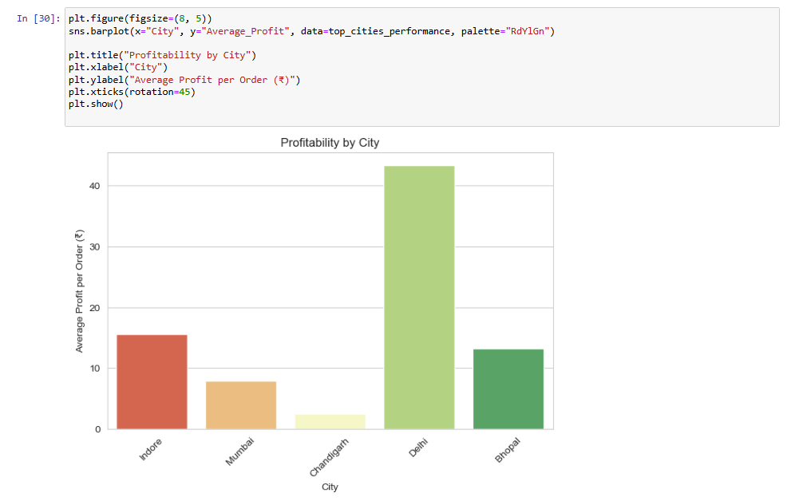**Profit Margin by City (Bar Chart)**

### ***Action Plan:***

* ***Focus on Chandigarh: Reduce discounts, improve product mix.***
* ***Optimize Mumbai & Bhopal: Increase average profit per order.***
* ***Maintain Delhi & Indore: Keep strategies consistent.***
* ***Future Expansion: Look at secondary cities with potential growth*.**

**QUESTION 2**

***Five Strengths of the Jar App:***

1. ***Automated Micro-Savings: Jar turns spare change into digital gold by automatically rounding up consumers' online transactions to the closest ten. Consistent savings are encouraged by this smooth process, which doesn't require user participation.***
2. ***User-Friendly layout: Even people with little financial literacy can use the app thanks to its safe and easy-to-use layout. Its features' simplicity and ease of use have been commended by users.***
3. ***Gamified Experience: Jar uses gamification components to make saving fun. Users can 'spin a jar' to get incentives after every investment, for example, which increases user engagement and offers positive reinforcement.***
4. ***Real-Time Gold Price Updates: By giving users access to the most recent gold prices, the app enables users to make well-informed investing decisions. This openness helps users track the value of their savings and fosters trust.***
5. ***Flexible Investment Options: Jar encourages inclusivity by letting users choose daily savings goals based on their financial comfort levels. Furthermore, consumers can sell or withdraw their gold assets whenever they choose because there is no lock-in period.***

***Five Things That Could Be Better:***

1. ***Charges and Withdrawal Process: A number of users have complained about disparities between the prices at which gold is bought and sold, which has resulted in unforeseen losses when making withdrawals. These worries might be allayed by improving transaction charge transparency and guaranteeing competitive pricing.***
2. ***Customer service responsiveness: According to user feedback, it might be difficult for consumers to get in touch with customer service, particularly when they have problems with withdrawals and account management. User satisfaction would increase if the support system was strengthened and prompt responses were guaranteed.***
3. ***Efficiency of the KYC Process: Some customers have had trouble finishing the Know Your Customer (KYC) process, which has prevented them from taking advantage of all the capabilities offered by the app. The onboarding experience might be improved by streamlining this procedure and offering precise instructions.***
4. ***Options for Deleting Accounts: Many customers have complained that it is difficult to remove their accounts. Addressing privacy concerns and meeting user expectations for control over their personal data would be achieved by implementing a simple feature that allows users to delete their accounts.***
5. ***Pricing and Fee Transparency: Customers have complained about unstated costs that reduce their savings and erode their trust. More transparency and trust would be promoted by giving users a comprehensive explanation of all relevant fees and making sure they are informed before completing transactions.***

**QUESTION 3**

***Opportunity:***

***Merchant Payments and UPI Cashback Rewards.***

***Introduce a UPI-based payment mechanism within the app, allowing users to conduct direct transactions.***

***Offer cashback benefits in the form of digital gold for purchases made from linked merchants.***

***How Jar Can Leverage Its Strengths:***

1. ***Automate cashback rewards for consumers in real-time, with no effort.***
2. ***Prioritize user experience by ensuring speedy, secure, and integrated transactions within the app.***
3. ***Build trust by partnering with brands and offering valuable benefits.***

***Micro-Loans and Credit Building Services.***

***Provide consumers with small-ticket, short-term loans depending on their savings history and spending habits.***

***Introduce a credit-building program in which consumers can gradually improve their credit scores by making responsible payments on tiny, automatic credit installments.***

***How Jar Can Leverage Its Strengths:***

1. ***Automate loan repayment from users' savings balances.***
2. ***User Experience: Offer paperless loan applications with rapid approvals.***
3. ***Ensure loan terms are straightforward with no hidden cost or predatory interest rate.***