Course: CS213 Object Oriented Programming (2026/2027 First Semester)
Faculty: Faculty of Computers and Artificial Intelligence, Cairo University
Instructor: Dr. Mohammad El-Ramly

Assignment 2 part 1

Team Member Name Student ID Section Email

Andrew Fawzy Mina 20250092 S19,S20 20250092@stud.fci-cu.edu.eg

Samy Atef Masoud 20250277 S29,S30 20250277@stud.fci-cu.edu.eg

Aly Sameh Mohamed 20250398 S19,S20 20250398@stud.fci-cu.edu.eg

Omar Ashraf Mostafa Helal 20250422 S29,S30 20250422@stud.fci-cu.edu.eg

Work breakdown
Andrew Fawzy Mina
Video , PDF , 3rd Design
Samy Atef Masoud
Program 2, 1st AI Design
Ali Sameh Mohamed
Final and Initial Designs
Omar Ashraf Mostafa Helal
Program 1 , 2nd design
introduction
The Vole Machine is an educational, simplified virtual computer designed to help students understand foundational computer architecture and low-level execution mechanics. Rather than utilizing complex modern hardware architectures, the Vole machine abstracts computer components into a streamlined model consisting of:
- 16 General-Purpose Registers for fast data manipulation.
- 256 Bytes of Main Memory for storing instructions and data.
- A Central Processing Unit (CPU) responsible for the fetch-decode-execute cycle, handling arithmetic operations, and managing program flow.
By sequentially processing short instruction sets—loading values, performing arithmetic, and committing results—the simulator provides a transparent environment for learning object-oriented software design principles alongside computer organization fundamentals.

Initial Design
This PlantUML diagrams show how the code is organized into different parts and how the system design improves step by step. The design connects a user menu (SimulatorUI) to the main computer (VoleMachine), which uses memory, registers, and specific instruction classes to run programs easily.

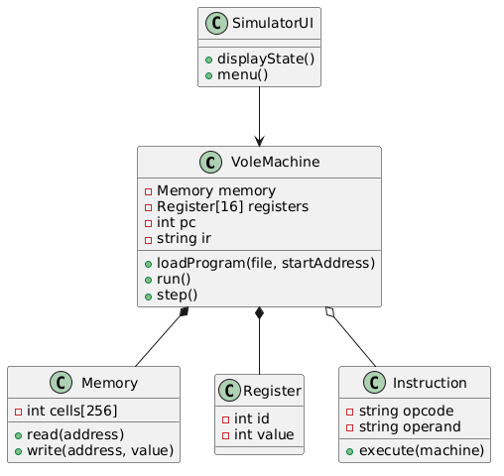

Classes and their responsibilities :
-SimulatorUI:
Acts as the user-facing layer, connecting user menu choices to the main computer and presenting the current status/state of the simulator.
-VoleMachine
Serves as the core central processing unit (CPU) model. It manages main memory, the 16 general-purpose registers, tracks execution flow via the program counter and instruction register, and handles loading and executing programs.
-Memory
Represents the 256 bytes of main memory used for storing instructions and data, providing access control to read from or write to specific memory addresses.
-Register
Represents individual general-purpose registers used for fast data manipulation within the machine.
-Instruction
Represents the instruction set components, parsing the opcode and operand to perform specific machine operations when executed.

1st AI Design
Conversation link: https://copilot.microsoft.com/shares/XScXNMF9b33s2SvRheksT
Key Improvements:
- Introduced an InstructionDecoder component to decouple parsing logic from the execution flow.
- Grouped registers into a dedicated RegisterFile class to encapsulate register management.
- Added validation methods and state-dump utilities for enhanced debugging.
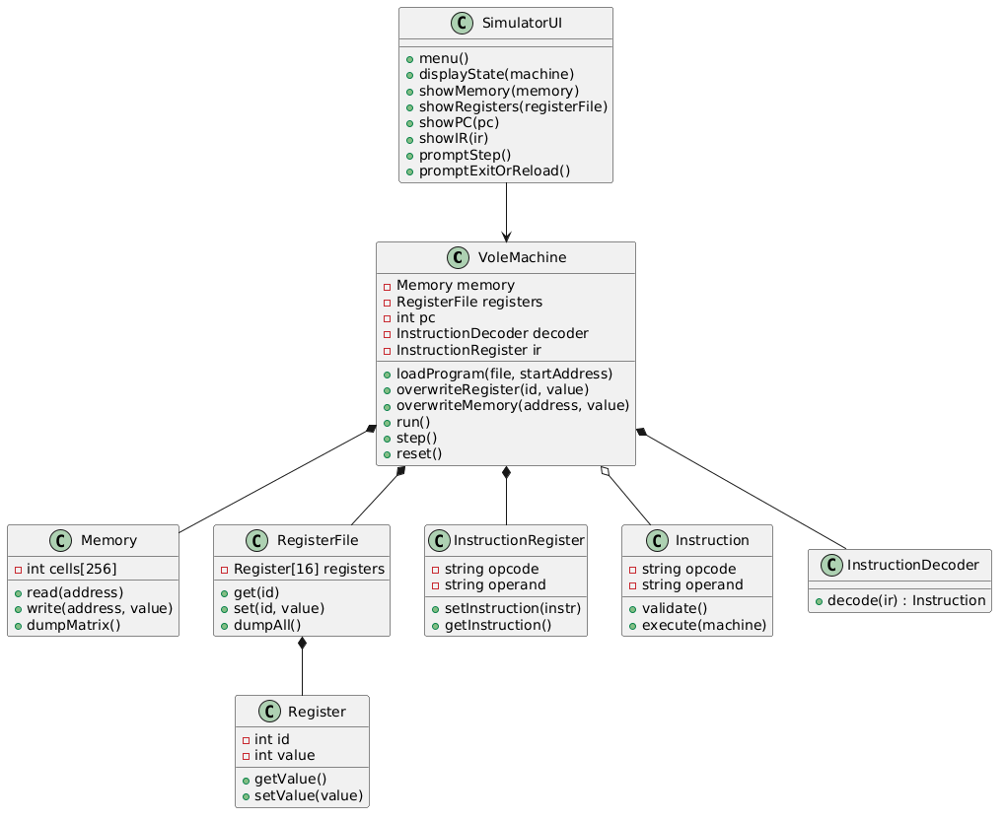

2nd AI Design
Conversation link: https://share.gemini.google/IViSnYbCynPZ
Key Improvements:
- Integrated an ALU (Arithmetic Logic Unit) class to explicitly separate computational logic (two's complement addition, floating-point math, and bitwise operations) from control flow.
- Standardized data types (utilizing fixed-width integer types such as uint8_t).
- Made Instruction an abstract base class to support specialized operation sub-typing.

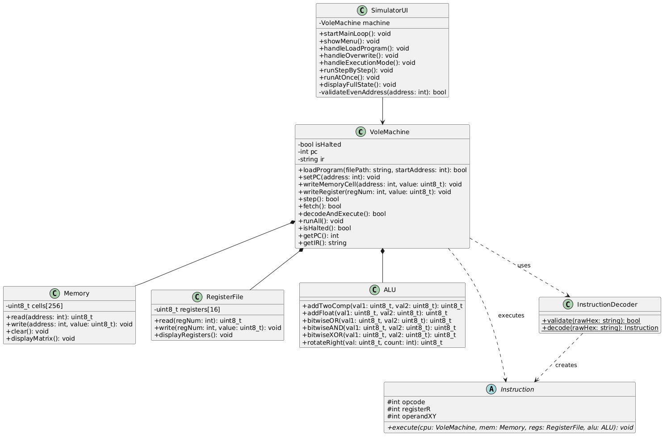

3rd AI Design
Conversation link: https://chatgpt.com/share/6add0fbb-82a8-83ea-b15f-b3cd9cb02250
Key Improvements:
- Separated file parsing concerns into a dedicated ProgramLoader class to follow the Single Responsibility Principle (SRP).
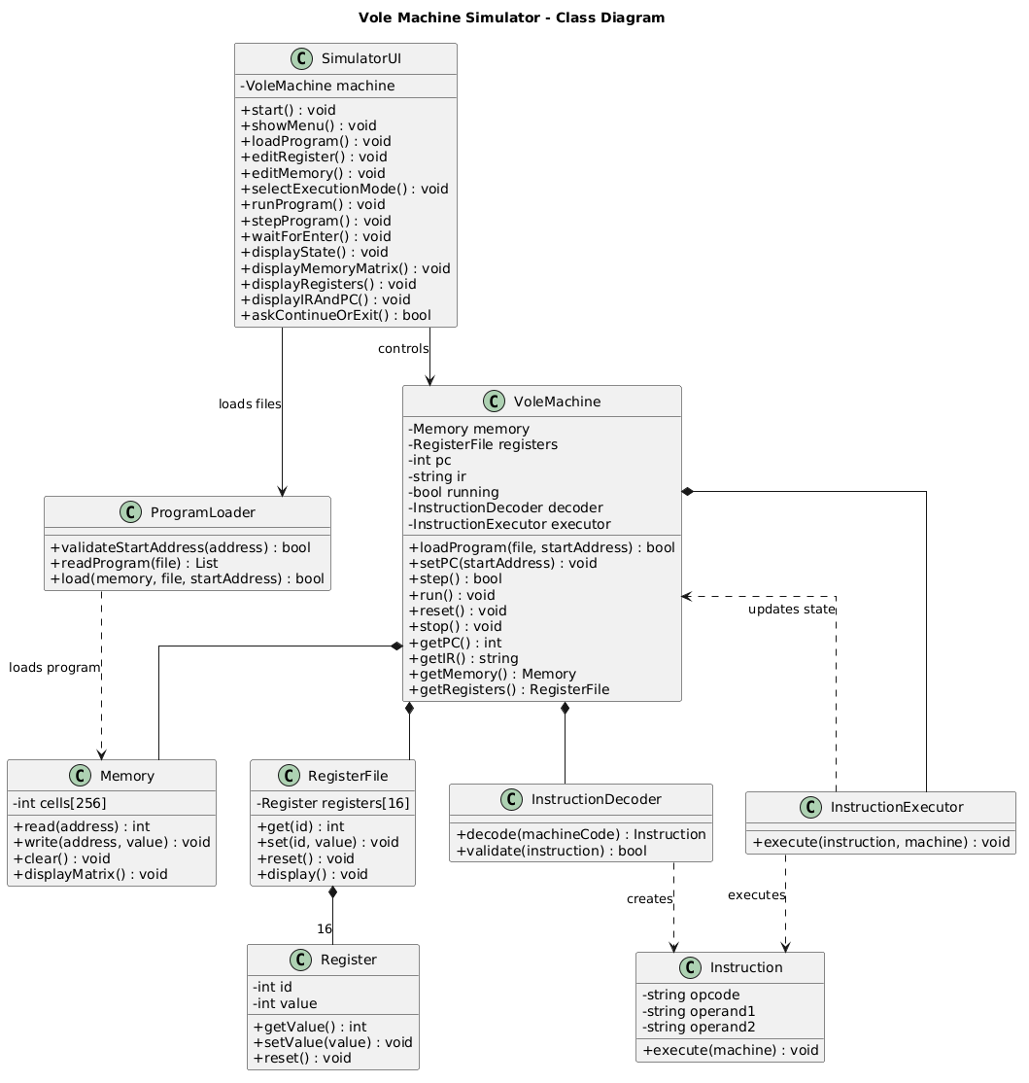
- Added an InstructionExecutor component to delegate execution paths cleanly away from the central machine state.

Final Design
Conversation link: https://claude.ai/share/2f7a249d-f69d-4177-bc1f-6f50c31e9bdd
Key Improvements:
- Consolidated and streamlined the architecture for optimal maintainability and clean C++ implementation.
- Implemented robust polymorphic instruction subclasses (LoadInstruction, StoreInstruction, MoveInstruction, ArithmeticLogicInstruction, JumpInstruction, and HaltInstruction) extending an abstract Instruction base class.
- Integrated screen/output handling directly into the system state and refined parser/execution notes for edge cases (e.g., memory bounds and text formatting).
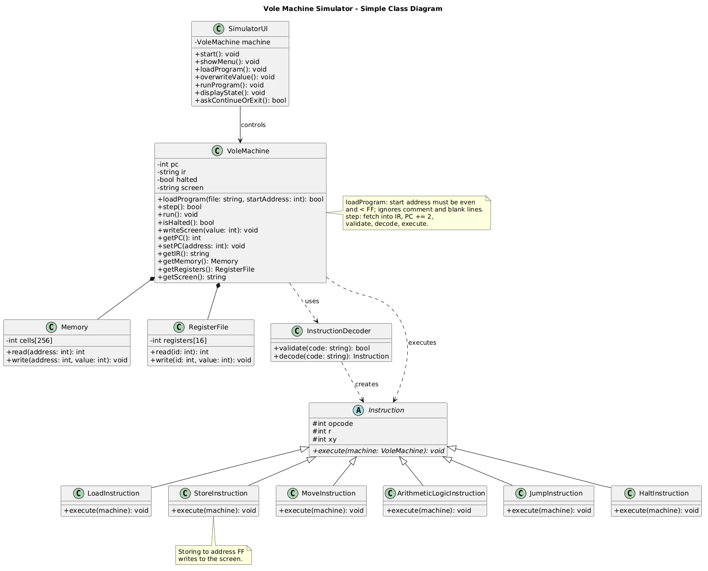

Examples

; Program 1: Addition and Bitwise AND
; This program adds three numbers and applies a Bitwise AND mask.
210A
220B
230C
5412
5543
260F
8756
37FF
C000

; Program 2: Countdown Loop
; This program runs a loop that counts down until it reaches zero.
2000
2103
22FF
31FF
5112
B10E
B006
C000

Video link: https://drive.google.com/file/d/1ponEPLA66F3uJvZX4LV4KhWAh7IExR6_/view?usp=drive_link

