Course: CS213 Object Oriented Programming (2026/2027 First Semester)
Faculty: Faculty of Computers and Artificial Intelligence, Cairo University
Instructor: Dr. Mohammad El-Ramly
Assignment 2 part 1

Team Member Name Student ID Section

Andrew Fawzy Mina 20250092 S19,S20

Samy Atef Masoud 20250277 S29,S30

Aly Sameh Mohamed 20250398 S19,S20

Omar Ashraf Mostafa Helal 20250422 S29,S30

introduction
The Vole machine is a tiny, fake computer built to help students learn how real computers work. Instead of using complex modern chips, it uses a very simple setup with 16 storage spots (called registers), a small 256-character memory, and a basic brain (the CPU) to process math and instructions. It reads short instructions one by one to load numbers, do simple math, and save the results, making it easy to understand the basics of computer hardware and code.

Initial Design
This PlantUML diagram shows a MenuUI that lets users interact with and view a central VoleMachine. This main machine uses a ControlUnit and ALU to process operations while connecting to a Memory component with 256 storage cells.
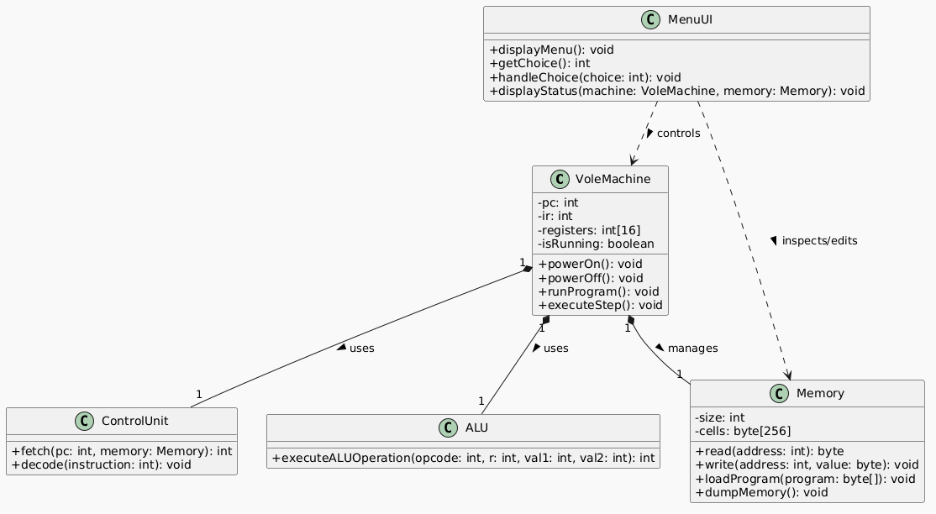

1st AI Design
Conversation link: https://drive.google.com/file/d/1fJvlOzKaA3p7wLEhCzCmlkP2eTH3rMYy/view?usp=drive_link
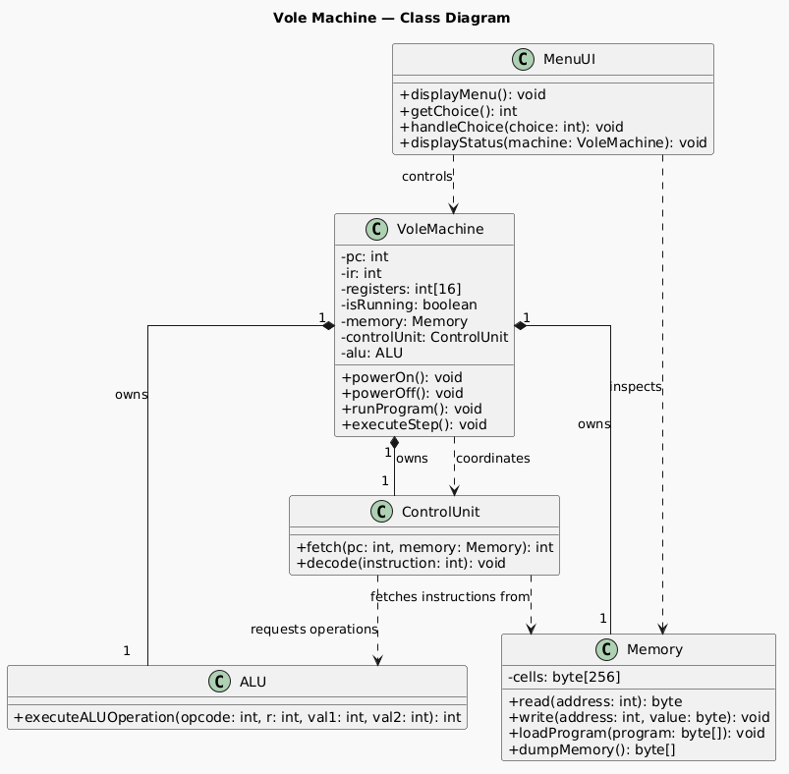

2nd AI Design
Conversation link: https://drive.google.com/file/d/1L8ytRwzzfvLufogxTpsIr9vsBzfca3Zd/view?usp=drive_link
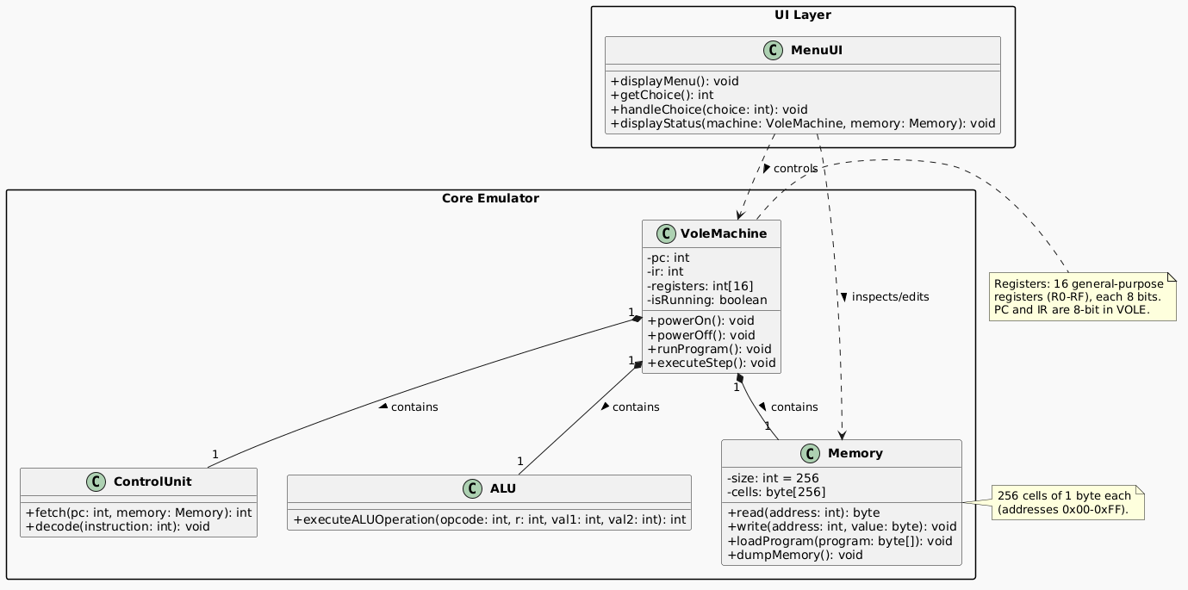

3rd AI Design
Conversation link: https://chatgpt.com/s/t_6ae0b6cd1f848191991457b722b464b5
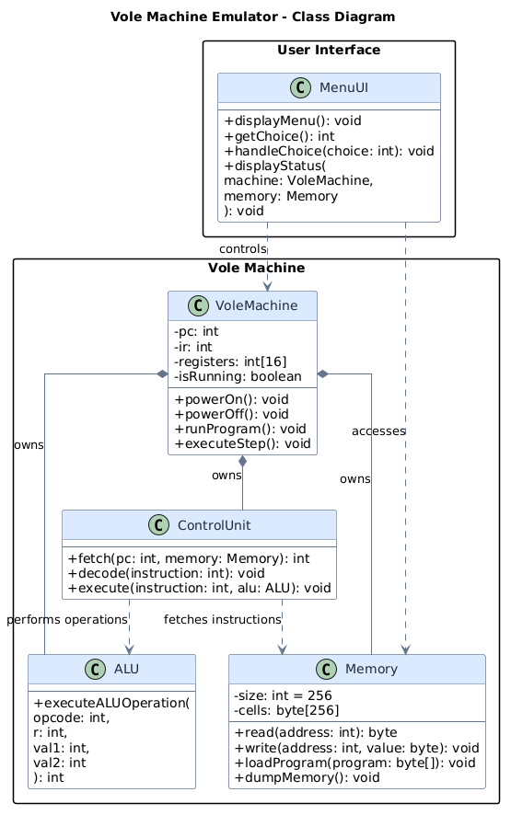

Final Design
Conversation link:
https://claude.ai/share/da600cc2-dbe6-4942-b122-4dba8e736a80
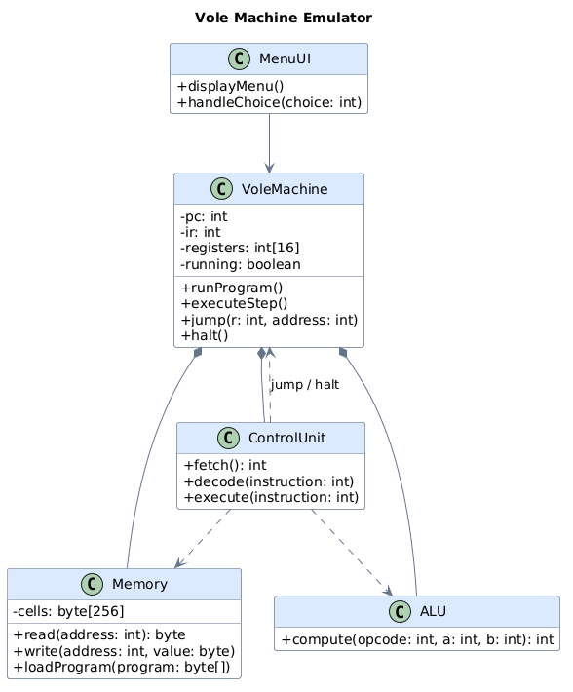

Examples

Video link:

