* Bootstrap:

Bootstrap is a widely-used open-source front-end framework for web development, providing a collection of HTML, CSS, and JavaScript components and tools that enable developers to build responsive, mobile-first websites with ease.

**What is Bootstrap?**

Bootstrap is a free and open-source tool collection for creating responsive websites and web applications. It is the most popular [HTML](https://www.geeksforgeeks.org/html/), [CSS](https://www.geeksforgeeks.org/css/), and [JavaScript](https://www.geeksforgeeks.org/javascript/) framework for developing responsive, mobile-first websites. Nowadays, the websites are perfect for all browsers (IE, Firefox, and Chrome) and for all sizes of screens (Desktop, Tablets, Phablets, and Phones)

**Why we use Bootstrap?**

By using this framework we can easily manipulate the styling of any web page, like font style, text color, background color, flex, grid system, etc. Bootstrap [Vesrion 4](https://www.geeksforgeeks.org/bootstrap-4-introduction/) & [Vesrion 5](https://www.geeksforgeeks.org/bootstrap-5-introduction/) are the most popular versions. There are lots of other CSS frameworks like [Tailwind CSS](https://www.geeksforgeeks.org/tailwind-css/), [Bulma](https://www.geeksforgeeks.org/bulma/), and [Foundation](https://www.geeksforgeeks.org/foundation/) but among them, this framework is the most popular because of below mentioned features:

* It is Faster and Easier way for Web-Development.
* It creates Platform-independent web-pages.
* It creates Responsive Web-pages.
* It designs responsive web pages for mobile devices too.
* It is a free and open-source framework available on www.getbootstrap.com

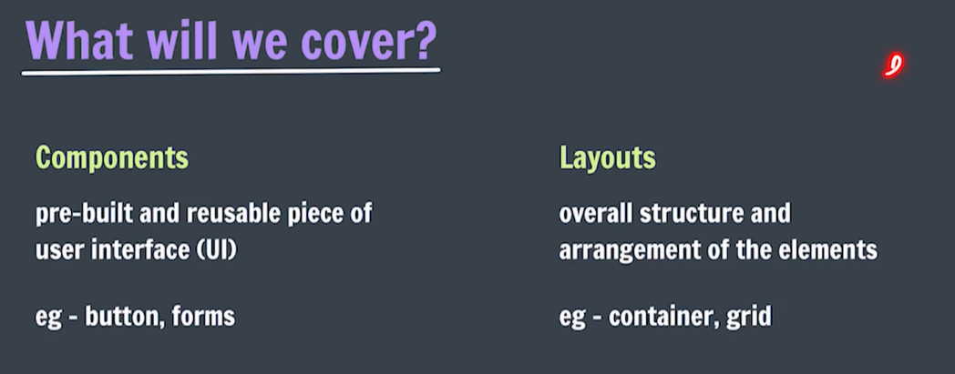

Containers

You learned from the previous chapter that Bootstrap requires a containing element to wrap site contents.

Containers are used to pad the content inside of them, and there are two container classes available:

1. The .container class provides a responsive **fixed width container**
2. The .container-fluid class provides a **full width container**, spanning the entire width of the viewport

<div class="container">  
  <h1>My First Bootstrap Page</h1>  
  <p>This is some text.</p>  
</div>

## Container Padding

By default, containers have 15px left and right padding, with no top or bottom padding. Therefore, we often use **spacing utilities**, such as extra padding and margins to make them look even better. For example, .pt-3 means "add a top padding of 16px":

### **Example**

<div class="container pt-3"></div>

## Container Border and Color

<div class="container p-3 my-3 border"></div>  
  
<div class="container p-3 my-3 bg-dark text-white"></div>  
  
<div class="container p-3 my-3 bg-primary text-white"></div>

## Components:

# Buttons:

**Syntax:**

<button class="badge bg-type"> Button Text <button>

**Types:** Following are the nine types of buttons available in Bootstrap 5:

* btn-primary
* btn-secondary
* btn-success
* btn-danger
* btn-warning
* btn-info
* btn-light
* btn-dark
* btn-link

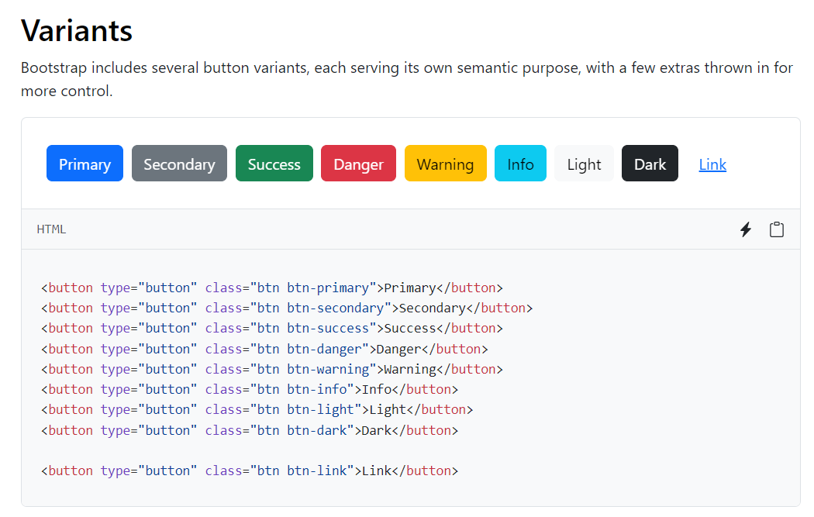

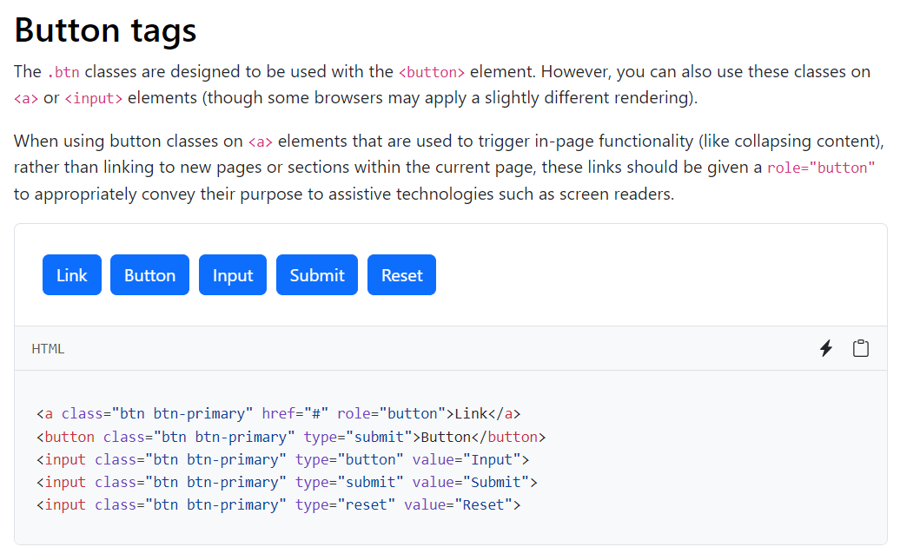

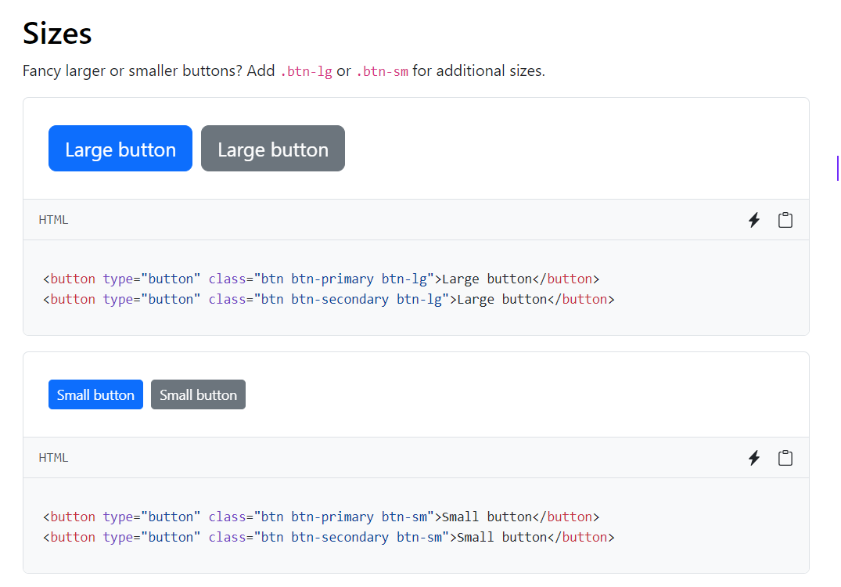

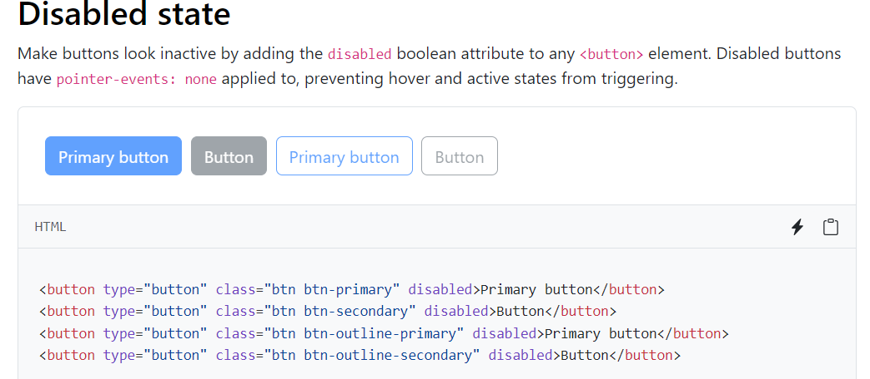

# Badges:

Documentation and examples for badges, our small count and labeling component.

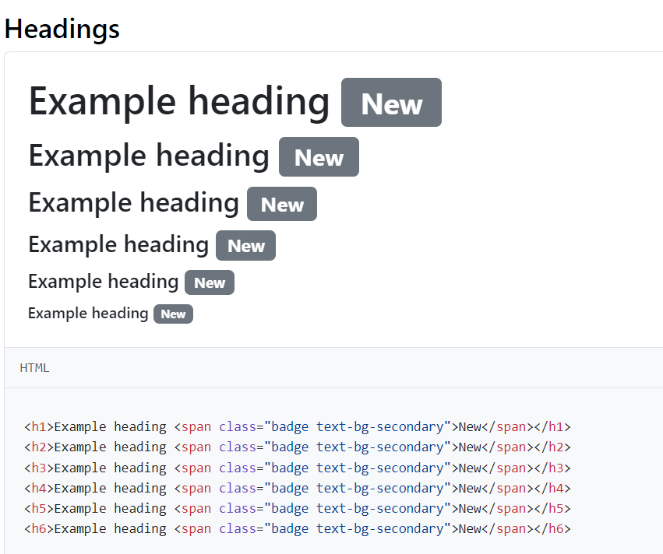

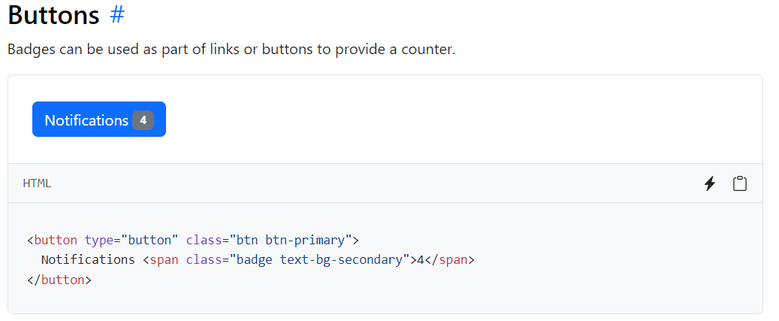

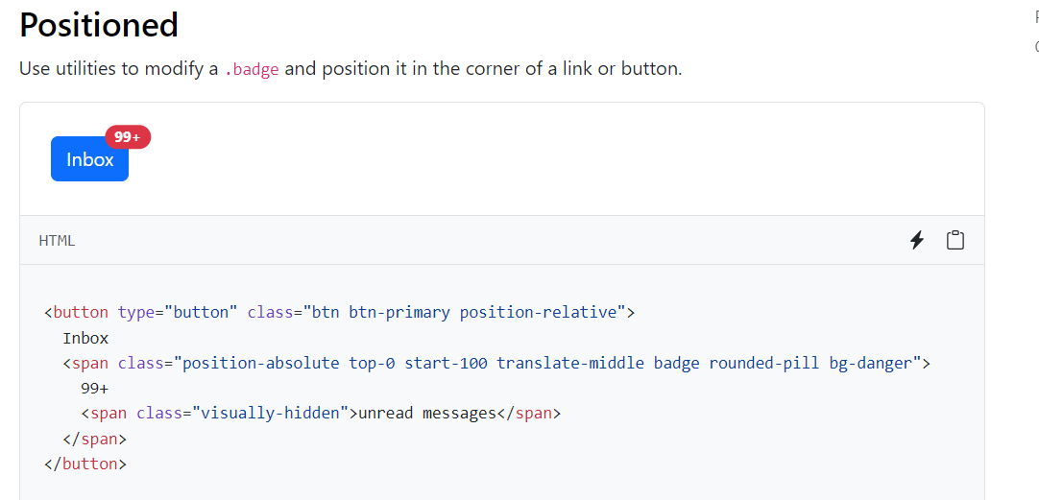

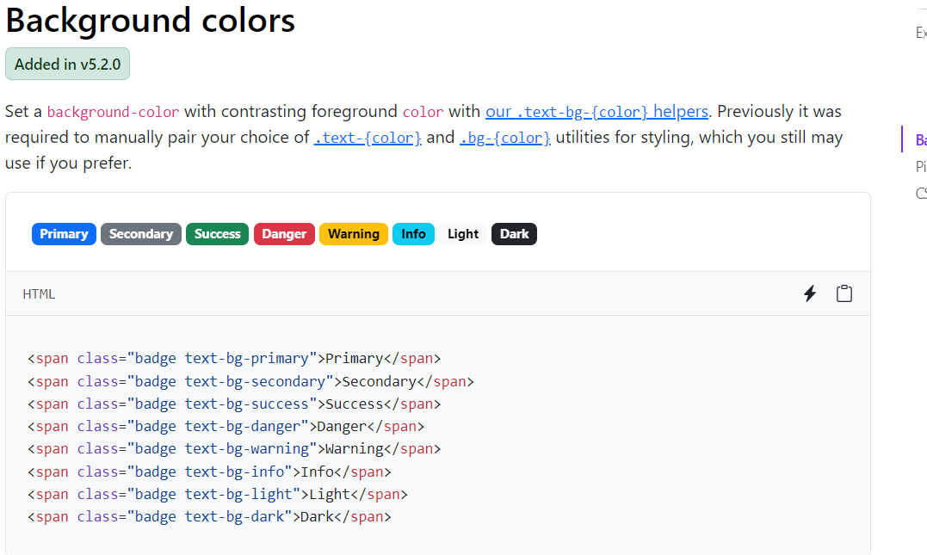

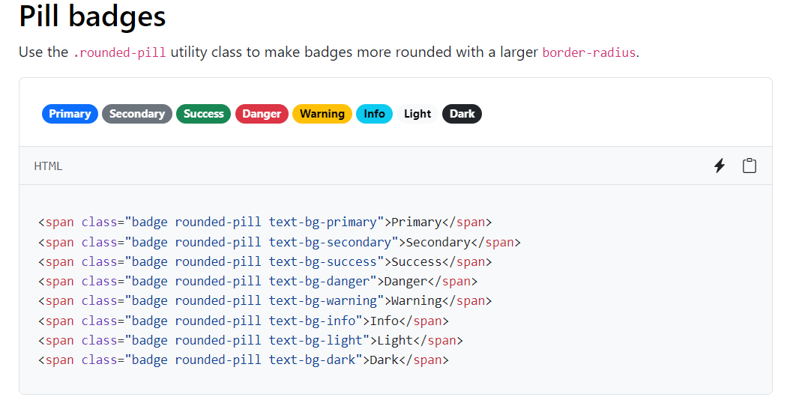

# Alerts:

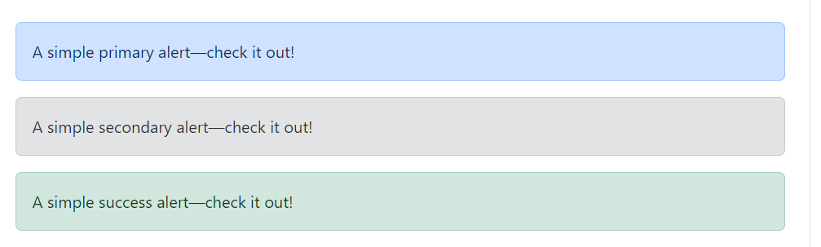

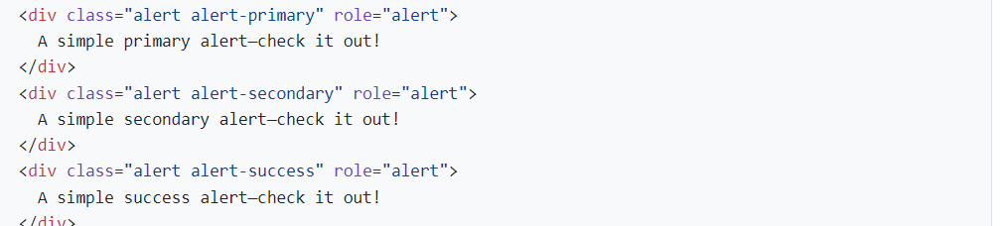

<https://getbootstrap.com/docs/5.3/components/alerts/>

# button group:

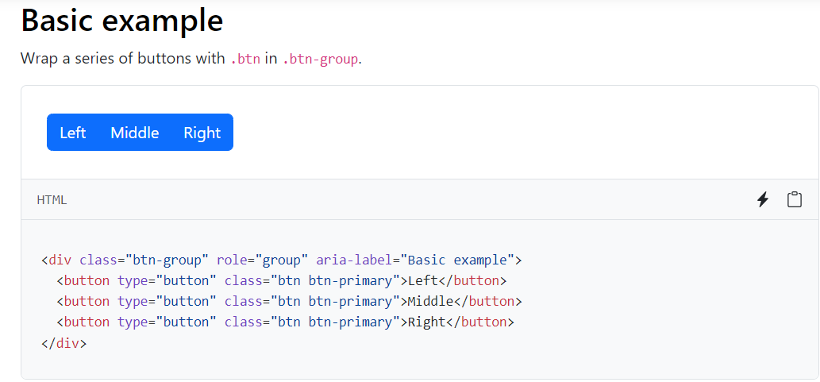

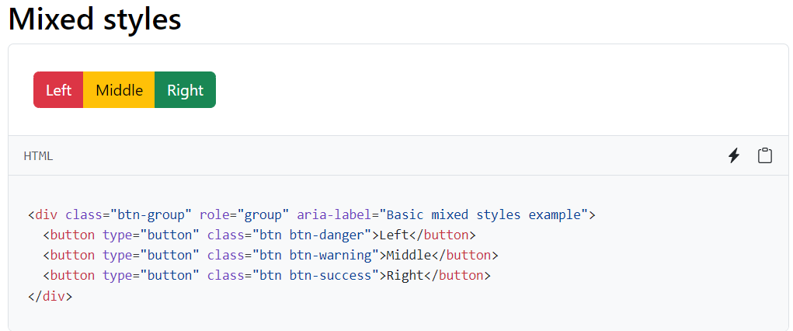

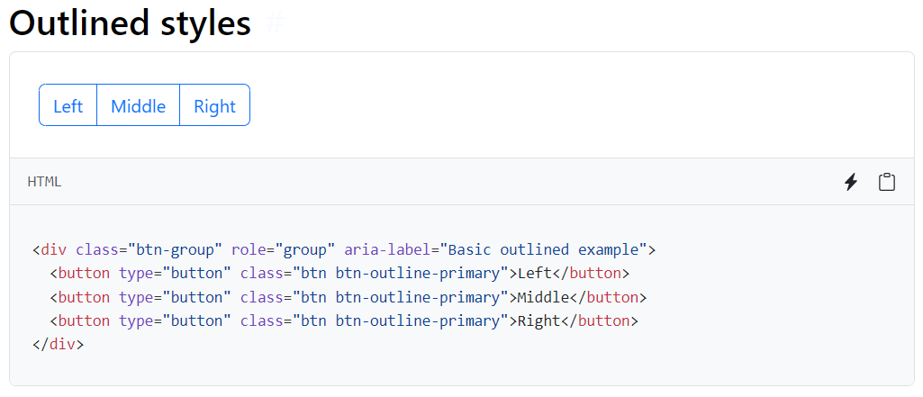

# navbar:

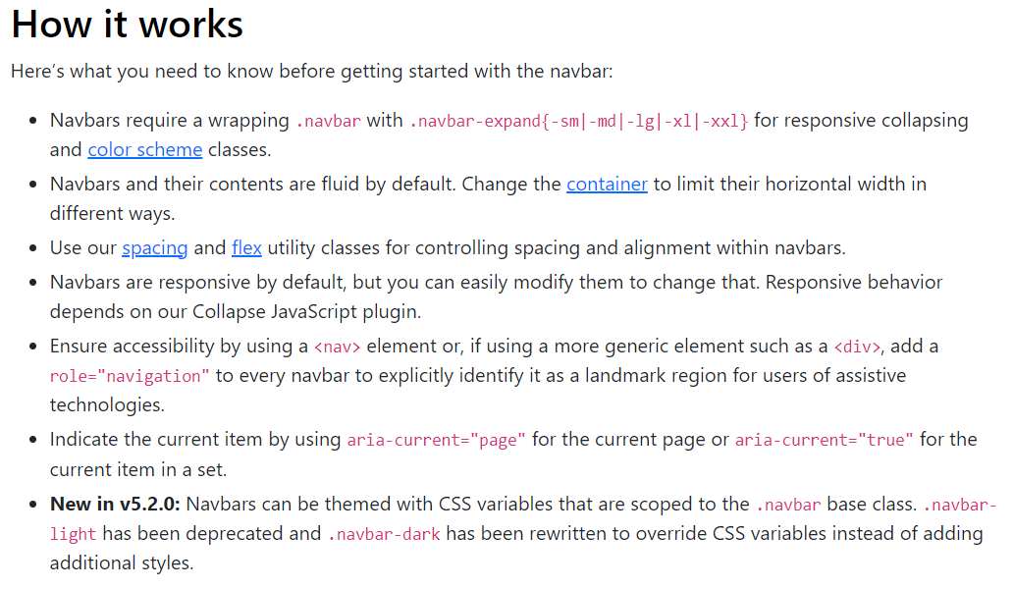

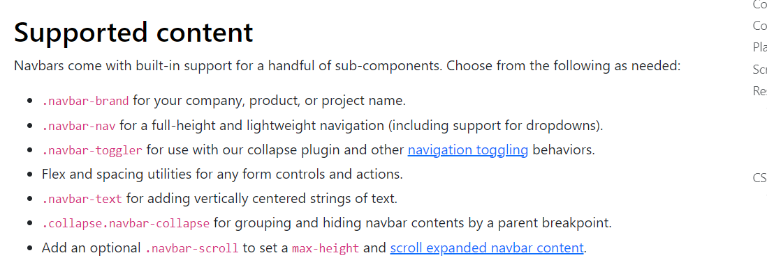

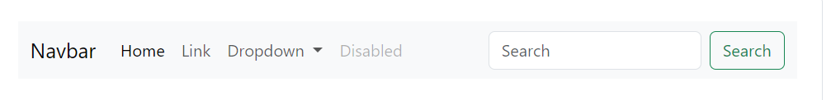

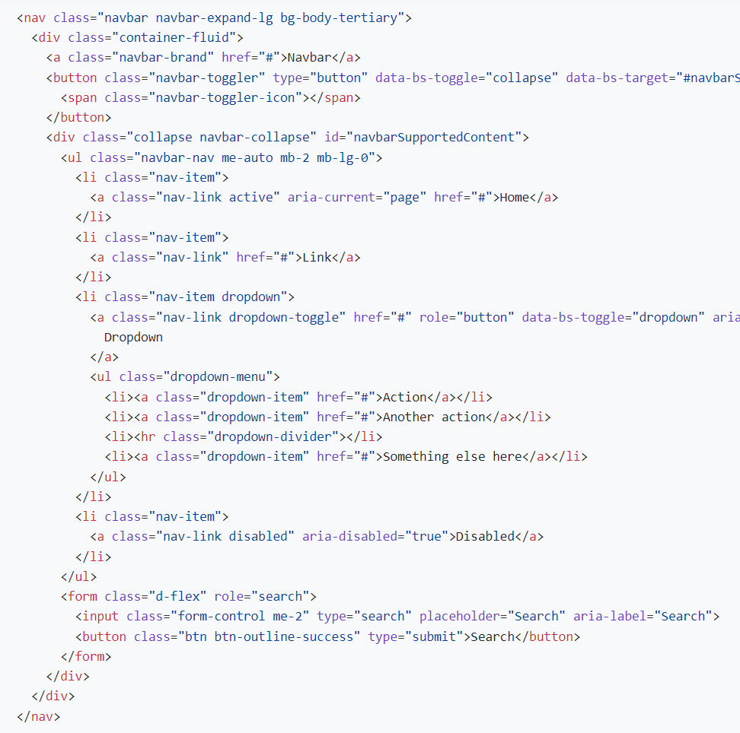

# cards:

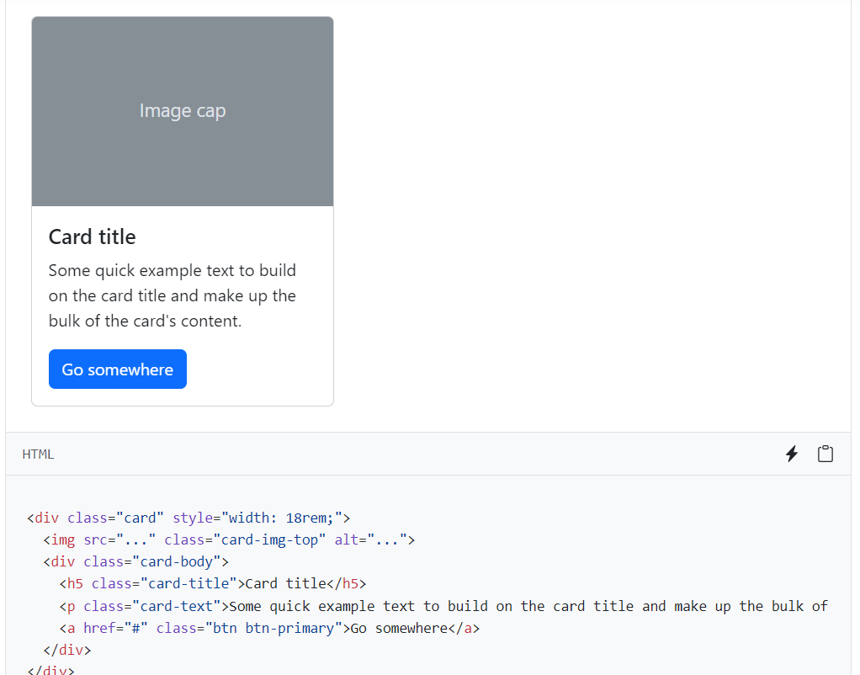

# grid system in css:

Use our powerful mobile-first flexbox grid to build layouts of all shapes and sizes thanks to a twelve column system, six default responsive tiers, Sass variables and mixins, and dozens of predefined classes.

Note:visit documentation.

# Forms:

# **Form controls**

Give textual form controls like <input>s and <textarea>s an upgrade with custom styles, sizing, focus states, and more.

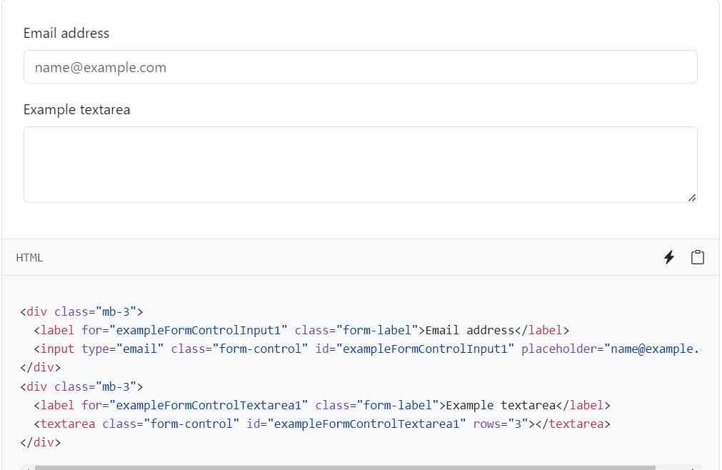

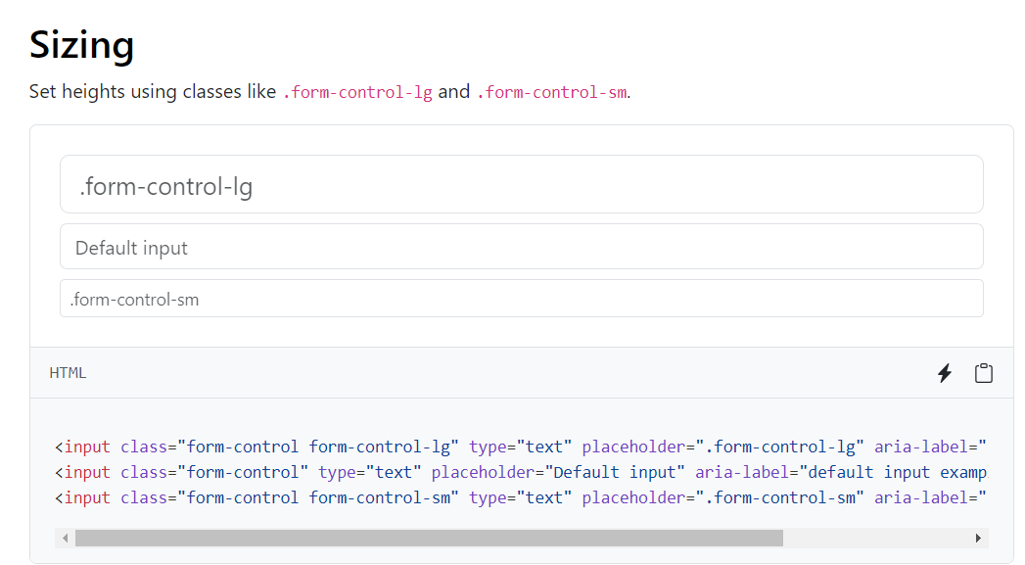

# **Select**

Customize the native <select>s with custom CSS that changes the element’s initial appearance.

