! DOCUMENTATION !

Customized Virtual File System

Name of the Project :-
Customized Virtual File System.

Technology Used :-
System Programming Using C.

User Interface Used :-
It is Command User Interface Based Project.

Platform required :-
We can run this project on windows,linux as well as macos but the command given in my project is based on linux operating system,so
run my project is more preferable on linux operating system.

Hardware Requirement :-
i) RAM :- Minimum 2 GB RAM can be used to get the effect of creating Inode.
ii) Hard Disk :- Minimum 2GB

Description of the Project :-
i) File sysetm is the way of storing and maneging the files in a proper format.
ii) In this project we are going to implement our own virtual file system.
iii)We are considerinf it as a virtual file system,because we implement
its existence inside the RAM.
iv)This project is considered as research oriented project because our target is used to learn the implementation of file system.

Data structure Used in the Project :-
I implement data structure concept to create Inode by using the concept of singly linear linked list.

Diagram of that data structures used in the project :-

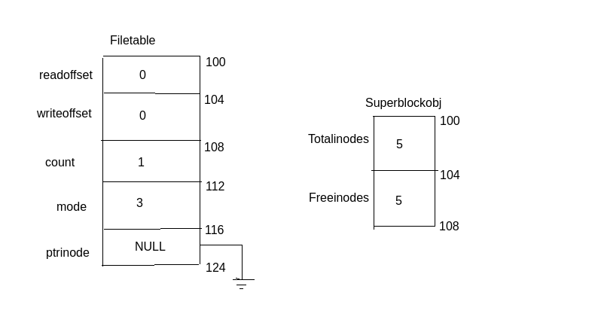
Actual Project Diagram :-

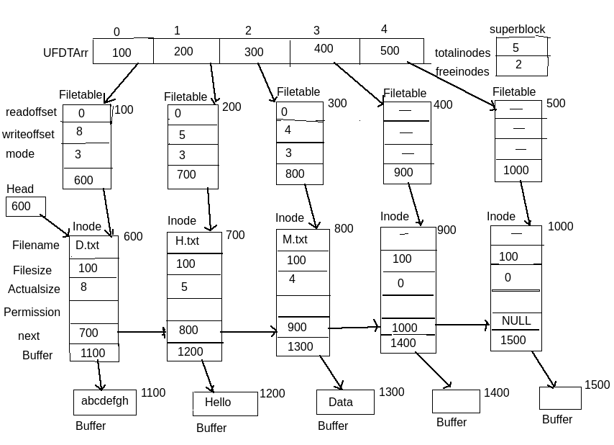

Flow of the Project :-
In this project first I write entry point function i.e. main function so that our compiler finds these main function after that control goes in main function.In main function I declare some local variables so that we can use some values by using these local variables i.e. ret is variable of type integer ans so on.
Now I call InitializeSuperBlock function so that this function can create node in our RAM,so that we can create one of the file and each file has one seperate node.Now I write infinite loop and each time accept on string and tokanize that string with one white space by using sscanf function,which are used to tokanized the string and we count the words on that string.By rule of linux commands every command has maximum three or four words.So ,we count that words and by using ladder else if condition we can call appropriate function means each if condition I call a particular function.
That set ,this is the small overview of flow of a project.

Output :-

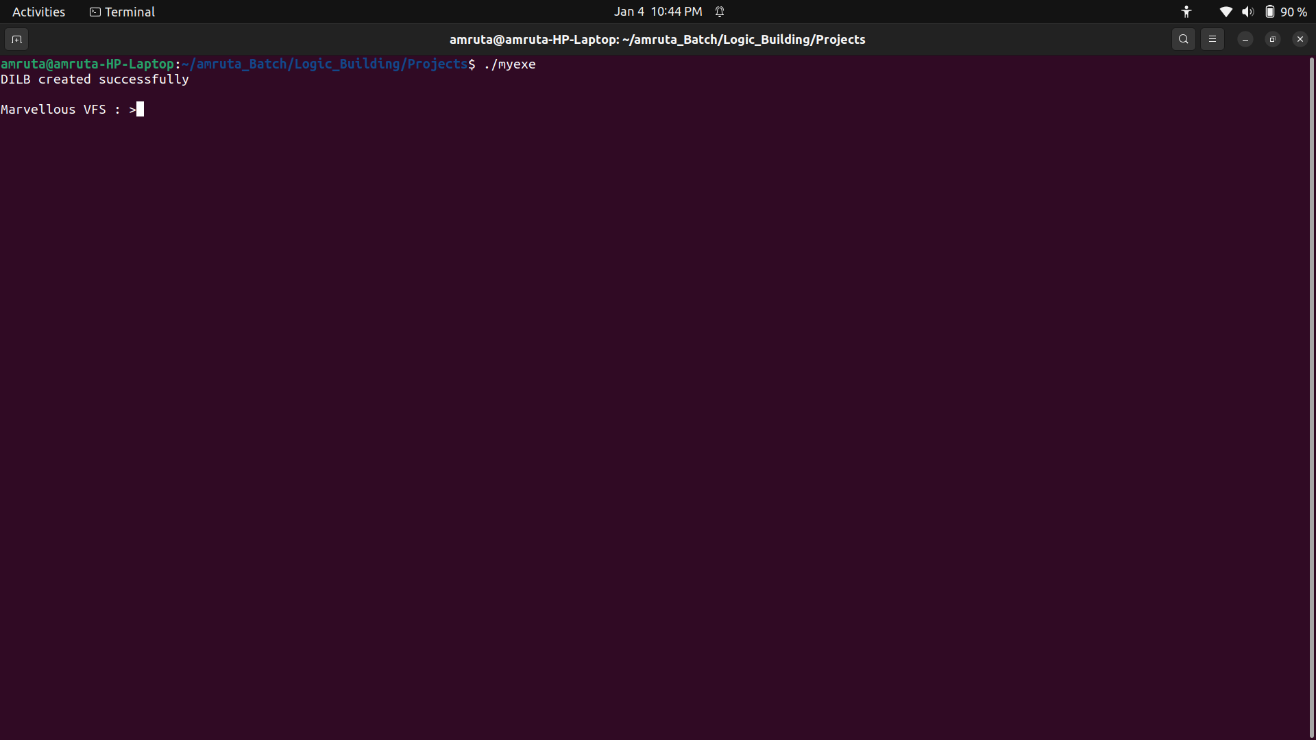
Functions Used In The Project :-
1] Name of the function :- InitialiseSuperBlock
Input Parameter :- Nothing
return value :- void
Description of the function :- No
Use :- It is used to initialise super block i.e. store the information about blocks and inodes

2] Name of the function :- CreateDILB
Input Parameter :- Nothing
return value :- void
Description of the function :- No
Use :- It is used to create Disk iNode List Block in that block all inode object are present.

3] Name of the function :- Get_Inode
Input Parameters :- character pointer
return value :- structure Inode pointer
Description of the function :- No
Use :- It gives a remaining one of the node on hard disk to our file.

4] Name of the function :- CreateFile
Input Parameter :- character pointer and integer
return value :- integer
Description of the function :- No
Use :- It is used to create one of the new file
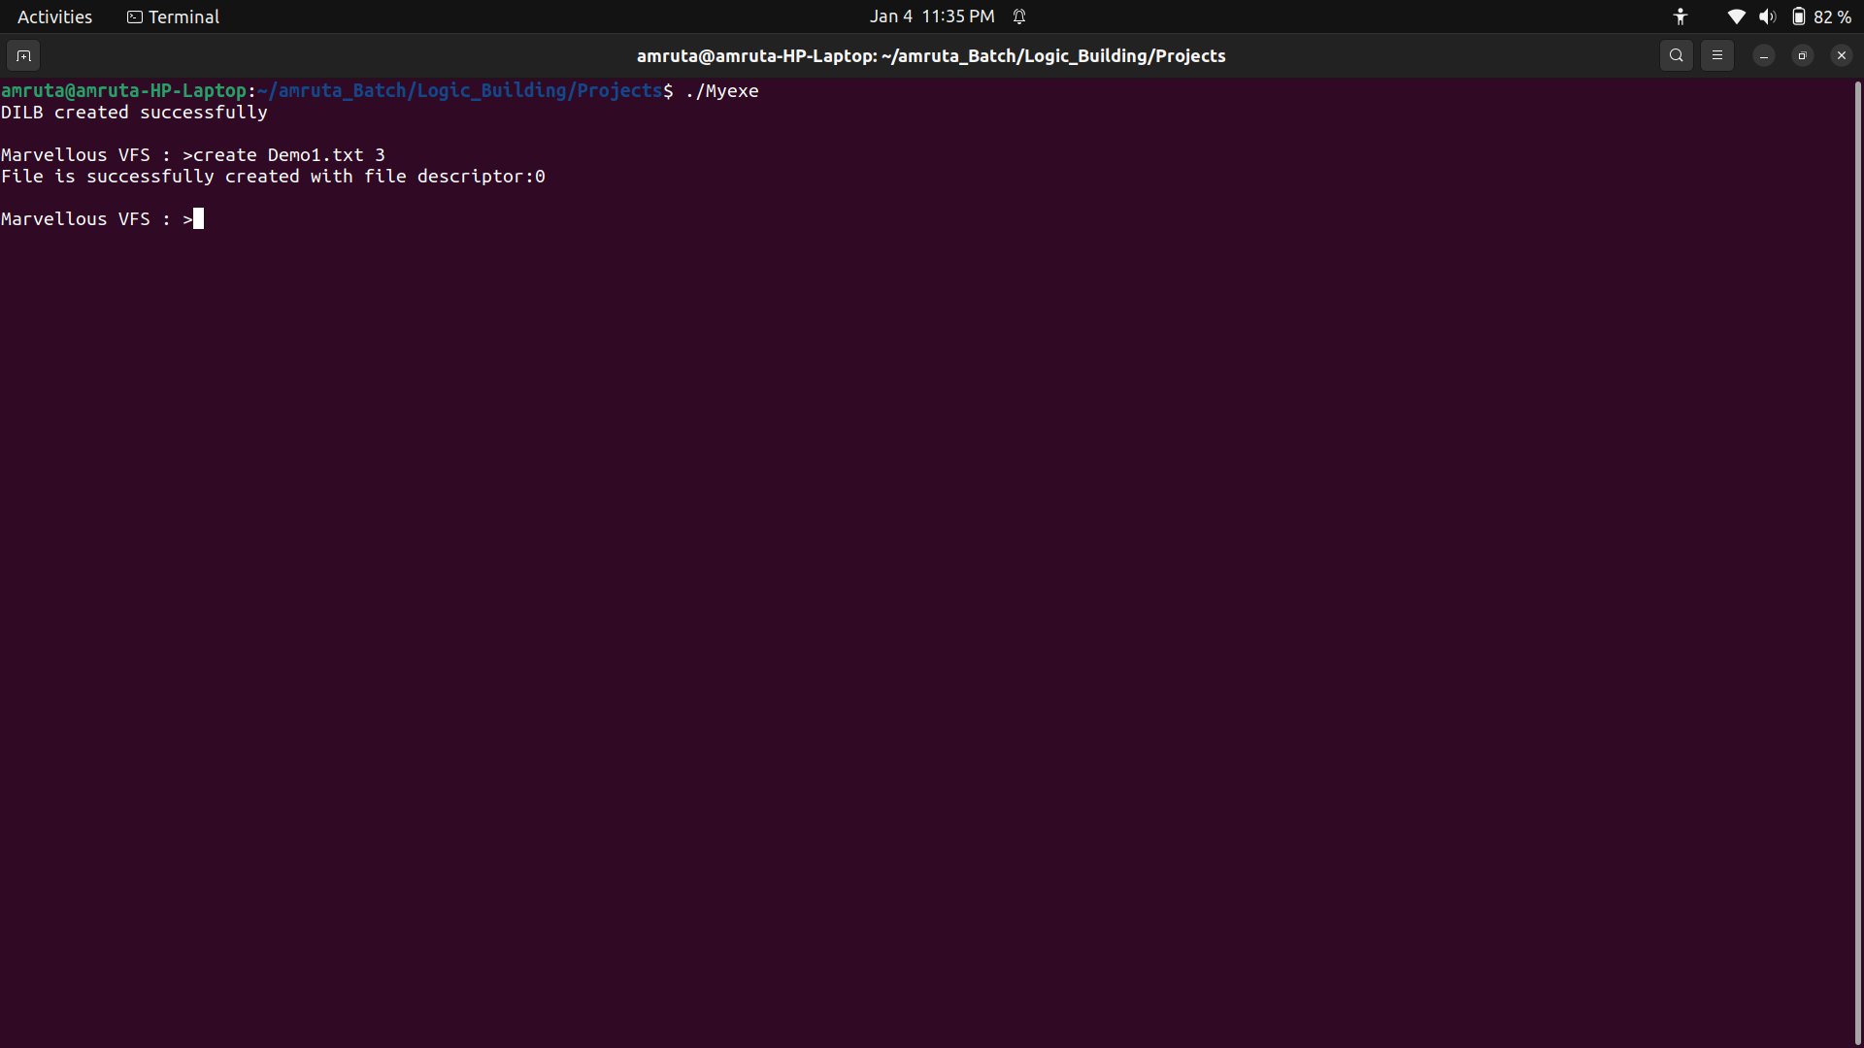
5] Name of the function :- OpenFile
Input Parameters :- charater pointer and one integer
return value :- integer
Description of the function :- No
Use :- It is used to open the file which are created by user.
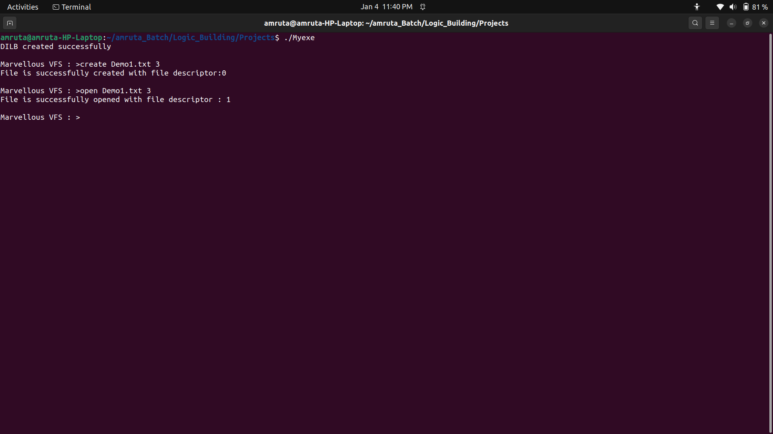
6] Name of the function :- WriteFile
Input Parameters :- character pointer and two integers
return value :- integer
Description of the function :- No
Use :- It is used to write the contents to file.
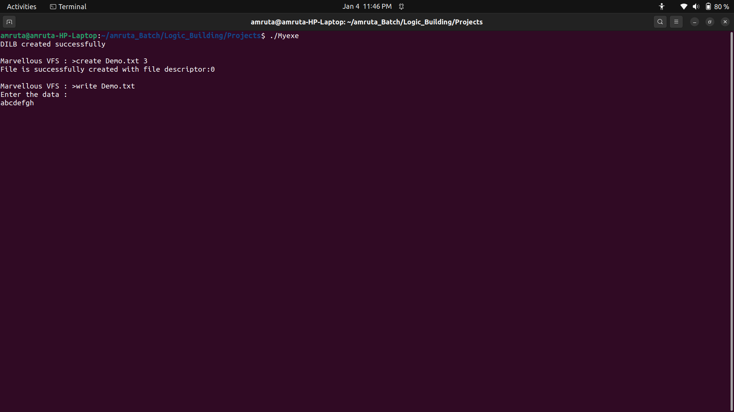
7] Name of the function :- ReadFile
Input Parameters :- character pointer and two integers
return value :- integer
Description of the function :- No
Use :- Read the contents of the file which are created by user.
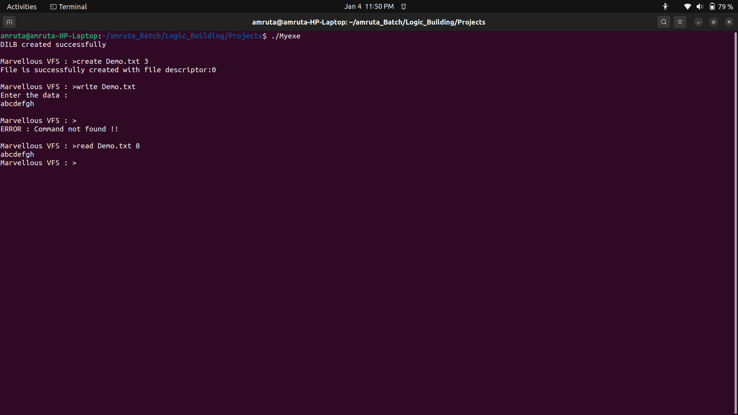
8] Name of the function :- man
Input Parameters :- character pointer
return value :- void
Description of the function :- No
Use :- Display the user manual of any command that we can run on the terminal.
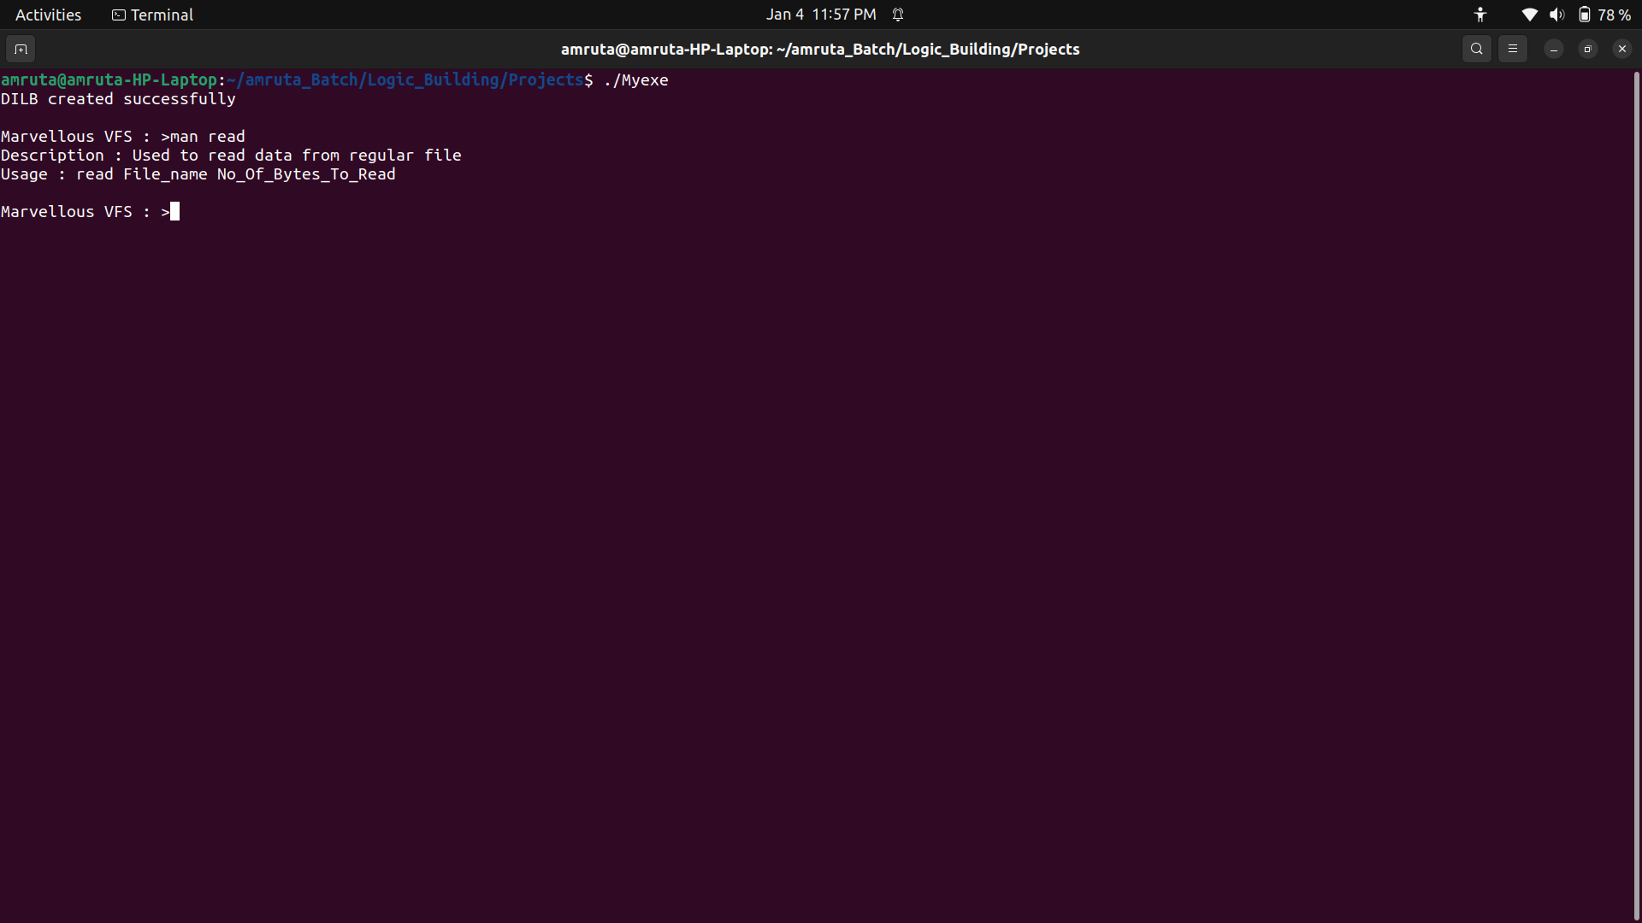
9] Name of the function :- DisplayHelp
Input Parametrs :- Nothing
return value :- void
Description of the function :- No
Use :- It displays(help) the information of used commands.
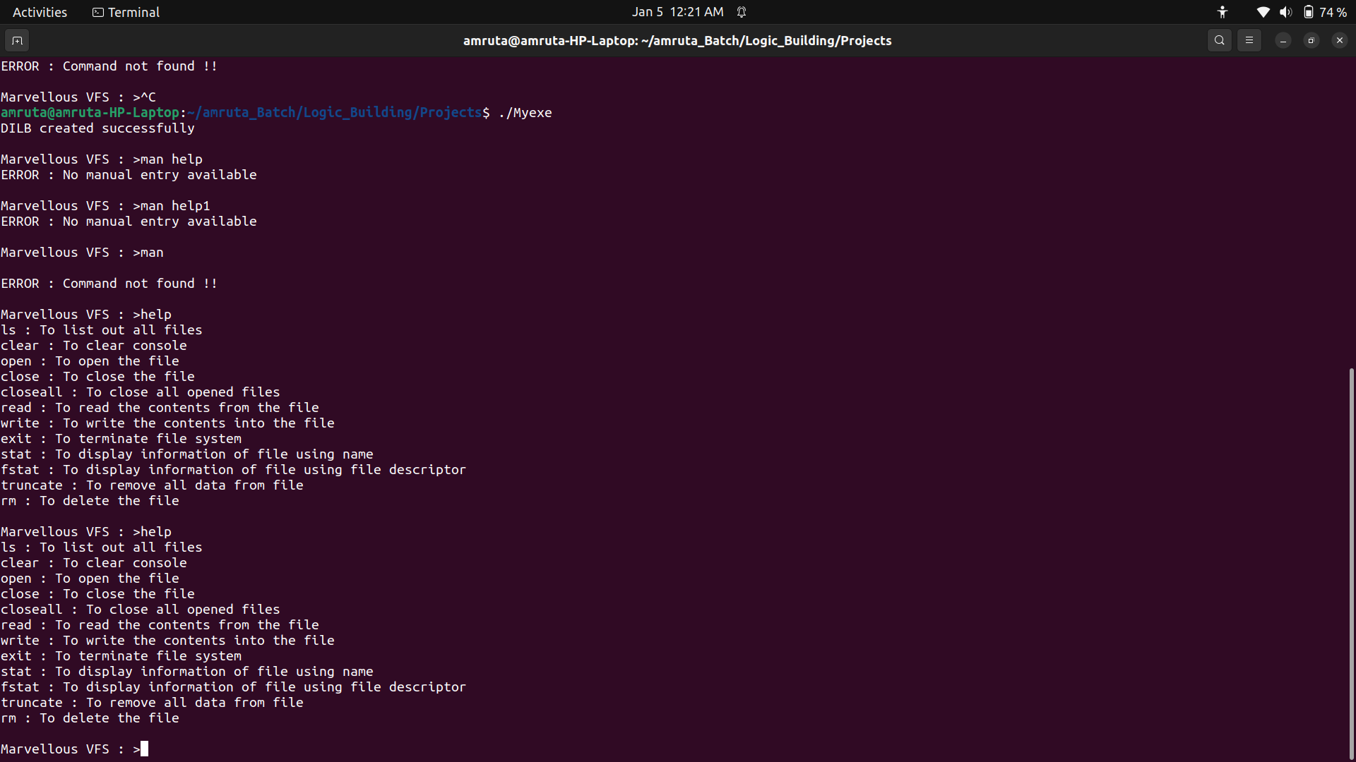
10] Name of the function :- GetFDFromName
Input Parameters :- character pointer
return value :- integer
Description of the function :- No
Use :- It gives the file name from file descriptor

11] Name of the function :- rm_File
Input Parameters :- character pointer
return value :- integer
Description of the function :- No
Use :- This function is used to delete the file.
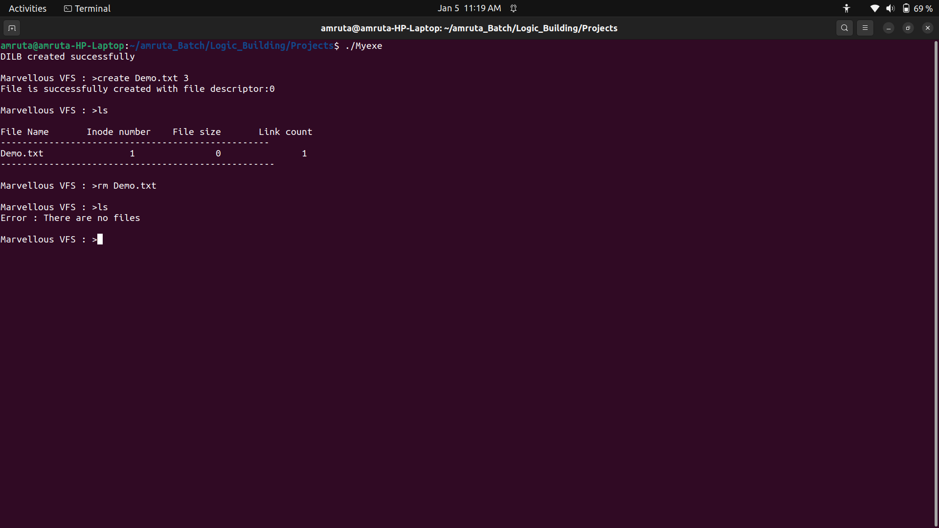
12] Name of the function :- CloseFileByName
Input Parameters :- one integer
return value :- void
Description of the function :- No
Use :- To close the opened file by the file descriptor
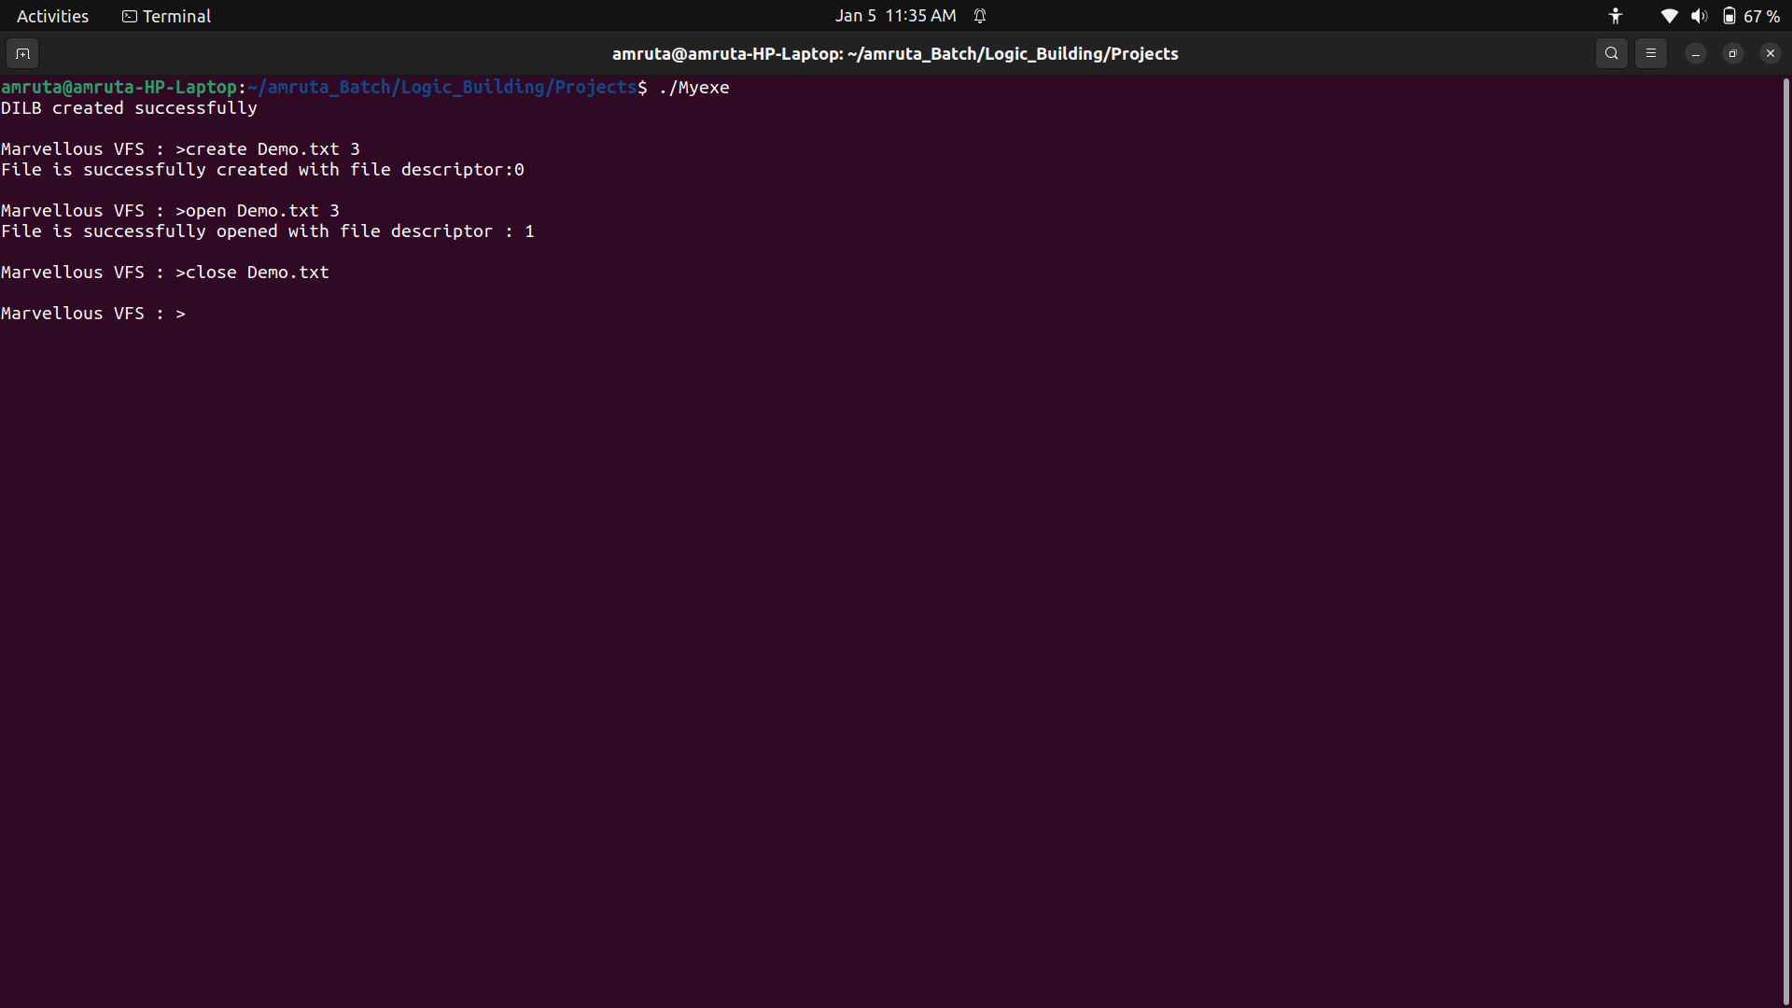
13] Name of the function :- CloseFileByName
Input Parameters :- One character pointer
return value :- Integer
Description of the function :- No
Use :- Used to close the opened file by file name

14] Name of the function :- CloseAllFile
Input Parameters :- No
return value :- void
Description of the function :- No
Use :- Used to close all opened files

15] Name of the function :- LseekFile
Input Parameters :- Three integers
return value :- Integer
Description of the function :- No
Use :- Used to shift the offset according to the user

16] Name of the function :- Is_file
Input Parameters :- Nothing
return value :- Void
Description of the function :- No
Use :- Used to Display the information of the file

17] Name of the function :- fstat_file
Input Parameters :- One Integers
return value :- Integer
Description of the function :- No
Use :- Used to Display the information of the file according to file Descriptor

18] Name of the function :- stat_file
Input Parameters :- One character Pointer
return value :- Integer
Description of the function :- No
Use :- Used to Display the information of the file according to file name

19] Name of the function :- truncate_file
Input Parameters :- One Integer Pointer
return value :- Integer
Description of the function :- No
Use :- Used to Display the information of the file according to file Descriptor

