Covid Death vs. Age group

Sophia Drewry, Alex Gil

2021-09-17

## 0.1 Initial Analysis Goals:

* What is the predominant condition contributing with COVID-19 deaths according with the age,
* Comparisons between year 2020 ans 2021 and see if the conditions are the same for both years

Since age data was categorical, analysis was kept to barcharts.

## 0.2 Data Cleaning & Import

The data using in this assignment is from the CDC <https://data.cdc.gov/NCHS/Conditions-Contributing-to-COVID-19-Deaths-by-Stat/hk9y-quqm>

* This dataset shows health conditions and contributing causes mentioned in conjunction with deaths involving coronavirus disease 2019 (COVID-19)

All cleaning and processing code is in the “code/processing” folder

## 0.3 Workflow

Table ?? shows a table summarizing the data.

Table 0.1: Data summary table.

|  |  |  |
| --- | --- | --- |
|  | Height | Weight |
| Min. | 133.00 | 45.00 |
| 1st Qu. | 155.25 | 54.25 |
| Median | 166.00 | 73.00 |
| Mean | 165.50 | 72.00 |
| 3rd Qu. | 177.25 | 87.50 |
| Max. | 192.00 | 110.00 |

Data was tranformed to be categorized by age first. The author intended on having porportions in the table, but the user error prevented this from happening in R.

Table ?? shows a table summarizing the data.

Table 0.2: Age stratified summary table.

|  |  |  |  |  |  |  |  |  |  |  |
| --- | --- | --- | --- | --- | --- | --- | --- | --- | --- | --- |
| Condition | 0-24 | 25-34 | 35-44 | 45-54 | 55-64 | 65-74 | 75-84 | 85+ | Not stated | All Ages |
| Influenza and pneumonia | 875 | 2349 | 6557 | 11609 | 25491 | 29002 | 29731 | 27428 | 6 | 18304 |
| Chronic lower respiratory diseases | 84 | 312 | 765 | 2888 | 5928 | 13977 | 17545 | 15390 | 1 | 31793 |
| Adult respiratory distress syndrome | 281 | 1409 | 2055 | 6148 | 13355 | 19317 | 15886 | 9361 | 2 | 31201 |
| Respiratory failure | 585 | 3214 | 4713 | 11403 | 21461 | 28661 | 30186 | 27524 | 4 | 18765 |
| Respiratory arrest | 27 | 124 | 361 | 1120 | 3015 | 2635 | 3562 | 4243 | 0 | 12407 |
| Other diseases of the respiratory system | 124 | 389 | 1082 | 3359 | 4136 | 6809 | 7621 | 6501 | 0 | 21201 |
| Hypertensive diseases | 50 | 663 | 3263 | 5525 | 12987 | 16222 | 21141 | 23798 | 3 | 29009 |
| Ischemic heart disease | 17 | 132 | 604 | 2565 | 6601 | 14912 | 17841 | 20455 | 2 | 32531 |
| Cardiac arrest | 224 | 1324 | 2748 | 5365 | 8957 | 13094 | 12812 | 11148 | 1 | 24417 |
| Cardiac arrhythmia | 33 | 146 | 429 | 2007 | 3615 | 8818 | 14625 | 18472 | 0 | 28391 |
| Heart failure | 30 | 163 | 569 | 2341 | 3727 | 8738 | 14112 | 20058 | 1 | 31914 |
| Cerebrovascular diseases | 36 | 128 | 512 | 2196 | 3437 | 6864 | 9064 | 10092 | 1 | 22996 |
| Other diseases of the circulatory system | 212 | 611 | 1755 | 2396 | 5704 | 9573 | 11113 | 11503 | 1 | 30186 |
| Sepsis | 200 | 870 | 3117 | 4605 | 10123 | 13838 | 12823 | 10177 | 1 | 30628 |
| Malignant neoplasms | 77 | 152 | 477 | 2199 | 4061 | 8348 | 9460 | 7123 | 0 | 23591 |
| Diabetes | 147 | 1013 | 3082 | 6832 | 12546 | 17476 | 18189 | 15150 | 2 | 31364 |
| Obesity | 471 | 2311 | 2602 | 4755 | 6989 | 6875 | 3384 | 1503 | 1 | 17561 |
| Alzheimer disease | 0 | 0 | 3 | 19 | 207 | 2600 | 6244 | 12855 | 0 | 17967 |
| Vascular and unspecified dementia | 0 | 1 | 7 | 58 | 1271 | 4940 | 16526 | 22215 | 1 | 27473 |
| Renal failure | 87 | 754 | 2558 | 4065 | 9993 | 13275 | 14447 | 14461 | 2 | 33473 |
| Intentional and unintentional injury, poisoning, and other adverse events | 172 | 415 | 679 | 1391 | 2359 | 2580 | 3104 | 3707 | 1 | 12330 |
| All other conditions and causes (residual) | 1260 | 2058 | 5140 | 13704 | 24490 | 30570 | 31855 | 32120 | 6 | 18186 |
| COVID-19 | 2811 | 5199 | 11359 | 22395 | 29817 | 23479 | 19803 | 23403 | 12 | 9467 |

# 1 This figure looks at death rates by age

Figure ?? shows a bar chart figure produced by one of the R scripts.

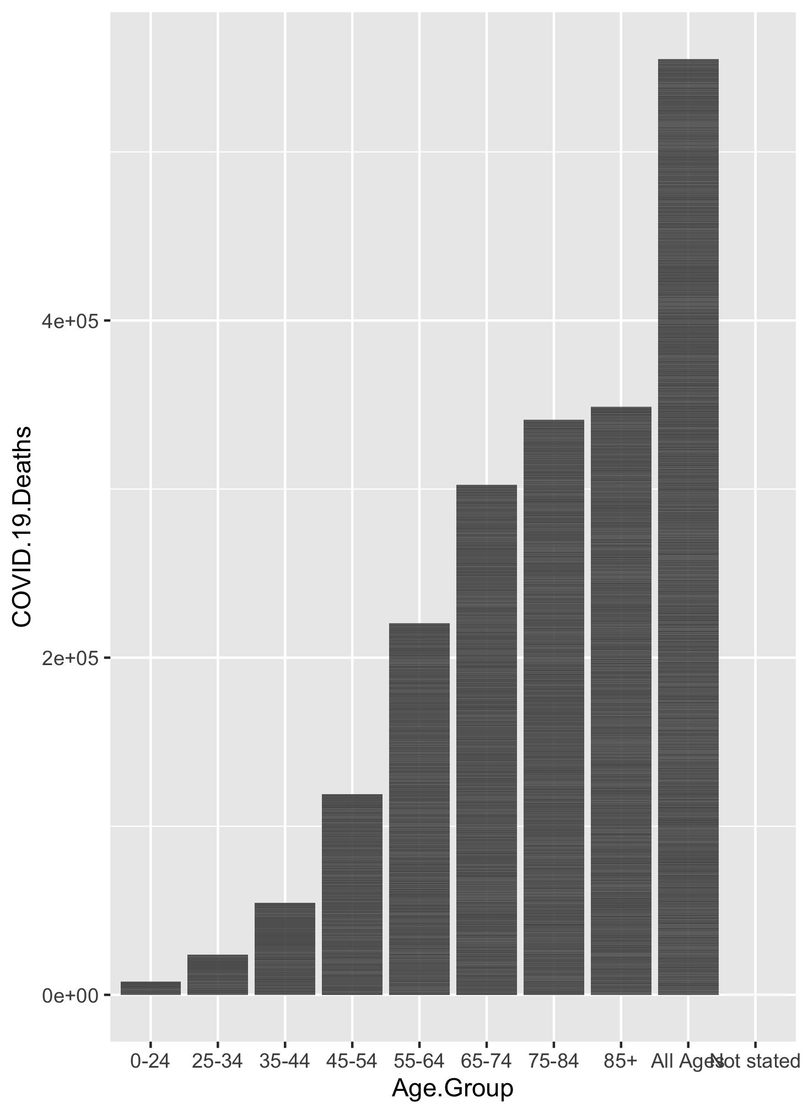

Figure 1.1: Analysis figure 1. Age stratified Covid-19 deaths

#This figure looks at conditions at time of death in those ages 0-24 Figure ?? shows a bar chart figure produced by one of the R scripts.

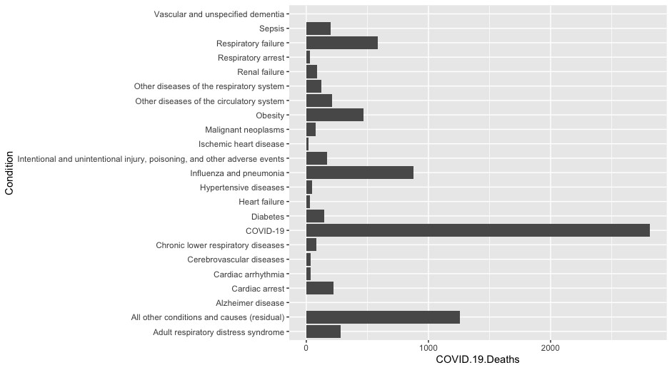

Figure 1.2: Analysis figure 1. Conditions at time of death in those ages 0-24