Plastic in the Urban Freshwater Environment

An Exploratory Study of Microplastics in the Upper Oconee Watershed via Community-Based Efforts

Amelia M. Foley

2021-11-12

# 1 Abstract

With growing awareness of plastic pollution and its detrimental environmental impacts, there has been increased attention on the study of microplastics. These small debris result from the weathering and breakdown of plastic waste from urban runoff, agricultural runoff, ocean dumping, stormwater, waste management, and other sources. Microplastics pose a threat to both aquatic life and human health due to their chemical makeup, their build-up in the environment, and their suspected long-term biological effects. As their ubiquity becomes more apparent, so does the need for accessible, affordable, and effective methods for the widespread study and quantification of microplastic pollution.

This study takes place in Athens, GA, an urban area which houses a population of about 127,000. The project relies on local volunteer citizen science efforts for water sampling, processing, and analysis. Given the local and regional ecological significance of the Oconee River—including its transport of freshwater to the Atlantic Ocean—this study aims to collect relevant data regarding microplastics in the Upper Oconee Watershed, which includes 2 rivers and 15 creeks in Athens-Clarke County.

Through community-based sample collection and analysis, volunteers quantified microplastics through membrane filtration and visual identification. Preliminary data consistently show that local freshwater microplastic levels are greater than the U.S. average in the Upper Oconee Watershed, a portion of the Oconee River basin with both a high population size and high population density relative to other regions of Georgia. Average and median concentrations of 95 particles/L and 46 particles/L, respectively, were recorded throughout one year of seasonal sampling. Further visual and statistical analysis will confirm the project’s results, and discussion of these results in context will reveal the efficacy of this community-based approach to the quantification of microplastics.

# 2 Introduction

## 2.1 Background

In the past two decades, the study of microplastics has expanded exponentially. Since the earliest paper mentioning small plastic particles in the ocean was published in the 1970s, before the term “microplastics” even existed, researchers across the globe have quantified microplastic particle levels in both marine and freshwater environments, assessed potential drivers and predictors of microplastic pollution, examined the presence of microplastics in the food chain, and explored the potential human health impacts of ingested microplastics [1]. Though the body of research on microplastics has grown in recent years, many knowledge gaps remain regarding this pollutant. The term microplastics was first coined in 2004, and today microplastics are defined as plastic particles smaller in size than 5 mm, though some studies examine particles as large as 20 mm [2]. Years of sampling, experimentation, and progress in research methods tell researchers that microplastics are a persistent class of pollutant and are found worldwide in a diverse assemblage of forms [3].

### 2.1.1 Pollution Sources

Microplastics are classified by source as either primary or secondary. Primary microplastics are those which are originally manufactured as microplastics, such as microbeads; primary microplastics are often found in personal care products, industrial scrubbers used for cleaning, plastic powder used for molding, and virgin resin used in plastic production [4]. Secondary microplastics begin as larger plastics and degrade into smaller pieces as the result of exposure to environmental stressors (e.g. sunlight, wind, water) [5]. For example, secondary microplastics occur when ultraviolet light exposure catalyzes photo-oxidation in plastic, leading to brittle pieces that are even more likely to break down [6]. A secondary microplastic source that is less obvious than the fragmentation of plastic debris is synthetic clothing. Clothes made of fibers such as nylon, polyester, rayon, or spandex shed microfibers during washing cycles; these fibers are later deposited into the environment through wastewater treatment plant effluent [5]. Most experts in the field agree that secondary microplastics are the most significant contributor to microplastic pollution, though a broad range of microplastic sources are recognized [7]. Researchers recognize wastewater treatment plant (WWTP) effluent as a major vector for both primary and secondary microplastics, and therefore WWTP effluent has been one area of focus in microplastics literature [5,7–10]. A team of scientists in Scotland examined WWTPs as a source of microplastics in the aquatic environment by sampling for microplastics at different stages of wastewater treatment; the team calculated a 98% reduction of microplastics from influent to effluent [5]. While an efficient removal rate, Murphy and collaborators estimate that 65 million microplastics are still released from the plant daily due to the large volume of effluent. Numerous other studies have evaluated WWTP effluent in relation to microplastic concentration as well [10]. Other predictors of microplastics particle concentration that researchers consider include land use (i.e. natural, agricultural, industrial, developed, forest & woodland, etc.) and population (total size, density, dwellings) [7,11–13]. Compared to the ocean, freshwater is the dominant source of microplastic due to land-based industrial and domestic pollution [14]. Rivers transport both point-source and diffuse pollution to the ocean, contributing an estimated 1.15 to 2.41 million tons of plastic waste annually [15]. Factors including anthropogenic impact, pollution sources, and hydrodynamics affect the rate of microplastic accumulation and transport [[14]; CITE]. Researchers continue to focus on identifying the variables influencing microplastic concentration in present day research (CITE).

### 2.1.2 Ecological Consequences

Despite their small size, microplastics have significant and quantifiable impact on aquatic ecosystems (CITE). Since microplastics permeate both marine and freshwater environments, aquatic animals easily mistake the particles for food and ingest them, allowing the pollutant to accumulate in their bodies; studies have shown that organisms ingest microplastics either by accident or by mistaking them for food [6,16,17]. Microplastics have been identified in the digestive tracts of fish and birds of prey, in mussels and other bivalves, and in natural populations of a crustacean species [17–21]. Microplastics are dangerous to organisms due to the physical accumulation of the particles themselves, and because they act as a transport mechanism for toxic chemicals in three main ways: (1) the plastic itself is toxic, (2) the plastic adsorbs and later releases environmental pollutants, and (3) the plastic leaches chemical additives [22,23]. The hydrophobic surface and high surface area to volume ratio of microplastics causes the adsorption and concentration of organic pollutants such as polychlorinated bisphenols (PCBs), dichlorodiphenyldichloroethylene (DDE), and nonylphenol (NP) [6,16]. Evidence of trophic transfer of microplastics through the food chain suggests that microplastics and the toxins that accompany them pose a threat to aquatic life further up the food chain, and to human health through consumption of seafood [3,16].

### 2.1.3 Relevance

Through decades of research, the scientific community proves that microplastics are ubiquitous, having identified microplastics in oceans, rivers, lakes, and other water bodies across the globe, including remote mountain lakes, the bottom of the ocean, and in ocean sediments offshore of Antarctica [24–26]. Modeling of current and future plastic production and pollution indicates that plastics are so pervasive that they have been considered as a geological indicator of the proposed Anthropocene era [27]. These models also suggest that microplastic concentrations will only increase in the future [3,28–30]. In a 2018 paper, Barboza and collaborators state that the increase in environmental microplastics is particularly concerning due to the contaminants’ small size, the limited technology for quantifying their presence, and their potential for adversely affecting both marine biota and humans [3]. Further, research shows that microplastic pollution is largely due to land-based sources; ocean-based sources such as commercial fishing, vessels, and other activities, contribute only 20% of the total plastic debris, while terrestrial activity contributes the other 80% of pollution in the marine environment [9,31]. Microplastics with various terrestrial origins mainly enter the marine environment via rivers, releasing most microplastics to the ocean and retaining some in freshwater systems [9,15,24,32]. However, a majority of microplastics research to date has focused on marine settings rather than freshwater, indicating that more studies are required in this area [33,34]. Examining freshwater systems as the dominant source of microplastics will lead to a better overall understanding of microplastics pollution input and therefore insight into the scale of the issue and mitigation strategies [15].

### 2.1.4 Present Research

This preliminary study sought to identify the presence of microplastics in the Upper Oconee Watershed, estimate the levels of microplastic pollution present in the freshwater systems of Athens, GA, observe temporal changes and trends, and explore the relationship between microplastic pollution and hypothesized predictors including population level, land use, and wastewater treatment plant proximity ([5]). We hypothesized that microplastics would be present in the Upper Oconee Watershed, that levels would be greater in more highly-trafficked areas with greater anthropogenic impact, and that microplastic pollution would correlate to other indicators of water quality [8].

## 2.2 Description of data and data source

The data that I am using for this project is from my personal undergraduate research project on freshwater microplastics in Athens, GA. The study is ongoing and was conducted in collaboration with the Upper Oconee Watershed Network (UOWN) via their quarterly sampling events. There is one year’s worth of quarterly data, with the following sample dates: November 2020, February 2021, April 2021, and July 2021. The data include variables such as sample site, latitude and longitude, watershed location, and duplicate A and B counts of microplastics observed per filter. For the most recent sampling date, July 2021, there is additional data where a second counting session was performed, in order to assess the comparability of parallel counts. There are about 136 observations of ~10 variables in total in the dataset. The independent variables – site location, coordinates, watershed location, etc – were retrieved from UOWN. Values for microplastic counts were recorded based on visual identification via a dissecting microscope, performed by myself and by a small team of <10 volunteers.

## 2.3 Questions/Hypotheses to be addressed

The questions that I want to answer with this data include the following: - Can we characterize microplastics in Athens, GA using a citizen science approach? - What are the levels of microplastics like in Athens, GA overall? - How do microplastic levels differ based on location within the region?

Questions that I want to answer that will require gathering more data using coordinates/watershed info include: - Is microplastic concentration impacted by local land use? - Is microplastic concentration impacted by localized population levels in specific neighborhoods? - Does wastewater treatment plant effluent from nearby facilities increase microplastic concentration at affected sites? - Are microplastic levels correlated to bacteria levels measured at the same sites? These questions also relate to hypothesized predictors of microplastic pollution: population level, land use, wastewater treatment plant effluent, and microbial water quality.

# 3 Methods

## 3.1 Data aquisition

*As applicable, explain where and how you got the data. If you directly import the data from an online source, you can combine this section with the next.*

### 3.1.1 Description of study area

The Upper Oconee Watershed is located in Northeast Georgia, spanning from Gainesville on the northern end to Lake Sinclair in Milledgeville, Georgia, on the southern end. The Upper Oconee Watershed encompasses 7590 km2, and includes more than 4000 km of streams [35]. Land within the Upper Oconee Watershed is historically agricultural, but has been subject to increasing urbanization in the past two decades; the study area contains developed and densely populated urban residential areas [35,36]. The Oconee Watershed is one of 14 river basins in the state of Georgia; the Oconee River feeds into the Altamaha River, which eventually deposits into the Atlantic Ocean off the Georgia coast (source: UOWN website). The Oconee River begins where the North and Middle Oconee Rivers meet, south of Athens, Georgia. The North and Middle Oconee Rivers begin in Lula, GA, and Brassleton, GA, respectively.

The Upper Oconee Watershed is regularly monitored by the Upper Oconee Watershed Network (UOWN), an Athens-based monitoring, education, advocacy, and recreation organization. Quarterly sampling events occur throughout the year, and the present research project was made possible via collaboration and eventual partnership with UOWN and the quarterly sampling events. The UOWN study area consists of 600 km2.

### 3.1.2 Experimental design: sample collection and processing

1-liter grab samples of water were collected quarterly from Fall 2020 through Summer 2021, in November, February, April, and July by UOWN community members. Samples were collected from 25 to 30 sites on each sampling date. The number of sites was decreased from previous sampling events due to COVID-19 public health restrictions with volunteers.

Samples were processed via vacuum filtration, which was performed in 150 mL volumes in duplicate for each site. Samples were pumped through gridded 0.45 micron membranes (Whatman) and immediately covered and stored covered in plastic petri dishes at room temperature for up to 8 weeks. Filters were visually inspected using a dissecting microscope with magnification ranging from [INSERT]. Microplastic particles were identified based on the following characteristic features: unnatural homogenous color, unnatural shape, homogenous texture, homogenous width (no tapered end)[37]. Microplastic concentration (No/L) was calculated by dividing the total microplastic particle count by the sample volume. Duplicates (samples A and B for each site) were averaged to obtain a singular concentration value for each sample site.

### 3.1.3 Controls

To evaluate contamination in the lab, blank filters were used to gauge airborne contamination and contamination within processing methods. Blank filters were placed in uncovered petri dishes on each work bench during sample filtration and processing. DI and MilliQ water were filtered in 150 mL volumes, in duplicate, to produce controls to represent potential contamination from filtration processes. The average contamination per sample was = INSERT.

## 3.2 Data import and cleaning

Since I am performing importing and cleaning in a separate document, in this section I will provide an overview of my steps/methods for wrangling the data, without actual code in this section.

To supplement my analysis, additional data was imported as detailed below.

### 3.2.1 UOWN Quarterly Data

Public data from Upper Oconee Watershed Network, Athens, Georgia; retrieved from www.uown.org ### Population NHGIS [**Mansen?**] ### Land Cover NHGIS [**Mansen?**] ### Water Reclamation Facilities Coordinates for Athens-Clarke county’s three water reclamation facilities: North Oconee, Middle Oconee, and Cedar Creek were manually located via Google Maps.

## 3.3 Exploratory analysis

This section will contain the key products of my exploratory analysis (located in exploration.Rmd) when complete. Since I am keeping this document in manuscript style, I will keep processing/exploration/analysis code separate.

Table ?? shows a table summarizing the data.

### 3.3.1 Distribution of Microplastic Concentration

Figure 1 shows a histogram of microplastic concentration observations. The minimum concentration is 16.67 particles/L and the maximum is 1193.33 particles/L. The mean concentration is 104.39 particles/L, and the median is 66.67 particles/L.

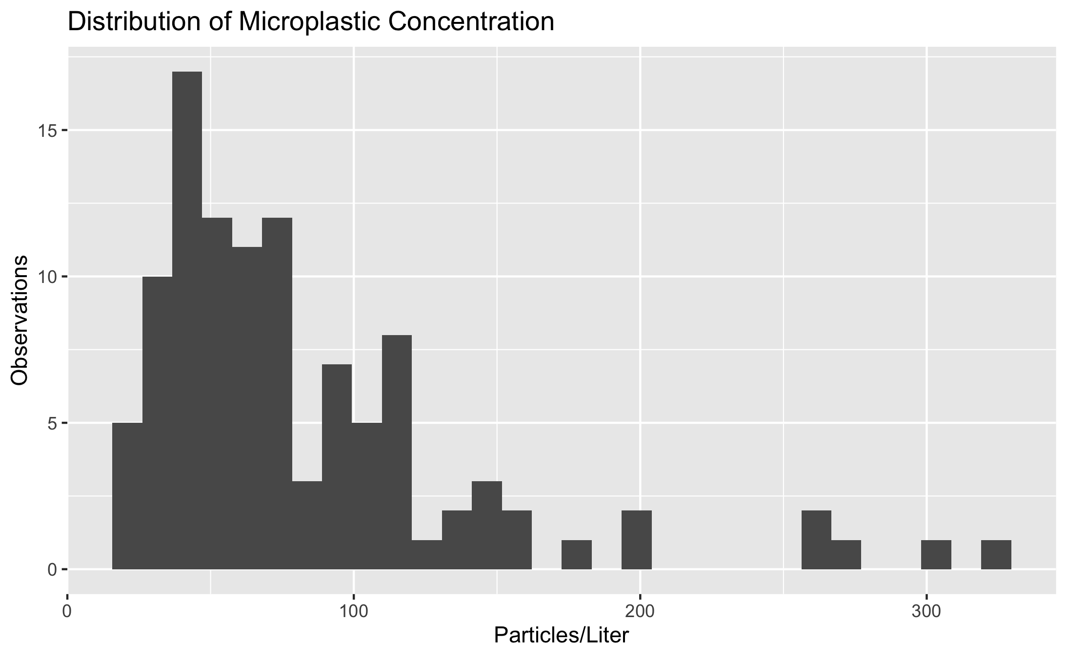

Distribution of Microplastic Concentration

Microplastic concentrations remained in similar ranges throughout the study period. Figure 2 shows a boxplot of concentrations by sample date.

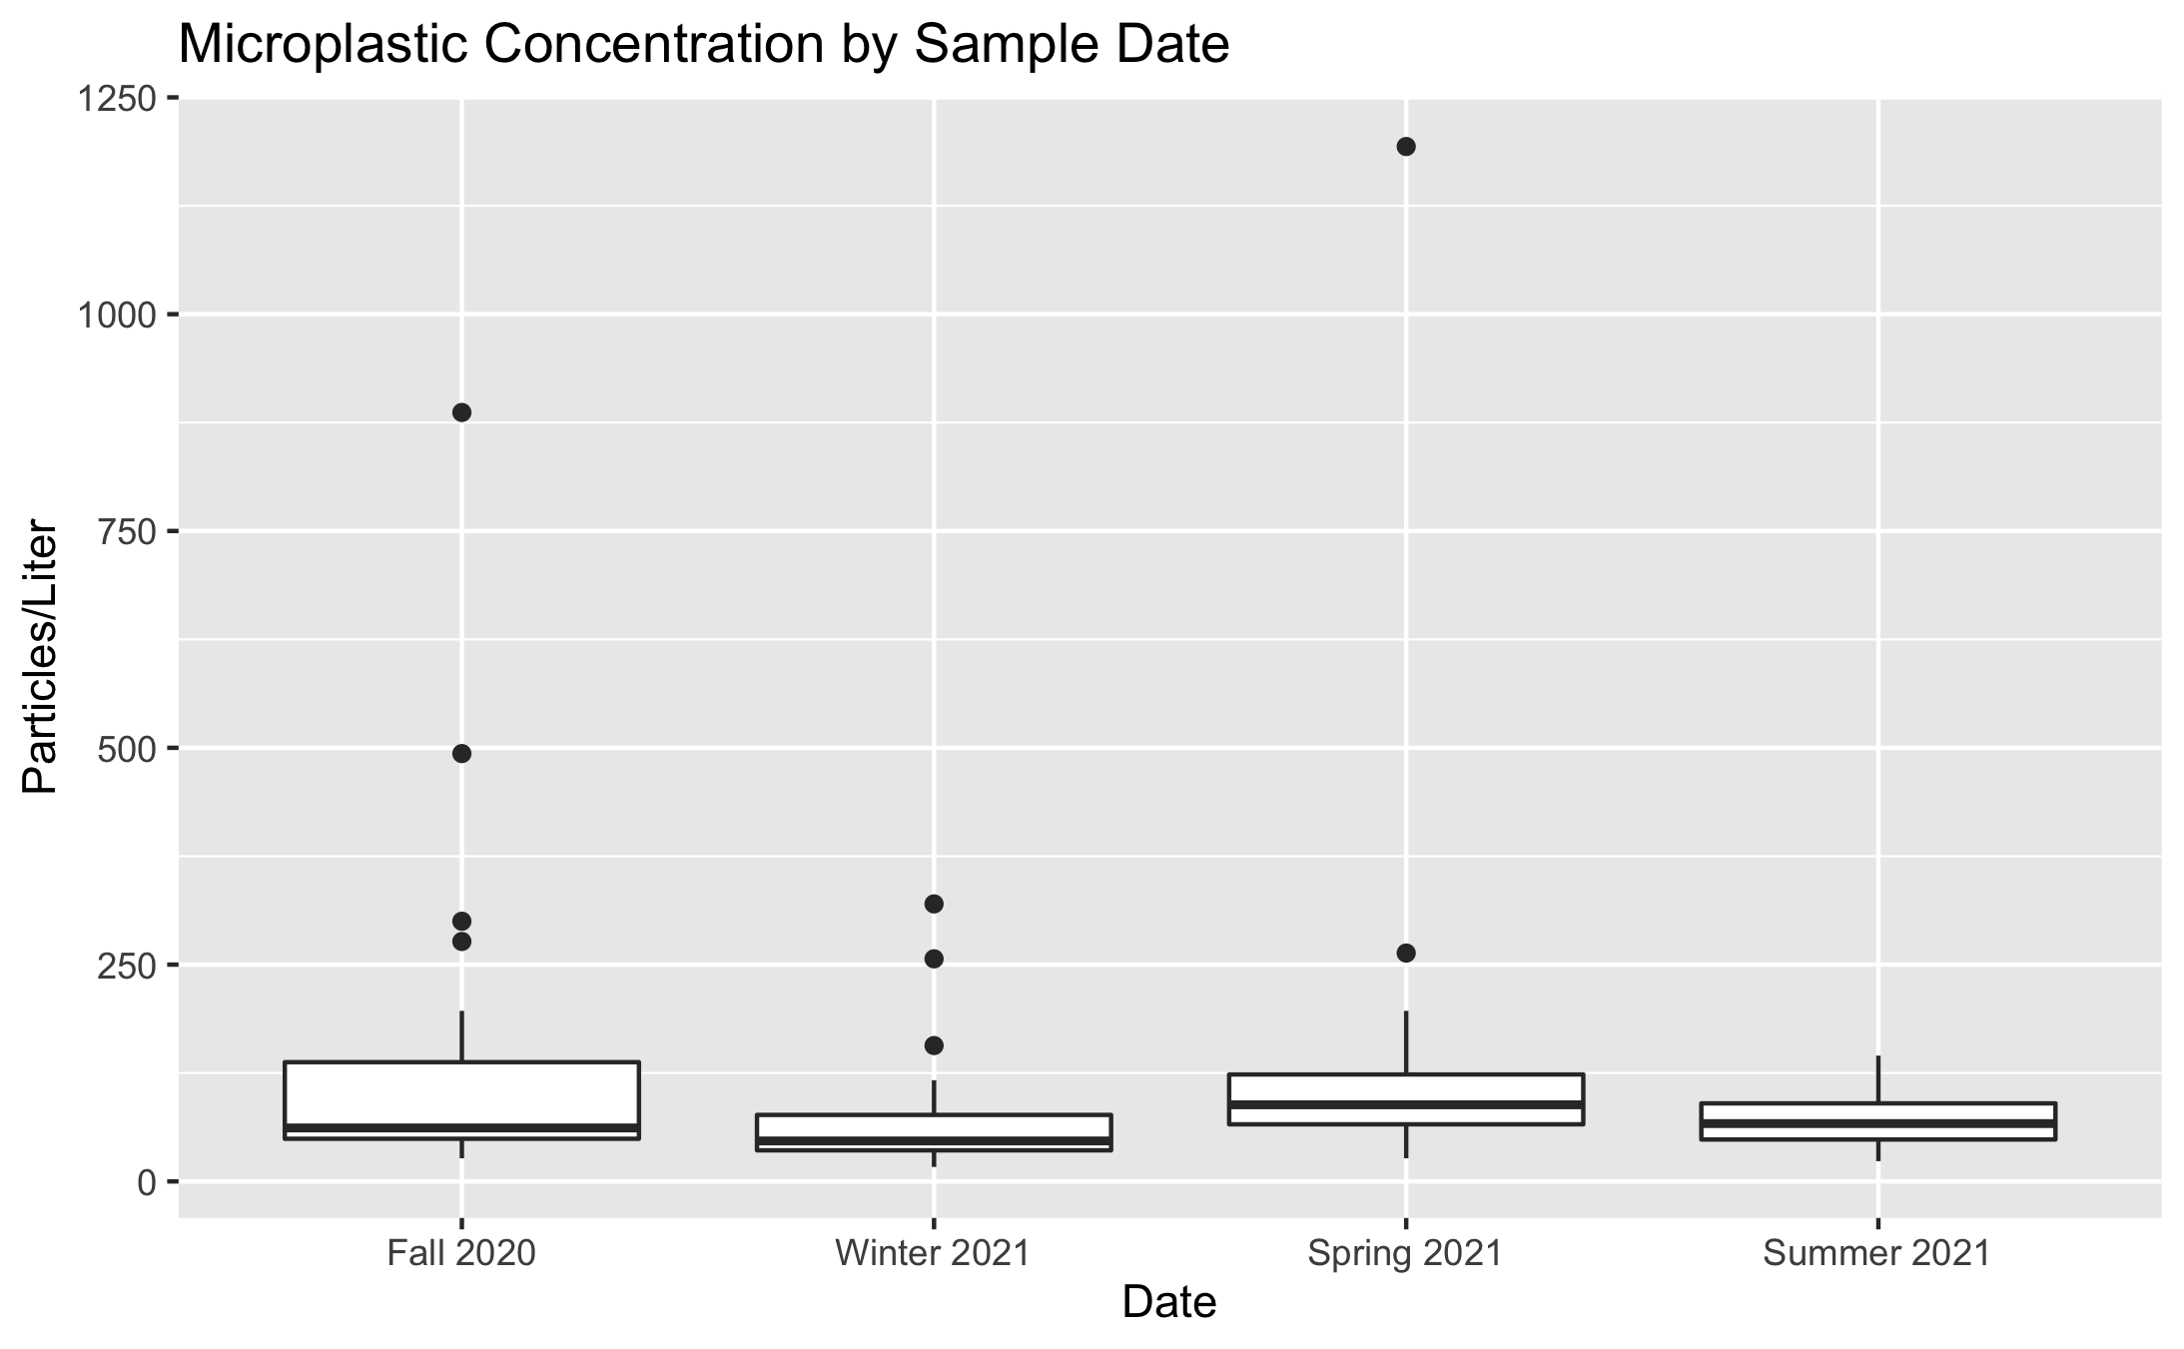

Particles/L by Sample Date

There is some seasonal variation in concentration at each individual site. Figure 3 shows a plot of concentrations at each site.

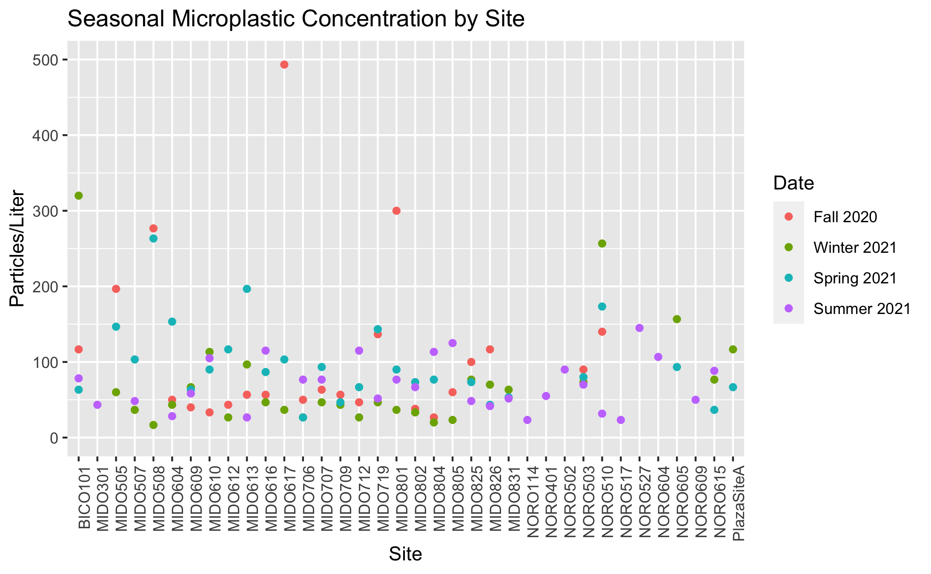

Seasonal Variation in Particles/L

Figure 4 shows a line graph of the mean watershed microplastic concentrations at each seasonal sampling date.

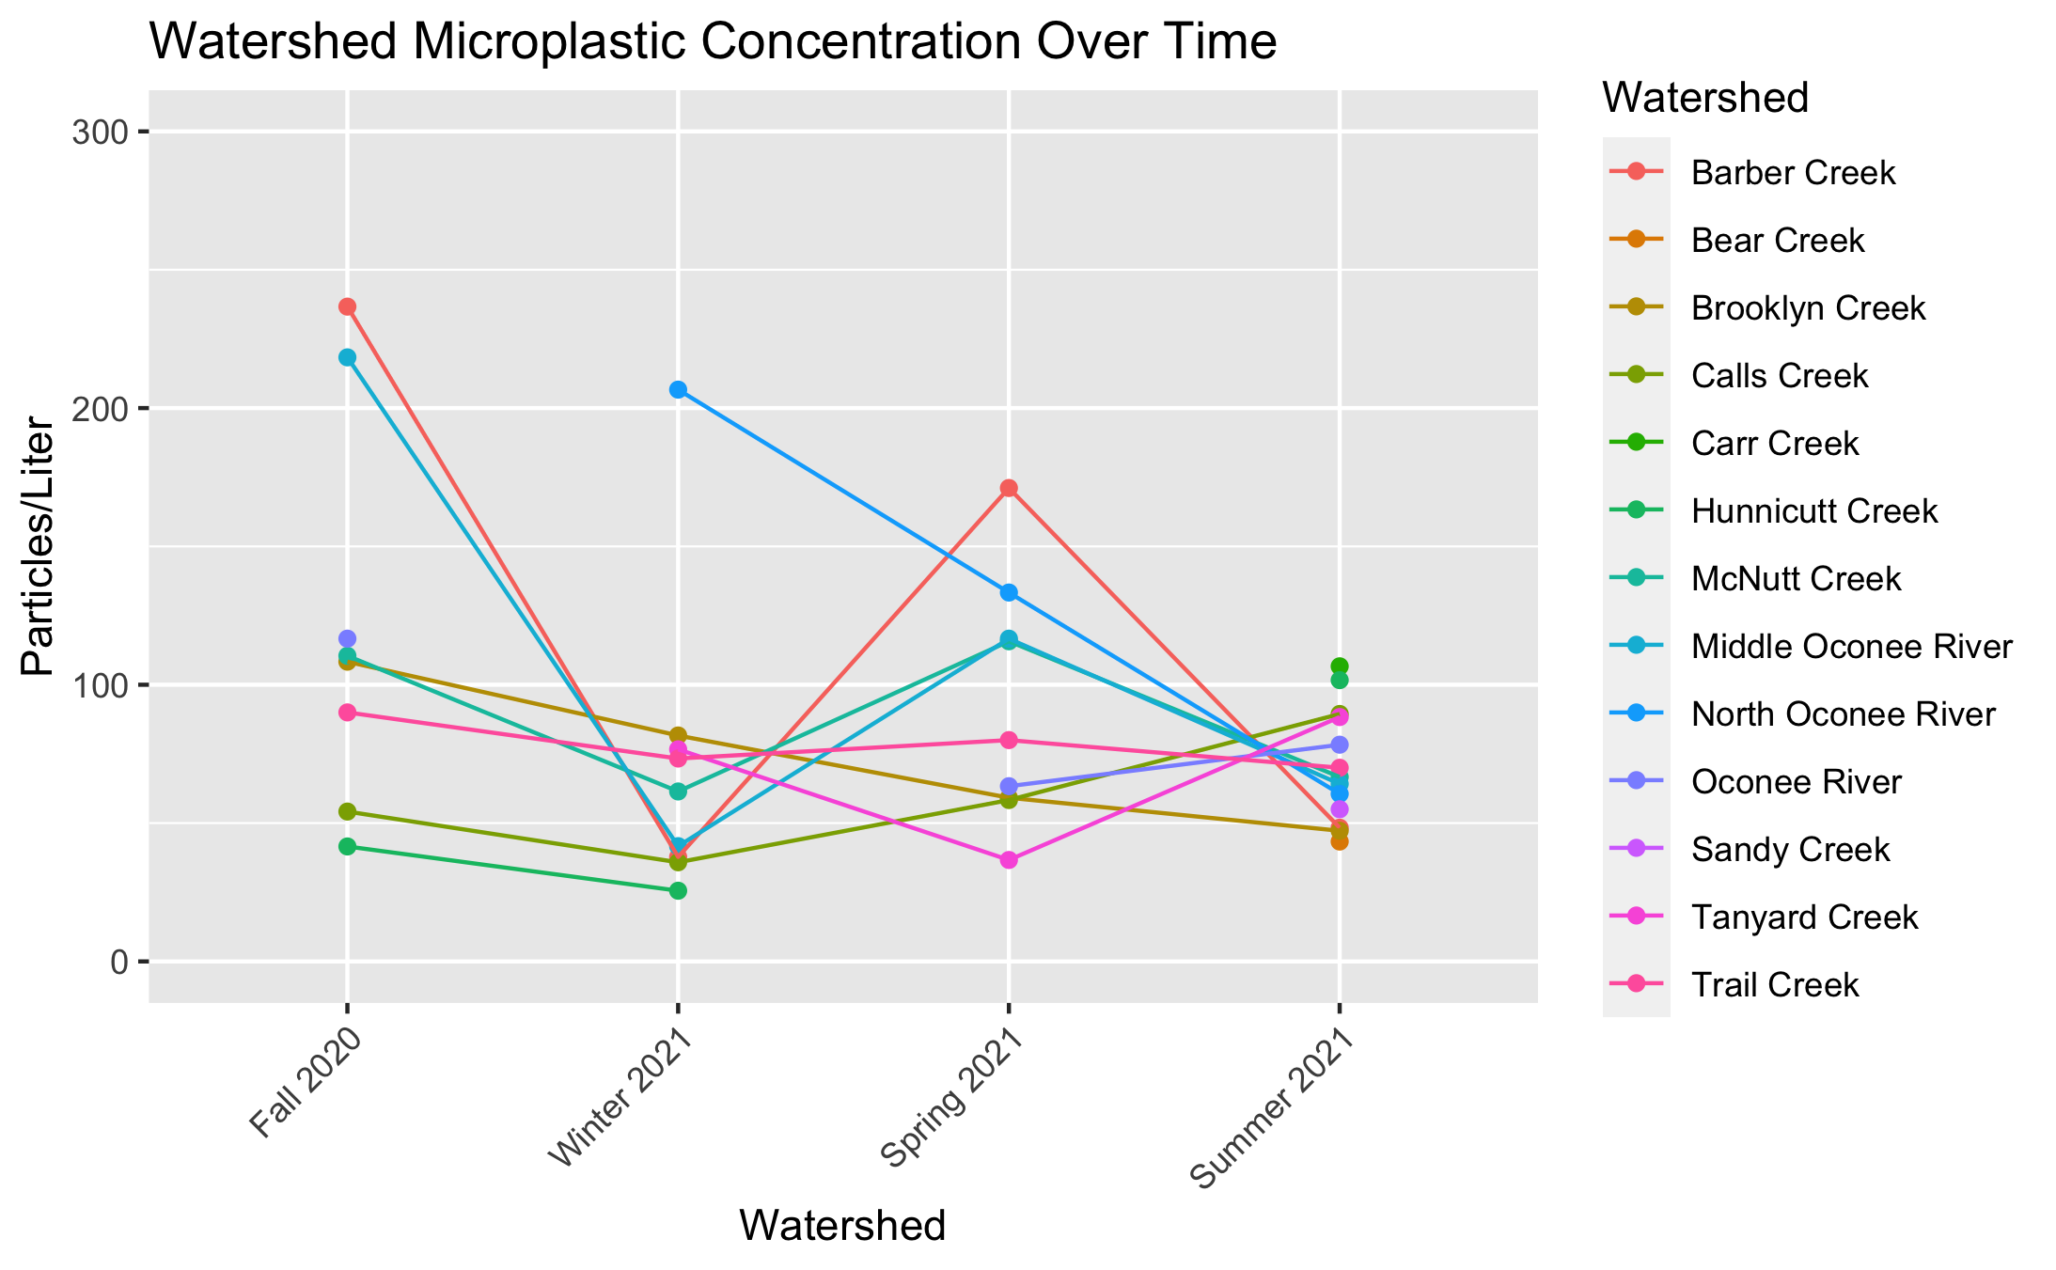

Microplastic Concentration Over Time

### 3.3.2 Predictors

Population, land cover/use, and bacteria levels are hypothesized predictors of microplastic concentration. Figure 5 and Figure 6 demonstrate the relationship between microplastic concentration and population and microplastic concentration and bacteria levels (CFU/L), respectively.

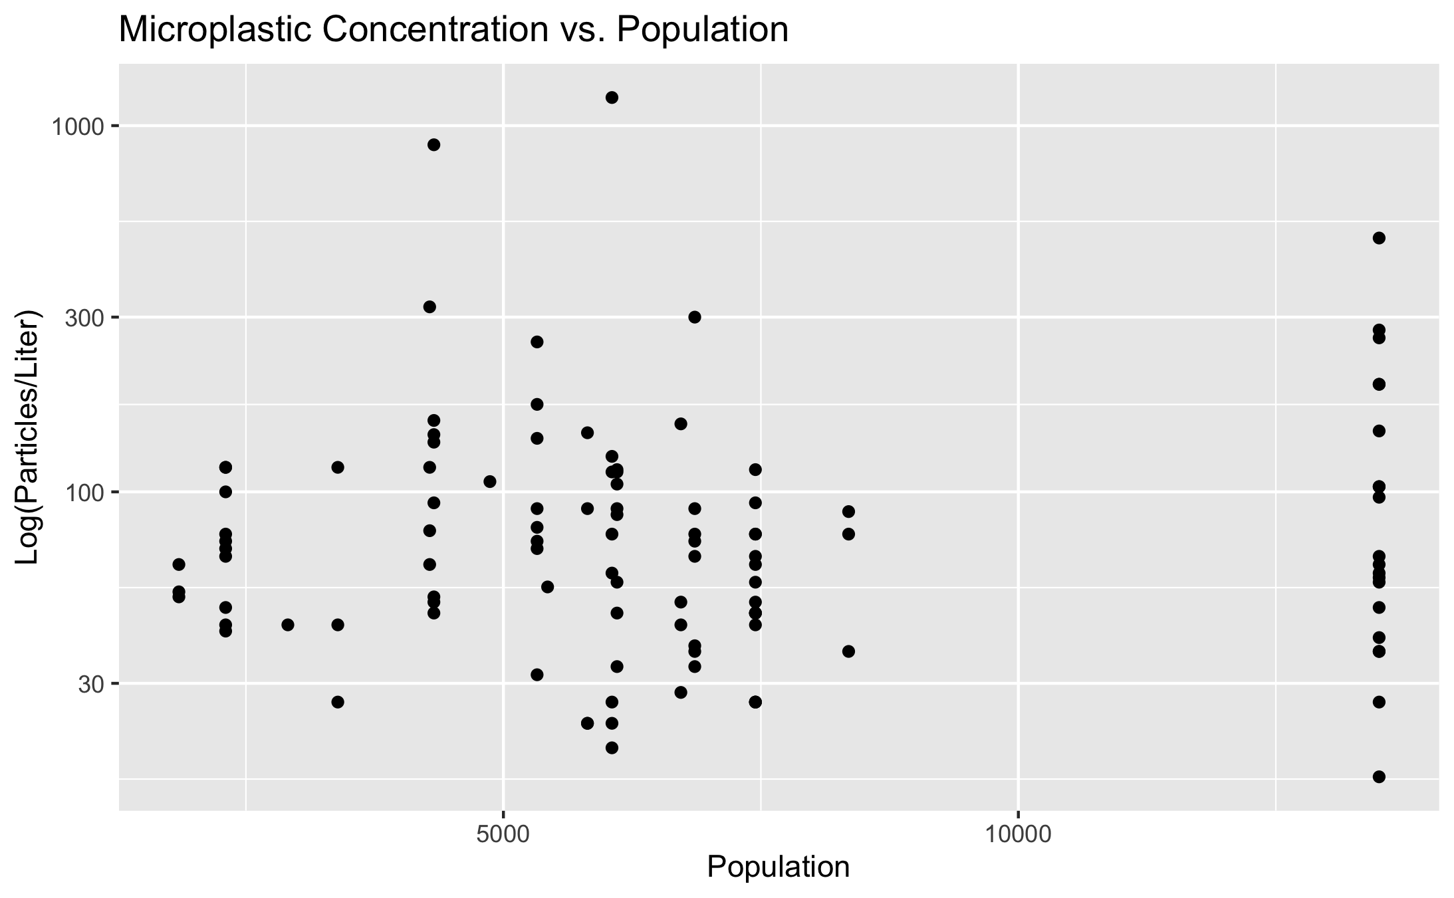

Particles/L vs Population

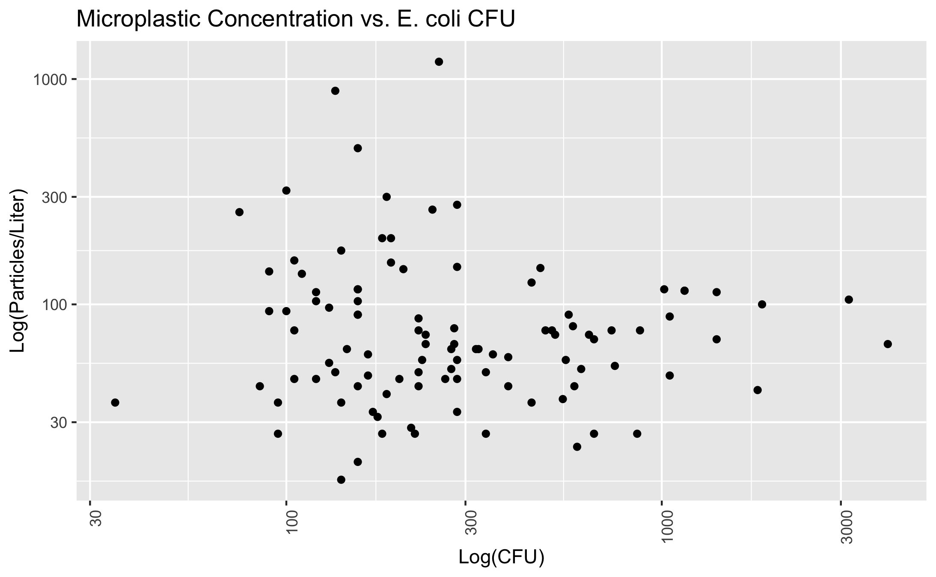

Log particles/L vs CFU

### 3.3.3 Mapping

I created some maps for concentrations at each sample sites throughout the seasons (saved as html files “map_season.html”) for now, but I am unsure of how best to display these maps in the manuscript word document output.

#mapview::knit_print.mapview(here("results", "map_spring.html"))

## 3.4 Full analysis

Preliminary modeling reveals that there is not a strong relationship between microplastic concentration and population level. Figure ?? demonstrates a linear model fit.

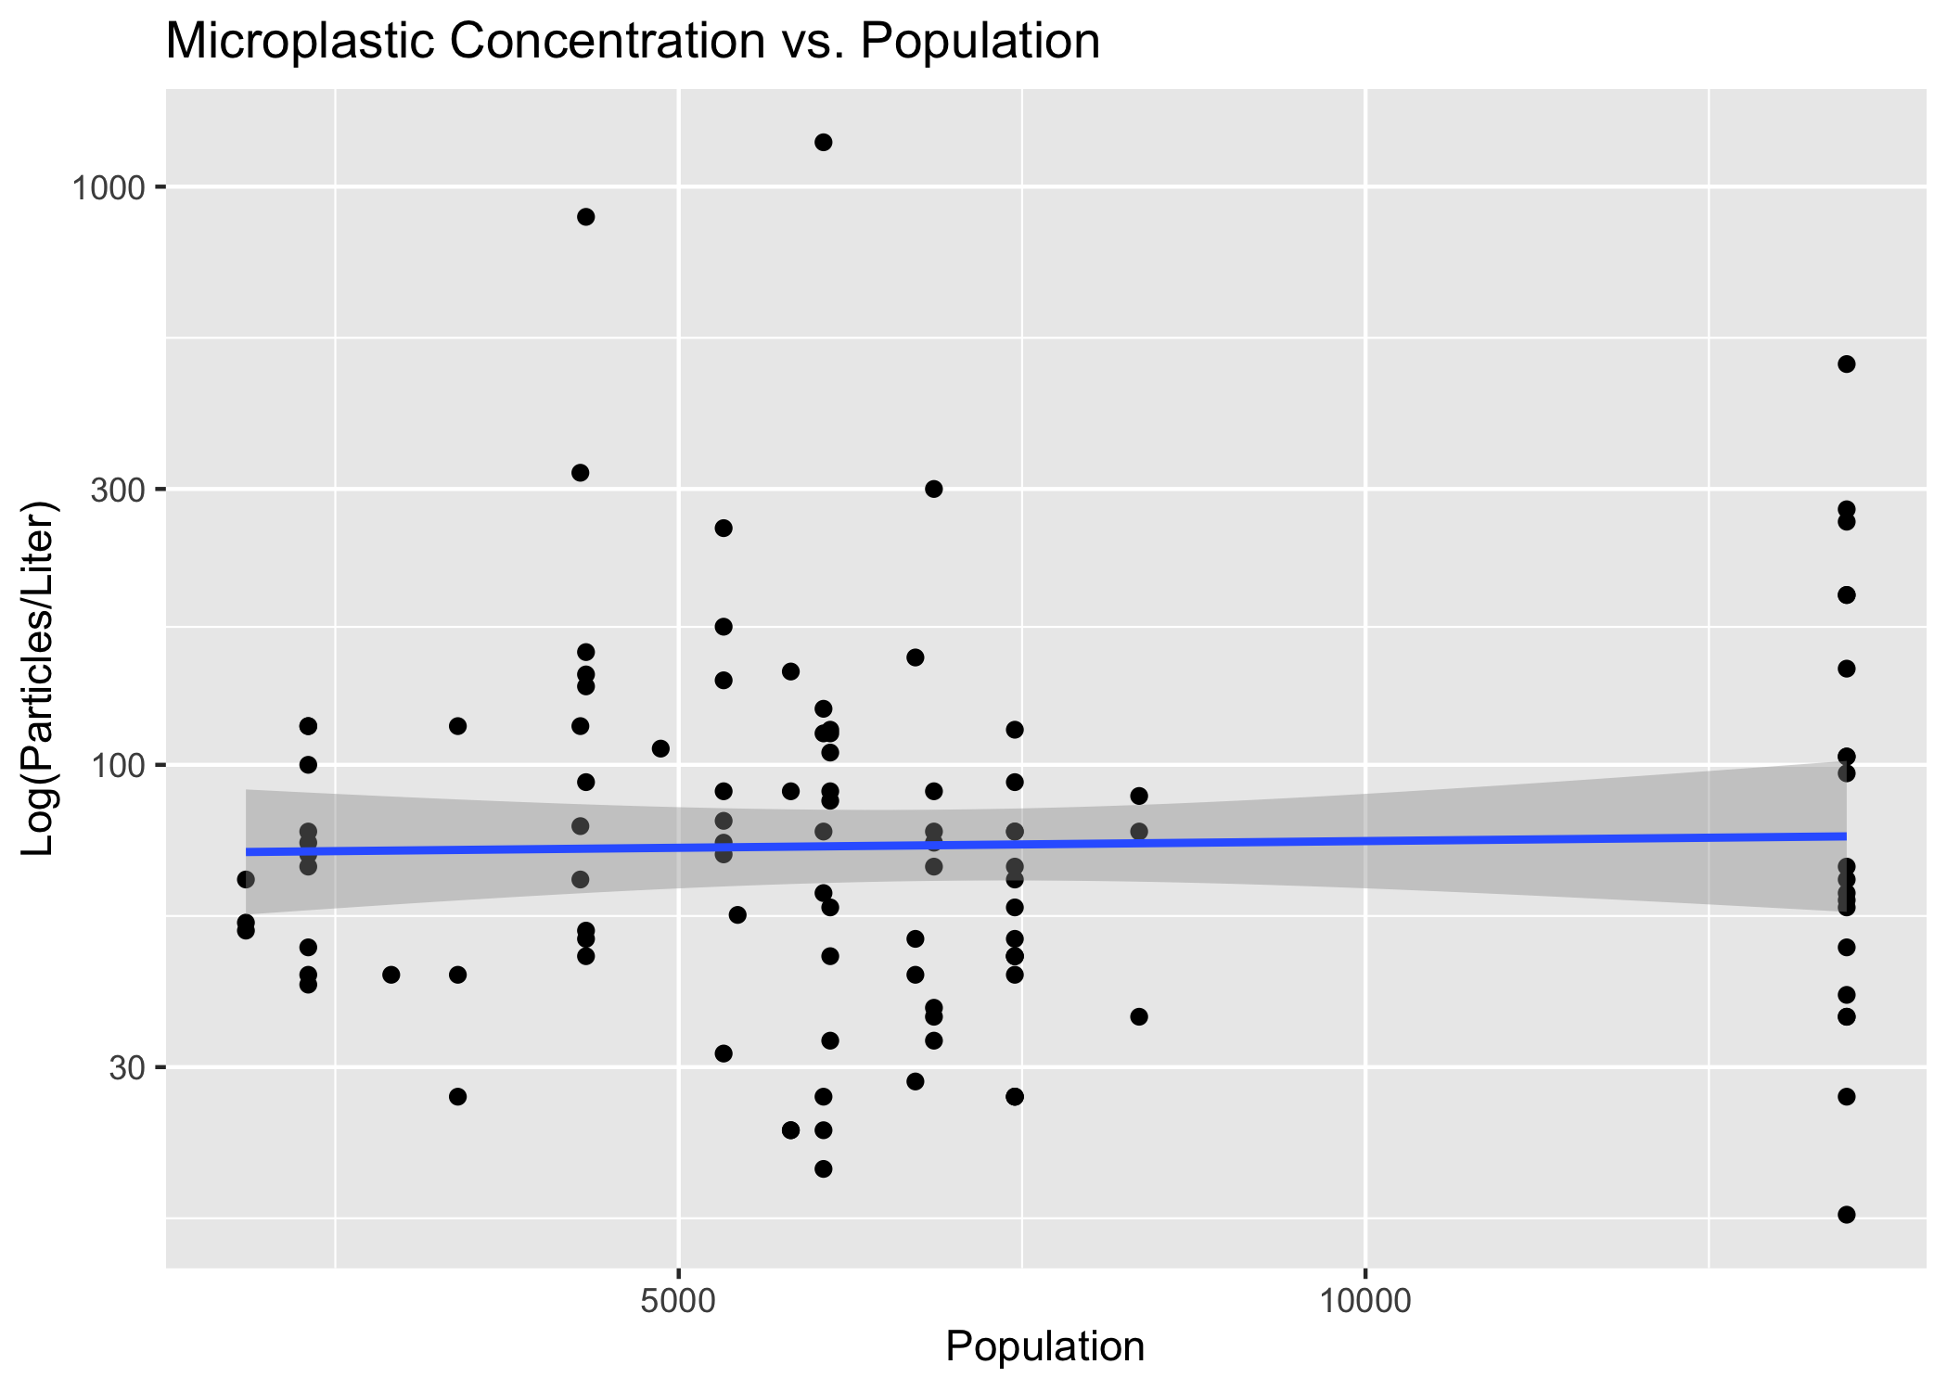

Concentration vs Population Linear Model

Figure 8 shows a linear model of microplastic concentration vs CFU (both variables log-transformed).

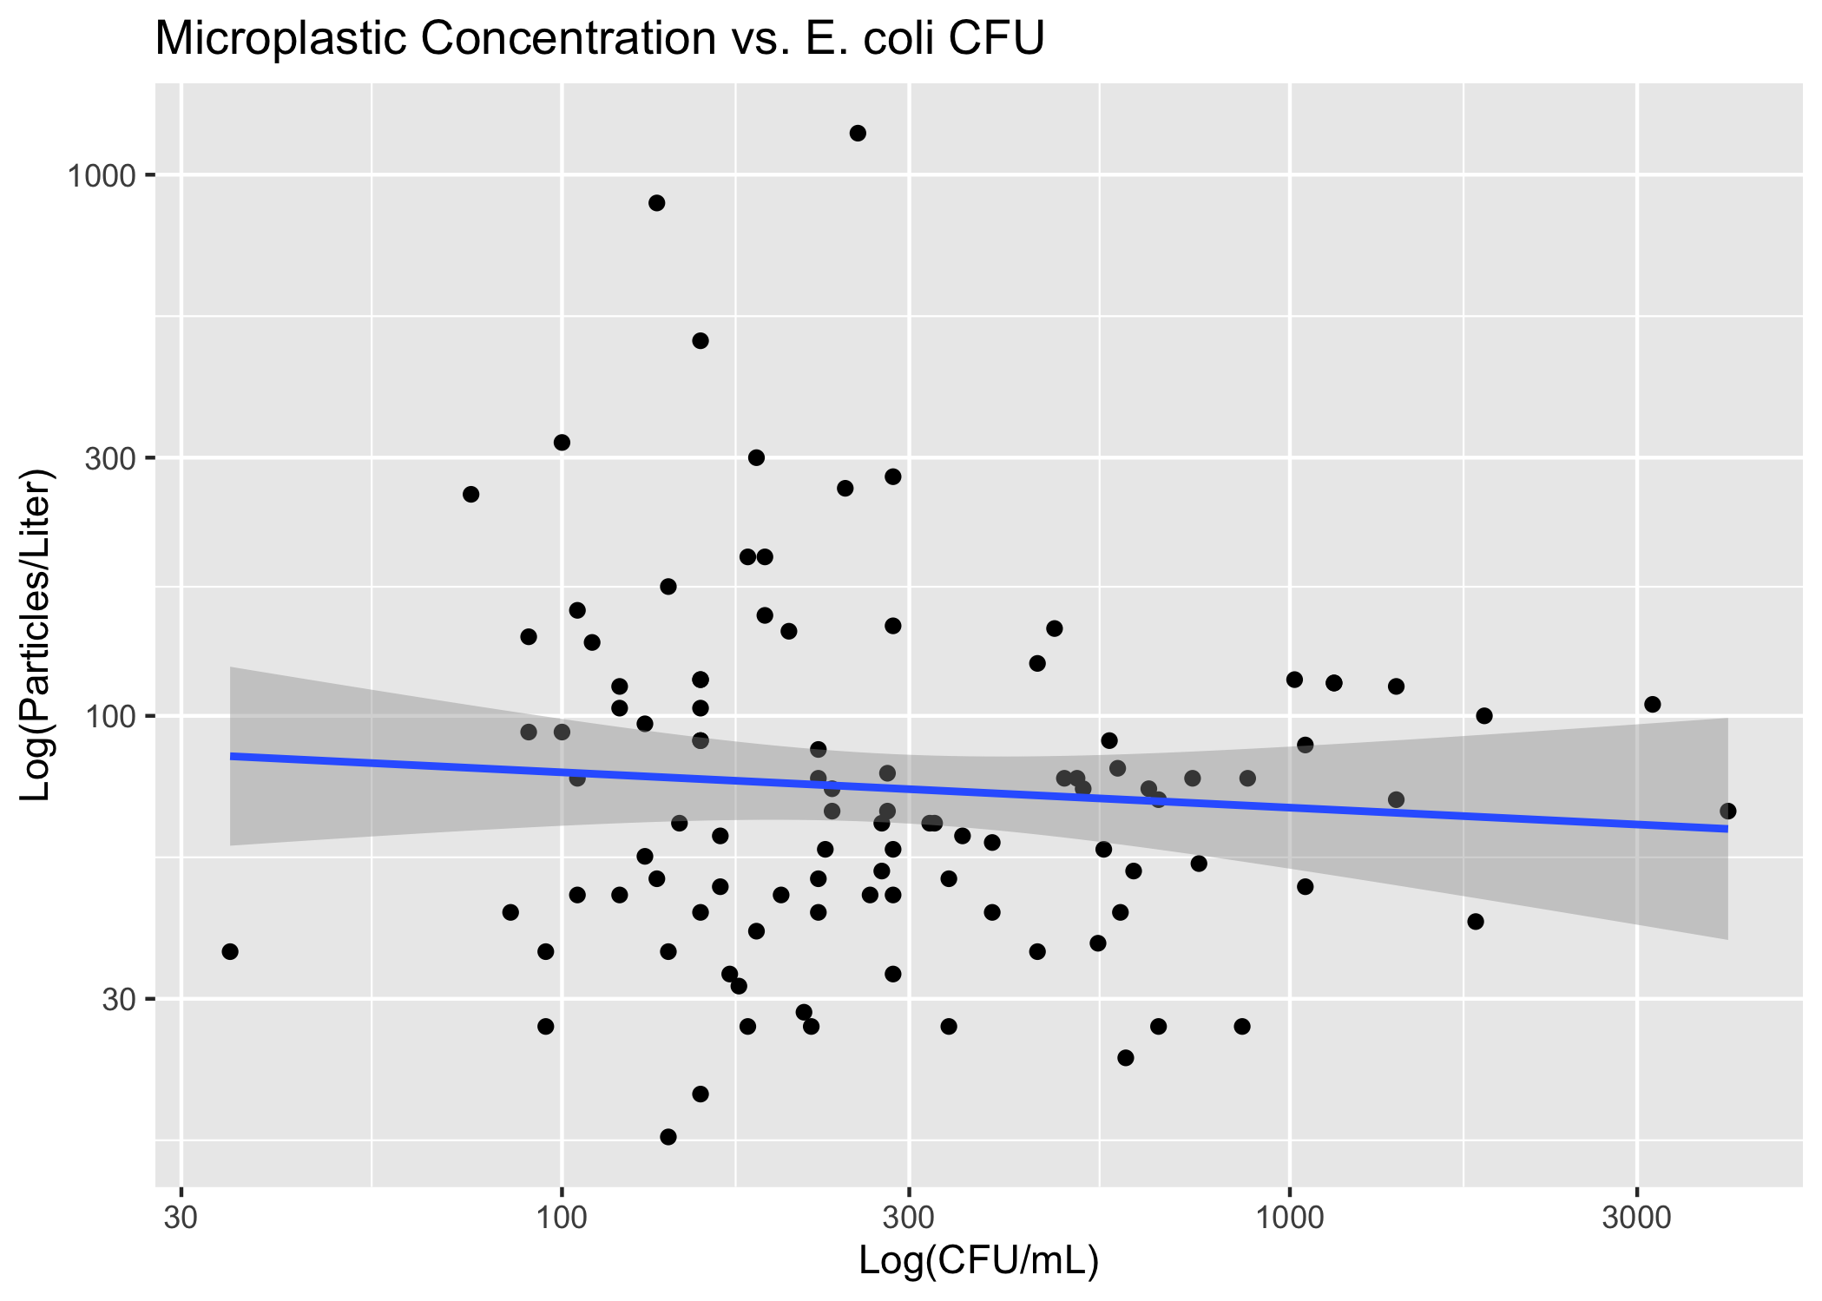

Concentration vs CFU Linear Model

Figure ?? demonstrates a linear model of particles/L vs turbidity.

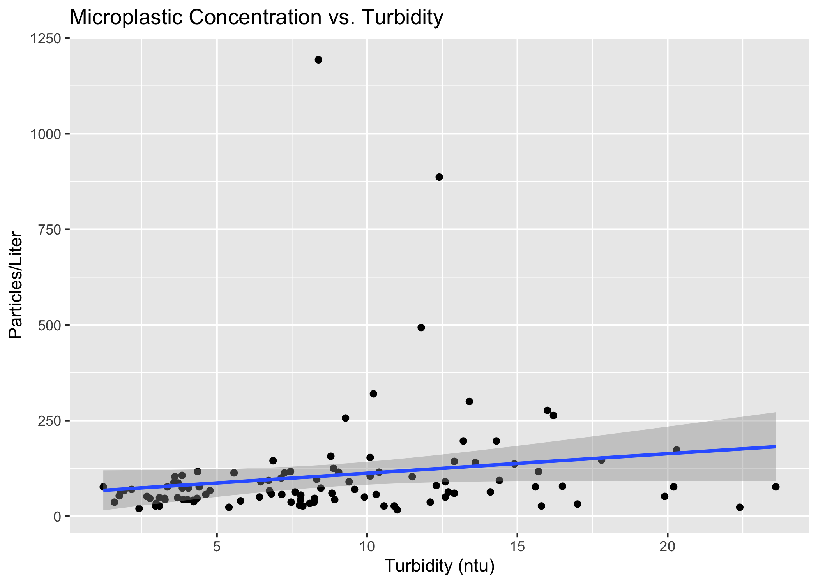

(#fig:m_concvturbidity)Concentration vs Turbidity Linear Model

Table 1 shows a table summarizing a linear model fit predicting particles/L with 6 predictors.

Linear model fit table.

| term | estimate | std.error | statistic | p.value |
| --- | --- | --- | --- | --- |
| (Intercept) | -85.4155522 | 200.1731751 | -0.4267083 | 0.6708307 |
| visual_score | 3.1501966 | 3.5503662 | 0.8872878 | 0.3777987 |
| turbidity.ntu | 8.1849262 | 5.1982368 | 1.5745582 | 0.1196244 |
| temperature.c | -0.9153529 | 3.7770358 | -0.2423469 | 0.8091818 |
| e.coli.cfu | -0.0269844 | 0.0352879 | -0.7646913 | 0.4468871 |
| population | -0.0019187 | 0.0108574 | -0.1767177 | 0.8602129 |
| dist | 0.0033504 | 0.0079782 | 0.4199472 | 0.6757408 |
| watershedBear Creek | -96.7602059 | 210.3266462 | -0.4600473 | 0.6468312 |
| watershedBrooklyn Creek | -4.7845357 | 140.7570975 | -0.0339914 | 0.9729755 |
| watershedCalls Creek | -17.2263069 | 97.7382122 | -0.1762495 | 0.8605794 |
| watershedHunnicutt Creek | 67.1138455 | 115.7405074 | 0.5798648 | 0.5637672 |
| watershedMcNutt Creek | -5.3292443 | 87.4009356 | -0.0609747 | 0.9515438 |
| watershedMiddle Oconee River | -49.3718448 | 114.0909789 | -0.4327410 | 0.6664615 |
| watershedNorth Oconee River | 104.2539248 | 116.1557777 | 0.8975354 | 0.3723442 |
| watershedOconee River | -0.7654564 | 137.9000000 | -0.0055508 | 0.9955861 |
| watershedSandy Creek | -60.1850641 | 203.0550068 | -0.2963978 | 0.7677565 |
| watershedTanyard Creek | 77.6196199 | 158.0304559 | 0.4911687 | 0.6247607 |
| watershedTrail Creek | 13.0256205 | 132.2887015 | 0.0984636 | 0.9218304 |

Beyond the basic linear model, we have applied additional methods to improve model performance, including LASSO regularization and building decision trees and random forests for model comparison. The predictions, outcomes, and residuals resulting from each type of plot are demonstrated in Figure 9

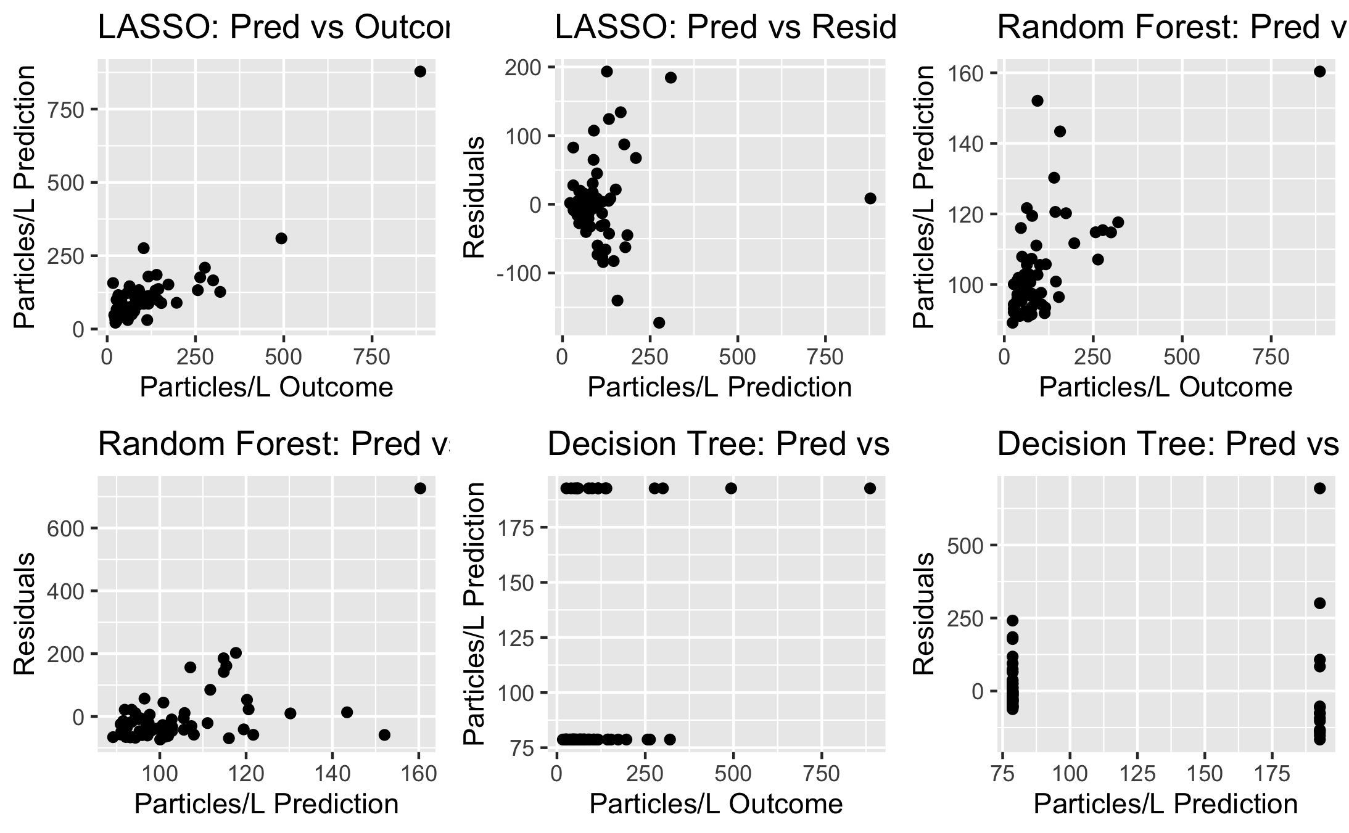

Model Quality

Based on the results of the three different models, the LASSO model is the best option for this dataset, though the minimal difference in RMSE when compared to the null model suggests that even though LASSO is the better model method compared to others, it still does not produce a great model for predicting microplastic concentration.

# 4 Results

# 5 Discussion

This exploratory pilot study demonstrates the presence of freshwater microplastic pollution in the Upper Oconee Watershed and makes an initial attempt to quantify the level of pollution throughout this region of Athens, GA. At the start of this project, there was little to no existing research on microplastics in Athens. Therefore, the data resulting from this study establish the presence of microplastics in the area [mention support of other studies showing MP in urban vs rural areas].

Overall, concentration levels were found to be higher than expected based on some previous studies of regional freshwater microplastic pollution. However, the body of research on microplastics as a whole reflects mixed evidence of concentrations. Recorded levels in the literature range from 1 or fewer particles per liter at some sites to greater than 1000 particles per liter at others. There is growing evidence that microplastic pollution in permeates ecosystems in unexpected, supposedly pristine regions across the globe; one study found between 22 and 117 particles per liter in the Antarctic, demonstrating that microplastic particles are being found in places you would never expect. ## Variation of Microplastic Concentration Limitations to the scope of this project include that it was designed as a student-led pilot with minimal funding. Visual identification via dissecting microscope was the method used due to its simplicity and accessibility; visual identification is used in most baseline microplastic studies, but can be up to 70% inaccurate and therefore is usually accompanied by spectroscopy technology which allows chemical identification of suspected microplastic particles and increasing the accuracy of quantification results.

This year-long pilot study is followed by a continued partnership with the Upper Oconee Watershed Network, who will continue sampling for microplastics quarterly through citizen-science volunteer efforts. Areas of focus for the future include furthering temporal data collection, refining quantification methods, observing the relationship between microplastic levels and other water quality indicators, and exploring other hypothesized water quality predictors. While limited in scope, this study provides valuable initial data on the presence of microplastics in the region and establishes a basis for continued and refined research on the growing subject of freshwater microplastics.

## 5.1 Summary and Interpretation

*Summarize what you did, what you found and what it means.*

## 5.2 Strengths and Limitations

*Discuss what you perceive as strengths and limitations of your analysis.*

## 5.3 Conclusions

*What are the main take-home messages?*

# References

[1] E.J. Carpenter, K.L. Smith, “Plastics on the Sargasso sea surface,” *Science*. 175 (1972) 1240–1241. https://doi.org/[10.1126/science.175.4027.1240](https://doi.org/10.1126/science.175.4027.1240).

[2] R.C. Thompson, Y. Olson, R.P. Mitchell, A. Davis, S.J. Rowland, A.W.G. John, D. McGonigle, A.E. Russell, “Lost at Sea: Where Is All the Plastic?” *Science*. 304 (2004) 838. https://doi.org/[10.1126/science.1094559](https://doi.org/10.1126/science.1094559).

[3] L.G.A. Barboza, A. Dick Vethaak, B.R.B.O. Lavorante, A.K. Lundebye, L. Guilhermino, “Marine microplastic debris: An emerging issue for food security, food safety and human health,” *Marine Pollution Bulletin*. 133 (2018) 336–348. https://doi.org/[10.1016/j.marpolbul.2018.05.047](https://doi.org/10.1016/j.marpolbul.2018.05.047).

[4] “Presence of microplastics and nanoplastics in food, with particular focus on seafood,” *EFSA Journal*. 14 (2016). https://doi.org/[10.2903/j.efsa.2016.4501](https://doi.org/10.2903/j.efsa.2016.4501).

[5] F. Murphy, C. Ewins, F. Carbonnier, B. Quinn, “Wastewater Treatment Works (WwTW) as a Source of Microplastics in the Aquatic Environment,” *Environmental Science and Technology*. 50 (2016) 5800–5808. https://doi.org/[10.1021/acs.est.5b05416](https://doi.org/10.1021/acs.est.5b05416).

[6] S.L. Wright, F.J. Kelly, “Plastic and Human Health: A Micro Issue?” *Environmental Science and Technology*. 51 (2017) 6634–6647. https://doi.org/[10.1021/acs.est.7b00423](https://doi.org/10.1021/acs.est.7b00423).

[7] J. Tibbetts, S. Krause, I. Lynch, G.H.S. Smith, “Abundance, distribution, and drivers of microplastic contamination in urban river environments,” *Water (Switzerland)*. 10 (2018). https://doi.org/[10.3390/w10111597](https://doi.org/10.3390/w10111597).

[8] A. McCormick, T.J. Hoellein, S.A. Mason, J. Schluep, J.J. Kelly, “Microplastic is an abundant and distinct microbial habitat in an urban river,” *Environmental Science and Technology*. 48 (2014) 11863–11871. https://doi.org/[10.1021/es503610r](https://doi.org/10.1021/es503610r).

[9] J. Li, H. Liu, J. Paul Chen, “Microplastics in freshwater systems: A review on occurrence, environmental effects, and methods for microplastics detection,” *Water Research*. 137 (2018) 362–374. https://doi.org/[10.1016/j.watres.2017.12.056](https://doi.org/10.1016/j.watres.2017.12.056).

[10] J.P. Harrison, T.J. Hoellein, M. Sapp, A.S. Tagg, Y. Ju-Nam, J.J. Ojeda, Microplastic-associated biofilms: A comparison of freshwater and marine environments, 2018. https://doi.org/[10.1007/978-3-319-61615-5_9](https://doi.org/10.1007/978-3-319-61615-5_9).

[11] A.P.W. Barrows, K.S. Christiansen, E.T. Bode, T.J. Hoellein, “A watershed-scale, citizen science approach to quantifying microplastic concentration in a mixed land-use river,” *Water Research*. 147 (2018) 382–392. https://doi.org/[10.1016/j.watres.2018.10.013](https://doi.org/10.1016/j.watres.2018.10.013).

[12] K.R. Townsend, H.C. Lu, D.J. Sharley, V. Pettigrove, “Associations between microplastic pollution and land use in urban wetland sediments,” *Environmental Science and Pollution Research*. 26 (2019) 22551–22561. https://doi.org/[10.1007/s11356-019-04885-w](https://doi.org/10.1007/s11356-019-04885-w).

[13] L.T. Yonkos, E.A. Friedel, A.C. Perez-Reyes, S. Ghosal, C.D. Arthur, “Microplastics in four estuarine rivers in the chesapeake bay, U.S.A.” *Environmental Science and Technology*. 48 (2014) 14195–14202. https://doi.org/[10.1021/es5036317](https://doi.org/10.1021/es5036317).

[14] W. Luo, L. Su, N.J. Craig, F. Du, C. Wu, H. Shi, “Comparison of microplastic pollution in different water bodies from urban creeks to coastal waters,” *Environmental Pollution*. 246 (2019) 174–182. https://doi.org/[10.1016/j.envpol.2018.11.081](https://doi.org/10.1016/j.envpol.2018.11.081).

[15] L.C.M. Lebreton, J. Van Der Zwet, J.W. Damsteeg, B. Slat, A. Andrady, J. Reisser, “River plastic emissions to the world’s oceans,” *Nature Communications*. 8 (2017) 1–10. https://doi.org/[10.1038/ncomms15611](https://doi.org/10.1038/ncomms15611).

[16] M. Carbery, W. O’Connor, T. Palanisami, “Trophic transfer of microplastics and mixed contaminants in the marine food web and implications for human health,” *Environment International*. 115 (2018) 400–409. https://doi.org/[10.1016/j.envint.2018.03.007](https://doi.org/10.1016/j.envint.2018.03.007).

[17] K. Tanaka, H. Takada, “Microplastic fragments and microbeads in digestive tracts of planktivorous fish from urban coastal waters,” *Scientific Reports*. 6 (2016) 1–8. https://doi.org/[10.1038/srep34351](https://doi.org/10.1038/srep34351).

[18] J. Carlin, C. Craig, S. Little, M. Donnelly, D. Fox, L. Zhai, L. Walters, “Microplastic accumulation in the gastrointestinal tracts in birds of prey in central Florida, USA,” *Environmental Pollution*. 264 (2020) 114633. https://doi.org/[10.1016/j.envpol.2020.114633](https://doi.org/10.1016/j.envpol.2020.114633).

[19] L. Van Cauwenberghe, C.R. Janssen, “Microplastics in bivalves cultured for human consumption,” *Environmental Pollution*. 193 (2014) 65–70. https://doi.org/[10.1016/j.envpol.2014.06.010](https://doi.org/10.1016/j.envpol.2014.06.010).

[20] L.I. Devriese, M.D. van der Meulen, T. Maes, K. Bekaert, I. Paul-Pont, L. Frère, J. Robbens, A.D. Vethaak, “Microplastic contamination in brown shrimp (Crangon crangon, Linnaeus 1758) from coastal waters of the Southern North Sea and Channel area,” *Marine Pollution Bulletin*. 98 (2015) 179–187. https://doi.org/[10.1016/J.MARPOLBUL.2015.06.051](https://doi.org/10.1016/J.MARPOLBUL.2015.06.051).

[21] F. Murray, P.R. Cowie, “Plastic contamination in the decapod crustacean Nephrops norvegicus (Linnaeus, 1758),” *Marine Pollution Bulletin*. 62 (2011) 1207–1217. https://doi.org/[10.1016/J.MARPOLBUL.2011.03.032](https://doi.org/10.1016/J.MARPOLBUL.2011.03.032).

[22] Y. Mato, T. Isobe, H. Takada, H. Kanehiro, C. Ohtake, T. Kaminuma, “Plastic resin pellets as a transport medium for toxic chemicals in the marine environment,” *Environmental Science and Technology*. 35 (2001) 318–324. https://doi.org/[10.1021/es0010498](https://doi.org/10.1021/es0010498).

[23] H. Bouwmeester, P.C.H. Hollman, R.J.B. Peters, “Potential Health Impact of Environmentally Released Micro- and Nanoplastics in the Human Food Production Chain: Experiences from Nanotoxicology,” *Environmental Science and Technology*. 49 (2015) 8932–8947. https://doi.org/[10.1021/acs.est.5b01090](https://doi.org/10.1021/acs.est.5b01090).

[24] C.M. Free, O.P. Jensen, S.A. Mason, M. Eriksen, N.J. Williamson, B. Boldgiv, “High-levels of microplastic pollution in a large, remote, mountain lake,” *Marine Pollution Bulletin*. 85 (2014) 156–163. https://doi.org/[10.1016/j.marpolbul.2014.06.001](https://doi.org/10.1016/j.marpolbul.2014.06.001).

[25] C.L. Waller, H.J. Griffiths, C.M. Waluda, S.E. Thorpe, I. Loaiza, B. Moreno, C.O. Pacherres, K.A. Hughes, “Microplastics in the Antarctic marine system: An emerging area of research,” *Science of the Total Environment*. 598 (2017) 220–227. https://doi.org/[10.1016/j.scitotenv.2017.03.283](https://doi.org/10.1016/j.scitotenv.2017.03.283).

[26] X. Peng, M. Chen, S. Chen, S. Dasgupta, H. Xu, K. Ta, M. Du, J. Li, Z. Guo, S. Bai, “Microplastics contaminate the deepest part of the world’s ocean,” *Geochemical Perspectives Letters*. 9 (2018) 1–5. https://doi.org/[10.7185/geochemlet.1829](https://doi.org/10.7185/geochemlet.1829).

[27] J. Zalasiewicz, C.N. Waters, J.A. Ivar do Sul, P.L. Corcoran, A.D. Barnosky, A. Cearreta, M. Edgeworth, A. Gałuszka, C. Jeandel, R. Leinfelder, J.R. McNeill, W. Steffen, C. Summerhayes, M. Wagreich, M. Williams, A.P. Wolfe, Y. Yonan, “The geological cycle of plastics and their use as a stratigraphic indicator of the Anthropocene,” (2016). https://doi.org/[10.1016/j.ancene.2016.01.002](https://doi.org/10.1016/j.ancene.2016.01.002).

[28] R. Geyer, J.R. Jambeck, K.L. Law, “Production, use, and fate of all plastics ever made,” *Science Advances*. 3 (2017) 25–29. https://doi.org/[10.1126/sciadv.1700782](https://doi.org/10.1126/sciadv.1700782).

[29] M.D. Prokić, T.B. Radovanović, J.P. Gavrić, C. Faggio, “Ecotoxicological effects of microplastics: Examination of biomarkers, current state and future perspectives,” *TrAC - Trends in Analytical Chemistry*. 111 (2019) 37–46. https://doi.org/[10.1016/j.trac.2018.12.001](https://doi.org/10.1016/j.trac.2018.12.001).

[30] G. Everaert, L. Van Cauwenberghe, M. De Rijcke, A.A. Koelmans, J. Mees, M. Vandegehuchte, C.R. Janssen, “Risk assessment of microplastics in the ocean: Modelling approach and first conclusions,” *Environmental Pollution*. 242 (2018) 1930–1938. https://doi.org/[10.1016/j.envpol.2018.07.069](https://doi.org/10.1016/j.envpol.2018.07.069).

[31] A.L. Andrady, “Microplastics in the marine environment,” (2011). https://doi.org/[10.1016/j.marpolbul.2011.05.030](https://doi.org/10.1016/j.marpolbul.2011.05.030).

[32] M.A. Browne, T.S. Galloway, R.C. Thompson, “Spatial patterns of plastic debris along estuarine shorelines,” *Environmental Science and Technology*. 44 (2010) 3404–3409. https://doi.org/[10.1021/es903784e](https://doi.org/10.1021/es903784e).

[33] E. Besseling, J.T.K. Quik, M. Sun, A.A. Koelmans, “Fate of nano- and microplastic in freshwater systems: A modeling study,” *Environmental Pollution*. 220 (2017) 540–548. https://doi.org/[10.1016/j.envpol.2016.10.001](https://doi.org/10.1016/j.envpol.2016.10.001).

[34] R. Dris, J. Gasperi, V. Rocher, M. Saad, N. Renault, B. Tassin, “Microplastic contamination in an urban area: A case study in Greater Paris,” *Environmental Chemistry*. 12 (2015) 592–599. https://doi.org/[10.1071/EN14167](https://doi.org/10.1071/EN14167).

[35] D.S. Fisher, J.L. Steiner, D.M. Endale, J.A. Stuedemann, H.H. Schomberg, A.J. Franzluebbers, S.R. Wilkinson, “The relationship of land use practices to surface water quality in the Upper Oconee Watershed of Georgia,” *Forest Ecology and Management*. 128 (2000).

[36] S. Cho, L.M. Hiott, J.B. Barrett, E.A. McMillan, S.L. House, S.B. Humayoun, E.S. Adams, C.R. Jackson, J.G. Frye, “Prevalence and characterization of Escherichia coli isolated from the Upper Oconee Watershed in Northeast Georgia,” *PLOS ONE*. 13 (2018) e0197005. https://doi.org/[10.1371/JOURNAL.PONE.0197005](https://doi.org/10.1371/JOURNAL.PONE.0197005).

[37] V. Hidalgo-Ruz, L. Gutow, R.C. Thompson, M. Thiel, “Microplastics in the marine environment: A review of the methods used for identification and quantification,” *Environmental Science and Technology*. 46 (2012) 3060–3075. https://doi.org/[10.1021/es2031505](https://doi.org/10.1021/es2031505).