Supplementary Materials: Plastic in the Urban Freshwater Environment

An Exploratory Study of Microplastics in the Upper Oconee Watershed via Community-Based Efforts

Amelia M. Foley

2021-11-12

## 0.1 Exploratory analysis

This section will contain the key products of my exploratory analysis (located in exploration.Rmd) when complete. Since I am keeping this document in manuscript style, I will keep processing/exploration/analysis code separate.

Table ?? shows a table summarizing the data.

### 0.1.1 Distribution of Microplastic Concentration

Figure 1 shows a histogram of microplastic concentration observations. The minimum concentration is 16.67 particles/L and the maximum is 1193.33 particles/L. The mean concentration is 104.39 particles/L, and the median is 66.67 particles/L.

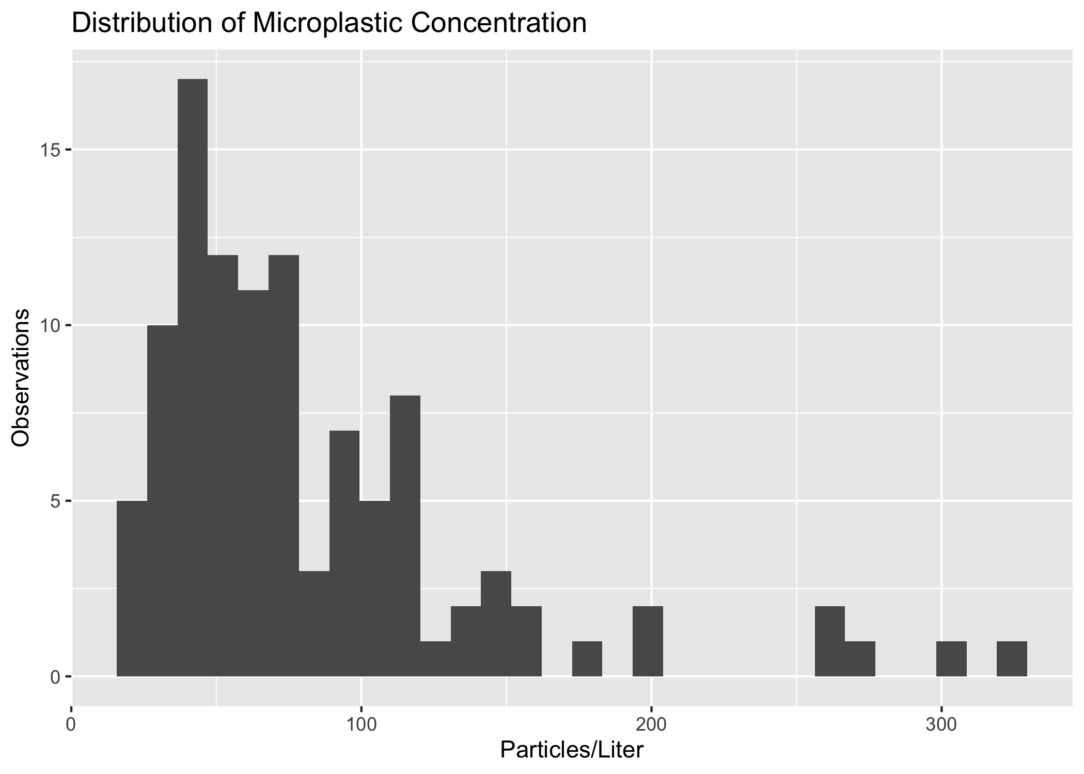

Distribution of Microplastic Concentration

Microplastic concentrations remained in similar ranges throughout the study period. Figure 2 shows a boxplot of concentrations by sample date.

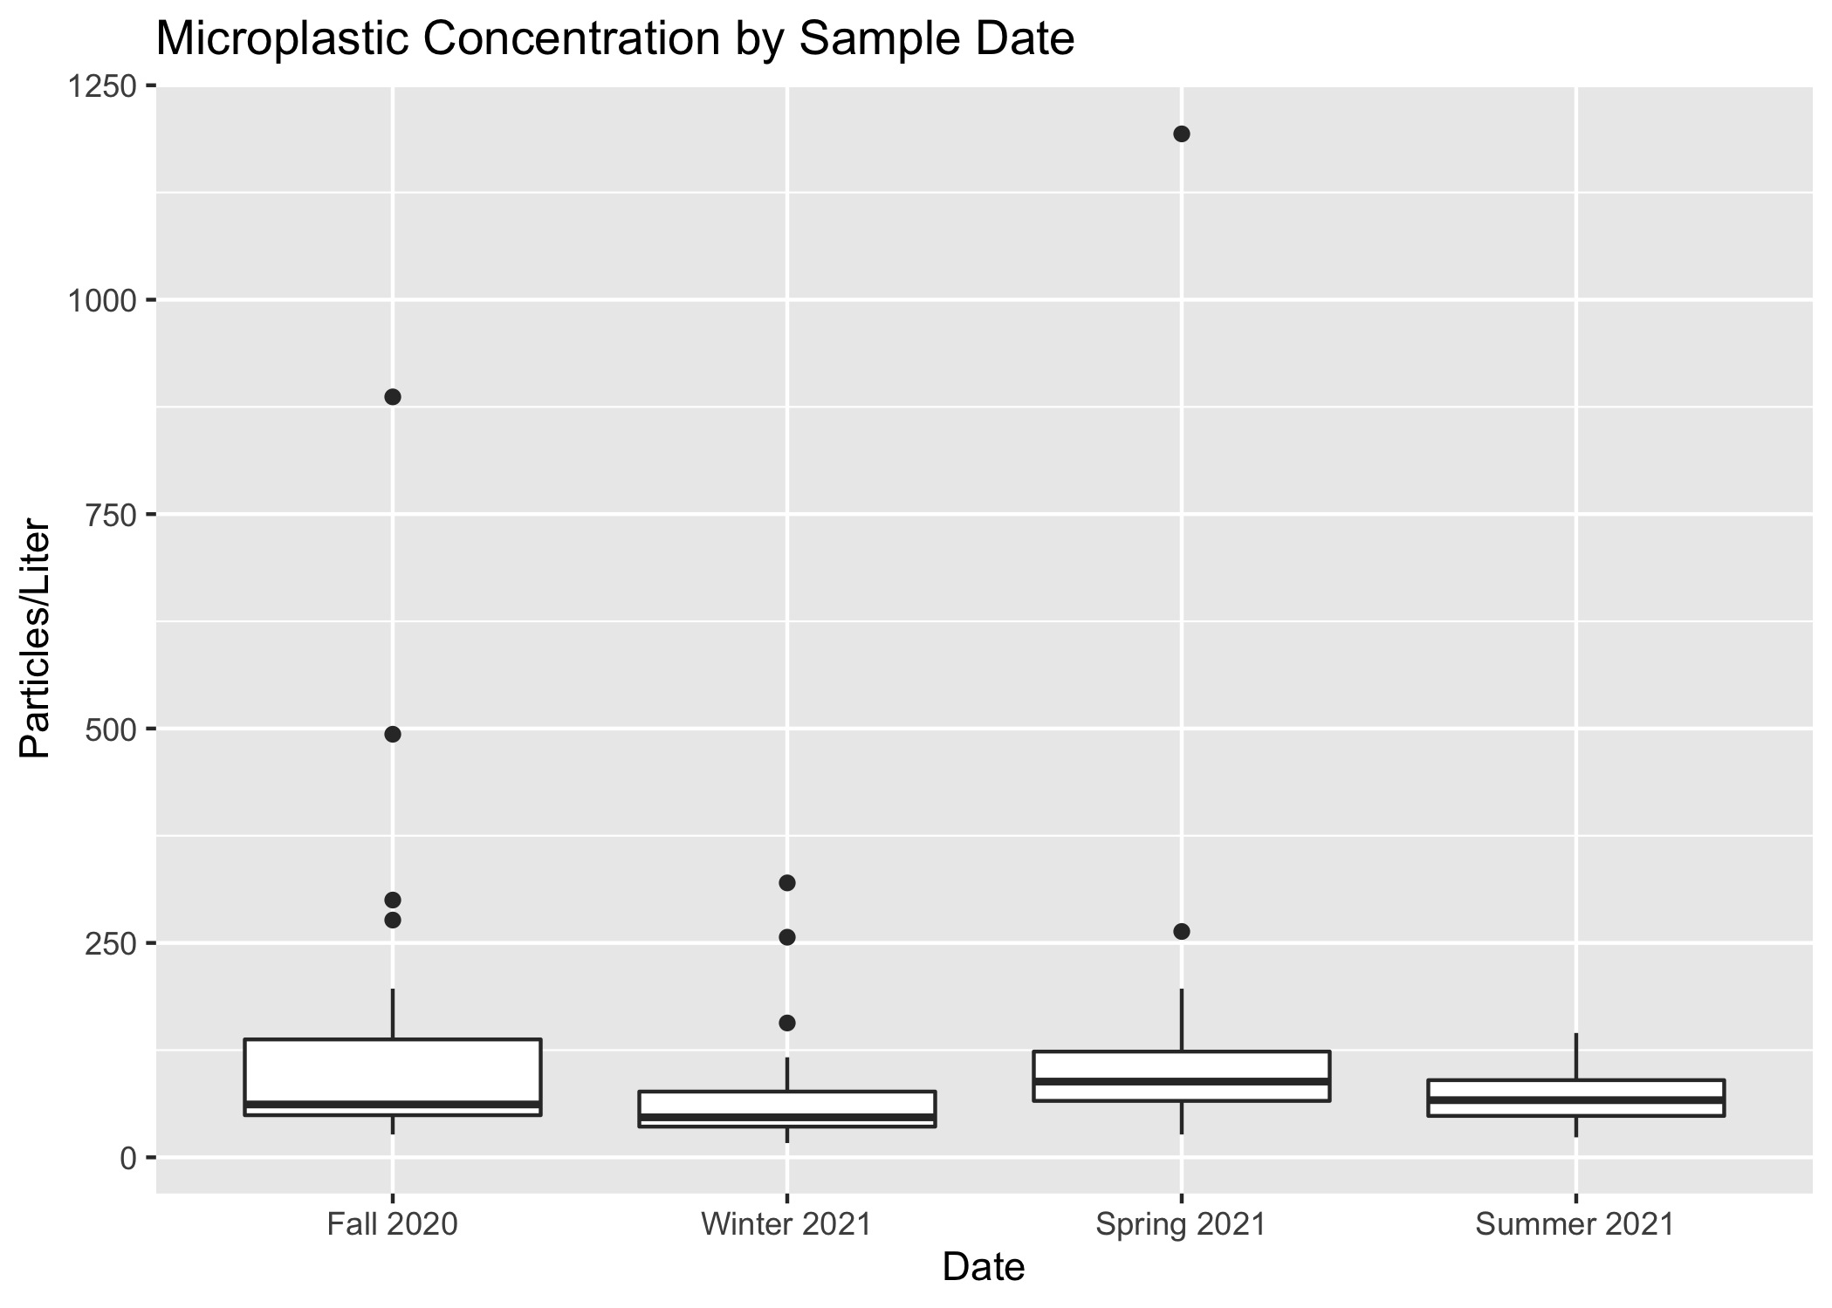

Particles/L by Sample Date

There is some seasonal variation in concentration at each individual site. Figure 3 shows a plot of concentrations at each site.

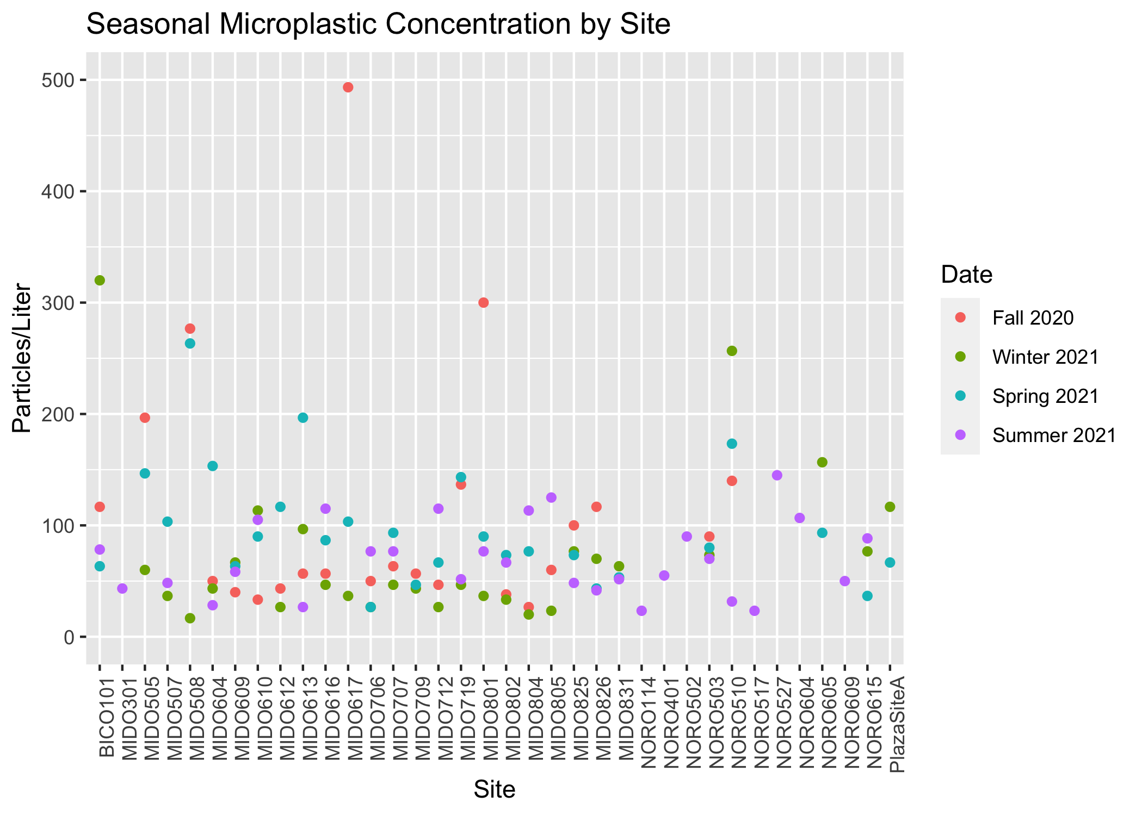

Seasonal Variation in Particles/L

There are similar microplastic levels throughout the watersheds within the Upper Oconee. Some watersheds experienced greater variation in microplastic levels than other watersheds. Figure 4 shows the microplastic concentrations by watershed.

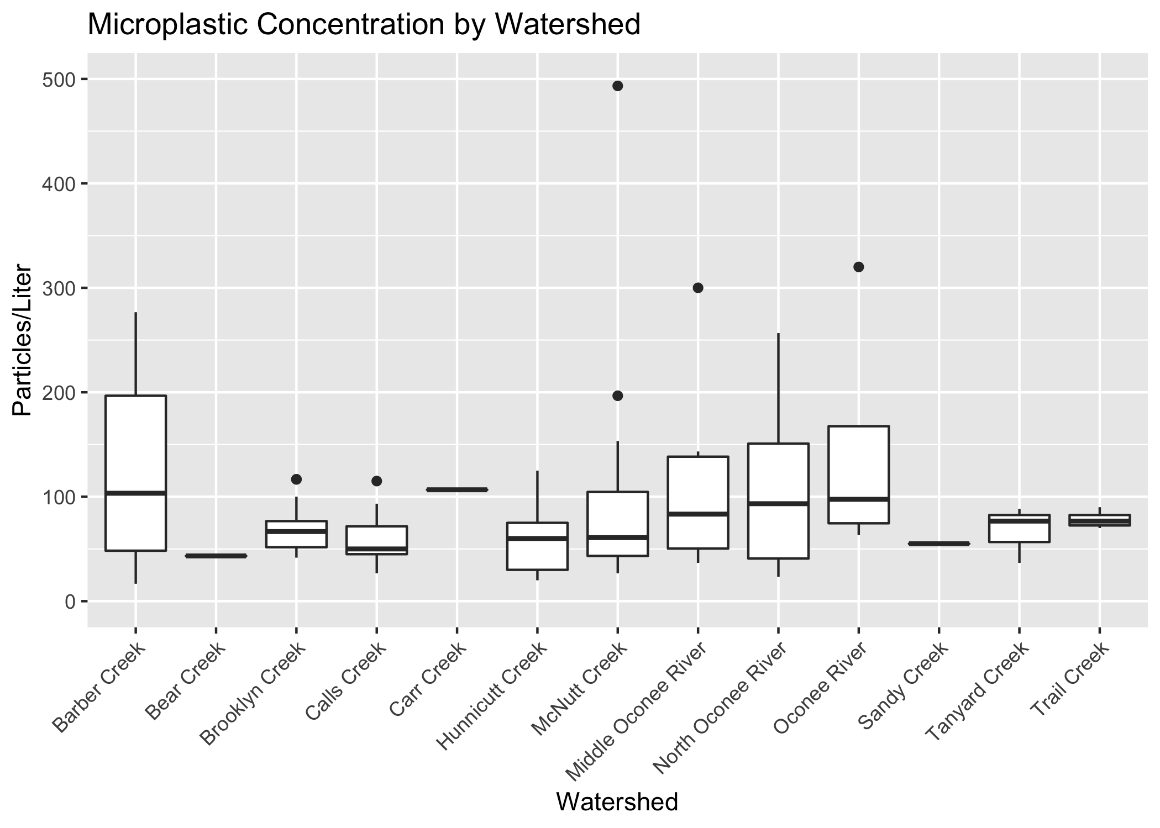

Watershed Microplastic Concentrations

Figure 5 shows a line graph of the mean watershed microplastic concentrations at each seasonal sampling date.

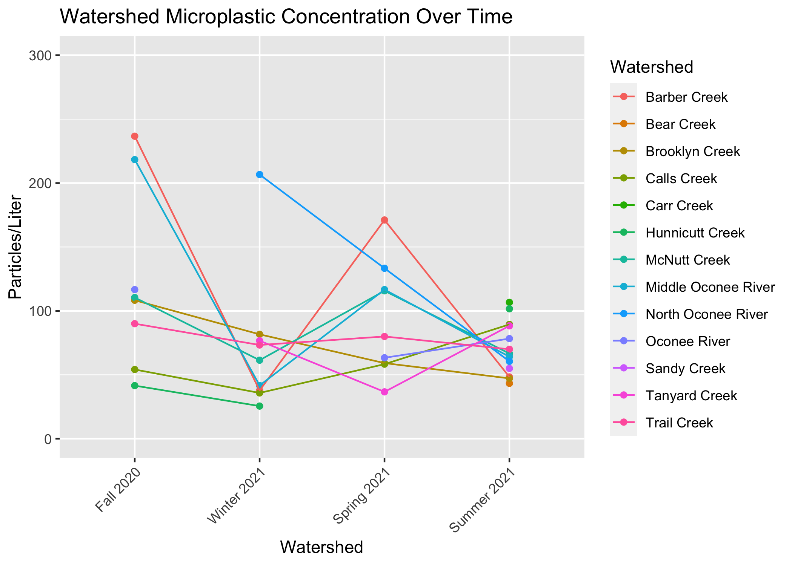

Microplastic Concentration Over Time

### 0.1.2 Predictors

Population, land cover/use, and bacteria levels are hypothesized predictors of microplastic concentration. Figure 6 and Figure 7 demonstrate the relationship between microplastic concentration and population and microplastic concentration and bacteria levels (CFU/L), respectively.

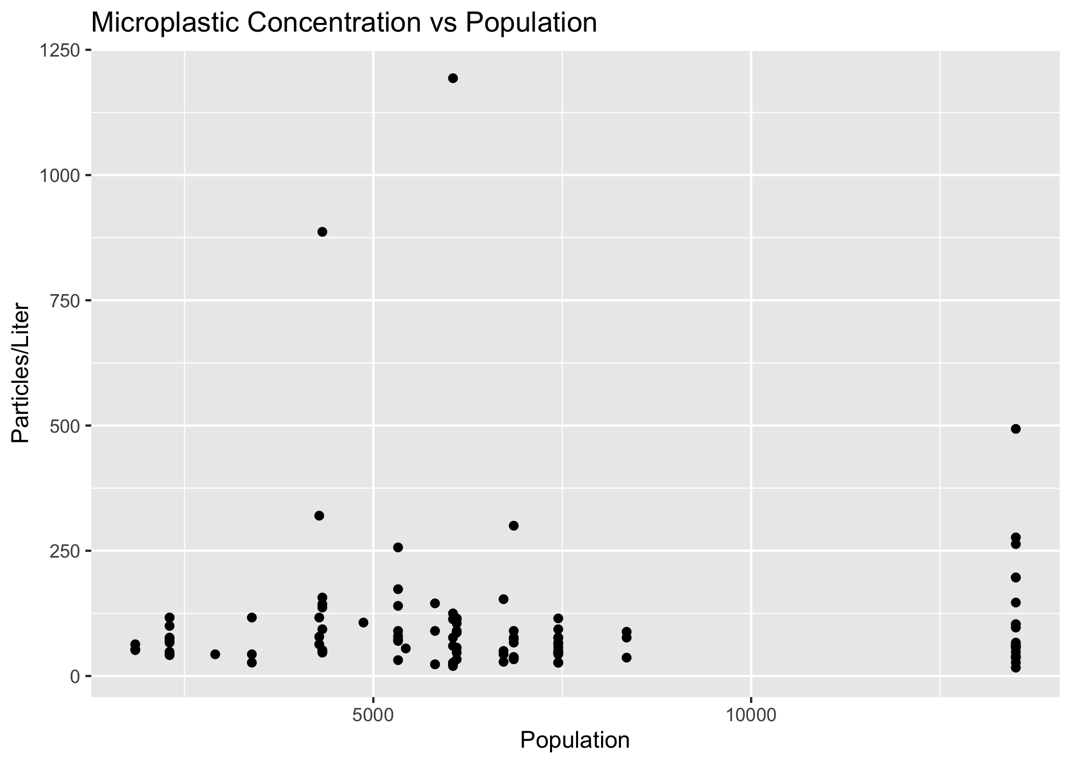

Particles/L vs Population

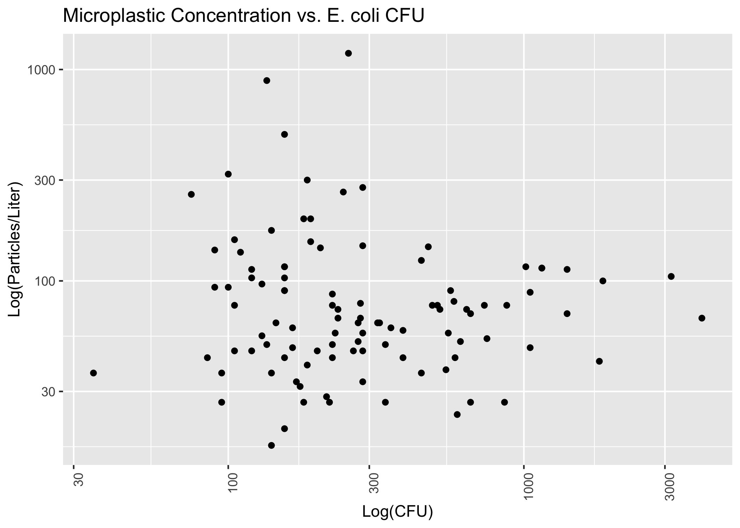

Log particles/L vs CFU

Figure 8 and Figure 9 show correlation matrices for the hypothesized predictor and for the different categories of land use.

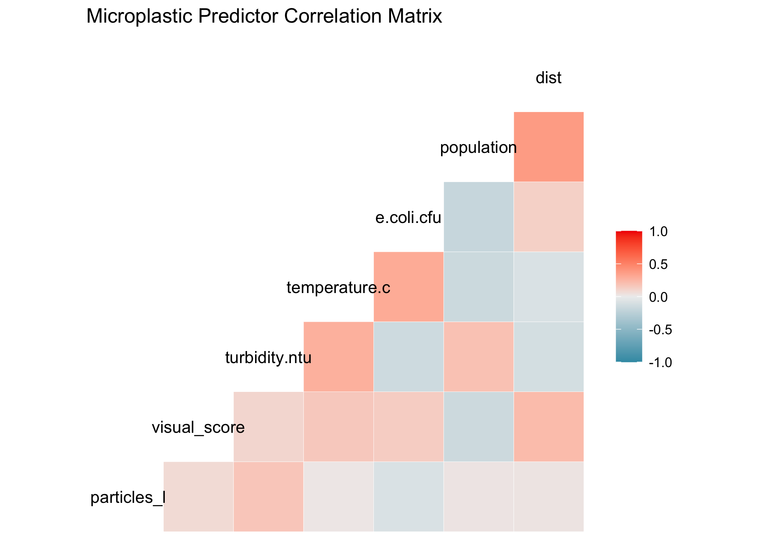

Predictor matrix

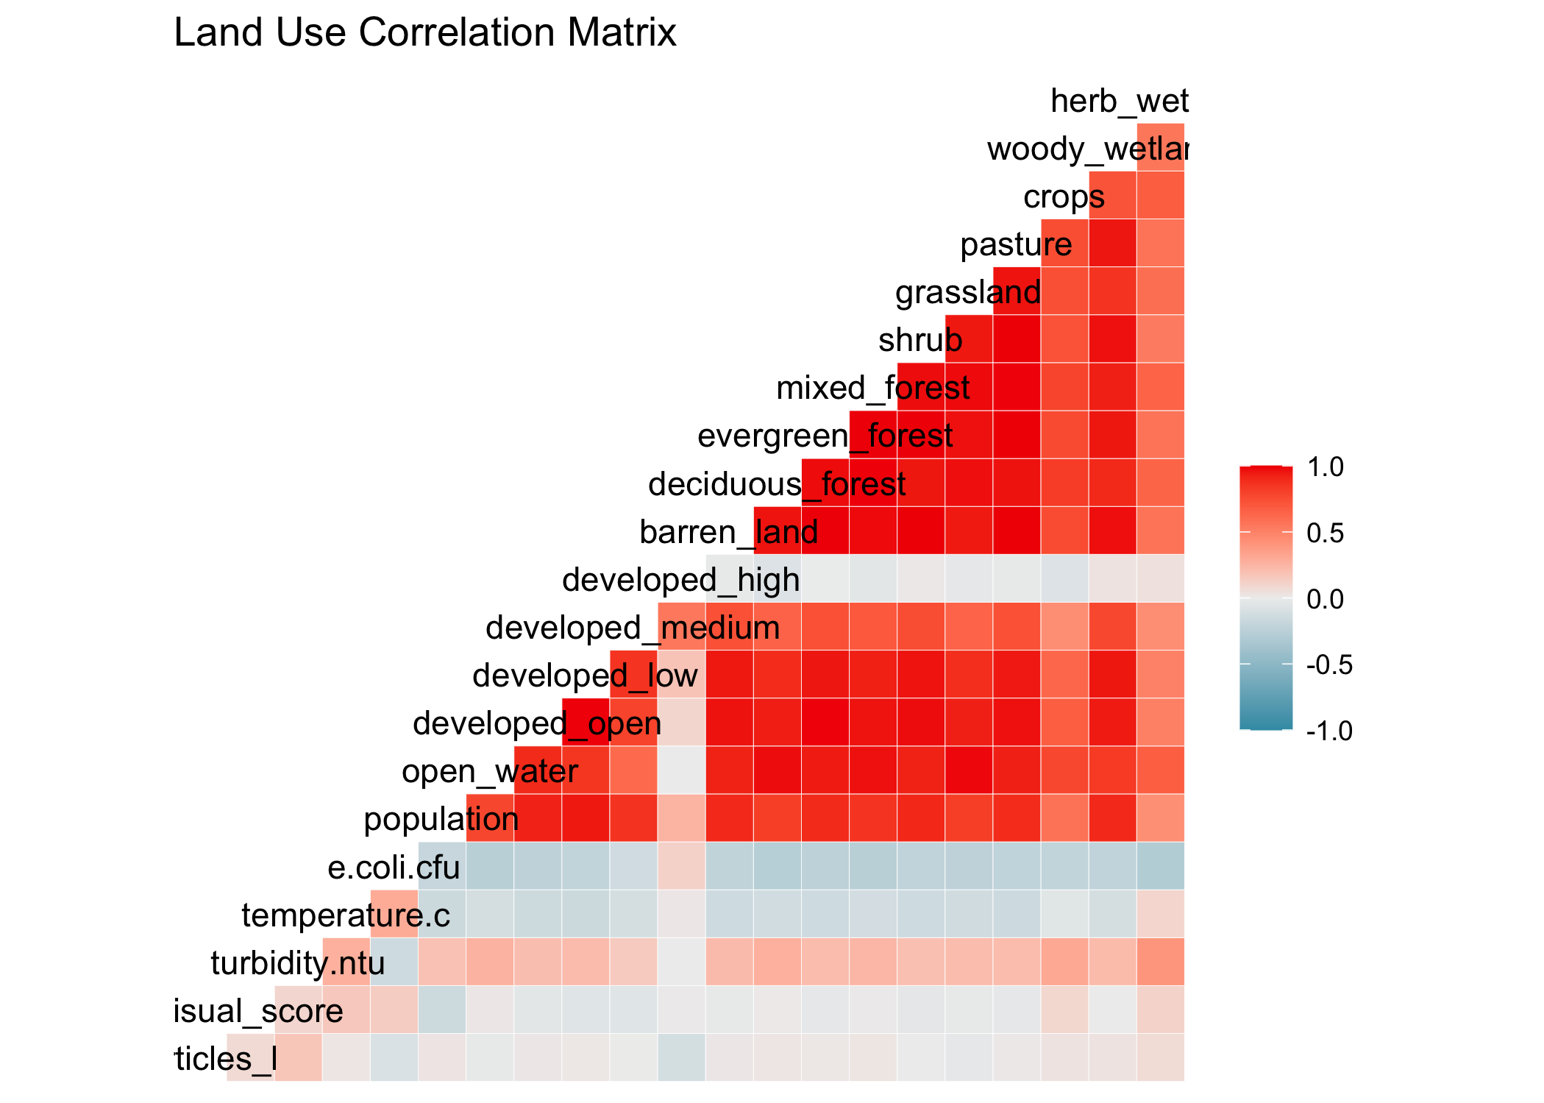

Land cover matrix

## 0.2 Full analysis

Preliminary modeling reveals that there is not a strong relationship between microplastic concentration and population level. Figure 10 demonstrates a linear model fit.

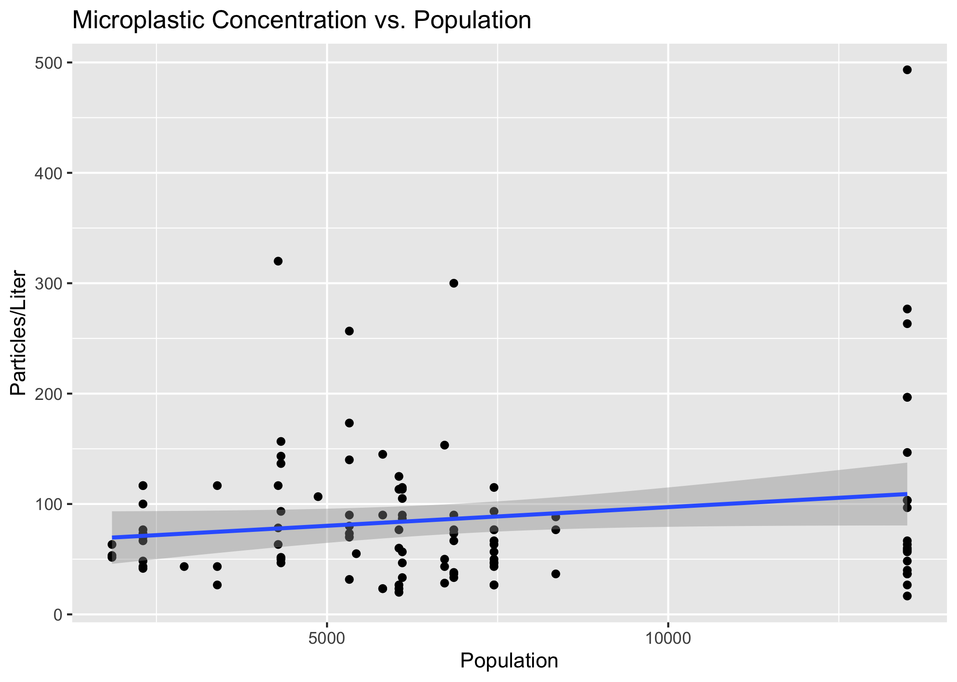

Concentration vs Population Linear Model

Figure 11 shows a linear model of microplastic concentration vs CFU (both variables log-transformed).

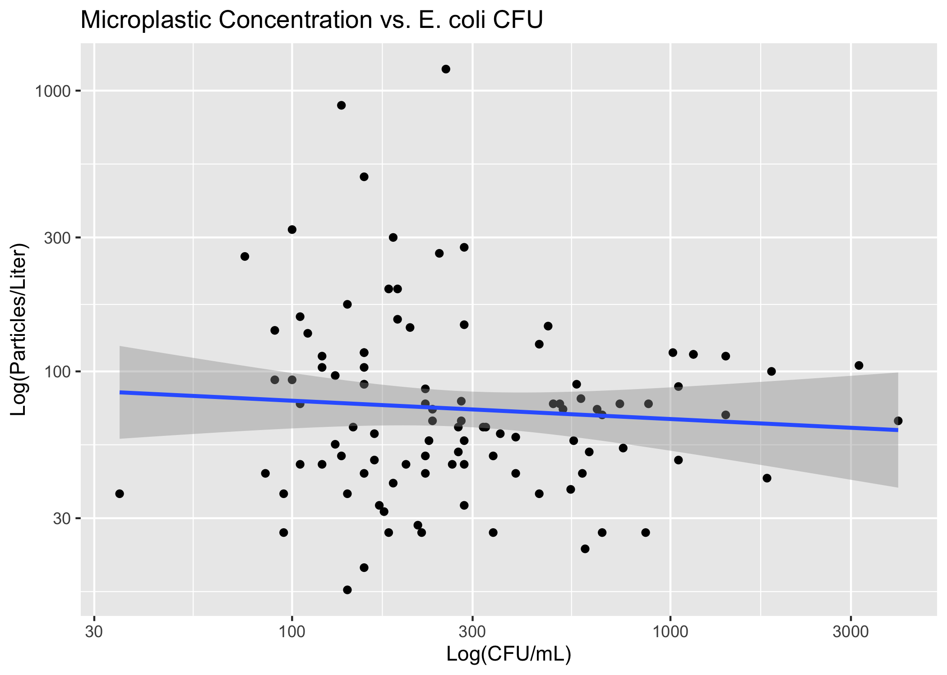

Concentration vs CFU Linear Model

Figure ?? demonstrates a linear model of particles/L vs turbidity.

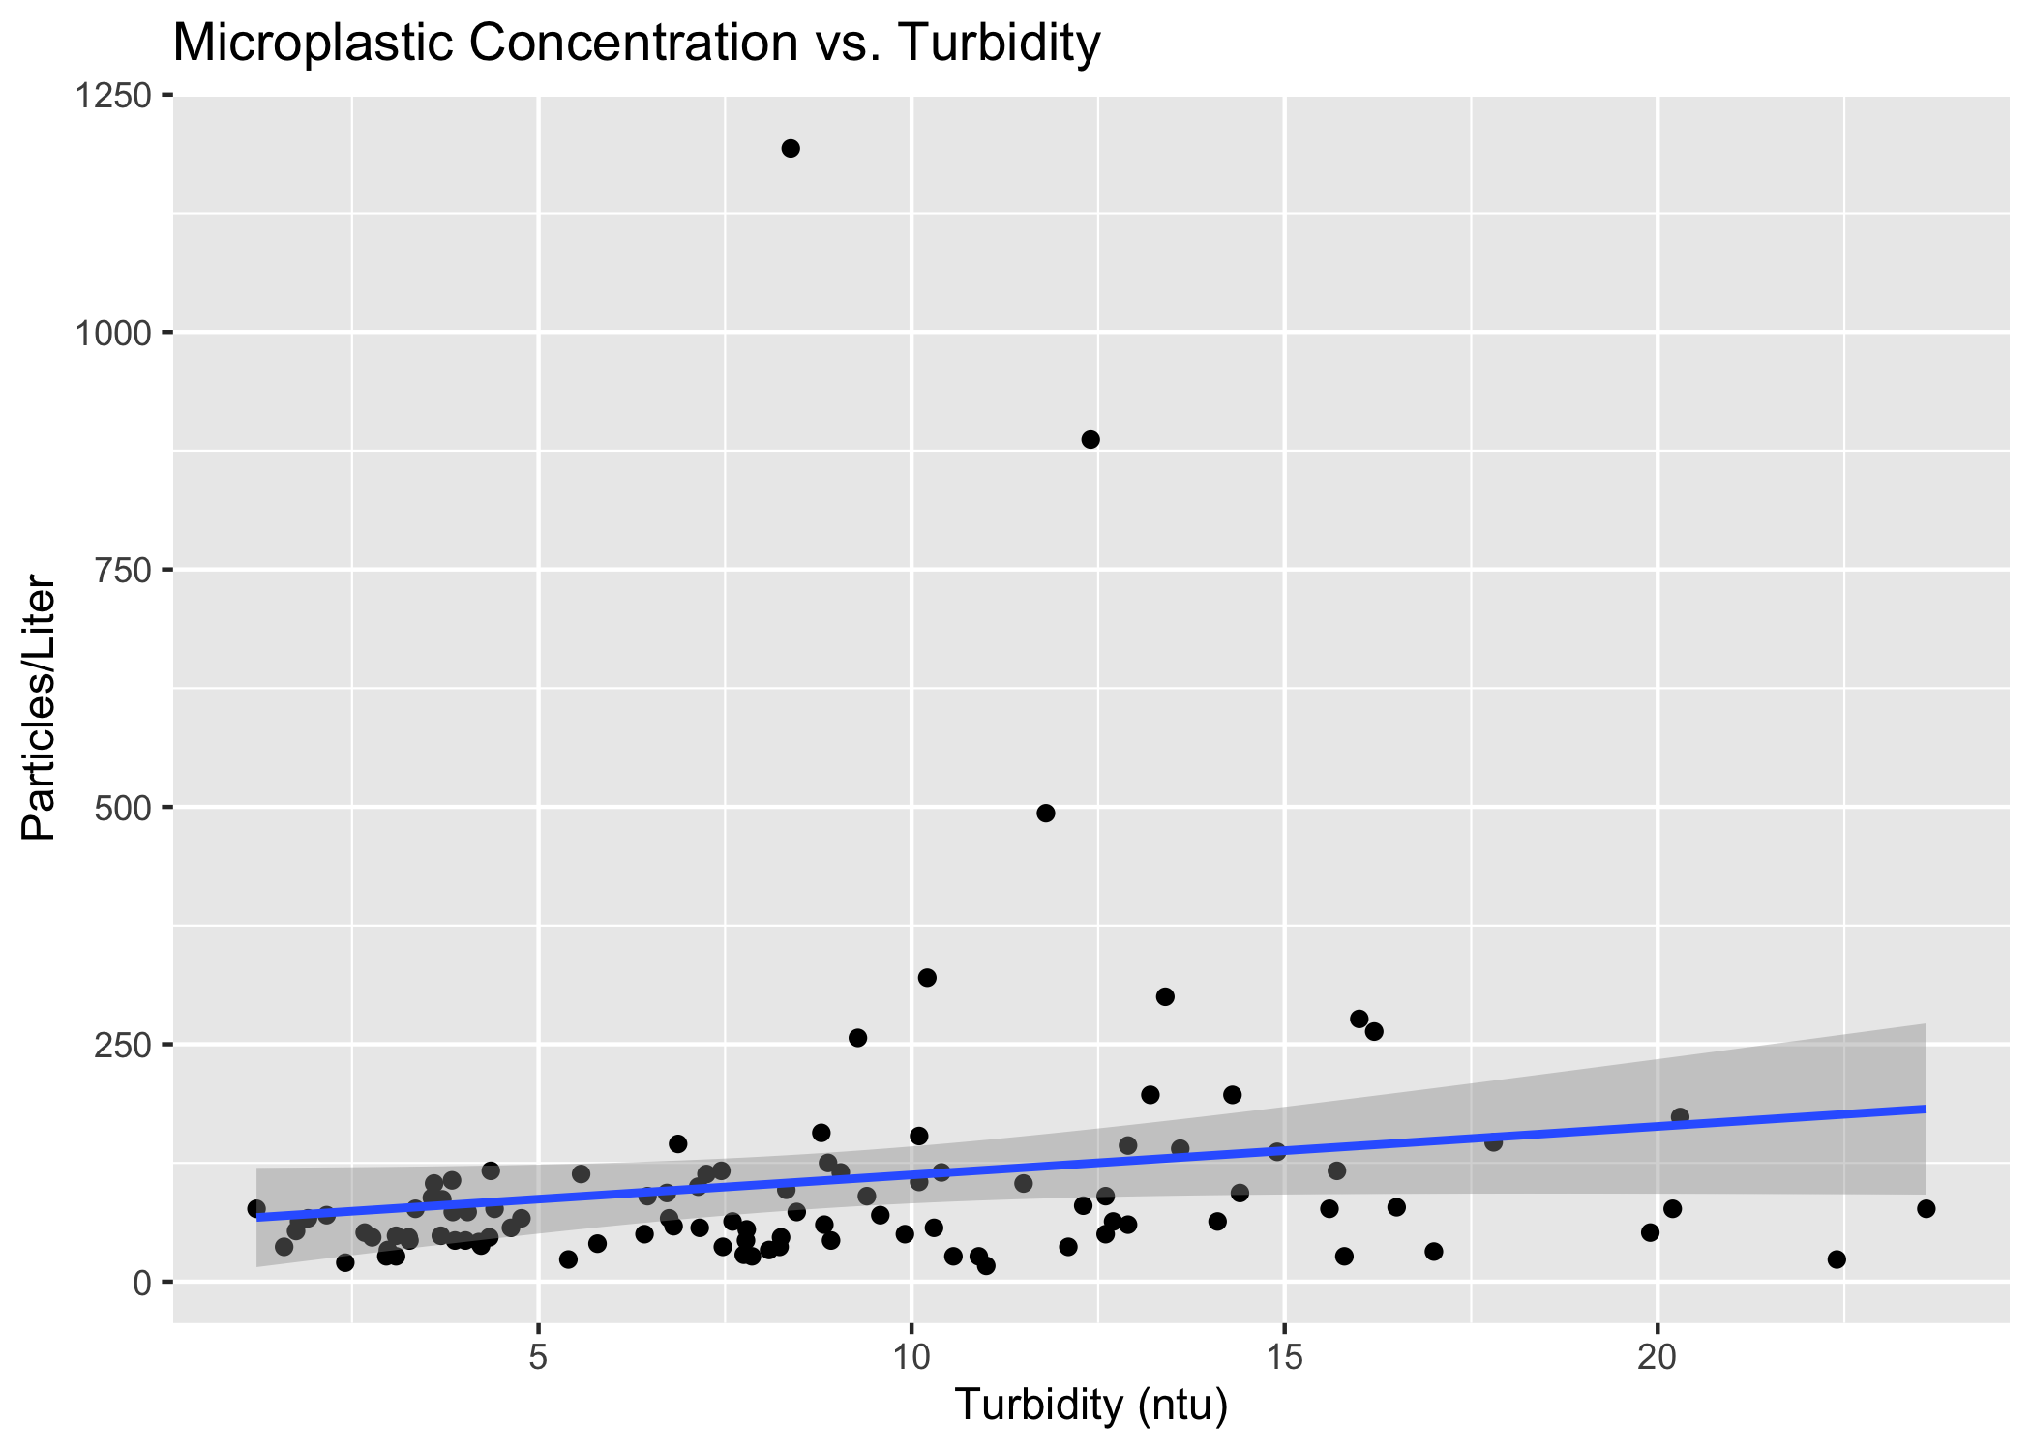

(#fig:m_concvturbidity)Concentration vs Turbidity Linear Model

Table 1 shows a table summarizing a linear model fit predicting particles/L with 6 predictors.

Linear model fit table.

| term | estimate | std.error | statistic | p.value |
| --- | --- | --- | --- | --- |
| (Intercept) | -85.4155522 | 200.1731751 | -0.4267083 | 0.6708307 |
| visual_score | 3.1501966 | 3.5503662 | 0.8872878 | 0.3777987 |
| turbidity.ntu | 8.1849262 | 5.1982368 | 1.5745582 | 0.1196244 |
| temperature.c | -0.9153529 | 3.7770358 | -0.2423469 | 0.8091818 |
| e.coli.cfu | -0.0269844 | 0.0352879 | -0.7646913 | 0.4468871 |
| population | -0.0019187 | 0.0108574 | -0.1767177 | 0.8602129 |
| dist | 0.0033504 | 0.0079782 | 0.4199472 | 0.6757408 |
| watershedBear Creek | -96.7602059 | 210.3266462 | -0.4600473 | 0.6468312 |
| watershedBrooklyn Creek | -4.7845357 | 140.7570975 | -0.0339914 | 0.9729755 |
| watershedCalls Creek | -17.2263069 | 97.7382122 | -0.1762495 | 0.8605794 |
| watershedHunnicutt Creek | 67.1138455 | 115.7405074 | 0.5798648 | 0.5637672 |
| watershedMcNutt Creek | -5.3292443 | 87.4009356 | -0.0609747 | 0.9515438 |
| watershedMiddle Oconee River | -49.3718448 | 114.0909789 | -0.4327410 | 0.6664615 |
| watershedNorth Oconee River | 104.2539248 | 116.1557777 | 0.8975354 | 0.3723442 |
| watershedOconee River | -0.7654564 | 137.9000000 | -0.0055508 | 0.9955861 |
| watershedSandy Creek | -60.1850641 | 203.0550068 | -0.2963978 | 0.7677565 |
| watershedTanyard Creek | 77.6196199 | 158.0304559 | 0.4911687 | 0.6247607 |
| watershedTrail Creek | 13.0256205 | 132.2887015 | 0.0984636 | 0.9218304 |