Vrinda Store Data Analysis – 2022 Summary
Prepared by: A Gnanaprakash | Generated on: Jan 03, 2026

Executive Summary
This report analyzes Vrinda Store orders and revenue using the provided Excel dashboard. In 2022, total revenue was ₹21,176,377 across 31,047 orders, with an Average Order Value (AOV) of ₹682. Delivery rate was 92.3% while cancellation, return, and refund rates were 2.7%, 3.4%, and 1.7% respectively. Peak revenue month was Mar with ₹1,928,066 in sales.

Key Performance Indicators (KPIs)
- Total Revenue: ₹21,176,377
- Total Orders: 31,047
- Unique Customers: 28,437
- Average Order Value (AOV): ₹682
- Delivery Rate: 92.3%
- Cancellation Rate: 2.7%
- Return Rate: 3.4%
- Refund Rate: 1.7%

Monthly Performance
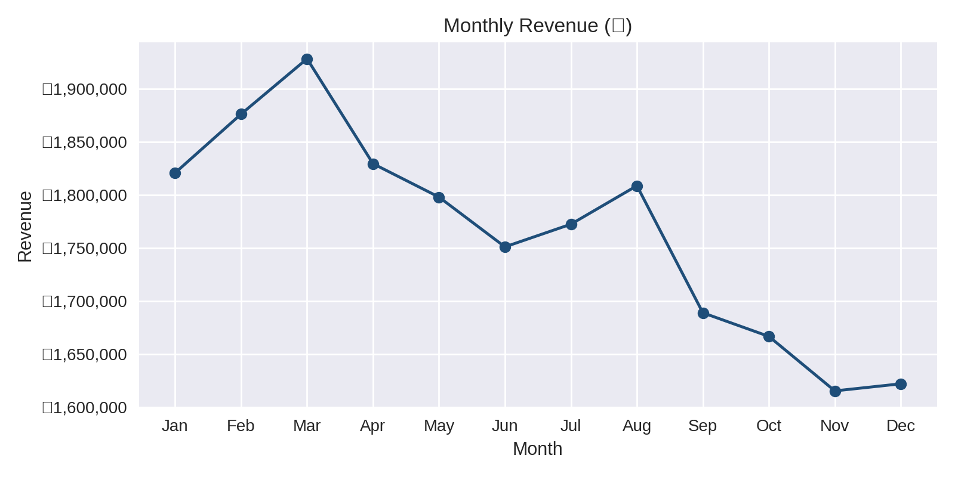
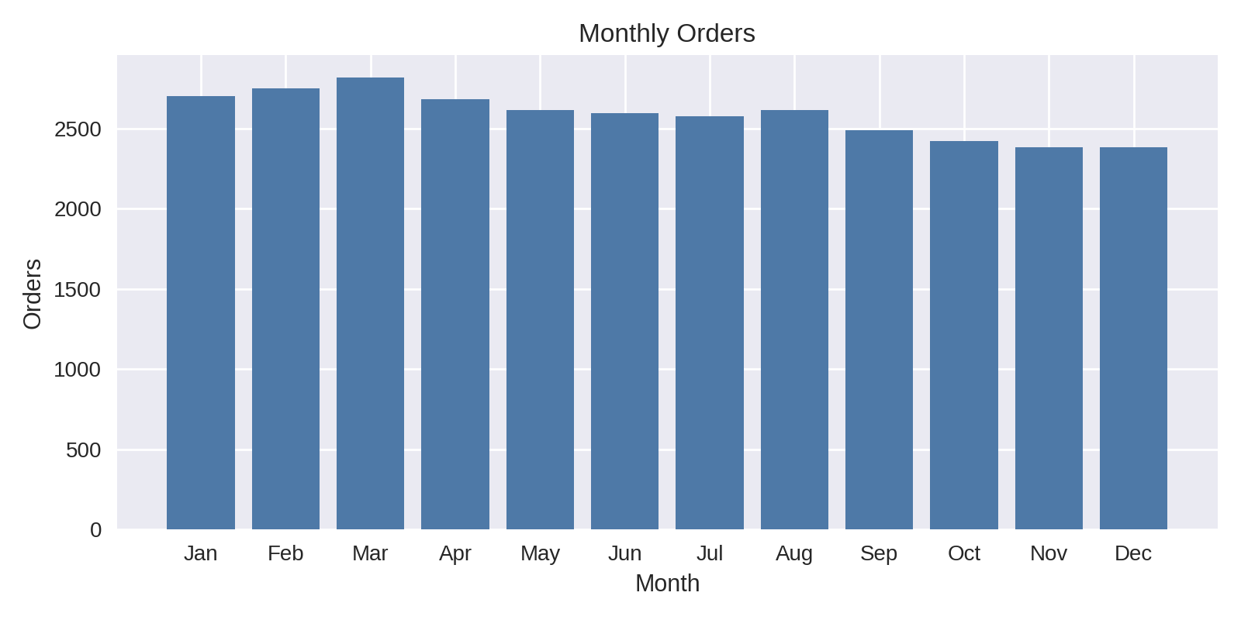

Segment Performance
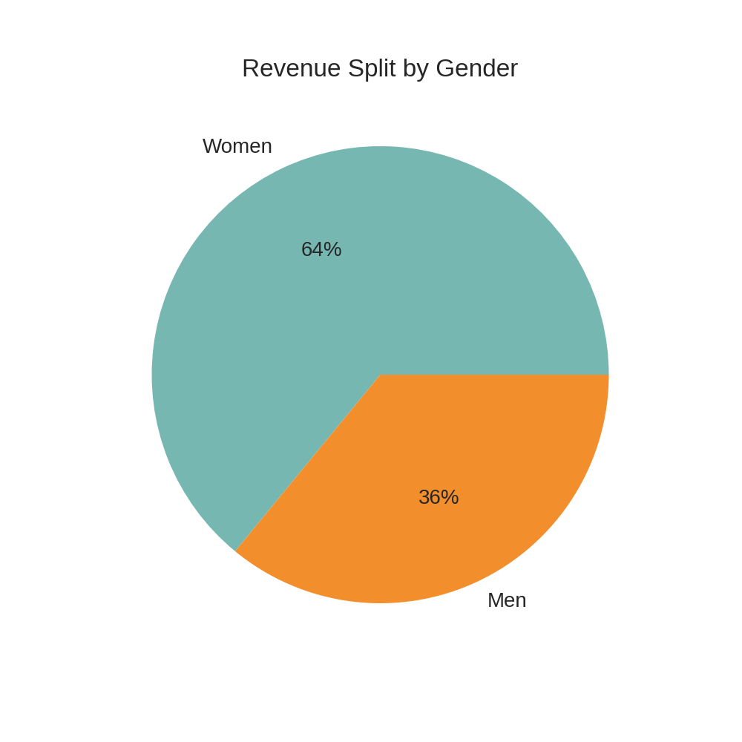
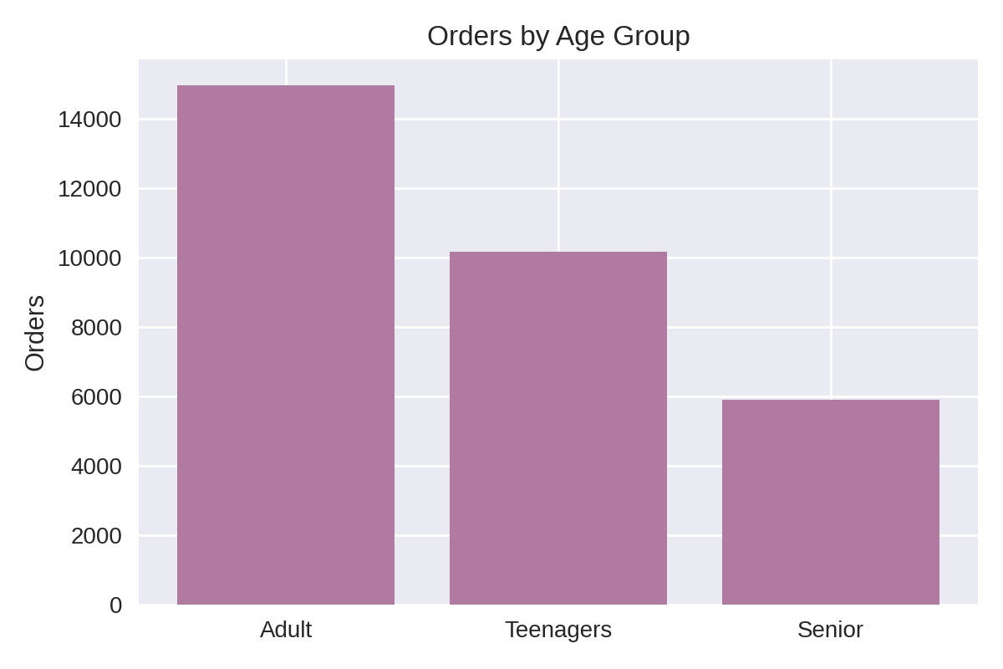

Channel & Geography
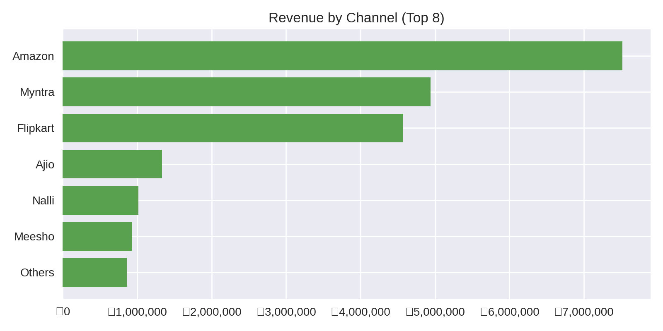
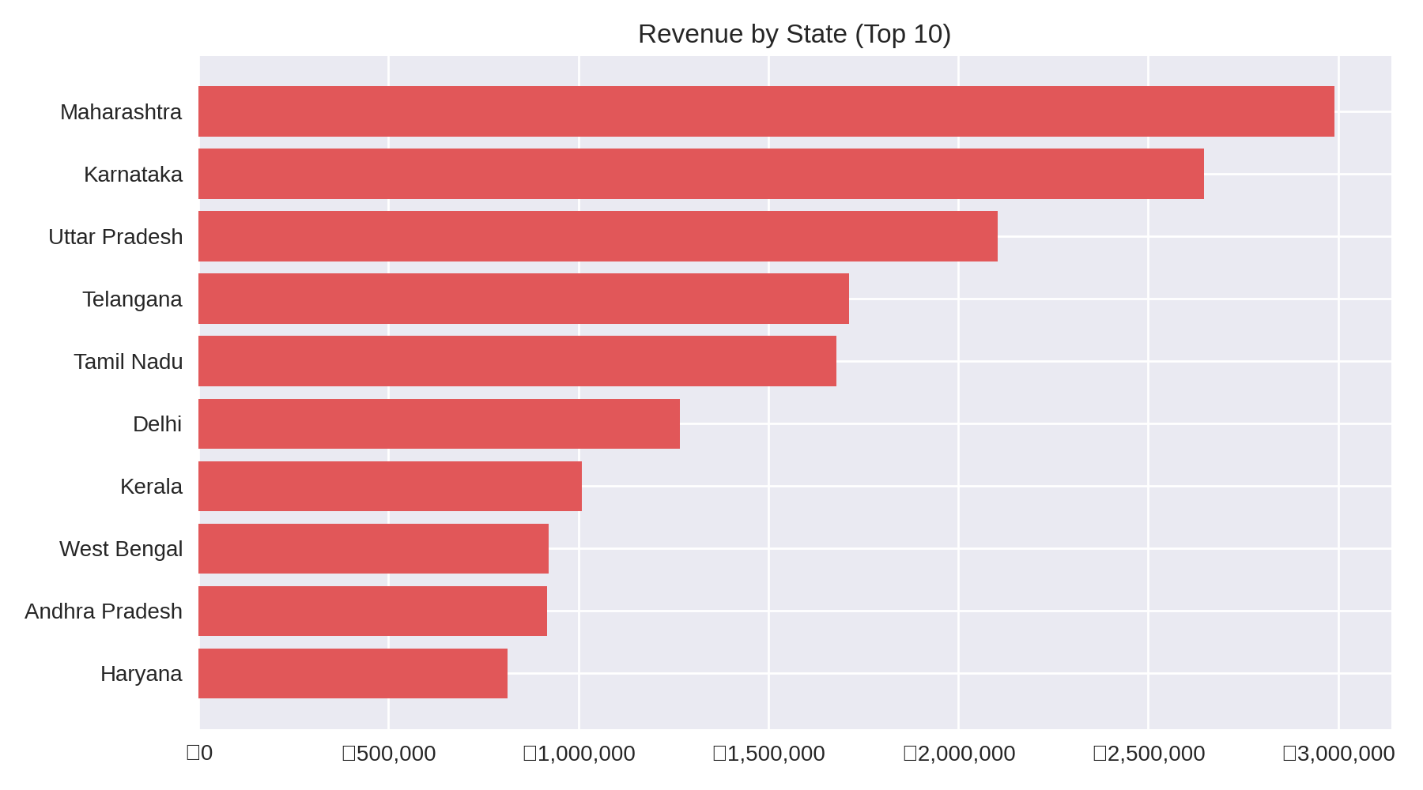

Category Mix
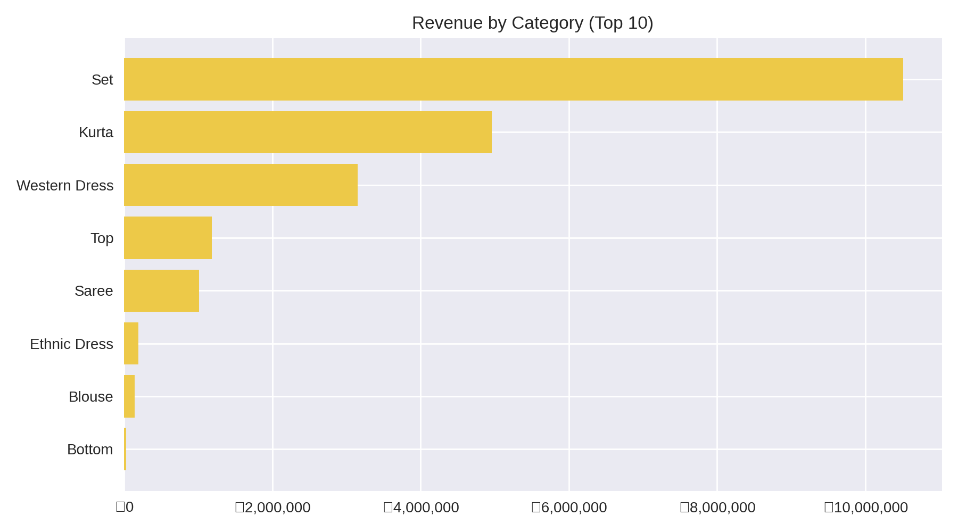

Insights
- Women drive ~64% of revenue vs Men ~36%.
- Peak month: Mar (₹1,928,066); consider aligning campaigns to seasonality.
- Top channel: Amazon contributing ₹7,519,933 revenue.
- Highest revenue state: Maharashtra (₹2,990,221); prioritize inventory & promotions.
- Leading category: Set; expand assortment and bundles.

Recommendations
- Use targeted campaigns in top states and channels; pilot promotions in underperforming segments.
- Optimize inventory for high-velocity SKUs; review slow-movers monthly.
- Standardize discounting by category to protect margins and lift AOV.
- Adopt a monthly KPI cadence using this dashboard to track trends.

