Group 12 – Case Study 2

Nancy Seevilai

Adriel Naranjo

Nattakrit Nimtagool

Prepare a case report that addresses the following issues and recommends an order quantity for the Weather Teddy product.

1. Forecasters Prediction: expected demand of 22500 units, with 0.97 probability of demand would be between 7000 units and 38000 units.

Variance: 7143 Mean: 22500

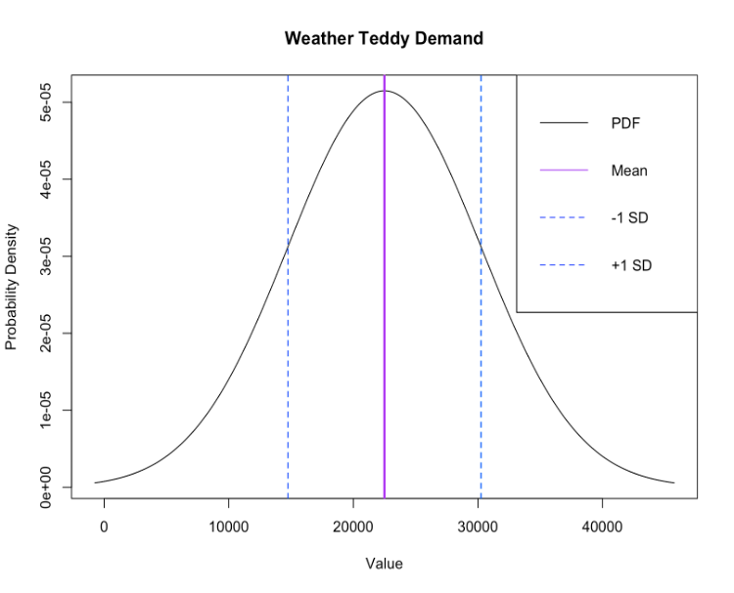

2. Order quantities suggested: 13,000 , 17,000 , 26,000 , and 29,000

x = the value being evaluated;

μ = 22500; σ = 7750 ;

x = 13000 , 17000 , 26000 , 29000 ; z = ( x - 22500 ) / 7750;

1. With a stock of 13,000 units the probability of running out of stock is 88.99%
2. With a stock of 17,000 units the probability of running out of stock is 76.10%
3. With a stock of 26,000 units the probability of running out of stock is 32.58%
4. With a stock of 29,000 units the probability of running out of stock is 20.08%

3. The inventory quantities suggested by the management team: | 13,000 | 17,000 | 26,000 | 29,000 |

Profit = (Units * sell price/unit - cost/unit) + (units not sold * clearance price/unit - cost/unit)

1. Worse Case: 12,000 units sold
   1. 13,000 units =>

The Projected Profit of selling 12,000 units with an inventory of 13,000 Weather Teddy is: $ 134,000

* 1. 17,000 units =>

The Projected Profit of selling 12,000 units with an inventory of 17,000 Weather Teddy is: $ 94,000

* 1. 26,000 units =>

The Projected Profit of selling 12,000 units with an inventory of 26,000 Weather Teddy is: $ 4,000

* 1. 29,000 units =>

The Projected Profit of selling 12,000 units with an inventory of 29,000 Weather Teddy is: $ -26,000

1. Most Likely Case: 22,500 units sold
   1. 13,000 units =>

The Projected Profit of selling 22,500 units with an inventory of 13,000 Weather Teddy is: $ 15,6000

* 1. 17,000 units =>

The Projected Profit of selling 22,500 units with an inventory of 17,000 Weather Teddy is: $ 204,000

* 1. 26,000 units =>

The Projected Profit of selling 22,500 units with an inventory of 26,000 Weather Teddy is: $ 235,000

* 1. 29,000 units =>

The Projected Profit of selling 22,500 units with an inventory of 29,000 Weather Teddy is: $ 205,000

1. Best Case: 33,000 units sold
   1. 13,000 units =>

The Projected Profit of selling 33,000 units with an inventory of 13,000 Weather Teddy is: $ 156,000

* 1. 17,000 units =>

The Projected Profit of selling 33,000 units with an inventory of 17,000 Weather Teddy is: $ 204,000

* 1. 26,000 units =>

The Projected Profit of selling 33,000 units with an inventory of 26,000 Weather Teddy is: $ 312,000

* 1. 29,000 units =>

The Projected Profit of selling 33,000 units with an inventory of 29,000 Weather Teddy is: $ 348,000

4.

* The z-value = 1.405072
* Inventory = 33389.3 ~ 33,390

i) 12,000 units => The Projected Profit with 33,390 units of Weather Teddy selling 12,000 units is: $ -69,900

ii) 22,500 units => The Projected Profit with 33,390 units of Weather Teddy but sell 22,500 units is: $ 161,100

iii) 33,000 units => The Projected Profit with 33,390 units of Weather Teddy selling 33,000 units is: $ 392,100

5. **Recommendation: 26400 units of Weather Teddy**

Our Projected Profit if we have an inventory of 26,400 units of Weather Teddy but sell 12,000 units is: $ 0

Our Projected Profit if we have an inventory of 26,400 units of Weather Teddy but sell 22,500 units is: $ 231000

Our Projected Profit if we have an inventory of 26,400 units of Weather Teddy but sell 33,000 units is: $ 316800

The Probability of running out of an inventory stock of 26,400 units with mean demand 22,500 is 30.74 %

Reasoning: We chose a quantity of 26,400 units because in the worst case scenario our net profit is at $0. We believe it is better to not make money rather than lose money with an inventory any higher. Although there is a 30% chance of stockout, we believe that it is better to sell all of the inventory rather than sell surplus at a price where we would lose profit.