Group 12 – Case Study 3

Adriel Naranjo

Nattakrit Nimtagool

1. Quality Associates, Inc’s Manufacturing Sample Summaries

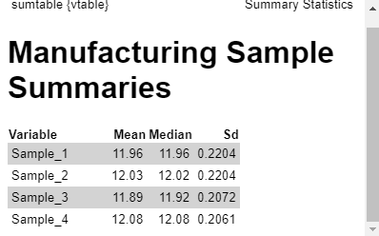

Interpreting Samples

* Mean and Median for Sample 1 and Sample 4 are the same value

Interpreting difference between Samples

* Sample 1 and Sample 2 have the same standard deviation but differing Means and Medians.
* Sample 3 has smaller Mean and Median than Sample 4 but a higher standard deviation.

1. First test: **Z-Test**

There is NOT sufficient statistical evidence to reject the null hypothesis for sample # 1

Z Test Statistic: -1.078057

P-value: 0.2810083

0.2810083 <= 0.05 ? FALSE

There is NOT sufficient statistical evidence to reject the null hypothesis for sample # 2

Z Test Statistic: 0.7476848

P-value: 0.4546503

0.4546503 <= 0.05 ? FALSE

There is sufficient statistical evidence to reject the null hypothesis for sample # 3

Z Test Statistic: -2.895105

P-value: 0.003790318

0.003790318 <= 0.05 ? TRUE

There is sufficient statistical evidence to reject the null hypothesis for sample # 4

Z Test Statistic: 2.121338

P-value: 0.03389336

0.03389336 <= 0.05 ? TRUE

Second test: **Chi-Squared Test**

There is NOT sufficient statistical evidence to reject the null hypothesis for sample # 1

Chi-Squared Test Statistic: 31.93076

P-value: 0.6458412

0.6458412 <= 0.05 ? FALSE

There is NOT sufficient statistical evidence to reject the null hypothesis for sample # 2

Chi-Squared Test Statistic: 31.93076

P-value: 0.6458412

0.6458412 <= 0.05 ? FALSE

There is NOT sufficient statistical evidence to reject the null hypothesis for sample # 3

Chi-Squared Test Statistic: 28.22381

P-value: 0.9880568

0.9880568 <= 0.05 ? FALSE

There is NOT sufficient statistical evidence to reject the null hypothesis for sample # 4

Chi-Squared Test Statistic: 27.9353

P-value: 0.9572509

0.9572509 <= 0.05 ? FALSE

After performing two tailed z-tests on all the samples, we reviewed our results which were inconclusive since two of the z-tests resulted in not rejecting the null hypothesis and the other two tests resulted in rejecting the null hypothesis of SD = .21. Since we lacked additional samples that could have potentially brought us to a proper consensus, we decided that performing a two tailed chi-squared test was our next best option in testing the standard deviation through the variance. Our results were definite with all of the chi-squared tests resulting in NOT rejecting the null hypothesis for SD=.21.

**Conclusion:** It is believed, thus far, that no action should be taken since the Chi-Square tests concluded that the null hypothesis of SD =.21 is not to be rejected for all samples.

1. As of right now, the Population Standard Deviation of .21 seems reasonable based off of the results of the Chi-Squared hypothesis tests. However, this is our expected Standard Deviation and the sample data provided may still deviate in value. Our next step would be to calculate Upper and Lower control limits and visualize our data to see if values fall within the expected/desired bounds.

1. A μ = 12 produces a Lower Control limit of 11.96243 and an Upper Control limit of 12.03757 with Margin of Error 0.03757308
2. If we were to increase the value of the significance level from α = 0.05 to α = 0.10 then this would increase our chances of rejecting the null hypothesis when it is actually true, also known as a Type I Error. Accepting weaker evidence makes it harder to detect real effects or differences if they exist and would directly impact the Manufacturing line's precision to produce satisfactory products since the test is wider and less constraining, making it easier to declare statistical significance.

On the other hand, if we were to decrease the value of the significance level from α = 0.05 to α = 0.01 then of course we would decrease the chances of making a Type I Error but consequently raise the chances of accepting a null hypothesis that is actually false, also know as a Type II Error. Being less willing to accept evidence or being more constraining could prolong the decision making process and could also make it hard to detect real difference which also impacts the precision of producing satisfactory products just as increasing the significance level does.

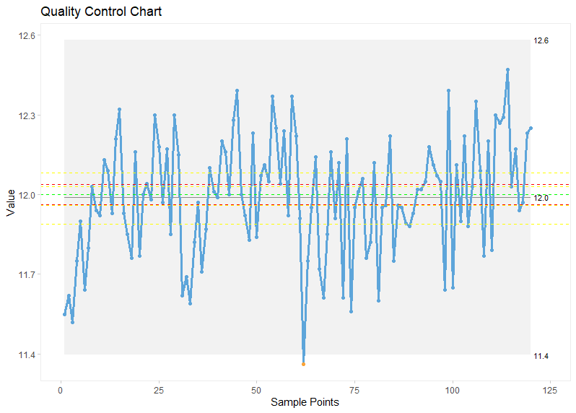Sample Means: - - -- UB & LB: - - - Pop Mean: - - -

Based on the Quality Control Chart, it is believed that this Manufacturing Process must be stopped immediately. This is because all of the Samples Means fall outside of both the Upper and Lower Control limits that were previously calculated around μ = 12. This suggests that the Manufacturing process goes beyond the expected variation and is unstable. The Manufacturing Process must be investigated further in order to produce products that fall within the expected Control Limits.