RETAIL CUSTOMER BEHAVIOUR ANALYTICS
Project Report — Data Preparation, SQL Analysis & Power BI Dashboard
Python · PostgreSQL · Power BI

1. Project Overview
This project examines shopping behavior across 3,900 retail transactions to understand what drives customer spending, product preference, and subscription loyalty. The goal is to turn raw transactional data into a set of actionable insights that a retail management team could use to shape marketing, discounting, and product strategy.
The work spans the full analytics lifecycle: cleaning and feature-engineering the raw data in Python, answering ten targeted business questions in PostgreSQL, and packaging the results into an interactive Power BI dashboard for non-technical stakeholders.

2. Dataset Summary
3,900  TRANSACTIONS | 18  COLUMNS | 37  MISSING REVIEW RATINGS | 4  PRODUCT CATEGORIES
Key fields fall into three groups:
- Customer demographics — age, gender, location, subscription status
- Purchase details — item purchased, category, purchase amount, season, size, color
- Shopping behavior — discount applied, promo code used, previous purchases, purchase frequency, review rating, shipping type

3. Data Preparation (Python)
The raw dataset was cleaned and transformed in pandas before being loaded into PostgreSQL:
- Missing data handling — the 37 missing values in review_rating were imputed with each product category's median rating, rather than a single global median, to keep the imputation category-aware.
- Column standardization — all column names were converted to snake_case for consistency between Python, SQL, and Power BI.
- Feature engineering — an age_group column (Young Adult / Adult / Middle-aged / Senior) was created via quartile binning, and a purchase_frequency_days column translated categorical purchase frequency into a numeric day count.
- Redundancy check — discount_applied and promo_code_used were found to be identical across every row, so promo_code_used was dropped.
- Database load — the cleaned DataFrame was loaded into PostgreSQL via SQLAlchemy for structured SQL analysis.

4. SQL Analysis — Key Findings
Ten business questions were answered directly in PostgreSQL.

4.1 Revenue by Gender
Gender | Revenue
Female | $75,191
Male | $157,890

4.2 High-Spending Discount Users
839 customers used a discount code and still spent above the dataset's average purchase amount ($59.76) — showing discounts aren't only attracting price-sensitive, low-spend shoppers.

4.3 Top 5 Products by Average Rating
Item | Average Rating
Gloves | 3.86
Sandals | 3.84
Boots | 3.82
Hat | 3.80
Skirt | 3.78

4.4 Shipping Type Comparison
Shipping Type | Avg. Purchase Amount
Standard | $58.46
Express | $60.48

4.5 Subscribers vs. Non-Subscribers
Subscribed | Customers | Avg. Spend | Total Revenue
Yes | 1,053 | $59.49 | $62,645
No | 2,847 | $59.87 | $170,436
Non-subscribers generate the majority of revenue simply due to volume, but subscribers spend at a nearly identical average — meaning subscription status isn't currently correlated with higher-value baskets. That's an opportunity, not a weakness: converting even a fraction of non-subscribers wouldn't cannibalize spend per order.

4.6 Discount-Dependent Products
Item | Discount Rate
Hat | 50.00%
Sneakers | 49.66%
Coat | 49.07%
Sweater | 48.17%
Pants | 47.37%

4.7 Customer Segmentation
Segment | Customers
Loyal | 3,116
Returning | 701
New | 83
The customer base skews heavily loyal — over 79% fall into the “Loyal” segment based on purchase history, suggesting the challenge isn't retention but acquisition of genuinely new customers.

4.8 Top 3 Products per Category
Category | Rank | Item | Total Orders
Accessories | 1 | Jewelry | 171
Accessories | 2 | Sunglasses | 161
Accessories | 3 | Belt | 161
Clothing | 1 | Blouse | 171
Clothing | 2 | Pants | 171
Clothing | 3 | Shirt | 169
Footwear | 1 | Sandals | 160
Footwear | 2 | Shoes | 150
Footwear | 3 | Sneakers | 145
Outerwear | 1 | Jacket | 163
Outerwear | 2 | Coat | 161

4.9 Repeat Buyers & Subscriptions
Subscribed | Repeat Buyers (>5 purchases)
No | 2,518
Yes | 958
Repeat buying behavior doesn't require a subscription — most repeat buyers aren't subscribed at all, reinforcing that subscription and loyalty are currently two separate dynamics in this customer base.

4.10 Revenue by Age Group
Age Group | Total Revenue
Young Adult | $62,143
Middle-aged | $59,197
Adult | $55,978
Senior | $55,763
Revenue is fairly evenly spread across age groups, with Young Adults contributing marginally the most — there's no single age group carrying the business disproportionately.

5. Dashboard in Power BI
The cleaned data was connected to Power BI (Import mode via PostgreSQL) to build an interactive dashboard, with filters for subscription status, gender, age group, and shipping type.
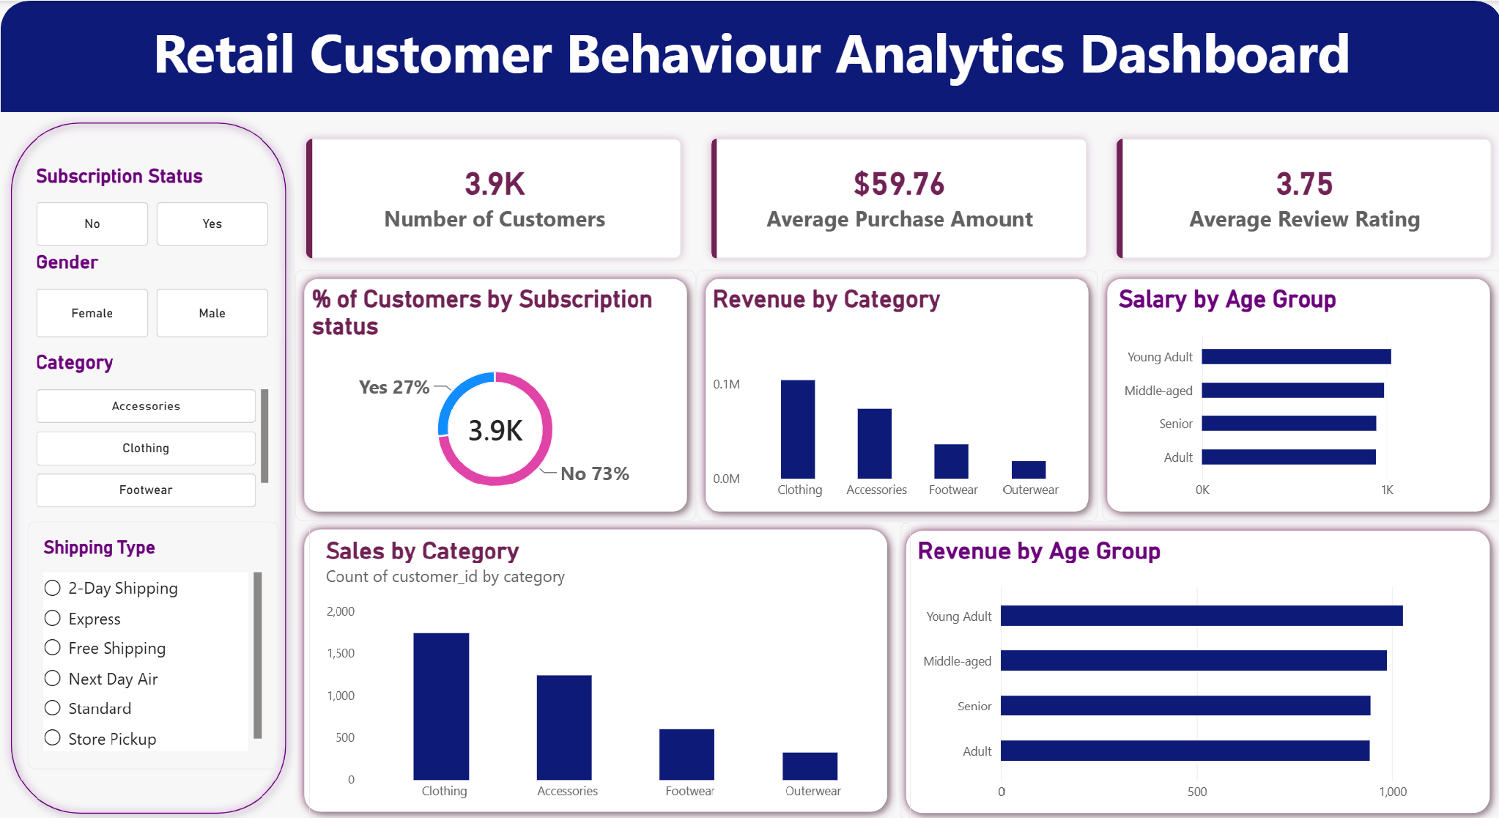

6. Business Recommendations
- Boost subscriptions — since subscribers and non-subscribers spend at similar averages, promote exclusive subscriber benefits to convert high-frequency non-subscribers rather than relying on discounting alone.
- Invest in customer loyalty programs — reward repeat buyers to move more of the “Returning” segment into “Loyal,” and study what differentiates the small “New” segment to improve acquisition.
- Review discount policy — products like Hats and Sneakers rely on discounts for roughly half of their sales; assess whether margin is being eroded unnecessarily on items that would sell at full price.
- Lead with top-rated products in campaigns — Gloves, Sandals, and Boots have the highest average ratings and are natural candidates for featured placement or upsell bundles.
- Target high-revenue segments — Young Adults and Express-shipping users show slightly higher spend; tailor campaigns and shipping incentives toward these groups first.

Retail Customer Behaviour Analytics — Python · PostgreSQL · Power BI
github.com/AGupta-23/Retail-Customer-Behaviour-Analytics

