CNN Dataset Preparation – Precise Output Screenshots
1. Environment & GPU Configuration
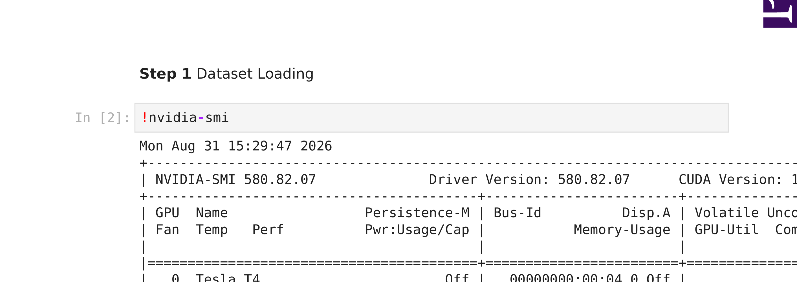

2. Dataset Acquisition
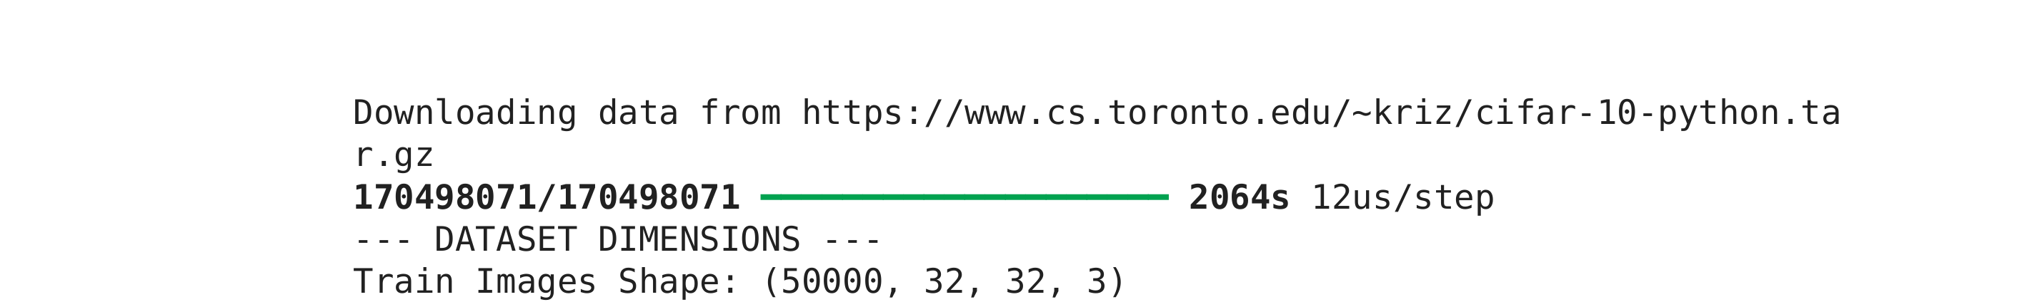

3. Target Class Definition
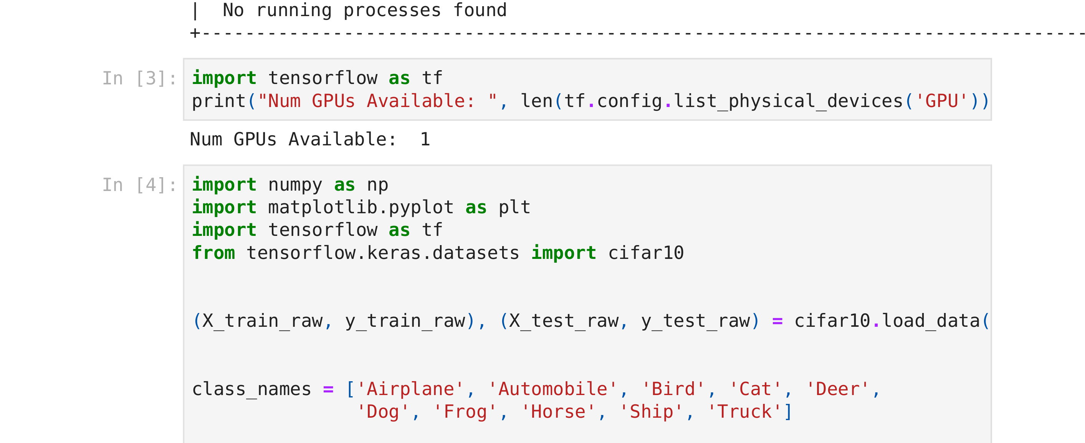

4. Dataset Splitting & Dimension Inspection
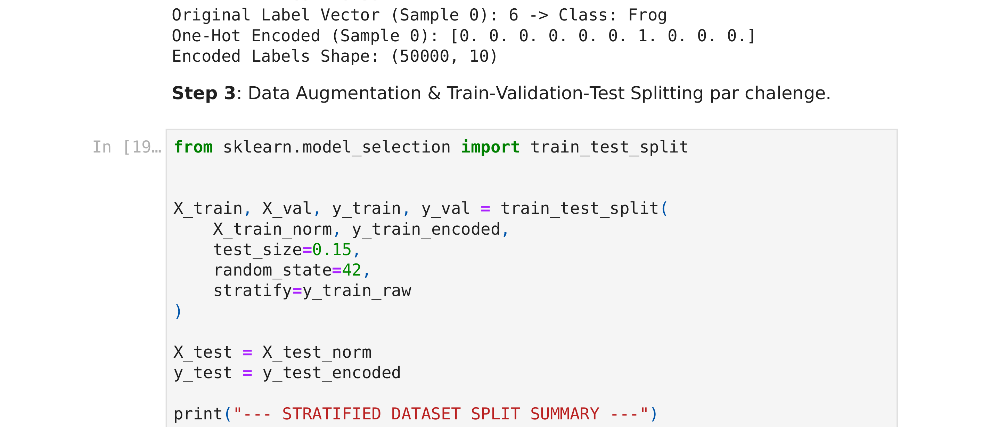

5. Missing Value Audit
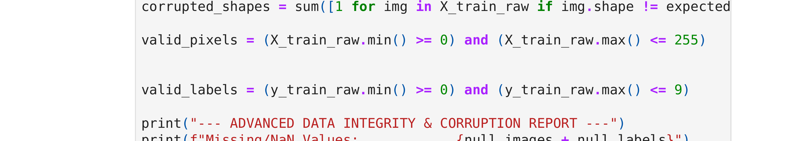

6. Image Resolution & Channel Validation
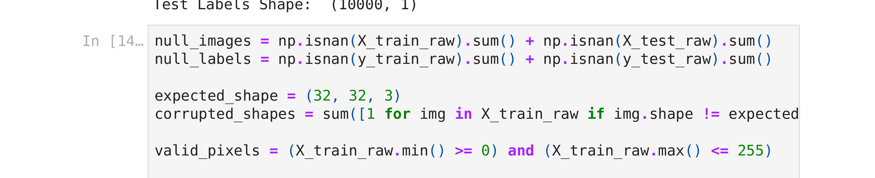

7. Pixel Value Range Check
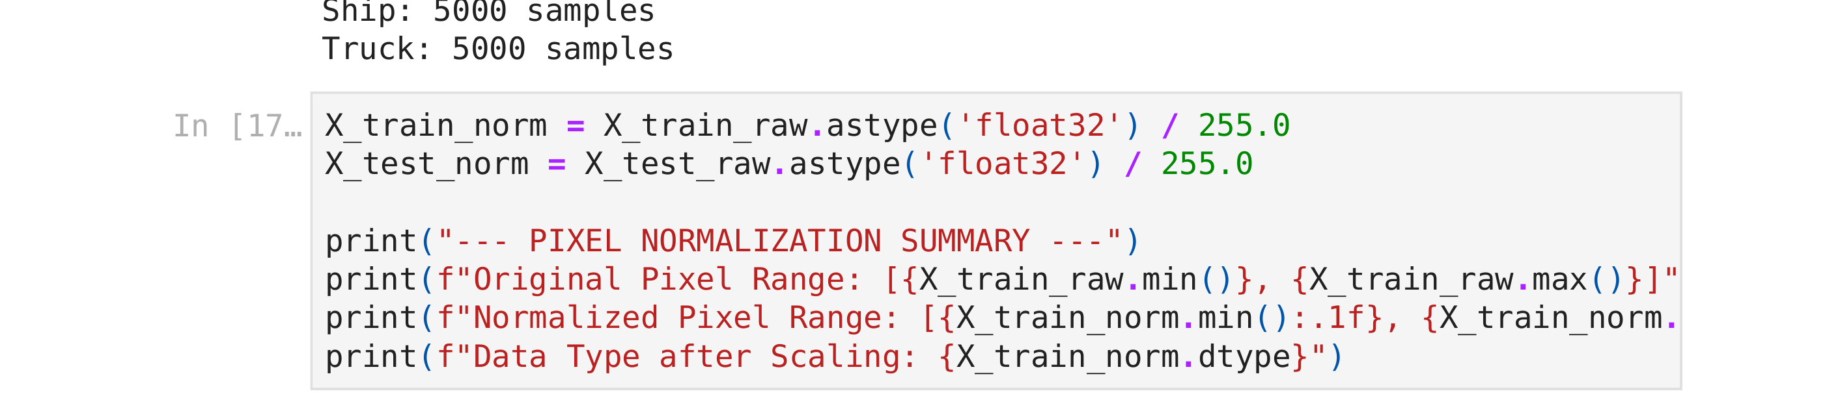

8. Label Index Validation

9. Data Visualization & Exploratory Inspection
