Time & Space Complexity — DSA Notes
1. Time Complexity
Definition:
Time complexity describes how the number of operations of an algorithm grows as the input size (n) increases.
Why?
- Helps compare algorithms.
- Doesn't depend on the actual computer speed.
- Focuses on growth as n becomes large.

2. Big O Notation — O
Big O describes an upper bound on how an algorithm's resource usage grows.
Important rules
1. Ignore constants
O(3n) → O(n)
O(100n) → O(n) 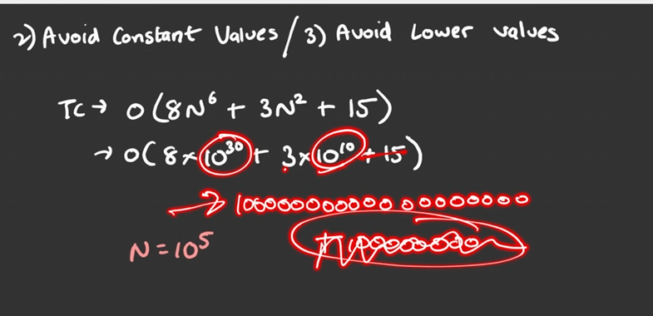

2. Ignore lower-order terms
O(n² + n + 10) → O(n²)
3. Sequential operations → Add
for i in range(n): # O(n)

for i in range(n): # O(n)
Total:
O(n) + O(n) = O(n)
4. Nested loops → Multiply
for i in range(n):
for j in range(n):
print(i, j)
O(n × n) = O(n²)

5.always calculate the time complexity in term of worst case
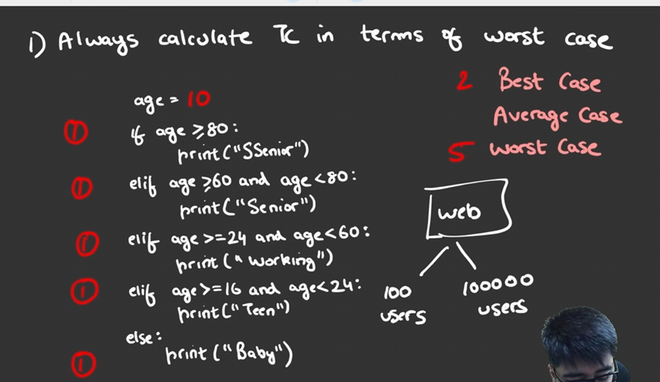

3. Common Complexities
Complexity | Name | Example
O(1) | Constant | Access arr[5]
O(log n) | Logarithmic | Binary Search
O(n) | Linear | One loop
O(n log n) | Linearithmic | Merge Sort
O(n²) | Quadratic | Nested loops
O(2ⁿ) | Exponential | Some recursion
O(n!) | Factorial | Permutations
Remember:
O(1) < O(log n) < O(n) < O(n log n) < O(n²) < O(2ⁿ) < O(n!)

4. O(), Ω(), Θ()
Big O — O()
Upper bound.
Omega — Ω()
Lower bound.
Theta — Θ()
Tight bound.
Important:
Don't memorize these as simply:
O = worst, Ω = best, Θ = average
That is an oversimplification.

5. Space Complexity
Space complexity describes the extra memory used by an algorithm as input size grows.
Auxiliary Space
Extra memory used by the algorithm.
Example:
def double(arr):
result = []

for x in arr:
result.append(x * 2)

return result
result stores n elements.
Auxiliary Space = O(n)
Input Space
Memory occupied by the input itself.
When discussing algorithm space complexity, we usually focus on auxiliary space, unless the question specifically asks for total space.

6. Quick Examples
Example 1 — O(n)
for i in range(n):
print(i)
Time = O(n)
Space = O(1)
Example 2 — O(n²)
for i in range(n):
for j in range(n):
print(i, j)
Time = O(n²)
Space = O(1)
Example 3 — O(n) Space
new_arr = []

for x in arr:
new_arr.append(x)
Time = O(n)
Auxiliary Space = O(n)

🎯 Interview Checklist
When given code, ask:
- How many times does each loop run?
- Are loops nested or sequential?
- Is there recursion?
- Are we creating another data structure?
- What happens when n becomes very large?
Then determine:
Time Complexity + Auxiliary Space Complexity

TLE — Time Limit Exceeded :-
What is TLE?
TLE (Time Limit Exceeded) occurs when your program takes longer than the maximum time allowed by the online judge.
It usually means your algorithm is too slow for the given constraints.

Constraints Matter
Always check the input size n.
The constraints help you decide what complexity is acceptable.
For example:
- Small n → O(n²) may be fine
- Large n → O(n²) may cause TLE
- Very large n → usually need O(n) or O(log n)-type solutions
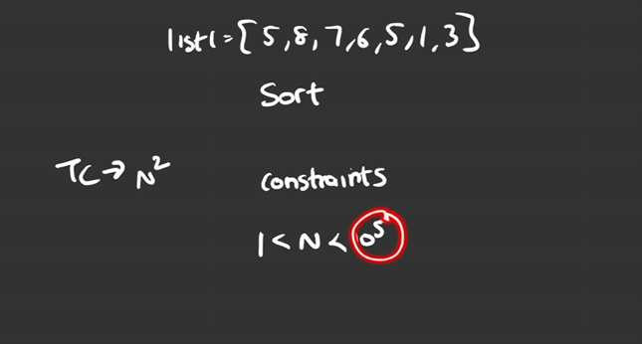

Example
Suppose:
n = 100,000
An O(n²) algorithm performs roughly:
100,000² = 10,000,000,000
operations.
That's extremely large and can lead to TLE.
An O(n) solution performs roughly:
100,000
operations — much more efficient.

How to Avoid TLE
When you get TLE:
- Check the constraints.
- Find your current time complexity.
- Look for unnecessary loops.
- Use better data structures/patterns.
- Try to reduce O(n²) → O(n) when possible.
Remember
Constraints → Choose Complexity → Write Algorithm
Don't memorize a fixed number of operations per second. The actual limit depends on the judge, language, and problem.

Python Data Structure Operations — Time Complexity
1. Python List
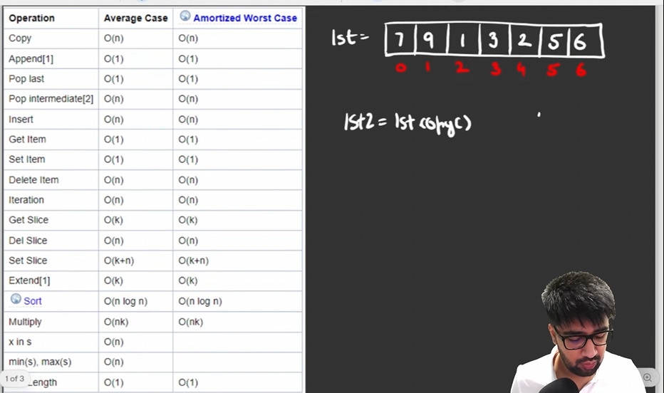
Important: List is implemented as a dynamic array.
Where is k=length of slice

2. Set
Set uses hashing, so these are generally O(1) average-case:
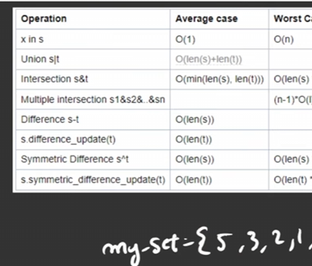
⚠️ Worst-case hashing can be worse, but O(1) average is what you normally use in DSA analysis.

3. Dictionary
Dictionary also uses hashing.
d[key] # lookup
d[key] = value # insertion/update
del d[key] # deletion
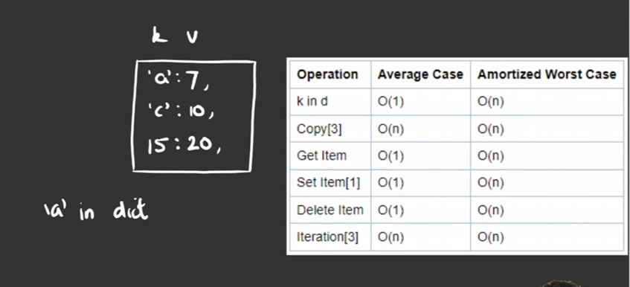

⭐ Most Important for DSA
Remember these:
List:
arr[i] → O(1)
x in arr → O(n)
append → O(1) amortized
pop() → O(1)

Set:
x in set → O(1) average

Dictionary:
d[key] → O(1) average

Sorting:
sort() → O(n log n)
DSA Trick
If you have:
if x in arr:
→ O(n)
But if you convert/use a set:
if x in my_set:
→ O(1) average
This difference is extremely important for optimizing LeetCode solutions and avoiding TLE.

Extract Digits from a Number:
Core Logic
1. Get the last digit → % 10
last_digit = num % 10
Example:
1234 % 10 = 4
So % 10 extracts the last digit.
2. Remove the last digit → // 10
num = num // 10
Example:
1234 // 10 = 123
So // 10 removes the last digit.
3. Repeat using while
while num > 0:
last_digit = num % 10
# process last_digit
num = num // 10

Example
For n = 1234:
1234 → digit 4
123 → digit 3
12 → digit 2
1 → digit 1
0 → stop
Output:
4 3 2 1

Python Template
n = 1234
num = n

while num > 0:
last_digit = num % 10
print(last_digit)

num //= 10
Why num = n?
It preserves the original input n while we modify num.

Complexity:-
If the number has d digits:
Time: O(d)
Space: O(1)
Since d ≈ log₁₀(n), this can also be written as:
Time: O(log n)

⭐ Remember
% 10 → GET last digit
// 10 → REMOVE last digit
while → REPEAT until number becomes 0
This pattern is useful for problems like:
- Reverse a number
- Count digits
- Sum of digits
- Check palindrome number
- Armstrong number
- Extract/process individual digits

Count the number of element:-

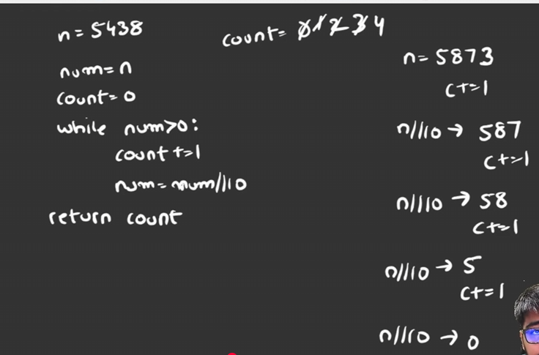
Time and space complexity:- 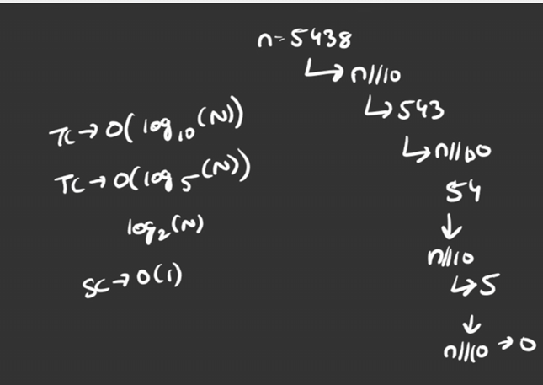

2) you can do with log10():-
