Time & Space Complexity — DSA Notes
1. Time Complexity
Definition:
Time complexity describes how the number of operations of an algorithm grows as the input size (n) increases.
Why?
- Helps compare algorithms.
- Doesn't depend on the actual computer speed.
- Focuses on growth as n becomes large.

2. Big O Notation — O
Big O describes an upper bound on how an algorithm's resource usage grows.
Important rules
1. Ignore constants
O(3n) → O(n)
O(100n) → O(n)

2. Ignore lower-order terms
O(n² + n + 10) → O(n²)
3. Sequential operations → Add
for i in range(n): # O(n)

for i in range(n): # O(n)
Total:
O(n) + O(n) = O(n)
4. Nested loops → Multiply
for i in range(n):
for j in range(n):
print(i, j)
O(n × n) = O(n²)

5.always calculate the time complexity in term of worst case
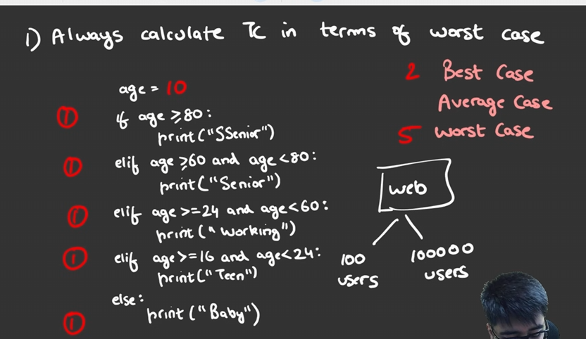

3. Common Complexities
Complexity | Name | Example
O(1) | Constant | Access arr[5]
O(log n) | Logarithmic | Binary Search
O(n) | Linear | One loop
O(n log n) | Linearithmic | Merge Sort
O(n²) | Quadratic | Nested loops
O(2ⁿ) | Exponential | Some recursion
O(n!) | Factorial | Permutatio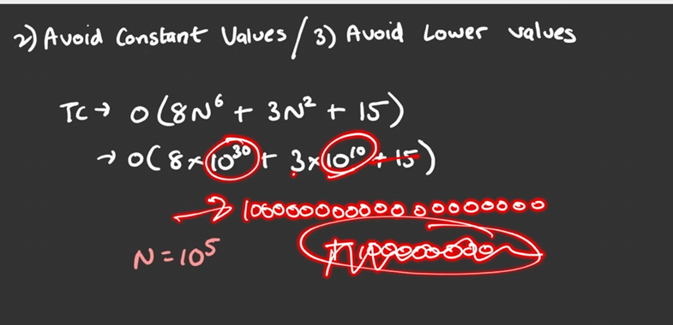ns
Remember:
O(1) < O(log n) < O(n) < O(n log n) < O(n²) < O(2ⁿ) < O(n!)

4. O(), Ω(), Θ()
Big O — O()
Upper bound.
Omega — Ω()
Lower bound.
Theta — Θ()
Tight bound.
Important:
Don't memorize these as simply:
O = worst, Ω = best, Θ = average
That is an oversimplification.

5. Space Complexity
Space complexity describes the extra memory used by an algorithm as input size grows.
Auxiliary Space
Extra memory used by the algorithm.
Example:
def double(arr):
result = []

for x in arr:
result.append(x * 2)

return result
result stores n elements.
Auxiliary Space = O(n)
Input Space
Memory occupied by the input itself.
When discussing algorithm space complexity, we usually focus on auxiliary space, unless the question specifically asks for total space.

6. Quick Examples
Example 1 — O(n)
for i in range(n):
print(i)
Time = O(n)
Space = O(1)
Example 2 — O(n²)
for i in range(n):
for j in range(n):
print(i, j)
Time = O(n²)
Space = O(1)
Example 3 — O(n) Space
new_arr = []

for x in arr:
new_arr.append(x)
Time = O(n)
Auxiliary Space = O(n)

🎯 Interview Checklist
When given code, ask:
- How many times does each loop run?
- Are loops nested or sequential?
- Is there recursion?
- Are we creating another data structure?
- What happens when n becomes very large?
Then determine:
Time Complexity + Auxiliary Space Complexity

TLE — Time Limit Exceeded :-
What is TLE?
TLE (Time Limit Exceeded) occurs when your program takes longer than the maximum time allowed by the online judge.
It usually means your algorithm is too slow for the given constraints.

Constraints Matter
Always check the input size n.
The constraints help you decide what complexity is acceptable.
For example:
- Small n → O(n²) may be fine
- Large n → O(n²) may cause TLE
- Very large n → usually need O(n) or O(log n)-type solutions
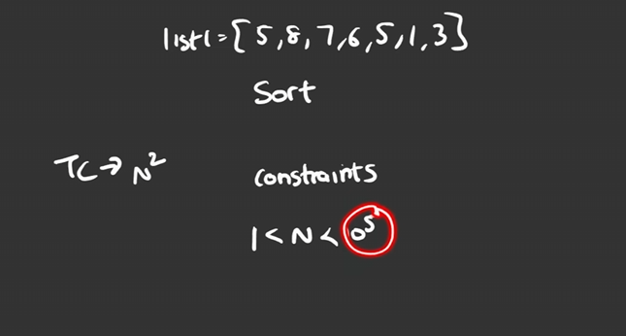

Example
Suppose:
n = 100,000
An O(n²) algorithm performs roughly:
100,000² = 10,000,000,000
operations.
That's extremely large and can lead to TLE.
An O(n) solution performs roughly:
100,000
operations — much more efficient.

How to Avoid TLE
When you get TLE:
- Check the constraints.
- Find your current time complexity.
- Look for unnecessary loops.
- Use better data structures/patterns.
- Try to reduce O(n²) → O(n) when possible.
Remember
Constraints → Choose Complexity → Write Algorithm
Don't memorize a fixed number of operations per second. The actual limit depends on the judge, language, and problem.

Python Data Structure Operations — Time Complexity
1. Python List
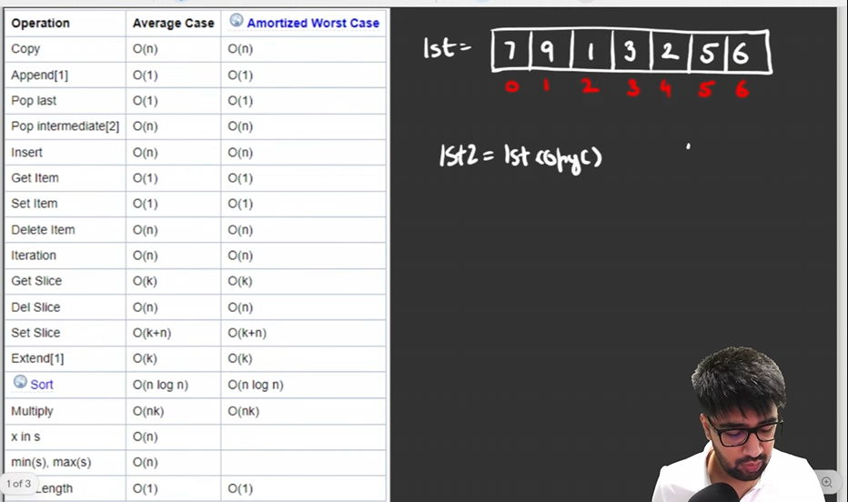
Important: List is implemented as a dynamic array.
Where is k=length of slice

2. Set
Set uses hashing, so these are generally O(1) average-case:
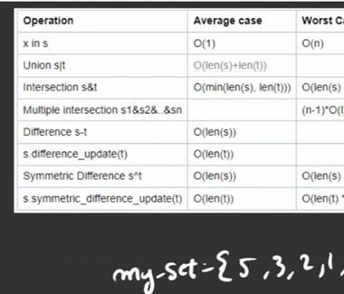
⚠️ Worst-case hashing can be worse, but O(1) average is what you normally use in DSA analysis.

3. Dictionary
Dictionary also uses hashing.
d[key] # lookup
d[key] = value # insertion/update
del d[key] # deletion
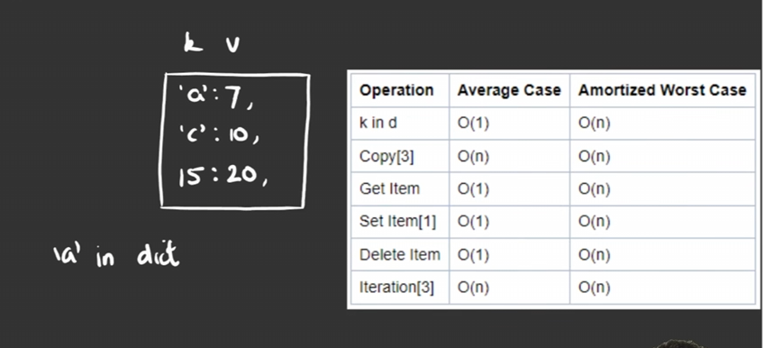

⭐ Most Important for DSA
Remember these:
List:
arr[i] → O(1)
x in arr → O(n)
append → O(1) amortized
pop() → O(1)

Set:
x in set → O(1) average

Dictionary:
d[key] → O(1) average

Sorting:
sort() → O(n log n)
DSA Trick
If you have:
if x in arr:
→ O(n)
But if you convert/use a set:
if x in my_set:
→ O(1) average
This difference is extremely important for optimizing LeetCode solutions and avoiding TLE.

Extract Digits from a Number:
Core Logic
1. Get the last digit → % 10
last_digit = num % 10
Example:
1234 % 10 = 4
So % 10 extracts the last digit.
2. Remove the last digit → // 10
num = num // 10
Example:
1234 // 10 = 123
So // 10 removes the last digit.
3. Repeat using while
while num > 0:
last_digit = num % 10
# process last_digit
num = num // 10

Example
For n = 1234:
1234 → digit 4
123 → digit 3
12 → digit 2
1 → digit 1
0 → stop
Output:
4 3 2 1

Python Template
n = 1234
num = n

while num > 0:
last_digit = num % 10
print(last_digit)

num //= 10
Why num = n?
It preserves the original input n while we modify num.

Complexity:-
If the number has d digits:
Time: O(d)
Space: O(1)
Since d ≈ log₁₀(n), this can also be written as:
Time: O(log n)

⭐ Remember
% 10 → GET last digit
// 10 → REMOVE last digit
while → REPEAT until number becomes 0
This pattern is useful for problems like:
- Reverse a number
- Count digits
- Sum of digits
- Check palindrome number
- Armstrong number
- Extract/process individual digits

Count the number of element:-

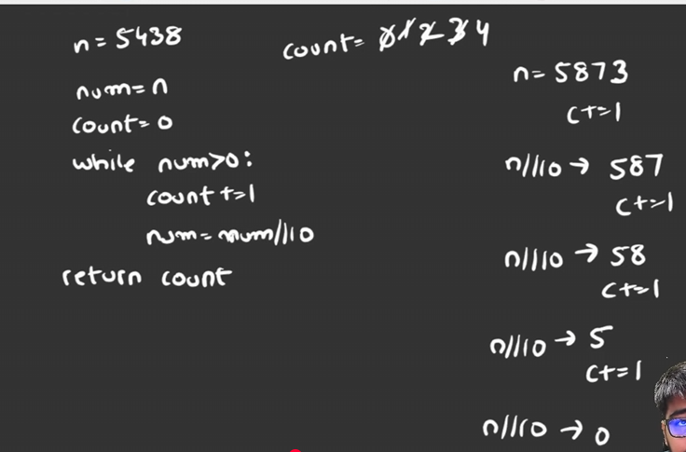
Time and space complexity:- 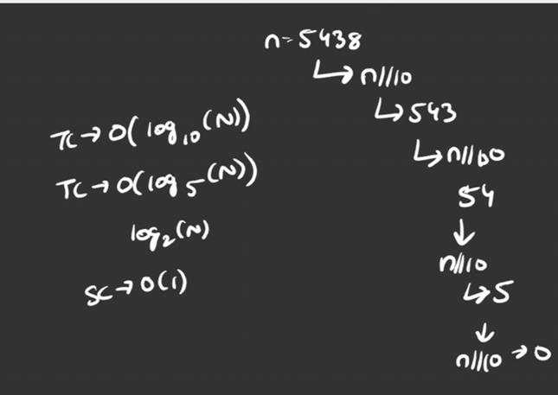

2) you can do with log10() :-
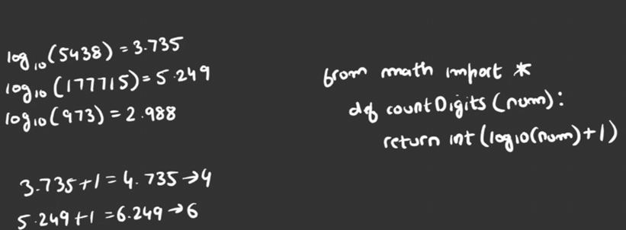

Palindrome Number:-
Key Concepts
- Definition: A palindrome is a number that remains the same when read forward and backward (e.g., 121, 1331).
- Approach: Avoid string conversion. Instead, reverse the digits mathematically and compare the reversed number with the original.

Step-by-Step Logic
- Store the original number: Keep a copy because num will be modified.
- Extract the last digit: Use num % 10.
- Build the reverse: Use result * 10 + last_digit.
- Remove the last digit: Use num // 10.
- Compare: If the original number equals result, it is a palindrome.

Code Structure:-
n = 121
num = n
result = 0

while num > 0:
last_digit = num % 10
result = result * 10 + last_digit
num //= 10

if n == result:
print("Palindrome")
else:
print("Not Palindrome")
Example: 121
121 → digit 1 → result = 1
12 → digit 2 → result = 12
1 → digit 1 → result = 121
0 → stop
Original = 121
Reverse = 121
Therefore, 121 is a Palindrome.

Complexity Analysis
If the number has d digits:
- Time Complexity: O(d) or O(log n)
- Space Complexity: O(1) — Constant space

⭐ Remember
% 10 → GET last digit
* 10 + d → BUILD reverse
// 10 → REMOVE last digit
original == reverse → PALINDROME

Armstrong Number:-
Key Concepts
- Definition: An Armstrong Number is a number where the sum of each digit raised to the power of the total number of digits equals the original number.
- Example: For 153 (3-digit number):
1³ + 5³ + 3³ = 153
So, 153 is an Armstrong Number.

Step-by-Step Logic
- Count the digits: Find the total number of digits in the number.
- Extract the last digit: Use num % 10.
- Calculate the power: Raise the digit to the power of the digit count using digit ** count.
- Add to total: Add the result to total.
- Remove the last digit: Use num // 10 and repeat until num becomes 0.
- Compare: If total == original, the number is an Armstrong Number.

Python Implementation
n = 153
num = n
count = len(str(n))
total = 0

while num > 0:
digit = num % 10
total += digit ** count
num //= 10

if total == n:
print("Armstrong Number")
else:
print("Not Armstrong Number")
Example: 153
153 → digit 3 → 3³ = 27
15 → digit 5 → 5³ = 125
1 → digit 1 → 1³ = 1

total = 27 + 125 + 1
= 153
Original = 153
Total = 153
Therefore, 153 is an Armstrong Number.

Complexity Analysis
If the number has d digits:
Time Complexity: O(d)
Space Complexity: O(1)

⭐ Remember
Count digits → power
% 10 → GET digit
** count → RAISE digit
// 10 → REMOVE digit
total == original → ARMSTRONG

Hashing
Key Concepts
- Number Hashing: Store the frequency (count) of integers using a pre-allocated list or a dictionary. This avoids repeatedly checking the entire array.
- Character Hashing: Store the frequency of characters. For lowercase English letters, a fixed-size list of 26 can be used.
- Performance Optimization: Hashing improves the solution from brute force O(n²) to an efficient approach of O(n) in many frequency-counting problems.

1. Number Hashing
Using a List
Create a frequency array where the index represents the number.
arr = [1, 2, 1, 3, 2, 1]

freq = [0] * 10

for num in arr:
freq[num] += 1

print(freq[1]) # 3
print(freq[2]) # 2
Here:
freq[1] → count of 1
freq[2] → count of 2
freq[3] → count of 3
Using a Dictionary
arr = [1, 2, 1, 3, 2, 1]

freq = {}

for num in arr:
if num in freq:
freq[num] += 1
else:
freq[num] = 1

print(freq[1]) # 3

2. Character Hashing
For lowercase letters a-z, we can use a list of size 26.
s = "abacaba"

freq = [0] * 26

for ch in s:
index = ord(ch) - ord('a')
freq[index] += 1

print(freq[0]) # frequency of 'a'
Why ord(ch) - ord('a')?
'a' → 0
'b' → 1
'c' → 2
...
'z' → 25
So each character gets a unique index.

Complexity
For n elements/characters:
Time: O(n)
Space: O(k)
where k is the size of the frequency table.

⭐ Remember
Hashing → Store frequency/count

Number → List or Dictionary
Character → List of 26 (a-z)

freq[x] += 1 → increase frequency

Brute Force → O(n²)
Hashing → O(n)

Recursion
Core Concept
Instead of using global counters, pass the required state as a parameter to the function. With every recursive call, modify the parameter to move toward the base condition.

Key Components of Recursion
1. Base Condition
The stopping point of recursion. It prevents the function from calling itself forever.
Example:
if n == 0:
return
2. Recursive Call
The function calls itself with a modified parameter.
Example:
print_number(n - 1)

Example
def print_number(n):

if n == 0:
return

print(n)
print_number(n - 1)

print_number(5)
Output:
5
4
3
2
1

Types of Recursion
1. Head Recursion
The task is performed before the recursive call.
print(n)
print_number(n - 1)
2. Tail Recursion / Backtracking
The recursive call happens first, and the task is performed when the function returns (stack unwinds).
print_number(n - 1)
print(n)

⭐ Best Practice: Dry Run
For recursion, always do a dry run by tracking:
Function call
↓
Parameter value
↓
Base condition
↓
Recursive call
↓
Return / Backtracking
A recursion tree can also help visualize how the function calls itself.

⭐ Remember
Base Condition → STOP
Recursive Call → CALL itself
Parameter → MOVE toward base condition
Dry Run → UNDERSTAND recursion
Golden Rule: Every recursive function must have a base condition, otherwise it can lead to infinite recursion.

Sum of N Natural Numbers Using Recursion:-
- Concept: Pass the current sum and initial values as parameters.
- Base Condition: When initial > last_number, stop and print the sum.
- Recursive Step: Add initial to sum, then call the function with initial + 1.
def func(sum, initial, last_number):

if initial > last_number:
print(sum)
return

sum += initial
func(sum, initial + 1, last_number)

func(0, 1, 10)
Output: 55
⭐ Remember
sum += initial → add number
initial + 1 → next number
initial > last → stop
Time: O(n)
Space: O(n) → recursion stack

Functional Recursion
2 Steps to Create Functional Recursion
- Create the flow → Decide how the function should calculate the answer.
- Create the base condition → Decide when recursion should stop.
Example
def func(n):

if n == 1:
return 1

return n + func(n - 1)

print(func(10))
Output:
55
⭐ Remember
Flow → How to calculate
Base Condition → When to stop
Recursive Call → n - 1
Return → Gives answer back
For func(10):
10 + 9 + 8 + ... + 1 = 55
Time: O(n)
Space: O(n) → recursion stack

Factorial
Logic:
- Base condition: n == 1 → return 1
- Recursive condition: n * func(n-1)
def func(n):

if n == 1:
return 1
else:
return n * func(n-1)

print(func(9))
Dry Run
func(9)
= 9 × func(8)
= 9 × 8 × func(7)
= ...
= 9 × 8 × 7 × ... × 1
= 362880
Output:
362880
📌 Short Note
Factorial using functional recursion:
n! = n × (n-1)!
- Base condition: n == 1
- Recursive call: func(n-1)
- Time Complexity: O(n)
- Space Complexity: O(n) — recursion stack

Palindrome String Using Loop
Logic
- Set left = 0 and right = len(s)-1.
- Compare s[left] and s[right].
- If different → Not Palindrome.
- Move left++ and right--.
- If all characters match → Palindrome.
Example
s = "mam"
left = 0
right = len(s) - 1

while left < right:
if s[left] != s[right]:
print(False)
break
left += 1
right -= 1
else:
print(True)
Time: O(n)
Space: O(1)

