

Faculty of Informatics and Computer Science

Computer Science

Machine Learning for Extraction and Classification of Adverse Drug Events from social Media

By: Ahmed Hossam Ahmed Mohamed ElSabbagh

Supervised By

Prof. Nahla Barakat

**June 2019**

Abstract

Adverse Drug Reactions/Events (ADR) are a harmful or unpleasant reaction caused by the use of medicinal product [1], these effects are studied through the science of Pharmacovigilance, the science and activities relating to the detection, assessment, understanding and prevention of these effects [2] [3]. The ADR caused by drugs after their release is considered a major health hazard, causing a large number of death, it is estimated that more then 6% of patients are hospitalized as a cause of serious ADRs, which is translated into more than 2 million patients, 0.32% of whom are fatalities or more than 100 thousands deaths in the US alone [4].

This project aims to research and find a good method to implement an Adverse Drug Reaction (ADR) detection program using machine learning based methods, with dataset collected from social media and/or medical forums.

Attestation &Turnitin Report

I understand the nature of plagiarism, and I am aware of the University’s policy on this.

I certify that this dissertation reports original work by me during my University project except for the following

**Signature** *(you must delete this, then sign and date this page)* **Date**

# Acknowledgements

Acknowledge anyone who has helped you in your work such as your supervisor, technical support staff, fellow students or external organisations. Acknowledge the source of any work that is not your own.

Table of Contents

Contents

 i

Faculty of Informatics and Computer Science i

Computer Science i

Machine Learning for Extraction and Classification of Adverse Drug Events from social Media i

By: Ahmed Hossam Ahmed Mohamed ElSabbagh i

Supervised By i

1 Abstract ii

2 Attestation &Turnitin Report iii

3 Acknowledgements iv

4 Table of Contents v

6 List of Figures vii

7 List of Tables viii

8 **Introductio**n 1

8.1 Overview 2

8.2 Scope and objectives 3

8.3 Work Plan 4

9 Related Work (State-of-The-Art) 5

9.1 Background 6

9.2 Literature Survey 7

9.2.1 Traditional ADR Detection Methods 7

9.2.2 Scope of research 7

9.2.3 Finding Datasets 7

9.2.4 General Text Processing Techniques: 8

9.2.5 Lexicon-Based Techniques 8

9.2.6 Supervised Learning 11

9.2.7 Hybrid and Unique 14

**10** Methodology and Implementation 16

10.1 Acquiring the dataset 17

10.1.1 Subjects to consider 17

10.1.2 Data retrieval 18

10.2 Build Dictionary: 19

10.2.1 Subjects to consider 19

10.3 Association with GloVe: 21

10.3.1 Implementation Details 21

10.4 Association with Apriori 23

10.4.1 Implementation Details: 23

10.5 Machine Learning: 25

10.5.1 Preparing the dataset: 25

10.5.2 Dataset Imbalance 27

10.5.3 Preparing the classifiers: 29

11 Results and Discussion: 37

11.1 GloVe Results 38

11.1.1 Drugs and ADR relation 38

11.1.2 Related Concepts Discovery 42

11.2 Apriori Results 45

11.3 Machine Learning Results: 53

11.3.1 First Arrangement 53

12 References 74

List of Figures

**No table of figures entries found.**

List of Tables

# Introduction

## Overview

Adverse Drug Reactions/Events (ADR) are a harmful or unpleasant reaction caused by the use of medicinal product [1], these effects are studied through the science of Pharmacovigilance, the science and activities relating to the detection, assessment, understanding and prevention of these effects [2] [3]. The ADR caused by drugs after their release is considered a major health hazard, causing a large number of death, it is estimated that more then 6% of patients are hospitalized as a cause of serious ADRs, which is translated into more than 2 million patients, 0.32% of whom are fatalities or more than 100 thousands deaths in the US alone [4].

There are many steps taken Through medical trials to find the ADRs, however some people may not have the same side effects as others and therefore not all ADRs that affect all different patients appear until phase IV trials -postmarketing trials- especially since most medical trials are concentrated on certain demographics, therefore are many uncertainties of the effect of the drugs on any given population [5] [6], and despite the many mediums offered by the FDA to report ADR (FAERS, MERP, MedWatch) [3], 90% of the ADR are in fact under-reported [7].

However, a new field of pharmacovigilance via social media has been introduced in recent years, as there are many disease support networks (DailyStrength and MedHelp), patient forums (AskAPatient) and miniblogs(Twitter) [8], where patients are involved in sharing their experiences with certain drugs, with many of them and their caregivers actively read said experiences [3]. Many data mining techniques were adapted to extract potential ADRs of drugs by through text mining and machine learning, allowing many researchers not only a new way research ADRs, but also help them find new ADRs they had not known to have previously existed in some drugs or find earlier occurances then previously reported [3] [9].

## Scope and objectives

This project aims to research and find a good method to implement an Adverse Drug Reaction (ADR) detection program using machine learning based methods, with dataset collected from social media and/or medical forums.

## Work Plan

Initial Gantt chart for the work plan.

# Related Work (State-of-The-Art)

## Background

There has been a lot of work related concerning ADR datamining, the most prevalent methodologies include lexicon-based pattern mining [5] [6] [9] [10] and supervised machine learning [11] [12] [13] approaches [3], however there are also rare cases of hybrid systems [14] [15], and partially supervised implementations [16]. The evaluation of these techniques was done mainly using three metrics, F-Score, Recall, and Precision [17] [18] [19].

## Literature Survey

### Traditional ADR Detection Methods

Electronic post marketing pharmacovigilance has traditionally been applied through FDA Adverse Event Reporting System (FAERS) [20], MedWatch [21] and the Institute of Safe Medication Practices Medication Error Reporting System (MERP) [3]. These methods however are voluntary for the public and healthcare professionals, meaning that data could be missing or incomplete, and clinical narratives are limited to researchers affiliated with medical research centers [3]. However, due to the widespread use of social media, the wider knowledge and the convenience of its use, patients have been more comfortable sharing their experiences and looking for answers as shown in a survey by Pew Research Center [22]. This is why many researchers have been trying to find ways to mine social media for ADR information.

### Scope of research

There has been two types of research, direct ADR research as surveyed by [3], which focuses on trying to discover a relation between a given drug and any ADRs, the second is drug-drug-interaction (DDI) as surveyed by [23], which focuses on the side effects of consuming several drugs in the same time. This project will focus on the first type of research.

### Finding Datasets

The first obstacle regarding ADR research is to find the necessary data. The data used in all projects is comprised of social media posts with mentions of drug names, these posts may or may not contain mentions of ADR related to the drug name. The posts are arranged into a corpus of data which is used to train and evaluate machine learning and pattern mining approaches [3] [6] [9] [10] [11] [12] [13] [14] [16]. The social media in question are twitter, the data of which is available at Arizona State University [3] [11] [14] [24], and DailyStrength [25], MedHelp [26], PatientsLikeMe [27], Yahoo! Forums [16], Medications.Com [28] and AskAPatient [29]. Using either purpose built crawlers [5] or API [12] to get the data.

### General Text Processing Techniques:

Generally, the following sequence of text processing techniques were used to make the data usable for learning process, with variations and different tools used to achieve it, the texts were split in the punctuations and whitespaces, creating tokens (Tokenization), stemming is applied to remove similar words or turn them to a simpler form (training, trainer, trained = train), stop words (a, and, but) are removed completely. The tokens are then turned into vectors, from which certain features are extracted and used in the learning algorithm [30].

Many researchers used lexicon for comparison, provided by UMLS Metathesaurus [31] , SIDER [32], MedEffect Canada [33] and manually allocated colloquial terms

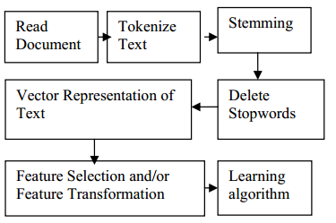

### Lexicon-Based Techniques

The first real attempt to create a pharmacovigilance program was in 2010 by Leaman et al. [5]. The lexicon is extracted from UMLS Metathesaurus [31] , SIDER [32], MedEffect Canada [33] and manually allocated colloquial terms [5]. It used a purpose built parallelized crawler to extract comments from DailyStrength [25], bringing about 3600 annotated comments and 450 reserved for evaluation, the information was taken for the following drugs, carbamazepine, olanzapine, trazodone, and ziprasidone [5]. The comments were annotated for adverse effects, beneficial effects, indications and other terms [5], where the following tools are using in text processing, Java (Tokenization), Snowball implementation (Stemming) [34], Jaro-Winkler measurement [35] (Similarity for misspelling) [5]. A basic lexical similarity comparison was applied, where a sliding window of tokens (size = 5) was go over the tokenized text, comparing them with lexical terms in the dictionary, pairing them in an assignment problem [5], the similarities were summed and normalized with the result by the number of tokens in lexical term [5]. The closest verbs were used to categorize the mention, where verbs like “taking” was an indication, since ADR are targeted, Indications, beneficial effects and others were filtered out [5]. 1260 adverse effects, 391 indications, 157 beneficial effects and 78 other, for a total of 1,886 annotations [5]. For the evaluation, Precision = 78.3%, recall = 69.9%, for an F-Score = 73.9%, not all known ADRs were recognized [5].

The following lexicon methods that followed use association rule, a data mining approach that tries to find statistical relation between drugs and ADRs, the goal is to find enough minimum support and confidence constraints [36]. The research by [6] [10] were among the first to apply this method.

The first research [6], which was made by the team working on [5], tried to match a comment with certain grammatical patterns in order to find the mention of ADR and detecting whether a person is actually inflicted or not [6]. To achieve that, the DailyStrength [25] dataset corpus was used, with an additional 3290 records were added for a total of 6890 records, including the original 1886 annotations from the previous research and using the same dictionary as before and the same drugs [6]. Then to solve the problem, it follows three steps: 1) Term Sequence Generation, the sequence of words in which an ADR is mentioned is stored in a file, each line in the file has the ADR replaced with ADR keyword, part of speech (POS) tagging is performed using the Stanford parser [6] [37]. Some POS were kept (like verbs) using Wordnet [6] [38]. Thus a term is created. 2) Frequent Rule Identification, Apriori tool [39] (which implements Apriori Algorithm) is used to mine association rule, where a term like “make PRP RB CC =>ADR” (which is a combination of verb make and POS tags) occurs when ADR is reported [6]. 3) Frequent Pattern Generation, where patterns based on Frequent Rule Identification are generated, with short patterns and patterns with placeholders after ADR being excluded. Precision = 70.01%, recall = 66.32% for an F-Score = 67.96%, with minimum support = 4, maximum=6, minimum number of terms per rule=4, other tunings and replacements in the input were tried, but this was by far the best result in all the attempts [6].

While [10] tried to detect ADRs through data in parenting sites using disproportionality techniques using the concepts discussed in the three Dutch examples methods [10] [40], the drugs used for this research were amoxicillin, paracetamol, ibuprofen, Bactrim, cetirizine, azithromycin, bacitracin, loratadine, xylometazoline [10], the data was collected from eight parenting web sites in a seven year period (2005-2012) [10], a total 1290 posts were collected, 900 annotated and 300 kept in reserve [10]. A database was created to keep drugs and posts, drugs were organized with their generic names and Anatomical Therapeutic Chemical (ATC) codes [10]. Used UMLS Metathesaurus [31] for biomedical vocabularies, and other resources such as European Agency for the Evaluation of Medical Products (EMEA), Medicines and Medical Devices Agency of Serbia (ALIMS) [41], the DrugBank Database [42], and MetaMap [10] [43], which is a lexical system that maps text to concepts in UMLS Metathesaurus. The following disproportionality measures were used to qualify drug safety: reporting ratio (RR), proportional reporting ratios (PRR) [10], reporting odds ratios (ROR) and information component (IC), each of these measures find the association between ADR and drug. The evaluation of this method resulted in precision = 75.3%, recall = 64.7%, and F-measure = 69.599% [10].

The research by [9] was unique as it tried to not only identify the ADR, but also identify when it was first mentioned [9], all using tensor decomposition to assist in the classification, having used tensors as data containers instead of matrices, greatly helping in missing data and helped identify some ADR mentions before the official FDA announcement [9]. The main advantage of this approach is that it does not require expert annotation for the data [9]. Matrix Based Technique (MBT) was compared to the proposed Tensor Based Technique (TBT). External resources are used for item extraction, mainly Consumer Health Vocabulary (CHV) for drugs and ADR lexicon [9]. Temporal factor is considered important for ADR detection and monitor association rule [9], which is why the association will be made based on a time period of a year, with value p being time window, and q being overlapping year, several combinations of both were tired to compare with TBT [9]. After the association rule mining is done with temporal analysis for each ADR, a matrix of drug x time is made where each cell is the lift measure between ADR and Drug under specific year [9]. TBT introduces using a tensor (3D matrix) between drug, ADR and time, using CANDECOMP/PARAFAC (CP) decomposition technique [9]. Tensors allow the observation of dataset in 1 year time window without overlapping, so data from 2001 and 2002 are used in the same vector, averaging the results from both years [9]. Dataset about 20 drugs were extracted from 500 threads each drug from MedHelp [26] totaling 16344 threads ranging from 1997 and 2011 [9]. Evaluation measures were not determined, but apparently several ADRs were discovered by TBT as opposed to MBT, and some of the existing ADR were discovered to have been mentioned earlier than when it was alerted by the FDA [9].

### Supervised Learning

Next is supervised learning approaches, most ambitious ADR detection system try to track them through twitter or a mix of twitter and other sources, trying to use the large data set that can be provided through twitter [11] [12] [13]. Among the three research SVM, Naïve Bayes, and Maximum entropy were the most commonly used and evaluated.

The first to create a model that follows this approach is [44], which tried to use an ensemble of classification algorithms to classify the dataset on several stages, namely Support Vector Machines (SVM) with RFB kernel and Naïve Bayes (NB), using messages in Yahoo! Forums as dataset (exact size not determined), it used two feature sets: general vocabulary, and meta-features with specialized lexicons from MedDRA [44] [45].

The research made in [11] tried to research the ability to use multi-source dataset corpus, mainly three, twitter with data provided from Arizona State University [24], using 10822 tweets. 1082 of which were annotated by experts using the Inter Annotator Agreement (IAA) using Cohen’s Kappa [11] [46]. DailyStrength [25] with 10617 posts were used (23.7 % contain ADR mentions). And the ADE corpus which contains 23516 phrases with 29% containing ADR mentions, the corpus is not social media but it was used as a proof of concept that the system introduced can analyse data from any source [11]. Three supervised classifiers were made to test the data, Naïve Bayes (NB), Support Vector Machines (SVM), and Maximum Entropy (ME). To perform pre-processing, Porter stemmer was used using implementation by NLTK toolkit [11] [47], POS tagging was done using Stanford parser [37] and twitter parser [48]. UMLS concepts were identified using MetaMap [11] [43]. Synonymous terms were identified with WordNet [11] [38]. The features were by how often a change happens, so if an ADR is reduced, a good change happens and vice versa, so the feature set is built by identifying these changes using a sliding window on the phrase, the features are More-Good, More-Bad, Less-Good, Less-Bad [11]. Two other features are lexicon related derived from Leaman’s [5] lexicon, the two features in question are the Boolean feature of presence or absence of ADR mention, and the numeric feature of the 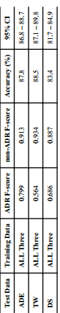number of times an ADR is mentioned, they also collect a topic based feature using Mallet tool [11] [49], the features are the topic mentioned and the sum of the relevance score [11]. Other features include: length of the text, the presence of certain tags from Stanford parser. To implement Naive Bayes (NB) and Maximum Entropy (ME) Weka tools are used, for SVM they use LibSVM implementation [11]. The SVM uses RBF kernel. Several combinations of the dataset were used to test the program, giving varying results, but the after combining all the datasets and testing them on the test data, it outperformed all the others, the results are shown in this table [11].

Also not all features have shown improvement as indicated by this table [11]. Where removing a feature tends to cause a drop in performance, except Synonyms (Syn-set) and topic model, have limited to no effect on the datasets (Except ADE corpus) [11].

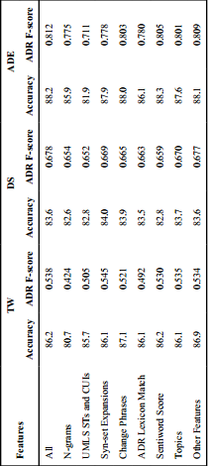

[12] Tried to not only identify ADRs but drug users, implementing two SVM classifiers, one to first identify users of five cancer drugs (still on trial) on Twitter , and the other to identify which ADR did they suffer [12]. The dataset acquired was is a 2 billion tweet collection collected using the Twitter API collected by [50] [51] for a different study [12]. For this study, the Tweets were reduced to four fields, 1) ID, 2) User ID, 3) Timestamp, and 4) text. The features extracted from the Tweets are textual and semantic [12], textual features include Bag-of-Words (BoWs), number of hasht-tags in the document, number of reply tags, number of negating words, the number of URLs, the number of pronouns, and the number of occurrences of the drug names or synonyms [12]. The semantic features are those derived from the UMLS [31] concepts extracted using MetaMap [43]. Trying to limit the data by choosing specific keywords more specifically the number of semantic type and group. After some trials, the Apache Lucene information retrieval library [52] parallelized with Amazon Cloud E2C was used. This lead to having the dataset limited to 239 potential users of the drug, 72 of them were confirmed. The evaluation of the classifiers was vaguely defined, but what is clear is that the first classifier had a prediction accuracy of 0.74 and an Area-Under the-Curve (AUC) of 0.82, and the second got an accuracy of 0.74 and AUC of 0.74 [12].

In [13], the works of the previous study was criticized over the technical aspect of using 72 sized dataset for both training and testing and not using the classifiers to classify more raw Tweets [13], it also criticises the lack of mentioning for the overall results, as well as using investigational drugs (still on trials) as it is not recognized whether the tweeter is using placebos or the real drugs [13]. With that in mind, the drugs chosen (Duloxetine, Gabapentin, Baclofen, Glatiramer, Pregabalin) have been chosen for being in the market for a number of years. This time the Tweets were mined manually of the period of 80 days using Twitter API (Which does not allow searching for posts older than 2 weeks) for a total of 6829 tweets, removing matching brand names of the drugs to peoples’ names and using only English tweets [13]. The features used were personal pronouns and sentiments derived from the NLTK [47], this is because the study required having “personal experience” tweets as opposed to “non-personal” tweets, according to the study; personal experience is expressed more often with pronouns. Using this principal, three classifiers were made, Naïve Bayes, SVM and Maximum Entropy (ME) [13]. ME was the most superior at precision= 0.866, Recall=0.842 and F-Measure=0.848, SVM’s result was precision= 0.856, Recall=0.810 and F-Measure=0.820, and Naïve Bayes was precision= 0.858, Recall=0.827 and F-Measure=0.835. Using 600 tweets for training and 285 for testing [13].

### Hybrid and Unique

Of mixed solutions, a mixed unsupervised and supervised learning [14] system (called ADRMine) had been developed. Data was provided by DailyStrength [25] and twitter using 81 drugs. The system used the same data provided in [24] which was used by [11]. Expert annotators annotated the posts and matched it with IAA’s Cohen’s Kappa [46], with the gold standard includes only reviews with complete IAA. The result is 4720 reviews from DailyStrength (+1559 test) and 1340 tweets (+444 test). An additional 313833 DS reviews and 397729 drug related tweets were gathered in a total 711562 postings to form an unlabelled set which would be used in unsupervised learning. A lexicon was generated using the previously mentioned tools UMLS [31] and SIDER [14] [32]. Concepts are extracted using Conditional Random Fields (CRF), a CRF classifier is used to extract ADR concepts from user sentences using CRFsuite implementation [53], turning them into individual tokens, beneficial effects were also identified as it was noted that including them improves performance of ADR extraction [14]. The CRF features extracted include context features: the 3 tokens before 3 tokens after and current token (Spelling correction was done with Apache Lucene [52]). ADR lexicon: a binary feature that shows whether or not current token is included in the lexicon [14]. POS: generated with Stanford parser. Negation: Features that indicated that the token is negated using syntactic dependency rule [14]. The other feature extracted is the learning word embedding, the embedding is a meaningful real-valued vector of configurable dimension (between 50 and 500), these vectors were generated using Word2vec tool [54], which learns the embedding based on the word’s contexts in different sentences, then a K-Mean clustering operation is performed to cluster the words into n (=150) different clusters (Each cluster has some common words, like one only including ADR or only including drug names or dates) [14]. Seven features are defined based on the generated clusters, which are the cluster numbers of the current token, the three preceding and the three following tokens. ADRMine’s CRF classifier was compared to 4 extraction techniques (SVM, Lexicon-based, and two simple baselines based on MetaMap). The system proved superior to the other techniques, reaching an F-Score= 0.821 for a recall=0.784 and precision=0.860 for DS dataset and F-Score =0.721 for Recall=0.682 and Precision=0.765 for twitter. It was concluded that the lexicon, POS and negation features did not add a significant contribution with a huge dataset as it did with smaller dataset [14].

There was only one example of hidden Markov Model [15], the study describes three type of sources for ADR information, biomedical sources (books, journals, magazines, drug package labels) which may not be up to date, most accurate [15]. Clinical sources (patients’ data) which are not free and are limited by ethical, legal and social constraints, may also be inaccurate. Online Forums are the most inaccurate, but they are the most numerous, up to date and totally free, refers to many other works found in the survey [15]. The data was extracted from Medication.com [28] and steadyHealth.com [55] using JSoup crawler, collecting 8065 posts from Medication and 11878 from SteadyHealth [15]. To extract relationships between entities, the information extraction module is made, consisting of Named Entity Recognition (NER) and Relationship Extraction (RE) sub-modules [15]. NER helps to identify entities of interest in a given text, such as names of drugs, side effects and keywords or phrases relating them together using lexicon based method [15]. The dictionary of drug names was crawled from the drug lists on drugs.com [56], side effects from SIDER [32]. RE than identifies the relationships between named entities using Hidden Markov Model, which learns the association between the drug name and side-effect in a given text [15]. The HMM is defined using the following parameters: N number of states, M number of observation symbols, A N by N transition probability matrix, B N by M observation probability matrix. Pi N by 1 initial state probability vector. Around 2000 annotated training data messages is used to train the classifier using the Baum-Welch training algorithm [15]. The learnt model is used with Viterbi decoding algorithm to predict the hidden states for the observed sequence data in the testing set, where if the three states (drug, side-effect, connecting keyword) then the text is flagged as a positive drug/side-effect relationship. Using 10-fold-cross validation, the model got an F-score = 0.76, HMM however was unable to distinct between ADRs and symptoms of the drug, reducing the dictionaries themselves causes problems, especially for the drug dictionary [15].

Another unique approach was the Partially Supervised Learning technique (PSL) [16], which tries to solve the lack of large labelled data, by only giving the classifier a small number of labelled data and dynamically augmented it throughout the learning process, this would eliminate the need for a large expertly annotated dataset [16]. The dataset in question I extracted from Yahoo! Forums ProzacAwareness (Prozac drug) and Selective Serotonin Reuptake Inhibitors (SSRIsex), having a total of 6400 posts (1600 ADR and 4800 Non-ADR posts) [16]. A consensus detection is used to identify which new example goes to which cluster of data (positive or negative) using Rocchio algorithm [16]. An SVM and Naïve Bayes (NB) classifiers were created with and without PSL for comparison. SVM and NB scored less than 68 F-score without PSL, while the SVM and NB with PSL reach 89.74 and 86.32 F-score respectively [16]. The proposed approach was compared using benchmark labelling heuristics (EAT and PNLH) outperforming both of them in terms of F-Score [16].

# Methodology and Implementation

The methodology of this project is separated into several parts

## Acquiring the dataset

 Acquiring the dataset was made possible by creating a data crawler using Java JSoup library using the following steps:

1. Get the establish connection to server.
2. Retrieve HTML scripts.
3. Use HTML hyperlink tags to navigate and retrieve post pages.
4. Find pages with the tags that contain the full text.
5. Get user profile pages which includes some user profile data (age and gender).
6. Find the personal data tag, split it into parts, take the age part and the gender part (which is marked by integers and the words male and female)
7. Repeat and store the data in an array list of data objects.
8. Store the dataset into CSV files that can be easily accessed later (switched to excel later because it is even more convenient).
9. Handle connection problems during the crawling process by Backing up the data.

### Subjects to consider

* Choosing the Drugs for this research: For the purpose of this research, drugs using for chronic diseases had to be chosen. After some consideration, drugs used for hypertension were chosen, and they are Lisinopril, Nadolol, Amlodipine, Diltiazem, Hydrochlorothiazide and Atenolol.
* Choosing the medical forums for mining: The websites chosen for this purpose are MedHelp and AskAPatient, which was chosen since most of its posting members are more committed to share their personal data, such as age and gender. The dataset acquired from both forums will be used comparing results and quality of the datasets.
* Finding the correct links and tags: JSoup establishes a connection to the server and returns the HTML script as text to a variable, and from that script tags can be chosen based on IDs or classes, given a universal search query link (example: <https://www.medhelp.org/search/expanded?cat=posts&page=2&query=Nadolol>), the web can easily be navigated through JSoup, and given the correct tags from each the given posts (example: subject_msg), data can extracted from each page and it’s HTML script.
* Store Data: The chosen data storage is on CSV file which can be accessed using MS excel, they can also be used later using Pandas library in Python, and later saved as excel files (which proved even more convenient than CSV files).
* AksAPatient: Using crawler was neither necessary nor possible, the site was protected against crawling activities. However its data was in a table format which was much easier to simply copy and paste, a script was later made to remove all the problems in the text format. AskAPatient is more consistent comparing to MedHelp, however user data is impossible to extract other than age and gender, however all data extracted is correct and therefore could be used for comparison against MedHelp dataset.

### Data retrieval

Several natural language processing techniques were implemented using Python to extract the data necessary, using NLTK (Natural Language Tool Kit) library

* Tokenize data: Turn the words into separate tokens.
* Remove stop-words: Stop-words like (and, a, or) were removed to decrease the size of data.
* Stemming data: Porter stemmer was used to turn words into their roots (exhaustion, exhaustive, exhausted= exhaust), both the original and the stemmed tokens were kept into separate csv columns.

## Build Dictionary:

A dictionary filled with concepts like ADR, Disease and Mental issues were needed to narrow down the search premise into the UMLS, using the following steps:



1. Find and store all unique tokens.
2. Identify UMLS concepts using MetaMap.
3. Parse MetaMap output into a python dictionary format.
4. Remove secondary concepts.
5. Stem the token to remove similarity.
6. Extract mentions from the Dataset using the dictionary.
7. Extract missing user profile data as features.
8. Store mentions as features and classes for classification.

### Subjects to consider

* Find term frequency: This in itself is not necessary for building a dictionary, but the TfidfVectorizer from Sklearn library can double as a retrieving method for all unique words in the text, term frequency will be used later, but for now all unique words are stored in two term frequency files, one for stemmed words and one without stemming.
* MetaMap batch: MetaMap as mentioned before is used to extract UMLS concepts, by sending a file to the batch system, which was necessary due to size of the dataset.
* Stemmed or Un-stemmed: The stemmed version was not effective in extraction because it removed the meaning of the words (“Acne” became “acn” which means nothing and was therefore undiscovered). Therefore the un-stemmed version was instead used for discovery, with the terms being stemmed later, which reduced the size of the dictionary by insuring that similar words are not repeated (confusion, confused = confus).
* Extract the concepts from MetaMap: MetaMap output needed is classified into three categories ([Signs and Symptoms] = ADR, [Disease or Syndrome], and [Mental or Behavioral Dysfunction]), a script was made to handle MetaMap output and extract these concepts into files containing the concept in Python Dictionary Format.
* Extract The concepts per post: The dictionary was copied and pasted into a python script (After some minimal manual revision) to be used for concept extraction from the dataset, every post had was scanned for any token that match any concept in the dictionary, and these concepts were than aligned it’s related meaning ('cramp': ['Muscle Cramp ', 'Cramping sensation quality ']) or meanings, this arrangement is made so that concepts with similar meanings don’t get repeated (Pain = Pain, Ache = Pain), secondary meanings were removed if they were similar and don’t add meaning. Age was also extracted by applying a moving window of three tokens that searches for some limited age related words couple with numbers (I am 28 years old). As well as blood pressure (150/70).

## Association with GloVe:

**Word Embedding:** A technique for language modeling and feature learning [57], which transforms words in a document into a continuous real number [57], traditional way to find calculate it include simple term frequency, TFIDF and co-occurrence matrix [58]. Newer methods however include the use of neural networks, such methods include Word2Vec [58].

**GloVe:** Global Vectors for Word Representation [59], is a very popular library created by Stanford to be used for word embedding based on co-occurrence matrix. It is used here to make some indications which can be observed later in the machine learning phase. Word embedding shows the association between all the words in the corpus.

GloVe works as follows [60]:

* Find the co-occurrence matrix probability of each word x [59] [60].
* Calculate the context of the words together based on the distance x+= 1/distance [59] [60].
* Take the log for each value in the matrix (+1 to avoid 0 values) [59] [60].
* Weight value x in the matrix from 0 to 1 based on a function (f(x) =(x /xmax)a) [59] [60].
* Calculate the final Co-occurrence matrix using the cost function [59] [60]:

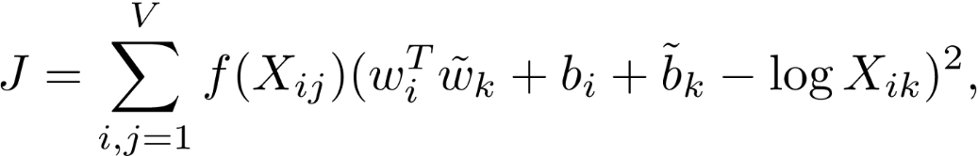

* The matrix can be calculated over many dimensions, creating many vector values that can be calculate to find the distance between two certain words using cosine or Euclidean distance [59] [60].

### Implementation Details

* Both stemmed and un-stemmed datasets were used to create a word vector models, the stemmed dataset turned out to be more effective as it generalized some terms instead of repeating them (confused, confusion=confus).
* The models were saved as 2D array for vectors in .txt format.
* The text file was loaded into tensorflow projector [61] [62]to represent the points of the model into an intelligible 3D (in truth 100D) plot (pictured above).
* This plot allows the observation of related concepts in a readable manner, each dot representing one of the model’s label. The closer two dots are to each other, the higher their association, and therefore the probability of co-occurrence.

Two approaches were made for the analysis:

1. Discover the relation between ADRs and Drugs.

* After the models were saved into several formats, they were trimmed to only include ADRs and Mental issues, as they are the most relevant for this analysis.
* By looking at the closest vectors to a certain drug, it was possible to find which ADRs and Mental issues have the highest chance to occur when using the drug. For example, amlodipine was found more related to hoarseness, frenzy and hallucinations than it is related to pain, nervousness and alcohol abuse. It is therefore more expected for a patient to encounter hoarseness- for example- than to encounter pain while taking the drug.

1. Discover any related concepts to the drugs and ADRs.

* The models were trimmed to include the words with a relatively high term frequency (above 20, 40, 60, or 100), in order to make it more readable by removing the least used words with little effect on the model.
* The goal is to find any randomly related concepts that might relate to the use of the drug, like for example dosage, age, a certain height or weight. It could therefore be understood from the results if there is any remote relation between the usage of this drug, or the presence of the ADR, and the presence of these other concepts.
* The dataset was slightly modified to attach several concepts to each other to become on term (200 mg = 200mg) which limits the model size and helps make it more accurate and readable.

## Association with Apriori

Association rule mining is extremely important as a data mining technique, it can be help for decision making. And in the context of this project, it can identify the relation between the occurrences of Drugs, Drug Family and all the ADRs, mental issues and diseases.

In association rules, the goal is to identify the following major components [63]:

* Support: Records Containing A/Total Records = the number of times one or more items appear in the records [63].
* Confidence: Confidence (A =>B) = (Records containing both (A and B)) / (Records containing A) = the likelihood that if one item appear in a record, another one also appears [63].
* Lift: Lift (A=>B) = (Confidence (A=>B)) / (Support (B)) = refers to the increase ration if item B when item A appear [63].

Apriori Algorithm is an application to the association rule mining used to decrease the run time for a large dataset [63] [64]. Generally, the standard algorithm is calculate all the rules for all the dataset. In Apriori however:

* Set a minimum requirement for any component, support as a beginning [63] [64].
* Calculate the support for all 1-itemsets (I1) [63] [64].
* Choose I1 that meet the minimum requirement as candidates (C1), and drop the rest [63] [64].
* Find I2 for C1 and calculate the rest of the components [63] [64].
* Repeat for Ix and C(x-1) until no more candidates are available [63] [64].
* Typically, the biggest length is C3 at I4 sets, in practice a limit to the length can be placed.

### Implementation Details:

Apyori [63] library was used for this implementation on python.

* As input, concepts mentioned were put into a list of lists, each list corresponding to a record of the posts (example: ["Hypothyroidism ", "Hypertensive disease ", "Ulcer "]).
* Each list was extended to include age, gender, drug and drug family, in order to obtain the relation between them (Drug and Drug Family relations were later removed to avoid confusion.
* After running Apriori using Apyori. The result was printed in a .txt file to be reviewed later.

## Machine Learning:

### Preparing the dataset:

After building the dictionary, it is now possible to identify the diseases, ADRs, and mental issues that were mentioned in the user posts.

* **Pandas** library was used to access and manipulate the data.
* A scanner was made to iterate on every token in every record in the stemmed version of the dataset, matching each token with an equivalent in the dictionary.
* When a token matches the dictionary, it marks the meaning of the concept as existing if another token with same meaning, such as (‘ache’: ‘pain’, ‘pain’: ‘pain’), it is ignored to limit repetition.
* The number of concepts (diseases, ADRs and mental issues), were counted for each record.
* Two types of classes are created using this process.
  1. Concept exists, where for each concept, a Boolean value is given to determine the existence of the concept in the record.
  2. Concept count, where the number of specific concepts in a particular range is drawn, meaning the number of distinct ADRs in a record for example is 5, this number is recorded and then assorted in the following ranges as a class.
     + 0 for 0 concept.
     + 1 for range [1,3].
     + 2 for anything more than 3.

In the previous example, 5 will be in the 2 class.

1. As for the features, user information harvested is used, such as age, gender, blood pressure, weight and height. Unfortunately, the MedHelp dataset has a lot of missing data, so not all user information could be used at the same time.
2. To solve this issue, the dataset was divided into three groups.
   1. Age + Gender only
   2. Age + Gender + Weight + Height
   3. Age + Gender + Blood Pressure

|  |  |  |  |  |
| --- | --- | --- | --- | --- |
| Dataset Description | MedHelp Complete | Weight/Height | Blood Pressure | Ask A Patient |
| Size | 1557 | 130 | 462 | 757 |
| Maximum size | 12951 | 7868 | 6829 | 1939 |
| Minimum Size | 8 | 254 | 174 | 3 |
| Features | Age, Gender, Drug, Drug Family | Age, Gender, Drug, Drug Family, Weight and Height | Age, Gender, Drug, Drug Family, Blood Pressure | Age, Gender, Drug, Drug Family |

|  |  |  |  |  |
| --- | --- | --- | --- | --- |
| Feature Description | MedHelp Complete | Weight/Height | Blood Pressure | Ask A Patient |
| Age | 12 to 107  Blank=515 | 15 to 79  Blank=10 | 12 to 80  Blank=107 | 15 to 91  Blank=0 |
| Gender | ‘Male’: 581, ‘Female’: 553, Blank: 423, | ‘Male’: 71, ‘Female’: 41, Blank: 18 | ‘Male’: 199, ‘Female’: 167, Blank: 96 | ‘Female’: 423,  ‘Male’: 333 |
| Weight |  | 27 to 172 KG |  |  |
| Blood Pressure |  |  | Max: 295/135  Min: 102/60 |  |

* Now that missing data is in an acceptable level, the remaining missing values (Age and Gender) were imputed using the SciKit learn library, SimpleImputer. Gender was imputed based on most frequent strategy, while age was imputed based on median strategy.
* The data sizes for the three datasets respectively is: 1557, 130, 462. With dataset 2 ⊆ dataset 1 and dataset 3 ⊆ dataset 1. Each subset is stored in a separate excel file.
* The classes labels were stored in separate excel files, from which they can be extracted later and used in the classifier.
* The same procedure was applied for AskAPatient dataset, however the dataset did not include anything other than age and gender, therefore as a whole the size of the dataset is 757 with no divided parts between them.
* The dataset can thus be modified to suite any learning model, either by including all the labels (except the class) as a part of the features, or by separating them completely and only using the patient profile and drug/drug family as features.
* Drug/Drug family can also be used as features, where the goal is to find out the possibility by which a drug could cause ADRs and diseases.

### Dataset Imbalance

All the dataset have data label imbalance due to infrequency in the ADRs per each patient, in the complete MedHelp dataset, the highest percentage is “Pain” label, with 76% negative and 24% positive. The subsets are generally more even, but there is still too much imbalance in most labels. The “Hypertensive Disease” label and count labels are however have a better distribution, so they could be used for a more accurate measure of the quality of the dataset.

As for the remaining labels, several techniques could be applied.

1. Oversampling re-use: Several records of the minority class are repeated [65].
2. Under-sampling: Several records from the majority class are unused [65].
3. SMOTE (Synthetic Minority Over-sampling Technique): Where entirely new instances of the records are created to fill the gaps [65].

Approach number 3 was chosen for this application, using the imbalanced-learn implementation [66], using SMOTENC library (NC = Nominal Continuous).

**SMOTE** works as follows [65]:

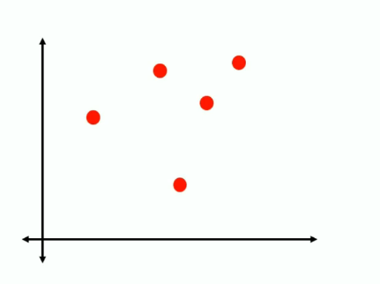1) Isolate the minority class [67]

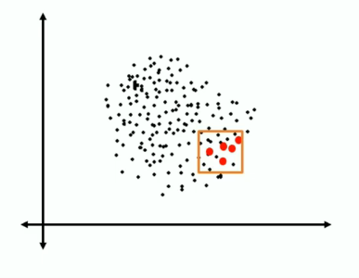

2) Find the k nearest neighbors depending on the over sampling requirement, calculate the distance between the two neighbors [67].

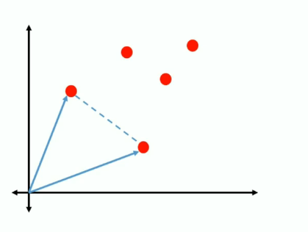

3) Multiply the distance with a random number between 0 and 1, placing a new record of the minority class on the new point created [67].

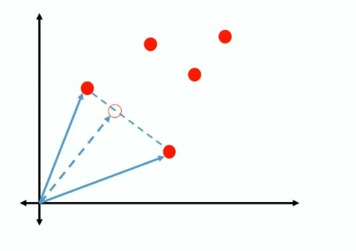

4) Repeat until data label imbalance is solved [67].

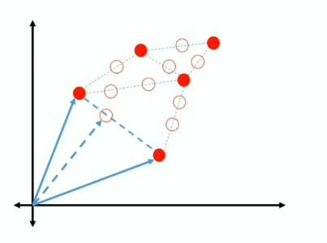

SMOTE however only works with continuous features, which is problematic since most the dataset is nominal/categorical, using either Boolean features or discrete categories that describe drug/drug family and counts.

This is why **SMOTENC** is used instead [65], SMOTENC looks acts the same way as SMOTE, however, between the closest neighbors, the median of the standard deviation of the nominal feature is taken into consideration for the distance [65]. With the distance calculated, continuous values are calculated based on normal SMOTE, while nominal features are given based on the majority of values within those neighbors [65].

SMOTENC implementation works exactly the same as SMOTE, by fitting the dataset to each other using SMOTENC object, only the difference is pointing out which of these features are nominal, SMOTENC is compatible with Pandas Dataframe, with the a list of new features as output to be used in the classifier.

Performance of the classifiers with and without SMOTENC will be compared together.

### Preparing the classifiers:

#### Goals

There are several goals that could be achieved by using classifiers.

1. Predict the possibility for a user to be affected by an ADR or Disease based on extracted profile.
2. Predict which drug or drug family is the cause of the ADRs or Disease affecting the user, with the help of the user profile.
3. Predict the number of ADRs or Diseases that could be caused by a drug, based on the user profile and/or existing cases.

A separate classifier group will be made for each goal, each classifier group using a different dataset arrangement, which will be furthermore elaborated on in the following section.

#### Dataset Arrangements:

Features differ depending on the used subset in terms of user profile.

|  |  |  |  |
| --- | --- | --- | --- |
| Arrangements | Labels | | Features |
| 1 | Labels, Counts are categorized while running.  One Label is chosen for each prediction. | | User Profile, drug and drug family, profile differs for |
|  |  | |  |
| 2 | Labels are only limited to identifying which drug or drugfamily was responsible for any given disease. | Features include labels from the arrangement 1 and the user profile. | |
| 3 | Labels and Features are mixed, with the wanted feature being removed from the comparison dynamically. | | |

Arrangement 1 and 3 will include predictions for the Count of ADRs diseases, mental issues count will be ignored as their mentions are very low for in askapatient dataset. However the mentions themselves will be used for as features.

#### The Classifiers

Three classifiers are made as a performance comparison.

1. Random Forests
2. SVM
3. Naïve Bayes

##### Random Forests (RF)

Random Forests is an ensemble classifier for classification and regression trees [68] [69].

It works as follows:

1. Create a certain number of decision trees classier N [69] [70].
2. Commence bootstrapping operation:
   * Subsets of the original dataset are randomly selected to be used for each tree classifier in N, repetitions are possible.
   * For each subset, choose random features to use instead of using them all [69] [70].
3. Each resulting tree can be completely different from the others and can give different classification results.
4. Each one of these results calculated in a vote, with the highest voted result being chosen as the final result for the classification [69] [70].

##### Random Forests (RF) in Scikit Learn

The random forests implementation is provided is SciKit learn as an ensemble classifier, the main parameter given is “n_estimators”, which is the number of bootstrapped trees that should be constructed. Estimators between 100 and 1000 were tested to ensure accuracy.

##### Feature Selection

In addition to the classification capabilities, RFs can be used for embedded feature selection [71], as each time a new tree is made with a subset, a purity metric can be measured, since not all trees see all features, there is an assured de-correlation between all features, this also makes them less prone to overfitting [71]. By calculating the purity of the tree can be used to derive the importance of the features, giving a standard on which feature is more important than the other and thus which feature could be removed [71]. Scikit Learn provides this capability view feature_selection library, which can use an RF classifier to test the data and choose the best features based on an initial classification [71]. This method will be tested on all the classification methods, and observations will be provided for the improved performance if any.

##### SVM (support vector machine)

First introduced by Vapnik, SVM is a very popular classification and regression technique [72]. It is based on the Structural Risk Minimization principle (SRM) [72], where the classifier maps input vectors to a higher dimensional space where a maximal separating hyperplane is constructed on each side of the hyperplane separating the data [72]. The goal is to maximize the hyperplane, the assumption being that when the bigger distance between two hyperplanes are maximized, the better the generalization error of the classifier [72].

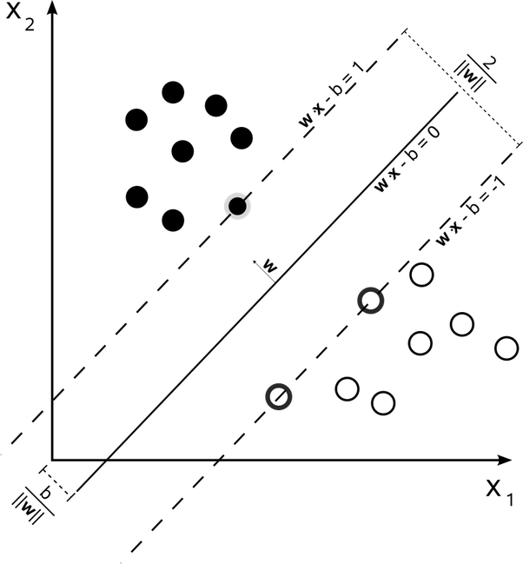The goal is to maximize 2 / | W |

The hyperplane is calculated based on several factors, the most important of which is kernel. Here are the most popular kernels [72]. RBF

* Linear
* Sigmoid
* Polynomial

RBF being the most commonly used for handling higher dimensional space better than Linear, with less parameter than Polynomial, and less numerical difficulties [72].

SciKit learn implementation provides all these assortment of kernels, as a parameter to the SVM classifier [72], with RBF as default kernel.

##### Naïve Bayes classifier

Naïve Bayes (NB) is one of the simplest probabilistic classifiers available, it is based on Bayes rule [73]. Where P© is the probability of a class (yes or no/Pain exist or doesn’t exist), and P(X) is the probability of all the features. P (C|X) is the probability of the class given all the features used [73]. If the probability of P(C=exist|X) > P(C=not|X), than the classifier predicts that yes, this ADR exists and vice versa [73].



Bayes rule

NB is reported to be extremely simple as it only relies only on simple mathematics.

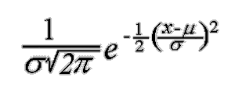The implementation on SciKit learn is GaussianNB, which uses the Gaussian distribution to represent continuous variables. Although there are other distribution options are available [74]. Including Bernoulli, Multinomial and Complement.

**Performance Metrics:** The performance of the classification is important to test capabilities of the trained classifier and evaluate the results without having to delve into specific cases [75]. The performance metrics used are based around the concept of the confusion matrix [75].

Each cell identifies the count of test cases that received a given result. True positives and negatives (TP and TN) indicate that the prediction was correct and matching to the actual test data. While false negative and positive (FN and FP) indicate the wrong in predictions. Usually it is better to have FP than FN because a positive can be an alert, while negative means no detection at all [75].

Based on the matrix, four metrics were chosen to measure the performance:

1. Accuracy = (TP+TN)/(FP+FN+TN+TP): Correct prediction/all predictions [75], it is good measure when most classes are nearly balanced [75].
2. Precision = TP/(TP+FP): The amount of TP in proportion to all the positives [75].
3. Recall = TP/(TP+FN): The amount of Negatives that were missed [75].
4. F1-Score= 2*Precision*Recall/(Precision + Recall): the harmonic mean of precision and recall, meant to be used as a simplification, instead of having to look into 2 different values, F1-Score gives an approximation that is closer to the smaller number, and thus more accurate and representable number [75].

There are other metrics that could be used, but these are the most standard (as discussed in the literature survey).

##### Testing Parameters:

To calculate the performance, the dataset has to be trained using a given set of data, and tested against another set it has never seen. The dataset can be used for that by randomly splitting the data into a testing set and training set, the usual ratio for this purpose is 70% for training and 30% for testing. Values in the confusion matrix can be calculated in the testing part, and from this the metrics can be calculated.

##### K-Fold Cross Validation

Sometimes the testing of a certain part of the dataset can have different consequences from another, as in, the 30% testing if chosen from another part of the dataset can have a completely different result if it was used for training, while another part was used for testing [76]. One way to test this is to use K-Fold cross validation, where the dataset is split into K parts, while each K-1 part is used for training and only one for testing, this is repeated K times with each part [76]. The metrics are calculated and averaged together over the value of K. This usually take a longer time but it should provide a better perspective [76].

##### Implementation Details

The implementation was originally meant to be made in python 2.7, and indeed most the text processing made Data retrieval and Dictionary Building was in 2.7. However the initial experiments with GloVe showed that 2.7 was extremely outdated. Therefore the learning process was moved to python 3.6, in which installing was much easier.

Environment: Using python required setting up an environment that could allow the use of all necessary libraries, thus Anaconda was installed, and configured for both 2.7 and 3.7 while each was in use.

This small list of libraries were necessary for the making of this project.

* Pandas: File and Dataset management
* NLTK (PorterStemmer, remove stopwords, tokenize text)
* Sklearn (classifiers, Count Vectorizer, label encoder, feature selection, K-Fold testing, imputer, TFidf Vectorizer)
* Imblearn.SMOTENC
* GloVe

##### IDE

Most text processing was made on anaconda’s Spyder IDE, however, while making the classifiers, the implementation was moved to Jupyter Notebook, which was more convenient as it allowed complete code separation and easier document comments. Jupyter uses separated cells which can be modified and run separately, while still maintaining the same variable and importation pool. This allowed the interfacing between several functions, where each classifier is in a different cell, each run of the classifiers is in a different cell, the dataset manipulation and preparation is independent from running the classifiers. Therefore whenever any arrangement was tested, the only change needed was to the data manipulation functions with minimal changes to the classifier.

Jupyter does not support concurrency. However for convenience, all cells could run at once in the sequence they were placed.

Cells could be changed from code to headings or simple text, they could be added, moved, stopped and repeated independently from one another.

##### Classifier Flow

As shown in this flow chart:

1. The dataset is collected from the excel files.
2. The dataset is modified to suit whichever dataset arrangement in use.
3. Then there are three steps, any of which can be skipped at any point, and two of which at most are meant to compare performance whenever they are applied:
   * SMOTENC resampling.
   * Feature Filtering with random forests.
   * KFold Cross Validation (Which can be replaced with fixed percentage testing)
4. Store metrics to be used for comparison between all combinations later on.



# Results and Discussion

## Unsupervised Algorithms

### GloVe Results

In this section, the results given from applying GloVe to the dataset will be discussed, where the closest terms given will be provided for context. All the experiments were run on a 100 dimensional parameter.

#### Drugs and ADR relation

Using the vectors acquired from GloVe, the following results were obtained:

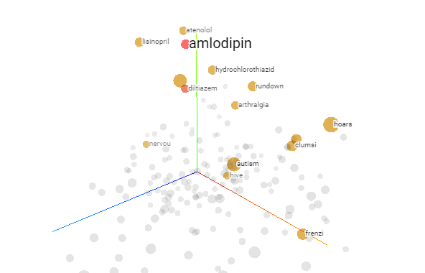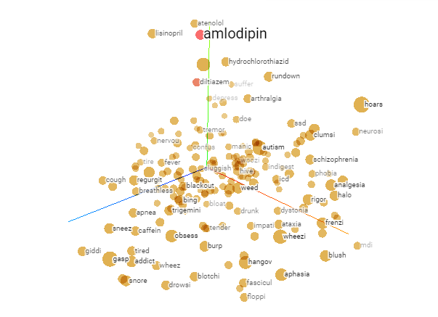The tensorflow projector [62] allowed displaying the results in a 3D view. By searching for a single word, mainly a drug or an ADR, the words closest to the meaning of the word are highlighted. The tool allows decrease the viewed portions to an intelligible level, this will be limited to 20 words. The distance between the words can be calculated with either Euclidean or cosine distance, which don’t make much difference, therefore Euclidean distance was used, it should be noticed that the words are stemmed.

##### MedHelp Dataset:

GloVe was able to identify which concept are the drugs, where for all the drugs, the closest concepts are in majority the five other drugs. It also shows the most frequent ADRs that were encountered in the dataset.

Despite Amlodipine and Diltiazem being of the same drug family, they have little ADRs in common, which could suggest that the problem is in the drugs themselves, not in the drug family. Atenolol and Nadolol on the other hand had more in common although in different degrees to the other.

|  |  |  |
| --- | --- | --- |
| Amlodipine | Diltiazem | Hydrochlorothiazide |
|  |  |  |

|  |  |  |
| --- | --- | --- |
| Nadolol | Atenolol | Lisinopril |
|  |  |  |

The Common ADRs that repeat most commonly are:

* Hoarseness
* Apnoea
* Sleeplessness (Insomnia)
* Anxiety
* Doe

##### Ask A Patient Dataset:

This dataset was more focused than MedHelp, and therefore its size was much smaller, especially that only two drugs were tested on it.

Despite this, it not only identified, several common ADRs, but it also identified other drugs that are not within the scope of the dataset search.

|  |  |
| --- | --- |
| Atenolol | Lisinopril |
|  |  |

#### Related Concepts Discovery

##### MedHelp Dataset:

The previous section discussed the results of the limiting presented vectors to drugs and ADR. In this section, the vectors presented are limited by their overall frequency, the goal is to discover what kind of general terms accompany drugs, to insure that drugs are mentioned, they are attached to posts before being trained as well as the drug family.

The results show that it was still capable of identifying other drugs, but less effectively, drug family is always the closest, since it is attached to wherever a drug is mentioned, the most common things people appear to mention in their posts is the dosage (x mg), the number of times they take a dose (twice), the duration (daily), and the injection method (pill or tablets), by far the most common word is ‘Hi’, which shows how this medical forum is aimed more towards community rather than a focused drug review website.

|  |  |  |
| --- | --- | --- |
| Amlodipine | Diltiazem | Hydrochlorothiazide |
|  |  |  |

|  |  |  |
| --- | --- | --- |
| Nadolol | Atenolol | Lisinopril |
|  |  |  |

##### Ask A Patient Dataset:

The previous analysis from the dataset is further confirmed, where dosage is even more frequent, however it is more discrete and to the point, with most words written being directly related to drug consumption and related issues to it and indicate more suffering compared to the community friendly MedHelp.

This does not necessarily mean that MedHelp users face any less issues, but it shows that Ask A Patient is efficient and compact, with less descriptions given comparing to MedHelp.

This however makes Ask A Patient harder for data mining as it contains less user information that users mention while talking about their issues.

|  |  |
| --- | --- |
| Atenolol | Lisinopril |
|  |  |

### Apriori Results

In this section, the results obtained from applying Apriori algorithm to the dataset’s mentioned ADRs, diseases, mental issues, gender of user and drug used, will be discussed. The parameters specified were made as follows:

* Minimum support = 2.5%
* Minimum confidence = 52%
* Minimum lift =1.5

This would essentially mean that all the resulting relations appeared at least in 38 posts (MedHelp) and 11 posts (AskAPatient), all the items co-appearing at least half the time, and the possible amount of one of them increasing by the presence of the other is 1.5 times.

#### MedHelp

For MedHelp dataset, these are the relations that appeared.

Rule: ['Cerebrovascular accident '] -> ['MUNGAN SYNDROME ']

Support: 0.026332691072575465

Confidence: 0.5189873417721519

Lift: 2.3220209515495416

=====================================

Rule: ['Atrial Premature Complexes '] -> ['Atenolol']

Support: 0.029543994861913937

Confidence: 0.6865671641791045

Lift: 1.724169475204622

=====================================

Rule: ['Pvc'] -> ['Atenolol']

Support: 0.06872190109184328

Confidence: 0.656441717791411

Lift: 1.6485157332277856

=====================================

Rule: ['Atrial Premature Complexes '] -> ['Beta']

Support: 0.03147077713551702

Confidence: 0.7313432835820896

Lift: 1.5408680548542806

=====================================

Rule: ['Atrial Premature Complexes '] -> ['Pvc']

Support: 0.028259473346178548

Confidence: 0.6567164179104478

Lift: 6.273051918322498

=====================================

Rule: ['Liver Cirrhosis '] -> ['Beta']

Support: 0.025048169556840076

Confidence: 0.8863636363636364

Lift: 1.8674806249231146

=====================================

Rule: ['Cerebrovascular accident '] -> ['Hypertensive disease ']

Support: 0.03789338471419396

Confidence: 0.7468354430379747

Lift: 1.6083302694469246

=====================================

Rule: ['Cerebrovascular accident '] -> ['MICROCEPHALY , EPILEPSY , AND DIABETES SYNDROME ']

Support: 0.02697495183044316

Confidence: 0.5316455696202531

Lift: 2.4783597362237546

=====================================

Rule: ['Common Cold '] -> ['Upper Respiratory Infections ']

Support: 0.0449582530507386

Confidence: 0.9722222222222222

Lift: 21.625

=====================================

Rule: ['Headache'] -> ['Pain']

Support: 0.03917790622992935

Confidence: 0.5213675213675213

Lift: 2.0868103618746288

=====================================

Rule: ['Malaise'] -> ['Pain']

Support: 0.028901734104046242

Confidence: 0.5487804878048781

Lift: 2.196532697974795

=====================================

Rule: ['Amlodipine', 'Pain'] -> ['Hypertensive disease ']

Support: 0.025048169556840076

Confidence: 0.7222222222222223

Lift: 1.5553250345781469

=====================================

Rule: ['Atenolol', 'Common Cold '] -> ['Upper Respiratory Infections ']

Support: 0.025048169556840076

Confidence: 0.975

Lift: 21.686785714285715

=====================================

Rule: ['Beta', 'Common Cold '] -> ['Upper Respiratory Infections ']

Support: 0.02697495183044316

Confidence: 0.9545454545454546

Lift: 21.231818181818184

=====================================

Rule: ['Dyspnea', 'Beta'] -> ['Female']

Support: 0.027617212588310854

Confidence: 0.5512820512820513

Lift: 1.5521630268465714

=====================================

Rule: ['Pain', 'Mental Suffering'] -> ['Hypertensive disease ']

Support: 0.02569043031470777

Confidence: 0.7407407407407408

Lift: 1.595205163669894

=====================================

#### Discussion on MedHelp

It can be noted that the only drugs mentioned within the given parameters are Atenolol and Amlodipine, being a beta-blocker and a calcium channel blocker respectively [77].

According to VeryWellHealth [77] [78], beta-blockers are used to treat Atrial Premature Complexes (PAC), and that its usage worsens dyspnea (shortness of breath). This could explain why there are relationships between both beta-blocker, Atenolol and PAC, it could also explain the relationship between ['Dyspnea', 'Beta'] -> ['Female'], which not only shows that Dyspnea and beta-blockers show up together also that it is very likely it happens to females, this relation does not necessarily include Atenolol as it could also include Nadolol, another beta-blocker [77].

No direct relations appear between Amlodipine and any known ADRs for calcium blockers, but other symptoms and diseases had a relation like ['Amlodipine', 'Pain'] -> ['Hypertensive disease '] in the first one, pain being an ADR, it could mean that if the use of Amlodipine caused pain, than it is likely that whoever took it needed it for hypertension, which may be very obvious until it is understood that Calcium-blockers in general could be used to lower heart beat besides its hypertension treatment [79].

In addition, some relations like ['Liver Cirrhosis '] -> ['Beta'] show a completely new and inexistent disease [80], which might suggest that this a new problem caused by the usage of beta-blockers in general, or it could mean that people who have Cirrhosis also happen to take beta-blockers to treat side effects caused by Cirrhosis.

Otherwise, all other relations are either common, well known or somewhat related issues, such as

['Common Cold '] -> ['Upper Respiratory Infections '] and ['Headache'] -> ['Pain']

#### Ask a patient

For AskAPatient dataset, these are the relations that appeared.

Rule: ['Asthma '] -> ['Coughing']

Support: 0.027777777777777776

Confidence: 0.875

Lift: 2.388086642599278

=====================================

Rule: ['Asthma '] -> ['Female']

Support: 0.0291005291005291

Confidence: 0.9166666666666666

Lift: 1.6382978723404253

=====================================

Rule: ['Common Cold '] -> ['Atenolol']

Support: 0.027777777777777776

Confidence: 0.5121951219512195

Lift: 2.889697852202403

=====================================

Rule: ['Common Cold '] -> ['Beta']

Support: 0.027777777777777776

Confidence: 0.5121951219512195

Lift: 2.889697852202403

=====================================

Rule: ['Common Cold '] -> ['Upper Respiratory Infections ']

Support: 0.051587301587301584

Confidence: 0.9512195121951219

Lift: 18.4390243902439

=====================================

Rule: ['Asthma ', 'Angiotensin'] -> ['Coughing']

Support: 0.027777777777777776

Confidence: 0.875

Lift: 2.388086642599278

=====================================

Rule: ['Asthma ', 'Angiotensin'] -> ['Female']

Support: 0.0291005291005291

Confidence: 0.9166666666666666

Lift: 1.6382978723404253

=====================================

Rule: ['Asthma ', 'Coughing'] -> ['Female']

Support: 0.026455026455026454

Confidence: 0.9523809523809523

Lift: 1.7021276595744679

=====================================

Rule: ['Asthma ', 'Lisinopril'] -> ['Coughing']

Support: 0.027777777777777776

Confidence: 0.875

Lift: 2.388086642599278

=====================================

Rule: ['Asthma ', 'Lisinopril'] -> ['Female']

Support: 0.0291005291005291

Confidence: 0.9166666666666666

Lift: 1.6382978723404253

=====================================

Rule: ['Atenolol', 'Common Cold '] -> ['Upper Respiratory Infections ']

Support: 0.02513227513227513

Confidence: 0.9047619047619048

Lift: 17.53846153846154

=====================================

Rule: ['Beta', 'Common Cold '] -> ['Upper Respiratory Infections ']

Support: 0.02513227513227513

Confidence: 0.9047619047619048

Lift: 17.53846153846154

=====================================

Rule: ['Asthma ', 'Angiotensin', 'Coughing'] -> ['Female']

Support: 0.026455026455026454

Confidence: 0.9523809523809523

Lift: 1.7021276595744679

=====================================

Rule: ['Female', 'MICROCEPHALY , EPILEPSY , AND DIABETES SYNDROME ', 'Angiotensin'] -> ['Coughing']

Support: 0.04365079365079365

Confidence: 0.55

Lift: 1.501083032490975

=====================================

Rule: ['Asthma ', 'Lisinopril', 'Coughing'] -> ['Female']

Support: 0.026455026455026454

Confidence: 0.9523809523809523

Lift: 1.7021276595744679

=====================================

Rule: ['Atenolol', 'Beta', 'Common Cold '] -> ['Upper Respiratory Infections ']

Support: 0.02513227513227513

Confidence: 0.9047619047619048

Lift: 17.53846153846154

=====================================

Rule: ['Female', 'MICROCEPHALY , EPILEPSY , AND DIABETES SYNDROME ', 'Lisinopril'] -> ['Coughing']

Support: 0.04365079365079365

Confidence: 0.55

Lift: 1.501083032490975

=====================================

#### Discussion on AskAPatient

It should be noted that the only two drugs in this dataset, Atenolol and Lisinopril, have appeared. Lisinopril is an angiotensin-converting enzyme (ACE) inhibitor [81], which can be used to decrease the blood pressure of type 2 diabetes. This explains this relation

['Female', 'MICROCEPHALY , EPILEPSY , AND DIABETES SYNDROME ', 'Angiotensin'] -> ['Coughing'], where the second element includes diabetes, this relation could mean that coughing is a side effect of using ACEs to treat diabetes (and the others) for females.

Strangely, only females appear within these parameters, which could direct result from females being the majority of users, however this they are only a slight majority (55%) so it does not explain why they have the most relations.

Asthma and coughing seem to be the most common ADRs, appearing for both drugs.

Similar results for common drugs, ADRs and diseases, which when combined with the use of Atenolol especially, and the fact that AskAPatient is more focused than MedHelp, the correctness of these ADRs can be confirmed, and the circumstances in which they appear could be medically studied in the future.

#### Discussion on Apriori

Apriori has proven to be powerful algorithm in discovering potential ADRs and identifying its potential causes, and if the search parameters is widened, further results can appear, although they may be less common and may not appear at all, or may appear but go unnoticed because of the many other ADRs found.

## Supervised Learning Results:

In this section, various datasets and the arrangements used in them to compare the performance between the prediction capability of the classifiers Random Forests, SVM and Naïve Bayes, the primary point of comparison will be FScore and accuracy, with recall and precision being available to interpret the results from FScore.

The main point of comparison is the performance when SMOTENC and RF filter is applied, and the performance when they are not.

### Legends

|  |  |
| --- | --- |
| **Dataset** | **Meaning** |
| Complete | The complete original 1577 posts taken from MedHelp, including all the missing data and only having age and gender as user data |
| Weighted | Subset of Complete made of 130 posts which includes Weights/Heights extracted from the posts, some Heights are imputed. |
| Pressure | Subset of Complete made of 461 posts the include blood pressure readingss |
| Ask | The dataset obtained from AskAPatient, which includes 757 drug reviews. |

### First Experiment

* The most common ADR (Pain) as labels.
* The most common disease (Hypertensive Disease) as labels.
* Counts for ADRs, diseases and mental issues as labels.
* Testing the best number of estimators in terms of F-Score for random forests was made by trying all estimators between 100 and 1000 at 100 increment..

|  |  |  |  |  |
| --- | --- | --- | --- | --- |
| **Labels/Datasets** | Hypertensive Disease | Pain | ADRCount | DiseaseCount |
| Complete | 0: 834, 1: 723 | 0: 1168, 1: 389 | 1: 695, 0: 560, 2: 302 | 1: 870, 2: 489, 0: 198 |
| Weight/Height | 1: 80, 0: 50 | 0: 89, 1: 41 | 2: 48, 1: 45, 0: 37 | 2: 64, 1: 58, 0: 8 |
| Pressure | 1: 273, 0: 188 | 0: 334, 1: 127 | 1: 229, 0: 137, 2: 95 | 1: 259, 2: 155, 0: 47 |
| Ask A Patient | 0: 608, 1: 148 | 0: 590, 1: 166 | 1: 493, 0: 194, 2: 69 | 1: 407, 0: 324, 2: 25 |

#### Random Forests

##### SMOTENC versus without SMOTENC

In this section, the different performance metrics between the usages of synthetized dataset is compared to non-synthetized dataset.**Hypertensive diseases:**

* Hyper Tension successfully predicted with blood pressure, with weights/heights being second. This gives importance to both readings as they can predict certain diseases.
* On trials without SMOTENC, the roles were reversed, weights/heights performance increasing much higher than blood pressure, this indicates that the unmodified pressure subset is inefficient compared to weights.
* 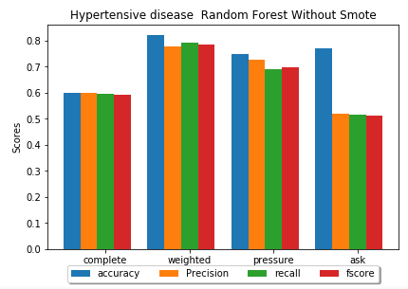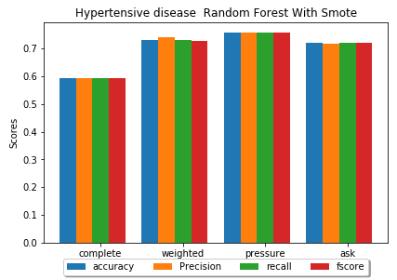While Ask a patient’s performance fell, MedHelp complete dataset had remained stable, which is a direct result from the imbalance in ask a patient compared to MedHelp. The results however are a good indication that Hypertension can be predicted with a decent accuracy based on age alone, with other factors such as weight and height aiding the predictions.

Figure 1 Hypertensive Disease RF Without SMOTE

Figure 2 Hypertensive Disease RF With SMOTE

|  |  |  |  |  |
| --- | --- | --- | --- | --- |
| **Datasets** | **Accuracy** | **Precision** | **Recall** | **FScore** |
| Complete | 0.592814 | 0.593139 | 0.592869 | 0.59254 |
| Weighted | 0.729167 | 0.739564 | 0.729167 | 0.726196 |
| Pressure | 0.756098 | 0.756061 | 0.756061 | 0.756061 |
| Ask | 0.720548 | 0.718645 | 0.720076 | 0.71901 |

|  |  |  |  |  |
| --- | --- | --- | --- | --- |
| **Dataset** | **Accuracy** | **Precision** | **Recall** | **FScore** |
| Complete | 0.598291 | 0.599863 | 0.595724 | 0.59287 |
| Weighted | 0.820513 | 0.777778 | 0.792208 | 0.78419 |
| Pressure | 0.748201 | 0.727473 | 0.68956 | 0.699413 |
| Ask | 0.770925 | 0.520792 | 0.514936 | 0.514319 |

Table 1 RF Hypertensive disease without SMOTENC

Table 2 RF Hypertensive disease with SMOTENC

**Pain:**

* For pain, weights/heights have the biggest effect, which could indicate that pain as an ADR is cause by weights gain in relation to height.
* On trials without SMOTENC however, all metrics drops far below the accuracy, which reflects the terrible imbalance in all the datasets, despite the fact that it is the most mentioned ADR at 25 % positives to 75% negatives in MedHelp Complete dataset.
* 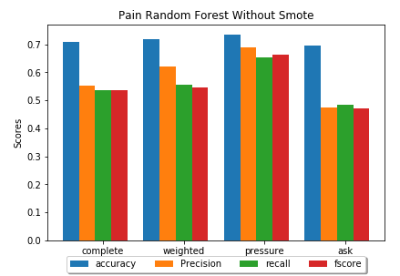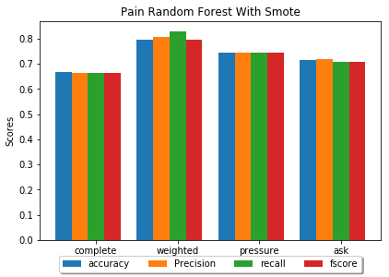Ask a patient has suffered the most, with a drop from 0.7 Fscore to 0.47.

Figure 3 RF Pain without SMOTENC

Figure 4 RF Pain with SMOTENC

|  |  |  |  |  |
| --- | --- | --- | --- | --- |
| **Datasets** | **Accuracy** | **Precision** | **Recall** | **FScore** |
| Complete | 0.666191 | 0.665535 | 0.664104 | 0.664272 |
| Weighted | 0.796296 | 0.807586 | 0.827941 | 0.794535 |
| Pressure | 0.746269 | 0.745526 | 0.745233 | 0.745361 |
| Ask | 0.714689 | 0.718844 | 0.708472 | 0.708642 |

|  |  |  |  |  |
| --- | --- | --- | --- | --- |
| **Datasets** | **Accuracy** | **Precision** | **Recall** | **FScore** |
| Complete | 0.709402 | 0.552477 | 0.536667 | 0.536188 |
| Weighted | 0.717949 | 0.621429 | 0.555195 | 0.546032 |
| Pressure | 0.733813 | 0.690711 | 0.652751 | 0.6622 |
| Ask | 0.696035 | 0.473708 | 0.483679 | 0.471291 |

Table 3 RF Pain without SMOTENC

Table 4 Pain with SMOTENC

**Counts:**

* It can be observed that the number of ADRs that a person might have is much harder to predict compared to disease counts.
* Weights/Heights are terrible for identifying ADR Count, however it performs slightly better for disease count without SMOTENC. Blood pressure decreased the least for ADR count, which could indicate the role it plays in causing ADRs in general.
* 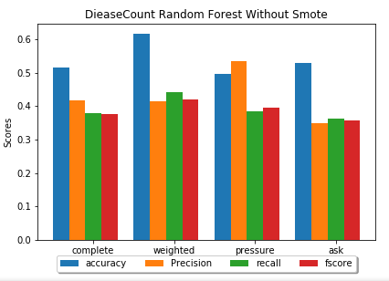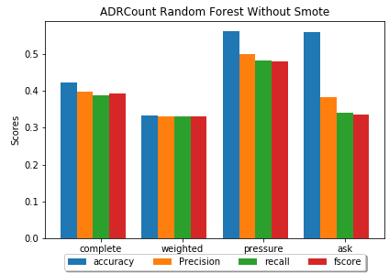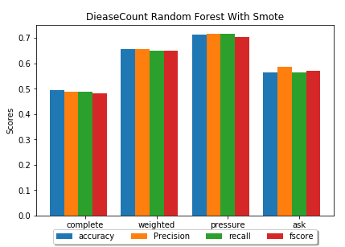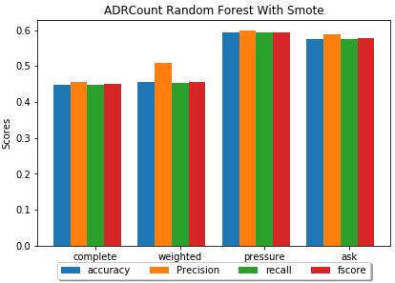It is unclear whether the reason for the terrible performance is due to data imbalance solved by SMOTENC, or that it is naturally impossible to discover ADR and disease Counts based only on these factors.

Figure 5 Disease Count RF without SMOTENC

Figure 6 ADR Count RF without SMOTENC

Figure 7 Disease Count RF with SMOTENC

Figure 8 ADR Count RF with SMOTENC

|  |  |  |  |  |
| --- | --- | --- | --- | --- |
| **Datasets** | **Accuracy** | **Precision** | **Recall** | **FScore** |
| Complete | 0.448882 | 0.455145 | 0.448323 | 0.449865 |
| Weighted | 0.454545 | 0.50864 | 0.452381 | 0.455265 |
| Pressure | 0.594203 | 0.597802 | 0.592951 | 0.594168 |
| Ask | 0.574324 | 0.587815 | 0.574266 | 0.577359 |

|  |  |  |  |  |
| --- | --- | --- | --- | --- |
| **Datasets** | **Accuracy** | **Precision** | **Recall** | **FScore** |
| Complete | 0.494253 | 0.489404 | 0.488716 | 0.482369 |
| Weighted | 0.655172 | 0.657018 | 0.649832 | 0.651343 |
| Pressure | 0.713675 | 0.715905 | 0.71548 | 0.703807 |
| Ask | 0.564033 | 0.587314 | 0.565223 | 0.572111 |

Table 5 RF Disease Count with SMOTENC

Table 6 RF ADR Count with SMOTENC

|  |  |  |  |  |
| --- | --- | --- | --- | --- |
| **Datasets** | **Accuracy** | **Precision** | **Recall** | **FScore** |
| Complete | 0.423077 | 0.39879 | 0.388964 | 0.391975 |
| Weighted | 0.333333 | 0.330159 | 0.330159 | 0.329885 |
| Pressure | 0.561151 | 0.499906 | 0.482774 | 0.479719 |
| Ask | 0.559471 | 0.382987 | 0.3419 | 0.336909 |

Table 7 RF ADR Count without SMOTENC

Table 8 RF DiseaseCount without SMOTENC

|  |  |  |  |  |
| --- | --- | --- | --- | --- |
| **Datasets** | **Accuracy** | **Precision** | **Recall** | **FScore** |
| Complete | 0.514957 | 0.416226 | 0.377881 | 0.377375 |
| Weighted | 0.615385 | 0.415344 | 0.441414 | 0.42037 |
| Pressure | 0.496403 | 0.534444 | 0.384615 | 0.395995 |
| Ask | 0.528634 | 0.349699 | 0.363579 | 0.356326 |

##### Feature Filtering versus Without Feature Filtering:

In this section, the comparison between the previous results before and after applying random forests filtering was applied, the conclusion is that it has very little effect on the results for this experiment, this can be attributed to the use of the very limited features. This point will be further tested with experiments 2 and 3, when all the remaining labels will be used as features. The following are some example that show how filtering performed with and without SMOTENC.

**Hypertensive diseases:**

* For SMOTENC: Ask a patient dataset and blood pressure subset have slightly improved their performance. The complete dataset and weight/height subset have decreased their performance slightly, but not far off from the original none filtered features.

|  |  |  |  |  |
| --- | --- | --- | --- | --- |
| **Dataset** | **Accuracy** | **Precision** | **Recall** | **FScore** |
| Complete | 0.58483 | 0.590532 | 0.585076 | 0.578583 |
| Weighted | 0.708333 | 0.708333 | 0.708333 | 0.708333 |
| Pressure | 0.79878 | 0.802252 | 0.79942 | 0.798413 |
| Ask | 0.734247 | 0.740344 | 0.7225 | 0.724099 |

|  |  |  |  |  |
| --- | --- | --- | --- | --- |
| **Dataset** | **Accuracy** | **Precision** | **Recall** | **FScore** |
| Complete | 0.587607 | 0.592206 | 0.583772 | 0.576133 |
| Weighted | 0.794872 | 0.763393 | 0.691558 | 0.711111 |
| Pressure | 0.726619 | 0.700376 | 0.707532 | 0.703258 |
| Ask | 0.819383 | 0.501885 | 0.500356 | 0.473377 |

* For Without SMOTENC: With the exception of blood pressure subset, the performance on all datasets slightly decreased.

Table 9 Hypertensive Disease RF with Featuer Filtering and without SMOTENC

Table 10 Hypertensive Disease RF with Feature Filtering and with SMOTENC

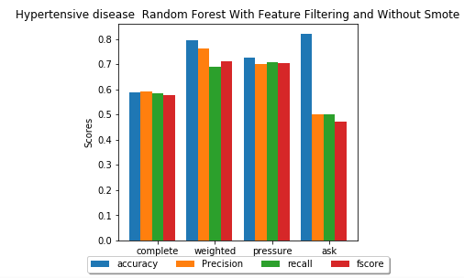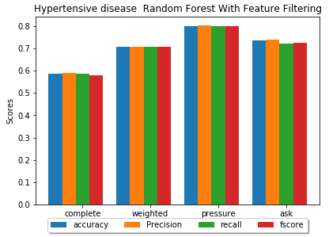

Figure 9 Hypertensive disease RF with Feature Filtering and without SMOTENC

Figure 10 Hypertensive disease RF with Feature Filtering and SMOTENC

**Pain:**

* For SMOTENC: Weight performances have increased, with slight decrease for the rest.

|  |  |  |  |  |
| --- | --- | --- | --- | --- |
| **Dataset** | **Accuracy** | **Precision** | **Recall** | **FScore** |
| Complete | 0.677603 | 0.701309 | 0.668407 | 0.660118 |
| Weighted | 0.851852 | 0.857143 | 0.882353 | 0.85 |
| Pressure | 0.741294 | 0.740859 | 0.739424 | 0.739845 |
| Ask | 0.700565 | 0.711313 | 0.69165 | 0.689782 |

Table 11 Pain RF With Feature Filtering and SMOTENC

* For without SMOTENC: Blood pressure and the complete MedHelp dataset improved slightly. The others decreased slightly.

Table 12 Pain RF with Feature Filtering and Without SMOTENC

|  |  |  |  |  |
| --- | --- | --- | --- | --- |
| **Estimators** | **Accuracy** | **Precision** | **Recall** | **FScore** |
| Complete | 0.587607 | 0.592206 | 0.583772 | 0.576133 |
| Weighted | 0.794872 | 0.763393 | 0.691558 | 0.711111 |
| Pressure | 0.726619 | 0.700376 | 0.707532 | 0.703258 |
| Ask | 0.819383 | 0.501885 | 0.500356 | 0.473377 |

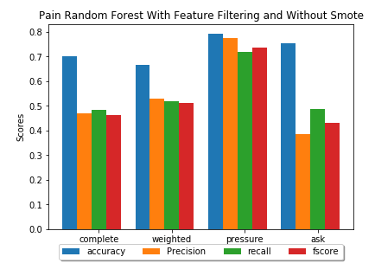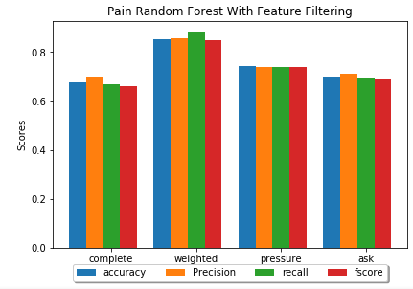

Figure 11 Pain RF with Feature Filtering and Without SMOTENC

Figure 12 Pain RF with Feature Filtering and SMOTENC

#### SVM

##### SMOTENC versus without SMOTENC

**Hypertensive diseases:**

* It can be noticed that SVM had much worse performance comparing to random forests.
* However the comparison between the dataset performances did not change, with weights/heights and pressure having the best results, complete is stable and changed positively little, ask a patient dropping masively without SMOTENC.

|  |  |  |  |  |
| --- | --- | --- | --- | --- |
| **Dataset** | **Accuracy** | **Precision** | **Recall** | **FScore** |
| Complete | 0.560878 | 0.562123 | 0.561012 | 0.558965 |
| Weighted | 0.6875 | 0.737363 | 0.6875 | 0.670179 |
| Pressure | 0.743902 | 0.753535 | 0.742674 | 0.74078 |
| AskAPatient | 0.619178 | 0.6234 | 0.623864 | 0.619132 |

* weights/heights however had worse performance without SMOTENC, even if it is higher than pressure.

Table 13 Hypertensive disease SVM with SMOTENC

* Pressure performance even dropped below the complete dataset in the FScore.

Table 14 Hypertensive disease SVM without SMOTENC

|  |  |  |  |  |
| --- | --- | --- | --- | --- |
| **Dataset** | **Accuracy** | **Precision** | **Recall** | **FScore** |
| Complete | 0.59188 | 0.599346 | 0.5875 | 0.577272 |
| Weighted | 0.769231 | 0.878378 | 0.590909 | 0.584615 |
| Pressure | 0.697842 | 0.693343 | 0.587111 | 0.573744 |
| AskAPatient | 0.837004 | 0.418502 | 0.5 | 0.455635 |

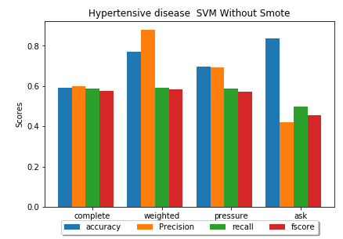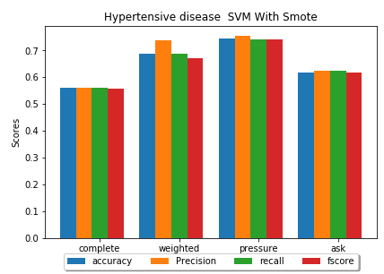

Figure 13 Hypertensive disease SVM without SMOTENC

Figure 14 Hypertensive disease SVM with SMOTENC

**Pain:**

* SVM again showed much less performance compared to random forests, and again showing a drop without SMOTENC.
* 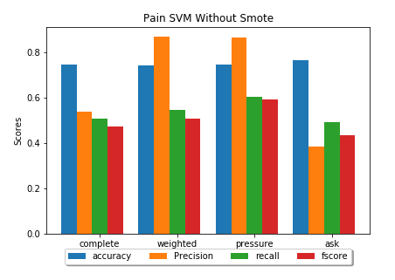It should be noted however that while the FScore decreased, the Accuracy is actually higher than RF. Which could mean that SVM could predict unbalanced data more accurately compared to RF, even if the overall performance is lacking.

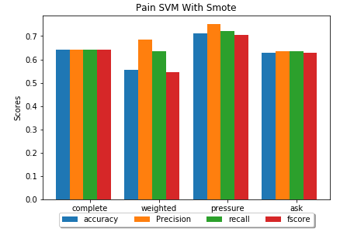

Figure 15 Pain SVM without SMOTENC

Figure 16 Pain SVM with SMOTENC

Table 15 Pain SVM with SMOTENC

|  |  |  |  |  |
| --- | --- | --- | --- | --- |
| **Dataset** | **Accuracy** | **Precision** | **Recall** | **FScore** |
| Complete | 0.64194 | 0.643159 | 0.643231 | 0.641937 |
| Weighted | 0.555556 | 0.684524 | 0.636765 | 0.545582 |
| Pressure | 0.711443 | 0.750337 | 0.7215 | 0.705308 |
| AskAPatient | 0.629944 | 0.634494 | 0.63362 | 0.629799 |

Table 16 Pain SVM without SMOTENC

|  |  |  |  |  |
| --- | --- | --- | --- | --- |
| **Dataset** | **Accuracy** | **Precision** | **Recall** | **FScore** |
| Complete | 0.745726 | 0.539855 | 0.508527 | 0.471888 |
| Weighted | 0.74359 | 0.868421 | 0.545455 | 0.507576 |
| Pressure | 0.748201 | 0.865385 | 0.602273 | 0.592034 |
| AskAPatient | 0.76652 | 0.386667 | 0.494318 | 0.433915 |

**Counts:**

* SVM still had equivalent or worse result in terms of F-Score to RF, but it performed better in the accuracy department, especially in the non-SMOTENC dataset.

|  |  |  |  |  |
| --- | --- | --- | --- | --- |
| **Dataset** | **Accuracy** | **Precision** | **Recall** | **FScore** |
| Complete | 0.436102 | 0.435908 | 0.43593 | 0.43584 |
| Weighted | 0.522727 | 0.742424 | 0.531746 | 0.509794 |
| Pressure | 0.608696 | 0.680497 | 0.618276 | 0.604497 |
| AskAPatient | 0.515766 | 0.509676 | 0.515725 | 0.495939 |

Table 17 ADR Count with SMOTENC

Table 18 ADR Count without SMOTENC

|  |  |  |  |  |
| --- | --- | --- | --- | --- |
| **Dataset** | **Accuracy** | **Precision** | **Recall** | **FScore** |
| Complete | 0.431624 | 0.347332 | 0.35475 | 0.334189 |
| Weighted | 0.410256 | 0.571895 | 0.398413 | 0.328704 |
| Pressure | 0.532374 | 0.674731 | 0.404633 | 0.360942 |
| AskAPatient | 0.665198 | 0.413203 | 0.351358 | 0.308581 |

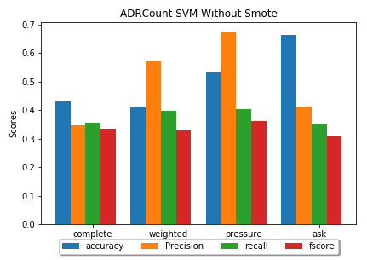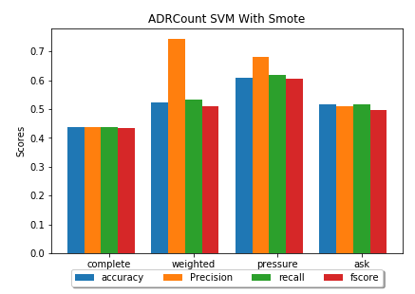

Figure 17 ADR Count Without SMOTENC

Figure 18 ADR Count with SMOTENC

##### Feature Filtering versus Without Feature Filtering:

**Hypertensive diseases:**

* The result compared to RF is still low for SMOTENC datasets.
* However for non-SMOTENC datasets, the overall resutls have improved, especially in the accuracy departement. While Fscore remained mostly unchanged except for pressure dataset.

Table 19 Hypertensive disease SVM with Feature Filtering

|  |  |  |  |  |
| --- | --- | --- | --- | --- |
| **Dataset** | **Accuracy** | **Precision** | **Recall** | **FScore** |
| Complete | 0.590818 | 0.593961 | 0.590996 | 0.587638 |
| Weighted | 0.645833 | 0.706388 | 0.645833 | 0.617799 |
| Pressure | 0.737805 | 0.758133 | 0.736055 | 0.731567 |
| AskAPatient | 0.591781 | 0.588914 | 0.589318 | 0.589004 |

|  |  |  |  |  |
| --- | --- | --- | --- | --- |
| **Dataset** | **Accuracy** | **Precision** | **Recall** | **FScore** |
| Complete | 0.58547 | 0.591346 | 0.58125 | 0.571671 |
| Weighted | 0.820513 | 0.9 | 0.681818 | 0.711111 |
| Pressure | 0.741007 | 0.753885 | 0.649611 | 0.656319 |
| AskAPatient | 0.828194 | 0.544283 | 0.505619 | 0.477175 |

Table 20 Hypertensive disease SVM with Feature Filtering without SMOTENC

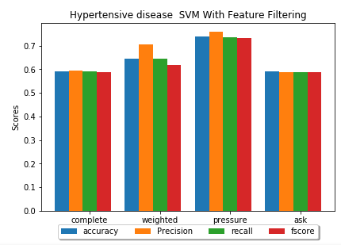 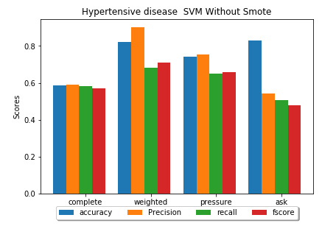 **Pain:**

Figure 19 Hypertensive disease SVM with Feature Filtering

Figure 20 Hypertensive disease SVM with Feature Filtering without SMOTENC

|  |  |  |  |  |
| --- | --- | --- | --- | --- |
| **Dataset** | **Accuracy** | **Precision** | **Recall** | **FScore** |
| Complete | 0.614836 | 0.613653 | 0.612231 | 0.612088 |
| Weighted | 0.537037 | 0.722222 | 0.632353 | 0.516995 |
| Pressure | 0.706468 | 0.756909 | 0.717875 | 0.697821 |
| AskAPatient | 0.587571 | 0.597529 | 0.594078 | 0.585666 |

Table 21 Pain SVM with Feature Filtering and SMOTENC

|  |  |  |  |  |
| --- | --- | --- | --- | --- |
| **Dataset** | **Accuracy** | **Precision** | **Recall** | **FScore** |
| Complete | 0.713675 | 0.443379 | 0.48134 | 0.443786 |
| Weighted | 0.717949 | 0.358974 | 0.5 | 0.41791 |
| Pressure | 0.769784 | 0.840286 | 0.642464 | 0.651411 |
| AskAPatient | 0.762115 | 0.386161 | 0.491477 | 0.4325 |

Table 22 Pain SVM with Feature Filtering Without SMOTENC

* 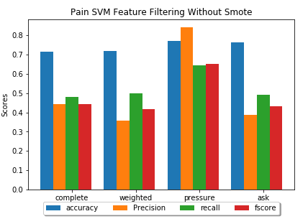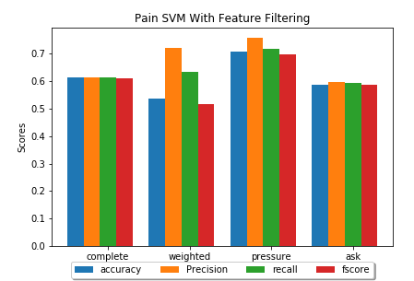Compared to RF, the result has dropped in almost all metrics, even accuracy, except complete non-SMOTENC dataset which has dropped slightly in everything except accuracy.

Figure 21 Pain SVM with Feature Filtering Without SMOTENC

Figure 22 Pain SVM with Feature Filtering and SMOTENC

* Compared to unfiltered SVM, the most metrics have dropped in performance as well.

#### Naïve Bayes

##### SMOTENC versus without SMOTENC

**Hypertensive diseases:**

* Naïve Bayes by far has the worst results, giving with all the metrics being much lower than those of SVM.
* Strangely, the results from ask a patient dataset without SMOTENC was exactly the same as those of SVM in all regards, which should show the consistancy of this dataset compared to the others.

Table 23 Hypertensive Disease NB

Table 24 Hypertensive Disease NB without SMOTENC

|  |  |  |  |  |
| --- | --- | --- | --- | --- |
| **Dataset** | **Accuracy** | **Precision** | **Recall** | **FScore** |
| Complete | 0.536926 | 0.539222 | 0.537155 | 0.530853 |
| Weighted | 0.604167 | 0.60582 | 0.604167 | 0.602614 |
| Pressure | 0.591463 | 0.594377 | 0.592369 | 0.589617 |
| AskAPatient | 0.520548 | 0.516347 | 0.516364 | 0.516351 |

|  |  |  |  |  |
| --- | --- | --- | --- | --- |
| **Dataset** | **Accuracy** | **Precision** | **Recall** | **FScore** |
| Complete | 0.523504 | 0.522391 | 0.517544 | 0.492884 |
| Weighted | 0.487179 | 0.458556 | 0.449675 | 0.442857 |
| Pressure | 0.568345 | 0.522665 | 0.522665 | 0.522665 |
| AskAPatient | 0.837004 | 0.418502 | 0.5 | 0.455635 |

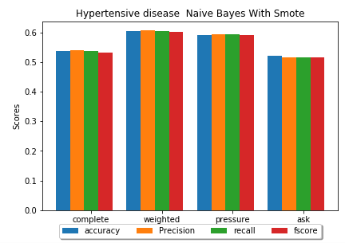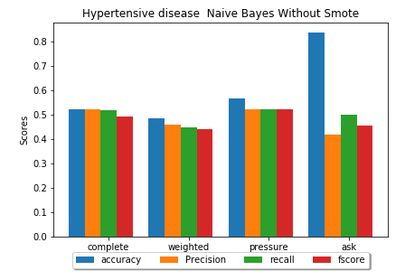

Figure 23 Hypertensive Disease NB without SMOTENC

Figure 24 Hypertensive Disease NB

**Pain:**

* The results here have shown a slight improvement over SVM in pressure results, otherwise all other results are mediocre.

Table 25 Pain NB

Table 26 Pain NB Without Smote

|  |  |  |  |  |
| --- | --- | --- | --- | --- |
| **Dataset** | **Accuracy** | **Precision** | **Recall** | **FScore** |
| Complete | 0.553495 | 0.553395 | 0.553513 | 0.5532 |
| Weighted | 0.703704 | 0.720833 | 0.733824 | 0.702069 |
| Pressure | 0.626866 | 0.626733 | 0.62711 | 0.626533 |
| AskAPatient | 0.5 | 0.535696 | 0.520443 | 0.451768 |

|  |  |  |  |  |
| --- | --- | --- | --- | --- |
| **Dataset** | **Accuracy** | **Precision** | **Recall** | **FScore** |
| Complete | 0.760684 | 0.380342 | 0.5 | 0.432039 |
| Weighted | 0.717949 | 0.621429 | 0.555195 | 0.546032 |
| Blood | 0.647482 | 0.509409 | 0.504187 | 0.472874 |
| AskAPatient | 0.77533 | 0.387665 | 0.5 | 0.436725 |

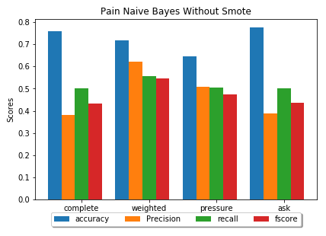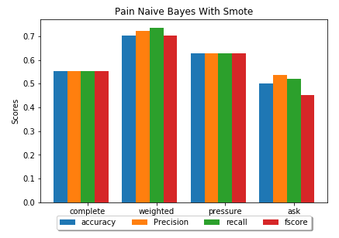 **Count:**

Figure 25 Pain NB Without Smote

Figure 26 Pain NB

|  |  |  |  |  |
| --- | --- | --- | --- | --- |
| **Dataset** | **Accuracy** | **Precision** | **Recall** | **FScore** |
| Complete | 0.57265 | 0.371117 | 0.343385 | 0.271581 |
| Weighted | 0.538462 | 0.342857 | 0.360606 | 0.350697 |
| Blood | 0.546763 | 0.367236 | 0.359568 | 0.287233 |
| AskAPatient | 0.506608 | 0.173454 | 0.316804 | 0.224172 |

* The predictions for disease count again proved to very bad, and again, NB performed far worse than RF classifier.

|  |  |  |  |  |
| --- | --- | --- | --- | --- |
| **Dataset** | **Accuracy** | **Precision** | **Recall** | **FScore** |
| Complete | 0.371648 | 0.369142 | 0.369659 | 0.369044 |
| Weighted | 0.568966 | 0.544067 | 0.553872 | 0.539088 |
| Blood | 0.512821 | 0.513312 | 0.516115 | 0.494191 |
| AskAPatient | 0.435967 | 0.421373 | 0.435923 | 0.412535 |

Table 27 Disease Count NB

Table 28 NB Count without SMOTENC

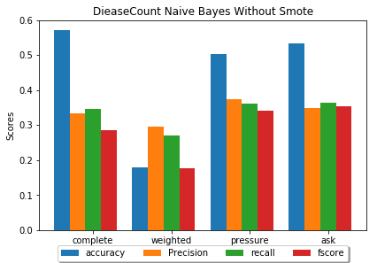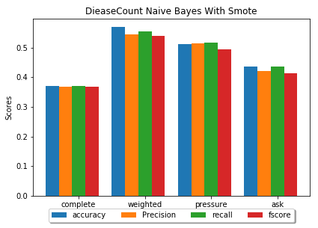

Figure 27 Disease Count NB without SMOTENC

Figure 28 Disease Count NB

##### Feature Filtering versus Without Feature Filtering:

**Hypertensive diseases:**

* Results were not as good as RF or SVM.
* NB performance improved slightly for some non-SMOTENC pressure and weight/height.

Table 29 Hypertensive Disease NB with Feature Filtering

Table 30 Hypertensive Disease NB with Feature Filtering without SMOTENC

|  |  |  |  |  |
| --- | --- | --- | --- | --- |
| **Dataset** | **Accuracy** | **Precision** | **Recall** | **FScore** |
| Complete | 0.520958 | 0.527749 | 0.521434 | 0.492315 |
| Weighted | 0.520833 | 0.52277 | 0.520833 | 0.510421 |
| Blood | 0.579268 | 0.581915 | 0.580173 | 0.577367 |
| AskAPatient | 0.528767 | 0.560603 | 0.549848 | 0.515227 |

|  |  |  |  |  |
| --- | --- | --- | --- | --- |
| **Dataset** | **Accuracy** | **Precision** | **Recall** | **FScore** |
| Complete | 0.534188 | 0.565179 | 0.524013 | 0.439921 |
| Weighted | 0.769231 | 0.760714 | 0.618506 | 0.628571 |
| Blood | 0.597122 | 0.562113 | 0.564332 | 0.562697 |
| AskAPatient | 0.837004 | 0.418502 | 0.5 | 0.455635 |

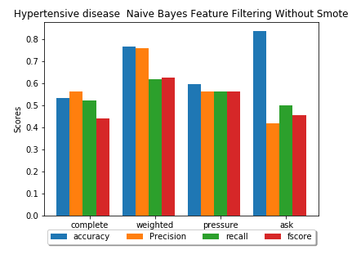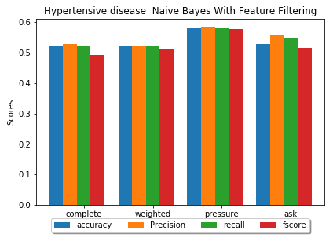

Figure 29 Hypertensive Disease NB with Feature Filtering

Figure 30 Hypertensive Disease NB with Feature Filtering without SMOTENC

**Pain:**

Improvements were either minimal or non existant for both against the other two classifiers and against itself.

Table 31 Pain NB with Feature Filtering without SMOTENC

|  |  |  |  |  |
| --- | --- | --- | --- | --- |
| **Dataset** | **Accuracy** | **Precision** | **Recall** | **FScore** |
| Complete | 0.562054 | 0.560617 | 0.554822 | 0.547433 |
| Weighted | 0.722222 | 0.746844 | 0.758824 | 0.721362 |
| Blood | 0.616915 | 0.61735 | 0.617676 | 0.616764 |
| AskAPatient | 0.508475 | 0.538858 | 0.526307 | 0.474509 |

|  |  |  |  |  |
| --- | --- | --- | --- | --- |
| **Dataset** | **Accuracy** | **Precision** | **Recall** | **FScore** |
| Complete | 0.760684 | 0.380342 | 0.5 | 0.432039 |
| Weighted | 0.717949 | 0.358974 | 0.5 | 0.41791 |
| Blood | 0.654676 | 0.533028 | 0.51555 | 0.489908 |
| AskAPatient | 0.77533 | 0.387665 | 0.5 | 0.436725 |

Table 32 Pain NB with Feature Filtering

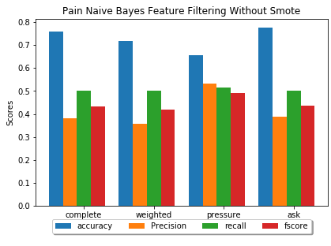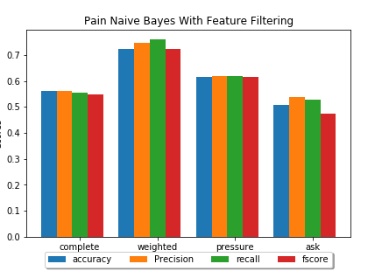

Figure 31 Pain NB with Feature Filtering without SMOTENC

Figure 32 Pain NB with Feature Filtering

### Second Experiment

* Predict the drug used based on the user profile and user history.
* Predict the drug family based on the user profile and user history.
* The user history is represented by ADR mention features.
* Testing the best number of estimators in terms of F-Score for random forests was made by trying all estimators between 100 and 1000 at 100 increment.

|  |  |  |
| --- | --- | --- |
| **Labels/Datasets** | Drugs | Drug Family |
| Complete | 'Atenolol': 620,  'Lisinopril': 428,  'Amlodipine': 161, 'Hydrochlorothiazide': 129, 'Nadolol': 119,  'Diltiazem': 100 | 'Beta': 739,  'Angiotensin': 428,  'Calcium': 261,  'Diuretics': 129 |
| Weight/Height | 'Lisinopril': 51,  'Atenolol': 45,  'Amlodipine': 14, 'Hydrochlorothiazide': 13 | 'Angiotensin': 51,  'Beta': 45,  'Calcium': 14,  'Diuretics': 13 |
| Pressure | 'Atenolol': 186,  'Lisinopril': 134,  'Amlodipine': 63, 'Hydrochlorothiazide': 51, 'Diltiazem': 26 | 'Beta': 186,  'Angiotensin': 134,  'Calcium': 89,  'Diuretics': 51 |
| Ask A Patient | 'Lisinopril': 622,  'Atenolol': 134 | Angiotensin': 622,  'Beta': 134 |

#### Random Forests

##### Without Feature Filtering.

###### Drug Prediction

* AskAPatient had the highest result, which reflects its accuracy regarding ADR, disease and mental issues detection, since the mentions are clearer and easy to find, therefore accurately finding the user history is much easier than the rest.
* Weights/Highest and blood pressure are very close in results, both of which have better predictions than the complete dataset, which shows how much role these two information play in the predictions. Which might indicate that high blood pressure, extremely light or heavy weight, might cause diseases that lead to the use of drugs that in turn cause ADRs for using the drug with such extreme
* It should also be noted that AskAPatient is only limited to two drugs, which might explain its high results, as it is easier to identify than the rest.

Table 33 Drug Prediction Random Forests

|  |  |  |  |  |
| --- | --- | --- | --- | --- |
| **Dataset** | **Accuracy** | **Precision** | **Recall** | **FScore** |
| Complete | 0.53405 | 0.530371 | 0.535376 | 0.532069 |
| Weighted | 0.629032 | 0.614183 | 0.629097 | 0.617931 |
| Pressure | 0.620072 | 0.614306 | 0.624035 | 0.616403 |
| Ask | 0.802139 | 0.803151 | 0.802735 | 0.802116 |

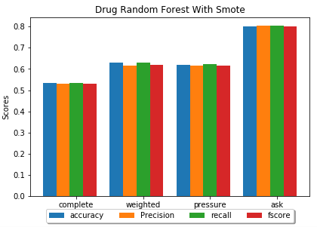

Figure 33 Drug Predictions Random Forests

###### Drug Family Prediction

|  |  |  |  |  |
| --- | --- | --- | --- | --- |
| **Estimators** | **Accuracy** | **Precision** | **Recall** | **FScore** |
| Complete | 0.572717 | 0.573601 | 0.574943 | 0.569366 |
| Weighted | 0.596774 | 0.593651 | 0.599063 | 0.596121 |
| Pressure | 0.544643 | 0.559338 | 0.550519 | 0.545089 |
| Ask | 0.802139 | 0.803151 | 0.802735 | 0.802116 |

* 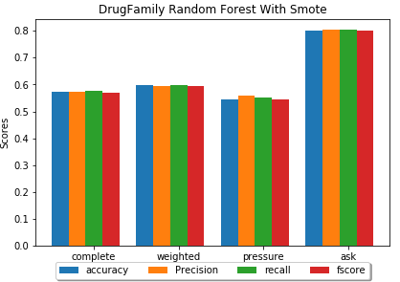 AskAPatient resutls did not change at all due to both drugs being from only two drug families, meaning that the exact same classification is made, just under different name.

Figure 34 Drug Family Prediction Random Forest

* The Complete MedHelp dataset had better performance identifying the drug family, mainly because the number of distinct labels have decreased to a more manageable four classes instead of 6.
* As for the decrease in weights/heights and pressure performance, there is no clear explanation for weights/heights since the same conditions as AskAPatient apply here, pressure on the other hand could be explained by possible difference of the two calcium-blockers have in common and their different uses, which results in poorer results when their drug family is identified.

Table 34 Drug Family Prediction Random Forest

##### With Feature Filtering.

Unlike the first experiment, this dataset arrangement has more potential for success with feature filtering since there is a lot more features that can be used in the predictions, some of which are useless and can be removed.

###### Drug Prediction

* The complete MedHelp dataset has dropped significantly in performance, when the selected features were reviewed, it turns out that it only selects age, mental issues count and disease count. Which are the most consistant features but also happen to be extremely terrible if chosen alone.
* Weight/Height performance increased, where the features chosen aslo included, weight height, mental issues and disease count, and Hypertensive disease, which shows how important this exact disease in determining the drug.
* Pressure also got its continues values, hypertensive disease, and also gender, and the same counts, but the performance decrease indicates that the other ADR are important, it should also be noted that the drugs used are more in the pressure dataset than weights/heights with an even larger dataset, so it is very possible that this is the reason why weight/height have better performance in generals.

|  |  |  |  |  |
| --- | --- | --- | --- | --- |
| **Estimators** | **Accuracy** | **Precision** | **Recall** | **FScore** |
| Complete | 0.335125 | 0.334382 | 0.33591 | 0.333261 |
| Weighted | 0.66129 | 0.648049 | 0.668111 | 0.648689 |
| Pressure | 0.594982 | 0.586339 | 0.597276 | 0.585986 |
| Ask | 0.828877 | 0.836913 | 0.827197 | 0.827277 |

* 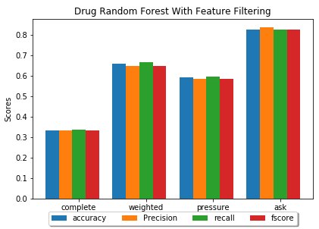 AskAPatient only took Coughing (the most common ADR) and age, the increase in performance prove that the other ADRs are not influential for this dataset.

Table 35 Drug Predictions Random Forest with Filtering

Figure 35 Drug Predictions Random Forest with Filtering

###### Drug Family Prediction

* The exact same observations in the previous section can be made in regards of the decrease and increase of performance for drug family predictions.
* What is interesting however is that other features were chosen, for MedHelp Complete, disease count was discarded in favour of PVC disease, which is one of the most commonly mentioned besides Hypertension. Weights/Heights included microcephaly, epilepsy, and diabetes syndrome. While pressure retained disease count and dropped mental issues count. No changes in AskAPatient.

|  |  |  |  |  |
| --- | --- | --- | --- | --- |
| **Estimators** | **Accuracy** | **Precision** | **Recall** | **FScore** |
| Complete | 0.392334 | 0.391084 | 0.393215 | 0.385144 |
| Weighted | 0.596774 | 0.575284 | 0.597724 | 0.582342 |
| Pressure | 0.477679 | 0.47844 | 0.478799 | 0.476218 |
| Ask | 0.828877 | 0.836913 | 0.827197 | 0.827277 |

Table 36 Drug Family predictions random Forest with feature filtering

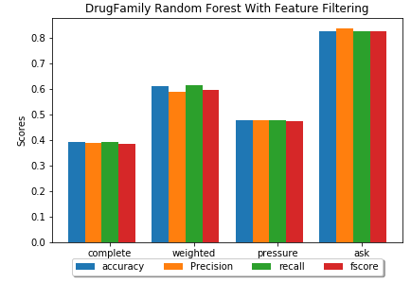

Figure 36 Drug Family predictions random Forest with feature filtering

#### SVM

* The SVM performance is much worse than Random Forests.
* Even Feature Filtering decreased SVM’s performance on all datasets except Weights/Heights.

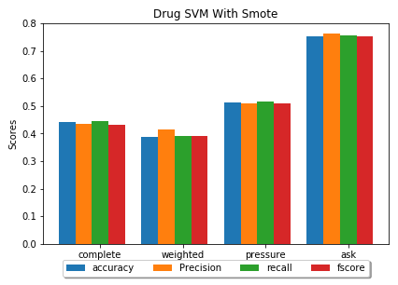 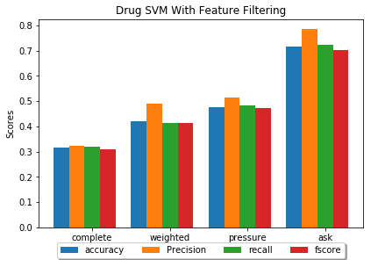

Figure 37 Drug prediction with SVM and Feature Filtering

|  |  |  |  |  |
| --- | --- | --- | --- | --- |
| **Dataset** | **Accuracy** | **Precision** | **Recall** | **FScore** |
| Complete | 0.317204 | 0.324079 | 0.318835 | 0.308868 |
| Weighted | 0.419355 | 0.490196 | 0.413183 | 0.413526 |
| Blood | 0.476703 | 0.51323 | 0.481905 | 0.474449 |
| AskAPatient | 0.716578 | 0.784646 | 0.721712 | 0.701521 |

Table 37 Drug prediction with SVM and Feature Filtering

Table 38 Drug Predictions with SVM

|  |  |  |  |  |
| --- | --- | --- | --- | --- |
| **Dataset** | **Accuracy** | **Precision** | **Recall** | **FScore** |
| Complete | 0.443548 | 0.436758 | 0.445805 | 0.432164 |
| Weighted | 0.387097 | 0.414805 | 0.390319 | 0.390853 |
| Pressure | 0.512545 | 0.50988 | 0.515292 | 0.510708 |
| AskAPatient | 0.754011 | 0.761474 | 0.755729 | 0.752994 |

Figure 38 Drug Predictions SVM

#### Naïve Bayes

* Naïve Bayes is also worse than random forests.

|  |  |  |  |  |
| --- | --- | --- | --- | --- |
| **Dataset** | **Accuracy** | **Precision** | **Recall** | **FScore** |
| Complete | 0.305556 | 0.364391 | 0.310105 | 0.273662 |
| Weighted | 0.451613 | 0.454023 | 0.454578 | 0.414229 |
| Blood | 0.365591 | 0.389339 | 0.354946 | 0.333318 |
| AskAPatient | 0.721925 | 0.757815 | 0.725803 | 0.714067 |

Table 39 Drug Predictions with Naive Bayes

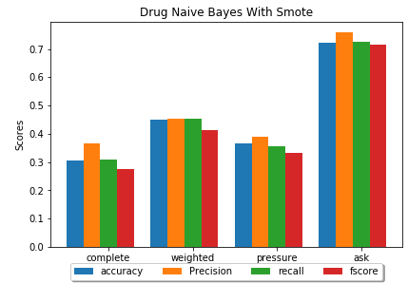

Figure 39 Drug Predictions with Naive Bayes

### Third Experiment

* Considering the previous results from the previous two experiments, unless SVM and Naïve Bayes show any improvements over the Random Forests, no results will be shown from them.
* This experiment compares the result between the first experiment’s limit on using user profile data only, and now using all other user history data in addition to the profile. The chosen labels are a part of the history, which are removed when the experiment runs.
* Pain will be used as the main label for this experiment, since it is the most common ADR, having the same values as the first experiment.

**Results:**

|  |  |  |  |  |
| --- | --- | --- | --- | --- |
| **Estimators** | **Accuracy** | **Precision** | **Recall** | **FScore** |
| Complete | 0.828816 | 0.836927 | 0.832474 | 0.828562 |
| Weighted | 0.925926 | 0.916193 | 0.930882 | 0.922078 |
| Pressure | 0.880597 | 0.880785 | 0.880105 | 0.880357 |
| Ask | 0.79661 | 0.799699 | 0.799699 | 0.79661 |

Table 40 Pain prediction random forests

* 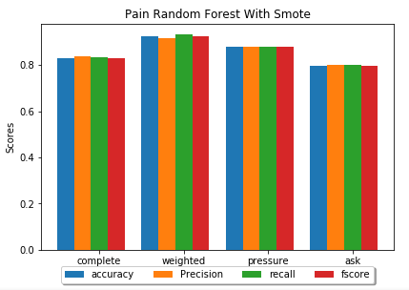 The usage of user medical history has proven to be a success, being able to predict the appearance of pain with more than 10% better results on all metrics.

Figure 40 Pain prediction random forests

# References

|  |  |
| --- | --- |
| [1] | R. Edwards and F. K. Aronson, "Adverse Drug Reactions: Definitions, Diagnosis and Management," *Lancet,* vol. 356, no. Number 9237, pp. 1255-1259, 7 October 2000. |
| [2] | World Health Organization, "The Importance of Pharmacovigilance-Safety Monitoring of Medicinal Products," 2002. [Online]. Available: http://apps.who.int/medicinedocs/en/d/Js4893e/1.html. [Accessed 18 11 2018]. |
| [3] | A. Nikfrajam, K. Oconnor, A. Sarker, R. Ginn, S. Jayaraman, T. Upadhya and G. Gonzalez, "Utilizing social media data for pharmacovigilance: A review," *Research Gate,* vol. 54, pp. 202-212, 2015. |
| [4] | US Food & Drug Administration (FDA), "Preventable Adverse Drug Reactions: A Focus on Drug Interactions," US Food & Drug Administration (FDA), 6 3 2018. [Online]. Available: https://www.fda.gov/drugs/developmentapprovalprocess/developmentresources/druginteractionslabeling/ucm110632.htm. [Accessed 19 11 2018]. |
| [5] | R. Leaman, L. Wojtulewicz, R. Sullivan, A. Shariah, J. Yang and G. Gonzalez, "Towards Internet-Age Pharmacovigilance: Extracting Adverse Drug," in *Proceedings of the 2010 workshop On biomedical Natural Language Processing*, Uppsala, Sweden , 2010. |
| [6] | A. Nikfarjam and G. H. Gonzalez, "Pattern Mining for Extraction of mentions of Adverse Drug Reactions From User Comments," *AMIA Annual Symposium Proceedings Archive,* vol. 2011, pp. 1019-1026, 2011. |
| [7] | D. Pappel, "Up To 90 Percent Of Adverse Reactions Unreported, Pharma Companies Search Social Media To Make Drugs Safer," Inquisitr, 14 3 2015. [Online]. Available: https://www.inquisitr.com/1914900/up-to-90-percent-of-adverse-reactions-unreported-pharma-companies-search-social-media-to-make-drugs-safer/. [Accessed 19 11 2018]. |
| [8] | R. Sloane, O. Osanlou, D. Lewis, D. Bollegala, S. Maskell and M. Pirmohamed, "Social media and pharmacovigilance: A review of the opportunities and challenges," *British Journal of Clinicla Pharmacology,* vol. 80, no. 4, pp. 910-920, 2015. |
| [9] | C. C. Yang and H. Yang, "Exploiting Social Media With Tensor Decomposition For Pharmacovigilance," in *2015 IEEE 15th International Conference on Data Mining Workshops*, Atlantic City New Jersey, 2015. |
| [10] | J. Hadzi-Puric and J. Grumsa, "Automatic Drug Adverse Reaction Discovery From Parenting websites using disproportionality methods," in *IEEE/ACM International Conference on Advances in Social Networks Analysis and Mining*, Istanbul, 2012. |
| [11] | A. Sarker and G. Graciela, "Portable Automatic Text Classification for Adverse Drug Reaction Detection Via Multi-Corpus Training," *Journal of biomedical informatics,* vol. 53, pp. 196-207, 2014. |
| [12] | J. Bian, U. Topaloglu and F. Yu, "Towards Large-Scale Twitter Mining For Drug-Related Adverse Events," in *Proceedings of the 2012 ACM International Workshop on Smart Health and Wellbeing*, Hawaii, 2012. |
| [13] | Y. Zheng and K. Jiang, "Mining Twitter Data for Potential Drug Effects," in *Advanced Data Mining and Applications*, Hangzhou, Springer, 2013, pp. 434-443. |
| [14] | A. Nikfarjam, A. Sarker, K. OConnor, R. Ginn and G. Gonzalez, "Pharmacovigilance from social media: mining adverse drug reaction mentions using sequence labeling with word embedding cluster features," *J Am Med Inform Assoc,* vol. 22, no. 3, pp. 671-681, 2015. |
| [15] | H. Sampathkumar, B. Luo and X. W. Chen, "Mining Adverse Drug Reactions from online healthcare forums using Hidden Markov Model," *BMC Medical informatics and Decision Making,* vol. 14, no. 91, 2014. |
| [16] | M. Yang, X. Wang and M. Kiang, "IDENTIFICATION OF CONSUMER ADVERSE DRUG REACTION MESSAGES ON SOCIAL MEDIA," in *PACIS 2013*, 2013. |
| [17] | J. Brownlee, "Classification Accuracy is Not Enough: More Performance Measures You Can Use," Machine Learning Mastery, 21 3 2014. [Online]. Available: https://machinelearningmastery.com/classification-accuracy-is-not-enough-more-performance-measures-you-can-use/. [Accessed 25 11 2018]. |
| [18] | Google, "Classification: Precision and Recall," Google, 1 10 2018. [Online]. Available: https://developers.google.com/machine-learning/crash-course/classification/precision-and-recall. [Accessed 25 11 2018]. |
| [19] | W. Koehrsen, "Beyond Accuracy: Precision and Recall," Towards Data Science, 3 3 2018. [Online]. Available: https://towardsdatascience.com/beyond-accuracy-precision-and-recall-3da06bea9f6c. [Accessed 25 11 2018]. |
| [20] | US Food & Drug Administration (FDA), "Questions and Answers on FDA's Adverse Event Reporting System (FAERS)," US Food & Drug Administration (FDA), 4 6 2018. [Online]. Available: https://www.fda.gov/Drugs/GuidanceComplianceRegulatoryInformation/Surveillance/AdverseDrugEffects/. [Accessed 20 11 2018]. |
| [21] | US Food & Drug Administration (FDA), "MedWatch: The FDA Safety Information and Adverse Event Reporting Program," US Food & Drug Administration (FDA), 14 11 2018. [Online]. Available: https://www.fda.gov/Safety/MedWatch/default.htm. [Accessed 20 11 2018]. |
| [22] | S. Fox, "The Social Life of Health Information," 12 5 2011. [Online]. Available: http://www.pewinternet.org/2011/05/12/the-social-life-of-health-information-2011/. [Accessed 20 11 2018]. |
| [23] | S. Vilar, C. Friedman and G. Hripcsak, "Detection of drug–drug interactions through data mining studies using clinical sources, scientific literature and social media," *Briefings in Bioinformatics,* vol. 19, no. 5, p. 863–877, 28 9 2018. |
| [24] | Arizona State University, "TWITTER ANNOTATED CORPUS," Arizona State University, 2014. [Online]. Available: http://diego.asu.edu/downloads/twitter_annotated_corpus/. [Accessed 20 11 2018]. |
| [25] | DailyStrength, "DailyStrength: Getting Better Together," DailyStrength, 2006. [Online]. Available: https://www.dailystrength.org/. [Accessed 20 11 2018]. |
| [26] | MedHelp, "MedHelp: Be your healthiest," MedHelp, [Online]. Available: https://www.medhelp.org/. [Accessed 20 11 2018]. |
| [27] | PatientsLikeMe, "PatientsLikeMe: Living better starts here.," PatientsLikeMe, 2005. [Online]. Available: https://www.patientslikeme.com/. [Accessed 20 11 2018]. |
| [28] | Medications.com, "The Premier Community to talk about Health," [Online]. Available: http://www.medications.com/. [Accessed 2 12 2018]. |
| [29] | Ask A patient, "When you need to know if a medication really works, why not Ask a Patient?," [Online]. Available: https://www.askapatient.com/. [Accessed 2 12 2018]. |
| [30] | E. K. Ikonomakis, T. V. and K. Sotiris, "Text Classification Using Machine Learning," *WSEAS Transactions on Computers,* vol. 4, no. 8, pp. 966-974, 2005. |
| [31] | U.S. National Library of Medicine, "Metathesaurus," U.S. National Library of Medicine, 12 4 2016. [Online]. Available: https://www.nlm.nih.gov/research/umls/knowledge_sources/metathesaurus/. [Accessed 28 11 2018]. |
| [32] | SiderEffects, "SIDER 4.1 : Side Effect Resource," SiderEffects, 21 10 2015. [Online]. Available: http://sideeffects.embl.de/. [Accessed 28 11 2018]. |
| [33] | Government of Canadian, "MedEffect Canada," Government of Canadian, 26 11 2018. [Online]. Available: https://www.canada.ca/en/health-canada/services/drugs-health-products/medeffect-canada.html. [Accessed 28 11 2018]. |
| [34] | Tartarus, "Snowball," Tartarus, 2 2002. [Online]. Available: http://snowball.tartarus.org/. [Accessed 28 11 2018]. |
| [35] | Rosettacode, "Jaro distance," Rosettacode, 29 7 2018. [Online]. Available: https://rosettacode.org/wiki/Jaro_distance. [Accessed 28 11 2018]. |
| [36] | B. Liu, W. Hsu and Y. Ma, "Integrating Classification and Association Rule Mining," in *The Fourth International Conference on Knowledge Discovery and Data Mining.*, New York, 1998. |
| [37] | The Stanford NLP Group, "Software > Stanford Log-linear Part-Of-Speech Tagger," The Stanford NLP Group, 16 10 2018. [Online]. Available: https://nlp.stanford.edu/software/tagger.shtml. [Accessed 28 11 2018]. |
| [38] | Princeton University, "WordNet A Lexical Database for English," Princeton University, 2018. [Online]. Available: https://wordnet.princeton.edu/. [Accessed 2018]. |
| [39] | Christian Borgelt's Web Pages, "Apriori - Association Rule Induction / Frequent Item Set Mining," Christian Borgelt's Web Pages, 18 10 2018. [Online]. Available: http://www.borgelt.net/apriori.html. [Accessed 28 11 2018]. |
| [40] | A. C. Egberts, R. H. Meyboom and E. P. van Puijenbroek, "Use of Measures of Disproportionality in Pharmacovigilance," *Spriner Link,* vol. 25, no. 6, pp. 453-458, 2002. |
| [41] | Serbian Government, "Medecines and Medical Devices Agency of Serbia," Serbian Government, [Online]. Available: https://www.alims.gov.rs/eng/. [Accessed 2 12 2018]. |
| [42] | DrugBank, "The DrugBank database is a unique bioinformatics and cheminformatics resource that combines detailed drug data with comprehensive drug target information.," DrugBank, [Online]. Available: https://www.drugbank.ca/. [Accessed 2 12 2018]. |
| [43] | USA government, "MetaMap - A Tool For Recognizing UMLS Concepts in Text," USA government, 23 1 2018. [Online]. Available: https://metamap.nlm.nih.gov/. [Accessed 29 11 2018]. |
| [44] | B. W. Chee, R. Berlin and B. Schatz, "Predicting Adverse Drug Events from Personal Health Messages," in *AMIA Annual Symposium Proceedings Archive*, Washington DC, 2011. |
| [45] | MedDRA, "Welcome to MedDRA," MedDRA, [Online]. Available: https://www.meddra.org/. [Accessed 1 12 2018]. |
| [46] | Brandeis University, "Inter Annotator Agreement," Word Press, 28 2 2017. [Online]. Available: https://corpuslinguisticmethods.wordpress.com/2014/01/15/what-is-inter-annotator-agreement/. [Accessed 29 11 2018]. |
| [47] | Sphinx, "Natural Language Toolkit," Sphinx, 17 11 2018. [Online]. Available: http://www.nltk.org/. [Accessed 29 11 2018]. |
| [48] | Carnegie Mellon, "Tweet NLP," Carnegie Mellon, [Online]. Available: http://www.cs.cmu.edu/~ark/TweetNLP/. [Accessed 29 11 2018]. |
| [49] | University of Massachusetts Amherst, "MAchine Learning for LanguagE Toolkit," University of Massachusetts Amherst, 2002. [Online]. Available: http://mallet.cs.umass.edu/index.php. [Accessed 29 11 2018]. |
| [50] | B. O'Connor, R. Balasubramanyan, B. R. Routledge and N. A. Smith, "From Tweets to Polls: Linking Text Sentiment to Public Opinion Time Series," in *Proceedings of the Fourth International AAAI Conference on Weblogs and Social Media*, 2010. |
| [51] | M. J. Paul and M. Dredze, "You are what you Tweet: Analysing Twitter fo public Health," in *file:///C:/Users/Ahmed/Downloads/2880-14200-1-PB.pdf*, Proceedings of the Fifth International AAAI Conference on Weblogs and Social Media, 2011. |
| [52] | Apache, "Apache Lucene Core," Apache, 2011. [Online]. Available: https://lucene.apache.org/core/. [Accessed 1 12 2018]. |
| [53] | N. Okazaki, "CRFsuite A fast implementation of Conditional Random Fields (CRFs)," Naoaki Okazaki's website, 25 5 2016. [Online]. Available: http://www.chokkan.org/software/crfsuite/. [Accessed 2 12 2018]. |
| [54] | Google, "word2vec," Apache, 30 7 2013. [Online]. Available: https://code.google.com/archive/p/word2vec/. [Accessed 2 12 2018]. |
| [55] | SteadyHealth, SteadyHealth, [Online]. Available: https://www.steadyhealth.com/. [Accessed 2 12 2018]. |
| [56] | Drugs.com, "Worried about drug interactions? Use the Interactions Checker," Drugs.com, [Online]. Available: https://www.drugs.com/. [Accessed 2 12 2018]. |
| [57] | L. Zhang, S. Wang and B. Liu, "Deep learning for sentiment analysis:A survey," 14 2 2018. [Online]. Available: https://onlinelibrary.wiley.com/doi/epdf/10.1002/widm.1253. [Accessed 9 6 2019]. |
| [58] | NSS, "An Intuitive Understanding of Word Embeddings: From Count Vectors to Word2Vec," Analytics Vidhya, 4 6 2017. [Online]. Available: https://www.analyticsvidhya.com/blog/2017/06/word-embeddings-count-word2veec/. [Accessed 9 6 2019]. |
| [59] | J. Pennington, "GloVe: Global Vectors for Word Representation," Stanford, 8 2014. [Online]. Available: https://nlp.stanford.edu/projects/glove/. [Accessed 10 4 2019]. |
| [60] | Towards DataScience, "20. GLoVe - Global Vectors for Word Representation," Towards DataScience, 13 1 2019. [Online]. Available: https://www.youtube.com/watch?v=Kc2IXCpdEoM. [Accessed 9 6 2019]. |
| [61] | Tensorflow, "Embeddings," Tensorflow, [Online]. Available: https://www.tensorflow.org/guide/embedding. [Accessed 8 5 2019]. |
| [62] | Tensorflow, "Embedding Projector," Tensorflow, [Online]. Available: https://projector.tensorflow.org/. [Accessed 8 5 2019]. |
| [63] | U. Malik, "Association Rule Mining via Apriori Algorithm in Python," Stack Abuse, 9 8 2018. [Online]. Available: https://stackabuse.com/association-rule-mining-via-apriori-algorithm-in-python/. [Accessed 8 6 2019]. |
| [64] | D. Bhende, U. Kosarker and M. Gedam, "Study of various Improved Apriori Algorithms," *Journal of Computer Engineering ,* vol. 13, pp. 55-58, 2016. |
| [65] | N. V. Chawla, K. W. Bowyer, L. O. Hall and W. P. Kegelmeyer, "SMOTE: Synthetic Minority Over-sampling Technique," *Journal of Artificial Intelligence Research ,* vol. 16, pp. 321-357, 2002. |
| [66] | imbalanced-learn, "imblearn.over_sampling.SMOTENC," imbalanced-learn, 2016. [Online]. Available: https://imbalanced-learn.readthedocs.io/en/stable/generated/imblearn.over_sampling.SMOTENC.html. [Accessed 3 6 2019]. |
| [67] | J. Khurkhuriya, "SMOTE - Synthetic Minority Oversampling Technique," Jitesh Khurkhuriya, 29 1 2018. [Online]. Available: https://www.youtube.com/watch?v=FheTDyCwRdE&t=306s. [Accessed 4 6 2019]. |
| [68] | A. Onan, S. Korukoglu and H. Bulut, "Ensemble of keyword extraction methods and classifiers in text Clasification," *Expert Systems With Applications,* vol. 57, pp. 232-247, 2016. |
| [69] | L. Breiman, "RANDOM FORESTS," 2001. [Online]. Available: https://www.stat.berkeley.edu/~breiman/randomforest2001.pdf. [Accessed 5 6 2019]. |
| [70] | J. Stamer, "StatQuest: Random Forests Part 1 - Building, Using and Evaluating," StatQuest with Josh Starmer, 5 2 2018. [Online]. Available: https://www.youtube.com/watch?v=J4Wdy0Wc_xQ. [Accessed 5 6 2019]. |
| [71] | A. Dubey, "Feature Selection Using Random forest," Towards Data Science, 15 12 2018. [Online]. Available: https://towardsdatascience.com/feature-selection-using-random-forest-26d7b747597f. [Accessed 6 6 2019]. |
| [72] | D. . K. SRIVASTAVA and L. BHAMBHU, "DATA CLASSIFICATION USING SUPPORT VECTOR MACHINE," 2005. [Online]. Available: http://www.jatit.org/volumes/research-papers/Vol12No1/1Vol12No1.pdf. [Accessed 6 6 2019]. |
| [73] | S. TAHERI and M. MAMMADOV, "LEARNING THE NAIVE BAYES CLASSIFIER WITH OPTIMIZATION MODELS," *International Journal of Applied Mathematics and Computer Science.,* vol. 23, no. 4, pp. 787-795, 2013. |
| [74] | SciKit learn, "API Reference," SciKit learn, 2019. [Online]. Available: https://scikit-learn.org/stable/modules/classes.html#module-sklearn.naive_bayes. [Accessed 7 6 2019]. |
| [75] | M. Sunasra, "Performance Metrics for Classification problems in Machine Learning," Medium Corporation, 11 11 2017. [Online]. Available: https://medium.com/thalus-ai/performance-metrics-for-classification-problems-in-machine-learning-part-i-b085d432082b. [Accessed 9 6 2019]. |
| [76] | J. Brownle, "A Gentle Introduction to k-fold Cross-Validation," Machine Learning Mastery, 23 5 2018. [Online]. Available: https://machinelearningmastery.com/k-fold-cross-validation/. [Accessed 9 6 2019]. |
| [77] | R. N. Fogoros, "Drugs Commonly Used to Treat High Blood Pressure," verywellhealth, 2 5 2019. [Online]. Available: https://www.verywellhealth.com/hypertension-drugs-1745989. [Accessed 11 6 2019]. |
| [78] | R. N. Fogoros, "Premature Atrial Complexes (PACs) Causes and Treatment," verywellhealth, 7 5 2019. [Online]. Available: https://www.verywellhealth.com/premature-atrial-complexes-pacs-1746248. [Accessed 11 6 2019]. |
| [79] | K. Shackelford, "Calcium Channel Blockers for Hypertension," verywellhealth, 26 7 2018. [Online]. Available: https://www.verywellhealth.com/calcium-channel-blockers-for-hypertension-1763792. [Accessed 11 6 2019]. |
| [80] | R. N. Fogoros, "Beta Blocker Drugs," verywellhealth, 10 3 2019. [Online]. Available: https://www.verywellhealth.com/beta-blocker-drugs-1745984. [Accessed 11 6 2019]. |
| [81] | M. Bihari, "Diabetes Medications to Prevent and Treat Heart Disease," verywellhealth, 14 7 2017. [Online]. Available: https://www.verywellhealth.com/diabetes-medications-to-prevent-and-treat-heart-disease-1123999. [Accessed 11 6 2019]. |