WeRateDogs, fun cute doggies.

WeRateDogs is a very famous twitter account with 7+ million followers. The account as it suggests takes a picture of your dog and gives a rating. The rating is unique, arbitrary and pure fun.

How arbitrary? Well it consistently gave scores above 10 for no reason, there is absolutely no way to determine how your dog is rated.

How fun? Well it had these two requests.

With that in mind. Let’s dive into the project shall we?

Those pictures (and many others) were fed into a prediction model to predict the type of dogs. And I helped myself into the Twitter API to collect more data. So after a lot of cleaning and removing some tweets, (Sorry Snoops, and I am not sure how to scale patriotism, so off you go too), I was able to obtain 1961 complete tweets with complete data. And I will use these data to answer this question:

How much does the community love different dogs?

Now I am not saying that dog can be compared, but apparently according to the account admins they can. So I will take their word on it and try to come up with satisfactory answers.

I will use tweet counts and favourites as metrics for popularity, as scores seem to be completely subjective. I will also use the Dogtionary terms created by the account to determine how they think about dogs.

For reference, that’s the Dogtionary.

I will never try to explain that.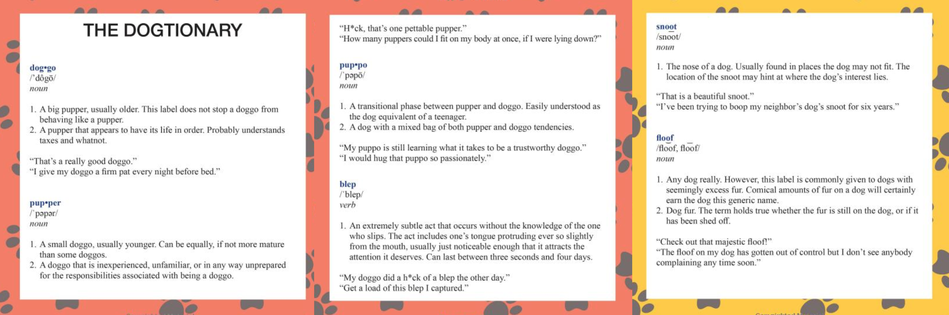

So for the first thing we have is.

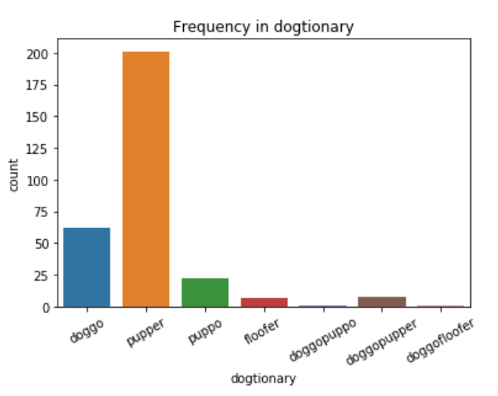

Apparently puppers are the most ones being provided for ratings.

But those that score higher are doggos:

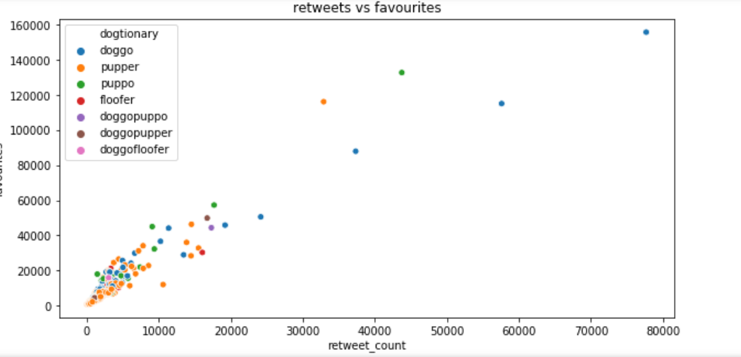

But we will not have any use of random made up words, we need something more concrete. Although we now know that there is indeed a relation between the number of retweets and the favourites, because of course the higher the retweets, the more we have people who see a dog and put favourites.

Let’s look at ratings, sure they are made up, but we can use them better.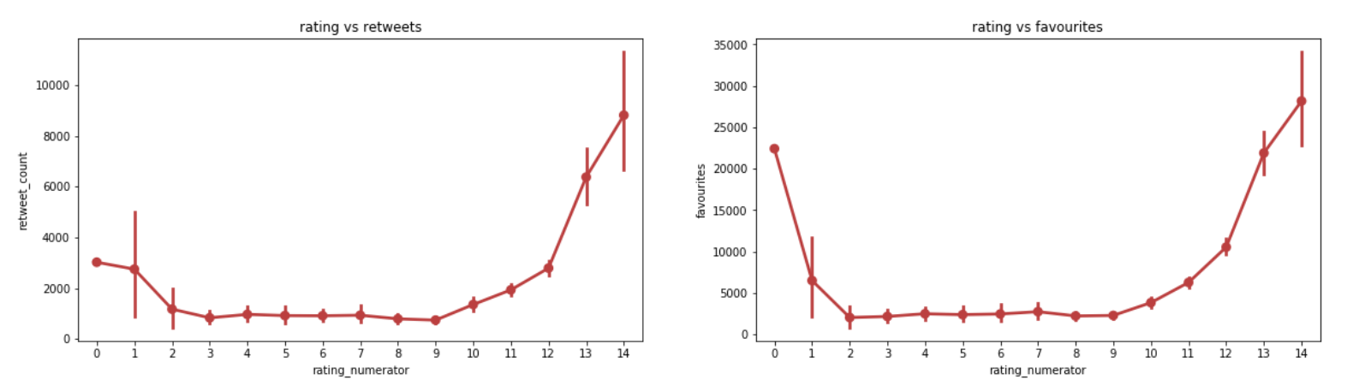

From this chart, I have one thing to say. THE GAME IS RIGGED. If you are rated higher than 9, you are automatically given a high number of retweets and favourites just by the merit of having a high rating. Apparently the community thinks so to and highly rates underdogs (no pun intended) but does not care about the average dog. This community is cruel.

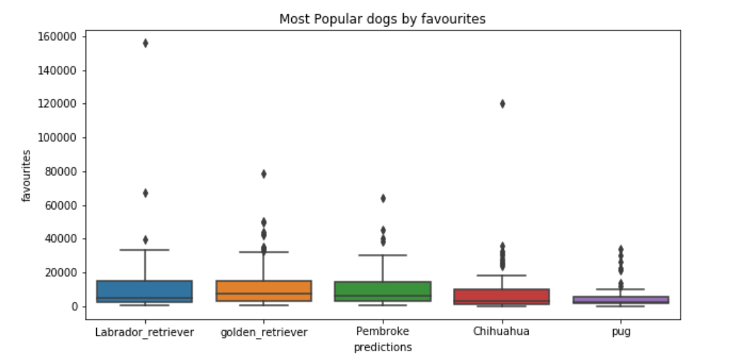And finally. If we look into the most number of dogs provided we will have 5 main dogs on the stage.

Small dogs like Pombroke, Chihuahua and pugs are very popular in the community, but not as popular as labradors and golden retrievers.

The competition is close, we need another chart.

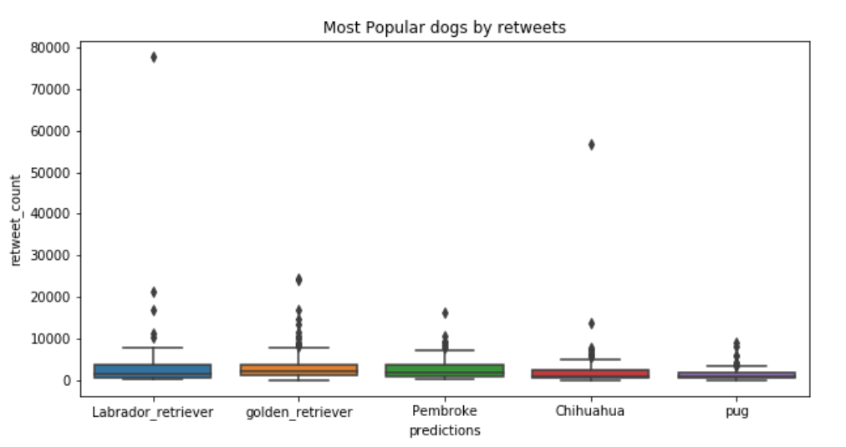

Well we got some answers, Golden Retrievers wins the game, they are the most frequently provided, they have the highest frequent retweets and favourites. However, the most popular dog we can mention will be the labrador with up to 78k favourites and retweets.

Lessons Learned:

1. All dogs are awesome; you can’t compare dogs, unless you are as cruel as WeRateDogs.
2. The younger dogs are preferred, no sympathy for old dogs :(
3. More retweets, more favourites.
4. The game is rigged, it’s all about the ratings.
5. Golden retrievers are the most popular, Labradors have the most popular dogs. Small dogs are the most frequently popular.

And that is how I spent my last 4 days.

Enjoy :D