BRIJESH A H

**Pre-Final Year Engineering**

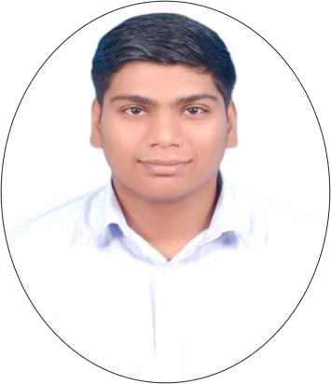

# PROFILE

I am a highly enthusiastic and sharp learner with impressive listening and speaking skills. I am eagerly looking forward to learning, discovering, and innovating in the emerging field of AI and Machine Learning and a Data Scientist Aspirant.

I am committed to upholding the values of loyalty and truthfulness in every aspect of my professional journey. With unwavering integrity, I aspire to contribute my dedicated efforts and genuine sincerity to create a positive and trustworthy impact in any role I undertake.

# CONTACT

PHONE:

+91 6384665931

EMAIL:

[ahbrijesh2004@gmail.com](mailto:ahbrijesh2004@gmail.com) GITHUB PROFILE:

<https://github.com/AHBRIJESH> LINKEDIN PROFILE:

<https://www.linkedin.com/in/brijeshah>

# LANGUAGE SKILL’s

ENGLISH (S/R/W)

HINDI (S/R/W)

TAMIL (S/R)

MALAYALAM (S)

# HOBBIE’s

DIY Disassembly Playing Indoor Games Listening Music Watching Web-Series

## EDUCATION

### RAJIV GANDHI COLLEGE OF ENGINEERING

Pursuing a bachelor’s degree in computer science engineering with an exceptional CGPA of 8.1 after the completion of the fourth semester. Demonstrated consistent academic excellence, active participation in campus activities, and maintained an unblemished record without any backlogs.

### KENDRIYA VIDYALAYA NAGERCOIL

Completed my schooling at Kendriya Vidyalaya with an impressive 85% academic achievement, maintaining an untarnished record. Engaged in various co-curricular activities, notably participating in numerous debates, highlighting a commitment to holistic development and positive contributions to the school community.

## PROJECT’s & JOB SIMULATION EXPERIENCE’s

### COGNIZANT ARTIFICIAL INTELLIGENCE JOB SIMULATION

I successfully completed tasks for Cognizant's Data Science team, encompassing exploratory data analysis using Python and Google CoLab for Gala Groceries, a technology- led client. Moreover, I prepared a Python module with code for model training and performance metrics for the Machine Learning engineering team, presenting the concise and insightful results in a PowerPoint slide. This experience enhanced Cognizant's AI capabilities, providing valuable insights for making informed business decisions.

### PROJECT’s

* [IBM Certification Projects](https://github.com/AHBRIJESH/IBM_Projects.git)
* [Mean Shift Clustering Algorithm](https://github.com/AHBRIJESH/Mean_Shift_Algorithm.git)
* [Student Success Predictor using Naive Bayes](https://github.com/AHBRIJESH/Naive_Bayes_Algorithm.git)
* [Handwritten digit Classifier with Neural Network](https://github.com/AHBRIJESH/Convolutional_Neural_Network-for-Handwritten-Digit-Predection.git)
* [Diabetes Prediction using Decision Tree Classifier](https://github.com/AHBRIJESH/Decesion_Tree_based_Diabetic_Predictor.git)
* [Sentence Emotion Classifier with Neural Network](https://github.com/AHBRIJESH/Sentence_Emotion_Predictor.git)

## SKILL’s

## 