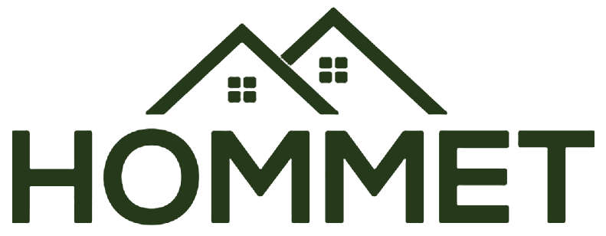
HOMMET INDUSTRIES PRIVATE LIMITED
Website Design & Build Brief
For the team building hommet.in

Purpose of this document. This is the brief for the Hommet website. It sets out who Hommet is, what the site needs to say, how it should look, and what pages to build. Everything you need to start is here. If anything is unclear, raise it before you start, not after the first draft.
How we will review. We review against this brief, section by section. A draft is complete when it meets every non-negotiable in Section 3 and the acceptance checklist at the end.

1. Who Hommet is, and what the site must say
Positioning: Integrated Building & Living Solutions. Hommet is the single building partner people trust for their home, from foundation to roof, backed by internationally trusted brands.
From foundation to roof, backed by trusted brands. This is the line that captures Hommet. The site should make a visitor feel it covers the whole home, not one product. Roofing is the flagship that leads, but the brand is the umbrella over every category.
Geographic claim: Rooted in Kerala, earning trust across India. Hommet delivers across India, so this is the honest present-tense claim. Do not shrink it to Kerala-only, and do not stretch it to global.

Message hierarchy for the homepage
- Tagline: Crafting Durable Dreams
- Headline: Everything your home needs, from one partner you trust
- Proof line: Rooted in Kerala. Earning trust across India.
- Supporting line: From foundation to roof, backed by internationally trusted brands, and known for getting it right.
Tone of the whole site: warm but firm. Calm, credible, handled. We do not argue our quality, we radiate it. No hype, no exclamation marks, no wellness or salesy jargon.
Look and feel: warm premium. Clean, spacious, considered, but warm, not cold or corporate. This is the feel to convey all through the site: generous whitespace, calm typography, the olive-and-cream palette, restraint over decoration.
Do not use the word "premium" in the copy. Premium is a feeling the design carries, never a claim we make. The website copy should not say "premium" (or "luxury," "world-class," or similar self-praise) anywhere. We show it through quality and restraint; we do not announce it. The word is for this brief and the design team, not for the visitor.
Primary audience: builders and contractors first. The site serves a wide audience (homeowners, architects, engineers, developers, dealers, consultants, facility managers, institutions), but when a choice has to be made about tone or hierarchy, speak to builders and contractors who buy on trust, spec, and reliability.
First ten seconds: a visitor should feel, within ten seconds, that Hommet is trusted, considered, and integrated, a partner for the whole home, not a single-product seller. That impression comes from the design and photography, not from us saying it.

2. What the site is for
The website carries more than product awareness. Design and structure should serve these objectives, roughly in priority order.
- Corporate brand positioning. Establish Hommet as a credible, premium, integrated building solutions company, not a single-product seller.
- Lead generation. Commercial project enquiries, residential enquiries, and consultation requests are the core conversions.
- Product awareness. Show the full range clearly so visitors grasp the breadth.
- Dealer acquisition. A clear path for prospective dealers and partners to reach us.
- Architect and consultant engagement. Make it easy for specifiers to find technical detail and enquire.
- Corporate and investor credibility. The About and Projects sections should read as a company with standing, not a catalogue.
- Recruitment. A simple careers path.

3. Non-negotiables
These are not preferences. A build that misses any of these is not accepted. Read them before you touch a wireframe.

Brand and visual
- Palette is olive and cream, per the brand palette sheet. Deep Forest #263A1B primary, Olive Green #687C3C secondary, Sage #9AA57A accent, Warm Ivory #F5F2E9 as the main background, Stone #D8D3C6 for support, Antique Brass #A58A52 as a rare accent only.
- Colour usage ratio: roughly 70% Warm Ivory background, 20% Deep Forest / Olive, 8% Stone / Sage, 2% Antique Brass. The site should read light and calm, not heavy.
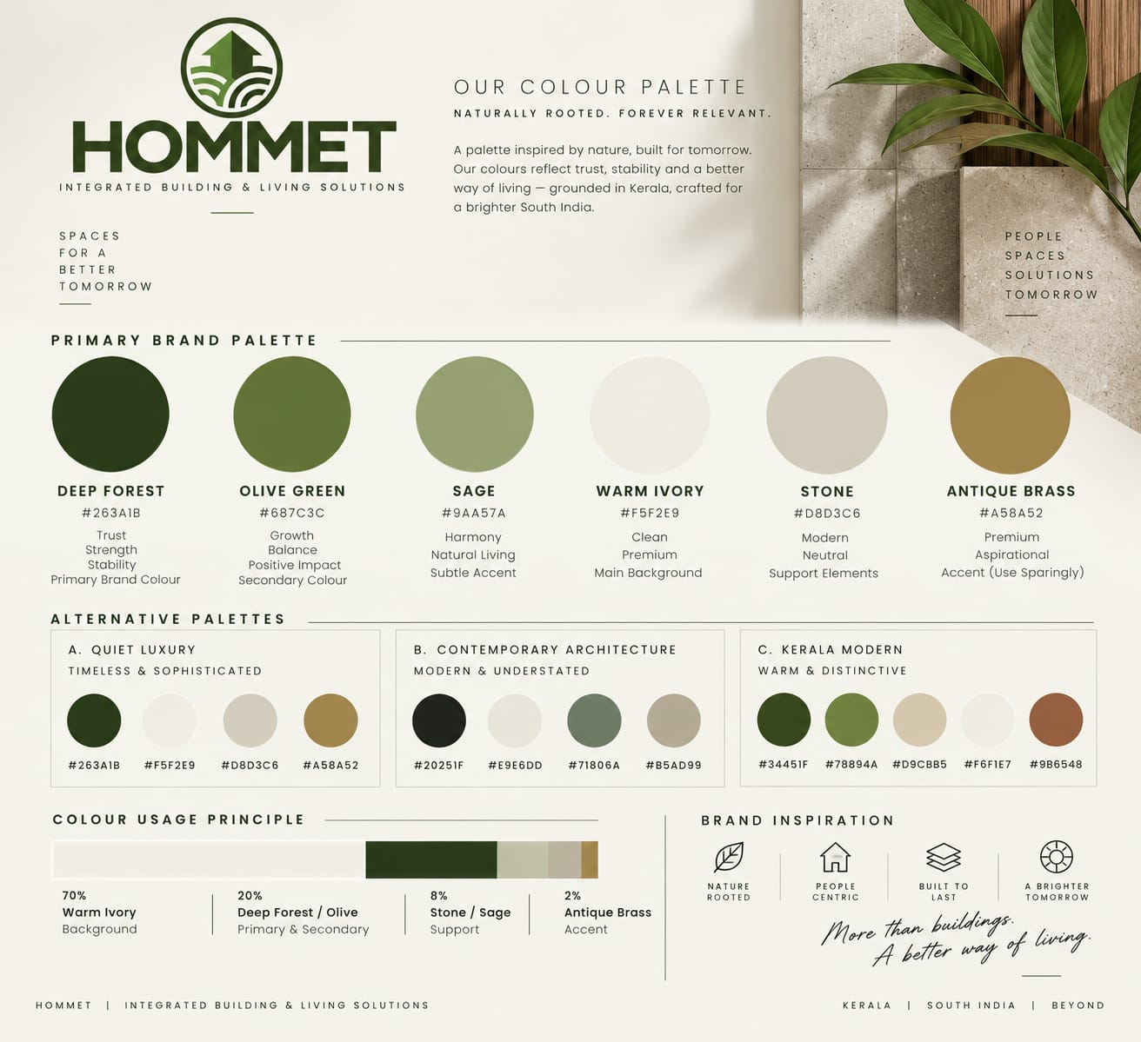
The Hommet brand palette. Use the primary palette swatches and hex codes above; the usage ratio at the bottom is the balance to hold across the site.
- No orange. Anywhere. Orange is off-brand for Hommet. The palette is olive and cream only.
- Hommet and Armstrong identities stay separate. The consumer brand is olive and cream. The Armstrong HVAC vertical uses its own navy and technical system and must feel like a distinct, linked section, not the same skin. Do not bleed one palette into the other.
- Real photography only. No stock, no aspirational CGI. Use real Hommet photography: completed projects, product close-ups, showroom, and real consultation shots. Do not use stock "premium residential," stock "commercial buildings," or 3D/CGI renders. A staged image that doesn't match the real space damages trust the moment a customer visits. Premium comes from layout and restraint, not stock gloss.
- Logo must stay legible on every background. Supply and use the correct logo variant, full-colour, all-white knockout, all-olive, so the mark never sits illegibly on a dark or olive block.

Performance and build
- Mobile-first. Design the mobile layout first and treat desktop as the adaptation. Most of our traffic is on a phone.
- Under 3 seconds to load on a mid-range phone on 4G. This is measurable and we will measure it. Tell us in the plan how you will hit it (image compression, lazy loading, font strategy) and how you will prove it (PageSpeed / Lighthouse score at handover).
- Every product is clickable. No product image is a dead end. Each links to its own page, or to a category page or WhatsApp enquiry as an interim. No dead tiles.
- One consistent set of contact details, site-wide: support@hommet.in, +91 7306982905, and the registered office address. No page may show a different number or email.
- Built to grow. Hommet plans to add brands and product categories over the next year or two. Build the architecture so a new category or partner slots in without a rebuild.

4. Typography
The Hommet website font is Manrope. Use it for both headings and body across all consumer pages. It is free and open-source (Google Fonts), loads fast, and is the font this brief is set in, so what you read is what the site should feel like.
- Headings: Manrope in a heavier weight (SemiBold or Bold). These carry the brand voice.
- Body: Manrope Regular / Medium, highly readable at small sizes on mobile. Generous line spacing.
- Armstrong section only: its own technical stack (e.g. Space Grotesk display, Inter body, a mono face for specs). Keep it visually walled off from the consumer pages.
- Text colour: body text is a soft warm grey (around #4A4A47), not pure black. It reads calmer and more premium against the ivory background. Headings use the brand greens (Deep Forest #263A1B, Olive #687C3C). Reserve near-black for nothing; the grey and greens carry everything.
Rule: do not mix font families across the consumer pages. No condensed or decorative fonts. One typeface, used well.

5. Sitemap and what each page does
Build these pages. The job of each is stated so structure is not left to guesswork.

Home
- Hero: tagline, headline, proof line, one primary call to action (Enquire / WhatsApp).
- Category strip: the whole catalogue at a glance, so a visitor sees the full range, not just roofing.
- Why Hommet: trust, integrated solutions, internationally trusted partners.
- Flagship spotlight: roofing leading, clearly one of many categories, with a link through to the Atlantique site.
- Selected flagship projects: a small, curated strip, not a full portfolio.
- Partner logos: Armstrong, Atlantique, and others, as trust signals.
- Footer with consistent contact block and office locations.

Products / Solutions
- Category landing pages for the full range: Roofing & Building Materials, Doors & Windows, Sealants & Construction Accessories, Architectural Terracotta, Sanitary Ware, Smart Toilets, Home Fitness Equipment, HVAC Solutions, Pumps & Fluid Systems, and Building Automation / Performance Solutions.
- Page depth varies by category. Some categories need a basic intro with benefits and applications, others a full catalogue-style page with specs. Match depth to the category; do not force one template on all.
- Where technical datasheets exist, offer them as downloads on the relevant page.
- Each product or category page: image, short description, key info, and a clear enquiry CTA. Every tile clickable, no dead ends.

Roofing — brief intro, redirect to Atlantique
- Atlantique has its own dedicated website. On Hommet, roofing gets a short, strong introduction that positions it as the flagship, then links out to the Atlantique site for full product detail.
- Do not rebuild the full Atlantique catalogue on Hommet. Introduce and redirect.

Armstrong (HVAC / B2B) — linked, visually separate
- Its own landing section for the Armstrong Fluid Technology partnership, aimed at MEP consultants, HVAC contractors, and facility managers.
- Navy / technical treatment, authorised-representative framing, the authorised product lines.
- Reachable from the main nav but clearly a different audience and look.
- Armstrong enquiry contact: Nirmal Kiran, Assistant Engineer, Energy Optimization & Pumping Solutions. +91 90721 21337, nirmal.kiran@hommet.in. Use this contact on the Armstrong section, not the general Hommet number.

Partner Brands
- A dedicated Partner Brands section presenting the internationally trusted brands Hommet works with (Armstrong, Staly, Leoplast, and others).
- Hommet stays the customer-facing brand. Even where the product comes from a partner, Hommet is who the customer deals with. Partners appear as credibility, not as separate storefronts. No dedicated per-partner product pages beyond the Armstrong section; partners are represented within this section and within relevant category pages.

Projects
- A selected flagship projects section, curated not exhaustive. Real completed work only.
- Used as a trust signal, not a full portfolio dump.

Dealers / Partners
- A clear "Become a Dealer / Partner" path with its own enquiry form, since dealer acquisition is a stated objective.

Careers
- A simple careers page, since recruitment is a stated objective. Keep it light: who we are, open roles or a general enquiry.

About
- The Hommet story, positioning, mission and vision, and the three offices: Pathanamthitta, Ernakulam, Bengaluru.
- Built to carry corporate and investor credibility, not just product. Partner and quality credentials shown through the brands we represent, not overclaimed as our own.

Founder & Story
- A dedicated page for the founder, co-founders, and the Hommet story: who started it, the people behind it, and the thinking behind building an integrated solutions company.
- Build the page structure and design now; the founder and co-founder details, roles, and the story copy will be provided soon. Leave clearly marked placeholders and wire it into the About / company section of the nav.
- Real photography only. If founder photos are used, they must be real, per the brand rule. No stock portraits or generated images.

Contact
- One clean contact page: enquiry form, WhatsApp, phone, email, office locations, map.
- Separate enquiry routes where useful: general enquiry, request a consultation, technical consultation, architect / consultant enquiry, dealer enquiry.
- Form submissions must route to a real, monitored inbox. Confirm where they land in the plan.

Site-wide calls to action
- Primary: WhatsApp, Submit Enquiry, Request a Consultation.
- Secondary, where relevant: Call, Request Product Details, Download Catalogue, Request Technical Consultation, Visit Atlantique / partner site, Become a Dealer.
- Downloadable product catalogues and technical datasheets where they exist.

6. Locked reference facts
Use these exactly. Do not invent, round, or vary them across pages.
Field | Value
Company | Hommet Industries Private Limited
Positioning | Integrated Building & Living Solutions
Tagline | Crafting Durable Dreams
Geographic claim | Rooted in Kerala. Earning trust across India.
General phone | +91 7306982905
General email | support@hommet.in
Domain | hommet.in
Locations | Pathanamthitta, Ernakulam, Bengaluru
Pathanamthitta office | 258, Sivasylam, Kadampanad, Adoor, Pathanamthitta, Kerala 691552
Ernakulam office | Aimury Kavala, Koovapady Post, Perumbavoor, Ernakulam 683544
Bengaluru office | 3rd Floor, Flat No. 50, 9th A Main Road, Binnamangala, Indiranagar, Bengaluru, Karnataka 560038
Roofing brand | Atlantique
HVAC partner | Armstrong Fluid Technology (authorised representative, Kerala)
Armstrong contact | Nirmal Kiran, Asst. Engineer, Energy Optimization & Pumping Solutions · +91 90721 21337 · nirmal.kiran@hommet.in
Other partners | STALY (steel doors), Leoplast (UPVC)
Note: if any existing asset shows a different phone or email (info@hommet.in, alternate numbers), it is out of date. The values above are correct.

8. Open decisions, to confirm before build
A few items are not yet settled. Do not guess these; flag them and wait for a decision.
- Publishable trust numbers. The only approved trust signal today is number of completed projects, but the figure itself is not yet confirmed. Do not invent or estimate it. Leave a clearly marked placeholder and we will supply the verified number. Nothing gets published as a statistic until we confirm it.
- Product assets. Technical datasheets exist; a fuller set of product photography, catalogues, and project photos is still being gathered. Build category pages so they look complete with what exists now and accept assets as they arrive. Tell us the asset format and specs you need.
- Founder & Story content. The founder and co-founder names, roles, the story copy, and any founder photos will be provided soon. Design the page now with placeholders; do not draft or invent this content.
- Reference style. Direction is given below under Reference sites. If the team wants to propose others, bring two or three for us to react to.
- Content approval. All website content is approved by Anisha before publishing. Build the approval step into your process.

Reference sites
Look at these for direction. Lead with Cosentino: it is the closest match to Hommet's structure, a premium parent brand holding several product categories and distinct sub-brands without fragmenting. Note: these are live sites and articles as of this brief; open each and confirm before relying on it.
- Cosentino: cosentino.com. The primary reference. A global building-surfaces company presenting flooring, cladding, countertops and facades under one parent brand, with sub-brands beneath it. This is the Hommet-over-Atlantique-and-partners structure done well: parent stays the hero, sub-brands sit under it. Calm, spacious, considered.
- Kingspan: kingspan.com. For architecture across very different product worlds. A building-materials group spanning multiple divisions that lets a visitor branch into distinct product areas without the site feeling scattered, the same challenge as splitting consumer categories from the Armstrong technical vertical.
- Silestone: silestone.com, Dekton: dekton.com. Cosentino's sub-brand sites. Useful for how a sub-brand gets its own space while clearly belonging to the parent, relevant to how roofing and partner brands relate to Hommet.
- IMKAT: imkatconstruction.com. Mood only, not structure. A photography-led, low-clutter builder site. Useful for the restrained, real-photography feel; ignore its single-product scope.
- Principles read: turnxmedia.com/blog/the-best-construction-website. An article on what separates good construction sites from great ones in 2026: mobile-first, real trust signals, and building content ecosystems around expertise rather than thin service pages. Worth reading before wireframing; it backs the page-depth and mobile-first rules in this brief.

9. Deliverables and the order we want them
We approve in stages so we catch direction early, not after a full build. Do not skip ahead.
- Sitemap and wireframes first (low fidelity). Structure and page flow only, mobile layout shown. We sign off before any visual design.
- Homepage visual design (mobile + desktop). One page, fully designed to this brief, for approval before you design the rest.
- Full design of remaining pages. After homepage sign-off.
- Build. Only after design sign-off. Staging link shared for review.
- Handover. Live site, PageSpeed / Lighthouse score, a short doc on how to edit content, and confirmation that every non-negotiable is met.
On timelines: The copy, structure, and brand are set out in this brief. Our target is to launch within about a month. Give us an honest build time for each stage above, separated from anything you need from us to proceed. If a month is not realistic for the full scope, tell us what a phased launch looks like: what goes live first and what follows.

10. Acceptance checklist
A stage is done only when every relevant box is true. We check this list on every review.
- Palette matches the brand sheet; no orange anywhere.
- 70/20/8/2 colour balance holds; the site reads light, warm, and calm, not heavy.
- Integrated-solutions positioning leads; roofing shown as the flagship, not the whole brand.
- Roofing is a brief intro that redirects to Atlantique, not a full rebuilt catalogue.
- Geographic claim is across India, matching the real delivery footprint.
- The full category range is represented, not just roofing.
- Partner brands sit in their own section; Hommet stays the customer-facing brand throughout.
- Armstrong section is visually separate, navy/technical, and clearly linked.
- Projects section is curated flagship work only, real completed projects.
- Real photography only; no stock residential/commercial or CGI.
- The copy never says "premium," "luxury," or similar self-praise; the feel is carried by design, not claimed in words.
- No unverified statistics; project-count figure left as a placeholder until confirmed.
- Logo is legible on every background it appears on.
- Mobile layout is designed first and looks right on a phone.
- Loads under 3 seconds on 4G; PageSpeed / Lighthouse score provided.
- Every product tile is clickable, no dead ends.
- Architecture is built to add future brands and categories without a rebuild.
- Contact details are identical on every page and match Section 6 exactly.
- Enquiry forms (general, consultation, technical, architect, dealer) route to real, monitored inboxes.
Anything not covered here is a design decision we trust you to make well, in the spirit of the brand above: calm, credible, and handled. When in doubt, choose the quieter option.

