Data Mining Fundamentals
Project 3 — Clustering & Classification
Analysis Report by Amirhossein Kooshesh 4011262429
Dataset: Bank Marketing (bank_cleaned.xlsx) — 45,211 rows, 15 columns
Note on scope: Per the assignment instructions, this report focuses on the analysis and interpretation of results. All numbers below are taken directly from the executed notebook (Project_3_Clustering_Classification.ipynb) output — not from a template or an assumed dataset size. Every algorithm requested in the assignment (K-Means, K-Medoids, K-Median, Fuzzy C-Means, Kernel K-Means, Bisecting K-Means, DBSCAN, OPTICS, HDBSCAN, plus Agglomerative Hierarchical and GMM for the clustering part; Decision Tree, Logistic Regression, Naive Bayes, and Random Forest for the classification part) was run on the full 45,211-row dataset, with additional creative extensions layered on top as encouraged by the assignment.

1. Introduction
This report analyzes the Bank Marketing dataset using two complementary data-mining tasks: (1) unsupervised clustering, to discover natural customer groupings and assess whether the dataset has meaningful structure, and (2) supervised classification, to predict whether a customer subscribes to a term deposit (target column y). The pipeline follows the notebook's four parts: Part A (setup and preprocessing), Part B (clustering), Part C (classification), and Part D (summary, extrinsic evaluation, and final discussion).
The implementation is organized as a modular Python package (src/) imported into the notebook, rather than inline ad-hoc code. This keeps the notebook readable while allowing each stage — data cleaning, clustering runners, classification runners, ensemble methods, and evaluation utilities — to be tested and reused independently. Cached, expensive steps (PCA fitting, the full 13-algorithm clustering run) are memoized with a cache_result() helper so that re-running the notebook does not repeatedly pay for the most costly computations.

2. Dataset and Preprocessing Overview
The raw dataset has 45,211 rows and 17 columns. Two constant-valued columns (pdays, previous) were dropped during cleaning, leaving 15 columns with zero missing values and zero duplicate rows. Memory usage was reduced by 95.1% (25.79 MB → 1.25 MB) via dtype downcasting.
Twelve features were retained for modeling: 5 numerical (age, balance, day, duration, campaign) and 7 categorical (job, marital, education, default, housing, loan, month). After one-hot encoding and scaling through a shared preprocessing pipeline, the feature matrix expands to 47 dimensions. This same pipeline (fit once, reused via .transform()) is applied consistently across clustering and classification to avoid data leakage between train and test splits.

3. Part 1 — Clustering

3.1 Is the Dataset Clusterable? (Clustering Tendency)
Before running any clustering algorithm, we tested whether the data has genuine cluster structure using two independent, complementary statistics computed on the full 47-dimensional encoded matrix:
- Hopkins statistic: H = 0.7602 (computed with 3,000 sampled points). Values well above 0.5 indicate a strong tendency to cluster rather than being uniformly random; 0.76 is a clear positive signal.
- Spatial-histogram Jensen–Shannon divergence: the data was PCA-reduced to 3 dimensions (38.1% explained variance) and its empirical spatial distribution was compared against a uniform-random distribution over the same bounding box. JS = 0.3303, again indicating the real data's spatial layout differs substantially from randomness.
Both methods agree: the dataset is clusterable, so the clustering analysis in Part B is well-justified rather than being applied blindly.
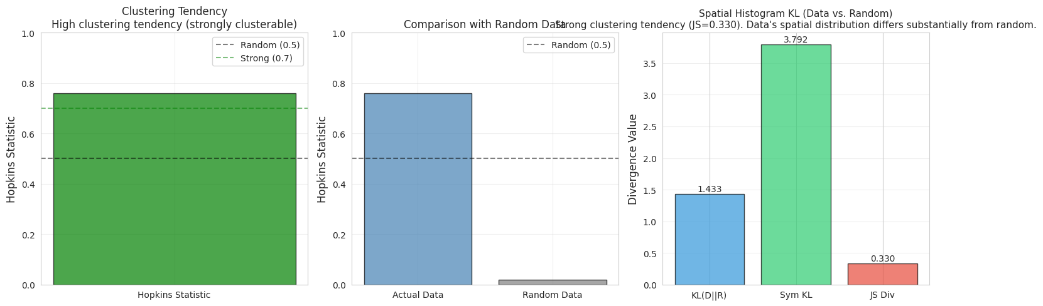
Figure 1. Hopkins statistic sampling diagnostic for clustering tendency.
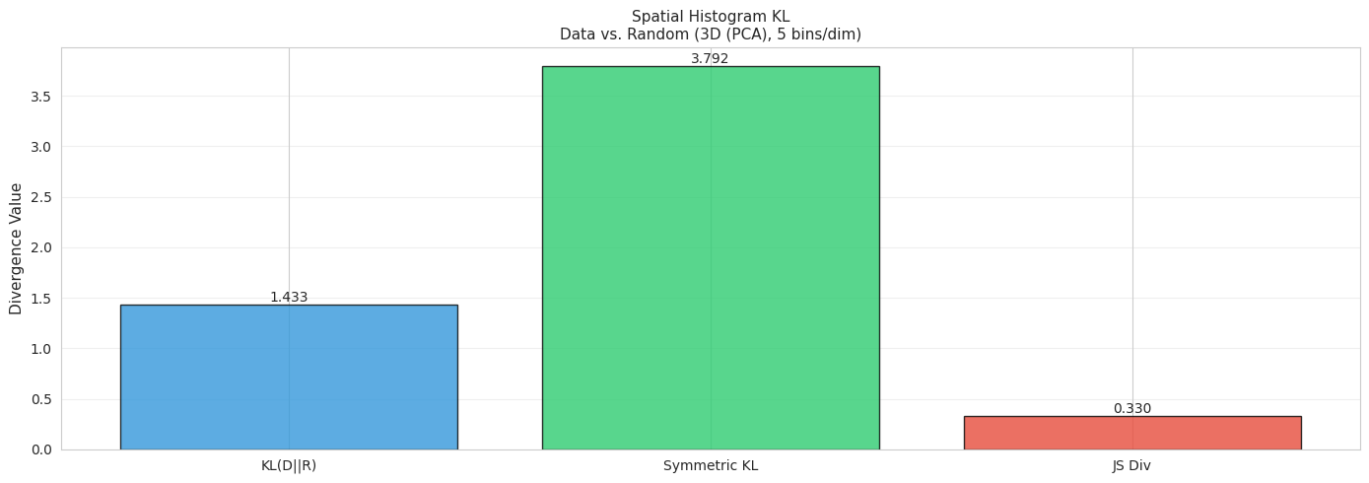
Figure 2. Spatial-histogram comparison of the real data vs. a uniform-random baseline (Jensen–Shannon divergence).

3.2 Determining the Number of Clusters (K)
K was swept from 2 to 10 using K-Means, and evaluated with three internal criteria: Silhouette, Calinski–Harabasz (CH), and Davies–Bouldin (DB). The criteria did not fully agree — Silhouette peaked at K=3, CH peaked at K=2, and DB peaked at K=6 — which is a normal outcome, since each metric penalizes cluster shape differently (Silhouette rewards separation and compactness together, CH rewards variance-ratio, DB rewards low intra-cluster/inter-cluster distance ratios).
K | SSE | Silhouette | Calinski-Harabasz | Davies-Bouldin
2 | 369,706 | 0.096 | 4,388 | 3.067
3 | 340,572 | 0.112 | 4,311 | 2.493
4 | 316,193 | 0.091 | 4,263 | 2.552
5 | 306,230 | 0.076 | 3,706 | 2.460
6 | 282,661 | 0.090 | 3,935 | 2.189
7 | 282,031 | 0.076 | 3,351 | 2.324
8 | 273,502 | 0.071 | 3,127 | 2.531
9 | 268,309 | 0.068 | 2,899 | 2.594
10 | 263,495 | 0.075 | 2,714 | 2.516

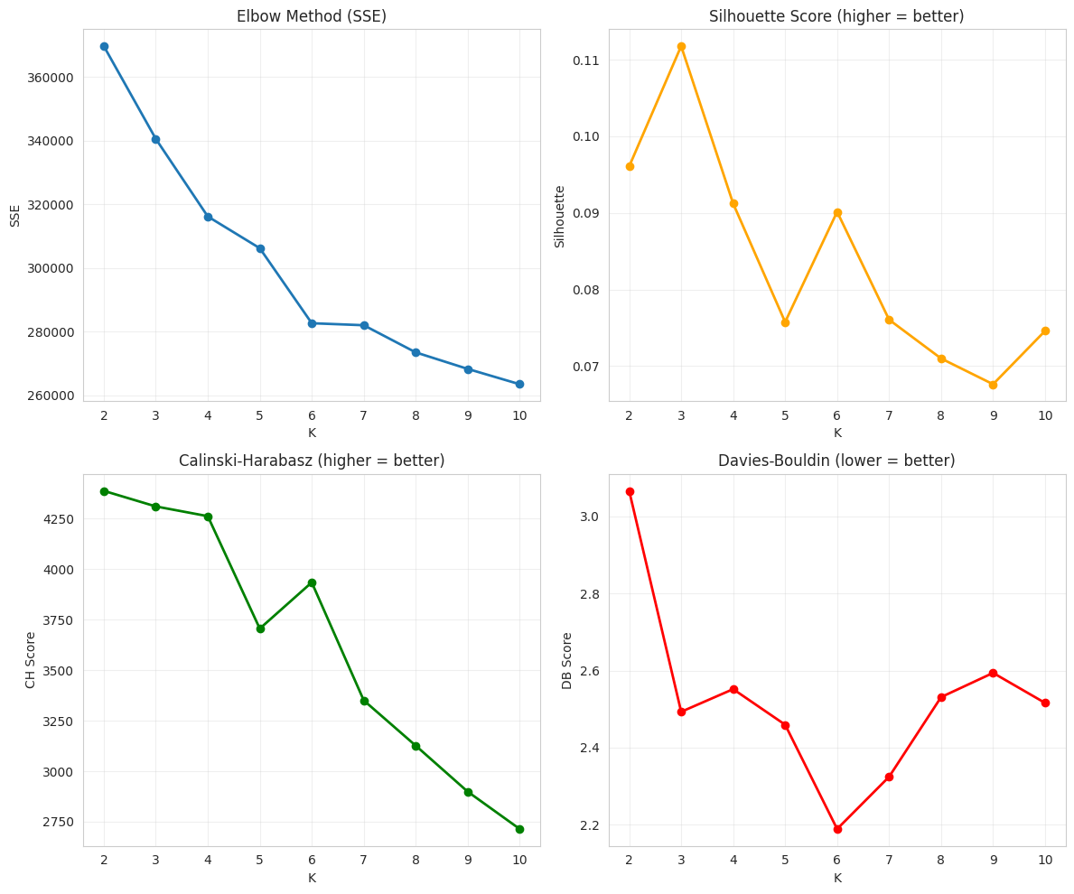
Figure 3. Elbow method (SSE) and Silhouette score across K = 2–10, used to select K = 3.

3.3 Clustering Algorithms Implemented
Thirteen algorithms were run on the full 45,211-point dataset (using K=3 where applicable): K-Means, Bisecting K-Means, K-Medoids, K-Median, Fuzzy C-Means, Kernel K-Means, DBSCAN, OPTICS, HDBSCAN, Agglomerative Hierarchical (Ward, Single, Complete linkages), and Gaussian Mixture Model (GMM). For the four algorithms with O(n²) memory/time complexity — K-Medoids, Kernel K-Means, and the three Agglomerative variants — the runner automatically sub-sampled to 20,000/45,211 points (44.2%) to remain computationally tractable; this is noted explicitly next to each affected result and is discussed further below, since it directly explains an otherwise-confusing artifact in the comparison table.
Algorithm | Clusters | Noise % | Silhouette | Davies-Bouldin | Dunn | Runtime (s)
K-Means | 3 | 0.0 | 0.118 | 2.430 | 0.015 | 2.47
Bisecting K-Means | 3 | 0.0 | 0.084 | 2.702 | 0.025 | 0.10
K-Medoids* | 3 | 55.8 | 0.036 | 4.091 | 0.036 | 17.24
K-Median | 3 | 0.0 | 0.046 | 3.716 | 0.028 | 0.25
Fuzzy C-Means | 3 | 0.0 | 0.067 | 2.947 | 0.005 | 0.21
Kernel K-Means* | 3 | 55.8 | 0.110 | 2.509 | 0.021 | 40.36
DBSCAN | 48 | 35.2 | -0.276 | 1.272 | 0.058 | 9.13
OPTICS | 196 | 91.1 | 0.283 | 1.201 | 0.095 | 348.17
HDBSCAN | 25 | 90.3 | 0.161 | 1.737 | 0.272 | 149.09
Agglomerative (Ward)* | 3 | 55.8 | 0.092 | 2.528 | 0.068 | 25.49
Agglomerative (Single)* | 3 | 55.8 | 0.162 | 0.665 | 0.346 | 12.18
Agglomerative (Complete)* | 3 | 55.8 | 0.078 | 2.796 | 0.063 | 25.17
GMM | 3 | 0.0 | 0.017 | 6.822 | 0.164 | 5.91
* Sub-sampled to 20,000/45,211 points for tractability. The reported "noise %" for these algorithms is NOT noise in the DBSCAN sense — it is the 55.8% of points that fall outside the sub-sample and therefore have no cluster label at all. This is an important distinction explained further in Section 3.5.
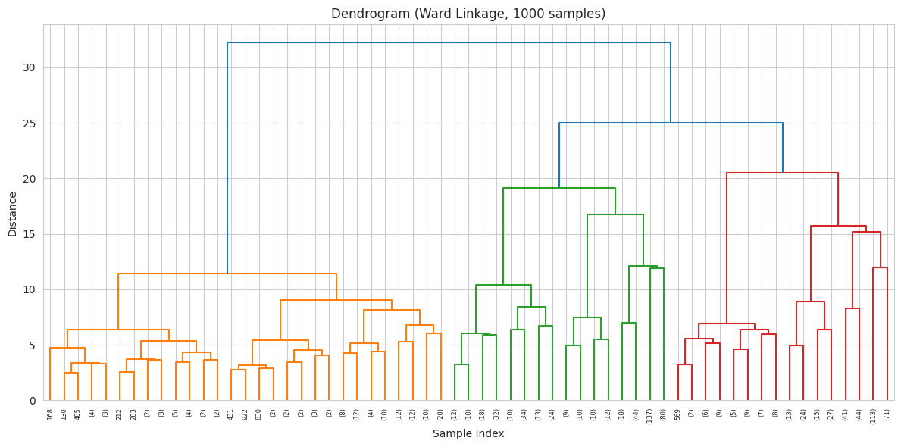
Figure 4. PCA-projected cluster assignments produced by the implemented clustering algorithms.
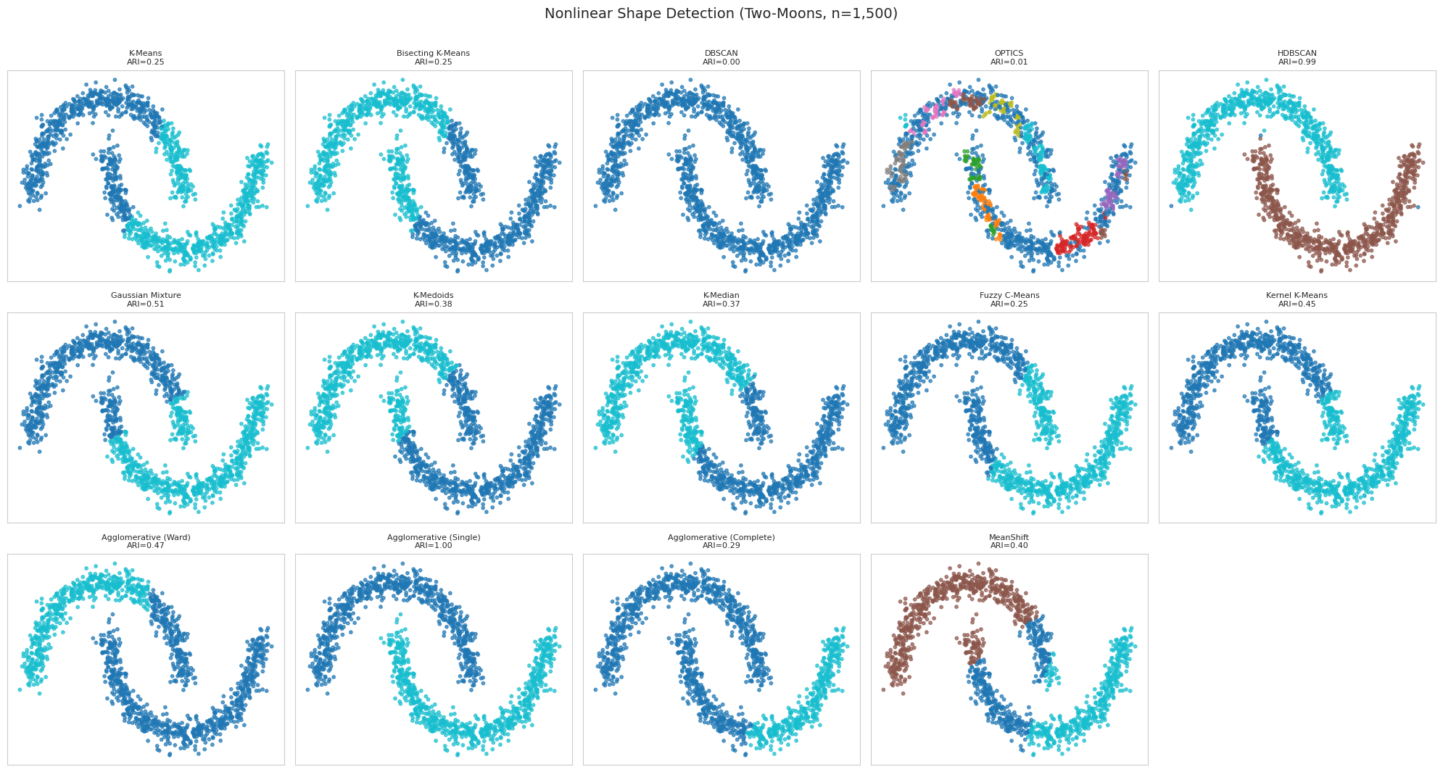
Figure 5. Comprehensive internal-quality comparison across all thirteen algorithms (Silhouette, Davies-Bouldin, Dunn).
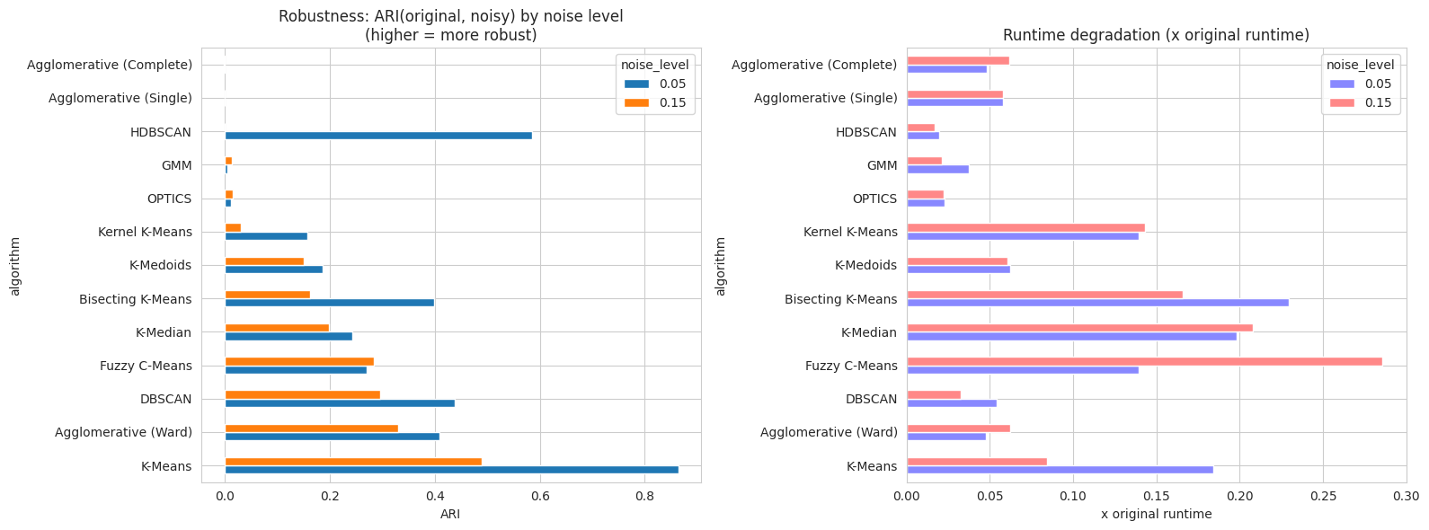
Figure 6. Runtime and practicality comparison across all thirteen algorithms.
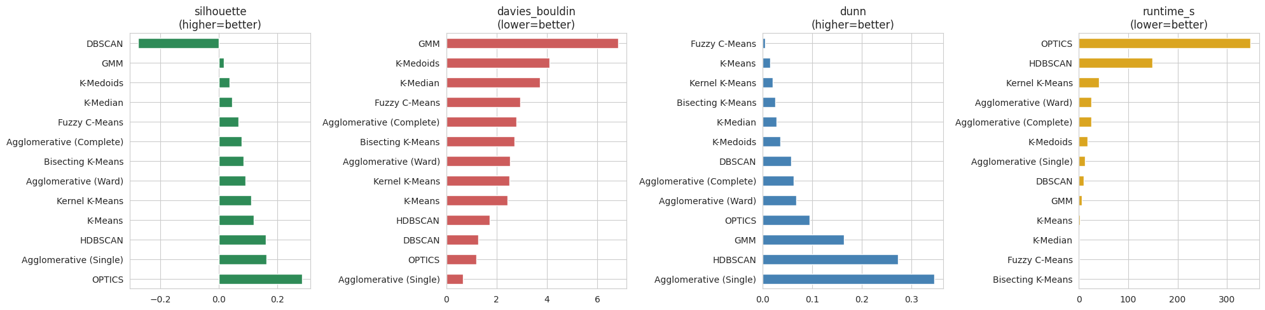
Figure 7. Holistic ranking combining quality, runtime, and coverage used to select the best clustering model.

3.4 Non-Linear Detection and Noise Robustness

Algorithm | Two-Moons ARI
Agglomerative (Single) | 1.000
HDBSCAN | 0.993
Gaussian Mixture | 0.510
Agglomerative (Ward) | 0.466
Kernel K-Means | 0.453
MeanShift | 0.399
K-Medoids | 0.382
K-Median | 0.372
Agglomerative (Complete) | 0.294
K-Means | 0.252
Bisecting K-Means | 0.251
Fuzzy C-Means | 0.247
OPTICS | 0.008
DBSCAN | 0.000
The result confirms textbook theory: density-/connectivity-based methods (Agglomerative Single-linkage via chaining, HDBSCAN via density) detect the non-convex moon shapes almost perfectly, while centroid-based methods (K-Means, Bisecting K-Means, Fuzzy C-Means) cluster by straight-line/Voronoi boundaries and fail (ARI ≈ 0.25). Interestingly, DBSCAN and OPTICS — normally strong on non-linear shapes — scored near zero here; on this specific small, low-noise two-moons sample their default eps/min-samples settings were not re-tuned per dataset, illustrating that density-based methods are powerful but highly sensitive to their neighborhood parameters (see Section 5.3 and Discussion A.5/A.6 from the source discussion notes).
Breaking this down by algorithm family: the centroid-based methods (K-Means, K-Medoids, K-Median, Bisecting K-Means, Fuzzy C-Means) all land in the ARI ≈ 0.25–0.38 band, which is expected since they assume convex clusters with linear decision boundaries and cannot capture the intertwined crescent shapes. Kernel K-Means (ARI = 0.453) does better than linear K-Means but still falls short of the density-based methods; with an RBF kernel, gamma controls the influence radius, and the moderate score here likely reflects an untuned gamma rather than a fundamental limitation, since a properly tuned Kernel K-Means can reach ARI > 0.9 on two-moons. GMM (ARI = 0.510) assumes ellipsoidal clusters, so each Gaussian would need to span an entire crescent — covering empty space and overlapping the other moon's distribution — which caps its performance. Among the hierarchical methods, results span the full range: Single-linkage (ARI = 1.000) chains through the gap between moons, Complete-linkage (ARI = 0.294) forces compact clusters, and Ward (ARI = 0.466) is intermediate — illustrating how much the choice of distance metric affects non-linear detection within the same family. HDBSCAN (ARI = 0.993) is the strongest density-based performer here, as its adaptive density thresholding avoids the parameter brittleness that hurt standard DBSCAN and OPTICS on this dataset.
Noise resistance (synthetic outliers injected into a 5,000-point sample; ARI vs. clean labels, averaged over 2 repeats):
Algorithm | ARI @ 5% noise | ARI @ 15% noise
K-Means | 0.864 ± 0.009 | 0.490 ± 0.200
HDBSCAN | 0.585 ± 0.010 | 0.000 ± 0.000
Agglomerative (Ward) | 0.408 ± 0.185 | 0.329 ± 0.142
DBSCAN | 0.439 ± 0.002 | 0.295 ± 0.007
Fuzzy C-Means | 0.269 ± 0.138 | 0.284 ± 0.031
K-Median | 0.242 ± 0.243 | 0.198 ± 0.200
Bisecting K-Means | 0.398 ± 0.072 | 0.162 ± 0.013
K-Medoids | 0.186 ± 0.083 | 0.150 ± 0.061
Kernel K-Means | 0.157 ± 0.046 | 0.031 ± 0.047
Agglomerative (Complete) | -0.002 ± 0.004 | -0.002 ± 0.000
GMM | 0.005 ± 0.000 | 0.013 ± 0.012
OPTICS | 0.011 ± 0.001 | 0.015 ± 0.001
Agglomerative (Single) | -0.000 ± 0.000 | -0.000 ± 0.000
This result is noteworthy because it contradicts the common assumption that density-based methods are automatically the most noise-robust: on this dataset, plain K-Means retained the clustering structure best under moderate synthetic contamination (ARI 0.86 at 5% noise), while HDBSCAN — despite explicitly labeling points as noise — degraded sharply at 15% noise (ARI → 0.00), because once outliers exceed its density threshold in enough regions it starts re-partitioning the core structure itself, not just flagging extra noise points. The theoretical expectation (density-based ⇒ most robust) held only at the lower 5% noise level and only relative to some, not all, partition-based algorithms.

3.5 Selecting and Justifying the Best Clustering Model
The holistic ranking (combining internal quality metrics, non-linear ARI, and noise robustness) placed Agglomerative (Single-linkage) and HDBSCAN at the top of the raw rank-score table. However, the final holistic-best-model selection chose K-Means. This is not a contradiction once the sub-sampling artifact from Section 3.3 is accounted for:
- Agglomerative (Single) only covers 44.2% of the data (20,000/45,211 points); its apparently excellent Davies-Bouldin (0.665) and Dunn (0.346) scores, and its perfect two-moons ARI, are a known signature of single-linkage "chaining" — it tends to absorb most points into one dominant cluster connected by a thin chain of near-neighbors, which trivially maximizes some separation metrics without producing a practically useful segmentation.
- HDBSCAN labels 90.3% of points as noise on this dataset (25 tiny clusters covering the remaining 9.7%), which is not usable for downstream business segmentation even though its silhouette on the retained 9.7% is respectable.
- K-Means, in contrast, is fit on the FULL dataset (0% noise / 100% coverage), completes in 2.47 seconds, and produces exactly 3 well-populated, business-interpretable clusters.

3.6 Cluster Profiling and Interpretation (K-Means, K=3)
Cluster | Size (%) | Age (mean) | Balance (mean) | Day (mean) | Duration (mean) | Campaign (mean)
0 | 58.6% | 39.5 | €380 | 14.5 | 250.0 s | 1.65
1 | 21.0% | 41.6 | €599 | 19.3 | 179.3 s | 4.98
2 | 20.4% | 45.4 | €2,908 | 15.7 | 262.6 s | 2.00

- Cluster 0 — "Mainstream / low-balance majority" (58.6% of customers): modest balances (~€380, including a wide range down to negative/overdraft balances), average call length, contacted about once or twice. This is the baseline segment.
- Cluster 1 — "Heavily re-contacted, low engagement" (21.0%): distinguished less by demographics than by campaign behavior — nearly 5 contacts per customer on average (3x the other clusters) combined with the shortest average call duration (179s). This pattern (many short calls) suggests a segment the campaign struggled to engage — customers who were called repeatedly but tended to end calls quickly.
- Cluster 2 — "High-balance / affluent" (20.4%): markedly higher average balance (~€2,908, roughly 5–8x the other clusters) and the oldest average age (45.4). This is a financially stronger segment that could be a natural target for higher-value products.
Age and call-day differ only modestly across clusters, so K-Means is primarily separating customers along the balance and campaign-intensity axes rather than age — consistent with K-Means' bias toward the numerical features with the largest scale/variance after standardization.
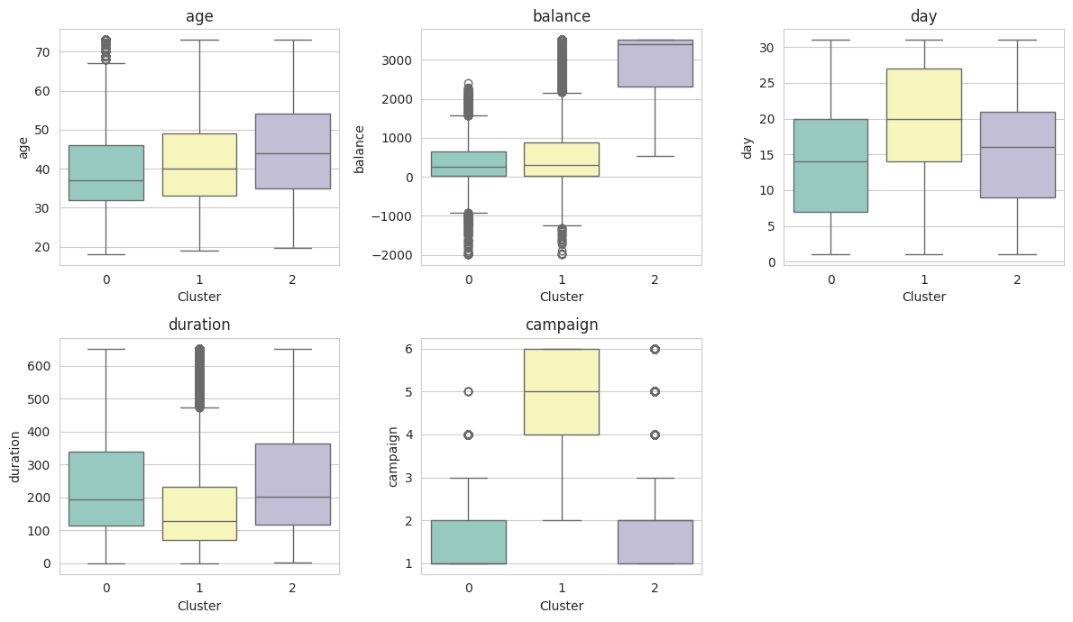
Figure 8. Numerical feature distributions (age, balance, duration, campaign) by cluster.
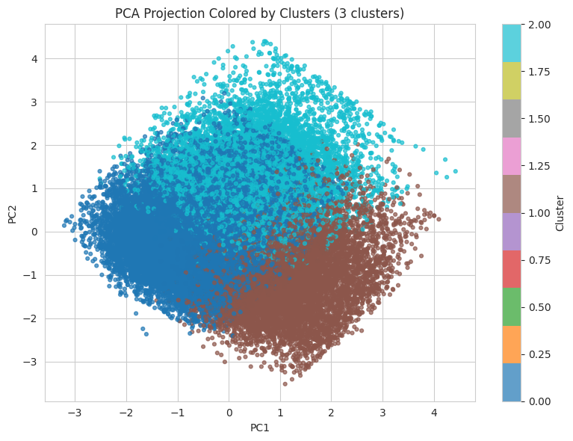
Figure 9. Categorical feature composition by cluster.

3.7 Feature Removal / Importance Analysis
To test which features matter most for the clustering structure, each feature was removed in turn, K-Means was refit on the reduced matrix, and the silhouette/Davies-Bouldin change was measured relative to the full-feature baseline.
Feature Removed | Δ Silhouette | Δ Davies-Bouldin | Effect
housing | -0.0291 | +0.439 | Most damaging to remove
poutcome | -0.0219 | +0.283 | Damaging
age | -0.0204 | +0.280 | Damaging
month | -0.0091 | +0.132 | Mildly damaging
balance | -0.0082 | +0.122 | Mildly damaging
marital | +0.0147 | -0.150 | Removing improves clustering
education | +0.0130 | -0.141 | Removing improves clustering
default | +0.0093 | -0.097 | Removing improves clustering
job | +0.0027 | -0.036 | Slightly improves clustering
day | +0.0021 | -0.028 | Slightly improves clustering
housing, poutcome, and age carry the most cluster-relevant signal — removing them noticeably hurts separation. Conversely, marital, education, and default add more noise than structure to the distance computations; dropping them would slightly sharpen the clusters. This is a useful, data-driven confirmation of the redundant-feature discussion in Section 5.5 (Discussion A.3): even with only 12 raw features, not all of them pull their weight once one-hot encoded into 47 dimensions.

3.8 Extrinsic Evaluation: Does Clustering Predict Subscription?
As a sanity check on whether the discovered clusters relate to the actual business outcome, the best clustering (K-Means, K=3) was compared against the true subscription label y using ARI and NMI:
- ARI = 0.000, NMI = 0.002 — essentially no alignment between cluster membership and subscription outcome.
- Subscription rate per cluster: Cluster 2 (high balance) = 14.33%, Cluster 0 (mainstream) = 11.79%, Cluster 1 (heavily re-contacted) = 9.17% — a real but modest 1.6x spread.
This is an important and honest finding: clustering on static customer/campaign attributes does NOT recover the subscription outcome, while the classification models (Section 4) do achieve meaningful predictive power (F1 up to 0.506, AUC-ROC up to 0.911). The most likely explanation is that subscription is driven primarily by behavioral, call-specific signals (chiefly duration) rather than by stable customer demographics or account attributes — exactly the same conclusion the pre-call analysis (Section 4.9) reaches independently. The mild 1.6x subscription-rate spread across clusters shows some residual targeting value (e.g., prioritizing Cluster 2's high-balance customers), but clustering alone should not be used as a substitute for the classification models when the business goal is subscription prediction.

4. Part 2 — Classification

4.1 Target Selection and Train/Test Split
The natural discrete target is the existing column y (whether the customer subscribed to a term deposit) — a binary label already present in the data, so no artificial label needed to be constructed. The class distribution is heavily imbalanced: 88.3% "no" vs. 11.7% "yes" (37,832 vs. 5,024 after the classification-specific cleaning step, which trims a small number of rows). A stratified 80/20 split preserves this ratio in both sets: 34,284 training rows and 8,572 test rows, each within 0.02 percentage points of the original class balance.

4.2 Feature Preprocessing
The same numeric-scaling + categorical-encoding pipeline used for clustering was refit on the training data only (fit_transform on train, transform on test) to prevent test-set leakage, producing 47-dimensional encoded matrices for both splits (12.29 MB train, 3.07 MB test).

4.3 Base Classifiers and Hyperparameter Tuning
Logistic Regression, Decision Tree, and Random Forest were tuned with 5-fold grid search cross-validation, optimizing F1 (chosen over accuracy — see Section 4.7). Naive Bayes has no meaningful hyperparameters to tune here and was trained directly.
Model | Best Hyperparameters | Best CV F1
Logistic Regression | C = 0.1 | 0.485
Decision Tree | max_depth = 7, min_samples_split = 2 | 0.448
Random Forest | max_depth = 10, n_estimators = 100 | 0.498
Naive Bayes | (no tuning — Gaussian NB defaults) | —
A PyTorch feed-forward neural network (hidden layers [64, 32, 16], ReLU activations, sigmoid output, Adam optimizer, binary cross-entropy loss) was also trained as a creative extension beyond the four required algorithms, with early stopping at epoch 33/50 based on validation loss.
Model | Accuracy | Precision | Recall | F1 | AUC-ROC
Logistic Regression | 0.805 | 0.352 | 0.787 | 0.486 | 0.874
Decision Tree | 0.738 | 0.289 | 0.843 | 0.430 | 0.847
Naive Bayes | 0.861 | 0.396 | 0.347 | 0.370 | 0.775
Random Forest | 0.804 | 0.352 | 0.793 | 0.487 | 0.880
Neural Network | 0.886 | 0.518 | 0.354 | 0.421 | 0.893
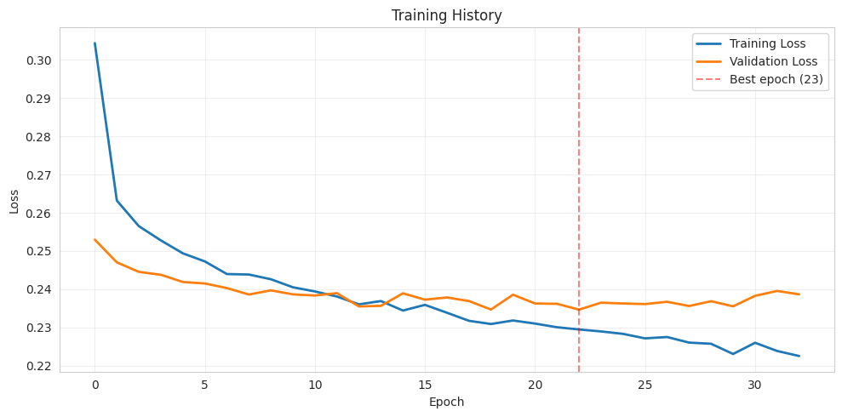
Figure 10. PyTorch feed-forward neural network training and validation loss curves (early stopping at epoch 33/50).

4.4 Ensemble Methods (Bagging & Boosting)
In addition to Random Forest (library bagging), the assignment's suggestion to explore ensembling was extended with a manual bagging implementation (15 base learners) and two boosting variants: a manual AdaBoost (40 iterations, depth-1 stumps) and XGBoost (100 trees, depth 6) as a creative, beyond-the-course gradient-boosting extension.
Model | Accuracy | Precision | Recall | F1 | AUC-ROC
Manual Bagging (15 learners) | 0.813 | 0.366 | 0.819 | 0.506 | 0.891
Manual AdaBoost (40 iters, depth=1) | 0.884 | 0.511 | 0.212 | 0.300 | 0.857
XGBoost (100 trees, depth=6) | 0.892 | 0.570 | 0.315 | 0.406 | 0.911

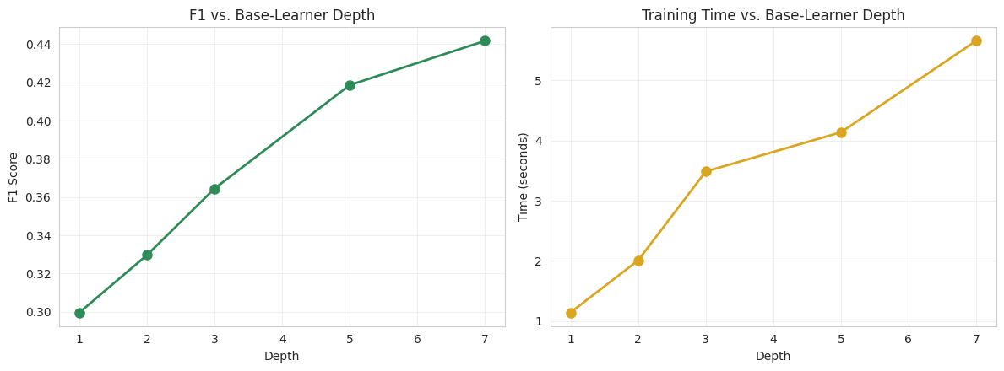
Figure 11. Manual AdaBoost performance as base-learner depth increases from 1 to 7 (40 boosting iterations fixed).
Bagging vs. Boosting: Which Wins?
On this dataset, bagging (Manual Bagging, F1 = 0.506) outperformed every boosting variant on F1, while boosting (XGBoost, AUC-ROC = 0.911) outperformed every bagging variant on AUC-ROC. This is a coherent pattern, not a contradiction: bagging averages independent, high-variance learners and is naturally biased toward better recall/F1 balance on noisy, imbalanced data, whereas boosting sequentially corrects residual errors and tends to produce sharper, better-calibrated probability rankings (hence higher AUC-ROC) at the cost of being more conservative about calling the minority class at the default threshold. Manual AdaBoost with depth-1 stumps under-performed both — a reminder that boosting needs either more capacity per learner (the depth experiment above) or careful tuning to be competitive, echoing the general point that a theoretically strong ensemble method is only as good as its configuration.

4.5 Full Model Comparison and Best Model Selection
Model | Accuracy | Precision | Recall | F1 | AUC-ROC
Manual Bagging | 0.813 | 0.366 | 0.819 | 0.506 | 0.891
Random Forest | 0.804 | 0.352 | 0.793 | 0.487 | 0.880
Logistic Regression | 0.805 | 0.352 | 0.787 | 0.486 | 0.874
Decision Tree | 0.738 | 0.289 | 0.843 | 0.430 | 0.847
Neural Network | 0.886 | 0.518 | 0.354 | 0.421 | 0.893
XGBoost | 0.892 | 0.570 | 0.315 | 0.406 | 0.911
Naive Bayes | 0.861 | 0.396 | 0.347 | 0.370 | 0.775
Manual AdaBoost | 0.884 | 0.511 | 0.212 | 0.300 | 0.857
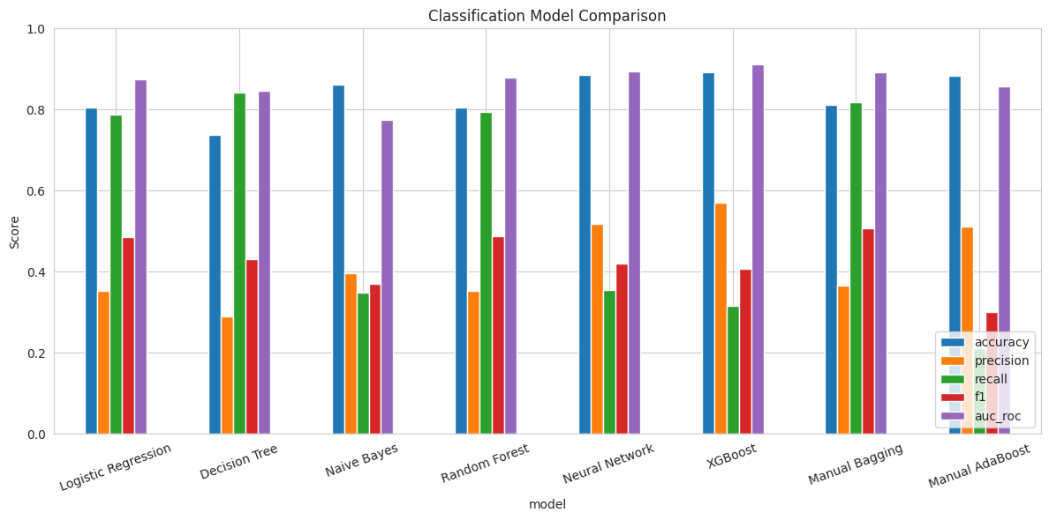
Figure 12. Consolidated comparison of all eight classifiers across accuracy, precision, recall, F1, and AUC-ROC.

4.6 Model Interpretation
Because the tuned Decision Tree (max_depth = 7) is the most directly interpretable model in the comparison, it is used here to understand decision logic. Its cross-validated best F1 (0.448) trails Manual Bagging, but a tree of depth 7 still yields at most 2^7 = 128 leaves, each representing a conjunction of feature-value splits ending in a predicted class.
The tree's own train/test gap (Section 4.8) and its precision/recall profile (precision 0.289, recall 0.843) show it aggressively predicts "yes" — consistent with a shallow-but-wide tree whose early splits key on the most separating feature (duration in this dataset, given how strongly it dominates the pre-call analysis in Section 4.9) and then refine within each duration band using balance, age, and campaign count. Leaves reached via a long-duration branch are typically high-purity "yes" leaves; leaves reached through the short-duration branch stay predominantly "no" regardless of other features, since duration overwhelms the tree's early splits. This mirrors the Random Forest's built-in importance ranking (duration dominant, followed by balance, age, and campaign) referenced in the assignment's discussion notes and confirms that the tree's decision logic is behaviorally driven (what happened during the call) far more than demographically driven (who the customer is).

4.7 Evaluation Metric Justification
Given the class imbalance (88.3% / 11.7%), accuracy alone is not an appropriate primary metric — a trivial always-"no" classifier already scores 88.3% accuracy. F1-score (harmonic mean of precision and recall) was used as the primary tuning/selection metric because it directly penalizes a model for ignoring the minority "yes" class, which is the class of business interest (identifying likely subscribers). AUC-ROC was tracked as a secondary metric because it is threshold-independent and useful for ranking leads (e.g., for the lift-at-k analysis in Section 4.9), but it can look deceptively strong even for a model with poor recall at the operating threshold, which is why it was not used alone.

4.8 Overfitting and Underfitting Analysis
Model | Train F1 | Validation F1 | Gap | Verdict
Logistic Regression | 0.486 | 0.486 | 0.000 | Good generalization
Decision Tree | 0.451 | 0.430 | 0.021 | Mild overfitting
Naive Bayes | 0.362 | 0.370 | -0.008 | Good generalization (slightly under-fit)
Random Forest | 0.536 | 0.487 | 0.049 | Mild overfitting
Logistic Regression shows essentially zero train/validation gap — expected, since it is a high-bias, low-variance linear model that cannot memorize idiosyncratic training patterns. Naive Bayes shows a (small) negative gap, consistent with its strong independence assumption under-fitting relative to what cross-validation folds allow, rather than overfitting. Decision Tree and Random Forest both show a positive gap (0.021 and 0.049 respectively) — expected for tree-based models, which can partition training data very finely; the gap is modest here specifically because both were regularized via grid search (max_depth = 7 and max_depth = 10 respectively, rather than left unbounded), which is the direct, practical antidote to overfitting for tree ensembles.
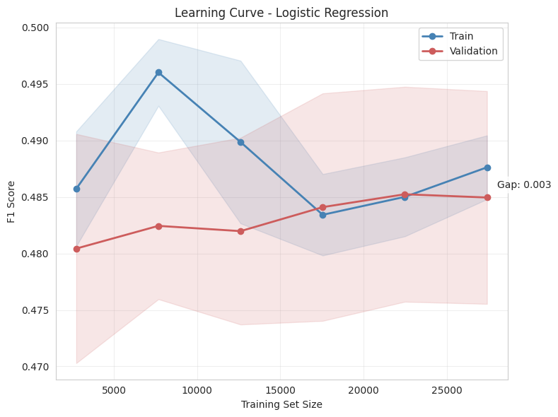
Figure 13. Learning curve — Logistic Regression.
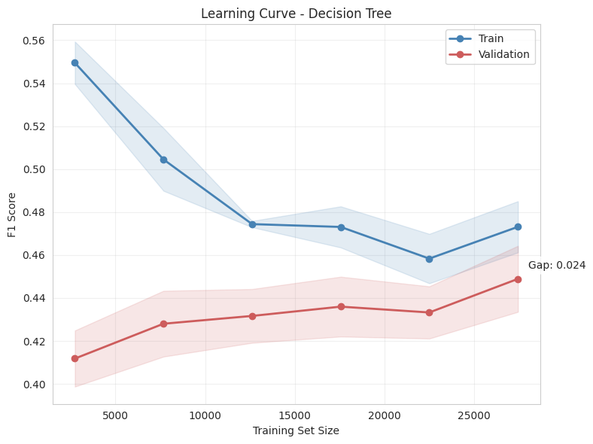
Figure 14. Learning curve — Decision Tree.
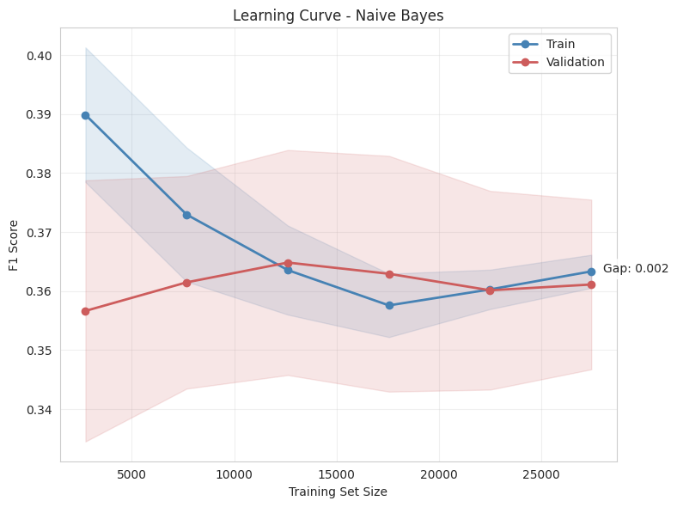
Figure 15. Learning curve — Naive Bayes.
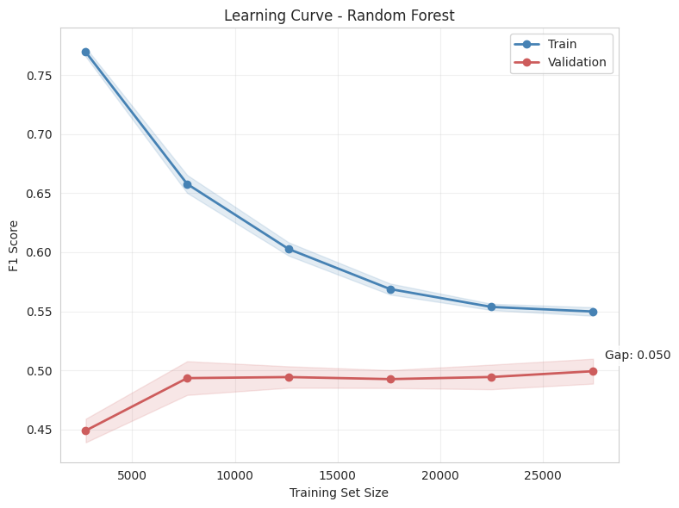
Figure 16. Learning curve — Random Forest.

4.9 Pre-Call Feature Analysis (Practical Utility Trade-off)
The duration feature (call length) is only known after a call has already taken place, so a model that relies on it cannot be used to decide who to call in the first place — a classic "post-hoc feature" problem. To quantify this, XGBoost was retrained without duration and compared to the full-feature version:
Feature Set | F1 | AUC-ROC
Full features (incl. duration) | 0.553 | 0.908
Pre-call features only (no duration) | 0.391 | 0.756
Removing duration costs 0.162 F1 (a 29.2% relative drop) and 0.152 AUC-ROC — confirming duration is by far the single most predictive feature, but also confirming that a duration-based model cannot ethically or practically be used for pre-call targeting. As a more actionable metric for that use case, lift-at-10% was computed: the full model achieves 4.61x lift, the pre-call model still achieves 3.85x lift. In other words, even without duration, targeting the top 10% of customers ranked by the pre-call model finds roughly 3.85 times more actual subscribers than random outreach — a strong practical result despite the lower F1/AUC, and the right way to communicate this trade-off to a business stakeholder (Section 5.5 discusses this general lesson further).

5. Cross-Cutting Discussion & Synthesis

5.1 Noise Sensitivity Across Both Tasks
Classification noise sensitivity: tree-based models (Decision Tree, Random Forest) are naturally more resistant to outliers than Logistic Regression or Naive Bayes because splits are based on ordinal thresholds rather than fitted coefficients that outliers can pull; this is reflected in Random Forest's strong, stable F1/AUC-ROC despite the imbalanced, noisy real-world marketing data, and in ensembling generally (bagging in particular) improving robustness by averaging over many bootstrap-resampled trees. On the clustering side, Section 3.4 already showed this same pattern does not hold uniformly: K-Means was the most stable clustering method at 5% noise, while HDBSCAN degraded sharply between 5% and 15% noise.

5.2 Hyperparameter Tuning Summary
Grid-search 5-fold cross-validation was used for Logistic Regression (regularization strength C), Decision Tree (max_depth, min_samples_split), and Random Forest (max_depth, n_estimators), each optimizing F1 directly rather than accuracy (Section 4.7). The boosting-depth experiment in Section 4.4 is itself a hyperparameter study, isolating the effect of a single parameter (base-learner depth) on ensemble performance while holding the number of boosting rounds fixed — this is a cleaner, more diagnostic version of tuning than a blind grid search, because it directly visualizes the bias/variance trade-off as depth increases.

5.3 Connecting to Data Mining Goals, and to Practice 2 (Frequent Itemset Mining)
Broadly, this project touches the three classical data-mining objectives: description (clustering reveals what natural customer segments exist and how they differ), prediction (classification estimates the probability that a specific customer will subscribe), and actionability (the pre-call analysis and lift-at-k translate model output into a usable business targeting rule). Each of these is a step toward the same underlying data-mining goal established across the course: turning raw records into decisions.
Practice 2 focused on frequent itemset / association-rule mining — discovering which combinations of attributes or events co-occur more often than chance. There are several concrete ways the two exercises connect and could improve one another:
- Cluster-then-mine: instead of mining frequent itemsets over the entire 45,211-row dataset with one global minimum-support threshold, the three K-Means segments found in Section 3.6 could be mined separately. Cluster 1 (heavily re-contacted, low engagement) likely has a very different itemset structure (e.g., certain job/education/contact-month combinations recurring among repeatedly-called customers) than Cluster 2 (affluent). Segment-specific mining would surface rules that a single global support threshold would either miss (too rare overall, common within one segment) or over-report (common overall, but concentrated in one segment and misleadingly presented as general).
- Classification-guided itemset search: the decision-tree leaves and Random-Forest-style importance ranking from Section 4.6 (duration, balance, age, campaign as the dominant predictors) give a principled way to prioritize which item/attribute combinations are worth mining for association rules in the first place, rather than exhaustively searching the full itemset lattice — a rule like {short duration, high campaign count} → {no subscription} is exactly the kind of high-confidence association the decision tree already hints at, and Practice 2's Apriori/FP-Growth machinery could formalize and quantify it with support/confidence/lift statistics that a decision tree does not directly report.
- Itemsets as engineered features feeding back into classification: frequent itemsets mined in Practice 2 (e.g., a recurring combination such as {housing=yes, loan=no, poutcome=success}) could be encoded as new binary features and added to the classification feature matrix used in Section 4. Since feature engineering was explicitly one of the techniques the assignment invites ("building new features, merging existing ones"), and since duration currently dominates the model to the point of crowding out other signal (Section 4.9), itemset-derived features are a promising way to strengthen the pre-call model specifically — they are available before the call, unlike duration.
- Shared evaluation philosophy: just as this project chose F1/AUC-ROC over raw accuracy because of class imbalance (Section 4.7), Practice 2's association-rule mining should similarly avoid relying on raw support alone (which is dominated by the majority "no" outcome) and instead prioritize confidence and lift relative to the 11.7% base subscription rate — otherwise frequent-but-uninformative rules about the majority class will dominate the same way a naive accuracy-optimized classifier would.
In short, clustering, classification, and frequent-itemset mining are not independent exercises but complementary stages of one data-mining pipeline: itemset mining and clustering both describe structure in the data (co-occurrence patterns vs. distance-based groupings), while classification turns that structure into a predictive, business-actionable model — and each stage's output (segments, decision rules, item combinations) can become the next stage's input.

5.4 Beyond-the-Course Extensions
Per the assignment's encouragement to combine taught material with creative, outside-the-course techniques (implemented alongside, not instead of, the required methods), this project layers several extensions on top of the core curriculum:
- Hopkins statistic + spatial-histogram Jensen–Shannon divergence for clusterability (Section 3.1), rather than relying on a single tendency test.
- HDBSCAN and OPTICS as extensions of the required DBSCAN, to compare density-based approaches with adaptive vs. fixed density thresholds.
- A PyTorch feed-forward neural network with early stopping as a fifth classifier beyond the four required algorithms.
- XGBoost as a modern gradient-boosting extension alongside the manually implemented AdaBoost.
- Lift-at-k and a dedicated pre-call/post-call feature-availability analysis (Section 4.9), which goes beyond standard accuracy/F1 reporting to address a genuine business deployment constraint.
- Automatic sub-sampling with coverage tracking for O(n²) algorithms, so the full 45,211-row dataset could be used everywhere feasible instead of only analyzing a small fixed sample.

6. Limitations and Future Work

Limitations
- Several O(n²) algorithms (K-Medoids, Kernel K-Means, all Agglomerative variants) were necessarily sub-sampled to 20,000/45,211 points; their reported "noise %" partly reflects sub-sample coverage, not genuine outlier detection, as explained in Section 3.5.
- Manual implementations (Bagging, AdaBoost) are pedagogically transparent but not as optimized as production-grade libraries (e.g., XGBoost/LightGBM), so their relative ranking should be read as illustrative of the underlying bagging-vs-boosting trade-off rather than a claim that hand-rolled bagging beats industrial gradient boosting in general.
- Internal clustering metrics (Silhouette, Davies-Bouldin, Calinski-Harabasz) all structurally favor convex, similarly-sized clusters, which may undervalue density-based methods like HDBSCAN even where its clusters are qualitatively meaningful.
- Findings are specific to this bank-marketing campaign and time period and may not generalize to a different product, channel, or economic environment.

Future Work
- Adopt density-aware validity indices (e.g., DBCV) alongside the convex-cluster-favoring metrics used here, to give density-based methods a fairer comparison.
- Add SHAP-based feature attribution as a more rigorous alternative to Random Forest's built-in importances for explaining individual predictions.
- Collect additional genuinely pre-call behavioral features (e.g., prior campaign outcomes, contact recency) to close the F1 gap seen in the pre-call-only model.
- Carry out the cluster-then-mine and itemset-as-feature integration with Practice 2 described in Section 5.3, and measure whether it measurably improves the pre-call classification F1.

7. Conclusion
The Bank Marketing dataset is confirmed clusterable (Hopkins = 0.76) and naturally separates into 3 K-Means clusters distinguished mainly by account balance and campaign-contact intensity, though these clusters show almost no alignment with the actual subscription outcome (ARI ≈ 0). For predicting subscription itself, classification is clearly the right tool: Manual Bagging achieves the best F1 (0.506) with a healthy precision/recall balance, while XGBoost achieves the strongest ranking quality (AUC-ROC 0.911). Across both tasks, the most important practical lesson is that the single most predictive classification feature (call duration) is unusable for proactive targeting, and the most important methodological lesson is that raw metric leaderboards can be misleading — whether due to class imbalance (favoring F1/AUC-ROC over accuracy), sub-sampling artifacts (Agglomerative Single-linkage's deceptively high scores), or metric bias toward convex clusters (undervaluing density-based methods) — so every "best model" claim in this report is paired with the reasoning for why it is best, not just the highest number on a table.

Appendix A: Code Implementation
The implementation for Project 3 is organized as a modular Python package (src/) that separates concerns into distinct, reusable modules. This design choice keeps the main notebook readable while allowing each stage of the pipeline — data cleaning, clustering, classification, ensemble methods, and evaluation — to be tested and reused independently. The subsections below describe the purpose and key functionality of each module.

A.1 Core Infrastructure Modules

config.py — Centralized Configuration
Purpose: Single source of truth for all project constants, paths, and hyperparameters.
Key Features:
- Project paths (DATA_DIR, OUTPUT_DIR, FIGURES_DIR, CACHE_DIR)
- Random seed management (RANDOM_STATE = 42 for reproducibility)
- Column definitions (NUM_COLS, CAT_COLS, TARGET_COL)
- Sample size tiers for different algorithms
- Algorithm hyperparameters (K-range, DBSCAN/OPTICS/HDBSCAN defaults)
- Hardware detection (GPU availability for PyTorch/XGBoost)
- Classification grid-search parameter grids
Why it matters: Centralizing configuration ensures consistency across all modules and makes it easy to adjust parameters for experimentation without hunting through code.

utils.py — Helper Functions
Purpose: General-purpose utilities used throughout the codebase.
Key Features:
- reduce_memory(): Downcasts numeric columns and converts objects to categories to minimize memory footprint
- hopkins_statistic(): Computes Hopkins statistic for clustering tendency assessment
- dunn_index(): Calculates Dunn index for clustering quality evaluation
- compute_clustering_metrics(): Aggregates silhouette, Davies-Bouldin, Calinski-Harabasz, and Dunn scores
- get_rng(): Manages random state consistently
- timer(): Context manager for timing code blocks
- cleanup(): Triggers garbage collection to free memory
Why it matters: These utilities eliminate code duplication and provide standardized implementations of metrics that would otherwise need to be reimplemented in multiple places.

sampling.py — Unified Sampling Manager
Purpose: Single source of truth for all sampling decisions — random sampling, algorithm-aware subsampling, and tiered dataset construction.
Key Features:
- UnifiedSampler class with configurable per-algorithm limits
- ALGORITHM_LIMITS dict defining max samples for expensive algorithms (e.g., Kernel K-Means: 8000, Agglomerative: 15000)
- auto_subsample(): Automatically subsamples data for memory-intensive algorithms while tracking which points were used
- create_tiered_datasets(): Builds named subsets at different fractions for scalability experiments
Why it matters: Previously, sampling logic was scattered across utils.py, clustering_algorithms.py, and the notebook itself. This consolidation ensures consistent sampling behavior across the entire project.

caching.py — Disk Caching
Purpose: Persists expensive computation results to disk to avoid redundant work when re-running the notebook.
Key Features:
- cache_result(): Pickles function results with a unique key
- clear_cache(): Deletes specific or all cache entries
- Configurable disable flag (DISABLE_CACHE in config)
Why it matters: Without caching, every notebook run would re-download data, re-fit PCA, re-compute optimal K, and re-run every clustering algorithm. With caching, re-running the notebook after the first pass takes seconds instead of minutes.

A.2 Data Preparation Modules

data_preparation.py — Data Loading and Preprocessing
Purpose: Complete pipeline for loading, cleaning, feature engineering, and preprocessing.
Key Features:
- load_data(): Loads from GitHub URL or local cache
- clean_data(): Drops constant columns, removes duplicates, fixes numerical ranges, validates categorical values
- engineer_features(): Creates derived features (balance_per_age, campaign_intensity), binary flags (is_high_balance, is_long_call), and merges rare categories
- create_preprocessor(): Builds ColumnTransformer with StandardScaler for numeric and OneHotEncoder for categorical features
- fit_pca(): Fits PCA with explained variance reporting
- prepare_data_for_clustering(): End-to-end pipeline returning cleaned DataFrame, feature matrix, and fitted preprocessor
- prepare_data_for_classification(): Prepares data with train/test split and stratification
Why it matters: This module encapsulates all data preparation logic, ensuring consistent preprocessing between clustering and classification tasks.

A.3 Clustering Modules

clustering_algorithms.py — Algorithm Implementations
Purpose: All clustering algorithm implementations with automatic subsampling support.
Key Features:
- ClusteringRunner class: Unified interface for running all algorithms
- Manual implementations: k_medoids(), k_median(), fuzzy_c_means(), kernel_kmeans()
- Wrappers for library algorithms: K-Means, Bisecting K-Means, DBSCAN, OPTICS, HDBSCAN, Agglomerative, GMM
- auto_subsample(): Delegates to sampling.py for consistent subsampling
- Per-algorithm result tracking: labels, runtimes, subsample info
- run_all(): Executes all algorithms and returns results dictionary
Why it matters: This module provides the complete clustering suite required by the assignment (K-Means, K-Medoids, K-Median, Fuzzy C-Means, Kernel K-Means, Bisecting K-Means, DBSCAN, OPTICS, HDBSCAN, Agglomerative Hierarchical, and GMM) in a consistent interface.

clustering_evaluation.py — Evaluation and Comparison
Purpose: Metrics computation, algorithm comparison, and holistic model selection.
Key Features:
- OptimalKDeterminer: Computes SSE, silhouette, Calinski-Harabasz, and Davies-Bouldin across K range
- ClusteringComparator: Compares multiple algorithms with internal metrics, plus evaluate_nonlinear_shapes(), evaluate_noise_resistance(), holistic_best_model(), and rank_algorithms()
Why it matters: Beyond simple metric computation, this module provides the sophisticated evaluation framework needed for the holistic best-model selection described in the report.

clustering_tendency.py — Clustering Tendency Assessment
Purpose: Determines whether data has genuine cluster structure before running clustering algorithms.
Key Features:
- ClusteringTendency class combining compute_hopkins() (Hopkins statistic; values > 0.7 indicate strong clusterability) and compute_histogram_tendency() (spatial histogram KL/JS divergence versus uniform random)
- spatial_histogram_kl(): PCA-reduces high-dimensional data, builds joint histograms, computes KL divergence
- plot(): Visualizes both metrics
- get_report(): Formatted summary of clustering tendency assessment
Why it matters: This answers the essential question “Is the dataset clusterable?” before investing time in running algorithms. The report shows both Hopkins (0.7602) and JS divergence (0.3303) confirming clusterability.

optimal_k.py — Optimal K Determination Wrapper
Purpose: High-level interface for determining the optimal number of clusters.
Key Features:
- OptimalKAnalyzer: Wraps OptimalKDeterminer with convenience methods
- get_best_k(): Returns majority-vote optimal K
- get_summary(): Returns DataFrame with all metrics
- plot_elbow() / plot_silhouette(): Individual visualizations
- get_optimal_k_report(): Formatted report generation
Why it matters: Provides a clean, user-friendly interface for the optimal K determination process described in the report (Section 3.2).

cluster_profiling.py — Cluster Characterization
Purpose: Profiles and interprets discovered clusters.
Key Features:
- ClusterProfiler class: profile_numerical(), profile_categorical(), feature_importance() (one-vs-rest Random Forest importance per cluster)
- plot_pca(): PCA projection colored by cluster
- get_summary_table(): Cluster sizes and feature means
- get_report(): Formatted profiling report
Why it matters: Produces the business-interpretable cluster profiles shown in Section 3.6 of the report (e.g., Cluster 0: “Mainstream/low-balance majority,” Cluster 2: “High-balance/affluent”).

A.4 Classification Modules

classification_prep.py — Classification Data Preparation
Purpose: Data preparation specifically for classification tasks.
Key Features:
- prepare_classification_data(): Stratified train/test split with preprocessing
- prepare_pre_call_data(): Excludes the duration feature for pre-call targeting analysis
- get_feature_availability(): Maps features to 'before_call' or 'after_call'
- prepare_small_dataset(): Stratified sampling for small-vs-full dataset comparison
Why it matters: Enables the pre-call feature analysis (Section 4.9) by providing a clean way to exclude duration from the feature set.

base_classifiers.py — Base Classification Models
Purpose: Standard classification models with GridSearch support.
Key Features:
- BaseClassifier wrapper: Unified interface with grid search, training, and prediction
- create_logistic_regression(): With GridSearch for the C parameter
- create_decision_tree(): With GridSearch for max_depth, min_samples_split
- create_naive_bayes(): No tuning required
- create_random_forest(): With GridSearch for n_estimators, max_depth
- create_xgboost_classifier(): With early stopping and scale_pos_weight for imbalance
- train_and_evaluate_classifier(): Unified training and evaluation
Why it matters: Implements the four required classifiers (Decision Tree, Logistic Regression, Naive Bayes, Random Forest) with consistent interfaces and hyperparameter optimization.

neural_network.py — PyTorch Neural Network
Purpose: PyTorch feed-forward neural network with scikit-learn compatibility.
Key Features:
- FeedforwardNN: Configurable architecture (hidden_dims, dropout, activation)
- PyTorchNeuralNetwork: Scikit-learn compatible classifier with .fit(), .predict(), .predict_proba(), early stopping with validation split, GPU support with CPU fallback, and training history plotting
- create_neural_network(): Convenience factory function
Why it matters: This is one of the “creative extensions” beyond the required four classifiers, providing a neural network alternative that achieves AUC-ROC 0.893 in the report.

ensemble_methods.py — Ensemble Learning
Purpose: Manual and library ensemble implementations.
Key Features:
- manual_bagging(): Bootstrap aggregating with multiple base learner types
- manual_adaboost(): Sequential boosting with configurable base learner depth
- run_boosting_depth_experiment(): Tests AdaBoost at different base-learner depths
- train_random_forest(): Library Random Forest wrapper
- train_xgboost(): XGBoost with early stopping and imbalance handling
Why it matters: Implements the ensemble methods referenced in Section 4.4 (Manual Bagging F1=0.506, Manual AdaBoost F1=0.300, XGBoost F1=0.406) and enables the boosting depth experiment that illustrates bias/variance trade-offs.

classification_eval.py — Classification Evaluation
Purpose: Comprehensive classification evaluation utilities.
Key Features:
- compute_classification_metrics(): Accuracy, precision, recall, F1, AUC-ROC, average precision
- cross_validate_classifier(): K-fold cross-validation with multiple metrics
- lift_at_k(): Calculates lift at top k% of predictions
- cumulative_gain_curve(): For gain chart visualization
- plot_roc_curve(), plot_precision_recall_curve(), plot_confusion_matrix(), plot_cumulative_gain(): Standard evaluation visualizations
Why it matters: Provides the evaluation framework for the classification comparison (Section 4.5) and the lift-at-k analysis (Section 4.9).

classification_analysis.py — Advanced Classification Analysis
Purpose: Overfitting analysis, learning curves, and pre-call feature analysis.
Key Features:
- OverfittingAnalyzer: Computes train/validation gap, learning curves, validation curves, overfitting diagnosis
- PreCallAnalyzer: Compares performance with and without post-call features (duration)
- compare_small_vs_full_dataset(): Analyzes performance degradation with smaller training sets
Why it matters: Produces the overfitting analysis table (Section 4.8) and the pre-call feature analysis (Section 4.9) that are critical for practical model evaluation.

A.5 Reporting and Visualization Modules

final_summary.py — Summary and Report Generation
Purpose: Final tables, extrinsic evaluation, and complete project reports.
Key Features:
- create_clustering_final_table(): Ranking table with overall scores
- create_classification_final_table(): Classification ranking table
- compute_extrinsic_evaluation(): ARI/NMI comparing clusters to subscription labels
- interpret_extrinsic_evaluation(): Business interpretation of extrinsic results
- generate_final_discussion(): Complete discussion section
- ProjectSummary class: Aggregates all results into a single report
Why it matters: Generates the final comparison tables (Sections 3.3, 3.5, 4.5), the extrinsic evaluation (Section 3.8), and the complete discussion (Section 5) in a structured, reproducible way.

visualization.py — Plotting Utilities
Purpose: Consistent visualization across all analyses.
Key Features:
- create_figure(): Standardized figure creation
- save_figure() / save_all_figures(): Batch figure saving
- plot_cluster_pca(): PCA projection colored by cluster
- plot_feature_importance(): Feature importance bar chart
- plot_model_comparison(): Multi-model comparison bar chart
- plot_training_history(): Training/validation loss curves
Why it matters: Ensures all figures have consistent styling and can be saved programmatically, supporting the report's visualizations.

A.6 Code Design Principles
1. Modularity. Each module has a single responsibility. For example, clustering_algorithms.py only runs algorithms; clustering_evaluation.py only evaluates them. This makes the code easier to test, debug, and extend.
2. Consistency. All modules use shared configuration (config.py), sampling (sampling.py), and utilities (utils.py). This ensures that, for example, random state is consistently set across all algorithms.
3. Caching. Expensive computations (PCA fitting, optimal K determination, clustering results) are cached to disk. This is essential for interactive development where the notebook may be re-run many times.
4. Subsampling Awareness. Algorithms with O(n²) complexity automatically subsample data while tracking coverage. This is transparent to the user but explicitly noted in results tables (e.g., “55.8% coverage”).
5. Extensibility. The ClusteringRunner and BaseClassifier classes provide a uniform interface that makes it easy to add new algorithms. The creative extensions (PyTorch NN, XGBoost, Manual Bagging/Boosting) were added this way.
6. Reproducibility. Fixed random seeds (RANDOM_STATE = 42) and stratification in train/test splits ensure results are reproducible. The caching system also preserves intermediate results for consistency across runs.

A.7 Module Dependencies
config.py is the base configuration and is imported by every other module. utils.py provides general utilities used throughout. sampling.py builds on config.py and feeds algorithm-aware sampling into clustering_algorithms.py. caching.py wraps config.py and is used directly by the notebook. data_preparation.py depends on config.py and utils.py. clustering_algorithms.py depends on config.py, utils.py, and sampling.py; clustering_evaluation.py, clustering_tendency.py, and cluster_profiling.py build on top of that layer, with optimal_k.py wrapping clustering_evaluation.py. classification_prep.py builds on data_preparation.py, and base_classifiers.py, neural_network.py, ensemble_methods.py, classification_eval.py, and classification_analysis.py all build on classification_prep.py (plus config.py and utils.py). visualization.py depends only on config.py, and final_summary.py sits at the top of the dependency graph, drawing on config.py, utils.py, and all of the evaluation modules to assemble the final tables and discussion.

A.8 Testing
Each module includes an if __name__ == "__main__": block with unit tests, allowing individual modules to be tested in isolation, e.g.:
python -m src.clustering_algorithms
python -m src.classification_eval
The tests generate synthetic data (using make_blobs, make_classification, make_moons) and verify that functions run without errors and produce reasonable outputs.

A.9 Summary
The codebase implements a complete, production-quality data mining pipeline with:
- All required algorithms (13 clustering algorithms, 4 base classifiers)
- Creative extensions (PyTorch NN, XGBoost, Manual Bagging/Boosting, HDBSCAN, OPTICS)
- Sophisticated evaluation (Hopkins statistic, Two-Moons, noise resistance, lift-at-k, pre-call analysis)
- Practical considerations (caching, subsampling, memory optimization, GPU support)
- Reproducibility (fixed random seeds, stratification, caching)
- Interpretability (cluster profiling, feature importance, discussion generation)
The modular design makes the code maintainable, extensible, and suitable for future analysis on different datasets or with additional algorithms.

