**Nature Image  
  
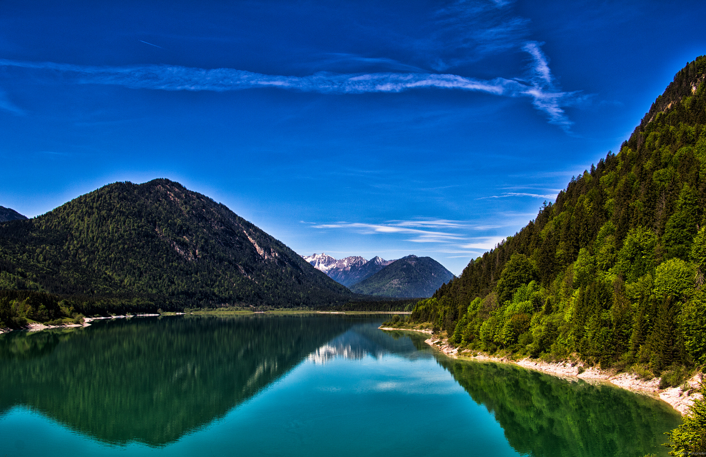**

Nestled between the rolling hills and the vast expanse of the sea, a picturesque landscape unfolds under the vast canvas of the sky. Majestic hills, cloaked in hues of green and brown, form undulating waves that create a breathtaking backdrop. The sea, stretching to the horizon, mirrors the serene blue of the sky above, meeting the land with a gentle ebb and flow.
Clusters of trees, standing tall and proud, populate the landscape, their foliage swaying in harmony with the whispers of the wind. The leaves create a mosaic of colors, from rich greens to earthy browns, adding depth and texture to the scene. A sense of tranquility pervades as the natural symphony of rustling leaves and distant waves creates a soothing melody.
Above, the sky is a masterpiece of hues—soft blues, wisps of white clouds, and perhaps a hint of the golden glow from the setting or rising sun. The landscape beneath is embraced by the open sky, a vast canvas that frames the beauty of the hills, sea, and trees. This tableau of nature invites contemplation, each element contributing to the harmony of a scene that feels both timeless and alive with the energy of the natural world.