## Purpose of the Project

A knock off NetHack: <https://en.wikipedia.org/wiki/NetHack>

## Explanation of Implementation

See UML diagram link: <https://drive.google.com/open?id=1t5gRbzgwKiveYqzts180YHv4eNBLEEw5end7maqsy0M>

## Project Roles

See todo list: <https://drive.google.com/open?id=1UC83deIhB41NaNxehZ5JdAZbHa2Yx5Wx7Y65jgYyzVI>

Our Dungeon Crawler is basically a knock off version of a single player Roguelike game called NetHack.

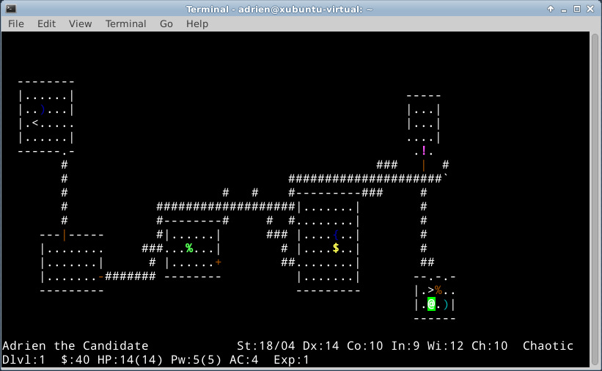  
We decided to produce our own version of NetHack because we thought it was a fun and easy enough game to recreate. We also added in our own graphics because a symbol is a lot less intuitive than a picture a of a slime.