**Ahmad Zaki Butmah**

**22 years old**

**Ramallah, West Bank, Palestine**

**Email: 1213413@student.birzeit.edu**



**~~I am a third-year student at Birzeit University, majoring in Computer Science. I have experience in programming with **Java** and **Python**, and I am also familiar with **Linux** operating system. I have completed advanced coursework in **Data Structures** and **Algorithms**, which has strengthened my understanding of fundamental programming concepts.~~**

~~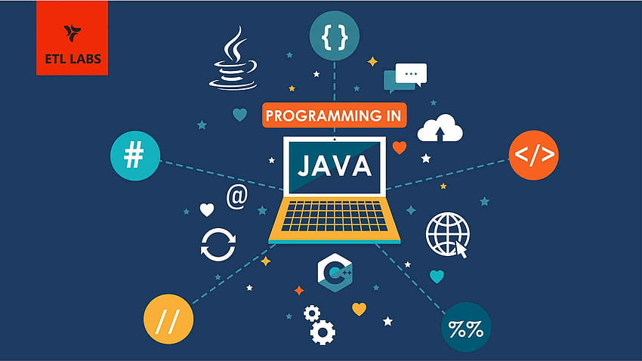~~

**At the beginning of my university studies, I worked on projects using **Java**, including developing user interfaces with **JavaFX**, where I wrote code and developed the interfaces. I also completed projects in **Data Structures** focusing on **LinkedList** and **Tree**. Additionally, I finished a **Database** course where I developed a project for an online pharmacy system.**

**I have also collaborated with my peers on several programming projects, including:Sure, here’s the full sentence in English:**

**- **Dynamic Programming** (traveling between cities and calcula g the minimum cost for fuel and accommodation)**

**.Huffman Coding file compression and**

**decompression**

**- **Dijkstra's Algorithm** finding the shortest paths**

g

**Through this internship, I aim to significantly enhance my practical skills in a professional environment. I look forward to applying what I have learned in university to real-world projects and gaining valuable experience to further my career in software development.**