**Swe-206-55**

**“Version Control System (GIT)”**

**Lab 03**

**Lab Section 55**

**Group Members**

**AHMED MOHAMED RADWAN / 202045860**

**ABDULRAHMAN AHMAD BUNAIYAN / 202064620**

**“All tasks were done collectively.”**

1. **Requirements**

* Read the student list.
* Input the number of groups then assigned the students in the groups equally.
* Input the maximum number of students in each group then assigned the students in the groups with caring of max limit.

1. **Design**

* Read the data from txt file.
* Getting the names of students and the number of students by making a while loop.
* Add students in an Array List to become easy when getting their names.
* Using math library to get a random student from Array List.
* Removing the student from Array List after taking it to his group.
* Assign each random group in a different Array List.
* Getting the appropriate distribution of students in each group
* Calculating the number of groups if we have the max students number in each of them.

1. **Implementation**

**Entering the number of groups**

**import** java**.**util**.**ArrayList**;**

**import** java**.**util**.**Scanner**;**

**import** java**.**io**.**File**;**

**import** java**.**io**.**FileNotFoundException**;**

public class Lab01 **{**

public static void main**(**String**[]** args**)** **{**

**try** **(**Scanner input **=** **new** Scanner**(new** File**(**"textlist.txt"**)))** **{**

ArrayList**<**String**>** ArrayList **=** **new** ArrayList**<>();**

int numberOfStudents **=** 0**;**

**while** **(**input**.**hasNext**())** **{**

ArrayList**.**add**(**input**.**next**());**

numberOfStudents **=** numberOfStudents **+** 1**;**

**}**

Scanner inputNumberOfGroups **=** **new** Scanner**(**System**.**in**);**

System**.**out**.**println**(**"Enter the number of groups"**);**

int numberOfGroups **=** inputNumberOfGroups**.**nextInt**();**

System**.**out**.**println**(**""**);**

**if** **((**numberOfStudents **%** numberOfGroups**)** **==** 0**)** **{**

int average **=** numberOfStudents **/** numberOfGroups**;**

**for** **(**int i **=** 1**;** i **<=** numberOfGroups**;** i**++)** **{**

ArrayList**<**String**>** ArrayListGroup **=** **new** ArrayList**<>();**

**for** **(**int j **=** 0**;** j **<** average**;** j**++)** **{**

int randomIndex **=** **(**int**)** **(**Math**.**random**()** **\*** ArrayList**.**size**());**

ArrayListGroup**.**add**(**ArrayList**.**remove**(**randomIndex**));**

**}**

System**.**out**.**println**(**"Group" **+** i**);**

System**.**out**.**println**(**""**);**

System**.**out**.**println**(**ArrayListGroup**);**

System**.**out**.**println**(**""**);**

**}**

**}**

**else** **{**

int remainder **=** numberOfStudents **%** numberOfGroups**;**

int average **=** numberOfStudents **/** numberOfGroups**;**

**for** **(**int i **=** 1**;** i **<=** numberOfGroups**;** i**++)** **{**

ArrayList**<**String**>** ArrayListGroup **=** **new** ArrayList**<>();**

**for** **(**int j **=** 0**;** j **<** average**;** j**++)** **{**

int randomIndex **=** **(**int**)** **(**Math**.**random**()** **\*** ArrayList**.**size**());**

ArrayListGroup**.**add**(**ArrayList**.**remove**(**randomIndex**));**

**}**

**if** **(**remainder **!=** 0**)** **{**

int randomIndex **=** **(**int**)** **(**Math**.**random**()** **\*** ArrayList**.**size**());**

ArrayListGroup**.**add**(**ArrayList**.**remove**(**randomIndex**));**

remainder **=** remainder **-** 1**;**

**}**

System**.**out**.**println**(**"Group" **+** i**);**

System**.**out**.**println**(**""**);**

System**.**out**.**println**(**ArrayListGroup**);**

System**.**out**.**println**(**""**);**

**}**

**}**

inputNumberOfGroups**.**close**();**

**}**

**catch** **(**FileNotFoundException e**)** **{**

e**.**printStackTrace**();**

**}**

**}**

**}**

**Entering the maximum number of students in each group**

**import** java**.**util**.**ArrayList**;**

**import** java**.**util**.**Scanner**;**

**import** java**.**io**.**File**;**

**import** java**.**io**.**FileNotFoundException**;**

public class Lab01B **{**

public static void main**(**String**[]** args**)** **{**

**try** **(**Scanner input **=** **new** Scanner**(new** File**(**"textlist.txt"**)))** **{**

ArrayList**<**String**>** ArrayList **=** **new** ArrayList**<>();**

int numberOfStudents **=** 0**;**

**while** **(**input**.**hasNext**())** **{**

ArrayList**.**add**(**input**.**next**());**

numberOfStudents **=** numberOfStudents **+** 1**;**

**}**

Scanner inputNumberOfMaxStudents **=** **new** Scanner**(**System**.**in**);**

System**.**out**.**println**(**"Enter the number of maximum Students in each group"**);**

int numberOfMaxStudents **=** inputNumberOfMaxStudents**.**nextInt**();**

System**.**out**.**println**(**""**);**

**if** **(**numberOfStudents **%** numberOfMaxStudents **==** 0**)** **{**

int numberOfGroups **=** numberOfStudents **/** numberOfMaxStudents**;**

int average **=** numberOfStudents **/** numberOfGroups**;**

**for** **(**int i **=** 1**;** i **<=** numberOfGroups**;** i**++)** **{**

ArrayList**<**String**>** ArrayListGroup **=** **new** ArrayList**<>();**

**for** **(**int j **=** 0**;** j **<** average**;** j**++)** **{**

int randomIndex **=** **(**int**)** **(**Math**.**random**()** **\*** ArrayList**.**size**());**

ArrayListGroup**.**add**(**ArrayList**.**remove**(**randomIndex**));**

**}**

System**.**out**.**println**(**"Group" **+** i**);**

System**.**out**.**println**(**""**);**

System**.**out**.**println**(**ArrayListGroup**);**

System**.**out**.**println**(**""**);**

**}**

**}**

**else** **{**

int numberOfGroups **=** numberOfStudents **/** numberOfMaxStudents**;**

int remainder **=** numberOfStudents **%** numberOfMaxStudents**;**

**for** **(**int i **=** 1**;** i **<=** numberOfGroups**;** i**++)** **{**

ArrayList**<**String**>** ArrayListGroup **=** **new** ArrayList**<>();**

**for** **(**int j **=** 0**;** j **<** numberOfMaxStudents**;** j**++)** **{**

int randomIndex **=** **(**int**)** **(**Math**.**random**()** **\*** ArrayList**.**size**());**

ArrayListGroup**.**add**(**ArrayList**.**remove**(**randomIndex**));**

**}**

System**.**out**.**println**(**"Group" **+** i**);**

System**.**out**.**println**(**""**);**

System**.**out**.**println**(**ArrayListGroup**);**

System**.**out**.**println**(**""**);**

**}**

ArrayList**<**String**>** ArrayListGroup2 **=** **new** ArrayList**<>();**

**for** **(**int i **=** numberOfGroups **+** 1**;** remainder **>** 0**;** i**++)** **{**

int randomIndex **=** **(**int**)** **(**Math**.**random**()** **\*** ArrayList**.**size**());**

ArrayListGroup2**.**add**(**ArrayList**.**remove**(**randomIndex**));**

remainder **=** remainder **-** 1**;**

**}**

System**.**out**.**println**(**"Group" **+** **(**numberOfGroups**+**1**));**

System**.**out**.**println**(**""**);**

System**.**out**.**println**(**ArrayListGroup2**);**

System**.**out**.**println**(**""**);**

**}**

inputNumberOfMaxStudents**.**close**();**

**}**

**catch** **(**FileNotFoundException e**)** **{**

e**.**printStackTrace**();**

**}**

**}**

**}**

1. **Testing**

* **Entering the number of groups**

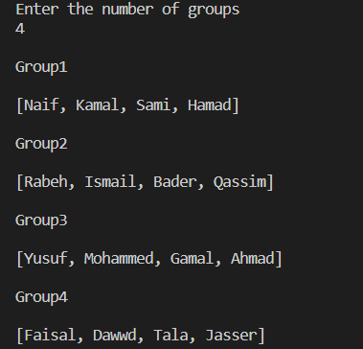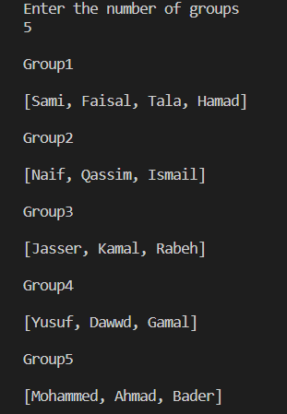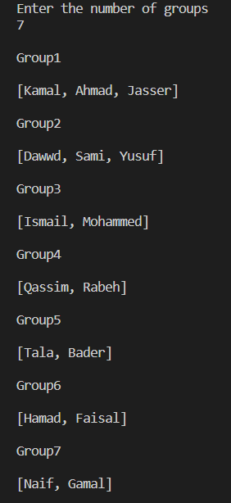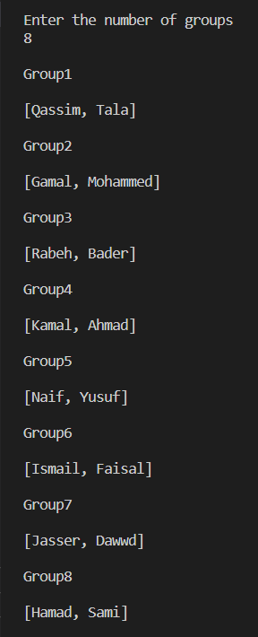

* **Entering the maximum number of students in each group**

