PakBzer OOP Project Explanation
A detailed guide to the four OOP pillars, UML arrows, and layered architecture used in the project
Java 17 | Spring Boot 3 | Thymeleaf | H2 | Stripe | Google OAuth2
Prepared on 18 June 2026
This document explains how PakBzer uses object-oriented design in a real e-commerce system.

1. Project Overview
PakBzer is a Pakistani fashion e-commerce web application built with Java 17 and Spring Boot 3. It lets users browse product categories, search items, add products to a cart, register or sign in with email or Google OAuth2, write reviews, and complete checkout through Stripe. Because the project is structured around domain objects, services, repositories, and controllers, it is a strong example of object-oriented programming in a practical web system.
The project is also a good teaching example because the code clearly separates responsibilities. The model classes hold the core data, the services hold business rules, the repositories hide database details, and the controllers handle web requests. That separation makes it easier to explain where each OOP concept appears in the code.

2. Quick map of the four OOP pillars
OOP pillar | Where it appears in PakBzer
Encapsulation | Product, User, Review, Cart, and CartItem keep their fields private and expose controlled behavior through methods.
Inheritance | BaseEntity provides shared id and timestamps to Product, User, and Review; CustomOidcUserService extends OidcUserService.
Abstraction | ProductService is an interface, BaseEntity is abstract, and Spring Data repositories hide SQL details.
Polymorphism | ProductServiceImpl implements ProductService, while CustomOidcUserService overrides loadUser() at runtime.

3. Encapsulation
Encapsulation means an object protects its own state and offers methods that control how that state changes. In PakBzer, this appears in both the domain model and the service layer. Instead of letting controllers calculate totals or ratings on their own, the objects that own the data perform those calculations internally.
For example, Product calculates its own average rating and in-stock status, Cart calculates item totals and the grand total, and CartItem computes its own line total. UserService also encapsulates registration rules by rejecting duplicate emails and hashing passwords before saving the account. That keeps the rules close to the data they protect.
Key PakBzer examples:
Product: getAverageRating(), getReviewCount(), and isInStock() are calculated inside the Product object.
Cart: add(), updateQuantity(), remove(), and getTotalPrice() control all cart changes.
CartItem: getLineTotal() computes unit price times quantity instead of storing a duplicate value.
UserService: register() checks for duplicate emails and stores BCrypt-hashed passwords.

4. Inheritance
Inheritance lets one class reuse the fields and behavior of another class. In PakBzer, the abstract BaseEntity class is the inheritance root for all persistent entities. It defines the shared id, createdAt, and updatedAt fields and uses JPA lifecycle hooks to set timestamps automatically.
Product, User, and Review extend BaseEntity, so each one gets the same identity and audit behavior without copy-pasting code. The project also uses inheritance outside the model layer: CustomOidcUserService extends Spring Security's OidcUserService so the Google login flow can be customized for PakBzer's own user database.
BaseEntity: shared id and timestamp logic for every persistent object.
Product / User / Review: domain classes that inherit the common audit fields.
CustomOidcUserService: specializes the Google sign-in flow by extending OidcUserService.

5. Abstraction and Polymorphism
Abstraction hides implementation details behind a contract. In PakBzer, ProductService is an interface that tells the rest of the system what catalogue operations exist without exposing how those operations are implemented. BaseEntity is also abstract: it exists only as a shared parent and cannot be instantiated directly.
Polymorphism is what lets the application use those abstractions flexibly. Controllers can depend on ProductService, but at runtime the actual object is ProductServiceImpl. The same idea appears in CustomOidcUserService, where overriding loadUser() changes the behavior of the Google login flow without changing Spring Security's external contract.
Practical effect:
ProductService interface: callers see findAll(), findById(), findByCategory(), search(), and save().
ProductServiceImpl: provides the real behavior by delegating to ProductRepository.
CustomUserDetailsService: implements Spring Security's UserDetailsService for local email/password login.
CustomOidcUserService: overrides loadUser() so Google-authenticated users are also provisioned inside PakBzer.

6. UML Relationships and Arrow Meaning
The UML diagram in this project uses standard class-diagram symbols. If you want the short answer to 'is this dependent or independent?', the rule is simple: composition is dependent, association is independent, and dependency is a temporary 'uses' relationship.
The diagram also distinguishes 'is-a' relationships from 'uses' relationships. A hollow triangle at the parent side means inheritance or interface realization. A filled diamond means strong ownership. A dashed arrow means one class depends on another for a specific operation.

7. How to read each arrow
Relationship | Symbol in the diagram | Dependent? | PakBzer example
Inheritance / generalization | Solid line with hollow triangle | Type relationship, not ownership | Product, User, and Review extend BaseEntity.
Realization / implements | Dashed line with hollow triangle | No ownership | ProductServiceImpl implements ProductService.
Composition | Filled diamond | Yes, strong dependency | Cart owns CartItem objects; Product owns Review objects.
Association | Plain line | Mostly independent | Product is associated with Category; User is associated with Role.
Dependency | Dashed arrow | Weak / temporary use | ProductServiceImpl uses ProductRepository; StripeService uses Stripe SDK.

7.1 What each arrow means in simple words
Composition: the child object belongs to the parent object. If the parent goes away, the child is not meant to stand alone in the model.
Association: the objects are linked, but neither side owns the other's lifecycle. The link is important, but the classes can exist independently.
Dependency: one class needs another class to perform a task. The relationship is temporary and weaker than composition or association.
Inheritance / realization: the child class specializes a parent class or fulfills an interface contract. This is the 'is-a' family of relationships.

7.2 PakBzer relationships in plain English
Product -> Review is a composition relationship because a product owns its reviews in the data model. Cart -> CartItem is also composition because the cart stores and manages its own line items. Product -> Category and User -> Role are association-style links because they are modeled as enum references; the category or role values exist independently of any one product or user. ProductServiceImpl -> ProductRepository is a dependency because the service calls repository methods when it needs data, but it does not own the repository. ProductServiceImpl -> ProductService is realization because the class fulfills the interface contract.
The CustomOidcUserService -> OidcUserService arrow is inheritance. That means PakBzer does not merely 'use' the parent class; it specializes it. The override of loadUser() lets the project keep Spring Security's behavior while adding the extra step of creating a PakBzer user record after Google login.

8. UML Class Diagram
The following diagram shows the core PakBzer domain classes and the most important service and repository relationships. It is the best visual reference for understanding the arrows described above.
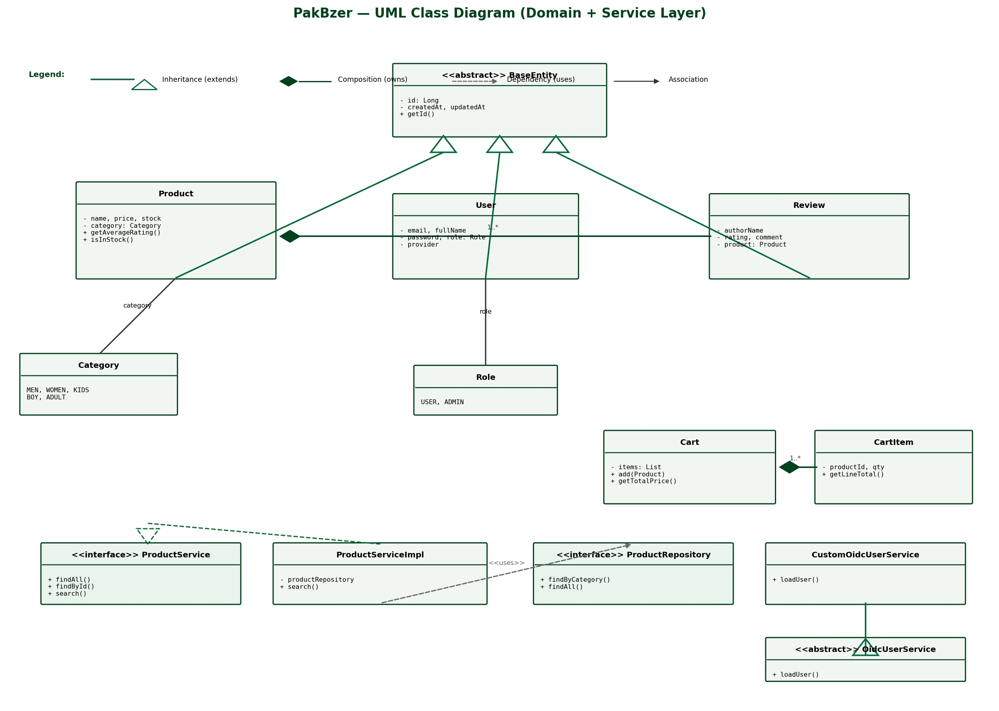
Figure 1. PakBzer UML class diagram showing inheritance, composition, association, realization, and dependency.

9. Layered Architecture
PakBzer is built with a layered architecture, which keeps the user interface, business rules, data access, and persistence concerns separate. That structure makes the code easier to test, easier to explain, and easier to extend.

10. Main layers in the system architecture
Layer | Main classes | Role in PakBzer
Presentation | HomeController, ProductController, CartController, AuthController, ReviewController, CheckoutController | Handles browser requests and returns Thymeleaf views.
Business logic | ProductService, ProductServiceImpl, UserService, ReviewService, Cart, StripeService | Contains the rules for search, registration, cart handling, reviews, and checkout.
Data access | ProductRepository, UserRepository, ReviewRepository | Wraps database queries through Spring Data JPA.
Domain model | BaseEntity, Product, User, Review, CartItem, Category, Role | Stores the core business data and object behavior.
Persistence and security | H2 database, SecurityConfig, CustomUserDetailsService, CustomOidcUserService, PasswordConfig, StripeProperties | Stores data and protects the application with login, OAuth2, and payment configuration.
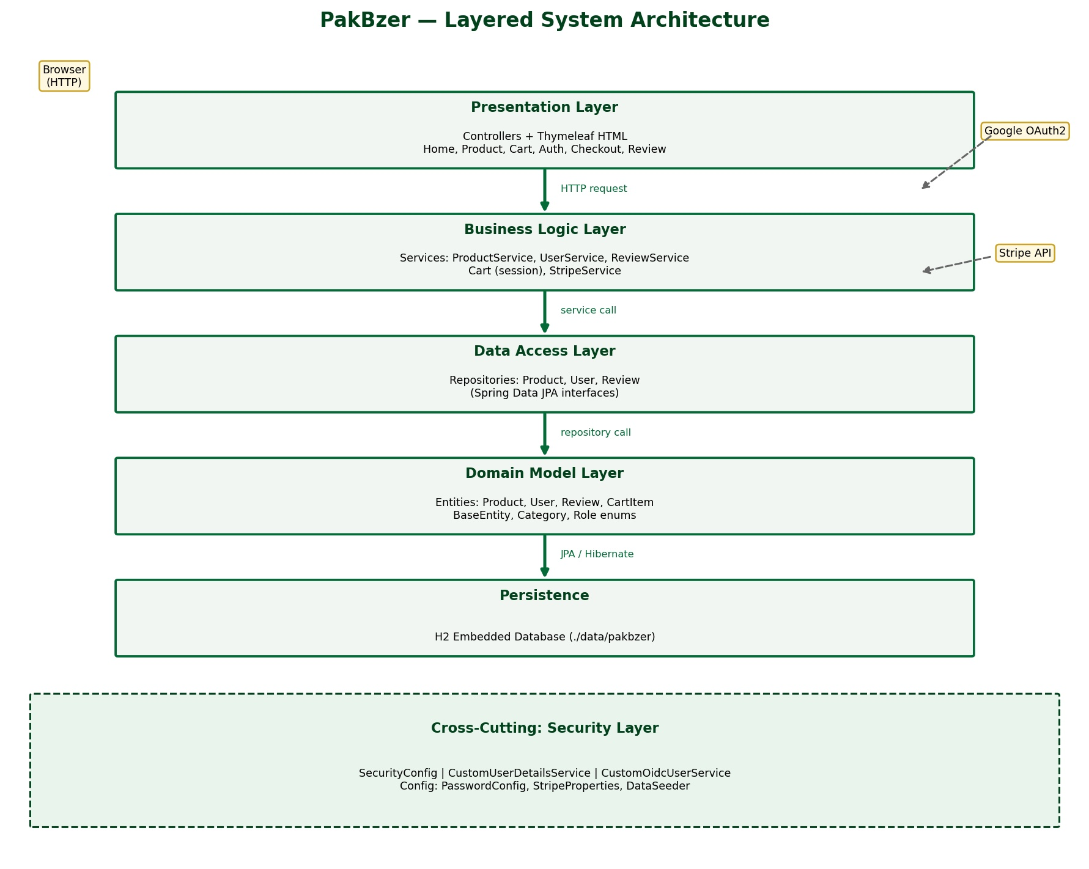
Figure 2. PakBzer layered system architecture from the browser down to the H2 database.
The arrow flow is top-down: browser request -> controller -> service -> repository -> database. The security layer and configuration classes sit across the stack, because authentication, password hashing, Google OAuth2, and Stripe do not belong to only one application layer. That cross-cutting design is another example of good separation of concerns.

11. Main Classes and Their OOP Role
This table ties the codebase back to the OOP explanation so the diagram is not just visual decoration. It shows where the most important classes live and what design idea each one demonstrates.

11. Package-level class map
Package | Key classes | Why they matter
model | BaseEntity, Product, User, Review, CartItem, Category, Role | Core object model. This is where encapsulation, inheritance, composition, and enums are most visible.
service | ProductService, ProductServiceImpl, UserService, ReviewService, Cart, StripeService | Business logic and object behavior. This is where abstraction and polymorphism are strongest.
repository | ProductRepository, UserRepository, ReviewRepository | Database abstraction through Spring Data JPA interfaces.
security | SecurityConfig, CustomUserDetailsService, CustomOidcUserService | Authentication and authorization, including Google sign-in customization.
controller | HomeController, ProductController, CartController, AuthController, ReviewController, CheckoutController, GlobalControllerAdvice | Web entry points that connect HTTP requests to the application logic.

12. End-to-End Example: Adding a Product to the Cart
A simple shopping action shows several OOP ideas working together. When the user clicks Add to Cart, the controller receives the request, the service layer loads the Product through ProductRepository, and the Cart object updates its own list of CartItem objects. The controller does not calculate totals or decide how items are merged; the Cart object owns those rules.
This single user action demonstrates encapsulation because the cart hides its internal list; abstraction because the controller talks to the service contract rather than SQL; and polymorphism because Spring can inject the correct service implementation behind the interface. It is a good real-world example of why OOP matters in PakBzer.

13. Conclusion
PakBzer uses OOP in a practical and understandable way. Encapsulation keeps state safe, inheritance removes duplicate audit fields, abstraction hides implementation details, and polymorphism makes the system flexible. The UML diagram shows how those ideas connect through inheritance, composition, association, dependency, and interface realization.
If you want a one-line summary: the project is not just an online store, it is a clean example of how object-oriented design can organize a real Spring Boot application.

