PakBzer
A Pakistani E-Commerce Web Application
Object-Oriented Programming Project Report
Language: Java 17 | Framework: Spring Boot 3 | Paradigm: OOP

1. Abstract
PakBzer is a full-stack online clothing store for the Pakistani market. It demonstrates Encapsulation, Inheritance, Abstraction, and Polymorphism in a layered Spring Boot application.

2. System Architecture
PakBzer follows a classic layered (n-tier) architecture. Each layer has a single responsibility and communicates with the layer directly beneath it.

2.1 UML Class Diagram
Inheritance (hollow triangle): Product, User, Review extend BaseEntity. Composition (filled diamond): Product owns Reviews; Cart owns CartItems. Association: Product→Category, User→Role. Dependency (dashed arrow): ProductServiceImpl uses ProductRepository. Realization (dashed triangle): ProductServiceImpl implements ProductService.
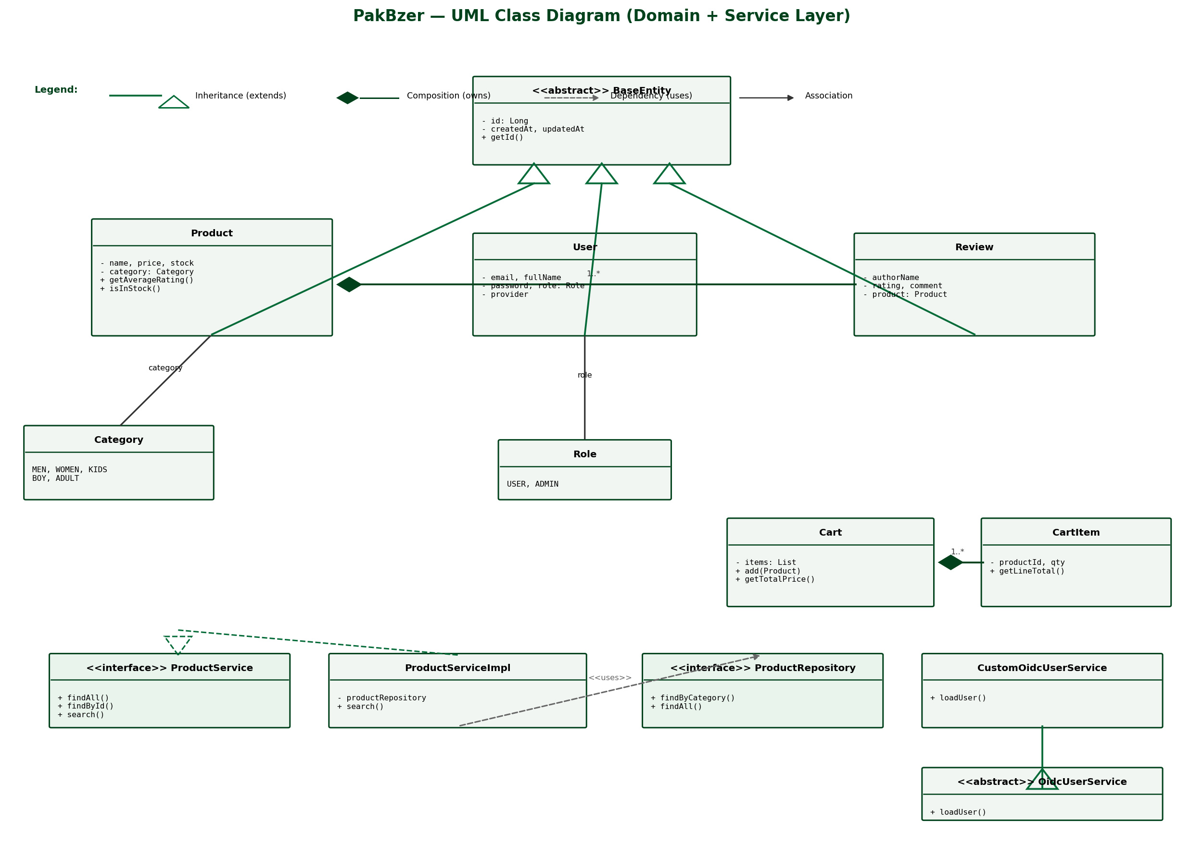

2.2 Layered Architecture Diagram
HTTP requests flow Browser → Controllers → Services → Repositories → H2 Database. Security (OAuth2, form login) and configuration cross-cut all layers.
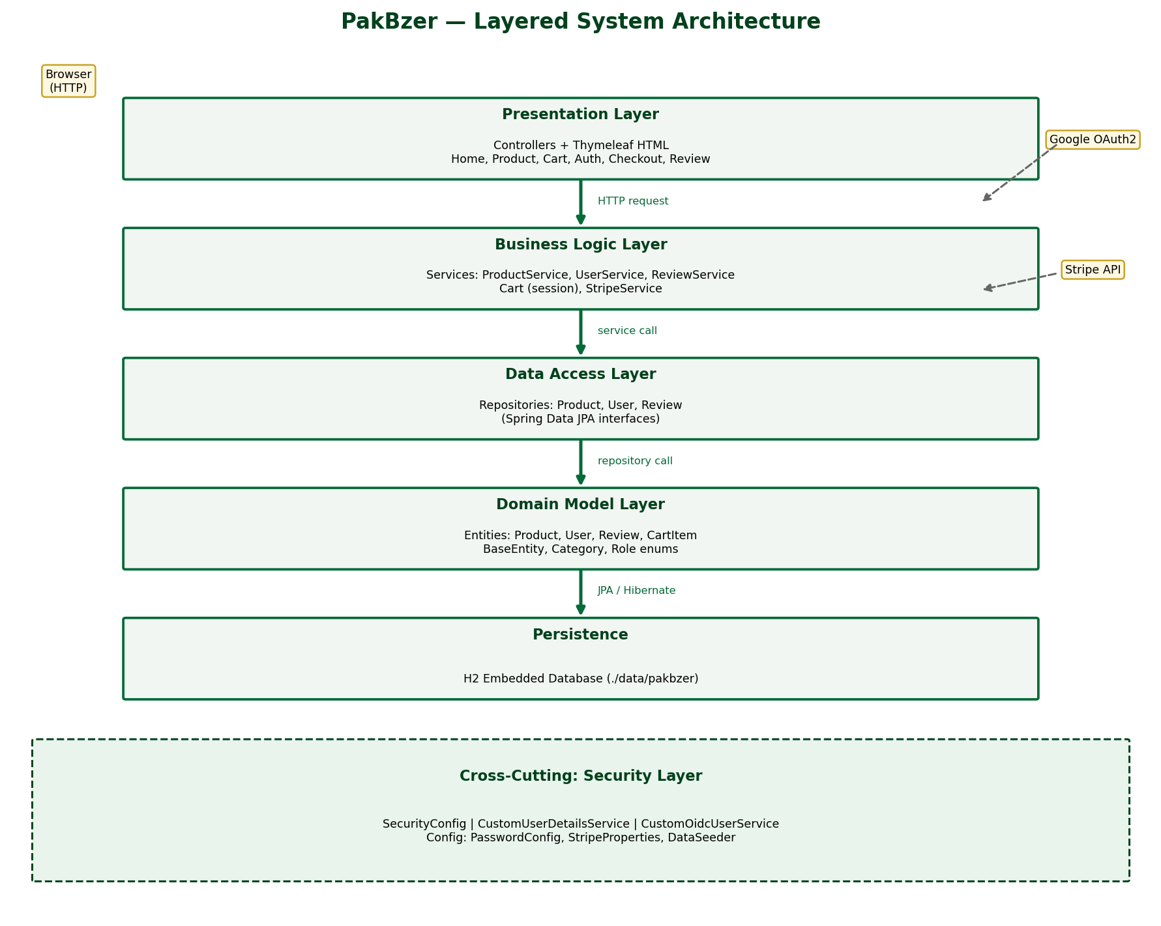

2.3 Add-to-Cart Sequence Diagram
Shows the presentation → business → data-access call chain when adding a product to the session cart.
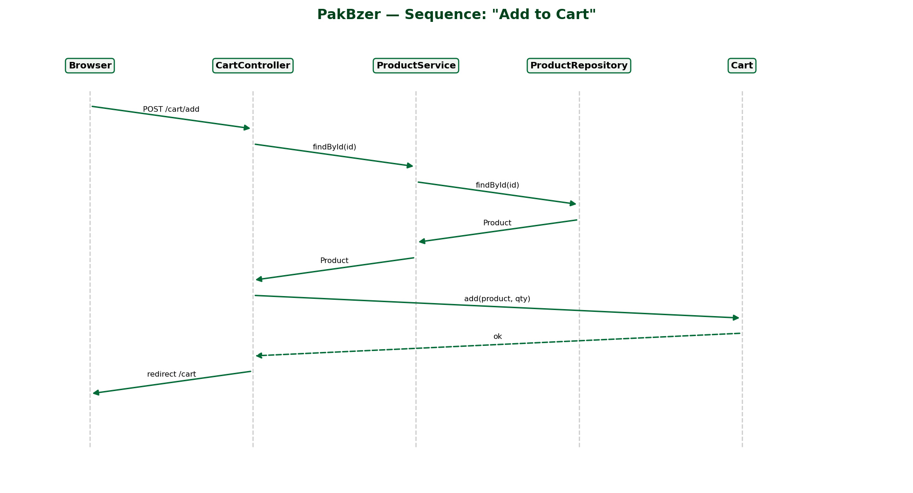

3. OOP Pillars & Relationships
Encapsulation: Private fields with getters/setters; business rules in methods (getAverageRating, getLineTotal).
Inheritance: Product, User, Review extend abstract BaseEntity for shared id and timestamps.
Abstraction: ProductService interface hides implementation; BaseEntity is abstract.
Polymorphism: ProductServiceImpl implements ProductService; CustomOidcUserService overrides OidcUserService.
Composition: Cart composes CartItems; Product composes Reviews (cascade ALL, orphanRemoval).
Association: Product linked to Category enum; User linked to Role enum; Review linked to Product.

4. Conclusion
PakBzer applies OOP principles in a modular Spring Boot e-commerce system that is reusable, testable, and easy to extend.

