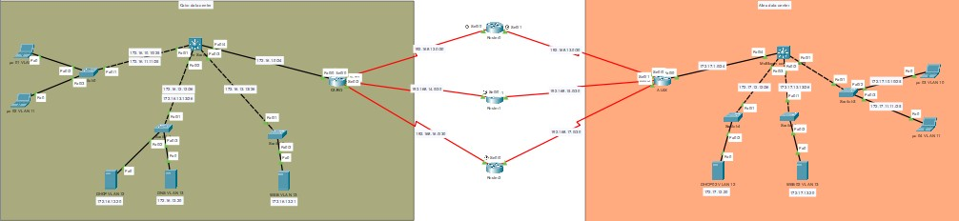

**Cairo data center**

* Creating VLANs on core switch

1. Switch(config)#vlan 10
2. Switch(config-vlan)#name VLAN-10
3. Switch(config)#vlan 11
4. Switch(config-vlan)#name VLAN-11
5. Switch(config)#vlan 12
6. Switch(config-vlan)#name dhcp
7. Switch(config)#vlan 13
8. Switch(config-vlan)#name dns.web

# VLANs

1) Switch(config)# int vlan 10

2) Switch(config-if)#ip add 172.16.10.10 255.255.255.128

3) Switch(config)# int vlan 11

4) Switch(config-if)#ip add 172.16.11.11 255.255.255.128

5) Switch(config)# int vlan 12

6) Switch(config-if)#ip add 172.16.12.12 255.255.255.192

7) Switch(config)# int vlan 13

8) Switch(config-if)#ip add 172.16.13.13 255.255.255.192

9) Switch(config)# int vlan 1

10) Switch(config-if)#ip add 172.16.1.1 255.255.255.0

# Activate VLANs

1. Switch(config-if)# int range f0/1 - 4
2. Switch(config-if-range)# switchport trunk encapsulation dotq1
3. Switch(config-if-range)# switchport mode trunk

# On core switch

1. Switch(config)# ip routing
2. Switch(config)# int vlan 10
3. Switch(config-if)#ip helper-address 172.16.12.20
4. Switch(config)# int vlan 11
5. Switch(config-if)#ip helper-address 172.16.12.20

6) Switch(config)# ip route 192.168.12.0 255.255.255.252 172.16.1.2

7) Switch(config)# ip route 192.168.14.0 255.255.255.252 172.16.1.2

8) Switch(config)# ip route 192.168.16.0 255.255.255.252 172.16.1.2

9) Switch(config)# ip route 172.17.0.0 255.255.0.0 172.16.1.2

10) Switch(config)# do show ip route

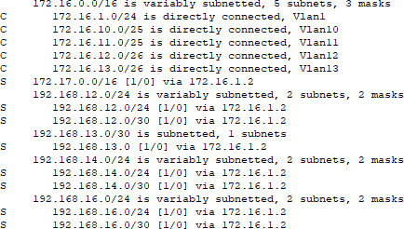

# On each L2 switch

1. Switch(config)# int f0/1
2. Switch(config-if)# switchport mode trunk
3. Switch(config-if)# int range f0/2 - 3
4. Switch(config-if-range)# switchport mode access

# On Cairo router

1) cairo(config)# do show ip route

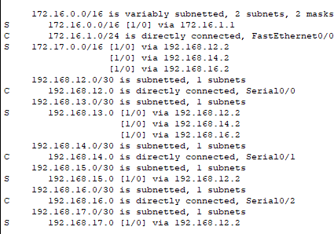

# Configurations of DHCP server

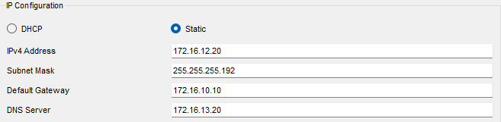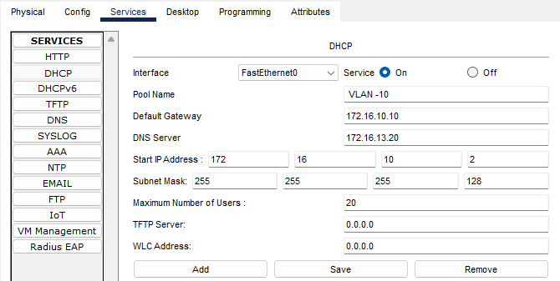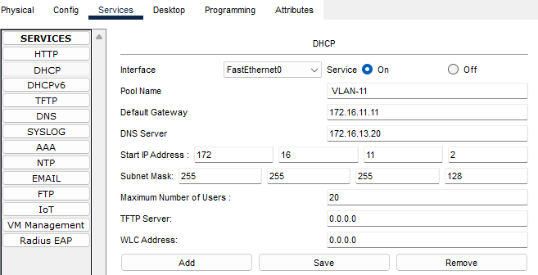

* Congratulations of DNS server

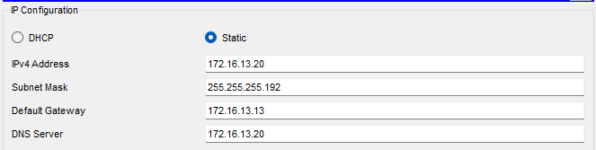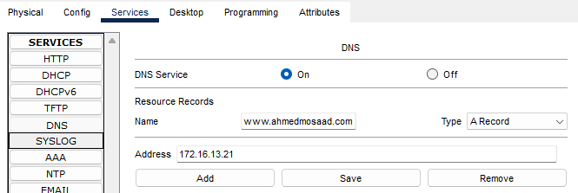

# Configuration of WEB server

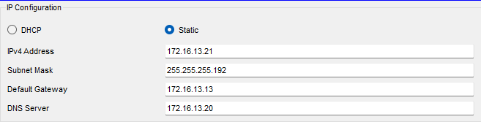

**Wan connection**

# On Cairo router

1) router (config)# int f0/0

2) router (config-if)#ip add 172.16.1.2 255.255.255.0

3) router (config)# int s0/0

4) router (config-if)#ip add 192.168.12.1 255.255.255.252

5) router (config)# int s0/1

6) router (config-if)#ip add 192.168.14.1 255.255.255.252

7) router (config)# int s0/2

8) router (config-if)#ip add 192.168.16.1 255.255.255.252

9) router (config)# ip route 172.16.0.0 255.255.0.0 172.16.1.1

10) router (config)# ip route 192.168.13.0 255.255.255.252 192.168.12.2

11) router (config)# ip route 192.168.15.0 255.255.255.252 192.168.14.2

12) router (config)# ip route 192.168.17.0 255.255.255.252 192.168.16.2

1. router (config)# hostname Cairo
2. Cairo (config)# do show run

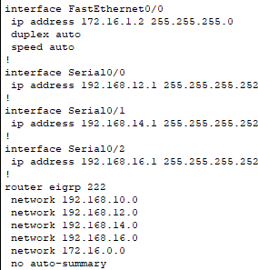

# On service provider routers

1) router (config)# int s0/0

2) router (config-if)#ip add 192.168.12.2 255.255.255.252

3) router (config)# int s0/1

4) router (config-if)#ip add 192.168.13.2 255.255.255.252

5) router (config)# int s0/0

6) router (config-if)#ip add 192.168.14.2 255.255.255.252

7) router (config)# int s0/1

8) router (config-if)#ip add 192.168.15.2 255.255.255.252

9) router (config)# int s0/0

10) router (config-if)#ip add 192.168.16.2 255.255.255.252

11) router (config)# int s0/1

12) router (config-if)#ip add 192.168.17.2 255.255.255.252

13) router (config)#ip route 172.16.0.0 255.255.0.0 192.168.12.1

14) router (config)#ip route 172.17.0.0 255.255.0.0 192.168.13.1

15) router (config)#ip route 172.16.0.0 255.255.0.0 192.168.14.1

16) router (config)#ip route 172.17.0.0 255.255.0.0 192.168.15.1

17) router (config)#ip route 172.16.0.0 255.255.0.0 192.168.16.1

18) router (config)#ip route 172.17.0.0 255.255.0.0 192.168.17.1

* **Backup routers or shared data routers same as active router but with different IPs**
* **ALEX data center same as cairo data center but with different IPs**