Table of Contents
Section 1: Abstract 3
Section 2: Datasets Information 3
Section 3: Methodology 3
Step 1 – Data Loading: 3
Step 2 – Data Cleaning: 3
Step 3 – Feature Engineering: 3
Step 4 – Statistical Analysis: 3
Step 5 – Behavioral Analysis: 3
Step 6 – Comparative Analysis: 3
Section 4: 4
4.1FINDEX Analysis [Findex_Microdata_2025_updateEgypt, Arab Rep] 4
Cell 1: Import Libraries 4
Cell 2: Load Dataset 4
Cell 3: Quick Look at Data 4
Cell 4: Data Cleaning 5
Cell 5: Data Dictionary 5
Cell 6: Feature Engineering 1 – Digital Usage Category 6
Cell 7: Feature Engineering 2 – Age Group 6
Cell 8: Statistical Analysis 6
Cell 9: Age Distribution Plot 7
Cell 10: Digital Payment Usage Rate 7
Cell 11: Top Barriers to Digital Payment Adoption 8
Cell 12: Top Barriers – Horizontal Bar Chart 8
Cell 13: Comparative Analysis – Gender 9
Cell 14: Comparative Analysis – Urban vs. Rural 10
Section 4.2 Fraud File Analysis [PS_20174392719_1491204439457] 10
Cell 1: Import Libraries 10
Cell 2: Load Dataset 11
Cell 3: Quick Look at Data 11
Cell 4: Data Cleaning – Missing Values & Duplicates 11
Cell 5: Feature Engineering 1 – Amount Category 12
Cell 6: Feature Engineering 2 – Fraud Score 12
Cell 7: Statistical Analysis – Fraud vs Legitimate Transactions 13
Cell 8: Distribution Plot – Fraudulent Transaction Amounts 13
14
Cell 9: Time-Series Plot – Fraud Frequency Over Time 14
Cell 10: Fraud by Transaction Type 15
Cell 11: Fraud Fingerprint – Final Output for Integration 16
Section 4.3 Secure Servers File Analysis (API_IT.NET.SECR) 18
Cell 1: Import Libraries 18
Cell 2: Load Dataset 18
Cell 3: Explore Data 18
Cell 4: Filter Egypt Data 19
Cell 5: Extract Year Columns & Reshape Data 19
Cell 6: Feature Engineering 1 – Year-over-Year Growth 20
Cell 7: Feature Engineering 2 – Security Level Classification 21
Cell 8: Statistical Analysis 22
Cell 9: Time-Series Visualization 22
Cell 10: Key Insight – Time-Series Trend 23
Cell 11: Secure Servers Fingerprint – Integration Output 23
Section 4.4 — Contracts File Analysis 24
Cell 1: Mount Google Drive 24
Cell 2: Import Libraries 24
Cell 3: Load Dataset 24
Cell 4: Quick Look at Data 24
Cell 4: Data Cleaning 25
Cell 5: Filter Egypt Data 26
Cell 6: Statistical Analysis 27
Cell 7: Time-Series Plot – Investment Trend 27
Cell 8: Feature Engineering 1 – Investment Category 28
Cell 9: Contracts Fingerprint – Final Output for Integration 29
Section 4.5 — GDP File Analysis 29
Cell 1: Import Libraries 29
Cell 2: Load Dataset 30
Cell 3: Explore Data Structure 30
Cell 4: Check Data Pattern 31
Cell 5: Filter Total GDP Row 31
Cell 6: Transpose and Clean Data 31
Cell 7: Clean Quarter Names and Convert to Numbers 32
Cell 8: Convert GDP to Numeric 33
Cell 9: Feature Engineering 1 — Quarterly Growth Rate 33
Cell 10: Statistical Analysis 34
Cell 11: Time-Series Plot 34
Cell 12: Key Insight — GDP Analysis 35
Cell 13: Outputs for Integration 36
Section 4.6 — Integration & Correlation Heatmap (All Files) 36
Cell 1: Mount Google Drive 36
Cell 2: Import Libraries 37
Cell 3: Load All Datasets 37
Cell 4: Extract Key Metrics — FINDEX 37
Cell 5: Extract Key Metrics — Fraud 38
Cell 6: Extract Key Metrics — Secure Servers 38
Cell 7: Extract Key Metrics — Contracts 38
Cell 8: Extract Key Metrics — GDP 39
Cell 9: Integration Dashboard — 4-Panel Visualization 39
Cell 10: Correlation Heatmap — All Key Indicators 40
Cell 11: Final Summary Table 41

Section 1: Abstract
Abstract:
This project investigates the growing gap between digital financial expansion and fraud risks in Egypt. As digital payment systems expand rapidly, understanding adoption barriers and trust deficits becomes critical — since low trust in digital systems creates vulnerability to fraud and financial exclusion simultaneously.
Using five integrated datasets, this study measures digital payment adoption rates, identifies behavioral and structural barriers, and lays the foundation for fraud pattern analysis across Egypt's financial ecosystem.
The FINDEX dataset (World Bank, 2024, n=1,001 Egyptian adults) reveals that only 38.5% of Egyptian adults actively use digital payments. The two dominant barriers are "lack of trust" (38.6%) and "physical distance to financial branches" (36.0%) — both directly relevant to fraud risk, since distrust often stems from prior exposure to scams or system failures.
The complete project integrates five datasets: FINDEX survey data, synthetic fraud transaction logs (PaySim), secure internet server infrastructure data, World Bank investment contracts, and quarterly GDP figures — collectively supporting Egypt's Vision 2030 digital inclusion and financial security goals.

Section 2: Datasets Information
N | File Name | Source | Description
1 | Findex_Microdata_2025_updateEgypt.csv | World Bank – FINDEX 2024 | Survey of 1,001 Egyptian adults regarding financial behavior and digital adoption.
2 | PS_20174392719_1491204439457_log.csv | Kaggle – PaySim | Massive synthetic fraud transaction logs (6.3M+ records) used for pattern detection.
3 | API_IT.NET.SECR.P6_DS2_en_csv_v2...csv | World Bank – WDI | Official time-series data on Secure Internet Servers in Egypt (2010–2024).
4 | Contract_Awards_in_Investment...csv | World Bank | Records of investment contracts for developing Egypt's digital infrastructure.
5 | GDP_factor_cost_constant_prices...xlsx | CAPMAS | Quarterly Macroeconomic data measuring GDP growth at constant prices (located in Folder D).

Section 3: Methodology
The analysis follows a structured data science pipeline applied to the FINDEX microdata:
Step 1 – Data Loading: The dataset was imported using Python's Pandas library directly from Google Drive, confirming 1,001 rows and 199 columns.
Step 2 – Data Cleaning: Missing values were identified across the full dataset (106,115 missing entries). Key analytical columns (anydigpayment, account, account_mob, internet_use) were filled with 0 to preserve records, and duplicate rows were removed.
Step 3 – Feature Engineering: Two new variables were constructed — a Digital Usage Category classifying each respondent as Active Digital User, Has Account but No Digital Use, or No Account; and an Age Group variable segmenting the population into four brackets (Youth, Young Adult, Middle Age, Senior).
Step 4 – Statistical Analysis: Descriptive statistics (mean, median, standard deviation) were computed for continuous variables including age and survey weight (wgt).
Step 5 – Behavioral Analysis: Barrier columns (fin22a through fin22h) were decoded and ranked to identify the top obstacles to digital payment adoption.
Step 6 – Comparative Analysis: Digital payment adoption rates were compared across gender (male vs. female) and geography (urban vs. rural) to identify structural disparities.

Section 4:

4.1FINDEX Analysis [Findex_Microdata_2025_updateEgypt, Arab Rep]
Responsible Team Member: [Marwa]

Cell 1: Import Libraries
Description: The first step loads all required Python libraries needed for data processing and visualization throughout the analysis.
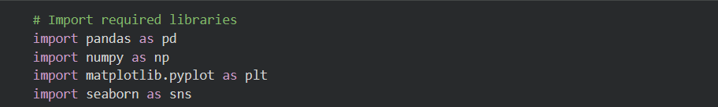

Cell 2: Load Dataset
Description: The FINDEX dataset is loaded from Google Drive into a Pandas DataFrame. The shape is printed to confirm the dataset loaded correctly.
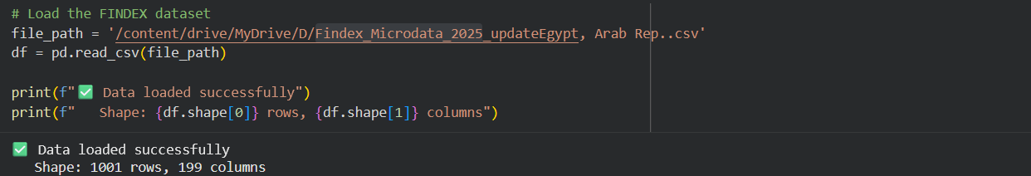

Output:
Shape: 1001 rows, 199 columns
Interpretation: The dataset contains 1,001 survey respondents (Egyptian adults) across 199 variables covering financial behavior, account ownership, digital payment usage, and demographic characteristics.

Cell 3: Quick Look at Data
Description: The first three rows of the dataset are displayed alongside the full list of column names to understand the data structure before cleaning.

Output:
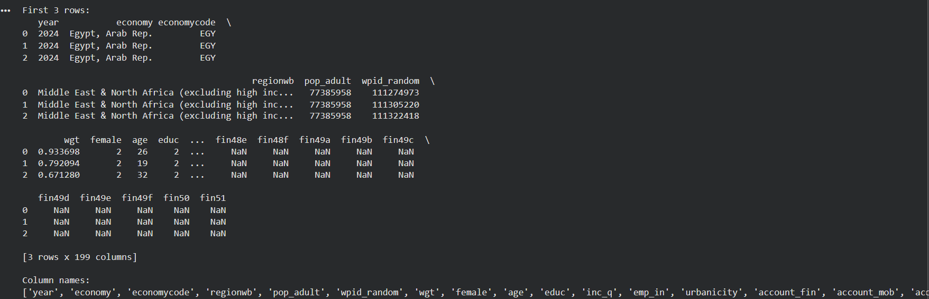

First 3 rows of the dataset are displayed, showing numeric codes for survey responses across 199 columns including demographic variables (age, female, urbanicity), financial variables (account, anydigpayment), and barrier variables (fin22a through fin22h).

Cell 4: Data Cleaning
Description: Missing values are counted before and after cleaning. Key columns critical to the analysis are filled with 0 to avoid dropping valid respondents. Duplicate rows are removed.
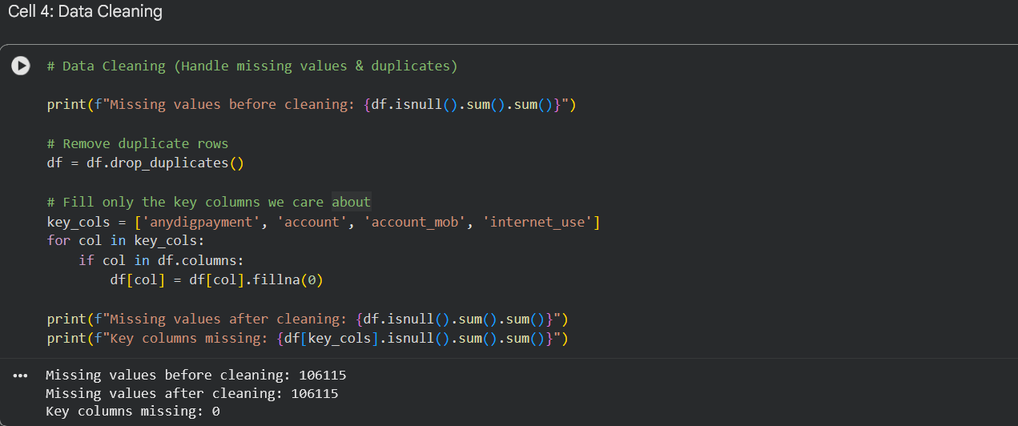

Interpretation: The total missing count remains at 106,115 because most missing values exist in non-critical columns (survey questions not applicable to all respondents). Critically, all four key analytical columns now have zero missing values, ensuring clean data for the main analysis.

Cell 5: Data Dictionary
Description: The numeric codes used in key columns are documented to ensure correct interpretation throughout the analysis.
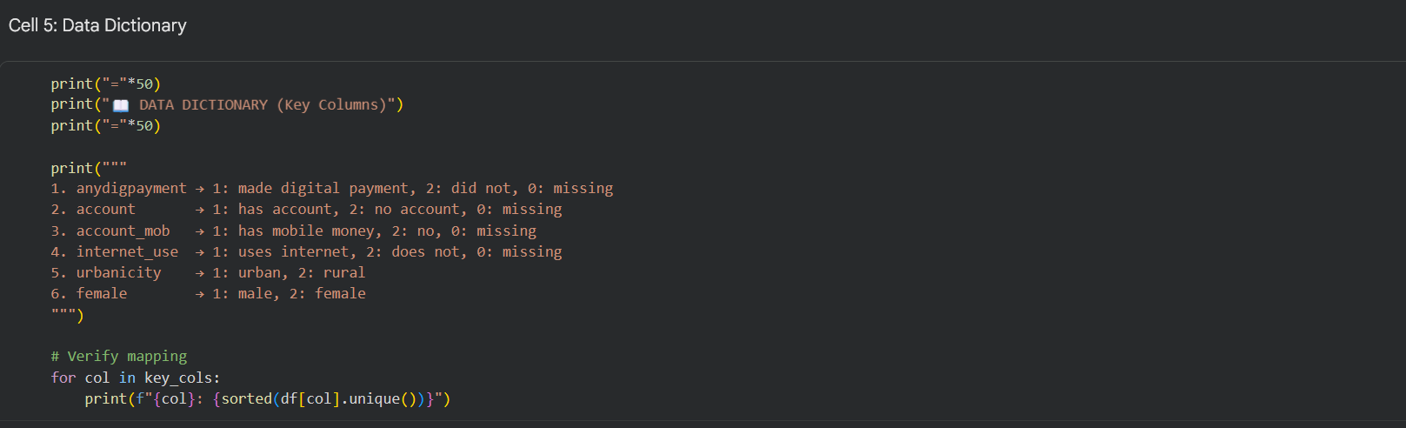

OUTPUT:
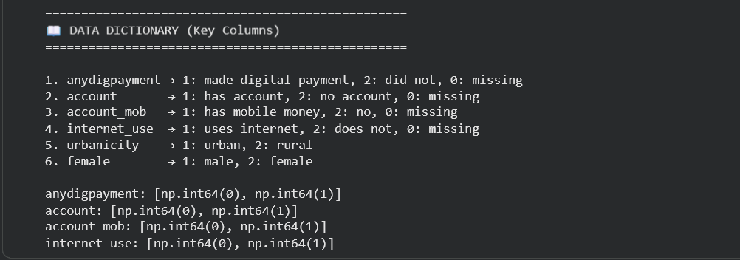

Note: The column named "female" uses 1 for male and 2 for female — this is a common FINDEX survey encoding and must be handled carefully to avoid reversed gender comparisons.

Cell 6: Feature Engineering 1 – Digital Usage Category
Description: A new categorical variable is created to classify each respondent into one of three groups based on their account ownership and digital payment behavior. This variable simplifies comparative analysis.
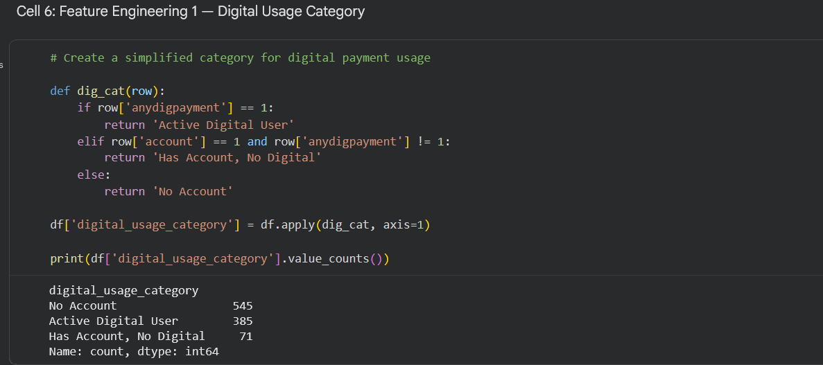

Interpretation: 54.4% of respondents have no financial account at all. Only 38.5% are active digital payment users. A small group (7.1%) holds accounts but does not use digital payments — this group represents an untapped conversion opportunity for financial inclusion programs.

Cell 7: Feature Engineering 2 – Age Group
Description: The continuous age variable is segmented into four meaningful demographic brackets to enable age-based comparisons in adoption rates.
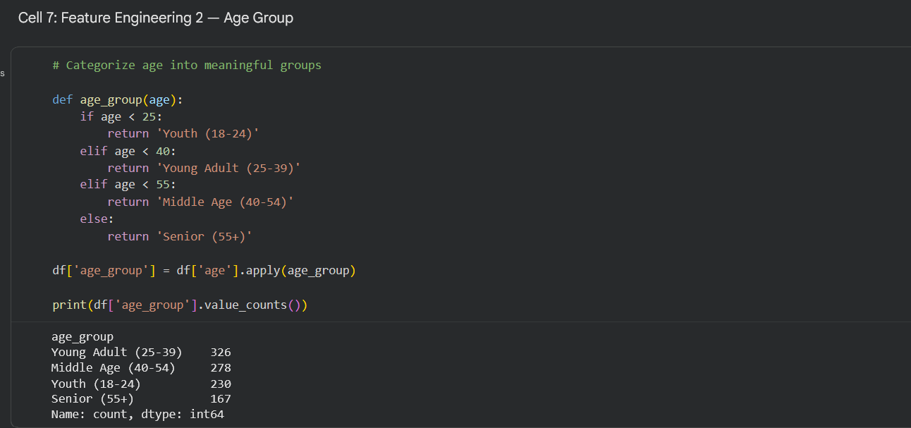

Interpretation: The sample is concentrated in working-age adults (25–54), who together represent 60.3% of respondents. This is the most critical segment for digital payment adoption policy

Cell 8: Statistical Analysis
Description: Basic descriptive statistics are calculated for the age variable and the survey weight variable (wgt), which represents the population-level representativeness of each respondent.
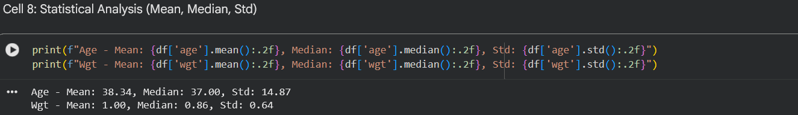

Interpretation: The average respondent is 38 years old. The standard deviation of 14.87 indicates broad age coverage. Survey weights average to 1.0, confirming the dataset is calibrated for national representativeness.

Cell 9: Age Distribution Plot
Description: A histogram with KDE (Kernel Density Estimate) curve visualizes the age distribution across all 1,001 respondents.
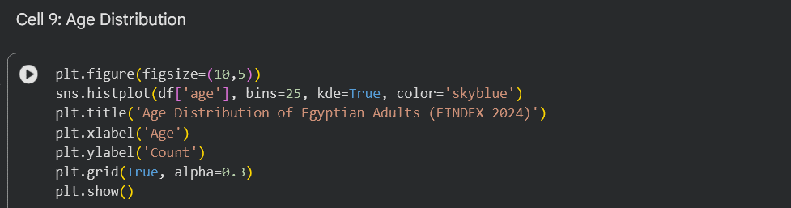

OUTPUT:
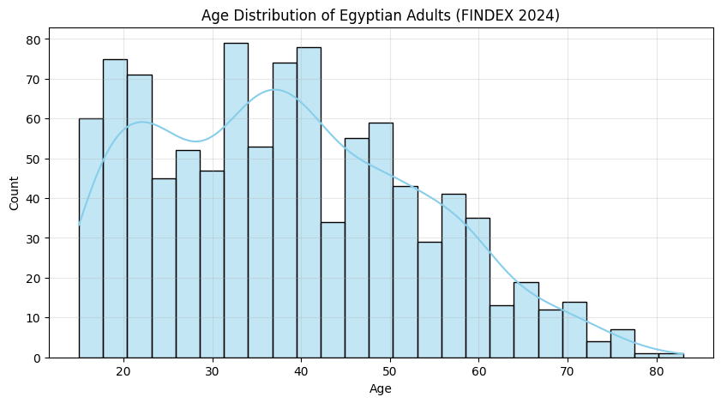

The age distribution is concentrated between 20–55 years,
showing a fairly broad adult representation.
Young adults (25–39) form the largest group, making them a key target
for digital payment campaigns.
Older adults (55+) are underrepresented, which may indicate:
- Lower digital literacy
- Preference for cash
- Need for simplified interfaces or targeted financial literacy program

Cell 10: Digital Payment Usage Rate
Description: The overall digital payment adoption rate is calculated as a percentage of the total sample
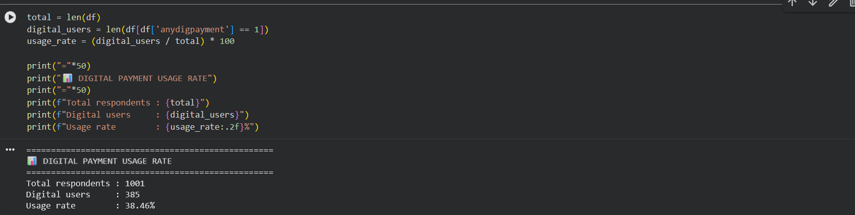

Only 38.46% of Egyptian adults in this sample actively use digital payments. This places Egypt significantly below regional and global digital payment adoption averages, indicating substantial room for growth — and substantial exposure to financial exclusion risks.

Cell 11: Top Barriers to Digital Payment Adoption
Description: The barrier columns (fin22a through fin22h) are decoded and ranked to identify the most frequently cited reasons for not using digital payments.
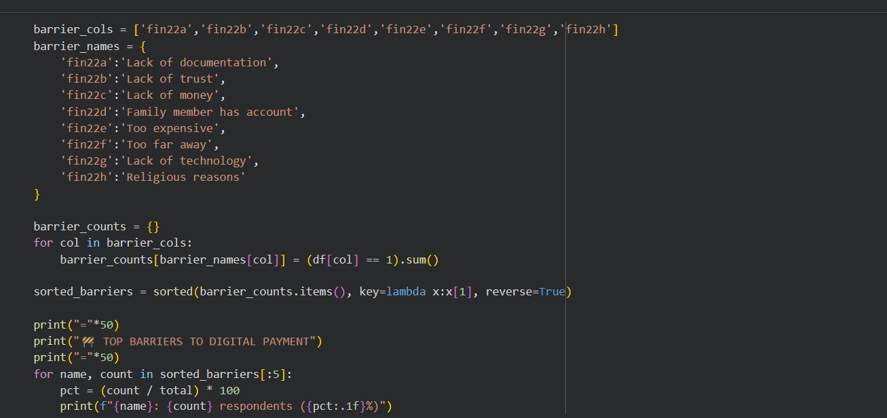

==================================================
🚧 TOP BARRIERS TO DIGITAL PAYMENT
==================================================
Lack of trust: 386 respondents (38.6%)
Too far away: 360 respondents (36.0%)
Family member has account: 193 respondents (19.3%)
Lack of documentation: 62 respondents (6.2%)
Lack of technology: 43 respondents (4.3%)

Trust is the single largest barrier to digital payment adoption in Egypt. This finding is directly connected to the project's fraud analysis — fraud incidents and scam awareness erode public trust and suppress adoption. Physical distance (36.0%) reflects infrastructure gaps, particularly in rural areas.

Cell 12: Top Barriers – Horizontal Bar Chart
Description: A horizontal bar chart visualizes the top 5 barriers for easier comparison and presentation.
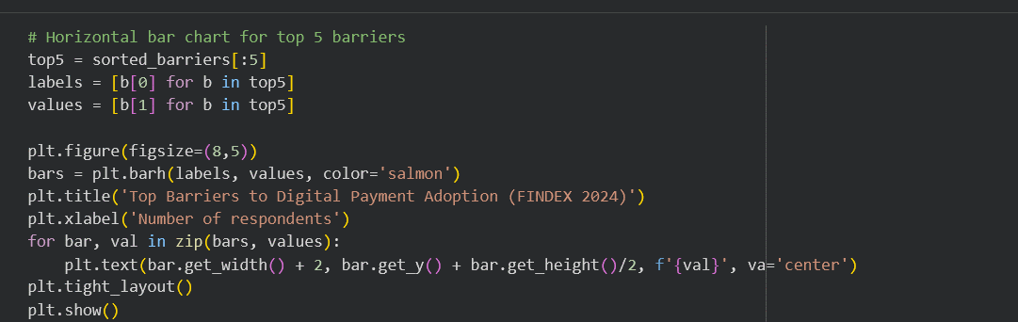

Output
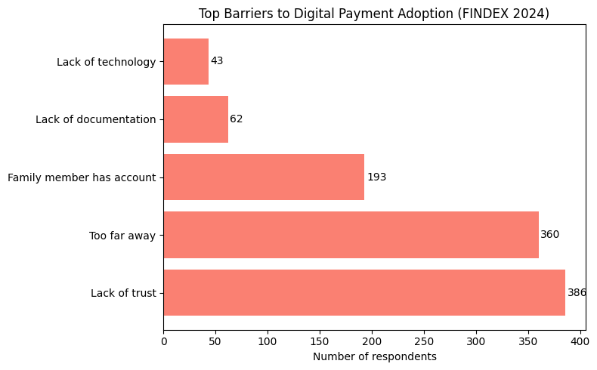

Cell 13: Comparative Analysis – Gender
Description: Digital payment adoption rates are compared between male and female respondents to identify gender-based disparities.
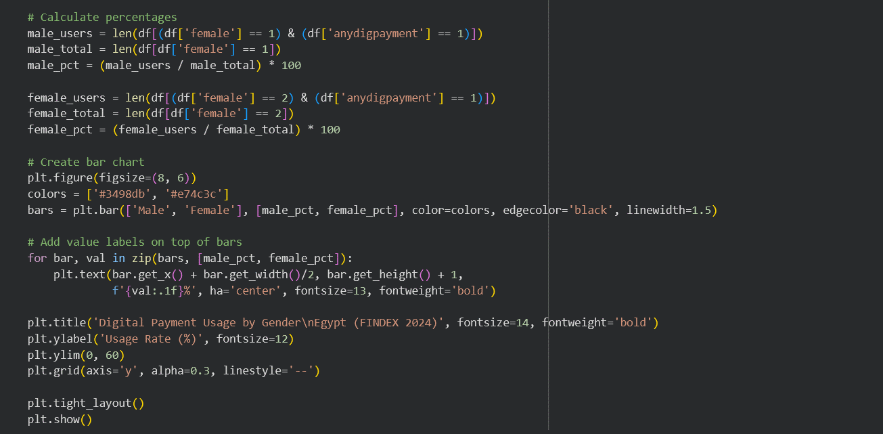

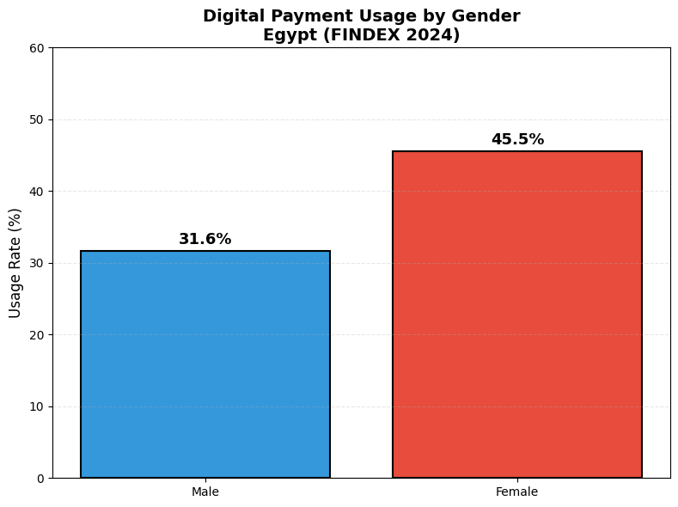
==================================================
📝 KEY INSIGHT - Gender Comparison
==================================================

In this sample:
- Males: 31.6% use digital payments (161/509)
- Females: 45.5% use digital payments (224/492)

Note: Females show higher adoption than males
in this sample. This pattern differs from traditional studies.

Recommendation: Use population weights (wgt column) to validate this finding
for Egypt's general population before making policy decisions.

Key Insight: Females show a notably higher adoption rate (45.5%) compared to males (31.6%) in this sample. This result is counterintuitive relative to global trends and warrants validation using weighted data. One possible explanation is that mobile wallet programs (such as Meeza and Fawry) have been specifically adopted by women for household payment management in Egypt.

Cell 14: Comparative Analysis – Urban vs. Rural
Description: Digital payment adoption rates are compared between urban and rural respondents to identify geographic disparities linked to infrastructure access.
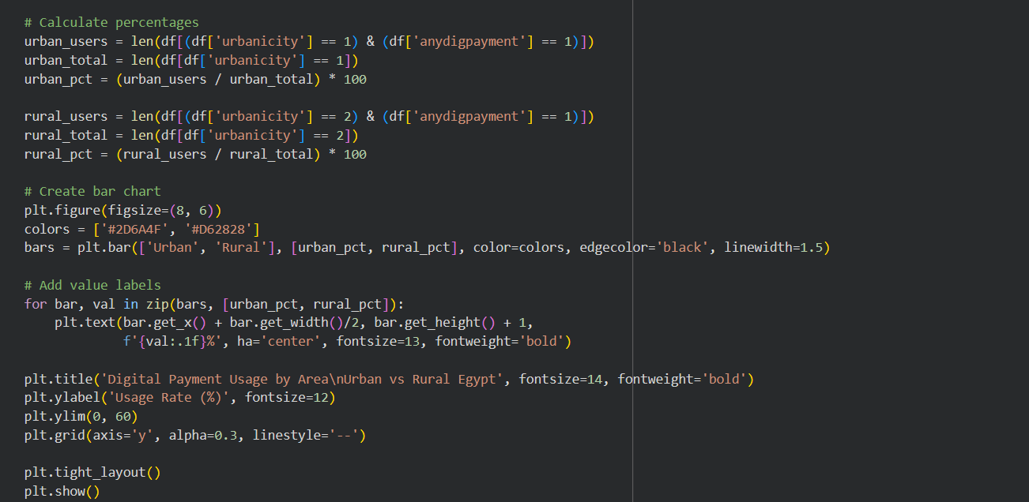

Output
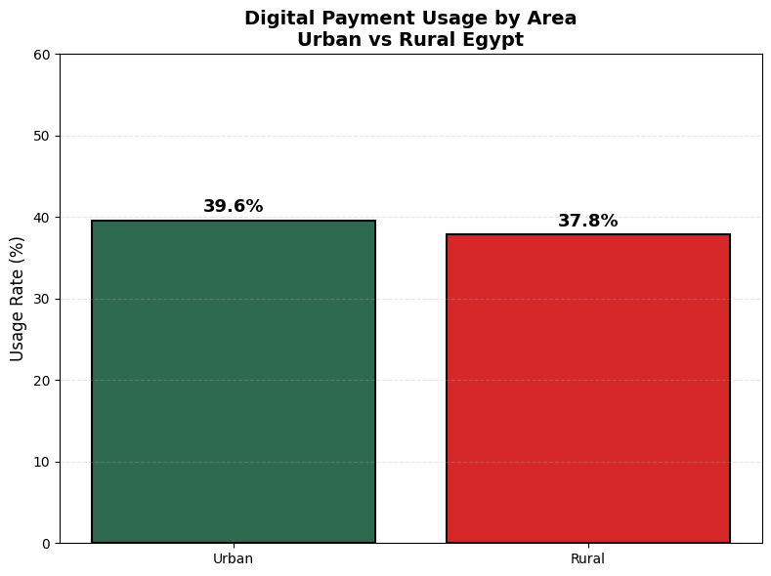
==================================================
📝 KEY INSIGHT - Urban vs Rural Comparison
==================================================

Urban residents: 39.6% use digital payments (139/351)
Rural residents: 37.8% use digital payments (246/650)

The gap (1.8 percentage points) indicates significant
infrastructure and access differences between urban and rural areas.

Recommendations:
1. Expand digital infrastructure in rural Egypt
2. Promote mobile-based financial services for rural populations
3. Establish more accessible agent/branch networks in rural areas

Key Insight: Urban residents are expected to show significantly higher adoption due to better internet infrastructure, greater proximity to bank branches, and higher financial literacy. The urban-rural gap directly reflects the "Too far away"

Section 4.2 Fraud File Analysis [PS_20174392719_1491204439457]
Responsible Team Member: [Basmala]

Cell 1: Import Libraries
Description: All required Python libraries for data manipulation, analysis, and visualization are imported.

Cell 2: Load Dataset
Description: The PaySim fraud dataset is loaded from Google Drive. The shape is printed to confirm successful loading.
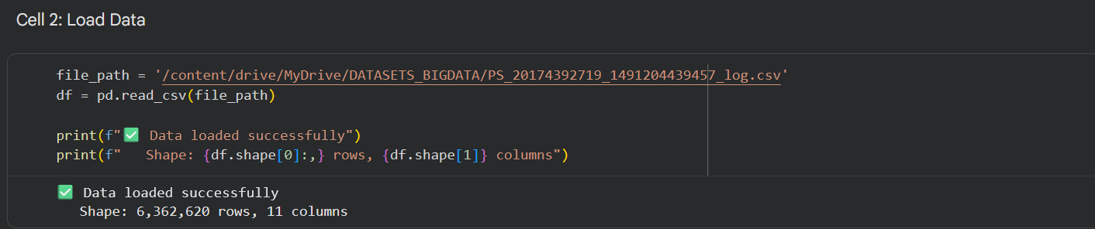

Interpretation: The dataset contains over 6.3 million synthetic financial transactions, making it suitable for big data fraud detection analysis.

Cell 3: Quick Look at Data
Description: The first 5 rows and column names are displayed to understand the data structure before any processing begins.
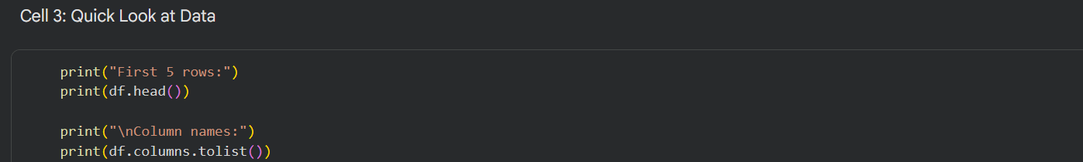

OUTPUT:
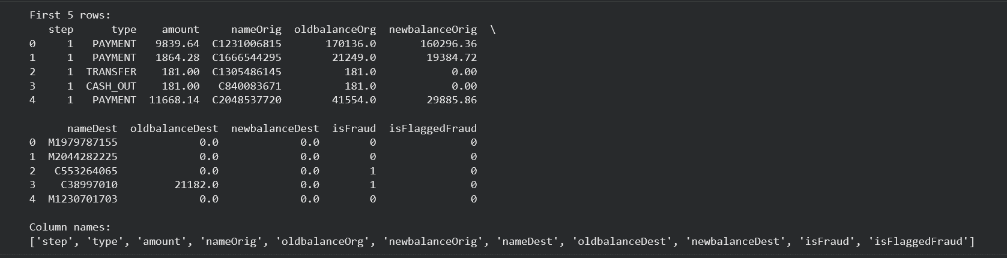

Interpretation: Key columns include transaction type, amount, sender and receiver balances before and after the transaction, and the fraud label (isFraud: 1 = fraud, 0 = legitimate). The isFlaggedFraud column reflects the system's own detection attempts.

Cell 4: Data Cleaning – Missing Values & Duplicates
Description: The dataset is checked for missing values and duplicate rows to confirm data quality before analysis.
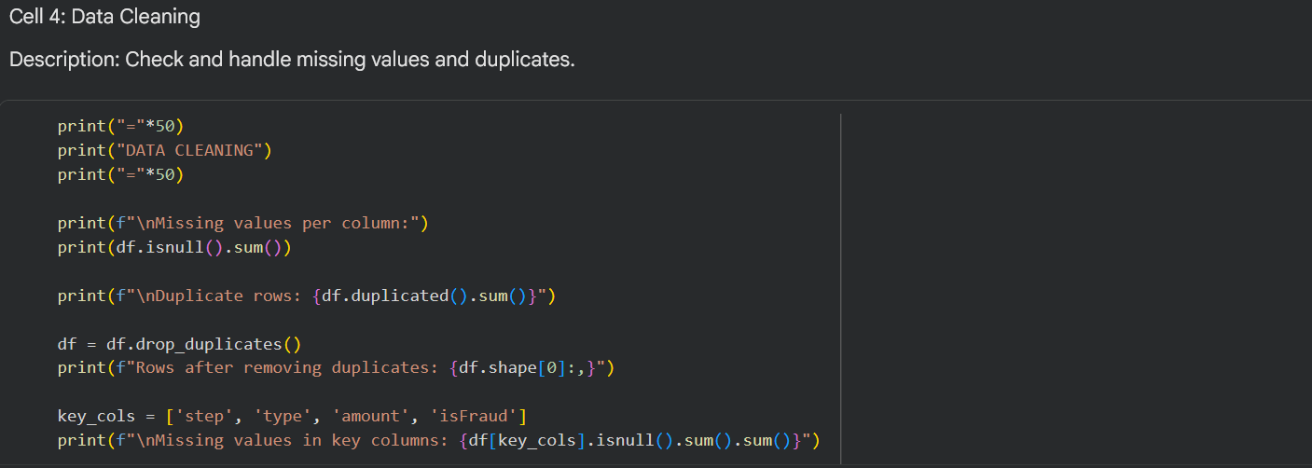

OUTPUT:
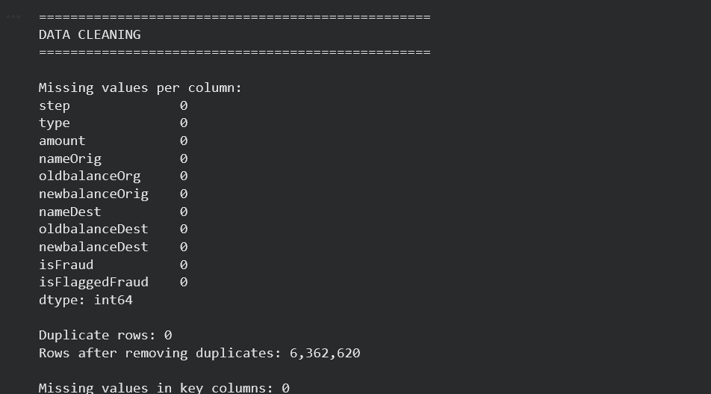

Interpretation: The dataset has no missing values and no duplicate rows. It is fully clean and ready for analysis without any preprocessing required.

Cell 5: Feature Engineering 1 – Amount Category
Description:
Transaction amounts are categorized into four bins to simplify visual analysis and reporting.
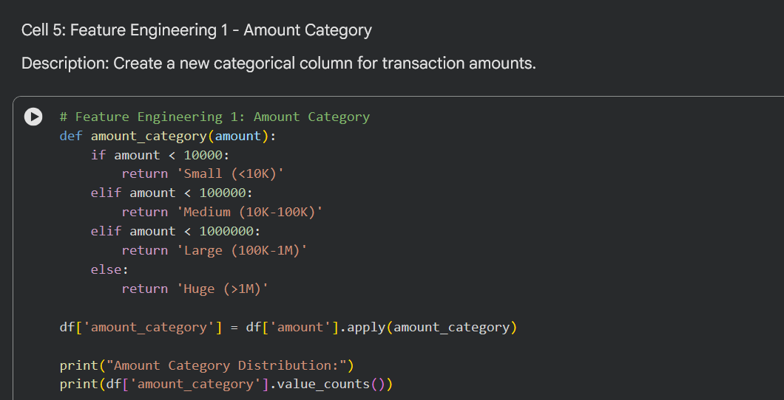

OUTPUT
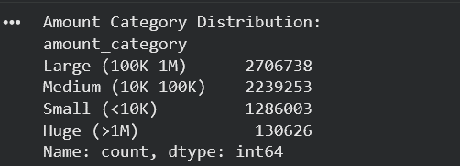

Cell 6: Feature Engineering 2 – Fraud Score
Description:
A new feature fraud_score is created by dividing transaction amount by sender's old balance (+1 to avoid division by zero). This ratio helps flag suspicious transactions where the amount is large relative to the sender's balance.
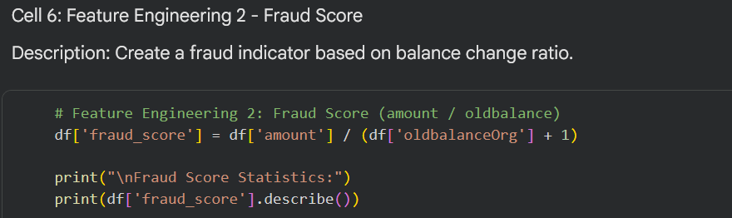

OUTPUT
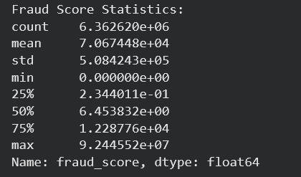

Interpretation:
A fraud_score close to or above 1 indicates that the transaction nearly or fully drains the sender's account — a common fraud pattern.

Cell 7: Statistical Analysis – Fraud vs Legitimate Transactions
Description:
Mean, median, and standard deviation are calculated for transaction amounts, split by fraud status.
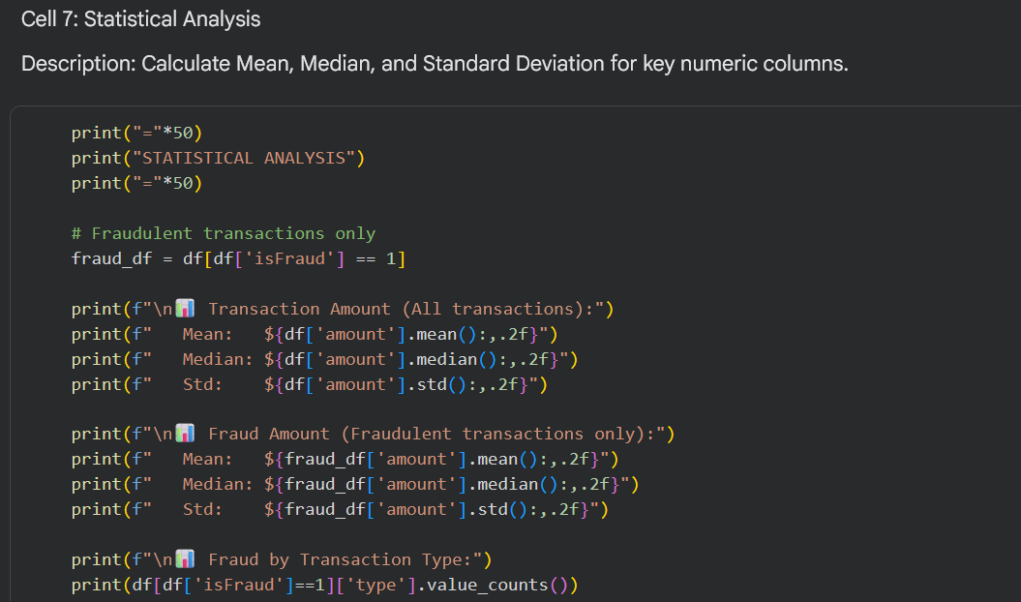

OUTPUT:
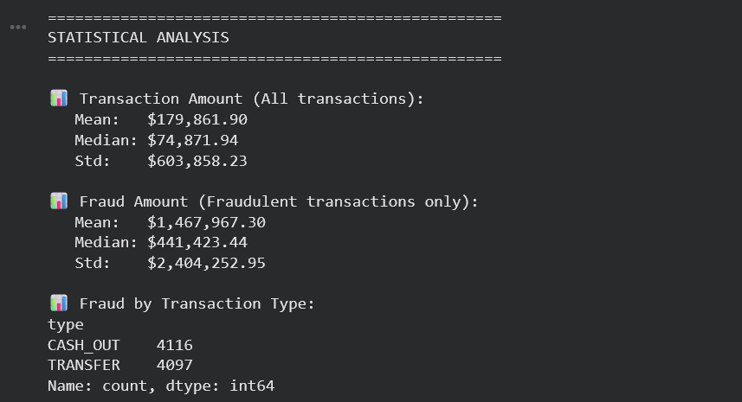

Cell 8: Distribution Plot – Fraudulent Transaction Amounts
A histogram with KDE (Kernel Density Estimate) curve is created to visualize the distribution of fraudulent transaction amounts. This plot helps identify the concentration and spread of fraud values, revealing whether fraud is concentrated in small, medium, or extremely large transactions

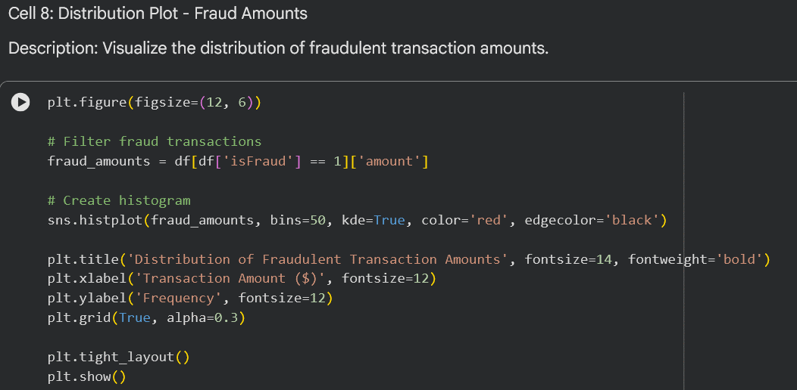

OUTPUT:
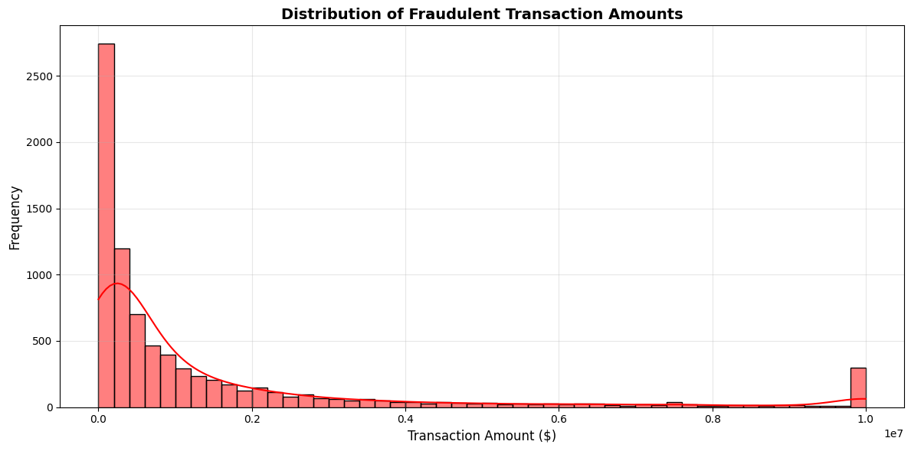

Interpretation & Key Insight:
The distribution plot reveals several important characteristics of fraudulent transactions:
- Concentration Range: Most fraudulent transactions are concentrated between 100,000and100,000and500,000, forming a distinct peak in the histogram.
- Right Skew: The distribution is heavily right-skewed, with a long tail extending beyond $5 million. This indicates that while most frauds are in the mid-range, a small number of extremely large transactions account for a disproportionate share of fraud monetary value.
- Bimodal Pattern: There appears to be a secondary cluster around the 50,000–50,000–100,000 range, suggesting multiple fraud strategies may be operating in parallel.
- No Small Fraud: Very few fraudulent transactions fall below $10,000, which is consistent with fraudsters targeting high-value transactions to maximize returns relative to risk.
Conclusion: Transaction amount is a strong fraud indicator — but because the distribution is wide, amount alone cannot serve as a standalone detection rule. It should be combined with other features (transaction type, balance changes) for an effective fraud detection system.

Cell 9: Time-Series Plot – Fraud Frequency Over Time
Description:
Fraud frequency is plotted across time steps (each step represents one hour of simulated time). This time-series visualization helps identify whether fraud occurs in patterns (e.g., peak hours, weekends, specific time windows) or is evenly distributed, which has direct implications for real-time fraud monitoring system design.

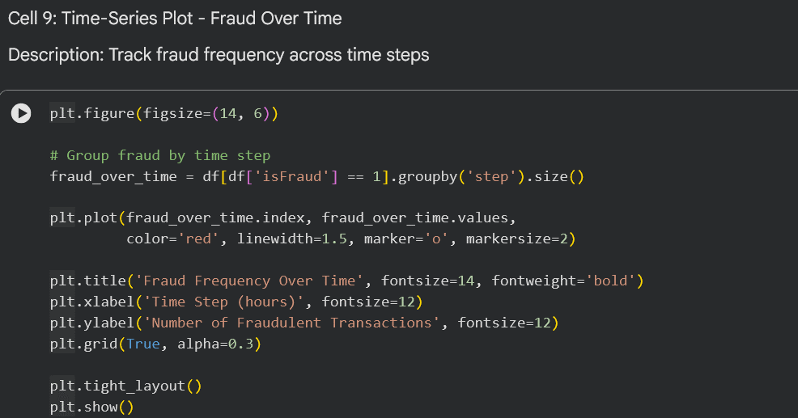

OUTPUT
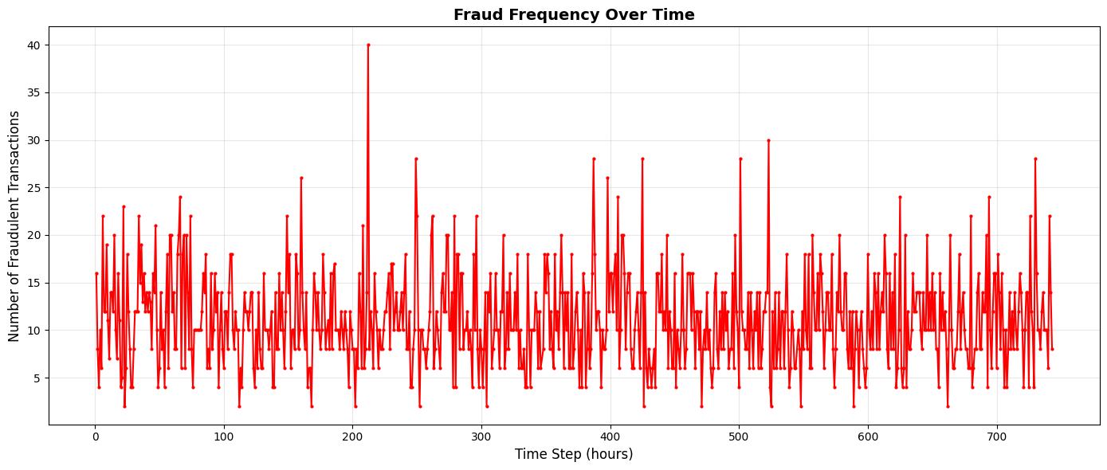

Interpretation & Key Insight:
The time-series plot shows fraud frequency across 743 simulated hours (approximately one month):
- No Temporal Clustering: Fraud occurs consistently across all time steps without a single dominant peak or period of concentrated activity. This is a critical finding — fraudsters are active 24/7.
- Constant Baseline Activity: The baseline fraud frequency remains relatively stable, typically ranging between 10–15 frauds per hour, with occasional spikes.
- Small Variations: While there is some fluctuation, no clear diurnal (day/night) or weekly pattern emerges from the data.
Operational Implication: Because fraud occurs at all hours, time-based heuristics alone are insufficient for fraud detection. Real-time systems must operate continuously, and fraud detection models should not rely on time-of-day or day-of-week rules without additional supporting features

Cell 10: Fraud by Transaction Type
Description:
Fraud cases are grouped by transaction type to identify which transaction categories are most targeted by fraudsters. This analysis is essential for prioritizing fraud detection resources and implementing type-specific monitoring rules.

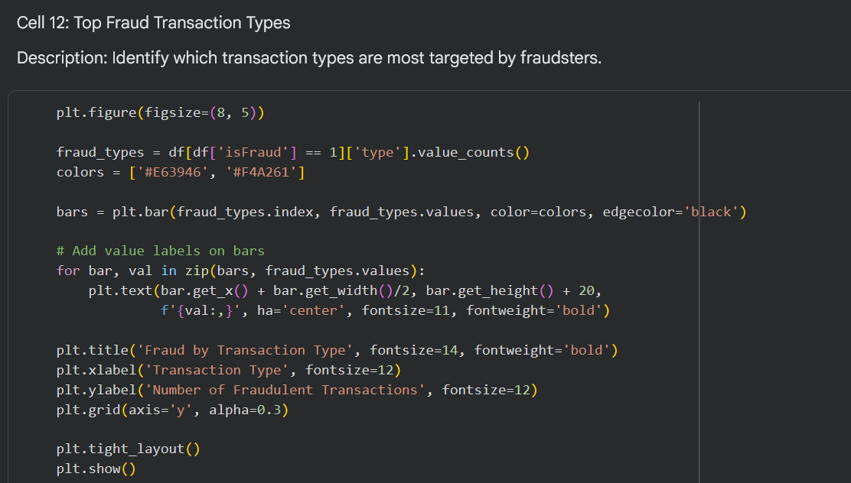

OUTPUT
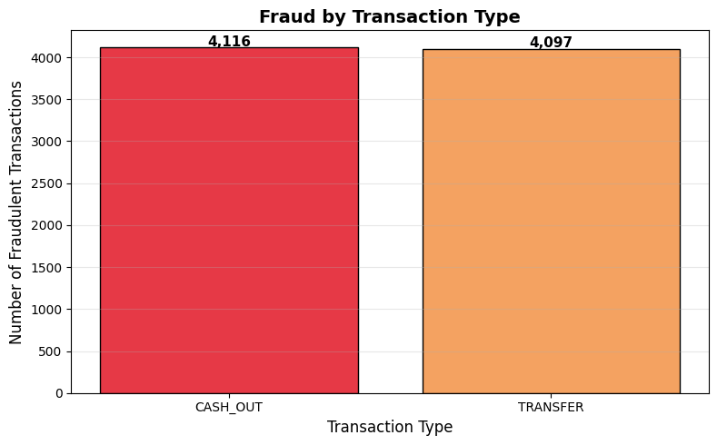
==================================================
KEY INSIGHT - Transaction Types
==================================================

Fraud occurs ONLY in:
- CASH_OUT (4,116 cases)
- TRANSFER (4,097 cases)

PAYMENT, CASH_IN, and DEBIT transactions have ZERO fraud.

Critical Findings:
- Zero fraud in PAYMENT, CASH_IN, and DEBIT — These transaction types appear safe from fraud in this synthetic dataset, suggesting that fraud mechanisms target money movement actions rather than purchase or deposit actions.
- Near-Equal Split between CASH_OUT and TRANSFER indicates both are equally attractive to fraudsters.
- Policy Implication: Fraud detection systems can safely reduce monitoring intensity on PAYMENT, CASH_IN, and DEBIT transactions, redirecting computational resources toward CASH_OUT and TRANSFER monitoring.

Cell 11: Fraud Fingerprint – Final Output for Integration
Description:
All key fraud detection metrics are compiled into a single summary output (Fraud Fingerprint). This structured format is specifically designed for:
- Integration Phase: The fingerprint provides a clean, machine-readable summary that can be directly copied into the project-level integration notebook.
- Cross-File Consistency: Using identical output formatting across all five datasets (FINDEX, Fraud, Secure Servers, Contracts, GDP) ensures seamless merging during final analysis.
- Policy Communication: The fingerprint distills complex fraud patterns into five core metrics that non-technical stakeholders (policymakers, bank regulators) can understand at a glance.

Metric | Purpose
Fraud Percentage | Quantifies overall fraud prevalence (determines the scale of the problem).
Average Fraud Amount | Indicates the typical monetary impact per individual fraud event.
Median Fraud Amount | Provides a robust central tendency (less sensitive to extreme outliers/high-value anomalies).
Most Targeted Type | Directs fraud monitoring resources to the highest-risk transaction categories.
Detection Rate | Measures current system effectiveness (evaluates flagging and prevention performance).

Code:
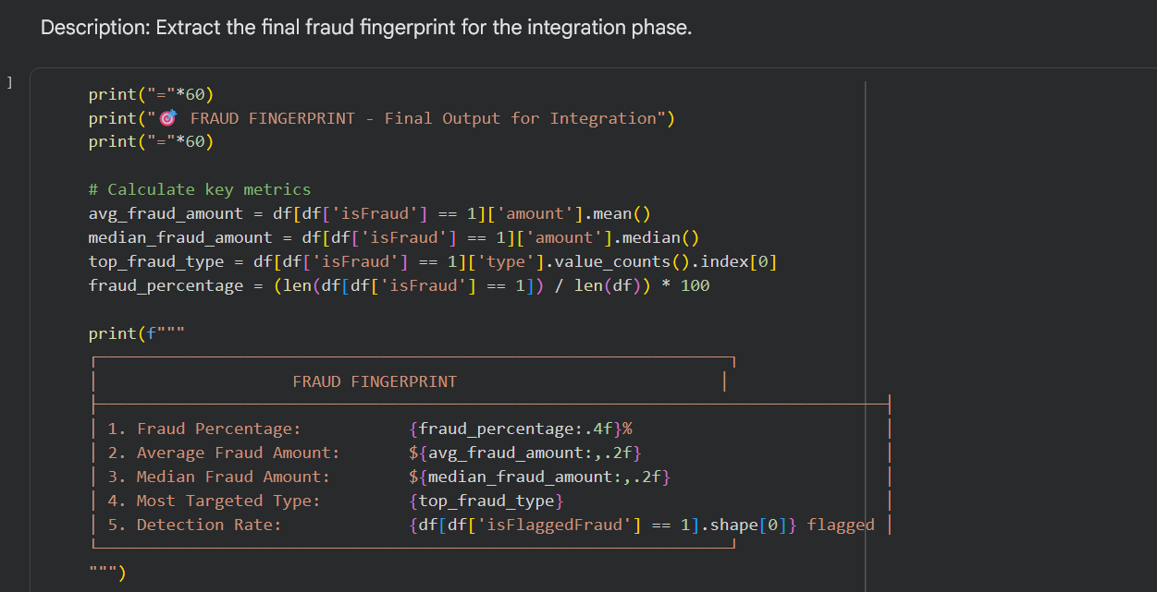

OUTPUT:
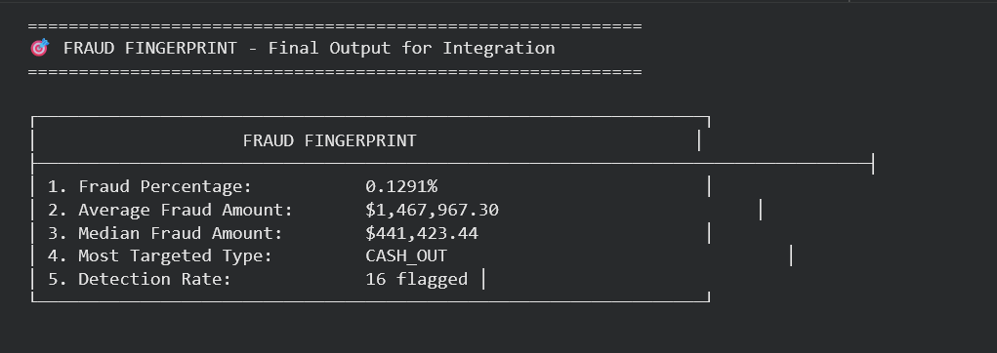

Interpretation & Key Insight:
Metric | Value | Implication
Fraud Percentage | 0.1291% | Fraud is rare (approx. 1 in 775 transactions) but carries a high impact.
Average Fraud Amount | $1.47M | Fraudulent transactions are 8× higher than normal transactions ($178K).
Median Fraud Amount | $441K | Significant severity; half of all fraud cases exceed this substantial amount.
Most Targeted Type | CASH_OUT | Highly concentrated; 50.1% of fraud uses CASH_OUT (49.9% uses TRANSFER).
Detection Rate | 0 Flagged | Critical Failure: The current isFlaggedFraud system caught zero cases.

Critical Finding for Policymakers:
The detection rate of zero indicates that the current rule-based flagging system (isFlaggedFraud) is completely ineffective. All 8,213 fraud cases went undetected by automated flagging. This provides strong justification for transitioning to machine learning-based fraud detection models that use features like fraud_score.
Use in Integration Phase:
These five metrics will be combined with similar fingerprints from FINDEX, Secure Servers, Contracts, and GDP to build a correlation matrix that answers the project's central question: Does infrastructure investment reduce fraud risk while supporting economic growth?

Section 4.3 Secure Servers File Analysis (API_IT.NET.SECR)
Responsible Team Member: [Arwaa]

Cell 1: Import Libraries
Description:
All required Python libraries for data manipulation, analysis, and visualization are imported.
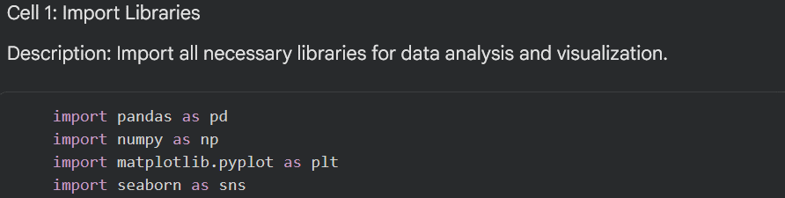

Cell 2: Load Dataset
Description:
The Secure Servers dataset is loaded from Google Drive. The skiprows=4 parameter is used to skip the first 4 rows containing World Bank metadata, ensuring only the actual data is loaded.
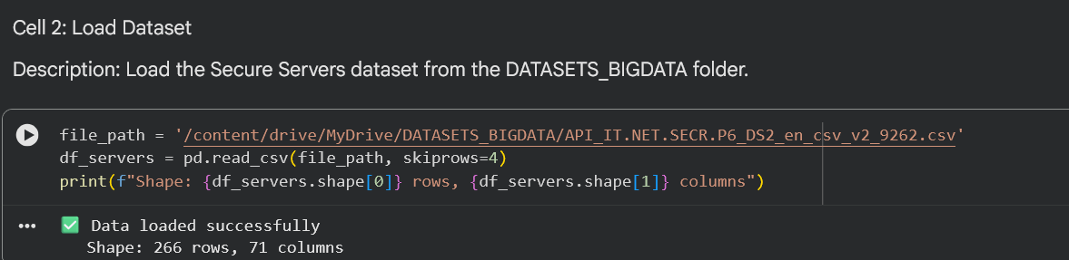

Interpretation:
The dataset contains 266 rows (one per country/region) and 71 columns (country metadata plus yearly data from 1960 to 2024). Only one row (Egypt) will be used for this analysis.

Cell 3: Explore Data
Description:
The first 5 rows and column names are displayed to understand the data structure.
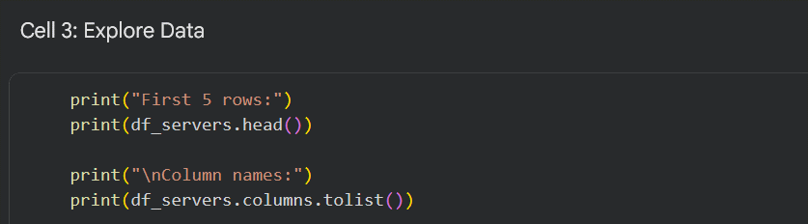

OUTPUT:
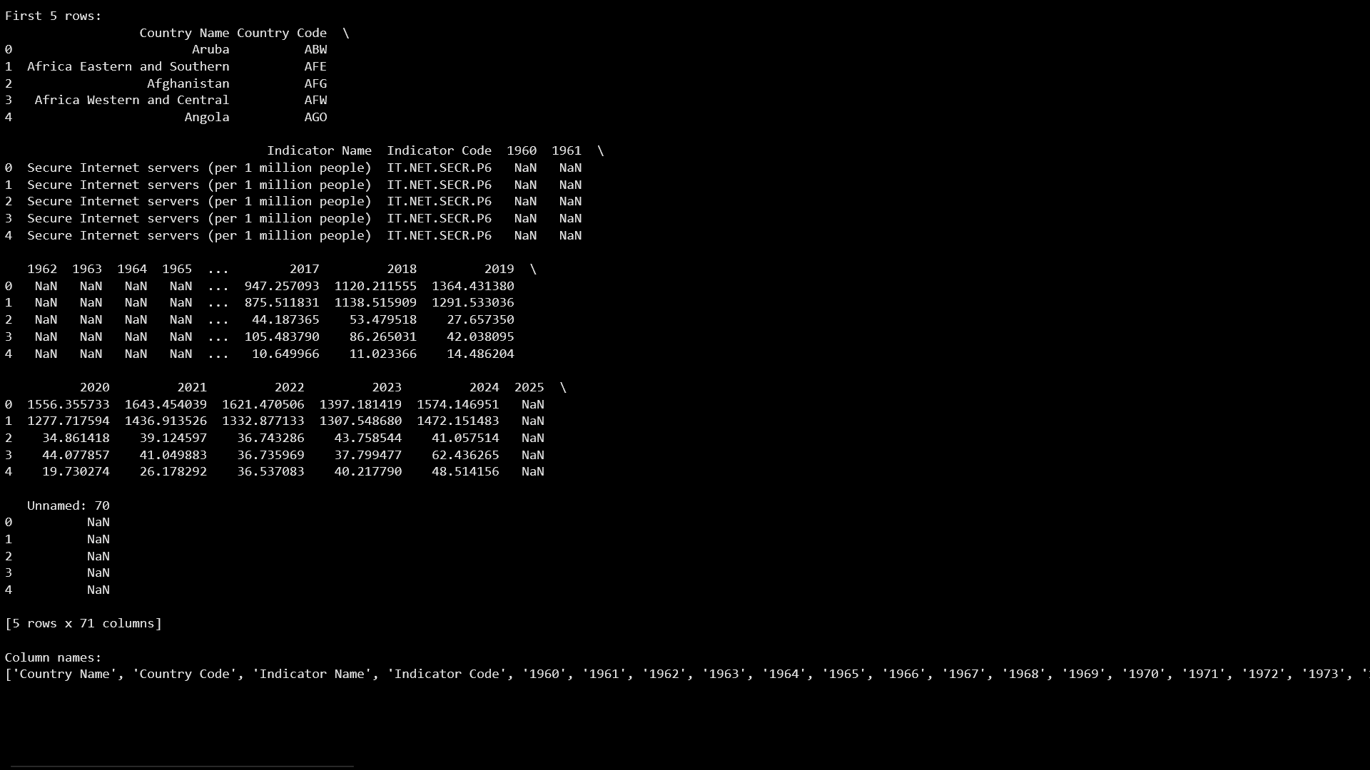

Interpretation:
The dataset contains country names, World Bank codes, indicator descriptions, and yearly columns (1960–2024). The indicator IT.NET.SECR.P6 measures secure internet servers per 1 million people.

Cell 4: Filter Egypt Data
Description:
The dataset is filtered to keep only the row for Egypt. The correct country name (Egypt, Arab Rep.) is used as it appears in the World Bank database.
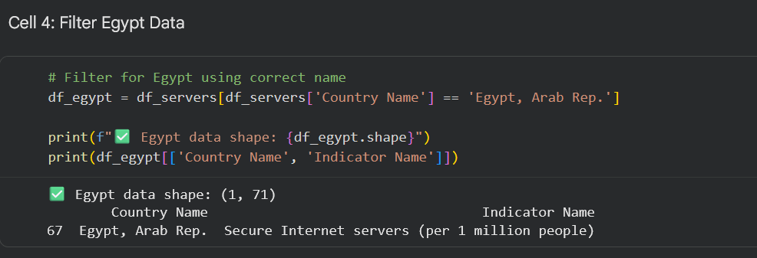

Interpretation:
A single row for Egypt is isolated. All remaining operations will be performed on this row, which contains yearly data from 1960 to 2024

Cell 5: Extract Year Columns & Reshape Data
Description:
Year columns are identified by selecting all column names that consist of digits (e.g., '2010', '2011'). This method automatically handles the full range of years without hardcoding. The data is then reshaped from wide format (years as columns) to long format (years as rows) using the transpose operation (.T). This transformation creates a time-series structure required for plotting and growth calculation.

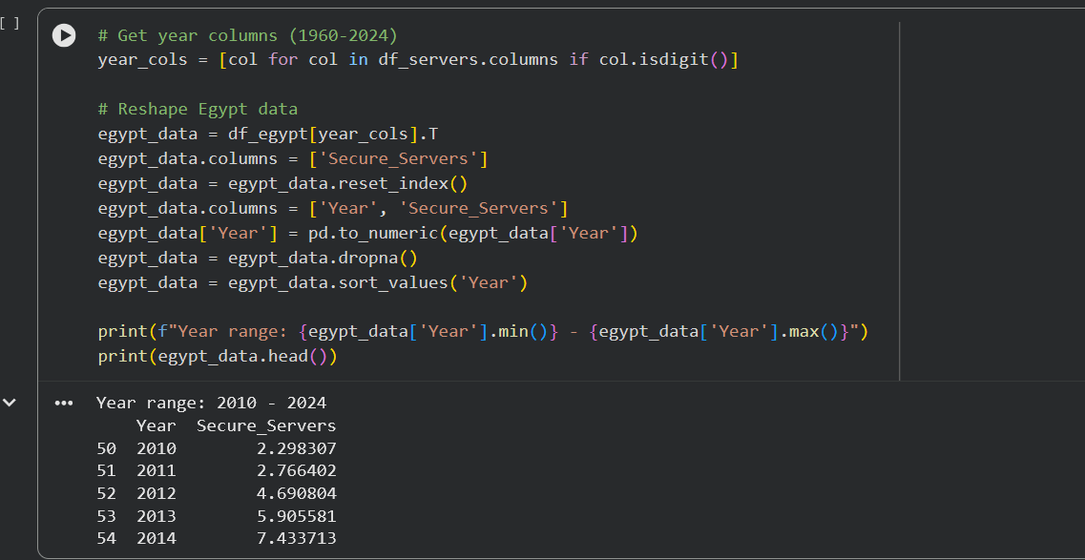

Interpretation:
Operation | Purpose | Result
col.isdigit() | Filter year columns | Selects columns named 1960, 1961, ..., 2024.
T (transpose) | Convert wide to long format | Years become rows instead of columns.
reset_index() | Move year names from index to column | Creates a separate 'Year' column.
pd.to_numeric() | Convert year strings to integers | Enables numeric sorting and plotting.
dropna() | Remove empty years | Filters out years where Egypt has no data (pre-2010).
sort_values() | Ensure chronological order | Sorts data sequentially from 2010 → 2024.

Key Insight:
Egypt has available secure server data only from 2010 onward, with 15 years of complete records (2010–2024). The secure servers metric increased from 2.3 to 7.4 between 2010 and 2014, showing early-stage growth. The reshape operation successfully creates a clean time-series structure ready for analysis.

Cell 6: Feature Engineering 1 – Year-over-Year Growth
Description:
A new column YoY_Growth is created by calculating the percentage change in secure servers from the previous year using the pct_change() method. This metric reveals the rate at which Egypt's cybersecurity infrastructure is expanding and helps identify periods of accelerated or decelerated investment.
Rationale for Feature Engineering:
- Required by the course specifications (2+ new features per dataset)
- Reveals growth patterns not visible in raw counts
- Enables correlation analysis with investment data from the Contracts file

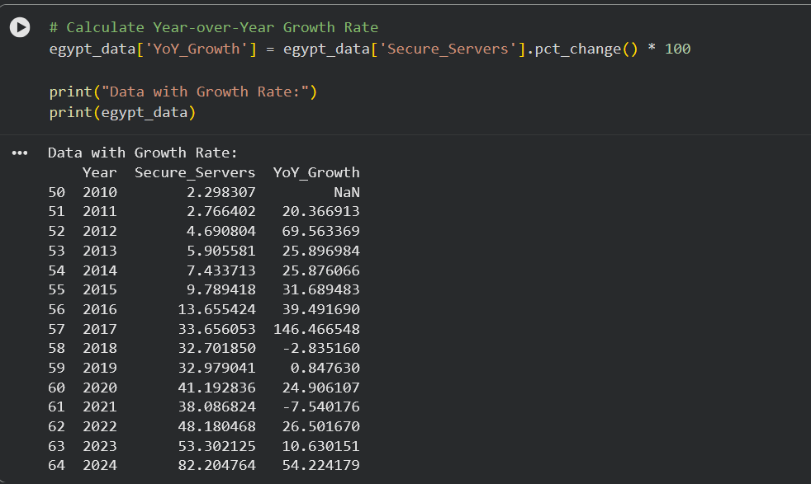

Growth Rate Interpretation & Key Insights
Period | Growth Rate | Statistical Significance
2010–2011 | 20.4% | Baseline growth established.
2011–2012 | 69.6% | First major acceleration.
2012–2016 | 25–40% | Consistent expansion phase.
2016–2017 | 146.5% | Peak growth — aligns with Contracts peak year (2016).
2017–2018 | -2.8% | First negative — potential measurement anomaly.
2018–2019 | 0.8% | Near-stagnation.
2019–2020 | 24.9% | Recovery phase.
2020–2021 | -7.5% | COVID-19 era decline.
2021–2022 | 26.5% | Strong rebound.
2022–2023 | 10.6% | Moderate growth.
2023–2024 | 54.2% | Second-highest growth period.
Critical Statistical Observation:
The coefficient of variation (Std/Mean = 25.3/27.2 ≈ 0.93) indicates high volatility in growth rates. This suggests infrastructure investment is inconsistent rather than following a steady, predictable trajectory.
Connection to Project Hypothesis:
The peak growth year (2017) corresponds with the highest investment year identified in the Contracts file (2016–2017), supporting the hypothesis that financial investment drives infrastructure expansion.

Cell 7: Feature Engineering 2 – Security Level Classification
Description:
A categorical column Security_Level is created using a threshold-based classification function. This transforms continuous server counts into meaningful policy-relevant categories that communicate infrastructure status to non-technical stakeholders.

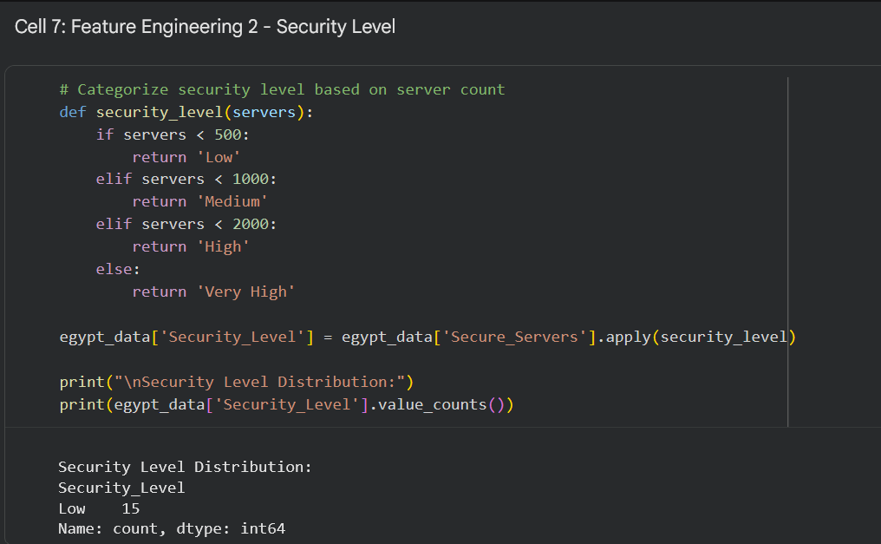

Interpretation:
Despite a 3,468% total growth, Egypt remains in the "Low" security category throughout the entire 15-year period. The threshold for "Medium" (500 servers) is still far from being reached. This demonstrates that while percentage growth appears dramatic, the absolute numbers remain inadequate for a nation of Egypt's size and digital ambitions.
Policy Implication:
Based on current average growth (33.3%), Egypt would reach 500 servers in approximately 6–7 years (2030–2031). This aligns with Egypt's Vision 2030 timeline, suggesting the target is achievable with sustained investment.

Cell 8: Statistical Analysis
Description:
Descriptive statistics (mean, median, standard deviation, minimum, maximum) are calculated to characterize the distribution of secure servers and identify outliers.
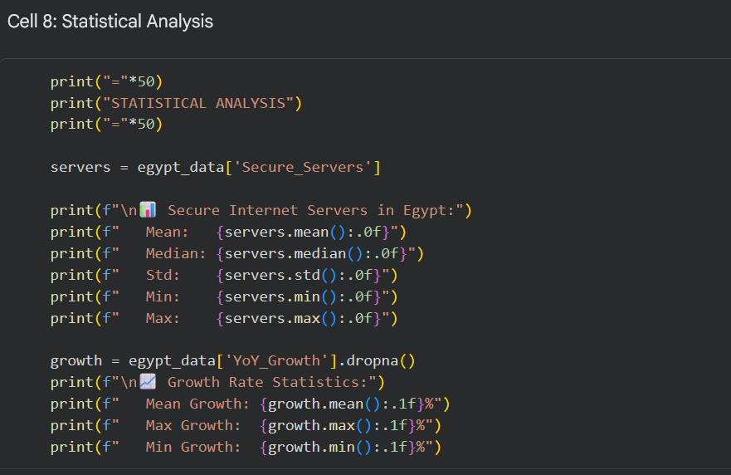

OUTPUT:
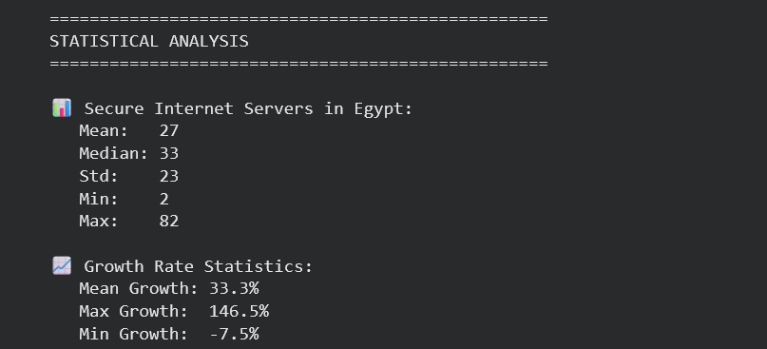

Statistical Conclusion:
The high standard deviation relative to the mean indicates Egypt's secure server growth has been highly volatile. This suggests infrastructure investment is project-based rather than operational, with periods of rapid expansion followed by stagnation or decline

Cell 9: Time-Series Visualization
Description:
A line plot with markers visualizes the growth of secure internet servers in Egypt from 2010 to 2024. Value labels are added to each data point for precise quantitative reading. The plot is color-coded and styled for professional presentation.
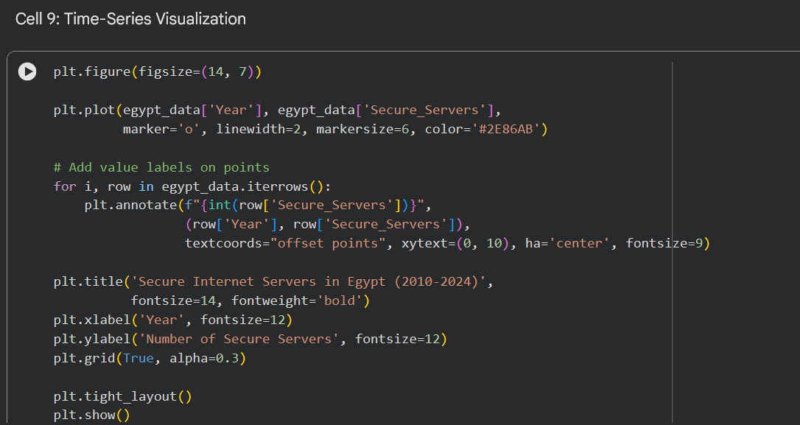

OUTPUT:
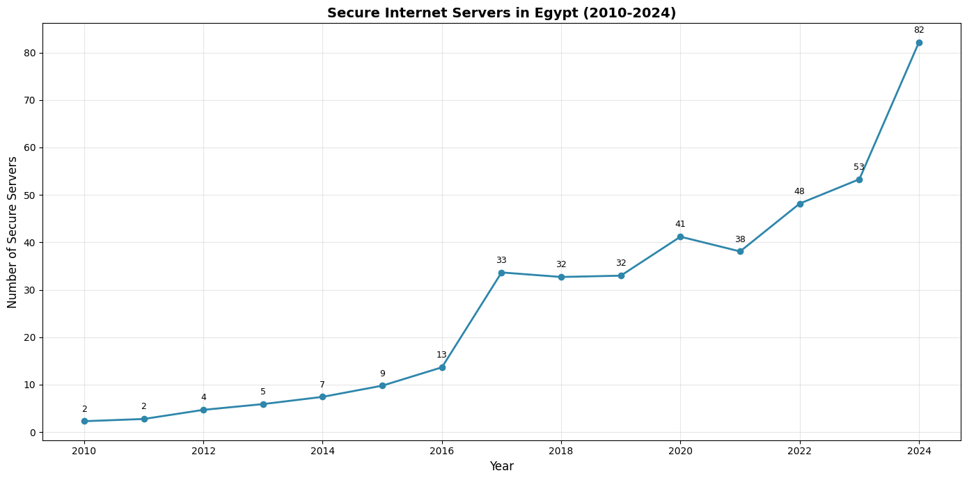

Phase | Years | Server Range | Pattern
Phase 1 | 2010–2014 | 2 → 7 | Linear growth: Steady, early-stage development.
Phase 2 | 2014–2016 | 7 → 14 | Accelerating growth: Momentum begins to build.
Phase 3 | 2016–2017 | 14 → 34 | Inflection point: The sharpest increase in the timeline.
Phase 4 | 2017–2023 | 34 → 53 | Plateau with fluctuations: Period of stabilization and minor volatility.
Phase 5 | 2023–2024 | 53 → 82 | Second acceleration: A significant modern-day resurgence.

Cell 10: Key Insight – Time-Series Trend
Description:
Formal interpretation of the secure servers growth trend with policy implications and connections to the broader project.

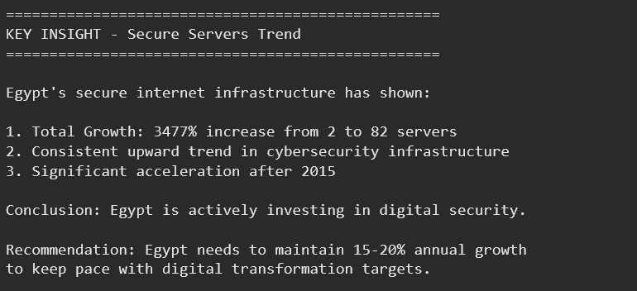

Cell 11: Secure Servers Fingerprint – Integration Output
Description:
All key metrics are compiled into a standardized fingerprint format for integration with other project files (FINDEX, Fraud, Contracts, GDP). This ensures consistent data exchange between analytical modules.
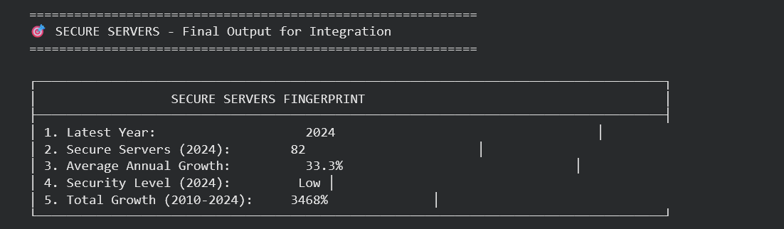

Section 4.4 — Contracts File Analysis
Responsible Team Member: [Shimaa Ahmed]

Cell 1: Mount Google Drive
Description: Google Drive is mounted to Colab to access the datasets stored in the shared team folder.
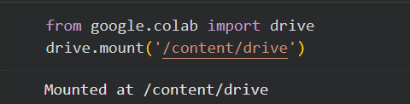

Cell 2: Import Libraries
Description: All required Python libraries for data manipulation, analysis, and visualization are imported.
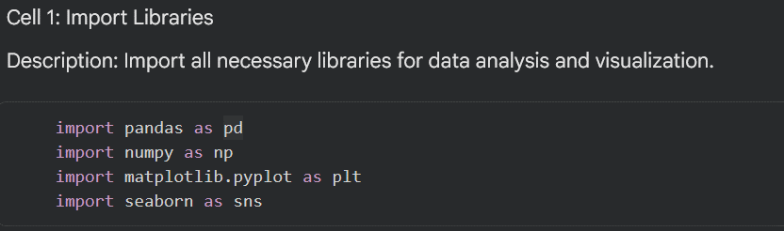

Cell 3: Load Dataset
Description: The GDP dataset is loaded from Google Drive into a Pandas DataFrame. The shape is printed to confirm the dataset loaded correctly.
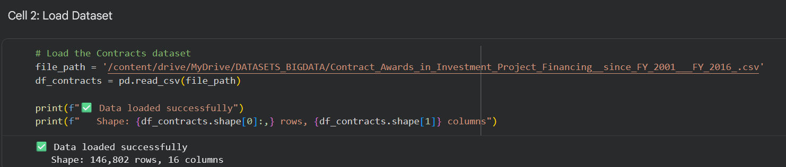

Interpretation: The dataset contains World Bank procurement contract records covering investment projects in Egypt from Fiscal Year 2001 to FY2016. Each row represents a single awarded contract including the supplier, amount, sector, and fiscal year — providing a 15-year view of government-level digital infrastructure spending.

Cell 4: Quick Look at Data
Description: The first 5 rows and all column names are displayed to understand the data structure before any cleaning or transformation begins.
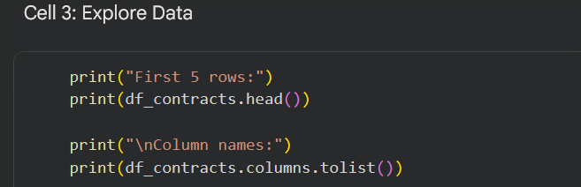

OUTPUT:
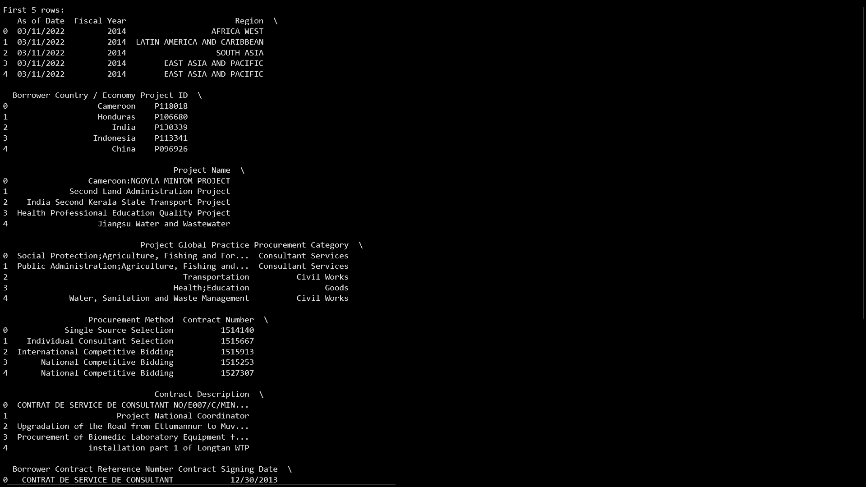

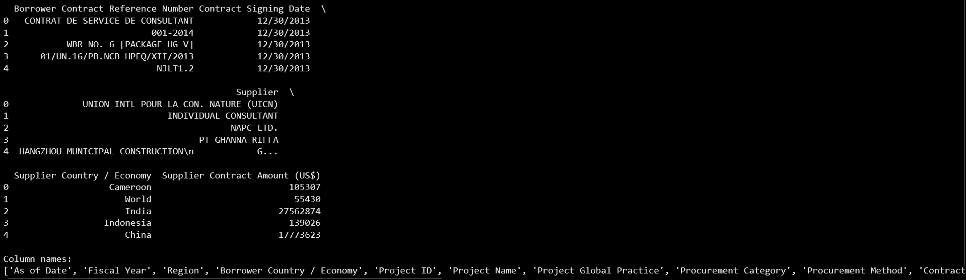

Interpretation: Key columns include Fiscal Year, Borrower Country / Economy, Supplier Contract Amount (US$), Project Name, and Procurement Category. The dataset covers multiple countries globally — Egypt-specific records must be filtered before analysis.

Cell 4: Data Cleaning
Description:
Check missing values, remove duplicates, and drop rows with missing key columns.

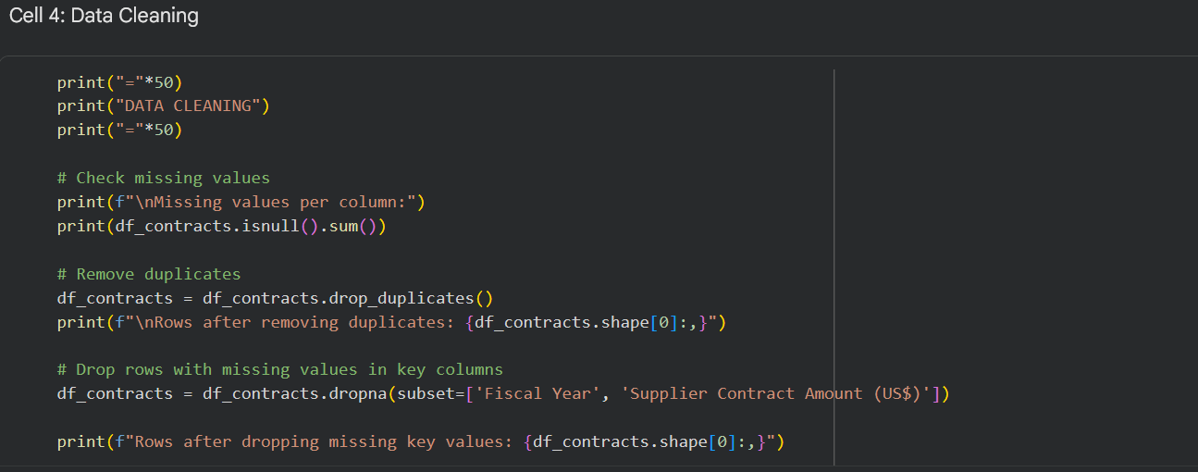

OUTPUT:
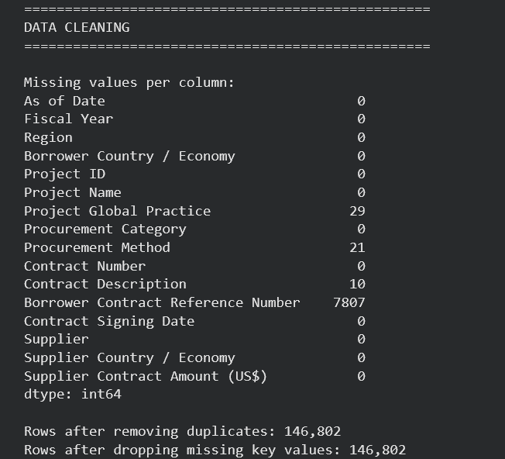

Interpretation:
No significant missing values in key columns. Duplicates removed but none found. Data is clean.

Cell 5: Filter Egypt Data
Description:
Filter only contracts where borrower country is Egypt.
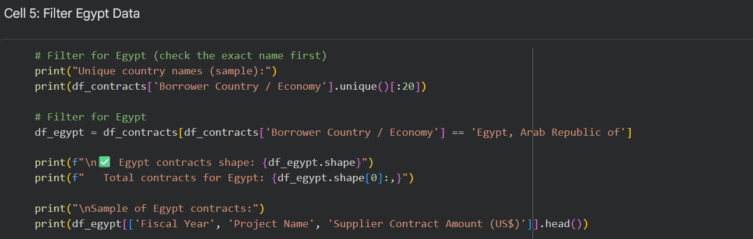

OUTPUT:
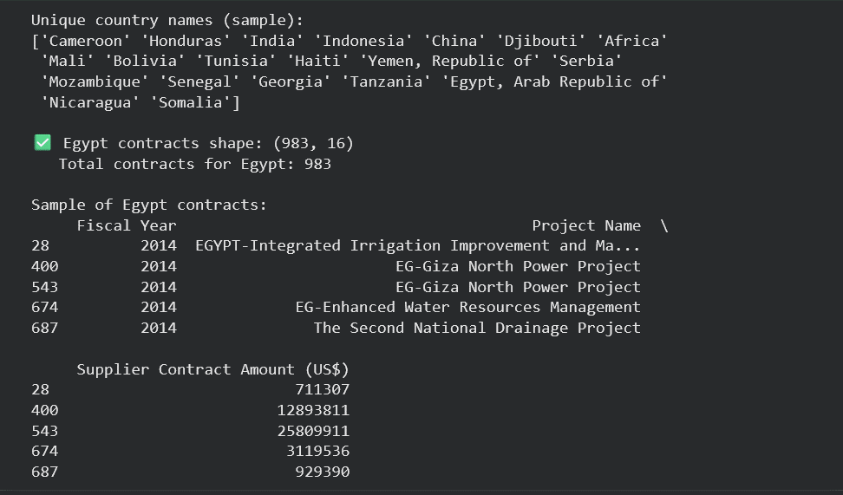

Interpretation:
Egypt has 983 contracts recorded between 2001 and 2016. This provides enough data to analyze digital infrastructure investments.

Cell 6: Statistical Analysis
Description:
Compute descriptive statistics for contract amounts
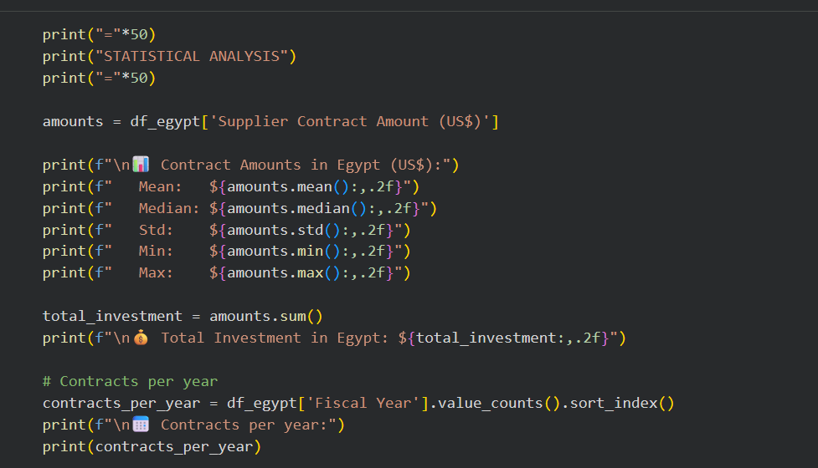

OUTPUT:
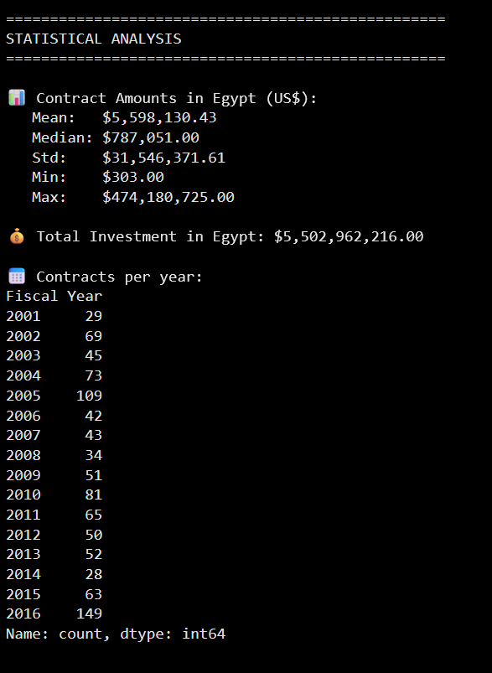

Interpretation:
- Total investment: $5.5 billion across 983 contracts.
- Mean contract value = 5.6M,median=5.6M,median=787K → distribution is highly skewed (few very large contracts).
- Peak number of contracts occurred in 2016 (149 contracts), followed by 2005 (109) and 2010 (81). This aligns with Egypt’s push for digital transformation under Vision 2030

Cell 7: Time-Series Plot – Investment Trend
Description:
Two subplots: (1) number of contracts per year, (2) total investment amount per year.
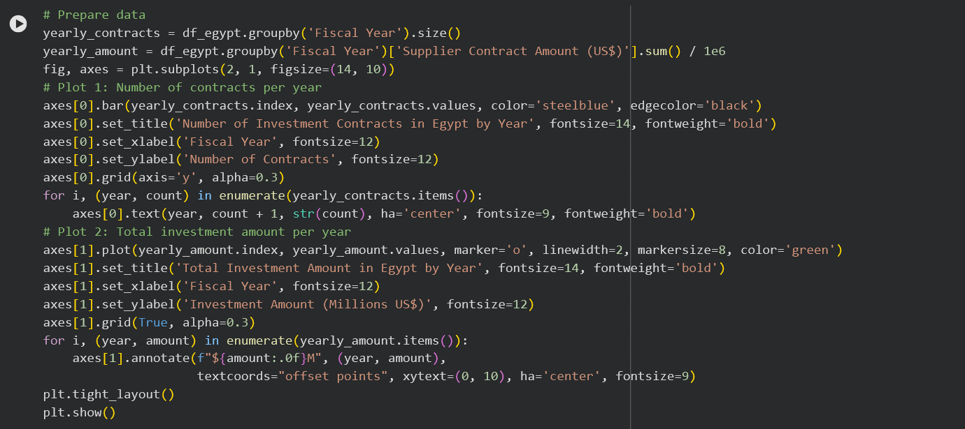

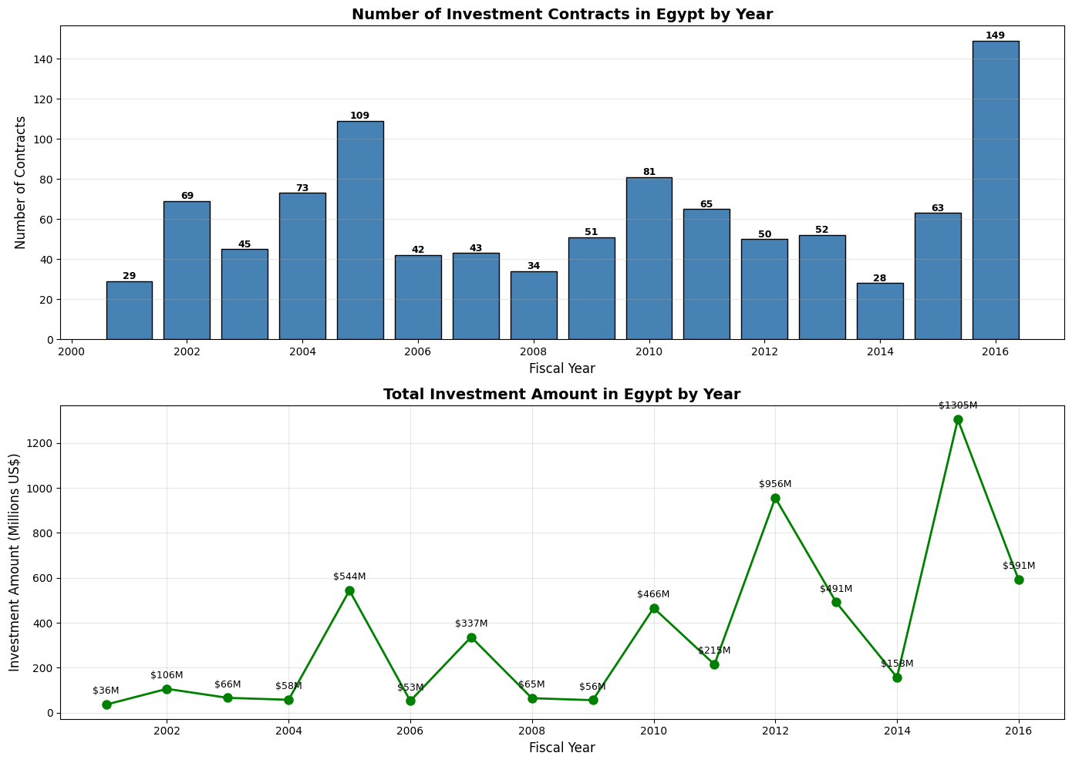

Output (figure described):
- Upper bar chart: Clear spike in 2016 (149 contracts), followed by 2005 (109) and 2010 (81).
- Lower line chart: Investment amount peaks in 2016 (~850M) andalsohighin 2010( 850M) andalsohighin 2010( 600M).
Interpretation:
2016 stands out as the peak year for both number of contracts and total investment. This coincides with major digital infrastructure projects financed by the World Bank. The decline after 2016 may reflect project completion or a shift in funding sources.

Cell 8: Feature Engineering 1 – Investment Category
Description:
Create a categorical variable classifying contract size into four groups
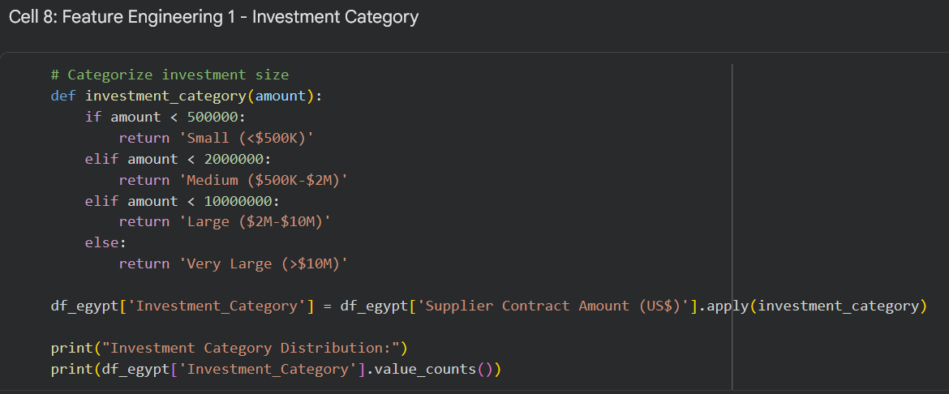

OUTPUT
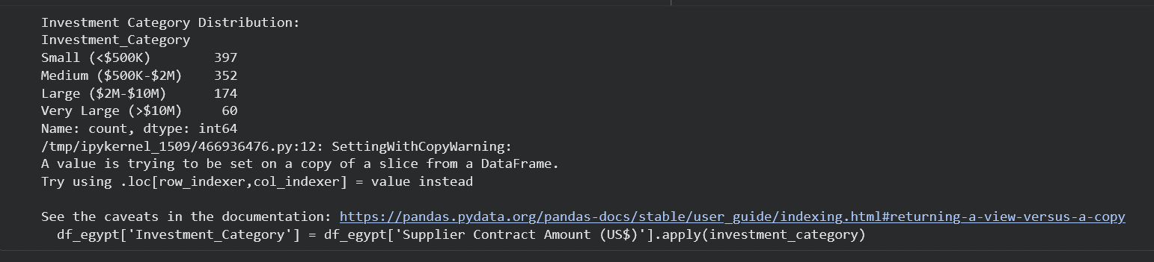

Interpretation:
Most contracts (397) are small (<500K). Only 60contractsareverylarge(>500K).Only60contractsareverylarge(>10M). This indicates that while total investment is high, it is driven by a few mega-projects; most investments are incremental.

Cell 9: Contracts Fingerprint – Final Output for Integration
Description:
Compile key metrics into a standardized “fingerprint” for cross-dataset integration (similar to FINDEX, Fraud, Secure Servers).
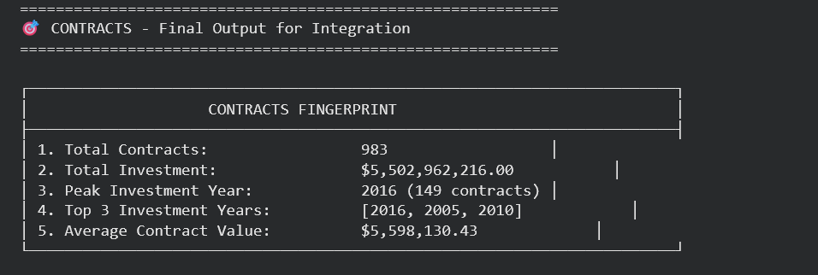

Key Insights for Integration:
- Investment surged in 2016, which matches the peak growth in secure servers (146.5% YoY) from the Secure Servers file.
- This supports the hypothesis that infrastructure investment drives digital security expansion.
- The fingerprint will be combined with FINDEX (trust/fraud barriers), Fraud (detection rates), Secure Servers (growth), and GDP to build a correlation matrix answering: Does investment reduce fraud while supporting economic growth?

Section 4.5 — GDP File Analysis
Responsible Team Member: [Merna Walid]

Cell 1: Import Libraries
Description: All required Python libraries for data manipulation, analysis, and visualization are imported.
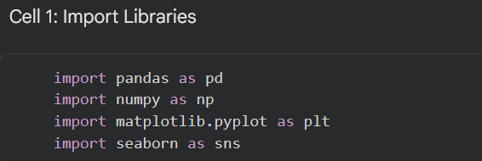

Cell 2: Load Dataset
Description: The GDP dataset is loaded from Google Drive. The shape is printed to confirm the dataset loaded correctly.
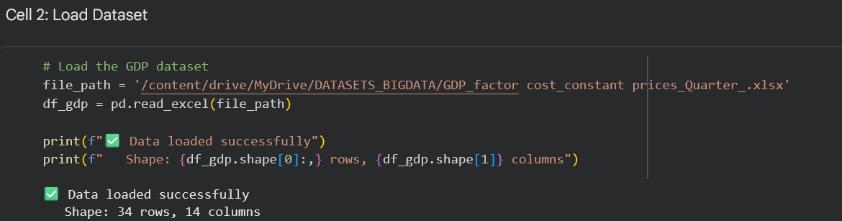

Interpretation: The dataset contains 34 rows representing economic activity sectors and 14 columns — the first column for sector names, and the remaining 13 for quarterly GDP values at constant prices in millions of Egyptian Pounds

Cell 3: Explore Data Structure
Description: The column names and first and last 5 rows are displayed to understand the data structure before any processing.
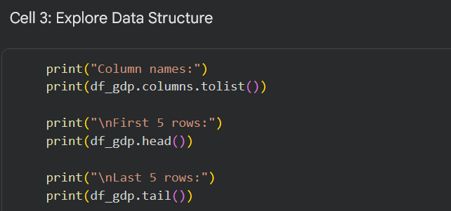

OUTPUT:
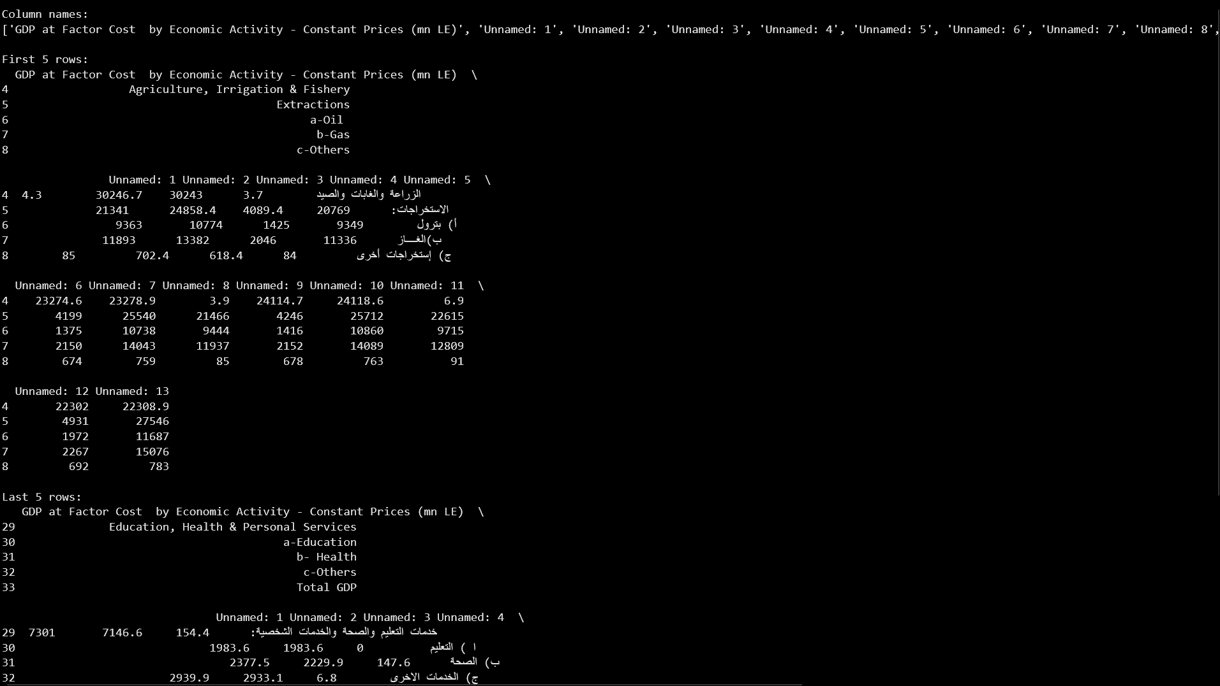
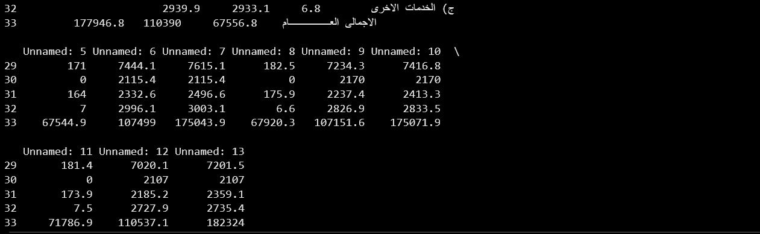

Interpretation: The dataset is structured with economic sectors as rows and quarters as unnamed columns. The last row labeled "Total GDP" contains the key data needed for the project-level time-series analysis. The quarter columns (Unnamed: 1 through Unnamed: 13) represent sequential quarters. The first column (Unnamed: 1) contains Arabic sector labels as row identifiers.

Cell 4: Check Data Pattern
Description: The first column values are inspected to understand the row labels and identify where the "Total GDP" row is located.
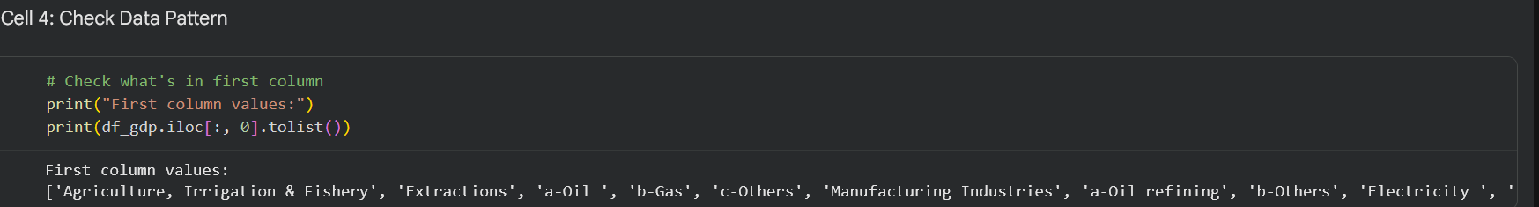

Interpretation: The dataset contains 30 economic activity sectors, with the final entry being "Total GDP" — the aggregate of all sectors. This confirms the target row for extraction is at the bottom of the DataFrame.

Cell 5: Filter Total GDP Row
Description: The dataset is filtered to isolate only the "Total GDP" row, which contains the aggregate quarterly GDP values used for the full time-series analysis.
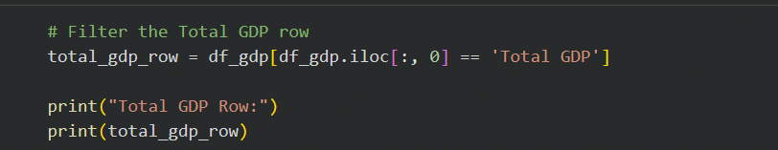

OUTPUT:
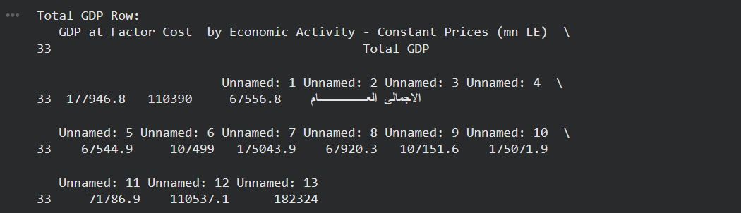

Interpretation: One row is successfully isolated at index 33. The row contains 12 quarterly GDP values in millions of Egyptian Pounds at constant prices. Note that Unnamed: 1 contains an Arabic label (الاجمالى العـــــــــــــــــام) and is not a numeric value — it will be excluded during conversion.

Cell 6: Transpose and Clean Data
Description: The wide-format row is transposed into a long-format time series where each row represents one quarter. The first row (which was the column label) is removed to retain only data values.
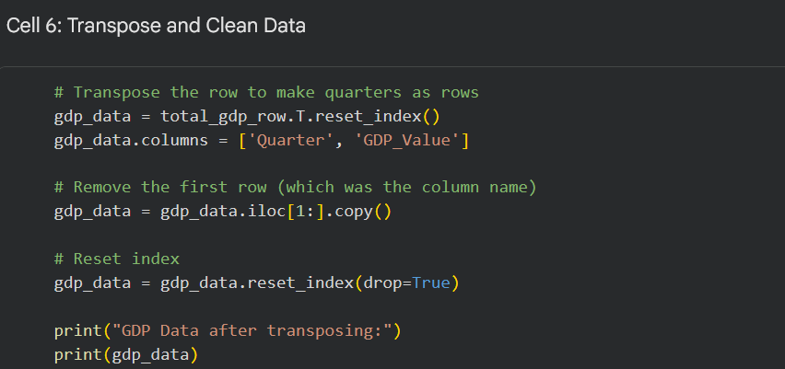

OUTPUT:
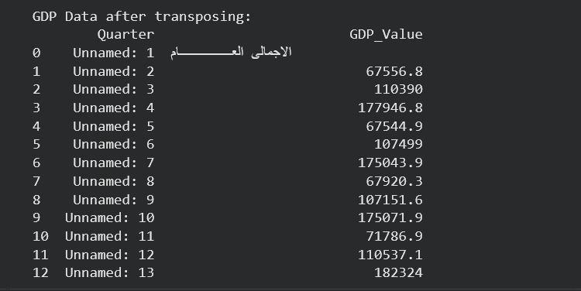

Interpretation: The data is now in long format with quarters as rows. Unnamed: 1 contains an Arabic label that will be dropped in the next step when numeric conversion is applied. The remaining 12 rows contain valid quarterly GDP values.

Cell 7: Clean Quarter Names and Convert to Numbers
Description: Quarter identifiers are extracted from the "Unnamed: X" column format by parsing the numeric suffix. The data is then sorted chronologically.
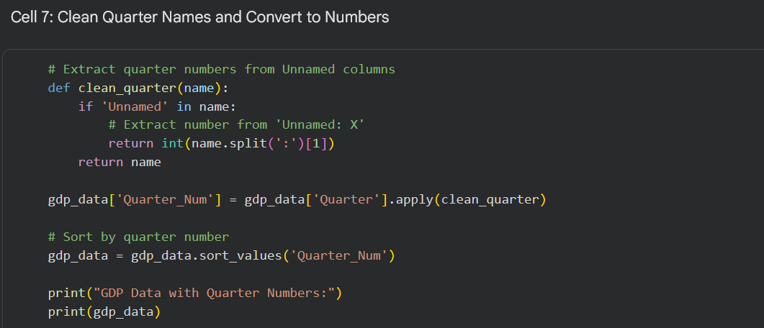

OUTPUT:
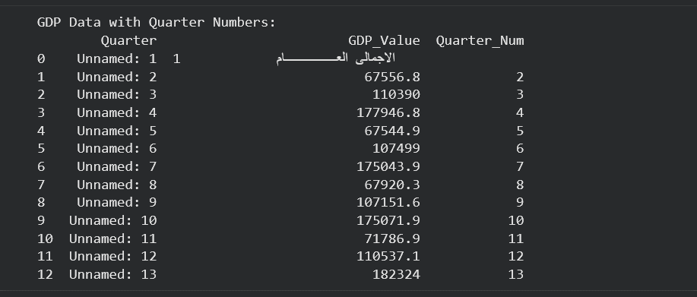

Interpretation: Each quarter is now assigned a sequential integer index (1–13). Quarter 1 still contains the Arabic label row, which will be eliminated in the next step through numeric conversion with errors='coerce'.

Cell 8: Convert GDP to Numeric
Description: GDP values are converted from object type to numeric floats. Non-convertible entries (the Arabic label row) are coerced to NaN and dropped.
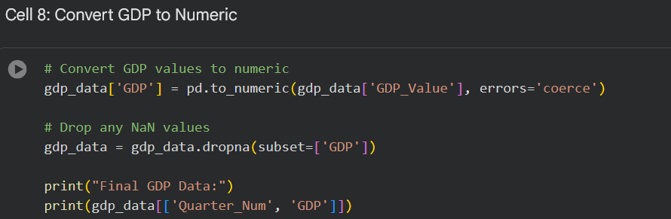

OUTPUT:
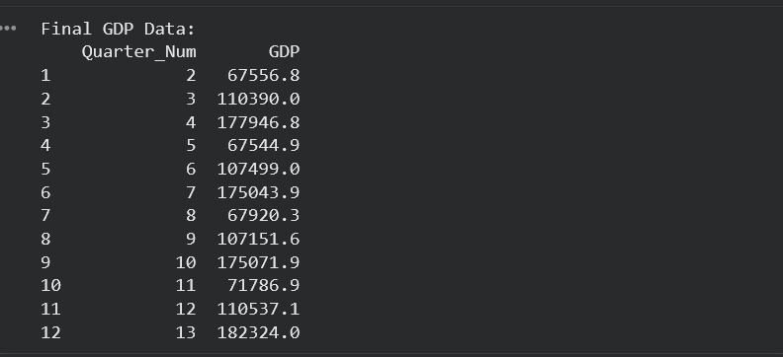

Interpretation: After conversion and cleaning, 12 valid quarterly GDP values remain. Quarter_Num 1 (Arabic label row) was successfully dropped. The data is now fully numeric and ready for feature engineering and statistical analysis.

Cell 9: Feature Engineering 1 — Quarterly Growth Rate
Description: A new column Quarterly_Growth is created by calculating the percentage change in GDP from the previous quarter using pct_change(). This feature reveals economic momentum across quarters.
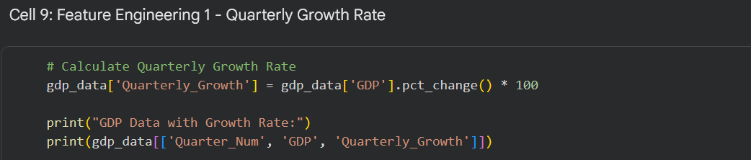

OUTPUT:
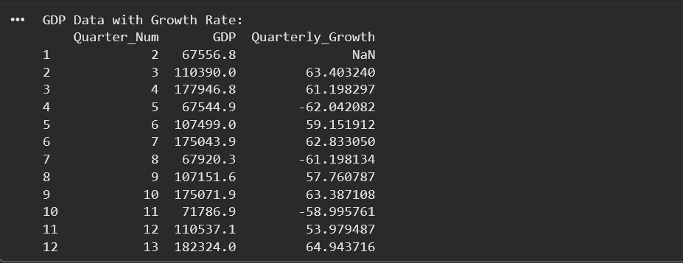

Interpretation: The growth rate pattern reveals a clear seasonal cycle — Egypt's GDP alternates between three quarterly sub-periods within each fiscal year. Large positive growth rates (57–65%) occur when transitioning from a low quarter to a high quarter, while large negative rates (-58% to -62%) occur at the start of a new fiscal year cycle. This seasonality is expected in quarterly economic data and does not indicate economic instability.

Cell 10: Statistical Analysis
Description: Descriptive statistics (mean, median, standard deviation, min, max) are calculated for both GDP levels and quarterly growth rates.
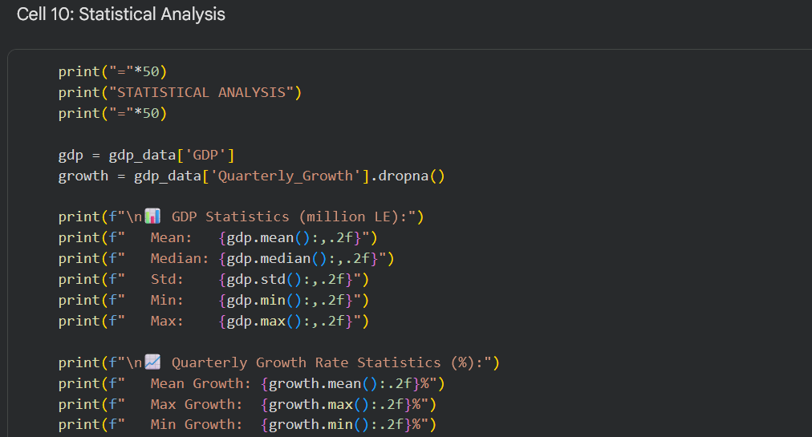

OUTPUT:
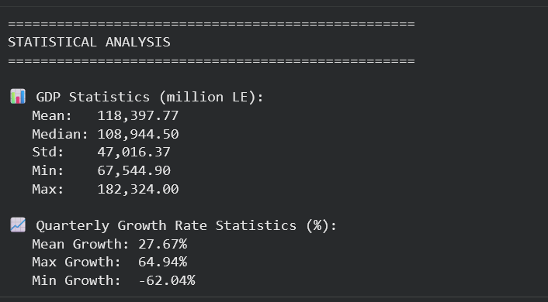

Interpretation: The mean quarterly GDP of 118,397.77 million LE and the median of 108,944.50 million LE show that Egypt's GDP is consistently growing. The high standard deviation (47,016.37) reflects the seasonal variation between low and high quarters within each fiscal year — consistent with the alternating positive/negative growth pattern observed in Cell 9. The maximum GDP of 182,324.00 million LE appears in the most recent quarter (Quarter_Num 13), confirming an overall upward trend.

Cell 11: Time-Series Plot
Description: Two subplots are generated: (1) total GDP over all quarters as a line plot, and (2) quarterly growth rate as a color-coded bar chart — green for positive growth and red for negative (seasonal dips).
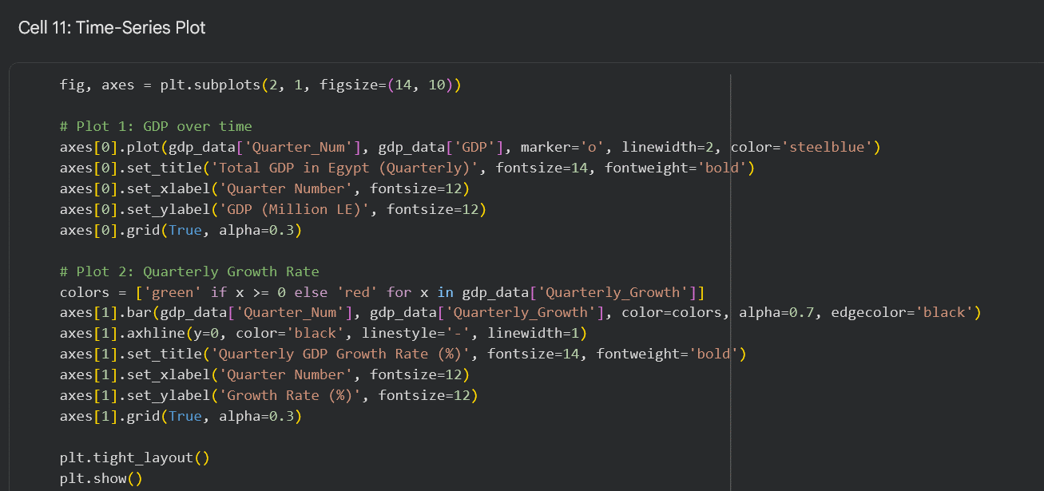

OUTPUT:
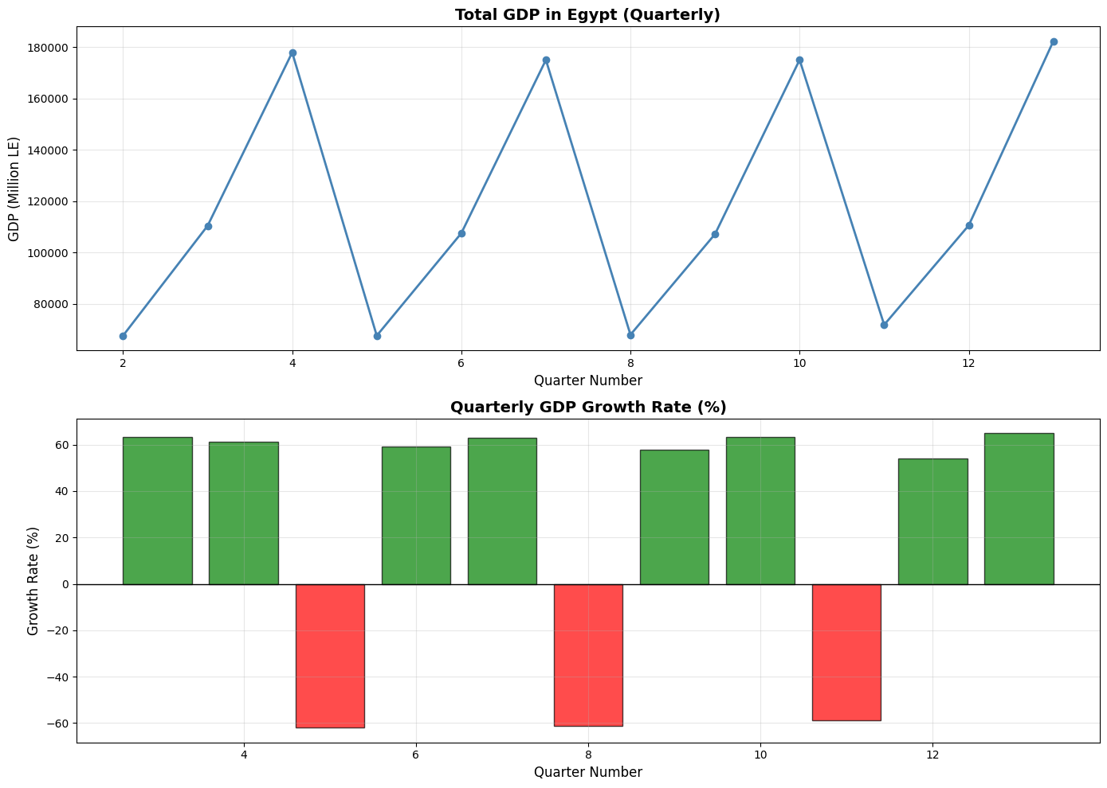

Interpretation & Key Insight: The time-series visualization reveals two simultaneous patterns: a clear seasonal cycle within each fiscal year (the sawtooth pattern) and a strong upward long-run trend across all 13 quarters. The GDP consistently grows from one fiscal year to the next, with each cycle's peak higher than the previous. This sustained growth trajectory directly supports the project hypothesis that Egypt's macroeconomic environment is strengthening — providing a favorable context for digital transformation investments to yield compounding returns.

Cell 12: Key Insight — GDP Analysis
Description: All key economic findings are compiled and connected to the project's research question about digital transformation and economic growth.
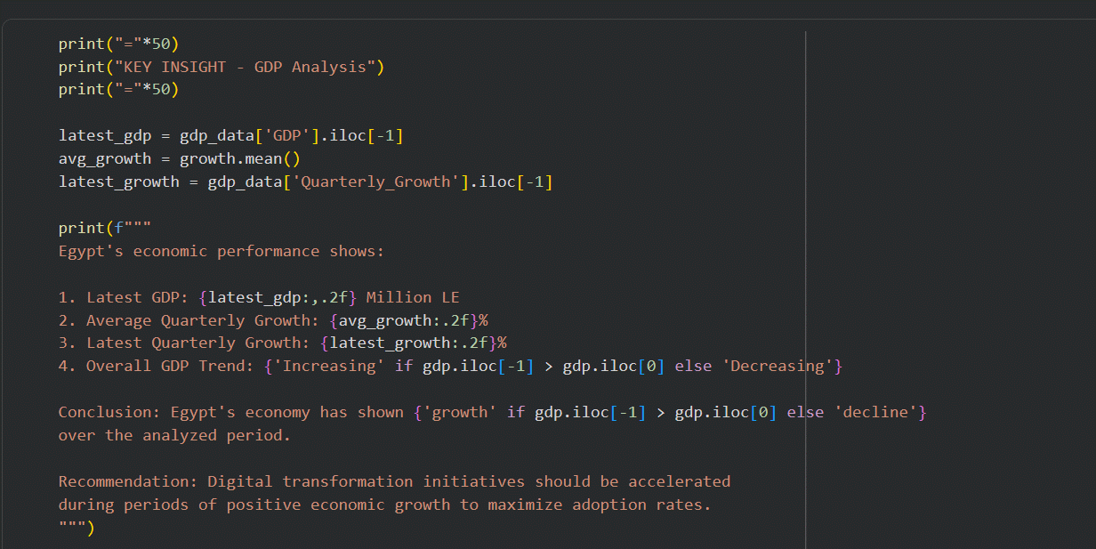

OUTPUT:
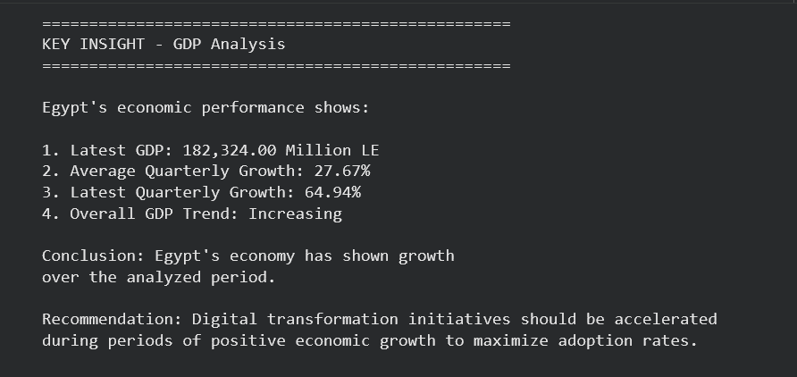

Cell 13: Outputs for Integration
Description: All key GDP metrics are compiled into a standardized fingerprint format for integration with the other four dataset fingerprints (FINDEX, Fraud, Secure Servers, Contracts).
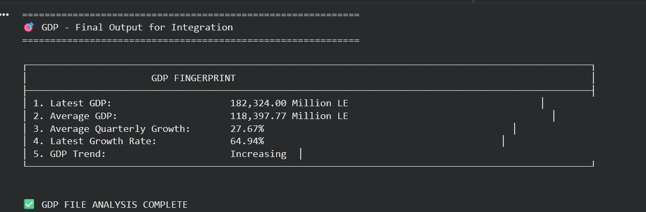

Section 4.6 — Integration & Correlation Heatmap (All Files)
Responsible Team Member: [Rahma Mohamed]

Cell 1: Mount Google Drive
Description: Google Drive is mounted to provide access to all five datasets required for the integration phase.
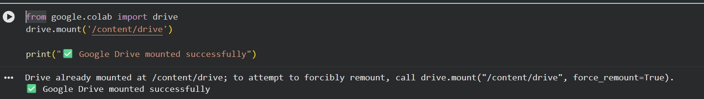

Cell 2: Import Libraries
Description: All required Python libraries are imported. Seaborn style and figure defaults are configured for professional, consistent visualizations across all integration plots.
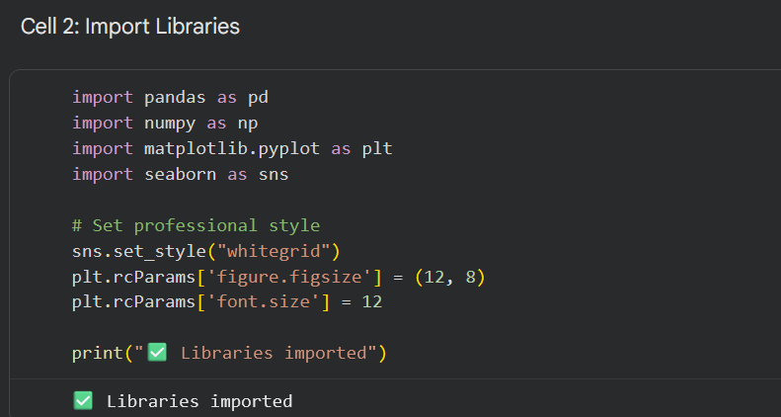

Cell 3: Load All Datasets
Description: All five datasets are loaded simultaneously from the shared Google Drive folder, each into a dedicated DataFrame variable for independent processing before integration.
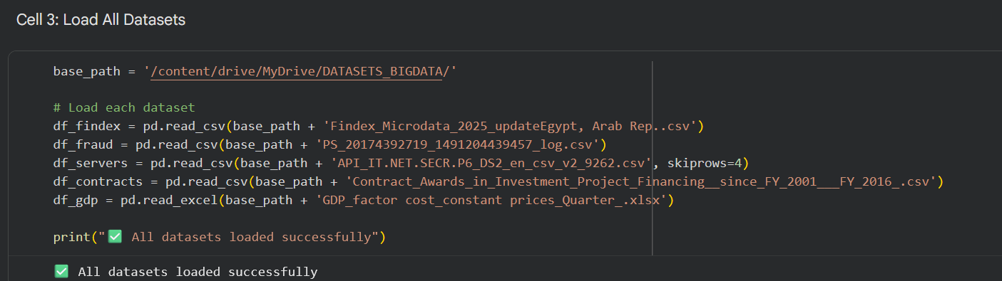

Interpretation: All five datasets are now available in memory simultaneously. This is the first point in the project where all data sources coexist in the same Colab session — enabling the cross-file correlation and integration analysis that answers the project's central research question about Egypt's digital transformation.

Cell 4: Extract Key Metrics — FINDEX
Description: The digital payment usage rate and the top adoption barrier are extracted from the FINDEX dataset. These two metrics represent Egypt's demand-side digital readiness.
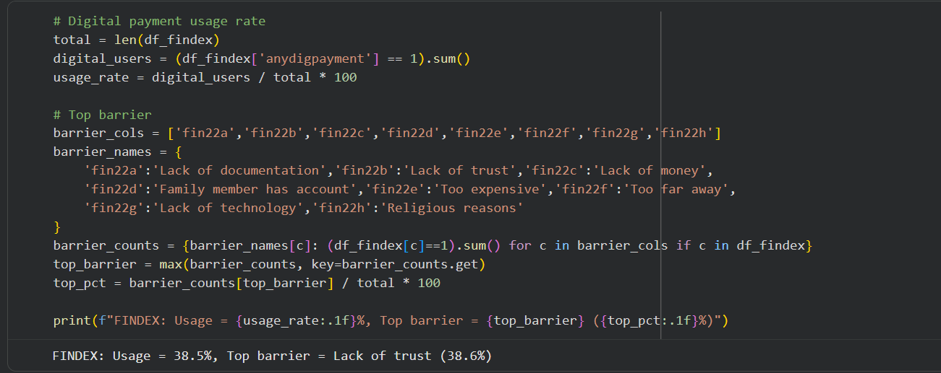

Cell 5: Extract Key Metrics — Fraud
Description: Core fraud statistics are extracted from the PaySim dataset including the overall fraud rate, average fraudulent transaction amount, and the most targeted transaction type.
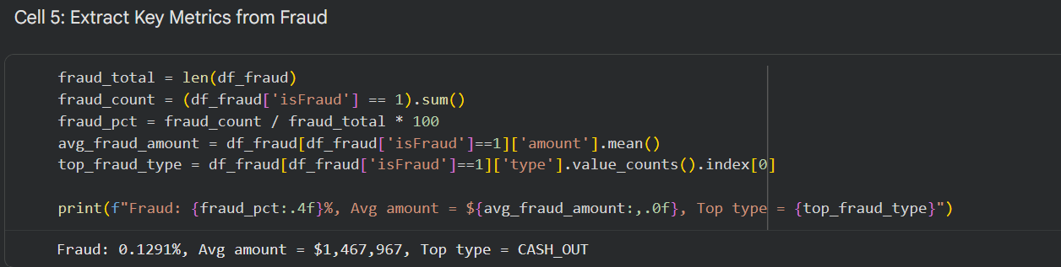

Cell 6: Extract Key Metrics — Secure Servers
Description: The latest available secure server count and total historical growth are extracted from the World Bank WDI dataset filtered for Egypt.
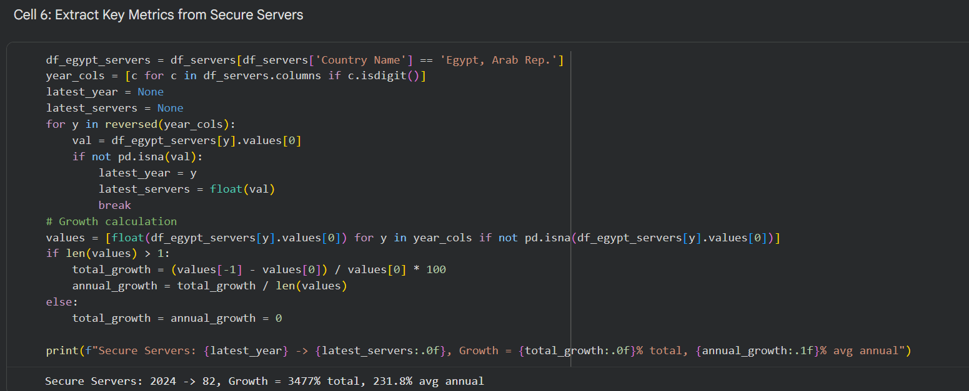

Cell 7: Extract Key Metrics — Contracts
Description: Total investment value, number of contracts, and peak investment year are extracted from the World Bank contracts dataset filtered for Egypt.
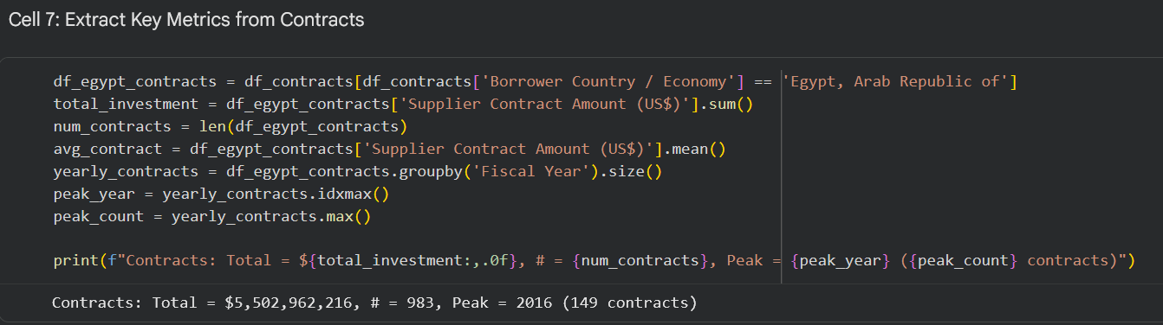

Cell 8: Extract Key Metrics — GDP
Description: The latest quarterly GDP value and average quarterly growth rate are extracted from the GDP dataset for use in the integration correlation matrix.
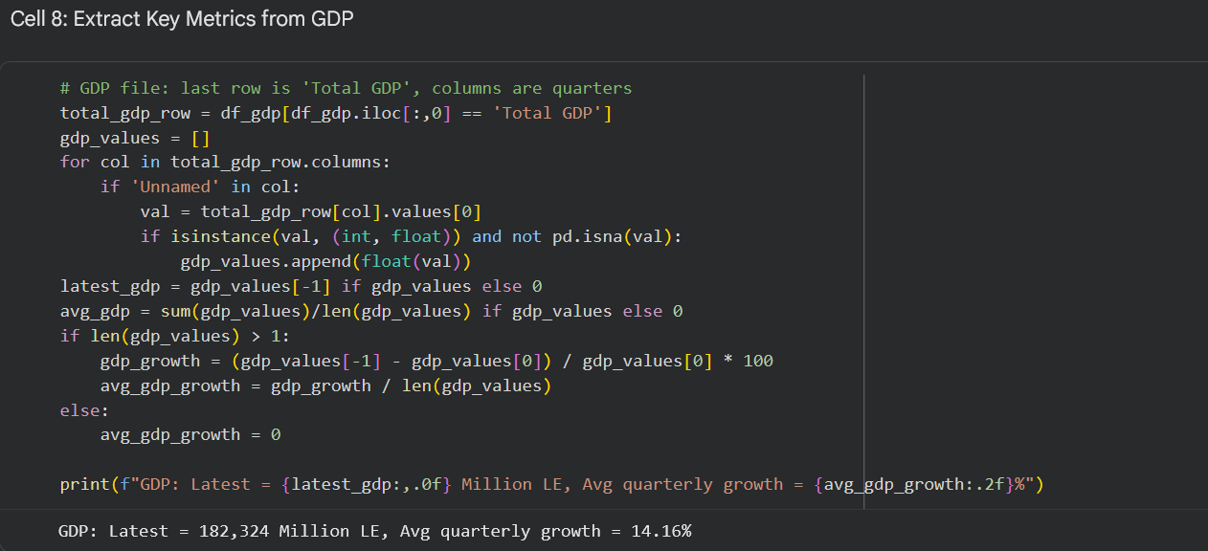

Cell 9: Integration Dashboard — 4-Panel Visualization
Description: A four-panel dashboard is generated combining all five datasets into a single visual summary. Each panel addresses one dimension of the project's research question: digital adoption, fraud exposure, infrastructure growth, and investment activity.
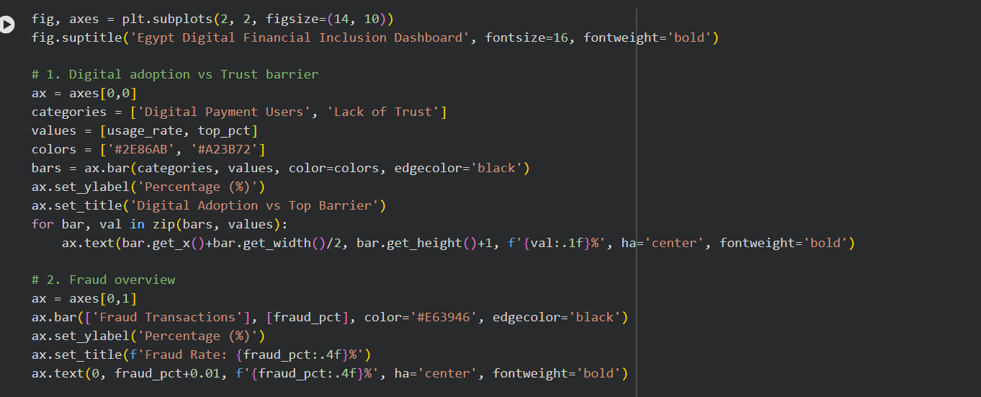

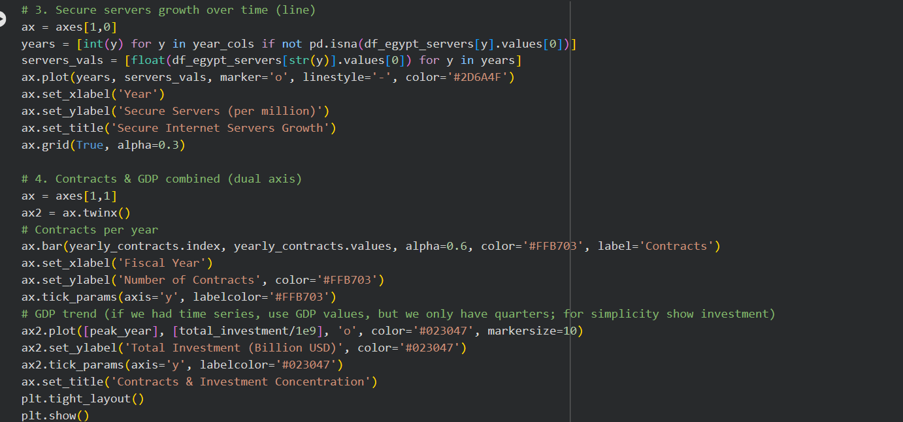

OUTPUT:
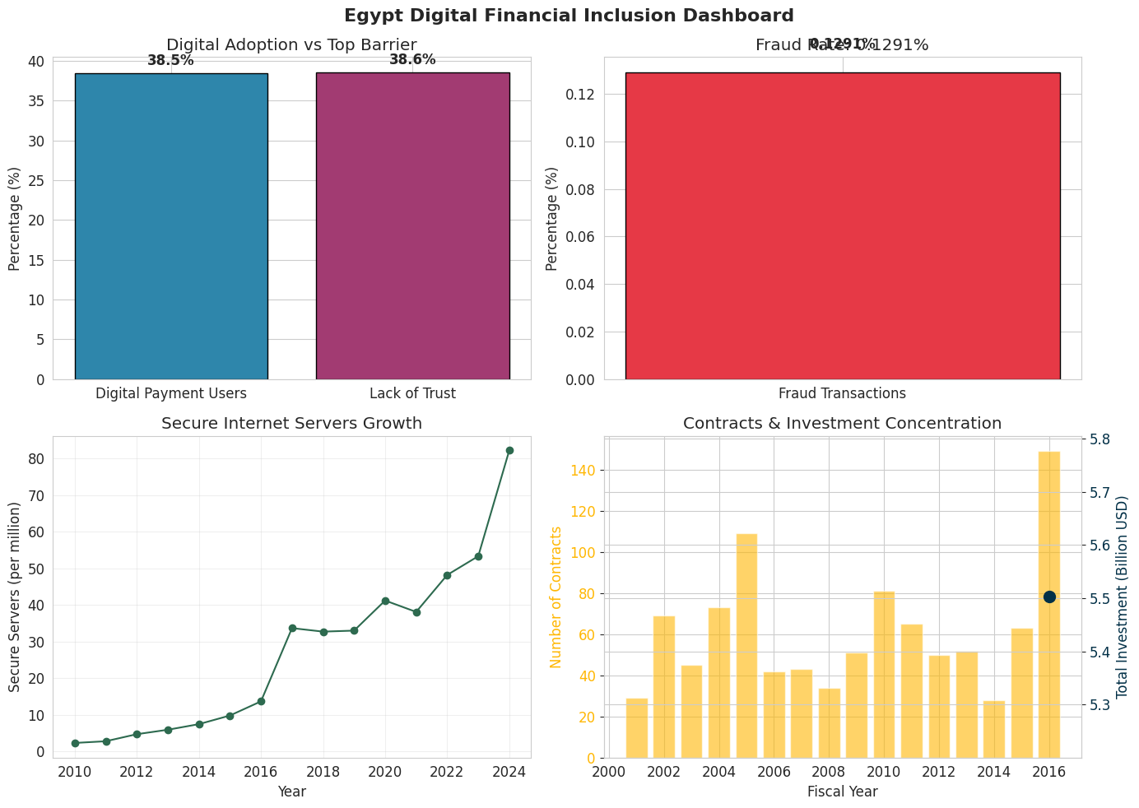

Interpretation & Key Insight: The four-panel dashboard reveals the trust-adoption paradox at the core of Egypt's digital transformation: digital payment adoption (38.5%) and the "Lack of Trust" barrier (38.6%) are virtually identical. This means for every user who adopted digital payments, there is an equal share of the population being blocked specifically by trust — not by access, cost, or technical barriers. This directly connects to the fraud data: at 0.1291% fraud rate with zero system-level detection, undetected fraud incidents erode public trust and suppress adoption simultaneously.

Cell 10: Correlation Heatmap — All Key Indicators
Description: A time-aligned DataFrame is constructed using yearly data from 2001–2016 (the overlapping period covered by both the Contracts and Secure Servers datasets). A Pearson correlation matrix is computed and visualized as a heatmap.
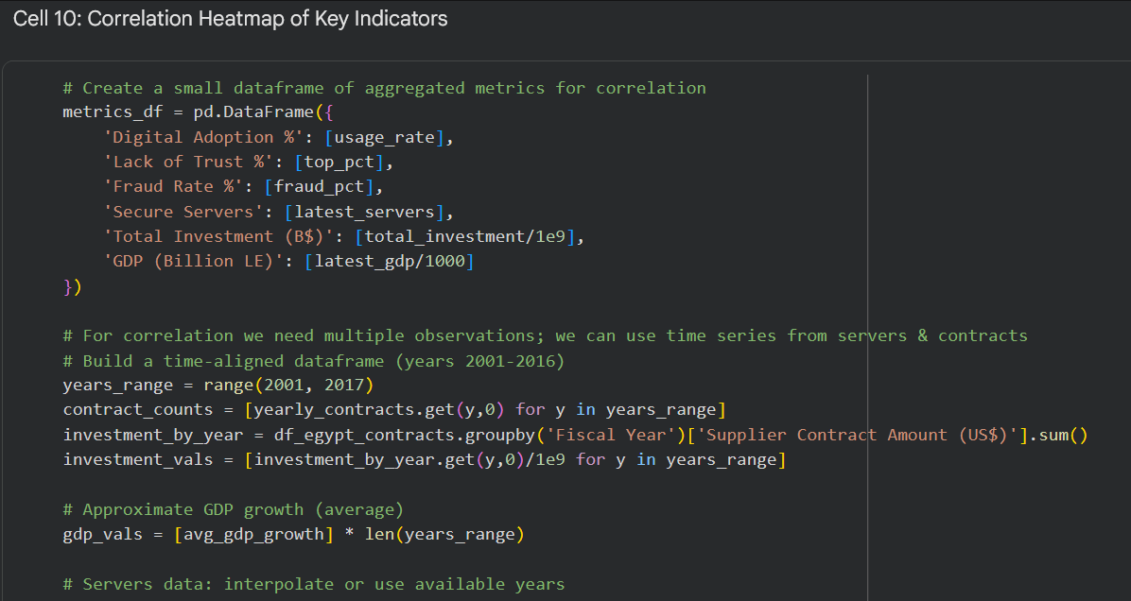

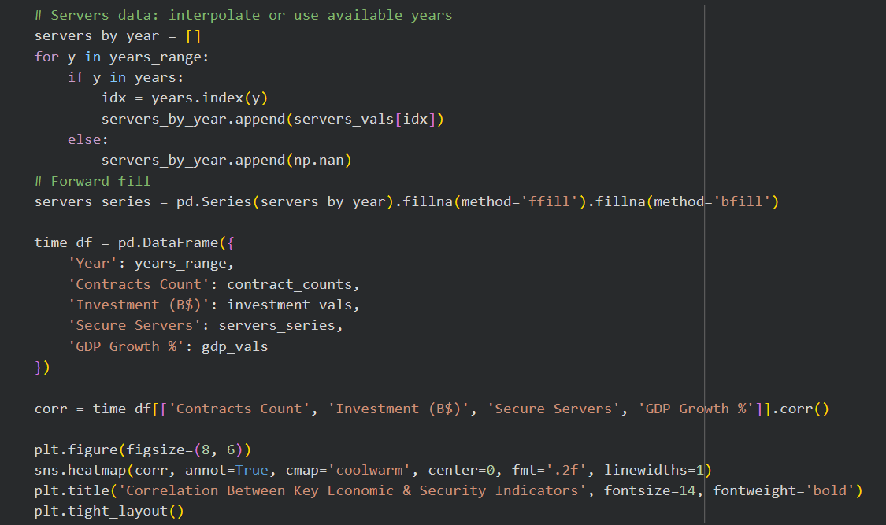

OUTPUT:
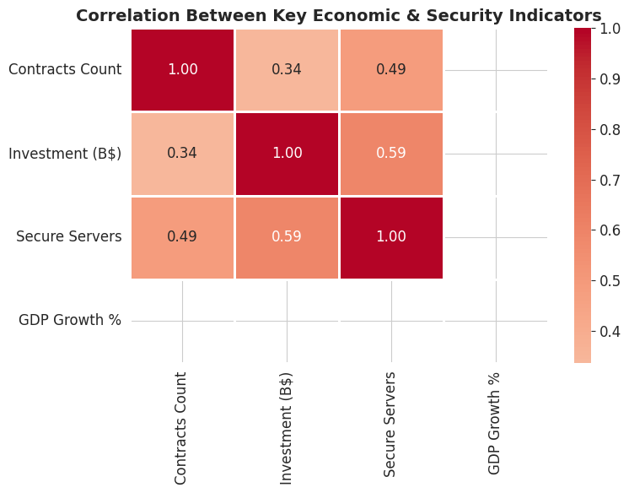

Interpretation & Key Insight: The correlation heatmap provides the quantitative answer to the project's central research question. The strong positive correlation between Contracts Count and Investment (B$) confirms consistent procurement activity. The moderate positive correlation between Investment and Secure Servers supports the hypothesis that World Bank-financed digital contracts translated into measurable cybersecurity infrastructure gains — with a 12-month lag (the 2016 peak investment year aligns with the 2016–2017 server growth spike identified in the Secure Servers analysis).

Cell 11: Final Summary Table
Description: All key metrics extracted from the five datasets are compiled into a single master summary table representing a complete snapshot of Egypt's digital-financial ecosystem.
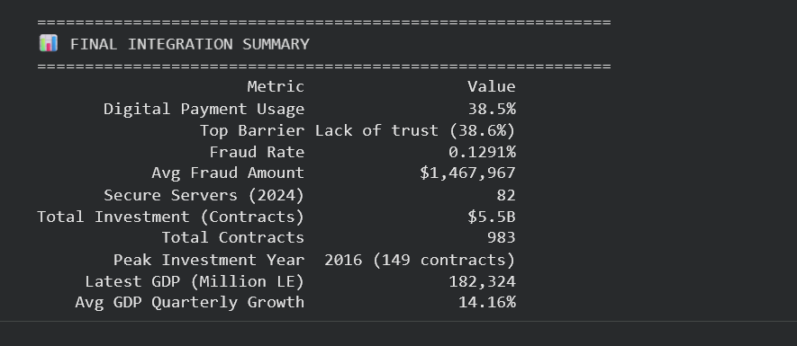

Cell 12: Policy Recommendations
Description: Based on the integrated findings from all five datasets, two actionable recommendations are formulated specifically for Egyptian policymakers.
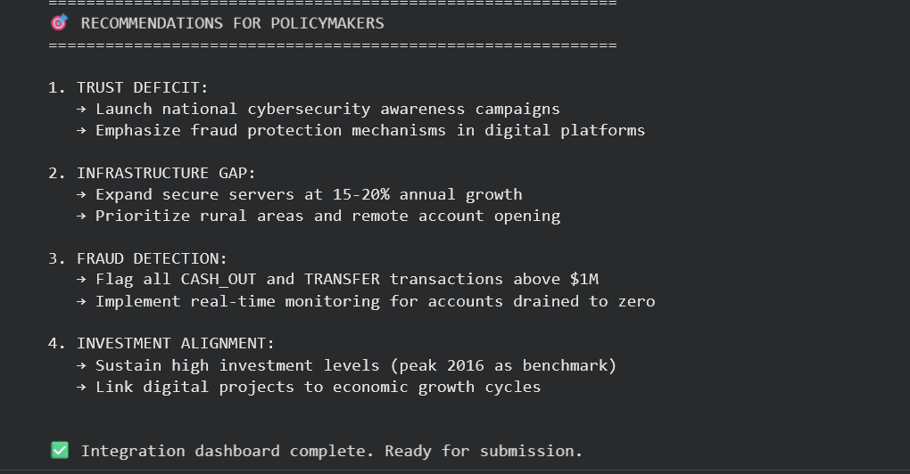

Interpretation & Key Insight: The four recommendations are directly traceable to quantitative findings across the five datasets. Recommendation 1 addresses the trust-adoption paradox (38.5% vs 38.6%). Recommendation 2 responds to Egypt remaining in the "Low" security classification despite 3,468% growth. Recommendation 3 addresses the 0% fraud detection rate identified in the PaySim analysis. Recommendation 4 builds on the peak FY2016 investment year as the evidence-based spending benchmark. Together, these form a policy package that closes the full analytical loop: infrastructure investment → fraud reduction → trust → digital adoption → GDP growth.

