  - BSc (Hons) in Software Engineering | Year 3
  - SE3070 - Case Studies in Software Engineering

Smart Wildlife Conservation and Anti-Poaching Monitoring System
  - Assignment 01
Functional and Interaction Design
Prepared for the Department of Wildlife Conservation of Sri Lanka. A complete proposed design covering the shared group model and four individual scenario packages.

Group details
Member | Name / student ID | Individual allocation
1 | [Enter name and ID] | UC01 - Patrol operations
2 | [Enter name and ID] | UC02 - Wildlife incidents
3 | [Enter name and ID] | UC03 - Conflict response
4 | [Enter name and ID] | UC04 - Conservation reporting
Group number: [Enter] Tutorial group: [Enter] Lecturer: [Enter]
Prepared: 4 September 2026 | Version 2.0 | Aligned to the highlighted requirements
Source basis: the supplied case study, assignment specification and highlighted requirements screenshot. All interface values are fictional examples; no external research or executed user-study results are claimed.

Document guide and assignment alignment
This report follows the highlighted Assignment 01 requirements: 2 shared group deliverables plus 5 individual components for each of 4 members, giving 22 required components in one document. Each low- or high-fidelity deliverable is a linked screen flow rather than an unrelated single screen.
Required item | Included in this document
Group deliverables | One high-level use case diagram (4 business use cases); one complete class diagram.
Each member: five components | One detailed scenario, one sequence diagram, one storyboard, one low-fidelity flow and one high-fidelity flow.
Four distinct packages | Member 1: UC01; Member 2: UC02; Member 3: UC03; Member 4: UC04. All diagrams are embedded.

Assessment coverage
Component | Ownership | Marks
Four-use-case diagram | Group | 25
Class diagram | Group | 25
Detailed scenario | Each member | 10
Sequence diagram | Each member | 15
Storyboard | Each member | 5
Low-fidelity wireframe | Each member | 5
High-fidelity wireframe | Each member | 15
The assignment contributes 20% of the module. Each member must own a different use case. Shared diagrams require collaborative review; this draft does not assert that group contributions have already occurred. [S2]
The Lecture 02 scenario template was not provided. The complete standard fields used here can be relabeled to match it without changing the design. The stated release date is 14/08/2026, but the deadline says 05/09/2025; confirm the correct deadline in the LMS. [S2]

1. Project overview and scope

Problem and objective
Rangers protect large areas with limited staff, difficult terrain and unreliable connectivity. Paper logbooks, radios and verbal updates fragment information about patrol coverage, poaching evidence and animal movement. The proposed platform consolidates field records, community reports and sensor inputs so authorized staff can coordinate responses and make evidence-based conservation decisions. [S1, pp. 1-3]

Proposed solution
A mobile application supports assigned patrols and incident capture on ranger devices. A central dashboard supports operational review, conflict response and reporting. A community SMS or basic-app channel supports residents without reliable smartphone data. GPS collar and camera-trap gateways supply external observations. The system is configurable by park, risk zone, species and incident type.
Stakeholder | Goal
Ranger | Record patrols and incidents; receive and acknowledge response assignments.
Park manager | Assign routes, review evidence, coordinate response and analyze coverage.
Community member | Report sightings and crop-raiding with understandable location details.
Liaison officer | Coordinate community-facing responses and record outcomes.
Researcher | Analyze authorized conservation data without unnecessary personal details.
Sensor gateway | Deliver collar readings and camera images with source/time identifiers.

Scope boundaries
Assignment 01 is a design submission. Hardware manufacture, live SMS procurement, production deployment and measured usability results are outside this deliverable. Camera images are reviewed by staff; automatic AI recognition is not required. Authentication is a supporting capability, not one of the four major business use cases. [S1-S2]

2. Requirements and proposed quality targets
ID | Functional requirement | Use case
FR01 | Assign and execute patrol routes; capture GPS/manual waypoints. | UC01
FR02 | Show recently recorded patrol coverage and gaps. | UC01 / UC04
FR03 | Capture incident type, photo, location and description. | UC02
FR04 | Store field records locally; synchronize automatically when connected. | UC01 / UC02
FR05 | Receive collar readings and evaluate risk-zone entry. | UC03
FR06 | Receive camera images and support staff review. | UC02
FR07 | Accept community SMS/app sightings and conflict reports. | UC03
FR08 | Support dispatch of rangers or liaison officers. | UC03
FR09 | Report incidents by type/location/time, coverage and conflict trends. | UC04
FR10 | Configure parks, species, hazards and reporting workflows. | All
Functional requirements summarize S1, pages 2-3. The targets below are proposed acceptance criteria, not measured results or explicit client thresholds.
Quality | Proposed acceptance criterion
Offline reliability | A saved patrol/incident remains available after app restart without connectivity.
Sync integrity | Repeated transfer of one stable record ID produces one server record.
Usability | Primary field actions use at least 48 x 48 logical-pixel touch targets; status includes text.
Responsiveness | Target local save feedback within two seconds on the agreed test device.
Authorization | A user cannot read or export another park’s restricted data without permission.
Data freshness | Every alert shows observed/received time; stale data does not appear as current.
Flexibility | Change a park’s categories and risk zones through configuration, not source-code edits.

3. Group high-level use case diagram
MUST DEMONSTRATE: exactly four major domain business goals, correct actors, a named system boundary, and no login/logout/admin-granting use cases.
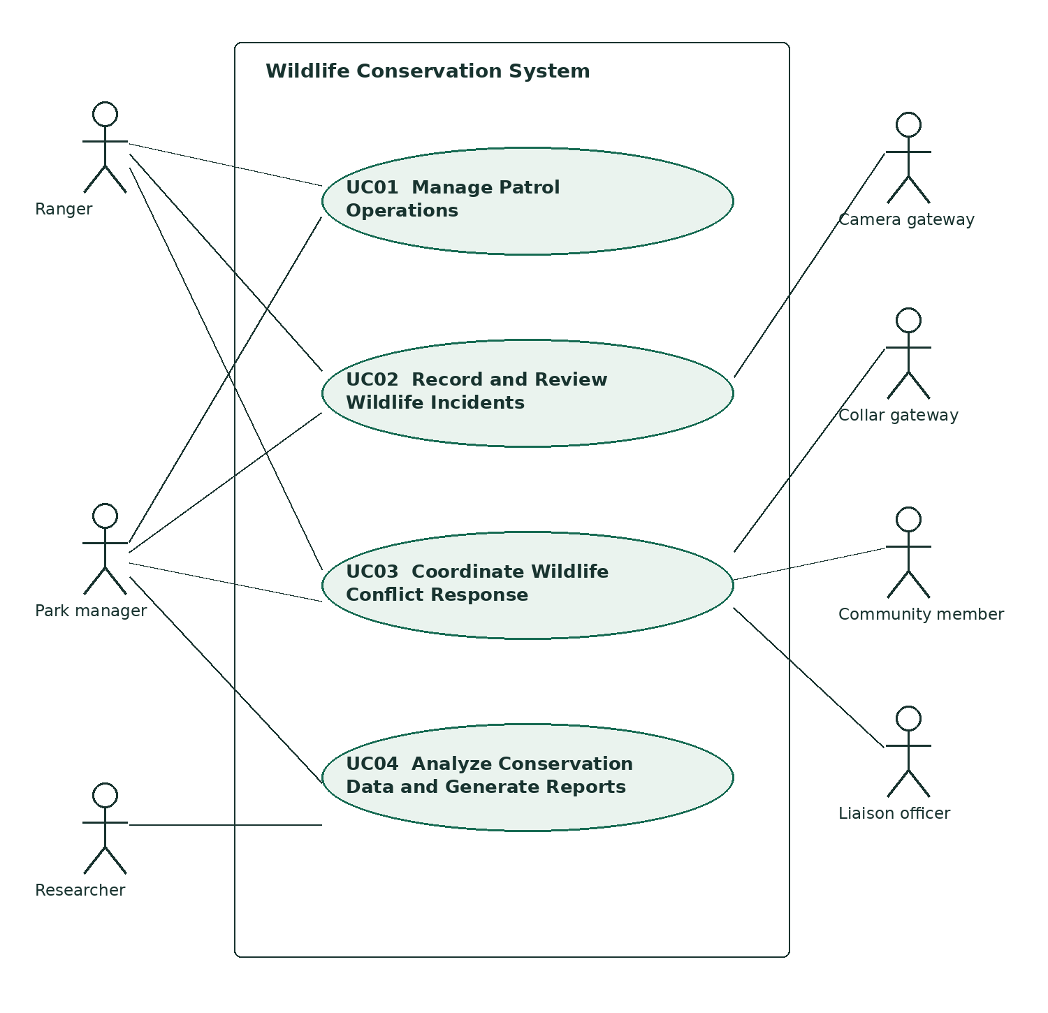
Figure G1. Exactly four major business use cases. Plain lines are actor associations; the sensor gateway represents collar and camera integrations.
UC01 covers route assignment and execution; UC02 covers field incidents and camera evidence review; UC03 accepts collar/community triggers and coordinates response; UC04 produces conservation analysis. Configuration and access control support these goals rather than becoming extra major use cases.

4. Shared UML class diagram - complete model
One integrated class diagram for all four major use cases. This landscape sheet is intentionally larger for diagram readability.
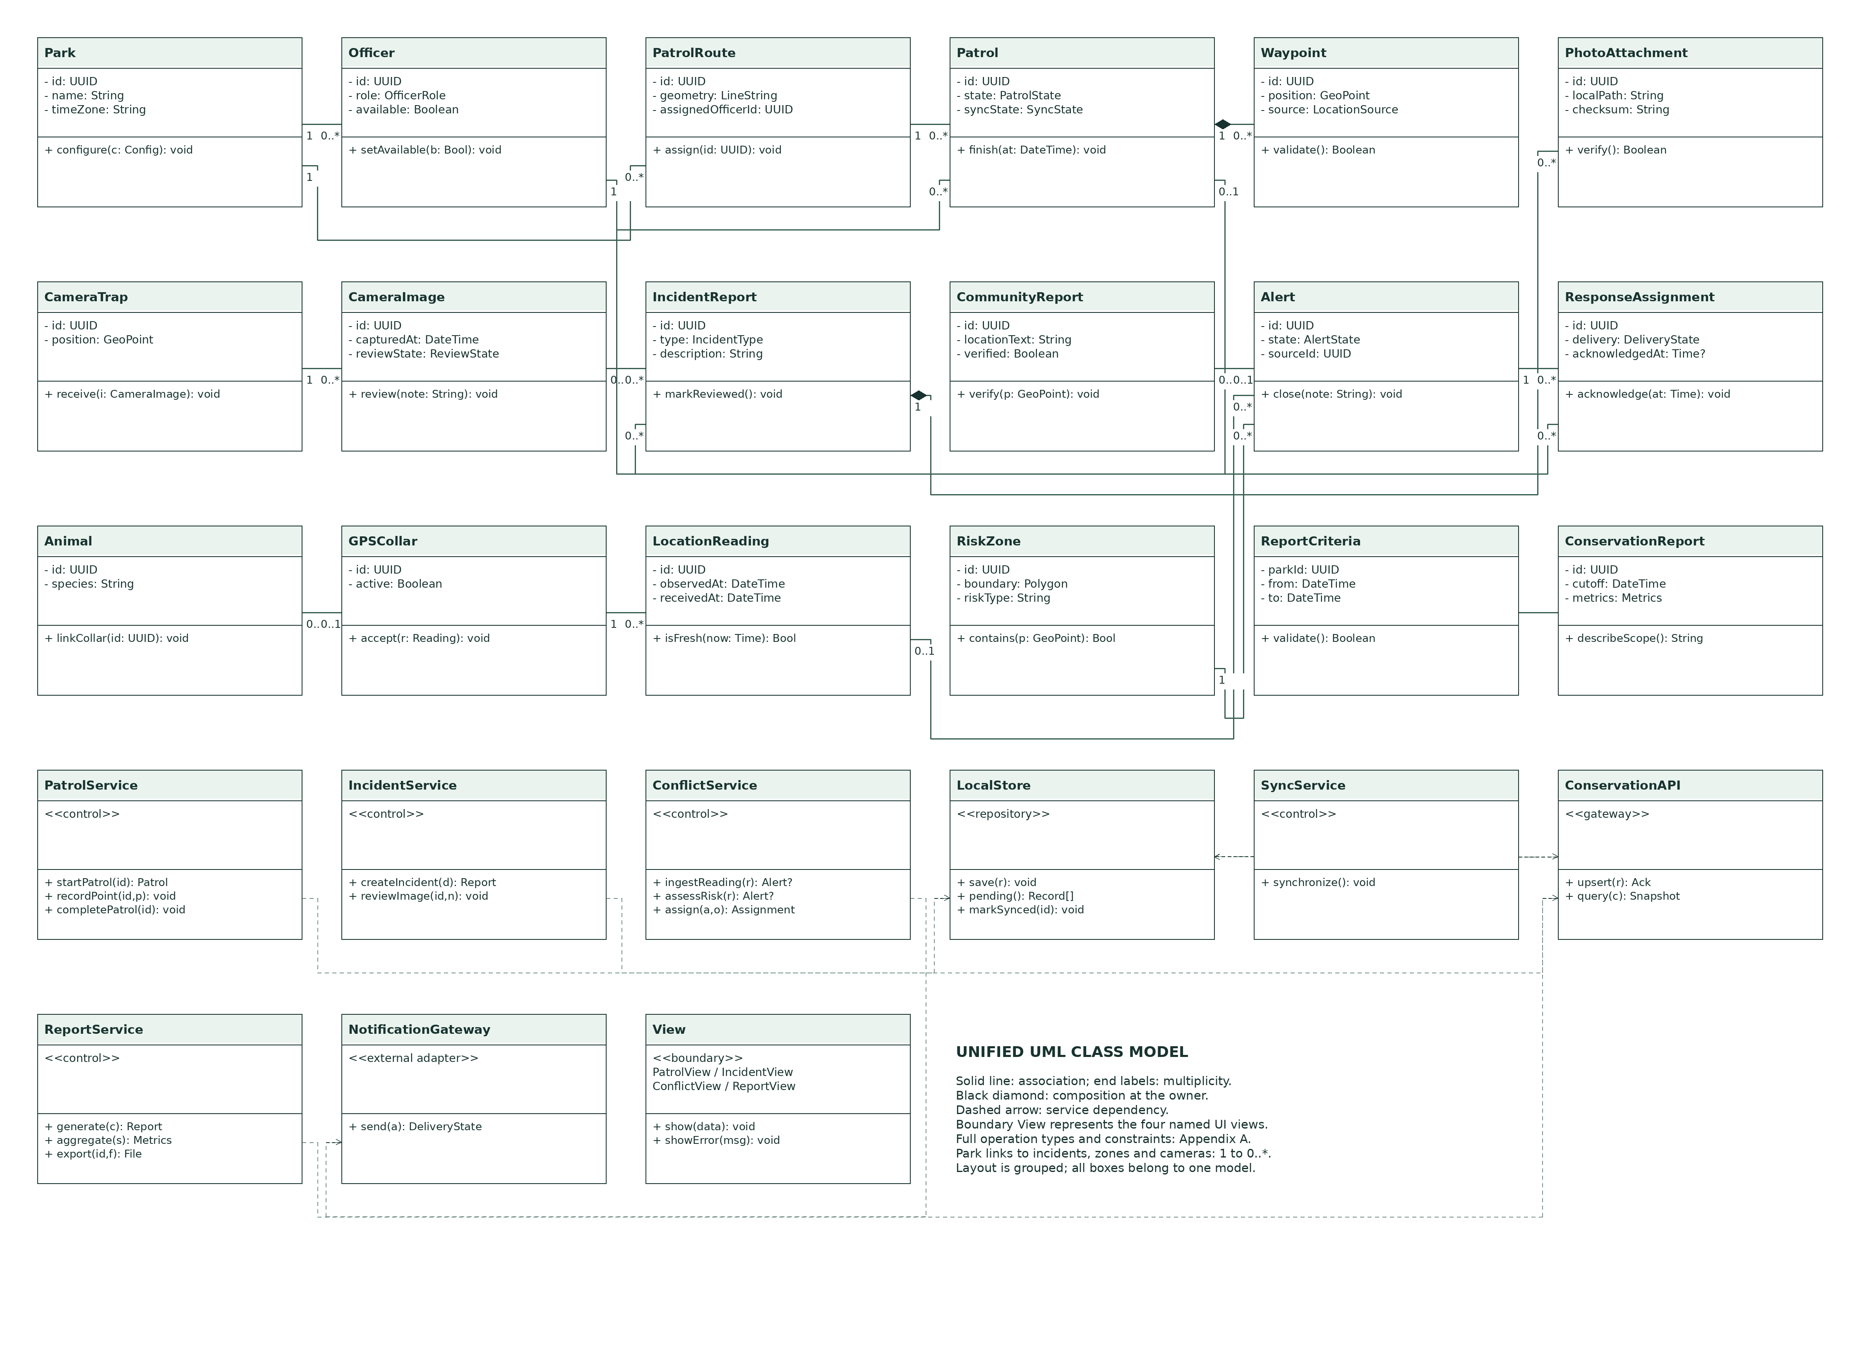
Figure G2. Domain entities, attributes, operations, relationships and service dependencies. Supplementary constraints and full signatures remain in the document.

4.1 Class relationships and invariants
Association | Multiplicity / constraint
Park - PatrolRoute / IncidentReport / RiskZone / CameraTrap | Each belongs to 1 park; a park has 0..* of each.
Park - Officer | A park has 0..* officers; each officer has 1 current home park (assumption).
Officer - PatrolRoute / Patrol | Each route has 0..1 assigned officer; each patrol has 1 ranger. An officer has 0..* routes/patrols.
Patrol - Waypoint | Composition: a patrol owns 0..* waypoints; each waypoint belongs to 1 patrol.
Patrol - IncidentReport | A report has 0..1 patrol context; a patrol has 0..* reports.
IncidentReport - PhotoAttachment | Composition: a report owns 0..* attachments. Each attachment has 1 report.
CameraImage - IncidentReport | An image may support 0..* reports; a report references 0..1 source camera image.
GPSCollar - Animal | At most 1 active collar per animal and 1 active animal per collar; retain historical assignment separately.
LocationReading - Alert | An alert references 0..1 triggering reading; one reading can trigger 0..* zone alerts.
CommunityReport - Alert | A community report can source 0..1 alert; an alert can group 0..* community reports.
Alert - ResponseAssignment - Officer | An alert has 0..* historical assignments; each assignment has 1 alert and 1 officer. At most 1 active assignment per alert.
ConservationReport - ReportCriteria | Composition: each report owns 1 immutable criteria snapshot.
Every alert has at least one source: a reading or a verified community report. Each location stores coordinates, observation time and GPS/manual source. Core entities have stable UUIDs; sync status belongs to the local record envelope, so all transferable records follow the same mechanism.
The unified diagram uses solid associations, black composition diamonds and dashed service dependencies. The relationship constraints above clarify cross-cutting park scope. OfficerRole distinguishes ranger and liaison responsibilities without requiring inheritance.

5. Business rules and interaction conventions

Record lifecycle
Patrol: ASSIGNED route → ACTIVE patrol → COMPLETED patrol. Incident review: NEW → UNDER_REVIEW → RESOLVED. Alert: OPEN → ASSIGNED → ACKNOWLEDGED → CLOSED. Reassignment retains history. These proposed domain states are separate from transfer states: LOCAL_DRAFT, PENDING, SYNCED and ACTION_REQUIRED.

Synchronization rules
Persist first and transfer second. Generate stable IDs on the device. Keep photos until the server acknowledges the complete report. Retry using the same IDs. Treat an acknowledgement lost in transit as an uncertain transfer, not proof of failure. Server upsert checks identity/version; conflicting edits require review rather than silently overwriting evidence. New observations remain append-only; corrections retain audit history.

Alert and reporting rules
Risk assessment uses configured zones and a configurable data-age threshold. Outside-zone readings remain historical data. A repeated animal-zone event reuses an open alert according to the configured deduplication rule. Assignment, notification delivery and officer acknowledgement are distinct events. SMS reports need interpretable location details and staff verification before they are used as a precise map position.
Reports count unique synchronized records within [from, to) in the park time zone. Incident time means observation time, not upload time. Coverage means configured eligible grid cells intersected by recorded patrol tracks divided by all eligible cells, multiplied by 100. Avoid connecting points across long GPS gaps; show coverage as recorded activity, not proof that an area is safe. Grid size and gap threshold are configuration decisions.

Common interface specification
High-fidelity screens use forest green #176B53 for primary actions, near-black #18332F text, pale green #EAF3EE surfaces and amber status notices. Proposed interface type sizes: 16 px body, 24 px screen title, 14 px secondary labels; controls at least 48 px high. Status always includes words and does not rely on color. Phone layouts also represent responsive operations views; wider dashboards may rearrange the same content.
All four screen sets use the same flow order: entry/context, review/action, result/status. The mockups are static designs, not a running prototype. They contain fictional IDs and schematic maps, so they expose no real wildlife locations.

6. UC01 - Manage Patrol Operations
  - Individual owner: [Member 1 name / student ID]

Detailed use case scenario
Scenario: Record an assigned patrol
Primary actor: Ranger
Scope: Wildlife Conservation System | Level: user goal | Frequency: as operationally required.
Goal: Record a trustworthy account of an assigned patrol, including work completed without network coverage.
Trigger: The ranger opens an assigned route and chooses Start patrol.
Preconditions: The ranger has authorized access. An assigned route and park map have been downloaded. Device storage is available.

Main success flow
Step | Actor / event | System response
P1 | Ranger opens route RT-07. | App displays the route, map availability and previous synchronization time.
P2 | Ranger chooses Start patrol. | PatrolService starts patrol PT-104 and LocalStore saves it.
P3 | Device supplies a position during patrol. | PatrolService records a timestamped waypoint and saves it locally.
P4 | Ranger chooses Finish and confirms. | PatrolService completes the patrol and queues it for synchronization.
P5 | Connectivity returns at base. | SyncService sends the pending record; ConservationAPI upserts by stable ID.
P6 | Server acknowledges the record. | LocalStore marks it synced; app displays completion and last-sync time.

UC01 - alternatives, exceptions and outcomes

Alternative flows

A1 at P3: GPS unavailable
Ranger selects Add waypoint, marks a location on the downloaded map and confirms it. Store source=MANUAL; continue at P3.

A2 at P4: cancel finish
Keep patrol ACTIVE and return to tracking; do not create a second patrol.

A3 at P5: already online
Run synchronization immediately after local save.

Exception flows

E1 at P2/P3: storage failure
Show Save failed; do not claim persistence. Keep the current input where possible and ask the ranger to free storage and retry.

E2 at P5: timeout or rejected access
Keep queued data; show pending or sign-in-required status. Retry after connectivity/access is restored.

E3 at P5: response lost after server commit
Retry with the same patrol ID; server returns the existing record instead of duplicating it.

Postconditions and minimum guarantee
A completed patrol and its waypoints are saved locally. The server receives one matching record after synchronization; pending status remains visible until acknowledgement.
On failure, do not display a successful outcome that has not occurred. Preserve already committed records; retain the user’s current input where feasible. A failed external operation does not erase a valid local or server record.

UC01 - detailed sequence diagram
MUST DEMONSTRATE: messages P1-P6 must match the UC01 scenario and operations in PatrolService, LocalStore, SyncService and ConservationAPI.
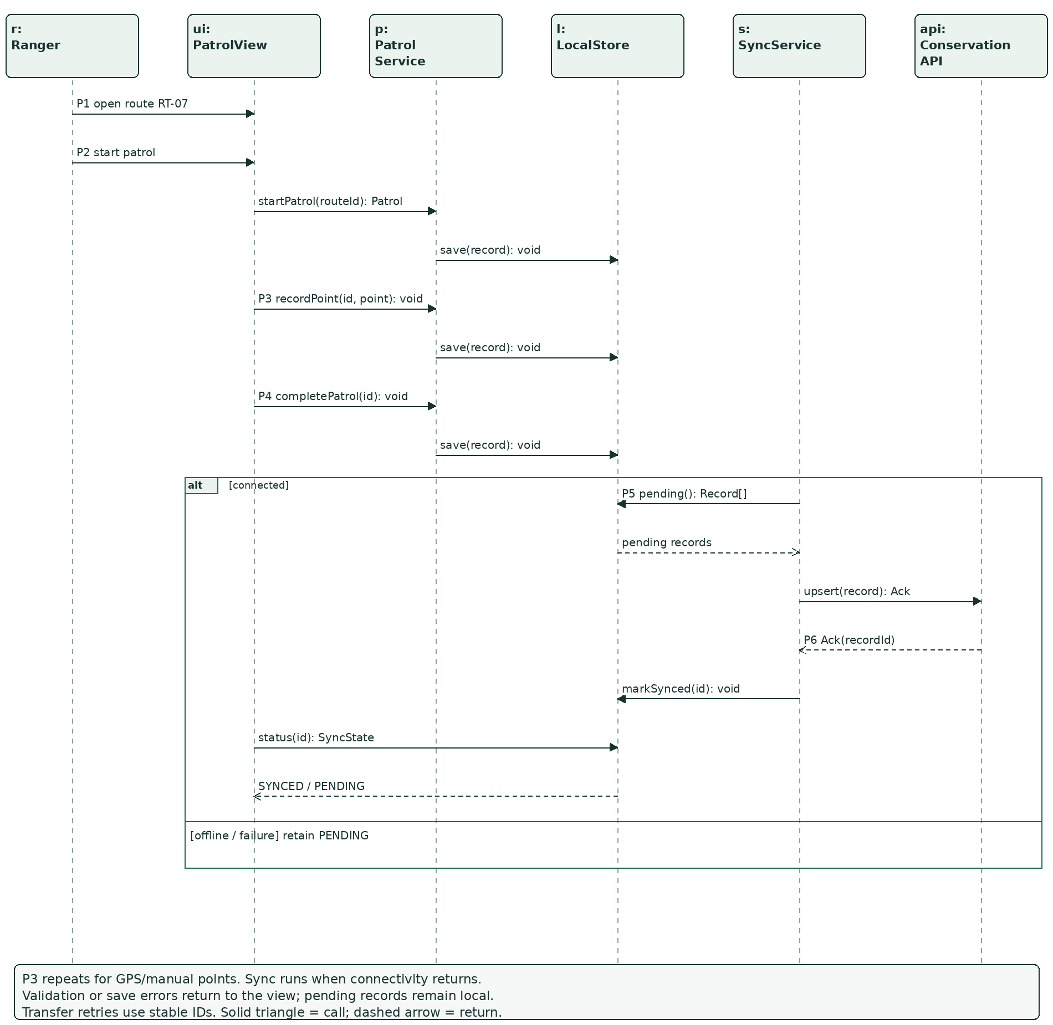
Figure UC01-SEQ. Message labels reference the scenario steps. Branch conditions and continuation behavior are stated inside the figure.
Boundary objects forward user input to the appropriate service. LocalStore and ConservationAPI own persistence interfaces. Calls and return values are defined in Appendix A; no view directly changes another user’s data.

UC01 - storyboard
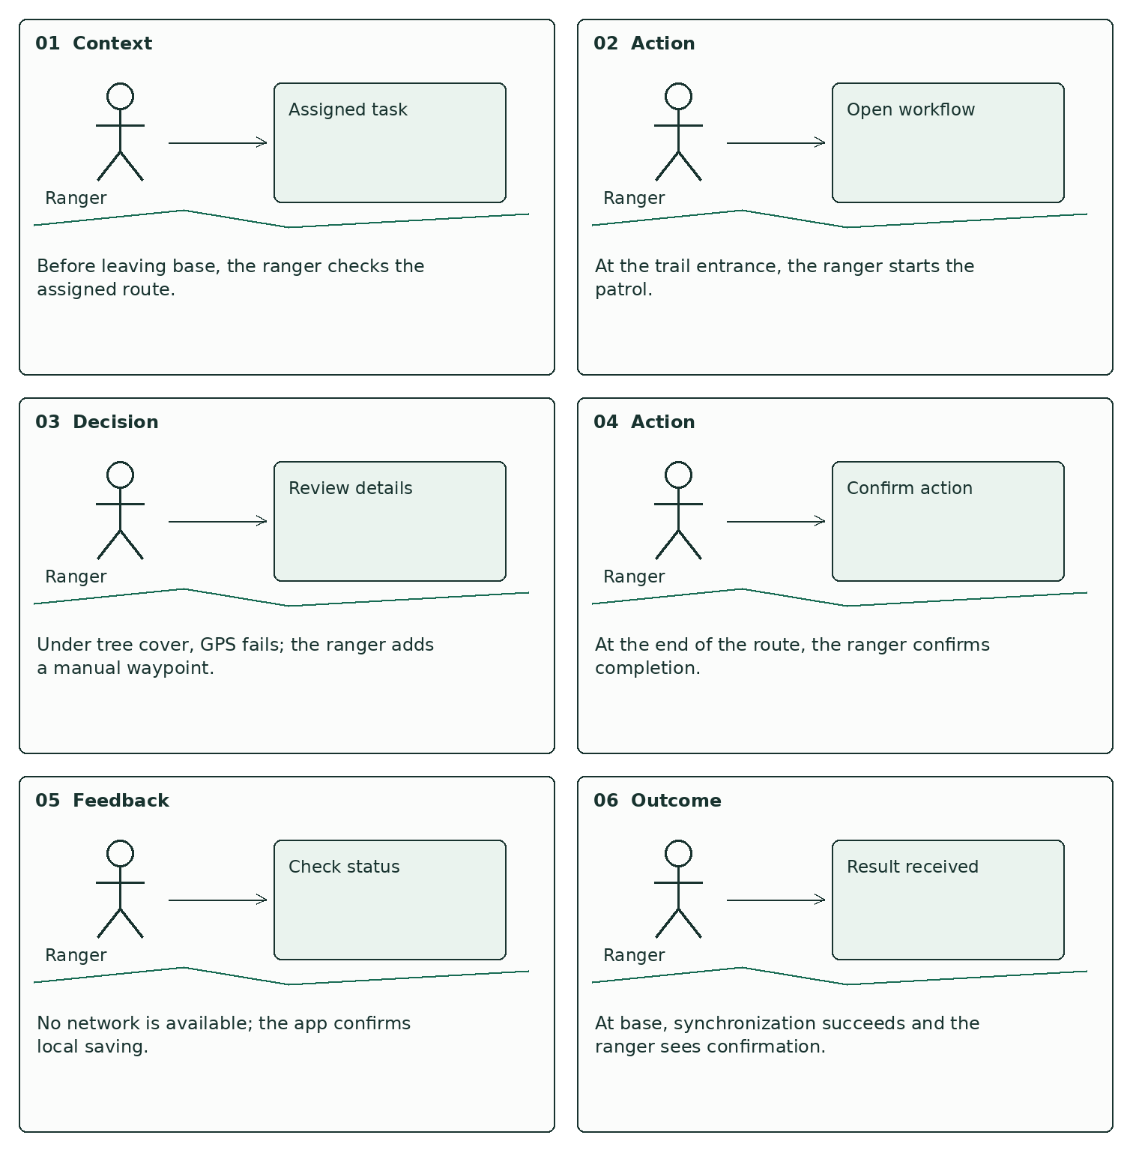
Figure UC01-SB. Six chronological panels show the user’s context, action and feedback for the same scenario.

UC01 - low-fidelity wireframe flow
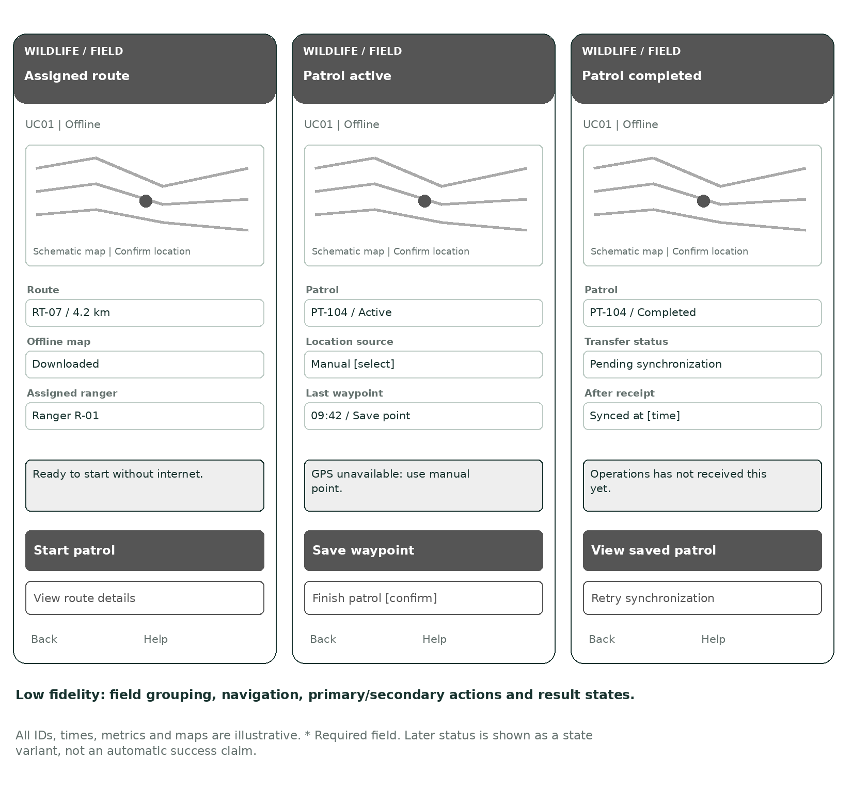
Figure UC01-LF. Three linked screens establish layout and interaction order before visual styling.
Navigation: the primary action advances to the next state after validation; Back returns without discarding unsaved input silently. Help explains the current task. Screen 3 is a result state, not a second submission.

UC01 - high-fidelity wireframe flow
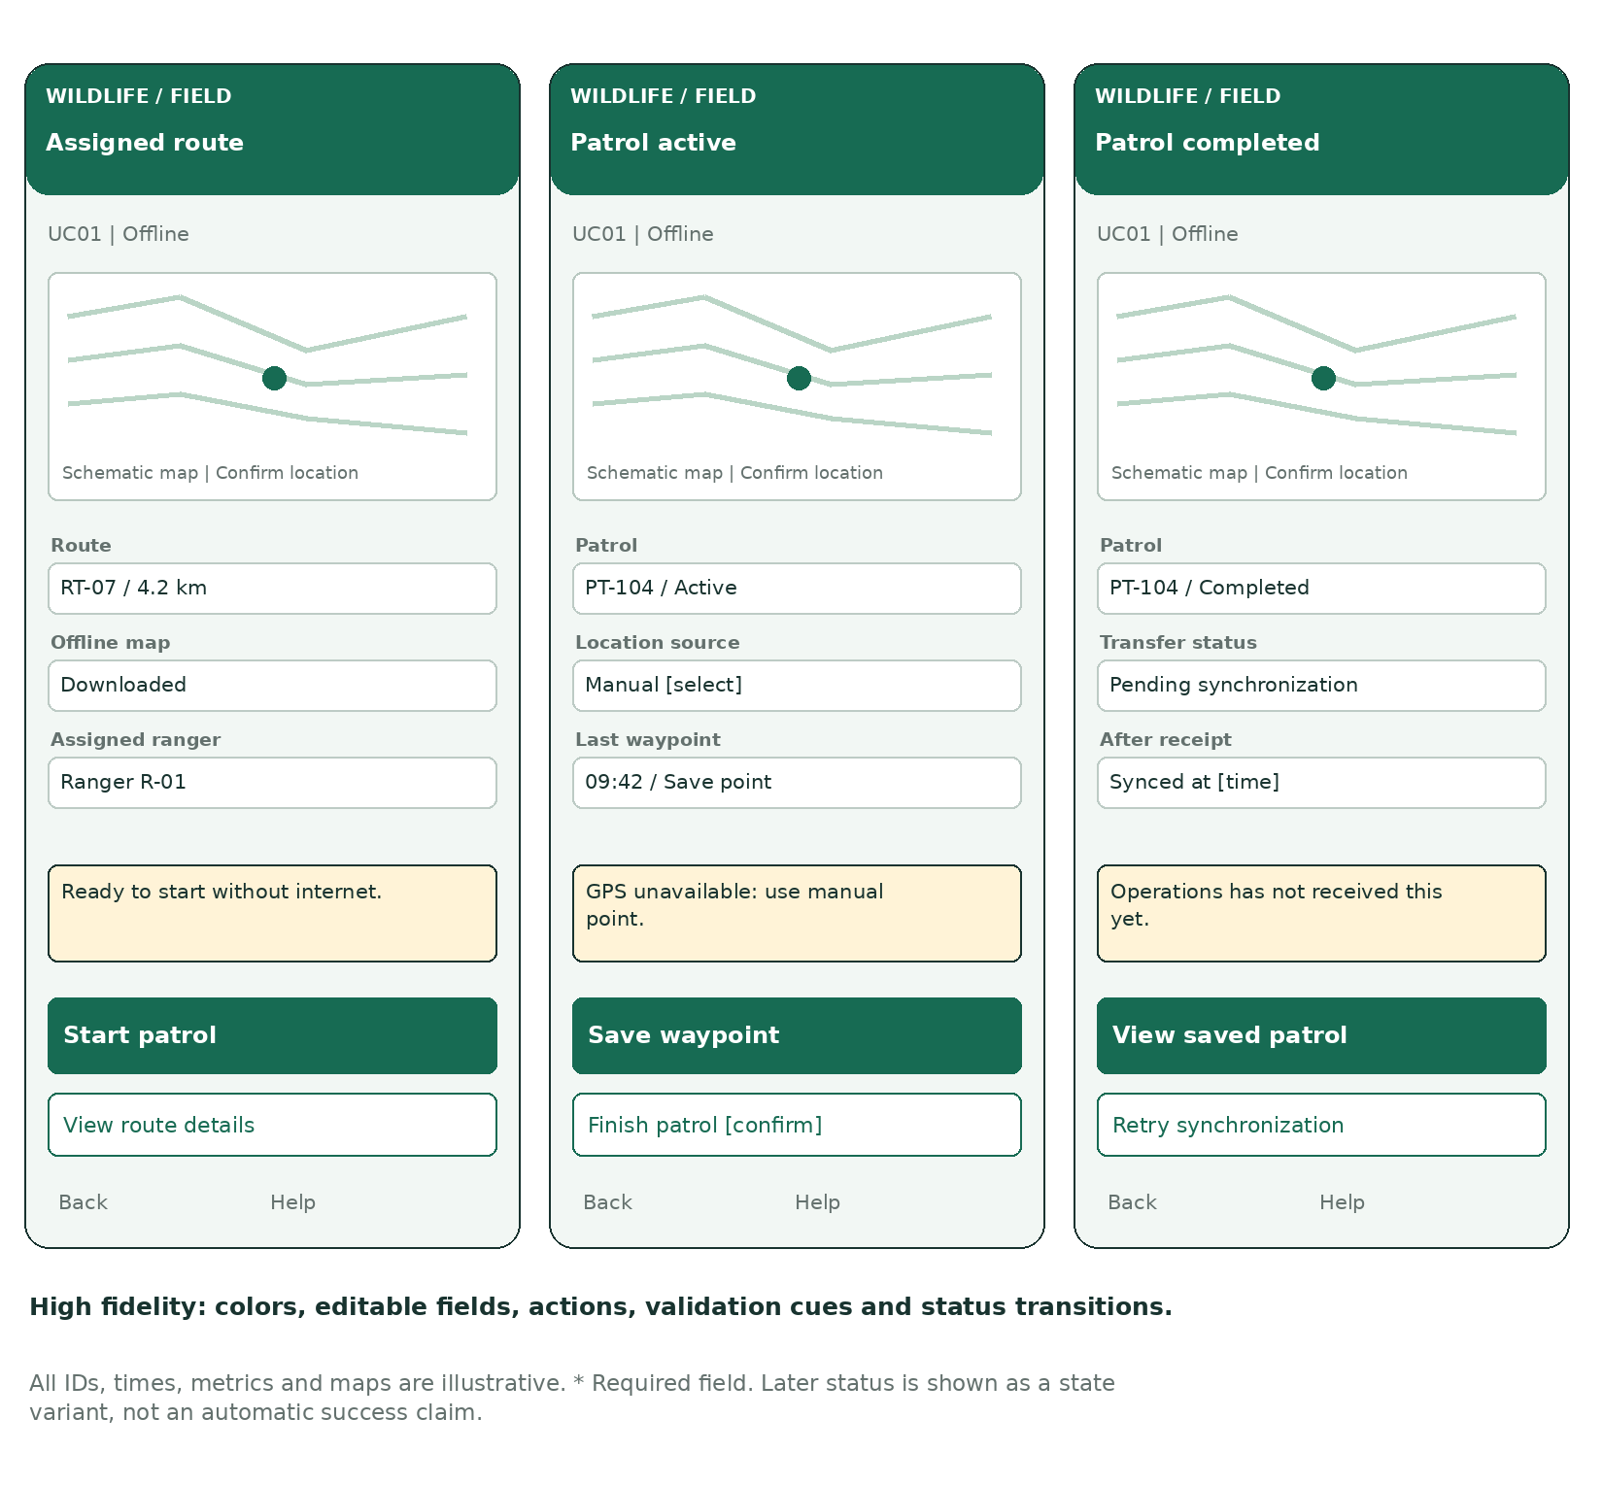
Figure UC01-HF. Detailed visual design of the same low-fidelity flow. Values are illustrative, not collected evidence.

Field states
When GPS is unavailable, enable Add waypoint and show Manual location. When sync completes, replace Pending synchronization with Synced at [time]. A finish cancellation returns to the active map.

7. UC02 - Record and Review Wildlife Incidents
  - Individual owner: [Member 2 name / student ID]

Detailed use case scenario
Scenario: Report a snare while offline
Primary actor: Ranger
Scope: Wildlife Conservation System | Level: user goal | Frequency: as operationally required.
Goal: Report wildlife evidence promptly and preserve it until the operations team can receive it.
Trigger: The ranger discovers an illegal snare while patrolling without mobile coverage.
Preconditions: The ranger has authorized access and cached park categories. A camera or a way to explain missing evidence is available. The device can store a report.

Main success flow
Step | Actor / event | System response
I1 | Ranger opens New incident and selects Snare. | App loads the incident form and cached categories.
I2 | Ranger takes a photo, confirms location and enters a description. | App retains the draft and shows the observation time and location source.
I3 | Ranger selects Save report. | IncidentService validates required fields and creates IR-208.
I4 | Device is offline. | LocalStore saves the report and attachment reference with syncState=PENDING.
I5 | Connectivity returns. | SyncService sends the report and evidence through ConservationAPI.
I6 | Server acknowledges complete receipt. | LocalStore marks it synced; app shows Submitted and the incident reference.

UC02 - alternatives, exceptions and outcomes

Alternative flows

A1 at I2: GPS unavailable
Ranger marks the location manually and confirms it; source=MANUAL is stored.

A2 at I2: photograph unsafe or unavailable
Ranger records an evidence-omission reason. This proposed rule allows urgent reporting without a photo.

A3 at I4: network available
Persist locally first, then attempt immediate synchronization.

A4 after I6: camera-trap review
Authorized staff review a received CameraImage and create an incident only when a finding warrants one; keep the image reference.

Exception flows

E1 at I3: missing required input
Highlight the missing category, location or description; preserve the draft and return to I2.

E2 at I4: local save fails
Show Not saved. Preserve inputs where possible; never show Pending synchronization for an unsaved report.

E3 at I5: photo upload interrupted
Retain the report and photo locally. Resume/retry; do not mark fully synced until evidence receipt is acknowledged.

E4 at I5: duplicate retry
Upsert the same report ID and attachment IDs; do not create a second incident.

Postconditions and minimum guarantee
An incident with a stable ID, location source, observation time and evidence is saved locally. Once synchronized it becomes available for authorized review; no central receipt is claimed before acknowledgement.
On failure, do not display a successful outcome that has not occurred. Preserve already committed records; retain the user’s current input where feasible. A failed external operation does not erase a valid local or server record.

UC02 - detailed sequence diagram
MUST DEMONSTRATE: messages I1-I6 must show local persistence before synchronization and complete-receipt acknowledgement for report evidence.
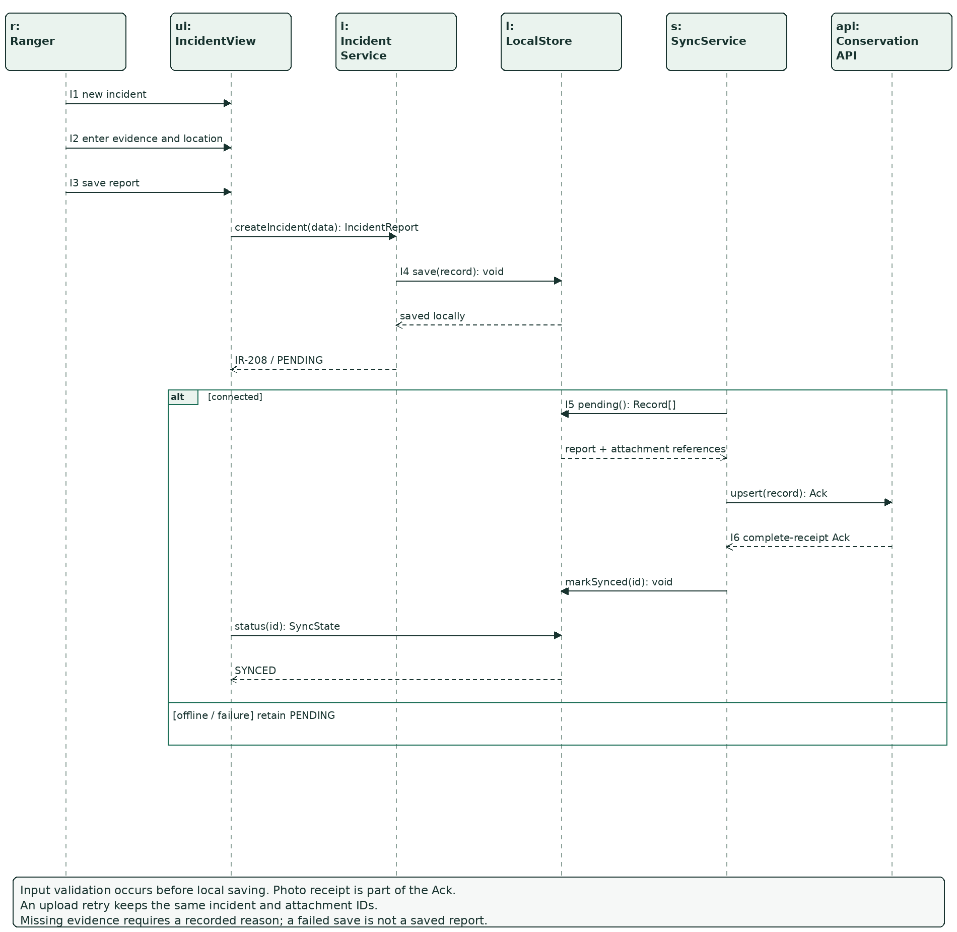
Figure UC02-SEQ. Message labels reference the scenario steps. Branch conditions and continuation behavior are stated inside the figure.
Boundary objects forward user input to the appropriate service. LocalStore and ConservationAPI own persistence interfaces. Calls and return values are defined in Appendix A; no view directly changes another user’s data.

UC02 - storyboard
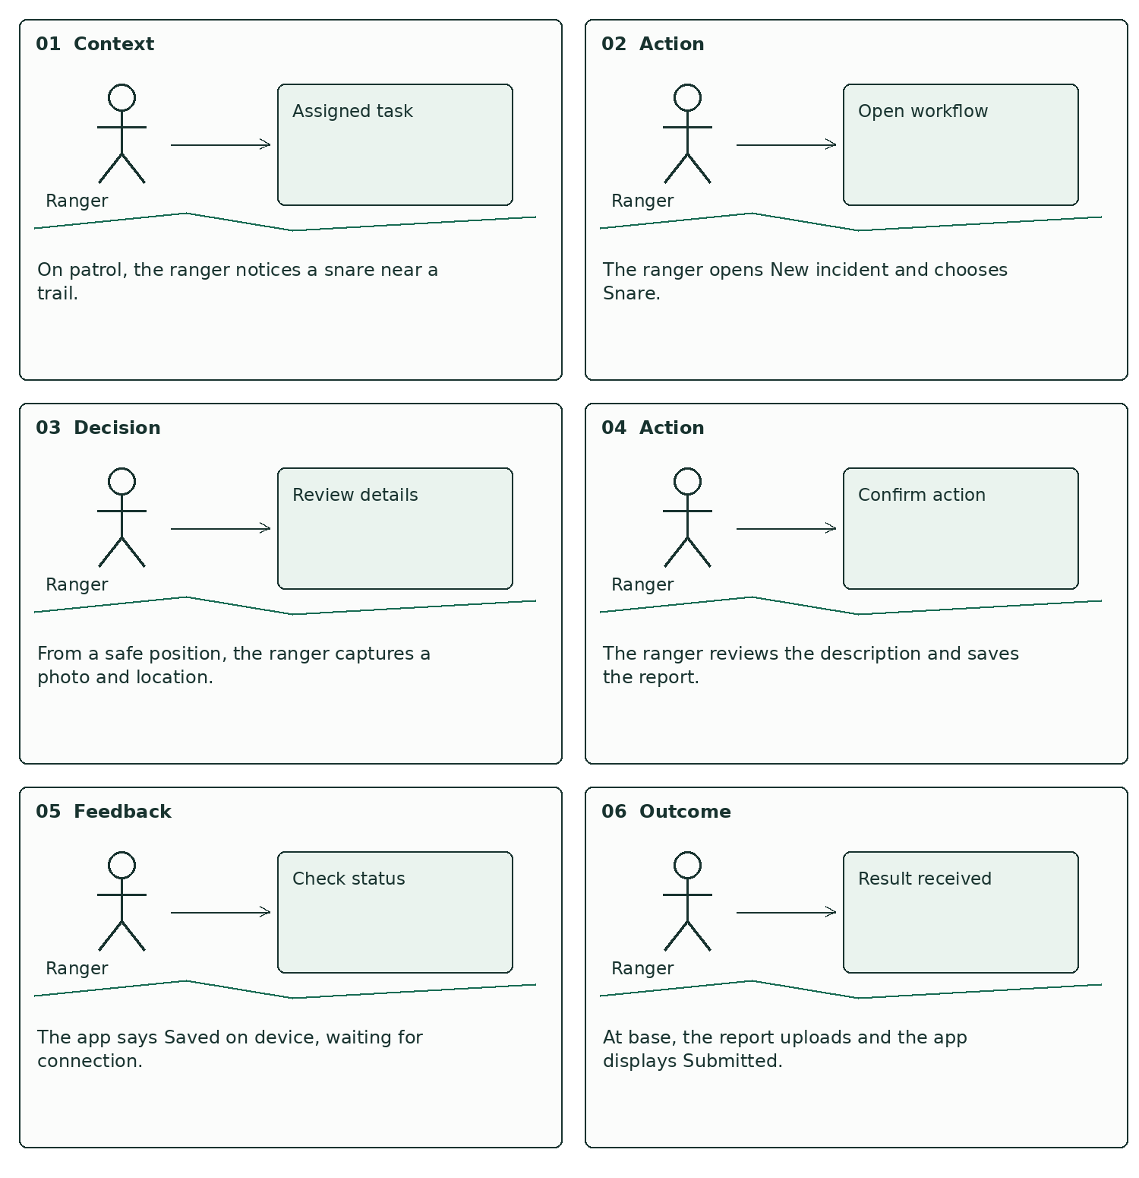
Figure UC02-SB. Six chronological panels show the user’s context, action and feedback for the same scenario.

UC02 - low-fidelity wireframe flow
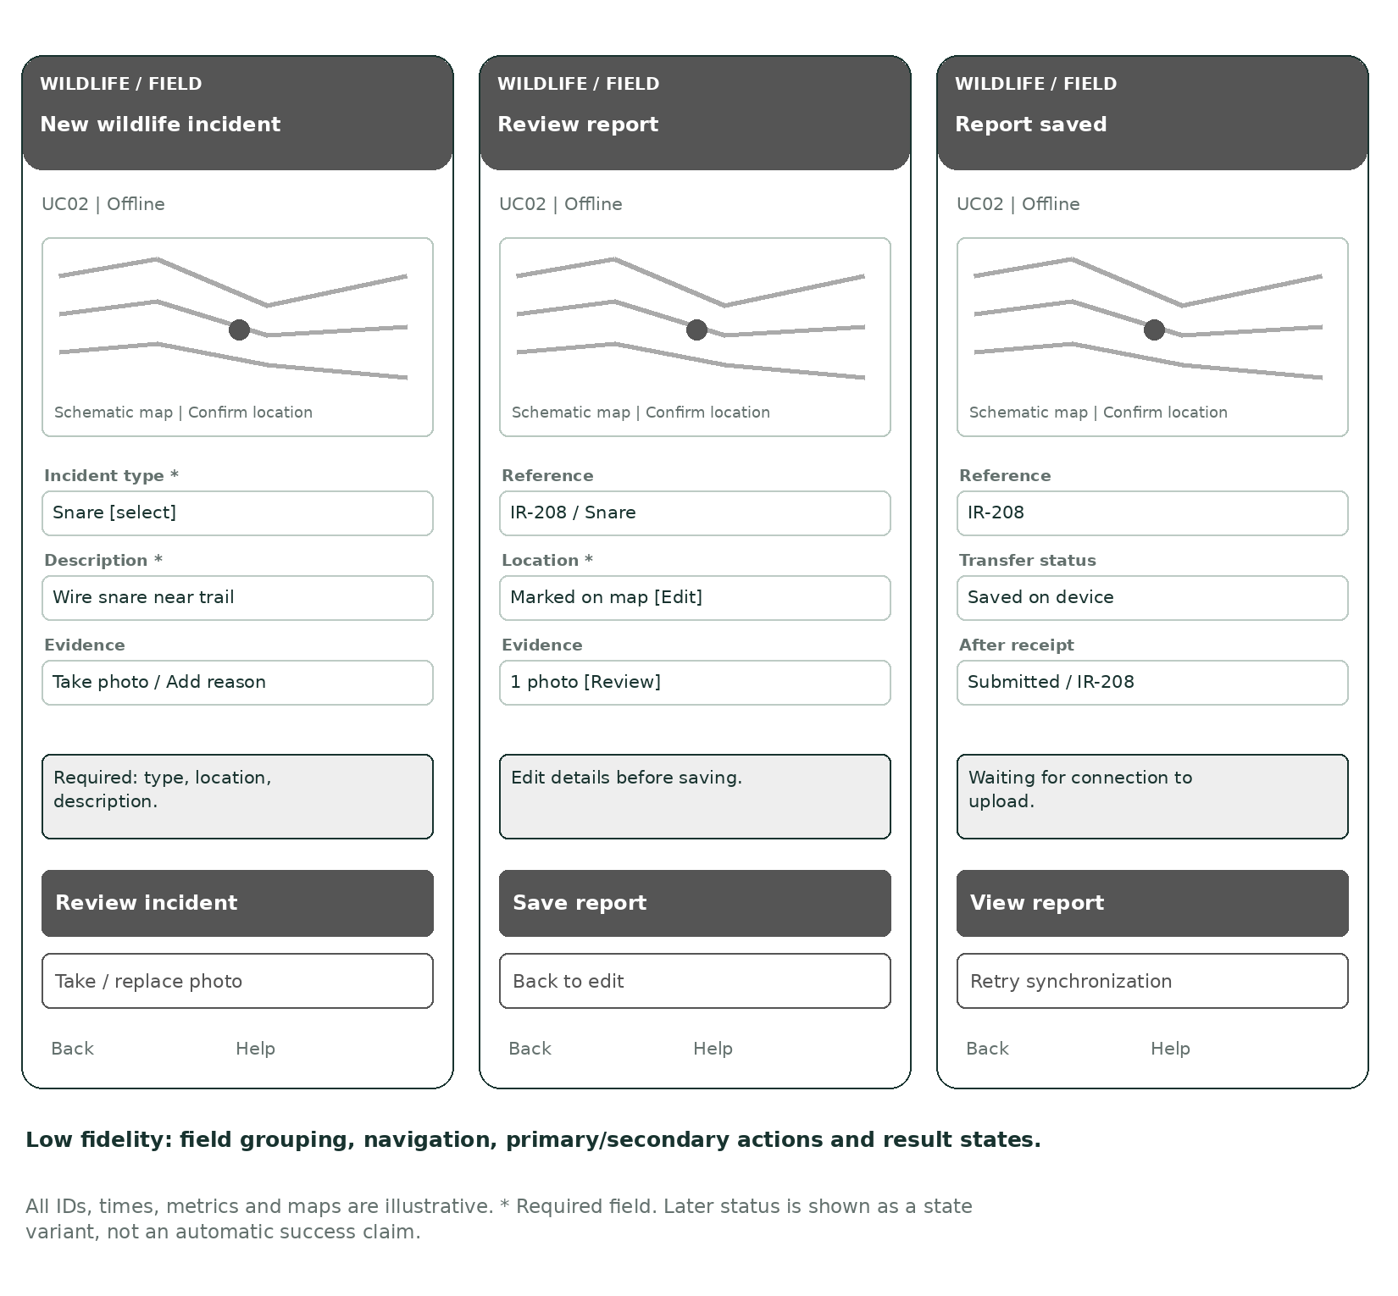
Figure UC02-LF. Three linked screens establish layout and interaction order before visual styling.
Navigation: the primary action advances to the next state after validation; Back returns without discarding unsaved input silently. Help explains the current task. Screen 3 is a result state, not a second submission.

UC02 - high-fidelity wireframe flow
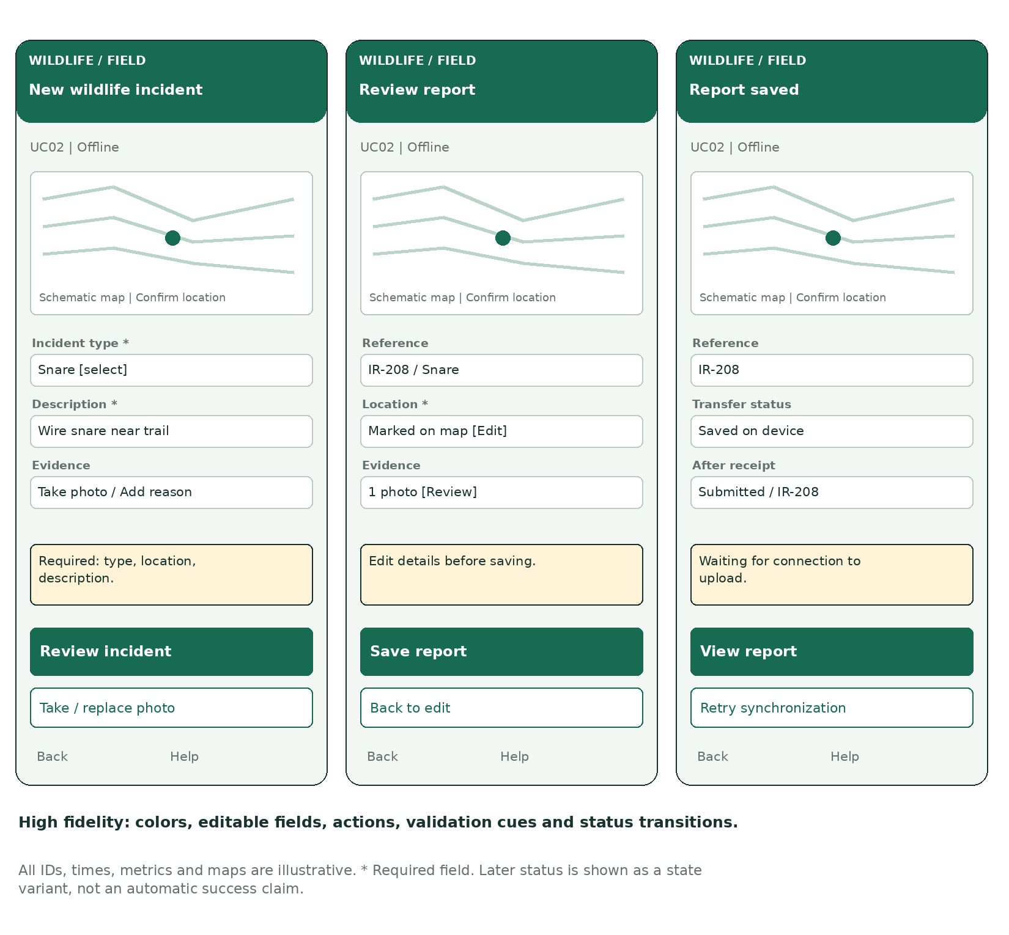
Figure UC02-HF. Detailed visual design of the same low-fidelity flow. Values are illustrative, not collected evidence.

Evidence and sync states
Add photo opens camera/attachment selection. Review allows editing. A failed save shows Not saved. A successful upload changes the result to Submitted, IR-208; interrupted evidence upload remains Pending.

8. UC03 - Coordinate Wildlife Conflict Response
  - Individual owner: [Member 3 name / student ID]

Detailed use case scenario
Scenario: Assign a response to a risk alert
Primary actor: Park manager
Scope: Wildlife Conservation System | Level: user goal | Frequency: as operationally required.
Goal: Coordinate an accountable officer response to a verified wildlife risk.
Trigger: A newly received collar reading places a tracked elephant inside a configured farmland risk zone.
Preconditions: The collar is linked to an animal; the zone and freshness threshold are configured. The manager can access this park. Officer availability is maintained.

Main success flow
Step | Actor / event | System response
C1 | Sensor gateway sends a collar reading. | ConflictService validates and records its ID, location and observation time.
C2 | System evaluates the reading against configured zones. | A fresh in-zone reading creates or updates an open alert.
C3 | Manager opens the alert. | Dashboard shows animal, zone, observed/received times and location confidence.
C4 | Manager selects an available ranger or liaison officer. | ConflictService validates availability and creates response RA-031.
C5 | System attempts notification. | NotificationGateway records delivery state; dashboard shows Awaiting acknowledgement.
C6 | Assigned officer acknowledges. | ConflictService records acknowledgement and dashboard shows Acknowledged.

UC03 - alternatives, exceptions and outcomes

Alternative flows

A1 at C1: community report
A villager submits SMS/app details. Staff verify location and urgency; a credible report creates an alert for the same response workflow.

A2 at C2: animal outside zone
Store the reading without creating a risk alert; this trigger ends.

A3 at C4: no available officer
Leave alert OPEN, show Unassigned and escalate to the manager for manual coordination.

A4 after C6: field resolution
Officer records outcome; manager closes the alert after review. Preserve the response history.

Exception flows

E1 at C1/C2: stale or invalid reading
Reject invalid coordinates; store a valid but stale reading as historical. Do not generate a fresh-location alert from stale data.

E2 at C2: repeated sensor message
Ignore duplicate reading ID; reuse an existing open animal-zone alert to reduce duplicate dispatch.

E3 at C4: assignment conflict
If another manager already assigned the alert, display the current assignment and require an explicit reassignment decision.

E4 at C5: notification fails
Keep the assignment and flag delivery failure. Offer retry or manual radio contact; do not claim officer acknowledgement.

Postconditions and minimum guarantee
A valid response assignment is stored and linked to the alert. Notification delivery and officer acknowledgement are recorded separately; an unacknowledged assignment remains visible.
On failure, do not display a successful outcome that has not occurred. Preserve already committed records; retain the user’s current input where feasible. A failed external operation does not erase a valid local or server record.

UC03 - detailed sequence diagram
MUST DEMONSTRATE: messages C1-C6 must distinguish reading ingestion, alert evaluation, assignment, notification delivery and officer acknowledgement.
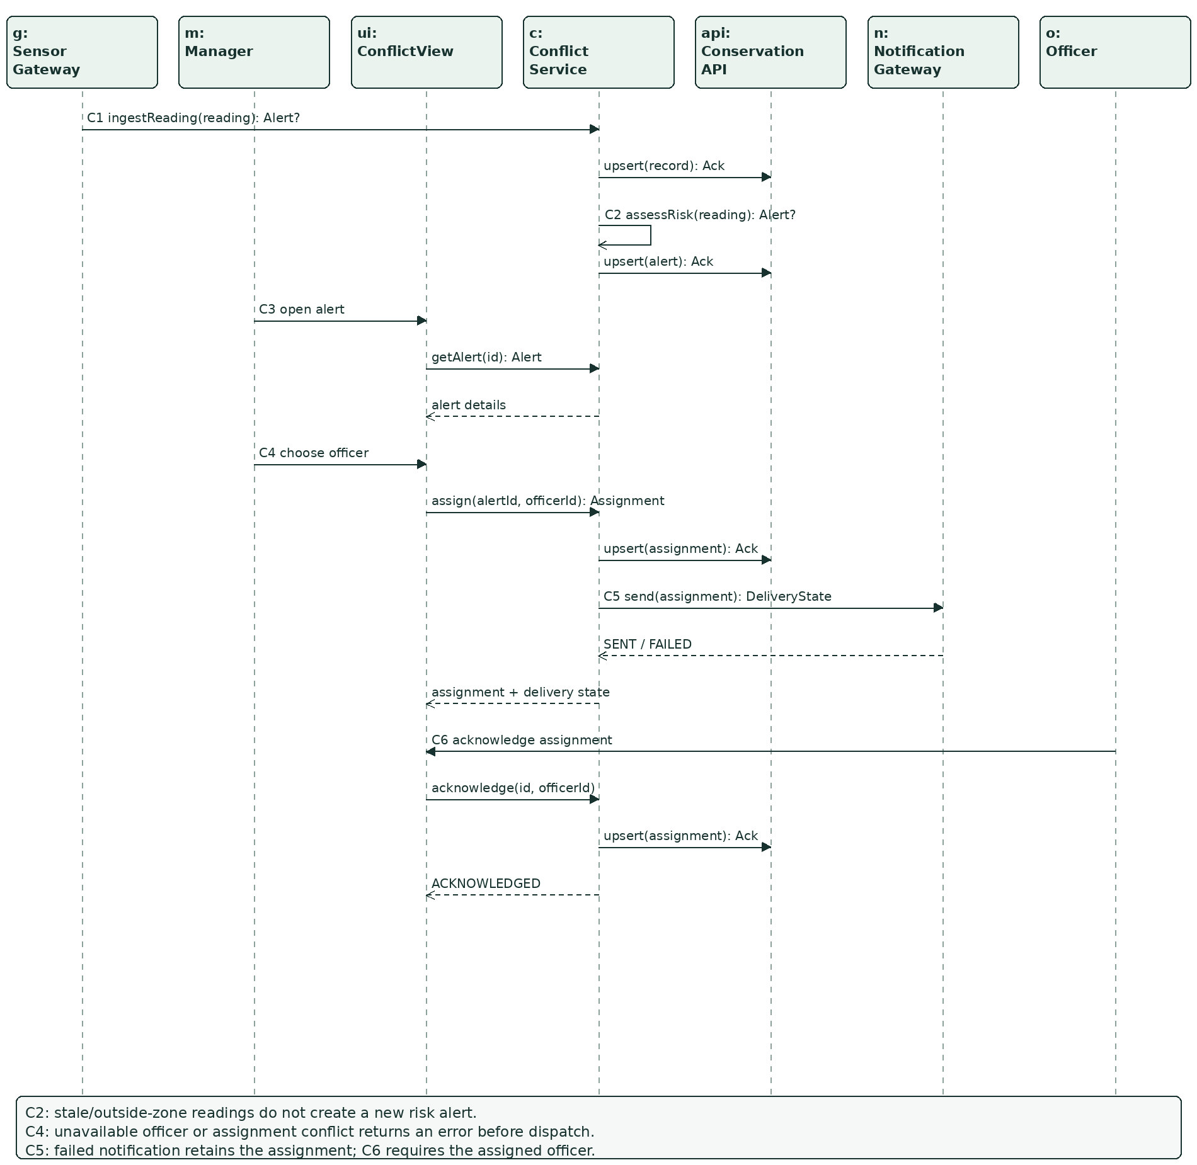
Figure UC03-SEQ. Message labels reference the scenario steps. Branch conditions and continuation behavior are stated inside the figure.
Boundary objects forward user input to the appropriate service. LocalStore and ConservationAPI own persistence interfaces. Calls and return values are defined in Appendix A; no view directly changes another user’s data.

UC03 - storyboard
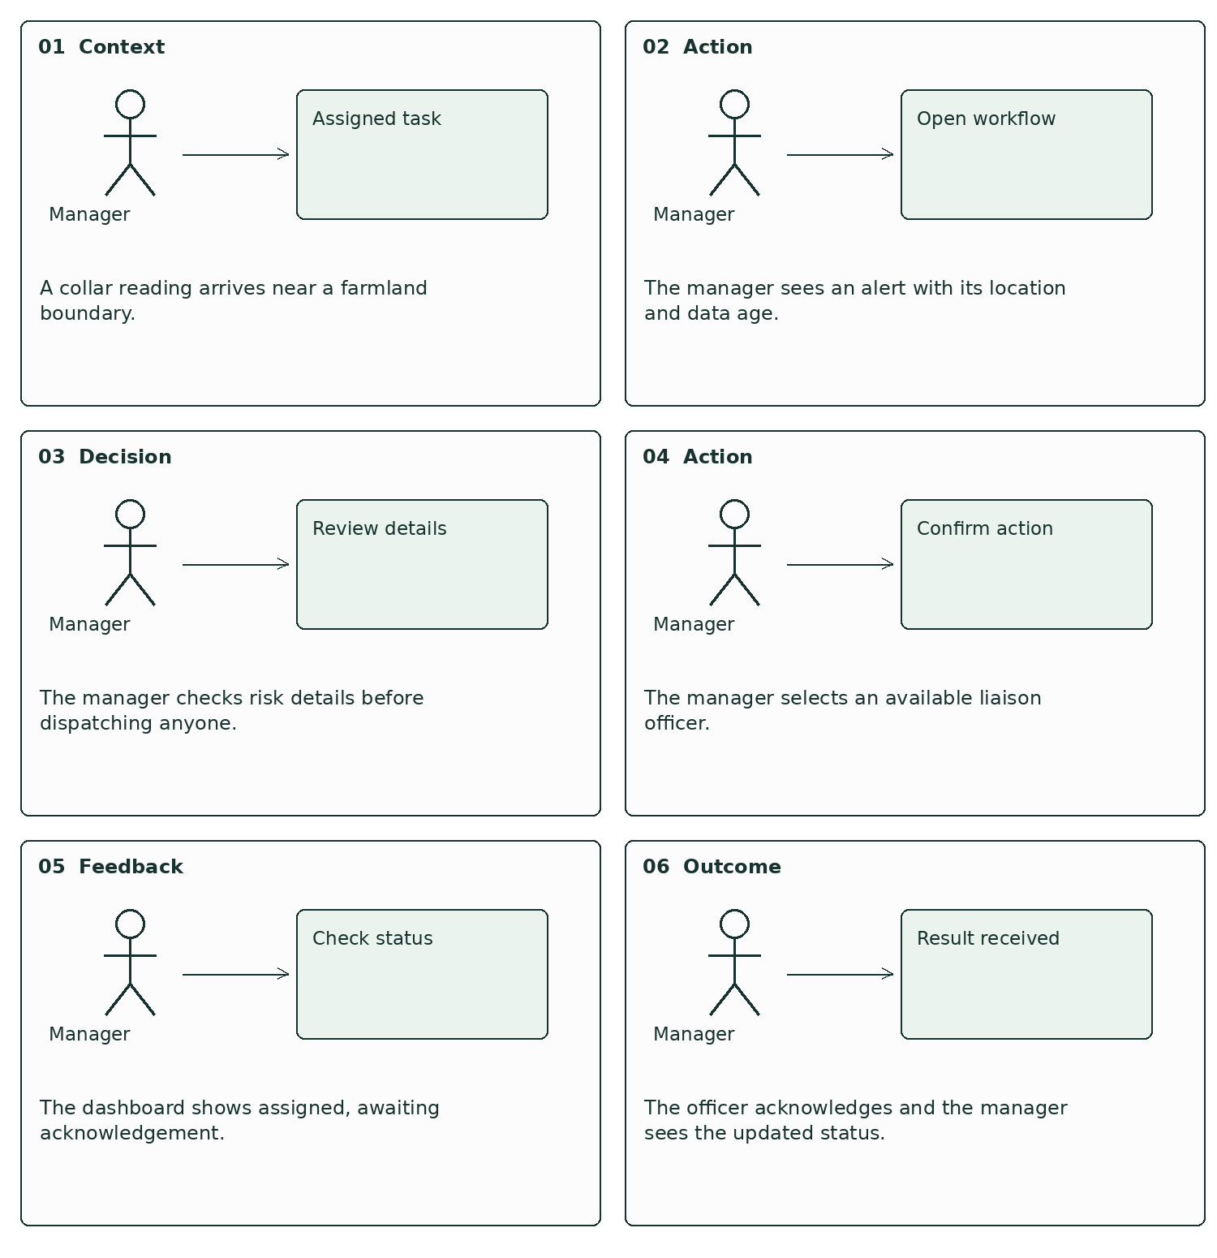
Figure UC03-SB. Six chronological panels show the user’s context, action and feedback for the same scenario.

UC03 - low-fidelity wireframe flow
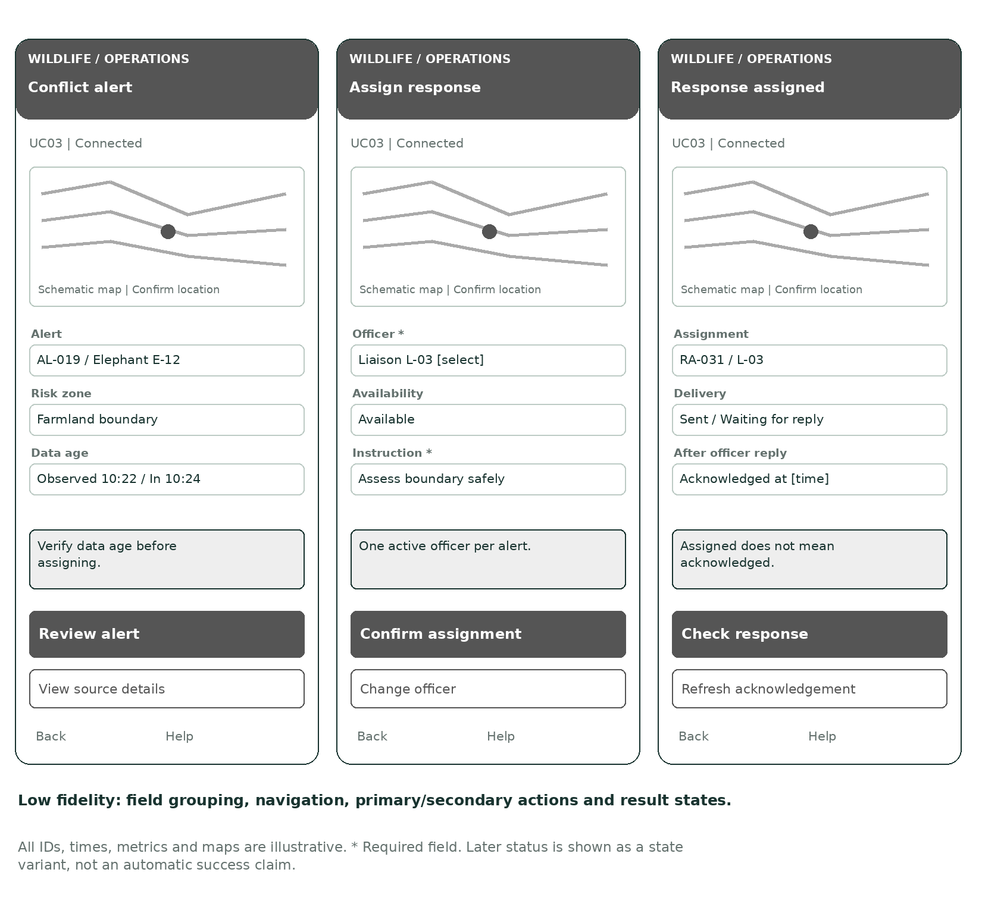
Figure UC03-LF. Three linked screens establish layout and interaction order before visual styling.
Navigation: the primary action advances to the next state after validation; Back returns without discarding unsaved input silently. Help explains the current task. Screen 3 is a result state, not a second submission.

UC03 - high-fidelity wireframe flow
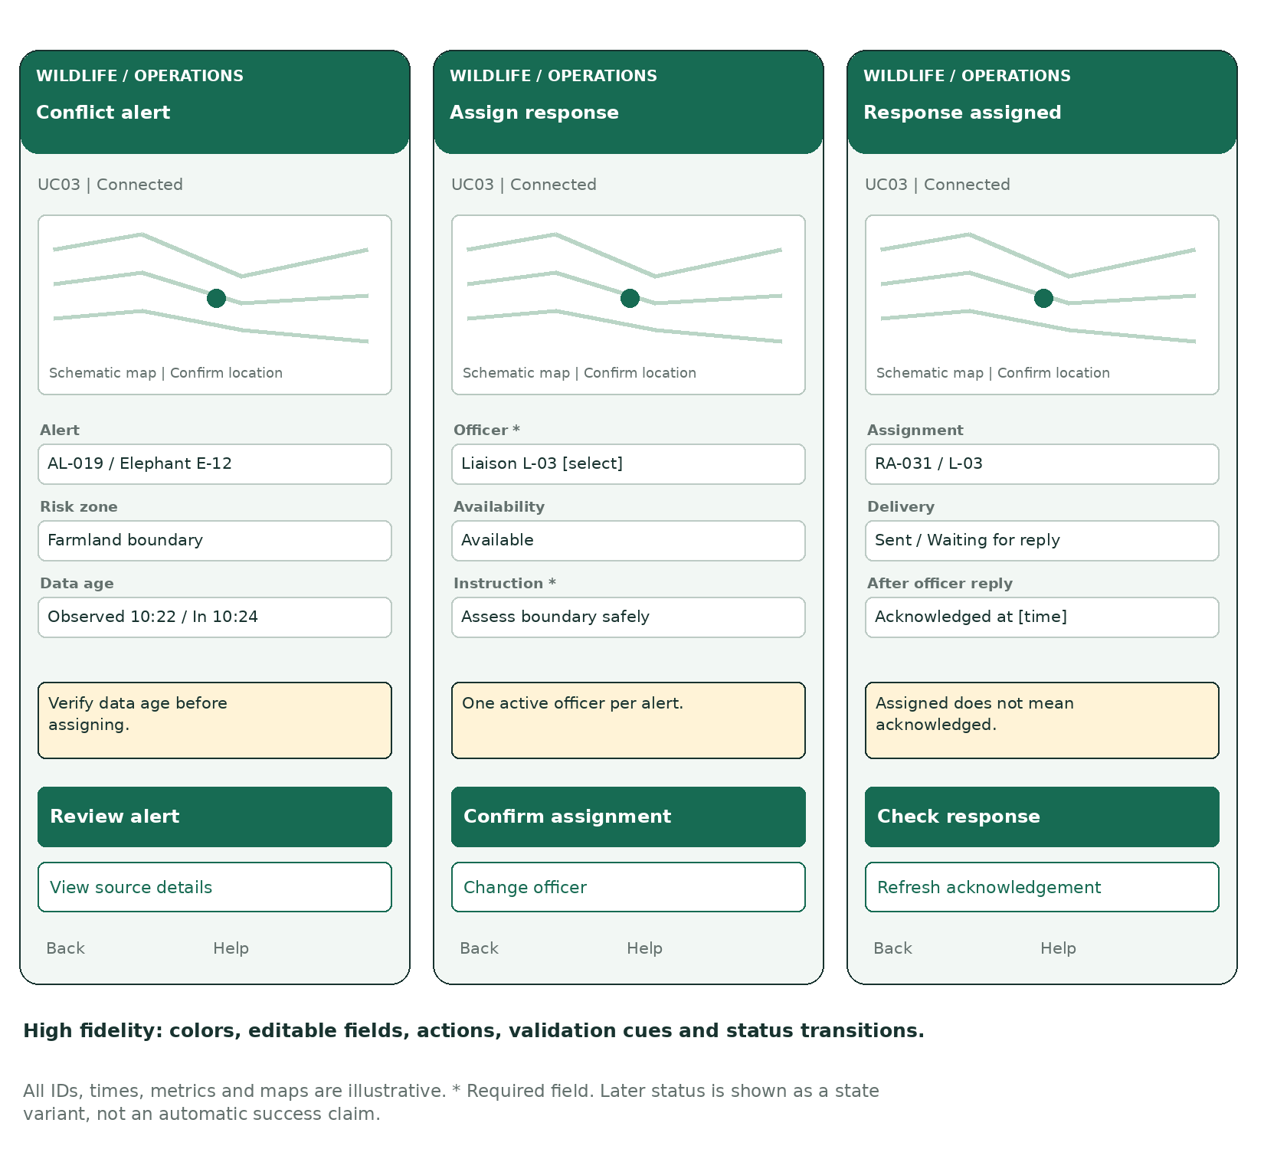
Figure UC03-HF. Detailed visual design of the same low-fidelity flow. Values are illustrative, not collected evidence.

Response states
The officer selector lists eligible available officers. Failed delivery shows Retry notification / Record radio contact. Acknowledgement updates the result to Acknowledged at [time]. Manual contact alone does not imply officer acknowledgement.

9. UC04 - Analyze Conservation Data and Generate Reports
  - Individual owner: [Member 4 name / student ID]

Detailed use case scenario
Scenario: Generate a park conservation report
Primary actor: Park manager / conservation researcher
Scope: Wildlife Conservation System | Level: user goal | Frequency: as operationally required.
Goal: Obtain conservation metrics for a defined park and period and export the same results.
Trigger: The user needs incident and patrol-coverage information for a selected reporting period.
Preconditions: The user has reporting permission for the selected park. Synced records are available. The reporting time zone and coverage grid are configured.

Main success flow
Step | Actor / event | System response
R1 | User opens Reports. | Dashboard displays permitted parks and filter controls.
R2 | User selects park, date range and incident categories. | ReportService validates scope and date order.
R3 | User selects Generate report. | ConservationAPI returns a consistent snapshot of synced records.
R4 | System calculates aggregates. | ReportService builds incident counts, patrol coverage and conflict trends.
R5 | User reviews the result. | Dashboard shows results with filters, cutoff time and limitations.
R6 | User selects Export PDF or CSV. | ReportService exports the same snapshot and returns the download.

UC04 - alternatives, exceptions and outcomes

Alternative flows

A1 at R3: no matching records
Return a valid empty report with zero counts and No records for these filters; do not display a system failure.

A2 at R5: adjust filters
Return to R2 and generate a new snapshot; do not mix new filters with old results.

A3 at R6: CSV selected
Export tabular metrics with the same report ID, filters and data cutoff.

Exception flows

E1 at R2: invalid dates or unauthorized park
Show the relevant validation error; no query is executed until corrected.

E2 at R3: unavailable data service
Show a retry state and preserve filters. Do not present old results as newly generated.

E3 at R6: export failure
Keep the displayed report available; allow retry against the same snapshot.

Postconditions and minimum guarantee
A report is generated with filters, time zone, generation time and data cutoff. Export reflects the same snapshot; pending field records are explicitly excluded.
On failure, do not display a successful outcome that has not occurred. Preserve already committed records; retain the user’s current input where feasible. A failed external operation does not erase a valid local or server record.

UC04 - detailed sequence diagram
MUST DEMONSTRATE: messages R1-R6 must preserve filter/snapshot consistency between the displayed report and export.
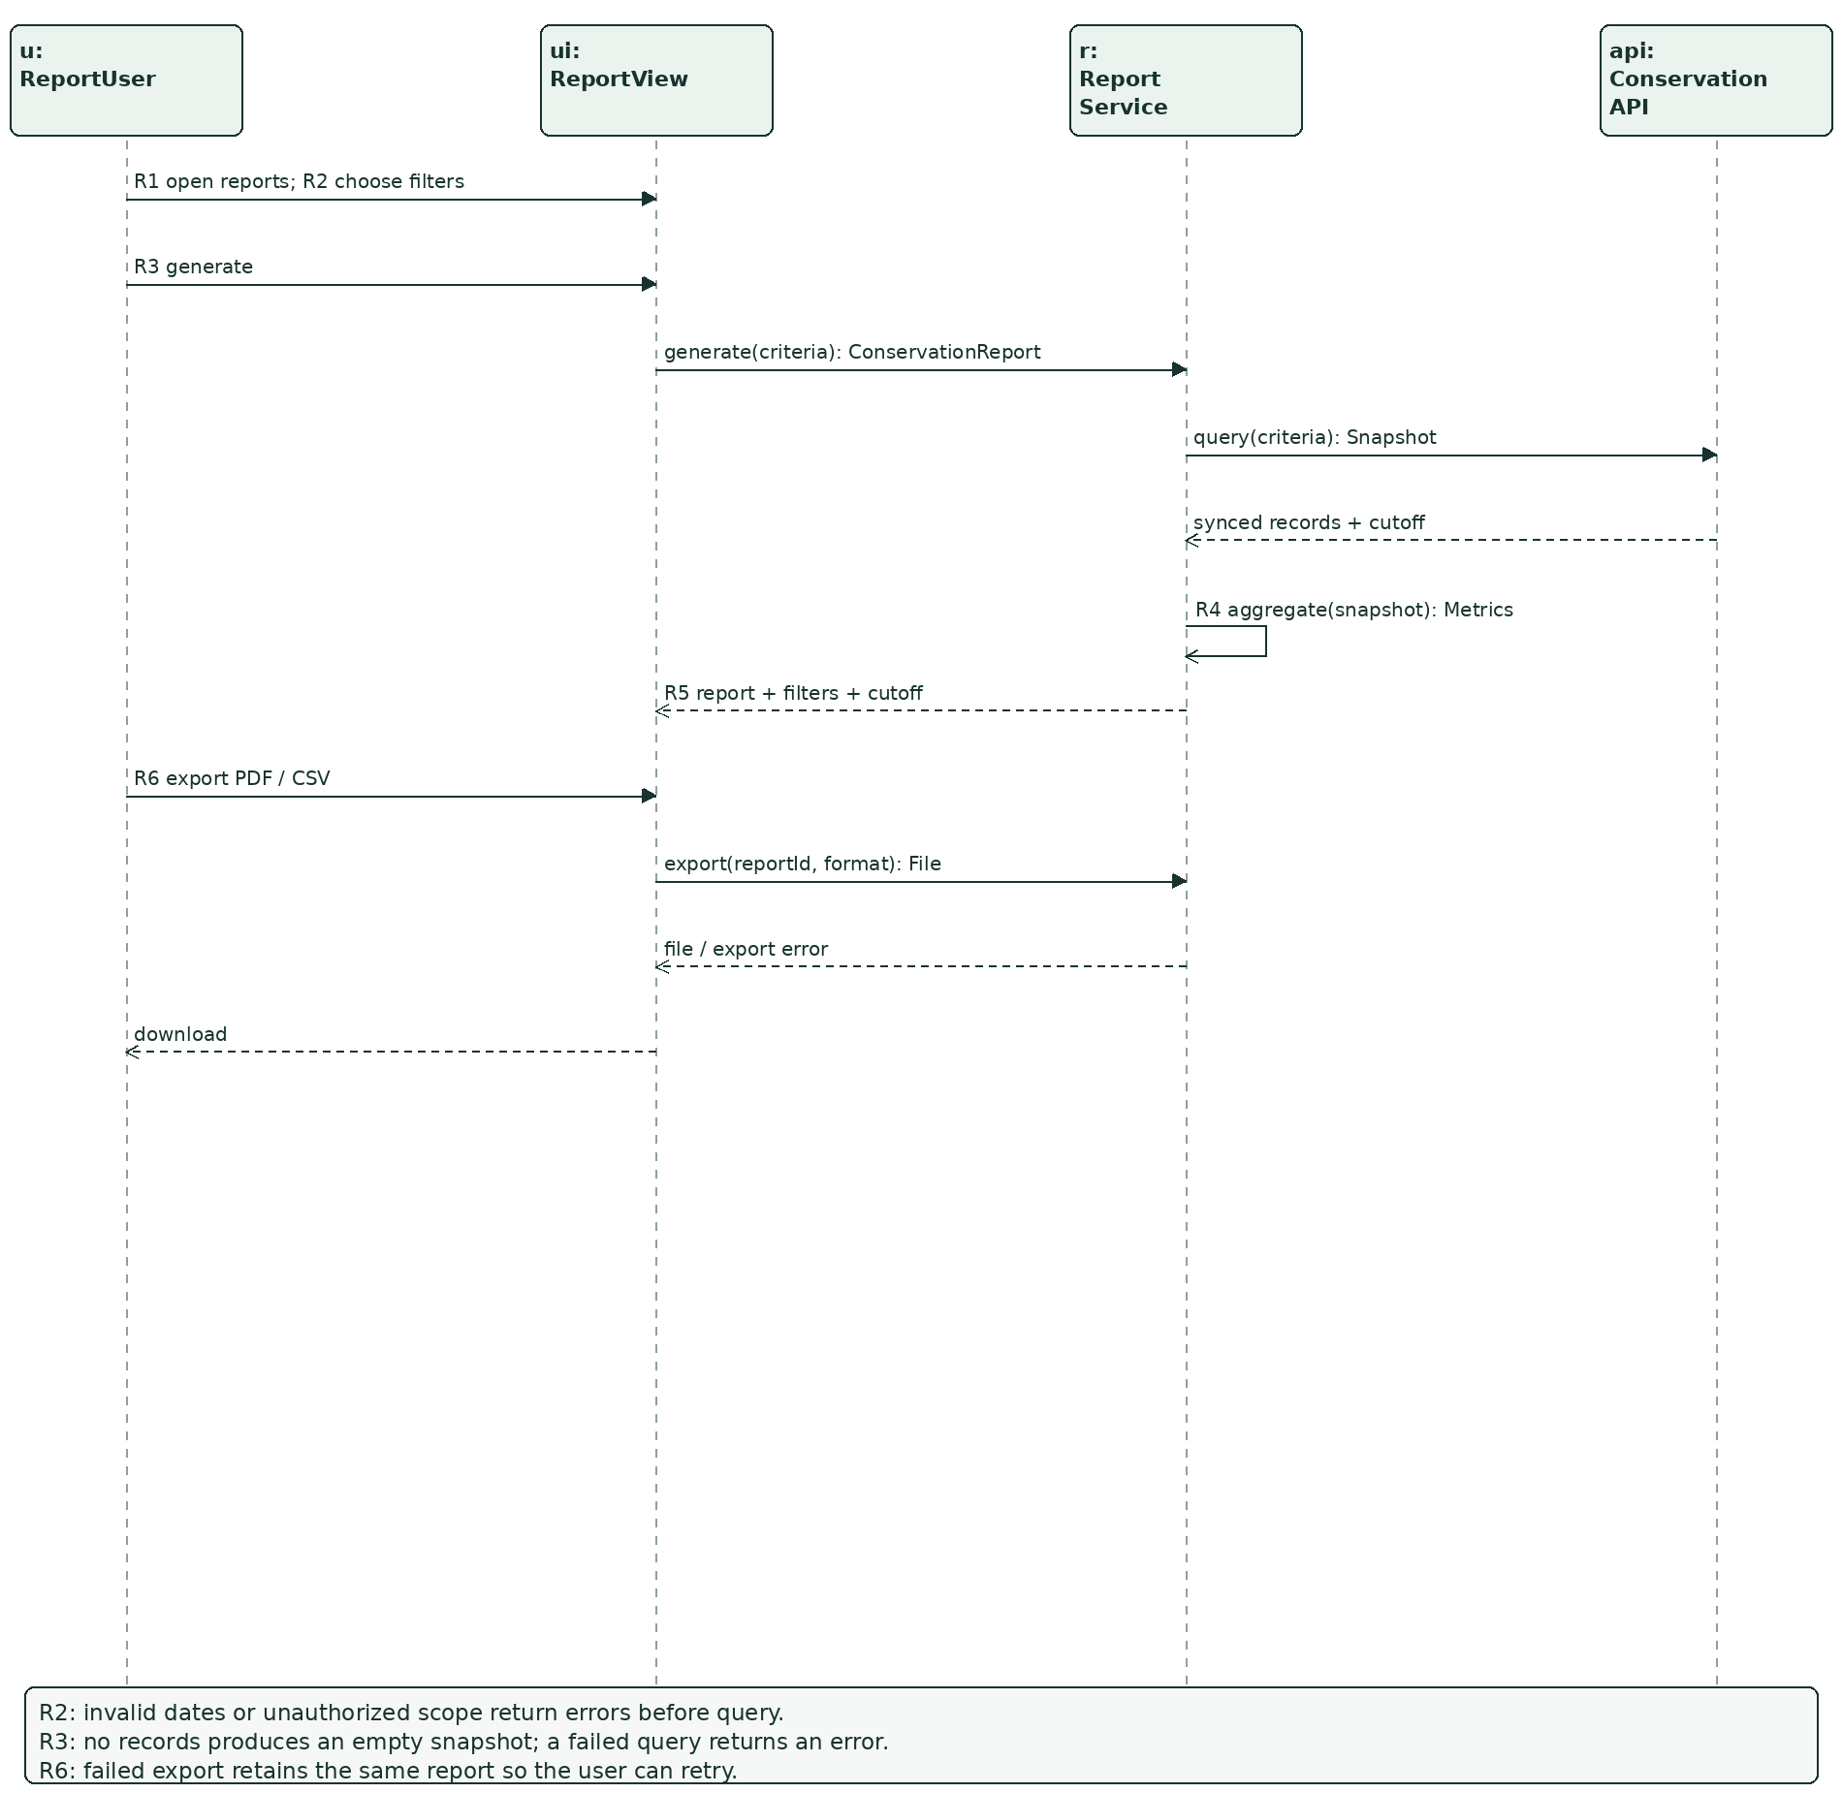
Figure UC04-SEQ. Message labels reference the scenario steps. Branch conditions and continuation behavior are stated inside the figure.
Boundary objects forward user input to the appropriate service. LocalStore and ConservationAPI own persistence interfaces. Calls and return values are defined in Appendix A; no view directly changes another user’s data.

UC04 - storyboard
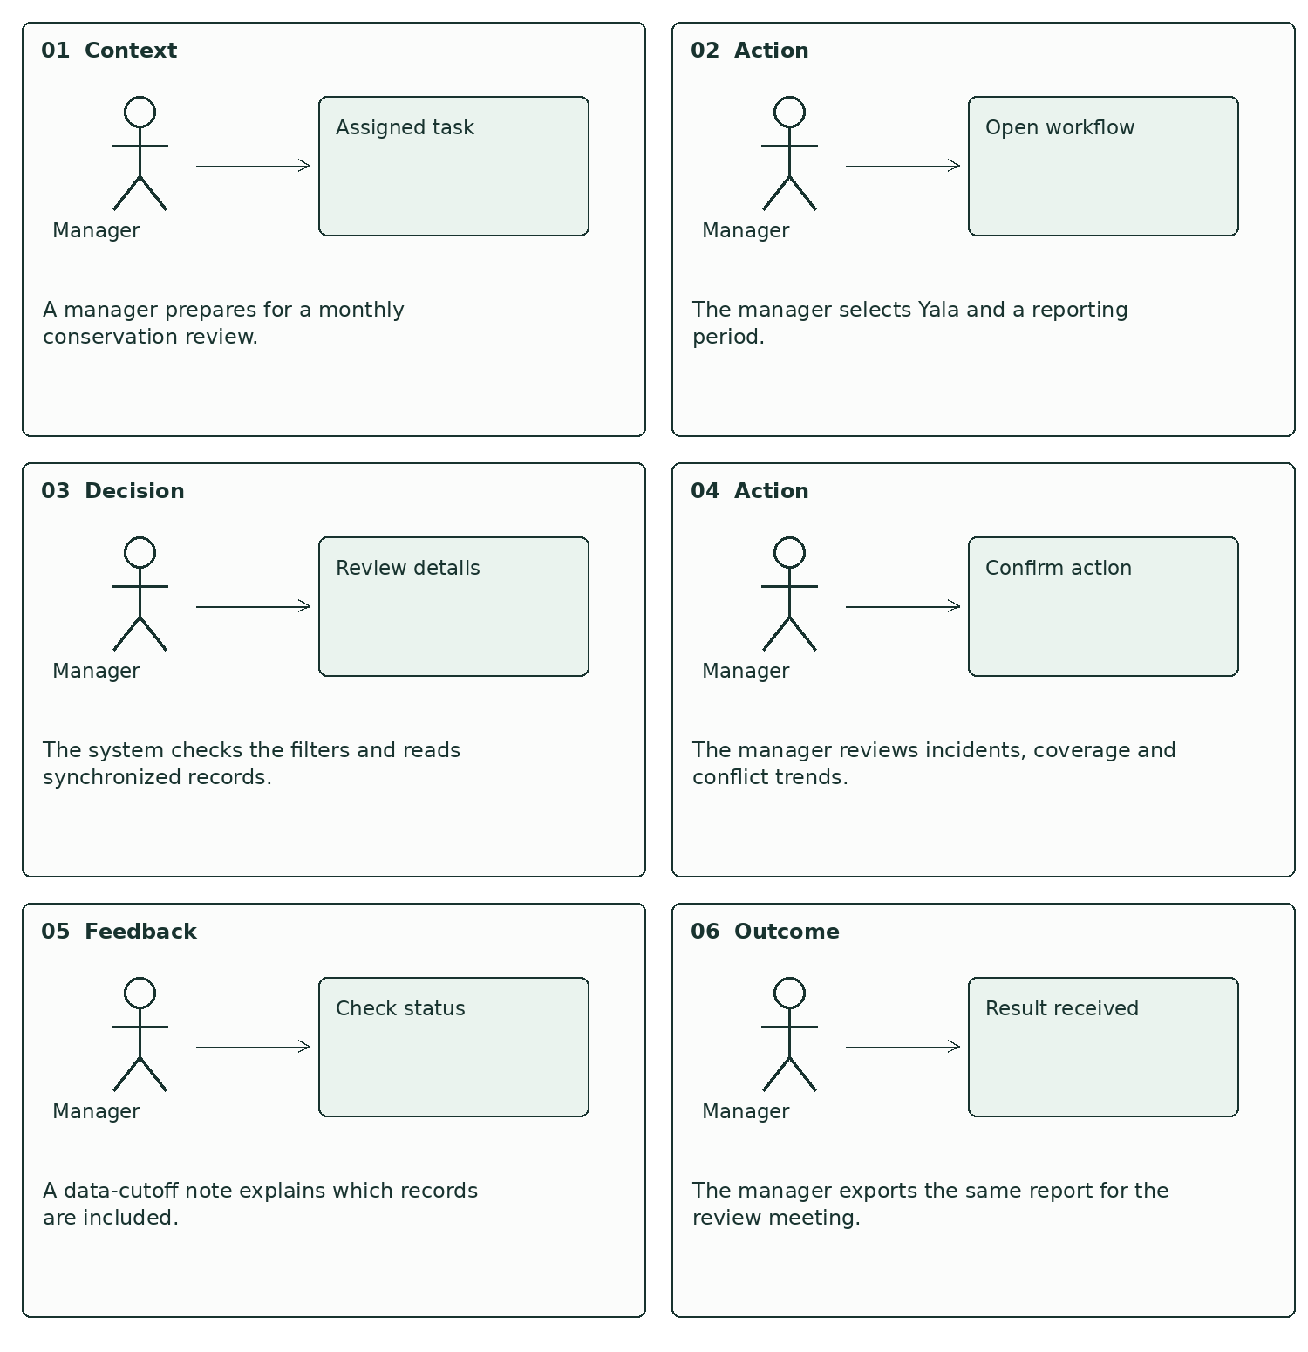
Figure UC04-SB. Six chronological panels show the user’s context, action and feedback for the same scenario.

UC04 - low-fidelity wireframe flow
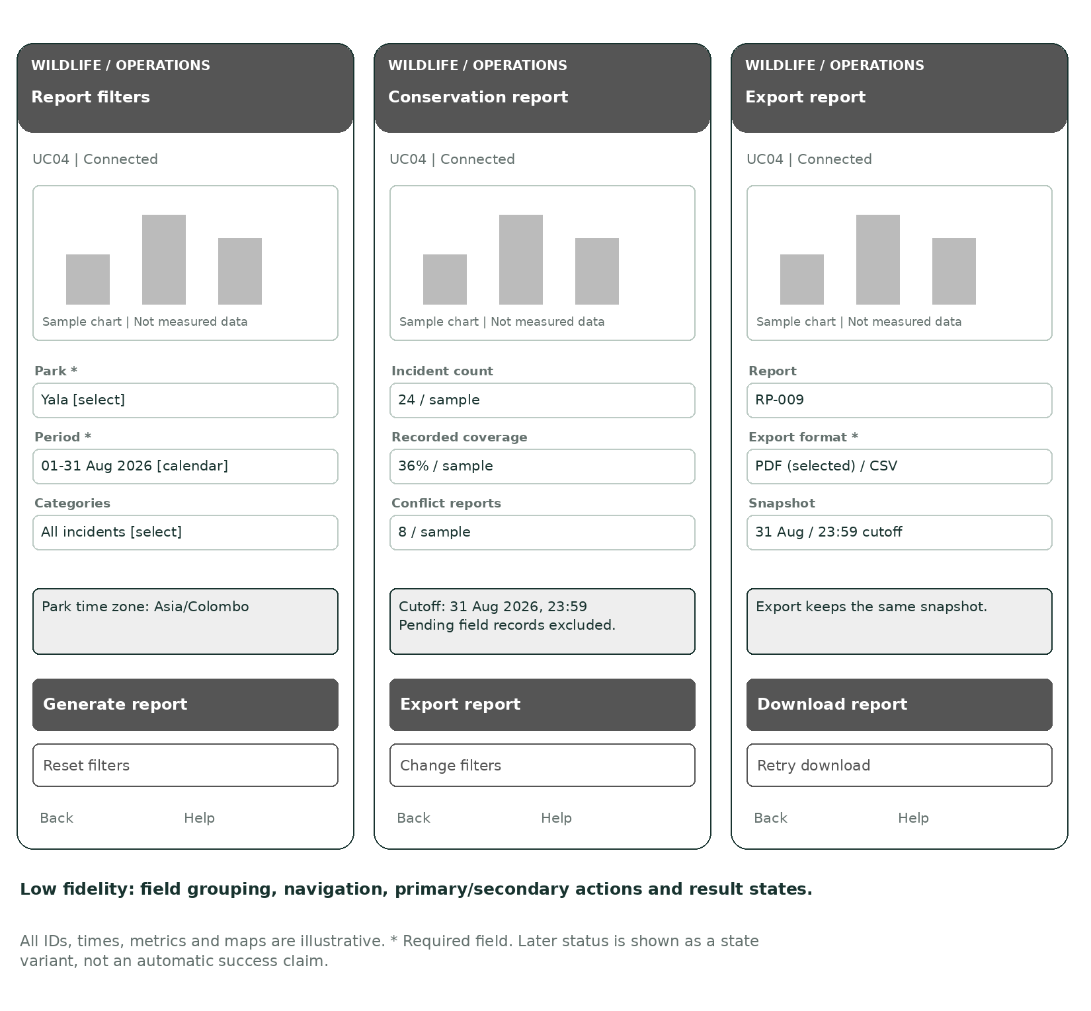
Figure UC04-LF. Three linked screens establish layout and interaction order before visual styling.
Navigation: the primary action advances to the next state after validation; Back returns without discarding unsaved input silently. Help explains the current task. Screen 3 is a result state, not a second submission.

UC04 - high-fidelity wireframe flow
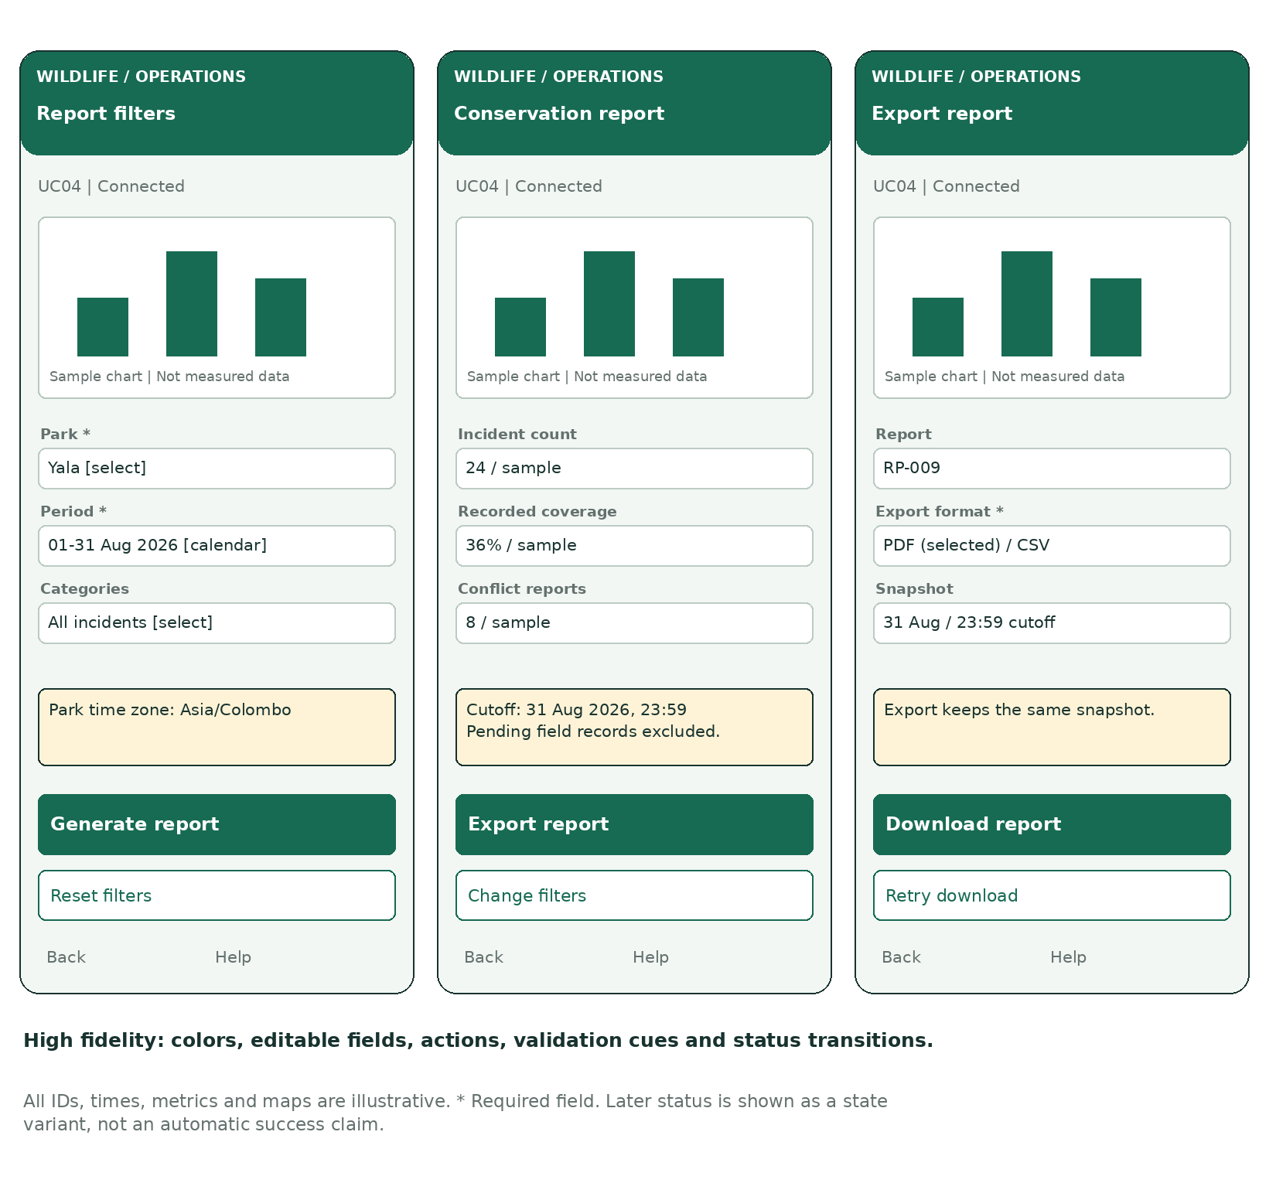
Figure UC04-HF. Detailed visual design of the same low-fidelity flow. Values are illustrative, not collected evidence.

Reporting states
Generate validates the date range. Empty results show zero counts and No matching records. Download uses the selected PDF/CSV format and the same snapshot. Display period, time zone and cutoff in the report header.

Appendix A. Operation contracts and model dependencies
Types: UUID = stable identifier; DateTime/Time = timestamp with zone/offset; GeoPoint = coordinates with source and observed time; Record = transferable entity envelope; Ack = server receipt with record ID/version; Snapshot = immutable synchronized dataset plus cutoff. Report aliases the relevant report class in compact diagrams.
Class | Complete operations used by scenarios
PatrolService | startPatrol(routeId: UUID): Patrol; recordPoint(patrolId: UUID, point: GeoPoint): void; completePatrol(patrolId: UUID): void
IncidentService | createIncident(data: IncidentInput): IncidentReport; reviewImage(imageId: UUID, note: String): void
ConflictService | ingestReading(reading: LocationReading): Alert?; assessRisk(reading: LocationReading): Alert?; getAlert(id: UUID): Alert; assign(alertId: UUID, officerId: UUID): ResponseAssignment; acknowledge(id: UUID, officerId: UUID): void
LocalStore | save(record: Record): void; pending(): Record[]; markSynced(id: UUID): void; status(id: UUID): SyncState
SyncService | synchronize(): void - triggered when network connectivity returns or a user retries.
ConservationAPI | upsert(record: Record): Ack; query(criteria: ReportCriteria): Snapshot
ReportService | generate(criteria: ReportCriteria): ConservationReport; aggregate(snapshot: Snapshot): Metrics; export(reportId: UUID, format: ExportFormat): File
NotificationGateway | send(assignment: ResponseAssignment): DeliveryState
Dependency direction: PatrolView → PatrolService → LocalStore; IncidentView → IncidentService → LocalStore; SyncService → LocalStore and ConservationAPI; ConflictView → ConflictService → ConservationAPI and NotificationGateway; ReportView → ReportService → ConservationAPI. SensorGateway invokes ConflictService for collar data and routes images to the camera review workflow.
Supporting operation contracts: route assignment requires an eligible officer; image review preserves the original image; report generation validates authorization before querying. The central gateway validates record ownership and version on every upsert. Failed validation returns a typed error to the calling service/view.

Appendix B. Requirements-to-design traceability
Requirement | Design location | Verification focus
FR01 / FR02 | UC01, PatrolRoute/Patrol/Waypoint; UC04 | Start assigned route, add manual point, show recorded coverage.
FR03 / FR04 | UC02; LocalStore/SyncService | Save evidence offline; retry without duplicate records.
FR05 | UC03; Animal/Collar/Reading/RiskZone/Alert | Fresh in-zone reading alerts; stale/outside reading does not.
FR06 | UC02 alternative A4; CameraTrap/CameraImage | Review image; preserve source reference when creating incident.
FR07 / FR08 | UC03 alternative A1 and main flow | Verify community location; assign and acknowledge response.
FR09 | UC04; ReportCriteria/ConservationReport | Counts, recorded coverage, conflict trends and matching export.
FR10 | Park configuration and business rules | Change zones/types/thresholds without code changes.

Individual consistency map
Member | Scenario steps | Linked artifacts
1 | P1-P6 | UC01-SEQ, UC01-SB, UC01-LF, UC01-HF
2 | I1-I6 | UC02-SEQ, UC02-SB, UC02-LF, UC02-HF
3 | C1-C6 | UC03-SEQ, UC03-SB, UC03-LF, UC03-HF
4 | R1-R6 | UC04-SEQ, UC04-SB, UC04-LF, UC04-HF
Coverage distinction: the four main scenarios are modeled in full. Camera review, SMS intake, route assignment and park configuration are supporting scope described in the requirements, class model and alternative flows; separate detailed screen/sequence packages for those supporting workflows are not claimed. This preserves the assignment’s four-major-use-case structure.

Appendix C. Proposed validation and usability evaluation
These are planned checks for the design or later prototype. They have not been executed against working software, and no user-study results are invented.
ID | Test / task | Expected outcome
T01 | Start cached patrol offline; record point; restart app. | Saved patrol and point remain available.
T02 | Disable GPS and add manual waypoint. | Manual location is labeled and persisted.
T03 | Report snare offline with photo. | Local receipt shown; no claim of server delivery.
T04 | Reconnect; interrupt upload; retry. | One complete server report, no duplicate photos.
T05 | Simulate local storage failure. | Not saved warning; no false pending/success state.
T06 | Send fresh in-zone, outside-zone and stale readings. | Only valid fresh risk condition creates a new alert.
T07 | Deliver the same reading twice. | No duplicate dispatch for the same open event.
T08 | Assign an unavailable officer or race two assignments. | Conflict shown; at most one active assignment remains.
T09 | Fail notification, then acknowledge as assigned officer. | Delivery failure and later acknowledgement shown separately.
T10 | Generate report with no data or invalid dates. | Empty report or field error, as appropriate.
T11 | Compare displayed report and exported file. | Same filters, metrics, report ID and cutoff.
T12 | Attempt restricted park access/export. | Access denied without disclosing restricted records.

Usability evaluation plan
Use representative participants acting as ranger, manager and liaison officer. Ask them to complete each main scenario without coaching, then an offline/error variation. Record task completion, wrong actions, requests for help and interpretation of status messages. Verify whether participants distinguish Saved on device from Submitted, and Assigned from Acknowledged. Evaluate touch-target size and readability on the agreed field device. Revise the designs based on observed issues.

Appendix D. Assumptions, submission checks and references

Explicit design assumptions
Four members are assumed because four distinct individual use cases are requested. A park manager may act as response coordinator. One active officer assignment per alert is proposed. GPS/manual locations, configurable freshness thresholds, evidence-omission reasons, grid-based coverage and PDF/CSV exports are design choices; they are not verbatim client rules. Domain states and screen values are illustrative. The report does not claim deployment, actual sensor integration or measured performance.

Before submission
Replace the member names, student IDs, group number and tutorial details. Confirm the intended deadline and the exact Lecture 02 scenario labels. Have all members jointly review the shared use case and class models. Keep scenario IDs and object/method names consistent if the group changes the design. Confirm whether the lecturer wants one combined submission or separately uploaded individual components. Follow the institution’s rules for acknowledging assistance.

Source references
[S1] SE3070 - Case Studies in Software Engineering. Assignment 1 - Case Study 1: Smart Wildlife Conservation and Anti-Poaching Monitoring System. BSc (Hons) in Software Engineering, Year 3, 2026 Semester 2. Supplied file: Case study 01(1).pdf, 3 pages. Page 1: background/objectives; page 2: field work, sensors and community reports; page 3: offline synchronization, analytics, flexibility and clarification guidance.
[S2] SE3070 - Case Studies in Software Engineering. Assignment 01 - Interaction and Functional Design of a Software Solution Based on a Case Study. Supplied file: SE3070 - Case Study Assignment 01 Specification.pdf, 4 pages. Pages 1-2: deliverables and instructions; pages 2-4: marking rubric. Release date printed as 14/08/2026; submission deadline printed as 11.59 PM, 05/09/2025 (inconsistent year).
No external websites were consulted for this report. The existing systems named in S1 are contextual examples only; this report does not make additional claims about their functionality.

Key terms
UML: Unified Modeling Language. Actor: a person or external service interacting with the system. Waypoint: a recorded location during a patrol. Risk zone: a configured geographic area requiring attention. Idempotent transfer: repeating the same transfer does not create another record. Data cutoff: the latest included synchronized data boundary. Wireframe: a screen design; high fidelity adds detailed visual styling and realistic example content.

UML Deep Demonstration and Rubric Evidence
MUST DEMONSTRATE: The following pages explain how every UML element earns rubric evidence. They are part of the design, not optional commentary.
The group model contains four major business goals: UC01 Manage Patrol Operations, UC02 Record and Review Wildlife Incidents, UC03 Coordinate Wildlife Conflict Response, and UC04 Analyze Conservation Data and Generate Reports. Each individual package uses one of these goals. Every scenario step is traced to a sequence message, responsible class operation, storyboard panel and wireframe state.
Required output | Deep evidence in this report | Rubric check
High-level use case diagram | Four domain goals, external actors, associations and system boundary; detailed actor/relationship table below. | No common login/logout use case; all goals originate in the case study.
One class diagram | Unified domain/control/boundary model plus typed-operation and multiplicity rationale. | Every sequence receiver has a matching class responsibility and operation.
Four scenarios | Main, alternative and exception flows; trigger, preconditions and postconditions. | A different scenario is allocated to each member.
Four sequence diagrams | Ordered calls/returns, lifelines, self-call, alt branches and persistence acknowledgements. | No unexplained magic message; scenario and class names remain consistent.
Storyboard -> low -> high fidelity | Six-panel context/action/feedback story followed by the same three-screen interaction flow. | No unrelated screen; state and primary action remain traceable.

UML 1. High-Level Use Case Model - Deep Specification
In UML, an actor represents an external role or external system, not a database table or screen. An oval represents a user goal. The rectangle is the Wildlife Conservation System boundary. Association lines show participation; they do not imply message order. The diagram deliberately keeps four major use cases, as required by the assignment. Supporting behavior is described inside each specification instead of being promoted into unrelated major use cases.
Use case | Primary / supporting actors | Included responsibility | Conditional extension / failure
UC01 Manage Patrol Operations | Ranger; Park Manager | Assign/view route, start patrol, capture GPS/manual waypoints, finish, save locally and synchronize. | Manual waypoint extends GPS capture when GPS is unavailable; retry extends synchronization failure.
UC02 Record and Review Wildlife Incidents | Ranger; Park Manager; Camera Gateway | Capture category, description, observation time, location and evidence; review camera finding; synchronize complete report. | Evidence-omission reason applies when capture is unsafe; partial-upload recovery applies on media failure.
UC03 Coordinate Wildlife Conflict Response | Park Manager; Ranger/Liaison Officer; Collar Gateway; Community Member | Ingest/verify source, evaluate risk, open alert, assign eligible officer, notify and acknowledge. | Community report is an alternative trigger; manual contact extends notification failure; no alert for stale/outside-zone data.
UC04 Analyze Conservation Data and Generate Reports | Park Manager; Researcher | Select authorized park/period, read one synchronized snapshot, calculate metrics and export the same snapshot. | Empty report extends no matching data; retry applies to data/export failure.

Use-case quality rules
- A goal is named with an action verb and business object; a UI control such as Click Submit is a scenario step, not a use case.
- The primary actor initiates the goal; a sensor or gateway can be a supporting actor when it supplies or receives information.
- Preconditions are facts that must already be true. They are not hidden steps. Postconditions state what is safely persisted or acknowledged.
- The model does not promise a central alert while a field device has no communication channel. Local and central receipts remain separate.

UML 2. Class Model - Responsibilities and Multiplicity Proof
The class model uses boundary-control-entity separation. View classes receive user interaction. Services coordinate business rules. Repositories and gateways own persistence/integration access. Entities retain domain state. This prevents a sequence diagram from sending a message directly from an actor to a database or inventing an operation that no class owns.
Use case | Boundary -> control | Core entities | Persistence / integration
UC01 | PatrolView -> PatrolService | Officer, PatrolRoute, Patrol, Waypoint | LocalStore -> SyncService -> ConservationAPI
UC02 | IncidentView -> IncidentService | IncidentReport, PhotoAttachment, CameraImage | LocalStore -> SyncService -> ConservationAPI
UC03 | ConflictView -> ConflictService | Animal, GPSCollar, LocationReading, RiskZone, Alert, ResponseAssignment, CommunityReport | ConservationAPI + NotificationGateway
UC04 | ReportView -> ReportService | ReportCriteria, ConservationReport | ConservationAPI snapshot query

Multiplicity and relationship rationale
Relationship | UML meaning | Why it matters
Patrol 1 ◆-- 0..* Waypoint | Composition | A waypoint has no independent lifecycle outside its patrol.
IncidentReport 1 ◆-- 0..* PhotoAttachment | Composition | Evidence belongs to one report; complete receipt covers every required attachment.
PatrolRoute 1 -- 0..* Patrol | Association | A route can be reused; every patrol uses one route.
Animal 0..1 -- 0..1 active GPSCollar | Optional one-to-one | Not every animal is collared and one active collar is linked to at most one animal.
RiskZone 1 -- 0..* Alert | Association | A zone can cause many historical alerts; one zone contextualizes each zone alert.
Alert 1 -- 0..* ResponseAssignment | Historical association | Reassignment preserves history while a business rule limits one active assignment.
ConservationReport 1 ◆-- 1 ReportCriteria | Composition | The immutable filter/cutoff snapshot travels with the report.

UML 3. Sequence Diagrams - Message-to-Method Traceability
Sequence time moves from top to bottom. A solid arrow is a call; a dashed arrow is a returned result. A self-call shows logic performed by the same lifeline. The alt frame separates mutually exclusive conditions. The following table proves that each important message has a receiver and matching method in the class model.
Scenario | Message / receiver operation | State or result demonstrated
UC01 P2 | PatrolView -> PatrolService.startPatrol(routeId): Patrol | Creates ACTIVE patrol; LocalStore.save confirms local persistence.
UC01 P3-P4 | recordPoint(patrolId, point); completePatrol(patrolId) | Looped GPS/manual capture then COMPLETED; no second patrol on retry.
UC01 P5-P6 | SyncService -> ConservationAPI.upsert(record): Ack | Connected branch marks SYNCED only after acknowledgement; offline branch retains PENDING.
UC02 I3-I4 | IncidentService.createIncident(data); LocalStore.save(record) | Validates and commits report/evidence reference before network transfer.
UC02 I5-I6 | ConservationAPI.upsert(report + attachments): complete-receipt Ack | Interrupted media remains pending; duplicate retry reuses report and attachment IDs.
UC03 C1-C2 | ConflictService.ingestReading(reading); assessRisk(reading): Alert? | Fresh/in-zone creates or reuses alert; stale/outside produces no new risk alert.
UC03 C4-C6 | assign(alertId, officerId); send(assignment); acknowledge(id, officerId) | Assignment, delivery and officer acknowledgement are separate states.
UC04 R3-R6 | ReportService.generate(criteria); aggregate(snapshot); export(reportId, format) | Display/export use the same immutable snapshot, filters and cutoff.

No-magic-message audit
Every persistence message terminates at LocalStore or ConservationAPI; every external notification terminates at NotificationGateway; every UI request passes through a named service. The operation contract appendix supplies parameter and return types. Errors return to the initiating view without silently mutating unrelated objects.

UML 4. Individual Deliverable Consistency
Member / scenario | Storyboard evidence | Low-fidelity flow | High-fidelity proof
M1 / UC01 patrol | Briefing -> start -> GPS/manual decision -> finish -> local status -> sync outcome | Assigned route -> active patrol -> completed/pending | Route/offline readiness, waypoint source, finish confirmation and retry/synced state.
M2 / UC02 incident | Finding -> choose type -> capture evidence -> review -> local receipt -> central receipt | New incident -> review report -> saved/pending | Required inputs, photo/reason option, no false server receipt and upload retry.
M3 / UC03 response | Alert -> assess freshness -> choose officer -> assign -> wait -> acknowledgement | Conflict alert -> assign response -> assignment status | Observed/received times, officer availability, delivery and acknowledgement distinction.
M4 / UC04 reporting | Need -> filter -> query -> inspect -> understand cutoff -> export | Report filters -> report result -> export | Authorized scope, empty/error behavior, metric notes and same-snapshot download.

Interaction-design rules derived from the case
- Outdoor users receive large primary controls, concise labels, readable contrast and confirmation before destructive or finishing actions.
- Offline state is visible at the top of field screens. Saved on device, Pending synchronization and Submitted are not interchangeable.
- A low-fidelity wireframe demonstrates layout and flow. The high-fidelity design preserves that structure and adds real labels, colors, field values and feedback states.
- The storyboard demonstrates the physical situation, goal, decision and system feedback; it is not merely a collection of screen thumbnails.

UML 5. Final Rubric Demonstration Checklist
Excellent-band expectation | Evidence demonstrated | Final group check
Four relevant business use cases with correct UML | Figure G1, deep use-case table and explicit domain actors/system boundary. | Confirm lecturer accepts the chosen four goals.
Comprehensive class model with methods, relationships and multiplicities | Figure G2, relationship table, operation contracts and UC responsibility map. | Review as a group; keep names identical in every diagram.
Complete scenario: main, alternative, exception, pre/postconditions | Each UC has a scenario page and a separate alternatives/exceptions page. | Relabel fields to the exact Lecture 02 template if required.
Accurate sequence syntax and no magic messages | Four scenario-specific sequences plus method traceability and no-magic audit. | Ensure exported images remain readable in the submitted PDF.
Strong usability and logical flow | Four storyboard, low-fidelity and high-fidelity sets with domain-specific state feedback. | Replace member placeholders; do not claim unperformed usability testing.
MUST DEMONSTRATE: Before submission, replace all four member names/IDs, group/tutorial details, and confirm the date because the supplied specification contains inconsistent years. All members must genuinely contribute to the shared diagrams.

Consistency rules that must not be broken
- Do not rename an actor, class, state or operation in only one artifact.
- Do not add login/logout as a major business use case.
- Do not display Submitted before central acknowledgement or Acknowledged before the assigned officer responds.
- Do not add an interface control that has no scenario step or system responsibility.
- Do not add a sequence message whose receiver lacks that responsibility in the class model.

