Sri Lanka Institute of Information Technology
Assignment 01
Y3S2-NU-WE-02
Case Studies in Software Engineering – SE3070
B.Sc. (Hons) in Information Technology – SE
Smart Wildlife Conservation and Anti-Poaching Monitoring System
Functional and Interaction Design
September 2026

Group Details
Group ID: Y3S2-NU-WE-02
Student ID | Student Name | Email Address | Contact Number
IT23811454 | Ahsan M.S.M | IT23811454@my.sliit.lk | 0725068682
IT23607996 | Sureka .A | IT23607996@my.sliit.lk | 0764617927
IT23635784 | Kajana .P | IT23635784@my.sliit.lk | 0769447392

# | Name | Individual Allocation
1 | Ahsan M.S.M (Leader) | UC01 – Manage Patrol Operations
2 | Kajana .P | UC02 – Record and Review Wildlife Incidents
3 | Sureka .A | UC03 – Coordinate Conflict Response + UC04 – Conservation Reporting

Contents
01. Use Case Diagram ........................................................ 3
02. Class Diagram ............................................................. 4
03. Use Case 01 – Manage Patrol Operations ........................ 5
04. Use Case 02 – Record and Review Wildlife Incidents ...... 10
05. Use Case 03 – Coordinate Wildlife Conflict Response ..... 15
06. Use Case 04 – Analyze Conservation Data and Reports ... 20

01. Use Case Diagram
All use cases are inside the system boundary. Major use cases include detailed use cases via <<include>>. Optional behaviour is shown with <<extend>>. Actors are outside the boundary and associate with the major goals they interact with.
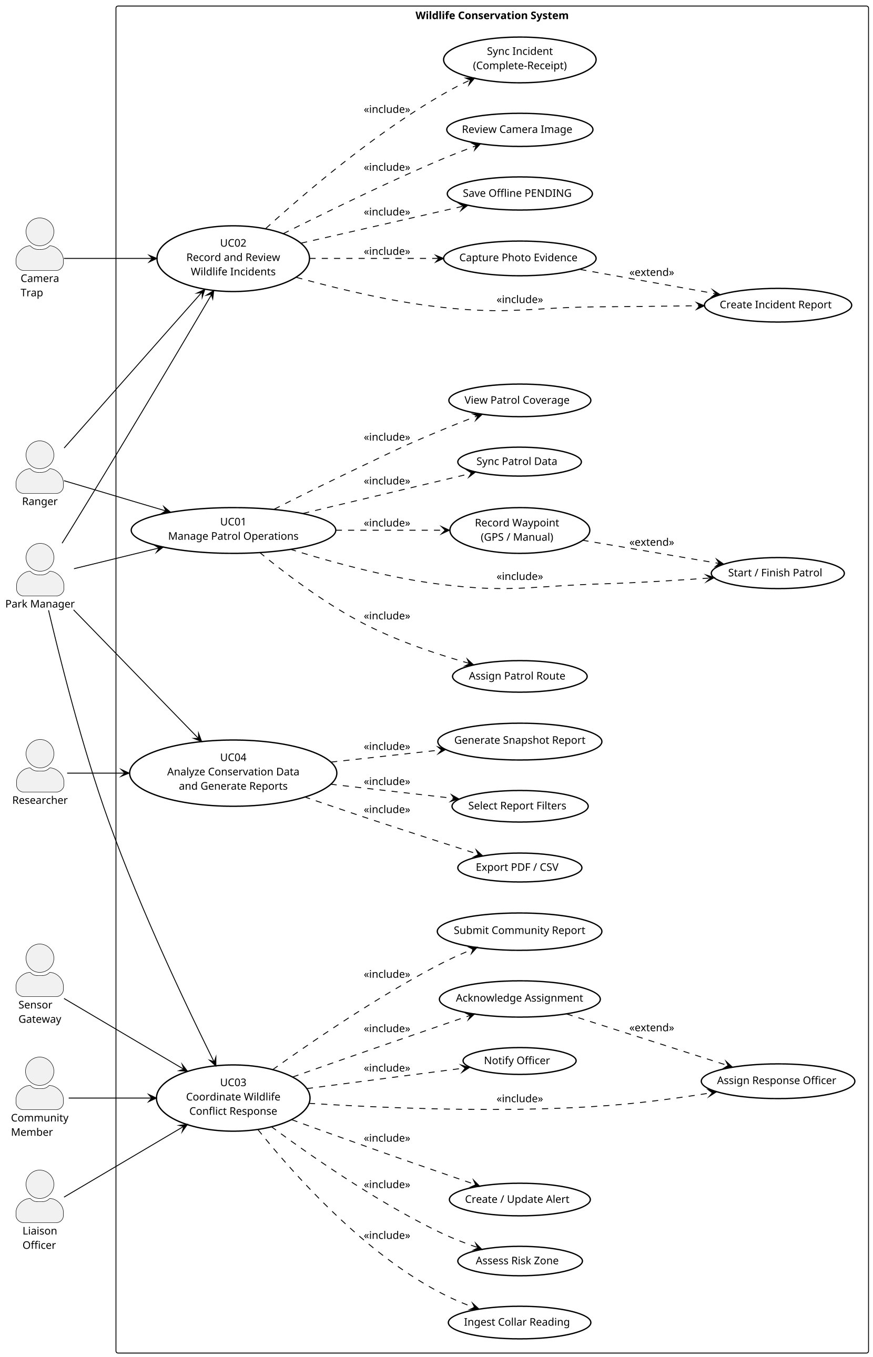
Figure 1 – Use case diagram (system boundary, <<include>>, <<extend>>, actor associations)
Relationship summary
Relationship | From | To | Meaning
Association | Ranger | UC01, UC02 | Ranger participates in patrol and incident goals
Association | Park Manager | UC01–UC04 | Manager participates in all four major goals
Association | Community Member | UC03 | Reports conflict-related sightings
Association | Liaison Officer | UC03 | Handles community-facing response
Association | Researcher | UC04 | Consumes conservation reports
Association | Sensor Gateway | UC03 | Supplies collar readings
Association | Camera Trap | UC02 | Supplies camera evidence
<<include>> | UC01 | Assign Route, Start/Finish, Record Waypoint, Sync, Coverage | Always part of patrol management
<<include>> | UC02 | Create IR, Capture Photo, PENDING, Review Cam, Sync Incident | Always part of incident handling
<<include>> | UC03 | Ingest, Assess, Alert, Assign, Notify, Ack, Community Report | Always part of conflict response
<<include>> | UC04 | Filters, Generate Snapshot, Export | Always part of reporting
<<extend>> | Record Waypoint | Start/Finish | Optional waypoint capture during active patrol
<<extend>> | Capture Photo | Create IR | Optional photo attached to incident
<<extend>> | Acknowledge | Assign Response | Optional ack after assignment

02. Class Diagram
Domain entities with attributes and operations. Composition (filled diamond) for Patrol–Waypoint, IncidentReport–PhotoAttachment, ConservationReport–ReportCriteria. Multiplicities shown on associations. Application services listed separately.
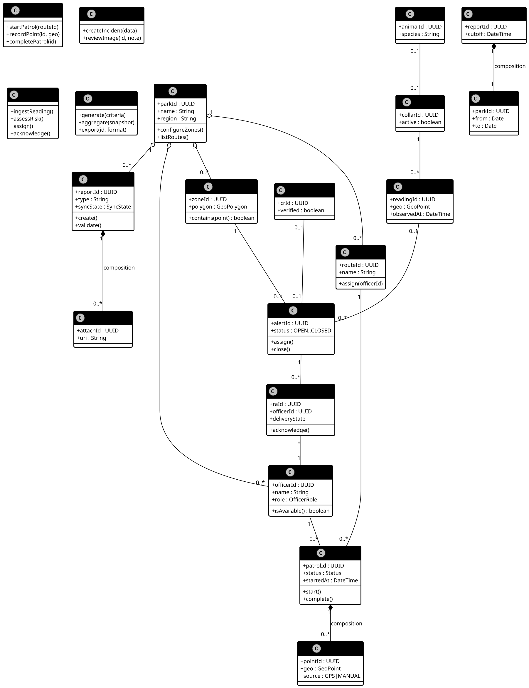
Figure 2 – Class diagram (attributes, operations, multiplicities, composition)

03. Use Case 01 – Manage Patrol Operations
Individual owner: Ahsan M.S.M (IT23811454)
Use Case Scenario
Field | Value
Use case ID | UC01-P01
Use case Name | Record an assigned patrol
Summary | Authorized ranger opens an assigned route, starts a patrol, records GPS or manual waypoints (including offline), finishes the patrol, and synchronizes a single trustworthy record when connectivity returns.
Priority | 5 (highest)
Preconditions | 1) Ranger has authorized access. 2) Assigned route and park map downloaded. 3) Device storage available.
Post Condition | Completed patrol and waypoints saved locally. Server receives exactly one matching record after sync. Pending status remains visible until acknowledgement.
Primary actor | Ranger
Trigger | Ranger opens assigned route and chooses Start patrol.

Main Success Scenario
Step | Action | System Response
1 | Ranger opens route RT-07 | App displays route, map availability and previous sync time
2 | Ranger chooses Start patrol | PatrolService starts PT-104; LocalStore saves ACTIVE
3 | Device supplies a position | Records timestamped waypoint locally
4 | Ranger chooses Finish and confirms | Completes patrol; queues for synchronization
5 | Connectivity returns at base | SyncService sends pending record; ConservationAPI upserts by stable ID
6 | Server acknowledges | LocalStore marks synced; app shows completion and last-sync time

Extensions / Alternate Flows
Step | Branching Action
3a | GPS unavailable → Add waypoint on downloaded map; store source=MANUAL; continue at step 3.
4a | Cancel finish → Keep patrol ACTIVE; do not create a second patrol.
5a | Already online → Run synchronization immediately after local save.
2b | Storage failure → Show Save failed; do not claim persistence; keep input; retry.
5b | Timeout or rejected access → Keep queued data; show Pending; retry after restored.
5c | Ack lost after server commit → Retry same patrol ID; server returns existing record (no duplicate).

Open Issues
1. Auto-pause after long GPS gap? 2. Maximum offline storage quota? 3. Can manager re-assign an active patrol?

03 – Sequence Diagram
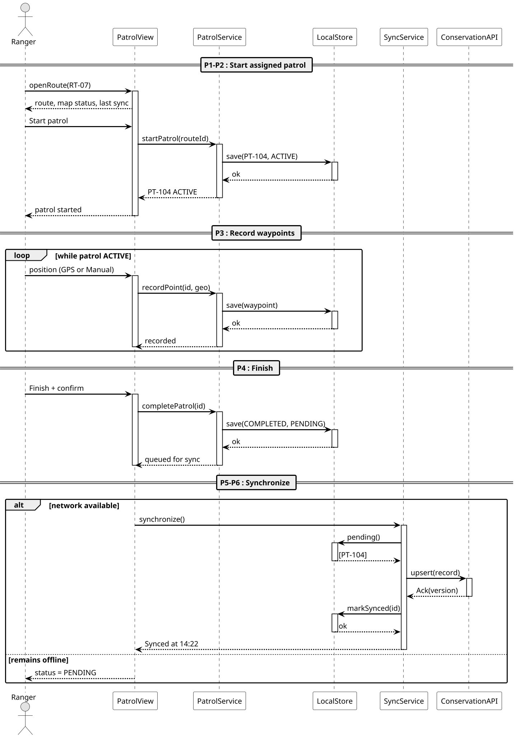
Sequence diagram – UC01-P01

03 – Storyboard
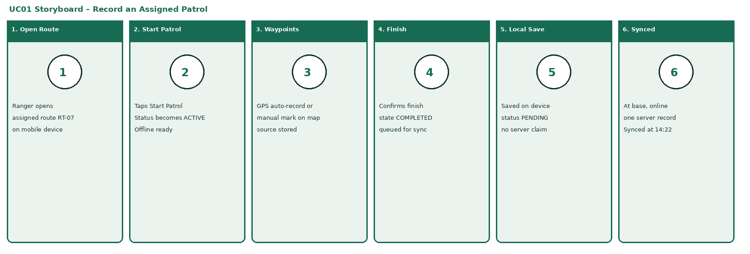
Storyboard – UC01-P01

03 – Low-Fidelity Wireframe
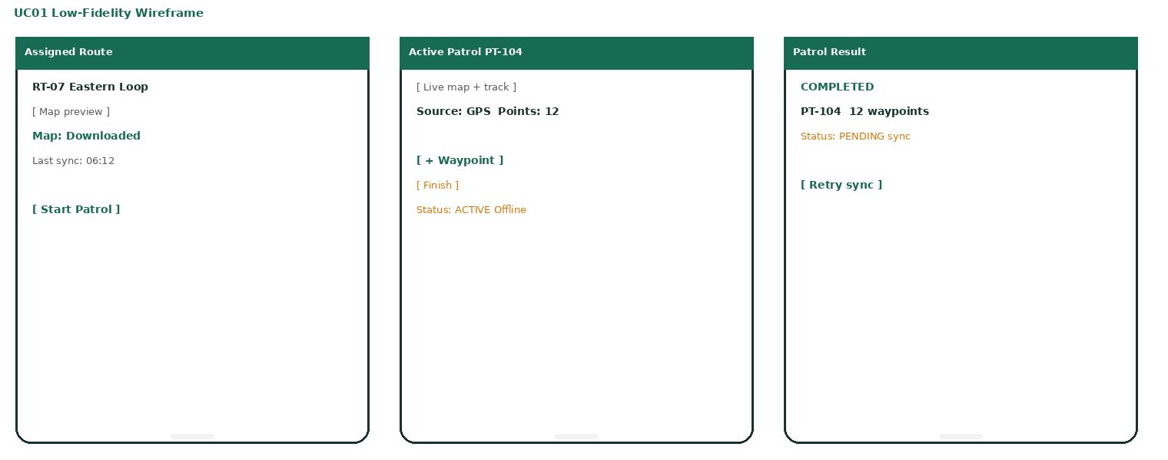
Low-fidelity wireframe – UC01-P01

03 – High-Fidelity Wireframe
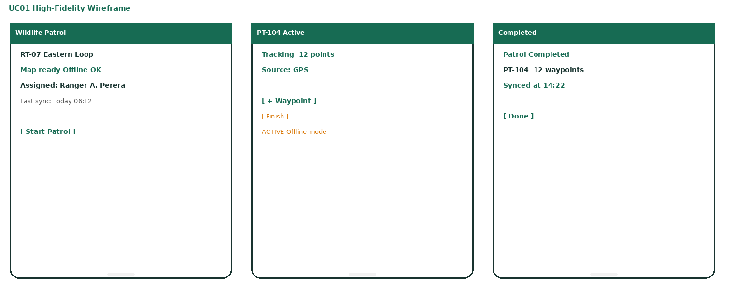
High-fidelity wireframe – UC01-P01

04. Use Case 02 – Record and Review Wildlife Incidents
Individual owner: Kajana .P (IT23635784)
Use Case Scenario
Field | Value
Use case ID | UC02-I01
Use case Name | Report a snare while offline
Summary | Ranger discovers an illegal snare without coverage, captures category, photo, location and description, saves locally with a stable ID, and obtains complete-receipt acknowledgement when connectivity returns so the report becomes available for review.
Priority | 5 (highest)
Preconditions | 1) Authorized access and cached categories. 2) Camera or evidence-omission reason available. 3) Device can store a report.
Post Condition | Incident with stable ID, location source, observation time and evidence saved locally. After complete-receipt Ack available for authorized review. No central receipt claimed before acknowledgement.
Primary actor | Ranger
Trigger | Ranger discovers an illegal snare while patrolling without mobile coverage.

Main Success Scenario
Step | Action | System Response
1 | Opens New incident, selects Snare | Loads form and cached categories
2 | Takes photo, confirms location, enters description | Retains draft; shows observation time and location source
3 | Selects Save report | IncidentService validates; creates IR-208
4 | Device is offline | LocalStore saves report+attachment with PENDING
5 | Connectivity returns | SyncService sends report and evidence via ConservationAPI
6 | Server complete-receipt Ack | markSynced; show Submitted IR-208

Extensions / Alternate Flows
Step | Branching Action
2a | GPS unavailable → mark location manually; source=MANUAL.
2b | Photo unsafe/unavailable → record evidence-omission reason; allow urgent report without photo.
4a | Network available → persist locally first, then attempt immediate sync.
3b | Missing required input → highlight fields; preserve draft; deny save until complete.
4b | Local save fails → show Not saved; never show Pending for unsaved report.
5a | Photo upload interrupted → retain locally; resume; do not mark synced until complete-receipt Ack.
5b | Duplicate retry → upsert same report and attachment IDs; no second incident.

Open Issues
1. Maximum photo size before compression? 2. Camera-trap: auto-incident or staff confirmation only? 3. How long to keep local PENDING media?

04 – Sequence Diagram
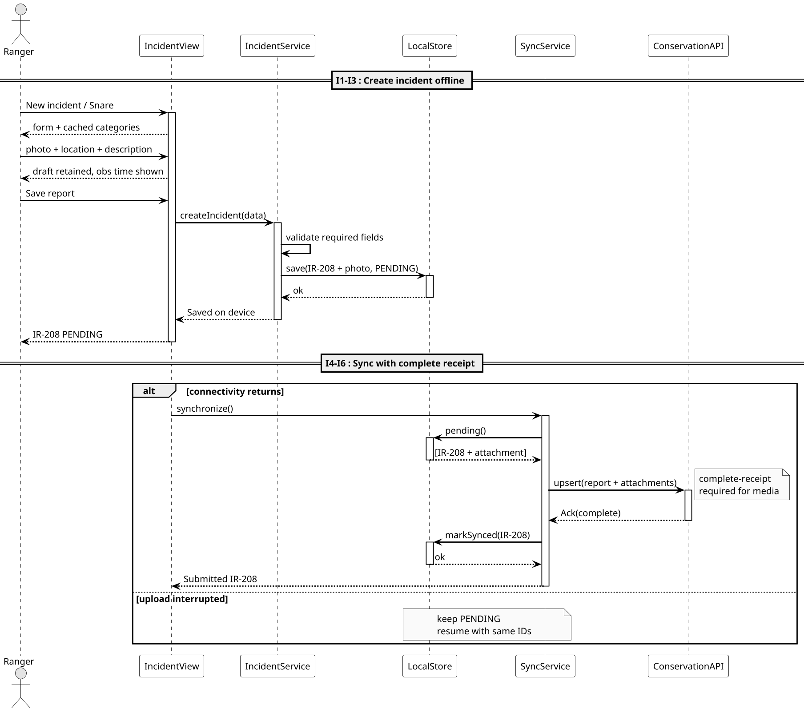
Sequence diagram – UC02-I01

04 – Storyboard
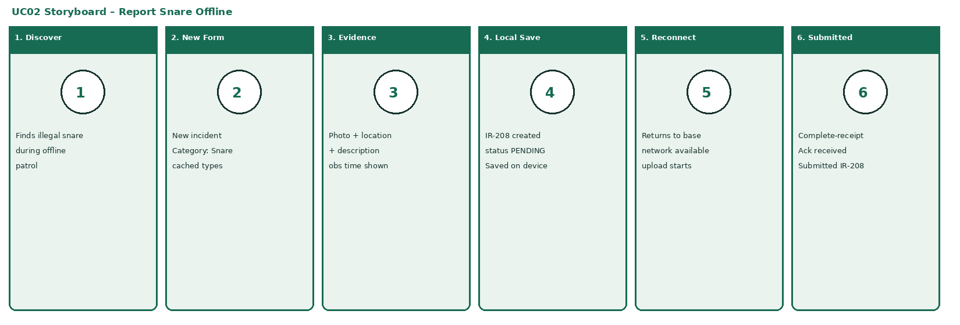
Storyboard – UC02-I01

04 – Low-Fidelity Wireframe
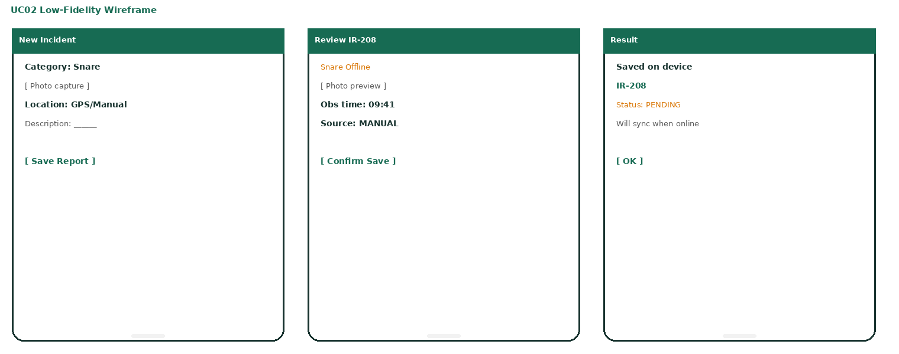
Low-fidelity wireframe – UC02-I01

04 – High-Fidelity Wireframe
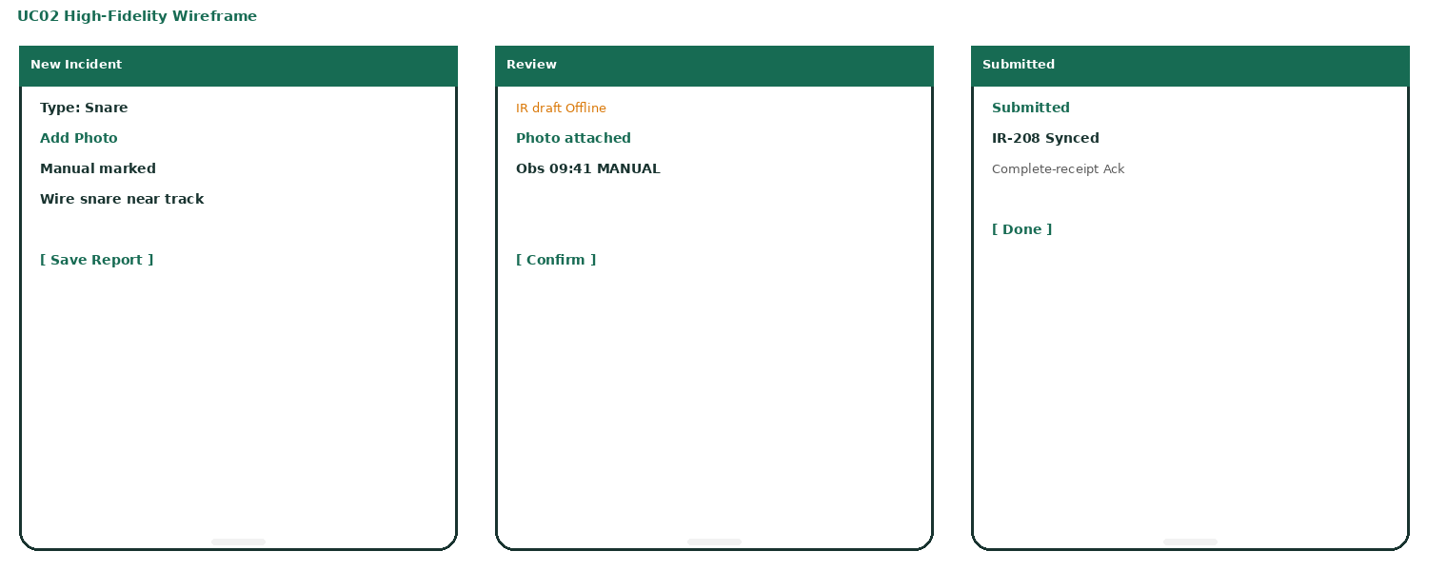
High-fidelity wireframe – UC02-I01

05. Use Case 03 – Coordinate Wildlife Conflict Response
Individual owner: Sureka .A (IT23607996)
Use Case Scenario
Field | Value
Use case ID | UC03-C01
Use case Name | Assign a response to a risk alert
Summary | A fresh collar reading places a tracked animal inside a configured risk zone. System creates or updates an open alert. Park manager reviews observed/received times and location confidence, assigns an available officer. System notifies. Officer acknowledgement is recorded as a distinct event from delivery.
Priority | 5 (highest)
Preconditions | 1) Collar linked to animal. 2) Zone and freshness threshold configured. 3) Manager can access this park. 4) Officer availability maintained.
Post Condition | Valid response assignment stored and linked to the alert. Notification delivery and officer acknowledgement recorded separately. Unacknowledged assignment remains visible.
Primary actor | Park manager
Trigger | Newly received collar reading places tracked elephant inside configured farmland risk zone.

Main Success Scenario
Step | Action | System Response
1 | Sensor gateway sends collar reading | ConflictService validates and records ID, location, observation time
2 | System evaluates against configured zones | Fresh in-zone reading creates or updates open alert
3 | Manager opens the alert | Shows animal, zone, observed/received times, location confidence
4 | Selects available ranger or liaison | Validates availability; creates response RA-031
5 | System attempts notification | NotificationGateway records delivery; shows Awaiting acknowledgement
6 | Assigned officer acknowledges | Records acknowledgement; shows Acknowledged

Extensions / Alternate Flows
Step | Branching Action
1a | Community SMS/app report → staff verify location/urgency; credible report creates alert for same workflow.
2a | Animal outside zone → store reading as historical; no risk alert.
2b | Stale or invalid reading → reject invalid coords; store valid-but-stale as historical; no fresh alert.
2c | Repeated sensor message → ignore duplicate reading ID; reuse existing open animal-zone alert.
4a | No available officer → leave alert OPEN; show Unassigned; escalate for manual coordination.
4b | Assignment conflict → display current assignment; require explicit reassignment decision.
5a | Notification fails → keep assignment; flag delivery failure; offer retry/radio; do not claim acknowledgement.

Open Issues
1. Deduplication window for same animal-zone events? 2. Auto-escalate if no Ack within N minutes? 3. Can liaison close alert without manager review?

05 – Sequence Diagram
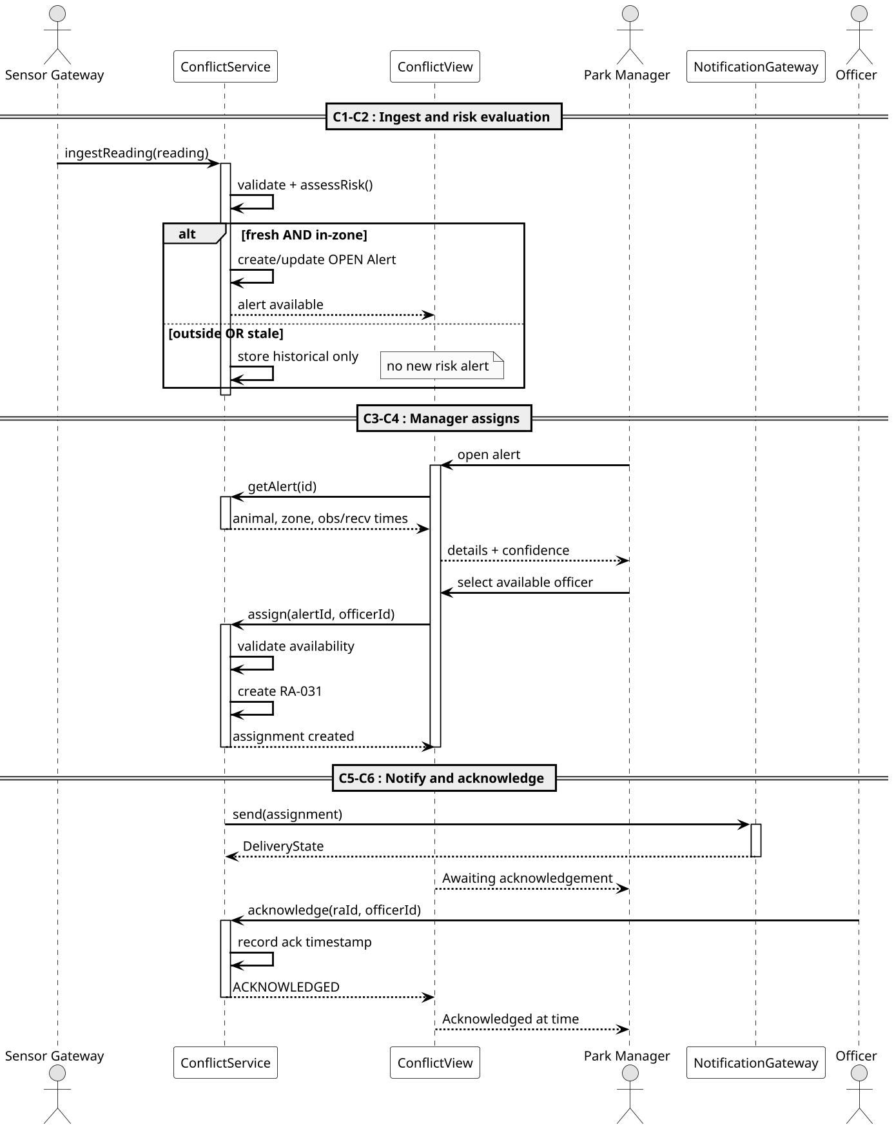
Sequence diagram – UC03-C01

05 – Storyboard
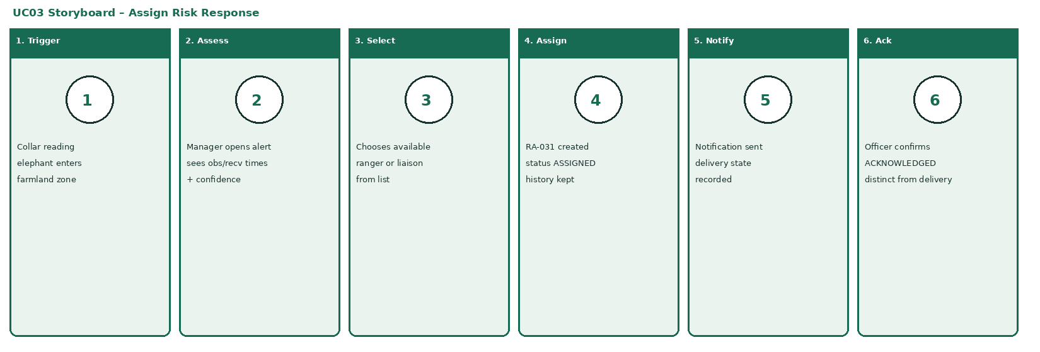
Storyboard – UC03-C01

05 – Low-Fidelity Wireframe
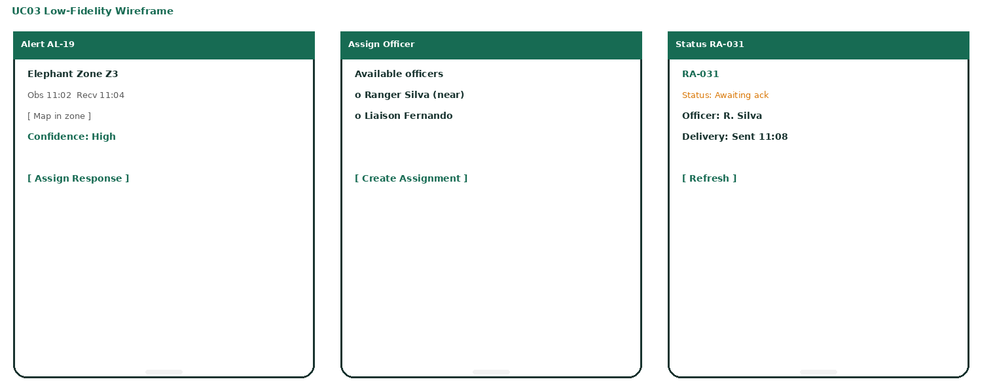
Low-fidelity wireframe – UC03-C01

05 – High-Fidelity Wireframe
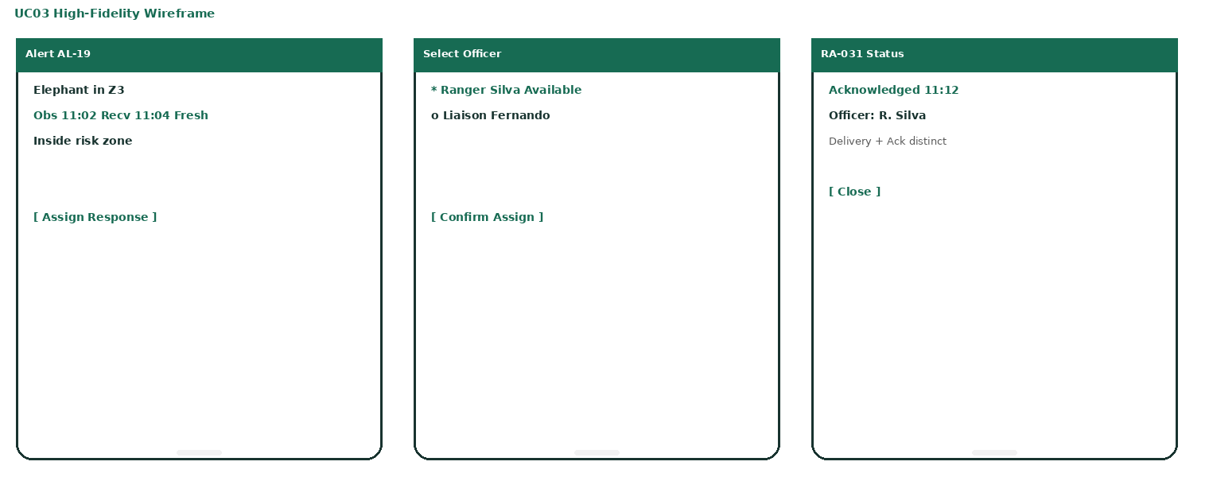
High-fidelity wireframe – UC03-C01

06. Use Case 04 – Analyze Conservation Data and Generate Reports
Individual owner: Sureka .A (IT23607996)
Use Case Scenario
Field | Value
Use case ID | UC04-R01
Use case Name | Generate a park conservation report
Summary | Authorized user selects park and reporting period. System returns one consistent snapshot of synchronized records, calculates incident counts, patrol coverage and conflict trends, displays results with data cutoff, and exports the identical snapshot as PDF or CSV.
Priority | 5 (highest)
Preconditions | 1) Reporting permission for selected park. 2) Synced records available. 3) Reporting time zone and coverage grid configured.
Post Condition | Report generated with filters, time zone, generation time and data cutoff. Export reflects the same snapshot. Pending field records explicitly excluded.
Primary actor | Park manager / conservation researcher
Trigger | User needs incident and patrol-coverage information for a selected reporting period.

Main Success Scenario
Step | Action | System Response
1 | Opens Reports | Displays permitted parks and filter controls
2 | Selects park, date range, categories | ReportService validates scope and date order
3 | Selects Generate report | ConservationAPI returns consistent snapshot of synced records
4 | System calculates aggregates | Builds incident counts, patrol coverage, conflict trends
5 | Reviews the result | Shows results with filters, cutoff time and limitations
6 | Selects Export PDF or CSV | Exports the same snapshot; returns download

Extensions / Alternate Flows
Step | Branching Action
3a | No matching records → valid empty report with zero counts; “No records for these filters”.
5a | Adjust filters → return to step 2; generate new snapshot; do not mix old results.
2a | Invalid dates or unauthorized park → validation error; no query until corrected.
3b | Unavailable data service → retry state; preserve filters; do not present old results as new.
6a | Export failure → keep displayed report; allow retry against same snapshot.

Open Issues
1. Exclude long GPS gaps in coverage by default? 2. Maximum export size before background job? 3. Researcher: anonymized only or full with audit?

06 – Sequence Diagram
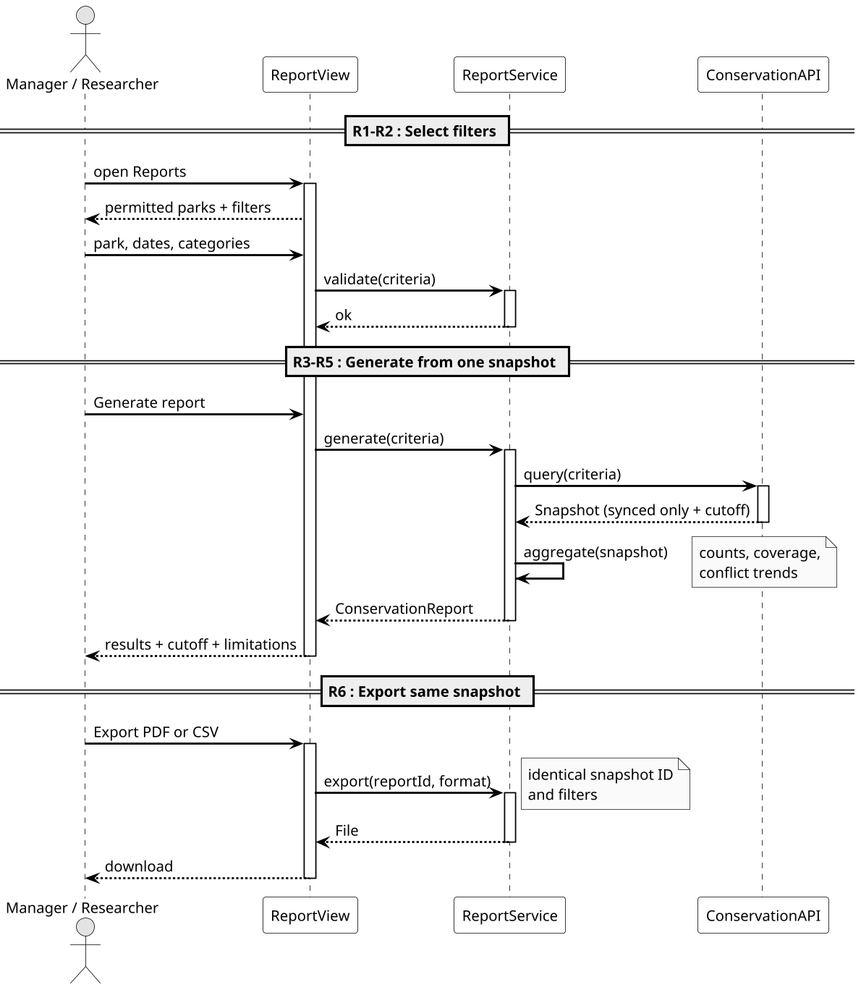
Sequence diagram – UC04-R01

06 – Storyboard
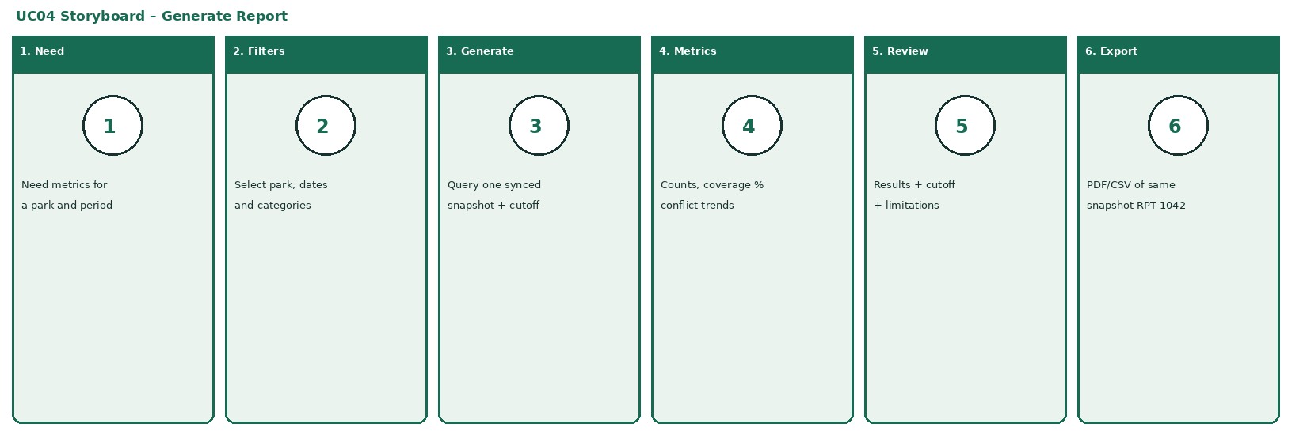
Storyboard – UC04-R01

06 – Low-Fidelity Wireframe
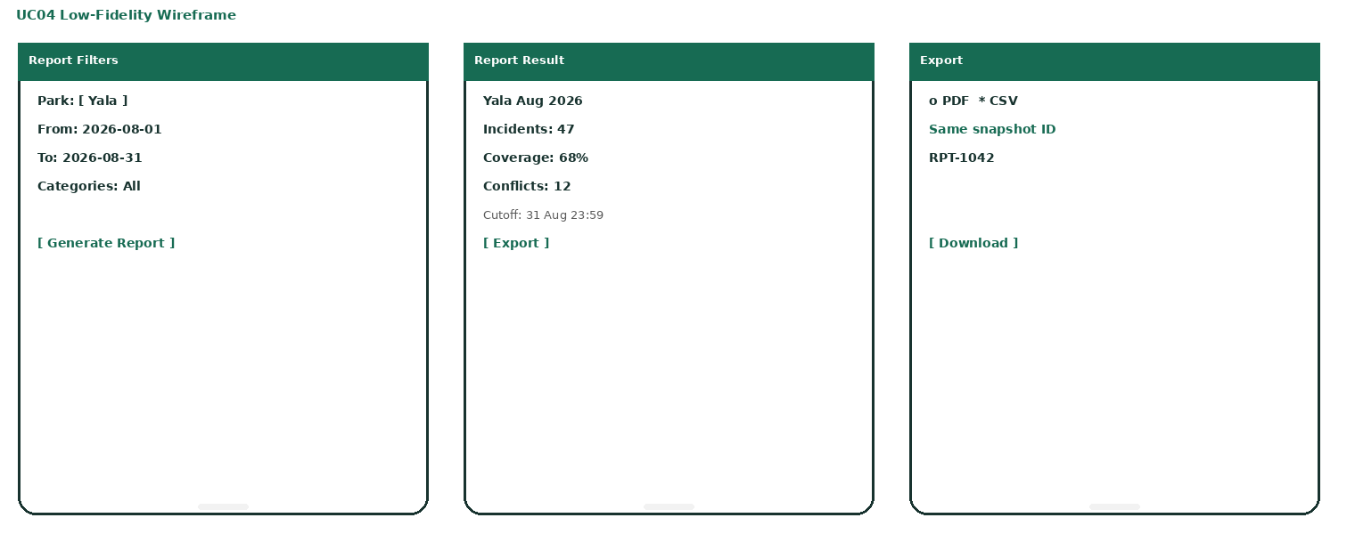
Low-fidelity wireframe – UC04-R01

06 – High-Fidelity Wireframe
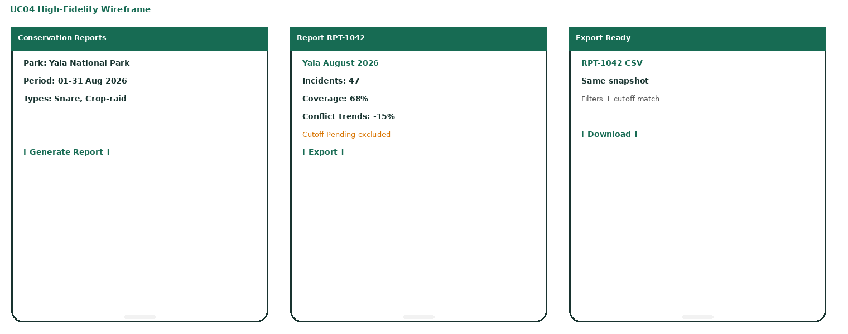
High-fidelity wireframe – UC04-R01

Appendix – Operation Contracts
Class | Operations
PatrolService | startPatrol, recordPoint, completePatrol
IncidentService | createIncident, reviewImage
ConflictService | ingestReading, assessRisk, getAlert, assign, acknowledge
LocalStore | save, pending, markSynced, status
SyncService | synchronize
ConservationAPI | upsert: Ack, query: Snapshot
ReportService | generate, aggregate, export
NotificationGateway | send: DeliveryState

UML generated with PlantUML (formal B&W). All use cases inside system boundary. <<include>> and <<extend>> shown. Wireframes use project colour theme.

