Remote Swab Collection Portal

Sample Collection

**It is important that the collection portal screen is completed at the time the swabs are handed out**. This ensures that all required information is recorded and attached to the appropriate swab. If the information is incomplete or we cannot match the swabs to the records, this will result in a delay in testing and possibly a rejection of the sample.

## Sample Details

***Q: what does vet verified mean?***

*This means that at collection a vet has verified the identity of the animal via its microchip or tattoo. This is a requirement of some breed and kennel clubs. Please consult your local Kennel club for more information.*

All parts of this section must be completed.

The Swab number is linked to the animal and test details. This will change automatically each time a new animal is entered.

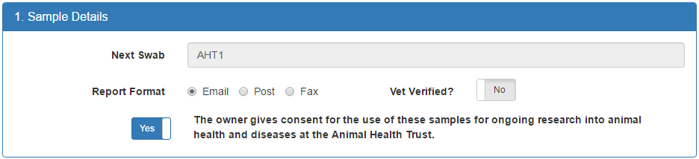

Select how you would like to receive your test results.

By purchasing your DNA test from the Animal Health Trust you are helping to support our comprehensive research programme into animal disease and welfare. The money from your order goes back in to helping fund our research; we hope that you are happy to help us further by allowing us to us your dog’s sample in future research.

Swab ID labels will be supplied with the swab kits. These swab numbers are what physically link each swab with their order details, therefore, please pay close attention to the numbers used.

### Vet Verification

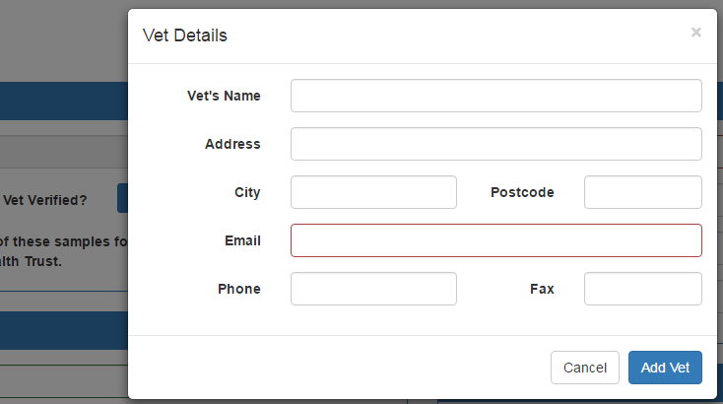If the sample is collected at the same time as the portal form is filled out, and a Vet is present, veterinary verification of the animal via microchip or tattoo can be recorded.

This verification is a requirement by some Kennel Clubs and some breed clubs.

## Dog Details

All the sections outlined in red must be completed to place the order.

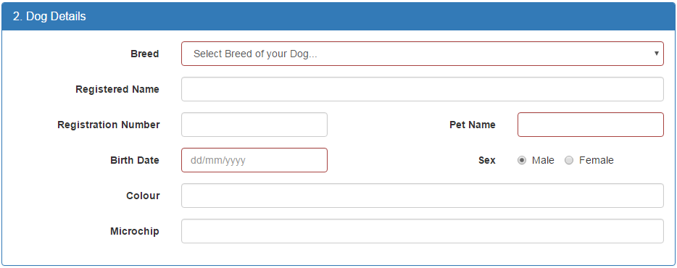

***Q: What if I don’t know the microchip or registration name/number? Or don’t have them with me?***

*You can still order your test and have the swab taken. You will just need to email us at* [*DNAtesting@aht.org.uk*](mailto:DNAtesting@aht.org.uk) *from the email address given for reporting and we can add these*

Please make sure that all the required fields, outlined in red, are filled in. You will not be able to submit the form without completing these. These fields are the minimum information that we require to process your sample. Many of our tests are reported directly to the kennel club and breed clubs. For your results to be logged correctly with them you will also need to provide as much of the extra information as possible, such as the registration details.

If you do not know the answer for any of the non-required fields, simply drop us an email to provide this information. You **MUST** send the email from the address provided in section 3.

## Owner Details

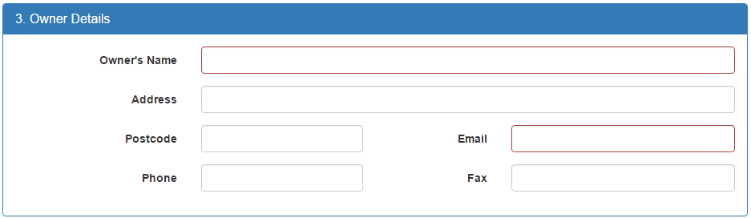

The red outlined sections on this form are compulsory and must be completed to allow successfully ordering of your test.

It is recommended that as much information as possible is supplied in both sections 2&3. This information will appear on your certificate, and will be used to report the results to you. Please be very careful entering this information.

## Tests Available

Once you have filled out all the required information in sections 1 to 3, the tests available for your dog will appear in section 4. The below example is for a Border Collie.

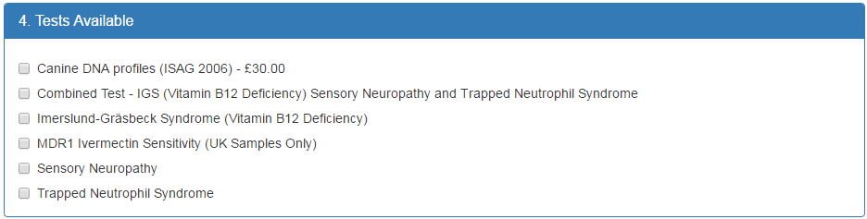

Where the test procedures and technology make it possible, we offer combination tests. These offer the best value to the customer. If a combination test is selected please ensure that the individual listings for those tests are not ticked.

Tick the boxes for the tests you require and press the “Record Details” button. If there are any fields on the form that are required and haven’t been filled in, the button will not be available to click.

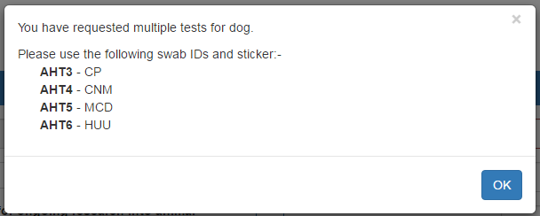If multiple tests have been orders, and therefore, multiple swabs are required, you will see a popup box appear detailing the swab ids assigned to the individual testing in your order. The test codes should be completed on the correctly numbered swab label. See page 4 for further details.

On completion of your order, a row for each swab/test will appear in the table at the bottom of the page. Please tick the checkbox in the first column when the swab is returned.

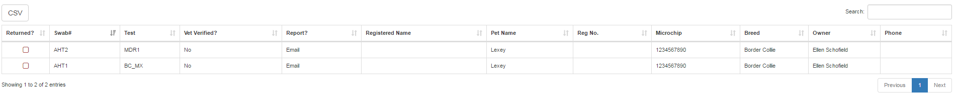

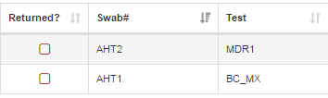

NB. If you are taking samples from multiple animals, it is recommended that you complete the swabbing of each one prior to moving on to the next - thus reducing the of change of sample mix-up.

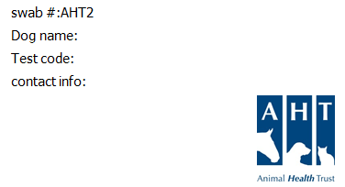Sample Returns

Along with the portal you will have been sent a sheet of pre-printed labels with corresponding swab IDs. Please write the name of the animal, the code of requested test and contact information, phone or email, on the correct label and affix to the envelope supplied with each swab kit. The contact information should be for the owner submitting the sample. This is necessary to allow the processing staff you resolve any queries with the minimum of delays to processing.

The swabs should be collected from the animal as per the swab collection instructions supplied.

Once the swabs are dry they should be placed in to the labelled envelope.

Return the envelope to the collection organiser who will mark it as “returned” in the portal and will then arrange for the swap to be returned to the AHT for testing.

Test results are returned directly to each individual, as per their selected reporting method.

Once all swabs have been returned, please click the CSV button at the top of the table to export a comma separated value (CSV) file and save this to your computer. This file may be opened with any spreadsheet programs such as Microsoft Excel. Please print a copy of this spreadsheet and send, with your payment, and all returned swabs, back to the AHT.

A copy of the CSV file must be emailed to [dnatesting@aht.org.uk](mailto:dnatesting@aht.org.uk).

In this email please confirm the shipment date of the batch of swabs. This will allow us to schedule the processing in the most efficient way, to ensure results are reported promptly after receipt.

**Q: How long will it take to get a result?** ***The turnaround time for testing is 2 weeks from receipt of samples by the AHT DNA testing service, as standard. Please confirm with the collection organiser when the sample will be supplied to the AHT, so that you have an accurate idea of when your test results should be returned.***