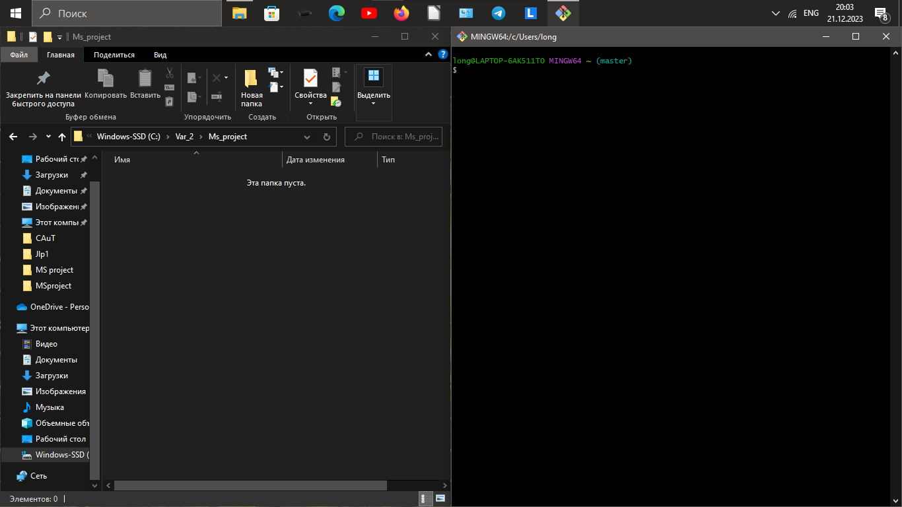

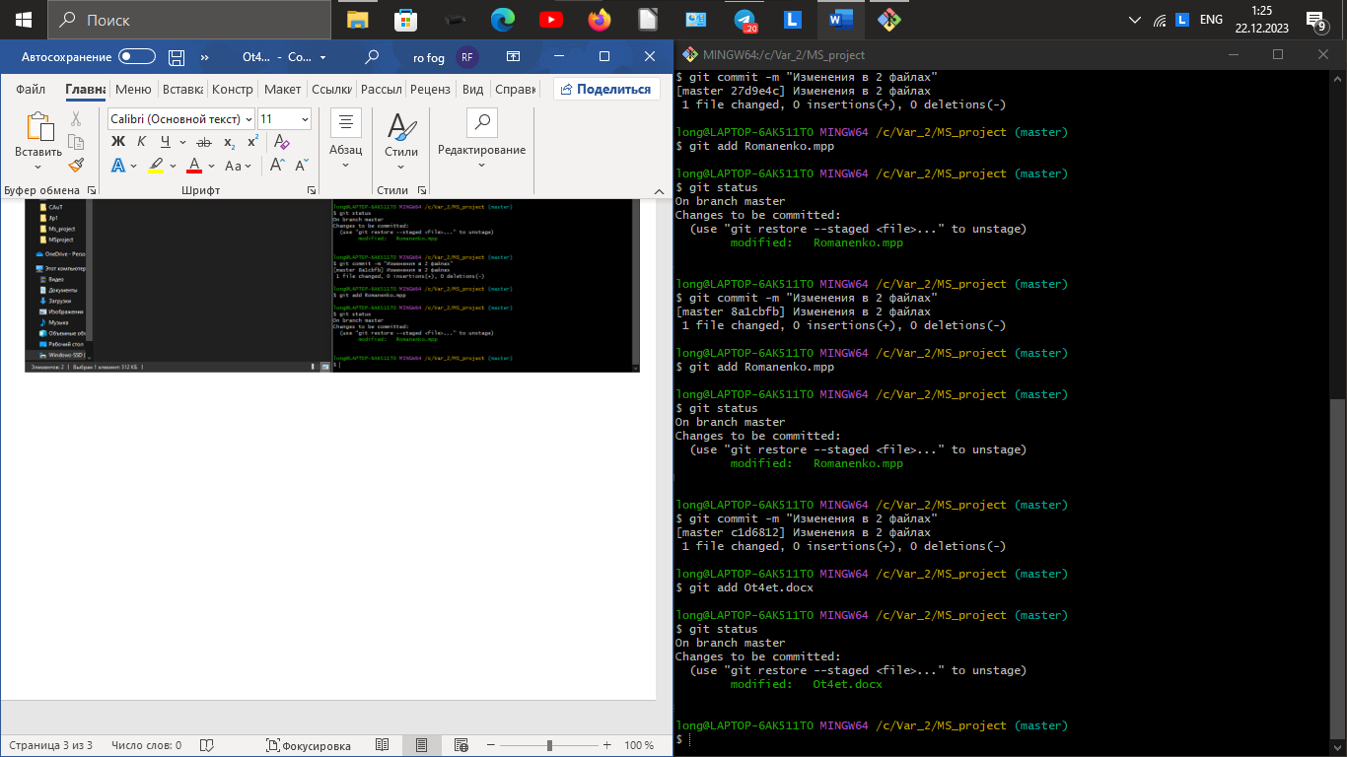

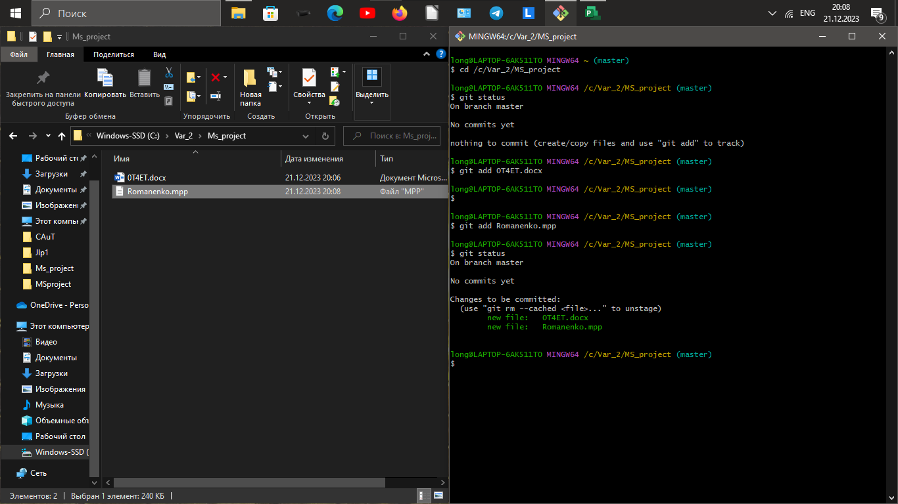

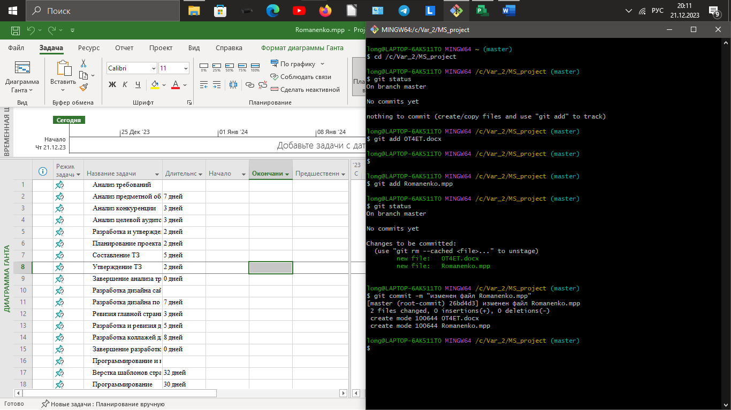

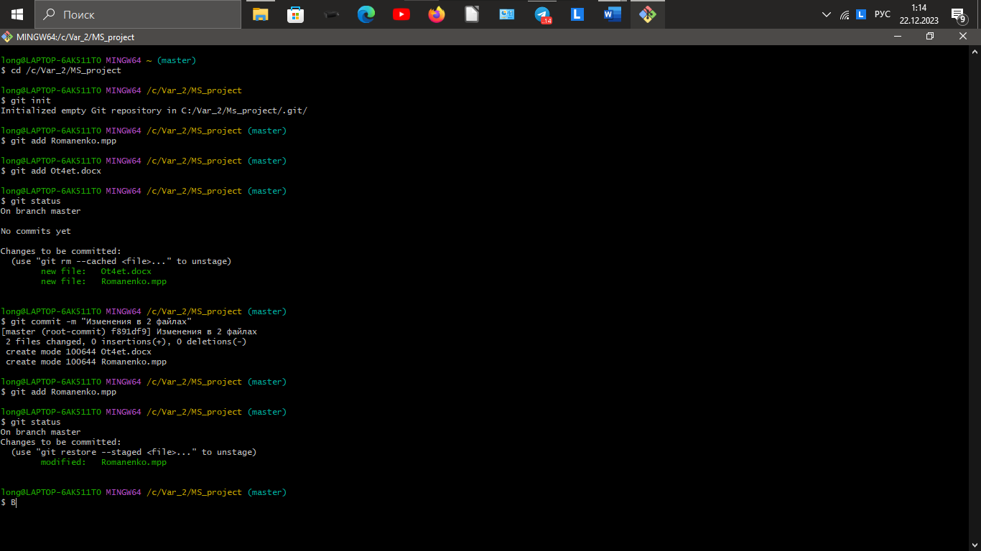

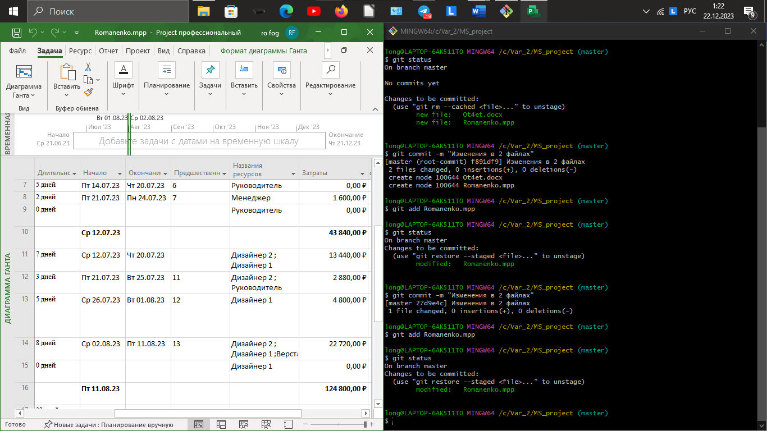

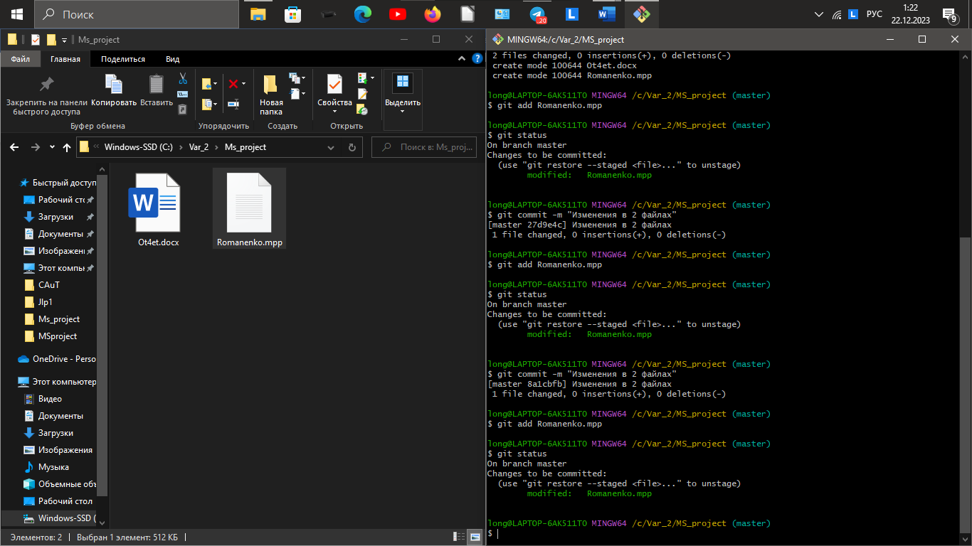

[Upload files · AHTuqpPu3/Variant2 (github.com)](https://github.com/AHTuqpPu3/Variant2/upload/%D0%9F%D0%95%D0%A0%D0%95%D0%94%D0%95%D0%9B%D0%90%D0%9D%D0%9D%D0%9E%D0%95) (Ветка ПЕРЕДЕЛАННОЕ)