1. **简单工厂**

汽车类

**public abstract class** Car {  
 **public abstract void** produce();  
}

宝马汽车类

**public class** BMW **extends** Car {  
 @Override  
 **public void** produce() {  
 System.***out***.println("生产宝马汽车");  
 }  
}

丰田汽车类

**public class** Toyota **extends** Car {  
 @Override  
 **public void** produce() {  
 System.***out***.println("生产丰田汽车");  
 }  
}

沃尔沃汽车类

**public class** WOW **extends** Car {  
 @Override  
 **public void** produce() {  
 System.***out***.println("生产沃尔沃汽车");  
 }  
}

简单工厂类

**public class** CarFactory {  
 **public static** Car produceCar(String carName) {  
 Car car = **null**;  
 **if** (carName.equals("宝马")) {  
 car = **new** BMW();  
 } **else if** (carName.equals("丰田")) {  
 car = **new** Toyota();  
 } **else if** (carName.equals("沃尔沃")){  
 car = **new** WOW();  
 }  
 **return** car;  
 }  
}

测试类

**public class** Test {  
 **public static void** main(String[] args) {  
 Car car;  
 Scanner in = **new** Scanner(System.***in***);  
 System.***out***.println("请输入汽车类型：");  
 String name = in.next();  
 car = CarFactory.produceCar(name);  
 car.produce();  
 }  
}

运行结果

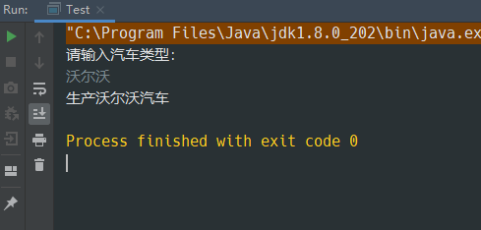

1. **工厂方法**

汽车类

**public abstract class** Car {  
 **public abstract void** produce();  
}

宝马汽车类

**public class** BMW **extends** Car {  
 @Override  
 **public void** produce() {  
 System.***out***.println("生产宝马汽车");  
 }  
}

丰田汽车类

**public class** Toyota **extends** Car {  
 @Override  
 **public void** produce() {  
 System.***out***.println("生产丰田汽车");  
 }  
}

沃尔沃汽车类

**public class** WOW **extends** Car {  
 @Override  
 **public void** produce() {  
 System.***out***.println("生产沃尔沃汽车");  
 }  
}

工厂类

**public abstract class** Factory {  
 **public abstract** Car produceCar();  
}

宝马工厂

**public class** BMWFactory **extends** Factory {  
 @Override  
 **public** Car produceCar() {  
 **return new** BMW();  
 }  
}

丰田工厂

**public class** ToyotaFactory **extends** Factory {  
 @Override  
 **public** Car produceCar() {  
 **return new** Toyota();  
 }  
}

沃尔沃工厂

**public class** WOWFactory **extends** Factory {  
 @Override  
 **public** Car produceCar() {  
 **return new** WOW();  
 }  
}

测试类

**public class** Test {  
 **public static void** main(String[] args) {  
 // 生产宝马汽车  
 Factory factory1 = **new** BMWFactory();  
 Car car1 = factory1.produceCar();  
 car1.produce();  
 // 生产丰田汽车  
 Factory factory2 = **new** ToyotaFactory();  
 Car car2 = factory2.produceCar();  
 car2.produce();  
 // 生产沃尔沃汽车  
 Factory factory3 = **new** WOWFactory();  
 Car car3 = factory3.produceCar();  
 car3.produce();  
 }  
}

运行结果

