**Chapter2**

# CHAPTER 2

**LITEATURE REVIEW**

**2.1 Introduction**

job searching in the IT field has undergone a significant transformation, moving from the process of acquiring IT skills has evolved significantly, moving from traditional classroom learning to leveraging data-driven technologies and personalized platforms. In recent years, the development of IT skills recommendation systems has greatly enhanced the professional growth journey by utilizing data from platforms like LinkedIn. These systems analyze labor market trends and user profiles to provide targeted guidance for acquiring the most relevant skills.

These innovative tools are designed to bridge the gap between aspiring IT professionals and the rapidly changing demands of the job market.

Modern skill recommendation platforms utilize advanced algorithms to analyze a user’s current skills, career goals, and market trends, providing tailored suggestions for learning paths, these platforms offer a powerful resource for career planning.

## 2.2 DefPath Model Definitions

2.2.1 **Artificial Intelligence (AI):**

Artificial Intelligence is a broad field that encompasses the development of intelligent systems capable of performing tasks that would typically require human intelligence. AI aims to simulate human-like thinking and decision-making processes. It involves the creation of algorithms and models that enable machines to perceive, reason, learn, and make decisions. AI can be divided into two categories: Narrow AI and General AI. Narrow AI focuses on specific tasks and is prevalent in various applications today, while General AI refers to machines that possess human-like intelligence across a wide range of tasks. [1]

2.2.2 **Machine Learning (ML):**

Machine Learning is a subset of AI that focuses on the development of algorithms and models that allow computers to learn and improve from experience without being explicitly programmed. ML algorithms analyze large datasets to identify patterns and make predictions or decisions based on those patterns. It relies on statistical techniques to automatically learn from data and adapt its performance. ML can be categorized into three types: supervised learning, unsupervised learning, and reinforcement learning. [2]

2.2.3 **Natural Language Processing (NLP):**

Natural Language Processing is a branch of AI that focuses on the interaction between computers and human language. NLP enables machines to understand, interpret, and generate human language in a way that is meaningful and useful. It involves a range of tasks, including text classification, sentiment analysis, language translation, question-answering, and speech recognition. NLP utilizes techniques from linguistics, machine learning, and deep learning to process and analyze textual data. [3]

2.2.4 **Deep Learning:**

Deep Learning is a subfield of ML that employs artificial neural networks to model and understand complex patterns and relationships within data. Deep Learning algorithms are inspired by the structure and function of the human brain, consisting of multiple layers of interconnected nodes (neurons). These networks are capable of learning hierarchical representations of data, enabling them to extract high-level features from raw input. Deep Learning has achieved significant breakthroughs in various domains, including computer vision and natural language processing. [4]

2.2.5 **Large Language Model (LLM):**

A Large Language Model is a type of deep learning model trained on massive amounts of text data to understand, generate, and manipulate human language. LLMs, such as GPT (Generative Pre-trained Transformer), are designed to predict the next word in a sequence, enabling them to generate coherent and contextually relevant text. These models can be fine-tuned for specific tasks such as language translation, summarization, question-answering, and content generation. LLMs are highly effective in generating human-like text by leveraging the patterns and relationships they have learned during training. [5]

2.2.6 **Prompt Engineering:**

Prompt Engineering refers to the practice of designing and refining input prompts to optimize the performance of language models, particularly LLMs. The goal of prompt engineering is to create specific, clear, and concise instructions or queries that guide the model to generate the desired output. By adjusting the structure or content of the prompt, users can improve the accuracy, relevance, and creativity of the model’s responses. This is an essential technique for effectively using LLMs in tasks such as text generation, summarization, or roadmap creation. [6]

2.2.7 **Model Tuning (Fine-Tuning):**

Model Tuning, or Fine-Tuning, is the process of adapting a pre-trained machine learning model (such as an LLM) to perform a specific task or to improve its performance on a particular dataset. Fine-tuning involves training the model on a smaller, domain-specific dataset with task-specific labels, often after the model has been pre-trained on a large general dataset. This allows the model to specialize in certain types of content, enabling it to generate more relevant and accurate outputs for the intended application. [7]

## 2.3 Related Works of DefPath website

Many platforms are designed in this field such as:

**Skill Development Platforms:**

1. **Coursera**

Coursera is a leading online learning platform Offers courses from top universities like Stanford and Yale, covering everything from programming languages to cybersecurity.



Figure ‎2.1: Coursera

1. **Pluralsight**

Pluralsight is a premier online learning platform focused on IT and software development, offering skill assessments and targeted learning paths.

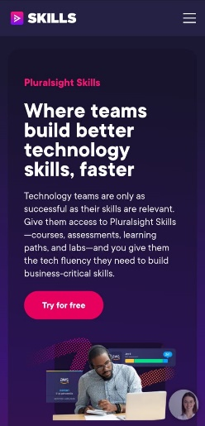

Figure ‎2.2: Pluralsight

**Job Seeking Platforms:**

1. **Monster**

Monster One of the largest job boards, featuring millions of jobs across industries and offering career advice resources.

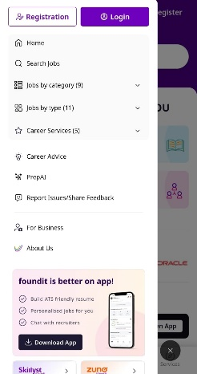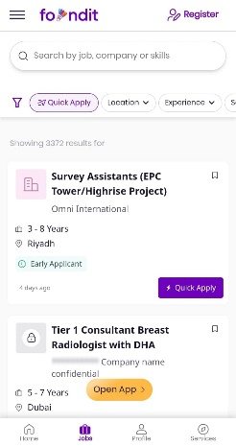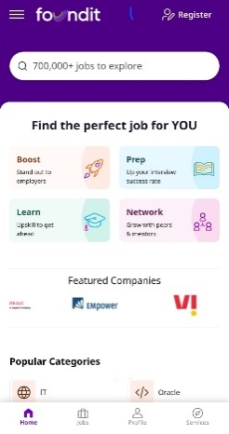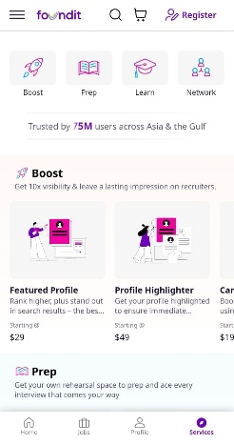

Figure ‎2.3: Monster

1. **Roadmap.net**

Roadmap.net is a career development platform designed to help users secure jobs more effectively, focusing on personalized career paths. It leverages real-time data to generate custom roadmaps that guide users through job search strategies, skill acquisition, and application processes. The platform emphasizes networking, connecting users with industry professionals, and improving job visibility through optimized LinkedIn and social media profiles.



Figure 2.4: Roadmap.net

|  |  |  |  |  |
| --- | --- | --- | --- | --- |
| Feature | AI models | Roadmaps | courses | Real-time data |
| **Coursera** | Checkmark | Close | Checkmark | Close |
| **Pluralsight** | Checkmark | Checkmark | Checkmark | Close |
| **Monster** | Checkmark | Close | Close | Checkmark |
| **Roadmap.net** | Close | Checkmark | Close | Close |
| **DevPath** | Checkmark | Checkmark | Checkmark | Checkmark |

*Table ‎2.1: Comparison Table*