

**Al-Hussein Bin Talal University**  
**Information Technology Collage**

**project name**

**Team Members:**  
**Ahmad Nairat**

**Ahmad Alshomari**

**Tuqa alsaeed**

**Mahmoud Zuraiqi**

**Abdel Majeed Al-Shattal**

**Besan Alqadi**  
**Supervisor: (Professor Ayman Al-Dmour)**

**BACHELOR'S DEGREE IN INFORMATION TECHNOLOGY**  
**AL-HUSSEIN BIN TALAL UNIVERSITY**  
**[2024-2025]**

**Permission to Use**

In presenting this project as part of the fulfillment of the requirements for a Bachelor’s Degree in Information Technology from Al-Hussein Bin Talal University, we agree that the University Library may make it freely available for public access. Additionally, we consent that permission for copying any portion of this project for scholarly purposes may be granted by our supervisor(s) or, in their absence, by the College of Information Technology.

It is understood that any reproduction, publication, or use of this project or any of its parts for financial gain is strictly prohibited without our written consent. Proper acknowledgment must be given to us and Al-Hussein Bin Talal University for any scholarly use of materials derived from this project. Requests for permission to copy or utilize materials from this project, in whole or in part, should be directed to the College of Information Technology.

College of Information Technology  
Al-Hussein Bin Talal University  
Ma’an, Jordan

**Abstract**

The rapid growth of the IT sector has created significant challenges in aligning job seekers' skills with market demands. Many individuals face difficulties in identifying suitable career paths due to the overwhelming variety of roles and technologies available. This project addresses these issues by developing an IT skills recommendation system designed to provide tailored skills suggestions based on users' skills demand, interests, and career goals.

Using advanced machine learning techniques, the system leverages collaborative filtering and content-based recommendations to match users with relevant job opportunities. This hybrid approach ensures personalized and accurate suggestions that evolve with changing user preferences and market trends. The system not only streamlines the job search process but also enhances the hiring process for employers by identifying candidates with the most relevant skills, thus bridging the gap between talent supply and demand

**Acknowledgement**

First, we praise God for our success in this journey.

To complement the thanks, we thank after God our father, our great guide and teacher, Professor Ayman Al-Damour, not only for teaching us, guiding us or even advising us throughout the journey, but also for standing with us emotionally and preparing us for the project psychologically before practically, encouraging us to enjoy work and discover team spirit and how standing next to each other is sometimes more important than achieving the goal.

To our friends and families for standing with us not only now, but always pushing us forward and achieving ourselves.

Finally, for ourselves, which never left us, always stood by us even before we realized.

This work is based on collective effort with understanding, with faith and pushing each other to reach.

# Table of Contents

Contents

CHAPTER 1 Introduction7

1.1Project Background 8

1.2 Problem Statement8

1.3 Project Objectives9

1.4 Project Significance9

1.5 Project Gantt Chart10

CHAPTER 2 Literature Review12

2.1 Introduction 12

2.2 DefPath Model Definitions 12

2.3 Related Works of DefPath website 14

List of Figure

Figure ‎1.1: Gantt chart 10

Figure ‎2.1: Coursera 14

Figure ‎2.2: Pluralsight 15

Figure ‎2.3: Monster 15

Figure ‎2.4: Roadmap.net 16

List of Tables

Table ‎2.1: Comparison Table 17

# CHAPTER 1

**INTRODUCTION**

The rapid growth of the information technology (IT) sector has created an immense demand for skilled professionals across various domains, ranging from software development to cybersecurity. However, matching the right talent to the right job remains a significant challenge for both employers and job seekers. Traditional job search platforms often fail to provide personalized recommendations, leaving users overwhelmed by a vast number of irrelevant job postings.

In response to this challenge, IT job recommendation systems have emerged as a powerful tool, leveraging data-driven algorithms to tailor job suggestions based on an individual’s skills, preferences, and career goals. These systems not only streamline the job search process but also help employers discover candidates who best fit their needs, thereby bridging the gap between talent supply and demand. By integrating technologies like machine learning and natural language processing, modern recommendation systems are transforming the hiring landscape, offering enhanced accuracy and efficiency in job matching.

.

**1.1 Project Background**

The head of the Civil Service Bureau (Sameh Al-Nasser) said that the Bureau’s job application stock indicators “sound the alarm” and indicate a “widening gap” between the outcomes of higher education and the needs of the labor market.

He added, in a press conference on Wednesday to launch the basic competitive examination for the year 2023, that the number of cumulative employment applications for this year reached 486 thousand, an increase of 6.7%.

Al-Nasser stressed that young people should take advantage of the job opportunities available in the private sector instead of waiting for public employment, given its limitations compared to the number of annual graduates.[2]

The information technology sector is characterized as a field with wide scopes, it is not only related to the government and private sector, but in addition to that there is (freelancing).

Programming languages are diverse, and selecting the right one can open doors to opportunities beyond a person’s local job market. By mastering a language that aligns with global demand, individuals can significantly expand their career prospects. Properly directing programming skills is crucial for achieving this, and it is from this foundation that our project begins.

**1.2 Problem Statement**

Anyone seeking a job in the IT field often encounters challenges in determining the right skillset due to the vast array of specializations available, from programming and data analysis to cloud computing and cybersecurity. This confusion arises not only from the diversity of technologies but also from a limited understanding of the labor market and its demands. Many job seekers struggle to identify which specific IT skills, tools, or certifications are most sought after by employers.

Bridging this knowledge gap is essential for improving job readiness. By gaining a clear understanding of the skills and technologies that are in high demand—whether it’s mastering a programming language, understanding cloud platforms, or gaining proficiency in security protocols—individuals can better align themselves with market needs. Our project aims to provide a structured environment that offers comprehensive guidance on various IT skills, potential career paths, and industry requirements. By equipping users with this knowledge, the project enhances their ability to confidently pursue roles in areas such as system administration, business analysis, or software development, thereby increasing their chances of securing meaningful employment in the IT sector.

**1.3 Project Objectives**

The primary goal of this project is to provide a platform that equips job seekers in the IT field with the technical skills needed for the labor market, even before they fully enter it. It aims to establish a solid technical foundation that boosts confidence and enhances awareness of industry requirements, helping users feel prepared and capable as they navigate the competitive job market.

**1.4 Project Significance**

Creating a personalized platform for each job seeker based on their IT skill preferences, whether in programming, networking, data analysis, or cybersecurity, and linking it to major employment platforms like LinkedIn. This platform aims to educate users about labor market trends and prepare them for various roles, boosting their confidence and technical awareness while increasing their chances of employment.

Additionally, the platform saves time and effort by guiding users to focus on the most in-demand IT skills and certifications, ensuring they are well-prepared for the job market's evolving needs.

**1.5 Project Gantt Chart**

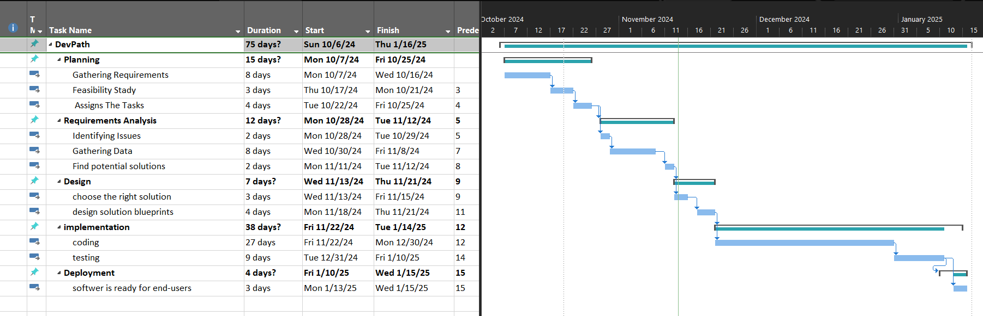

Figure ‎1.1: Gantt chart

# CHAPTER 2

**LITEATURE REVIEW**

**2.1 Introduction**

job searching in the IT field has undergone a significant transformation, moving from the process of acquiring IT skills has evolved significantly, moving from traditional classroom learning to leveraging data-driven technologies and personalized platforms. In recent years, the development of IT skills recommendation systems has greatly enhanced the professional growth journey by utilizing data from platforms like LinkedIn. These systems analyze labor market trends and user profiles to provide targeted guidance for acquiring the most relevant skills.

These innovative tools are designed to bridge the gap between aspiring IT professionals and the rapidly changing demands of the job market.

Modern skill recommendation platforms utilize advanced algorithms to analyze a user’s current skills, career goals, and market trends, providing tailored suggestions for learning paths, these platforms offer a powerful resource for career planning.

## 2.2 DevPath Model Definitions

2.2.1 **Artificial Intelligence (AI):**

Artificial Intelligence is a broad field that encompasses the development of intelligent systems capable of performing tasks that would typically require human intelligence. AI aims to simulate human-like thinking and decision-making processes. It involves the creation of algorithms and models that enable machines to perceive, reason, learn, and make decisions. AI can be divided into two categories: Narrow AI and General AI. Narrow AI focuses on specific tasks and is prevalent in various applications today, while General AI refers to machines that possess human-like intelligence across a wide range of tasks. [1]

2.2.2 **Machine Learning (ML):**

Machine Learning is a subset of AI that focuses on the development of algorithms and models that allow computers to learn and improve from experience without being explicitly programmed. ML algorithms analyze large datasets to identify patterns and make predictions or decisions based on those patterns. It relies on statistical techniques to automatically learn from data and adapt its performance. ML can be categorized into three types: supervised learning, unsupervised learning, and reinforcement learning. [2]

2.2.3 **Natural Language Processing (NLP):**

Natural Language Processing is a branch of AI that focuses on the interaction between computers and human language. NLP enables machines to understand, interpret, and generate human language in a way that is meaningful and useful. It involves a range of tasks, including text classification, sentiment analysis, language translation, question-answering, and speech recognition. NLP utilizes techniques from linguistics, machine learning, and deep learning to process and analyze textual data. [3]

2.2.4 **Deep Learning:**

Deep Learning is a subfield of ML that employs artificial neural networks to model and understand complex patterns and relationships within data. Deep Learning algorithms are inspired by the structure and function of the human brain, consisting of multiple layers of interconnected nodes (neurons). These networks are capable of learning hierarchical representations of data, enabling them to extract high-level features from raw input. Deep Learning has achieved significant breakthroughs in various domains, including computer vision and natural language processing. [4]

2.2.5 **Large Language Model (LLM):**

A Large Language Model is a type of deep learning model trained on massive amounts of text data to understand, generate, and manipulate human language. LLMs, such as GPT (Generative Pre-trained Transformer), are designed to predict the next word in a sequence, enabling them to generate coherent and contextually relevant text. These models can be fine-tuned for specific tasks such as language translation, summarization, question-answering, and content generation. LLMs are highly effective in generating human-like text by leveraging the patterns and relationships they have learned during training. [5]

2.2.6 **Prompt Engineering:**

Prompt Engineering refers to the practice of designing and refining input prompts to optimize the performance of language models, particularly LLMs. The goal of prompt engineering is to create specific, clear, and concise instructions or queries that guide the model to generate the desired output. By adjusting the structure or content of the prompt, users can improve the accuracy, relevance, and creativity of the model’s responses. This is an essential technique for effectively using LLMs in tasks such as text generation, summarization, or roadmap creation. [6]

2.2.7 **Model Tuning (Fine-Tuning):**

Model Tuning, or Fine-Tuning, is the process of adapting a pre-trained machine learning model (such as an LLM) to perform a specific task or to improve its performance on a particular dataset. Fine-tuning involves training the model on a smaller, domain-specific dataset with task-specific labels, often after the model has been pre-trained on a large general dataset. This allows the model to specialize in certain types of content, enabling it to generate more relevant and accurate outputs for the intended application. [7]

## 2.3 Related Works of DevPath website

Many platforms are designed in this field such as:

**Skill Development Platforms:**

1. **Coursera**

Coursera is a leading online learning platform Offers courses from top universities like Stanford and Yale, covering everything from programming languages to cybersecurity.



Figure ‎2.1: Coursera

1. **Pluralsight**

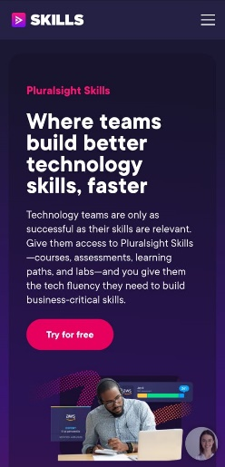Pluralsight is a premier online learning platform focused on IT and software development, offering skill assessments and targeted learning paths.

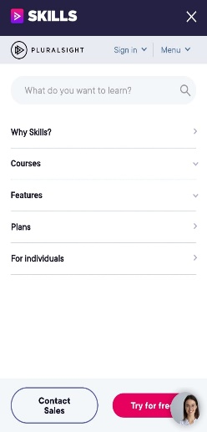

Figure ‎2.2: Pluralsight

1. **Roudmap.sh**

is a community-driven platform designed to provide structured learning paths and resources for developers and IT professionals. It offers a variety of interactive roadmaps that guide learners through the necessary skills and technologies required for specific roles in the tech industry.

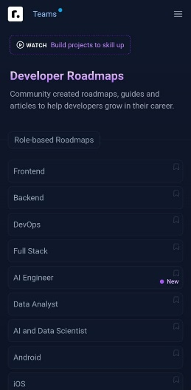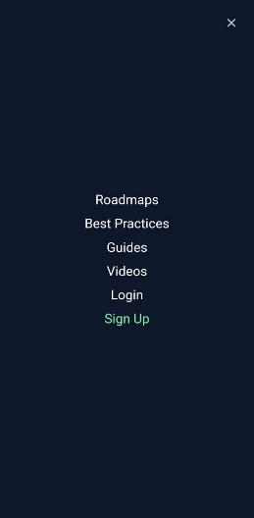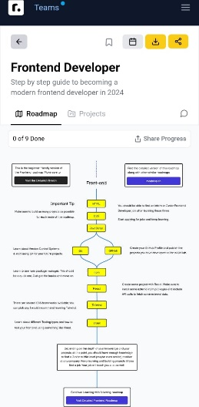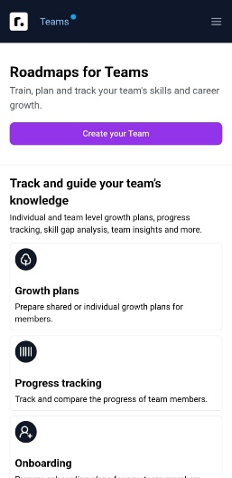

Figure ‎2.3: roudmap.sh

|  |  |  |  |  |
| --- | --- | --- | --- | --- |
| Feature | AI models | Roadmaps | courses | Real-time data |
| **Coursera** | Checkmark | Close | Checkmark | Close |
| **Pluralsight** | Checkmark | Checkmark | Checkmark | Close |
| **Roadmap.sh** | Close | Checkmark | Close | Close |
| **DevPath** | Checkmark | Checkmark | Checkmark | Checkmark |

*Table ‎2.1: Comparison Table*

# CHAPTER 3

**MITHODOLOGY**

The **DevPath** project will adopt an agile methodology for software development. This approach emphasizes flexibility, continuous feedback, and iterative progress, making it ideal for a dynamic and user-focused project like DevPath.

**3.1 Agile Methodology**

The agile methodology is a flexible and iterative approach to software development. It breaks down the development process into small, manageable cycles or sprints. Each sprint delivers a working increment of the product, enabling continuous refinement based on user feedback. Agile focuses on collaboration, adaptability, and delivering value quickly, ensuring that the software evolves in response to changing requirements and user needs.

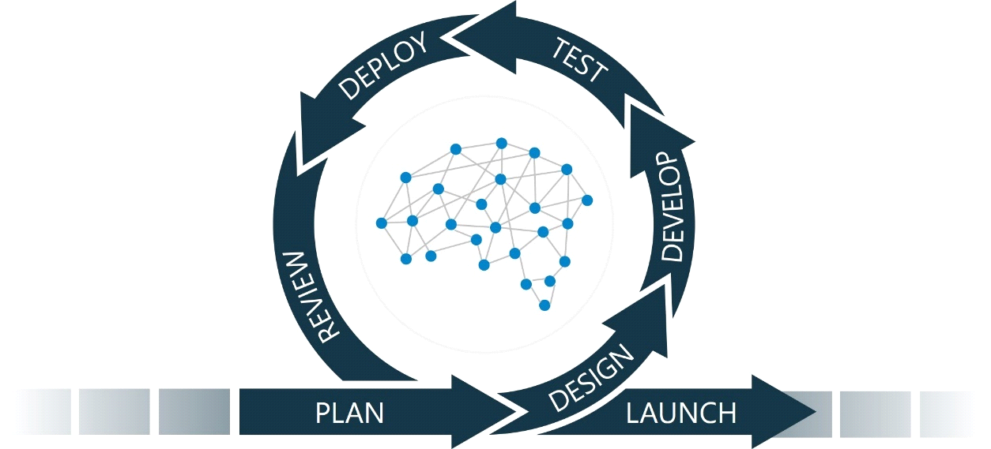Figure3.1: **Agile methodology**

**3.1.1 DevPath Analysis**

In the initial phase, we gathered detailed software requirements through discussions with key stakeholders, including potential users such as IT Students and hiring managers. This phase focused on defining the core functionalities of DevPath: user authentication, skill data collection, and personalized roadmap generation. By understanding user needs, we established a foundation for the system that aligns with both business goals and end-user expectations.

**3.1.2 DevPath System Design**

During the system design phase, the product is divided into smaller, modular components for easier development. This includes both logical design, such as defining system architecture and data flow, and physical design, detailing the software components. For DevPath, our team will create UML diagrams, including use case, sequence, class, and activity diagrams. Additionally, we will use react for frontend framework and node JS for backend framework to ensure a scalable and maintainable platform structure.

**3.1.3 DevPath Implementation and Incremental Testing**

DevPath will be developed incrementally (small parts). each feature is coded and tested in isolation before integration.

Initial increments include building robust authentication systems and user dashboards (web-based interface that provides users with a centralized hub to access, manage, and interact with their data and tools). Subsequent sprints will focus on real-time data collection from platforms like LinkedIn, generating tailored skill roadmaps and Implement job analysis for each skill by using AI features. Testing will involve unit tests for individual components and integration tests to ensure compatibility and seamless functionality within the system.

**3.1.4 DevPath Deployment**

The deployment will follow an iterative approach, beginning with beta testing of core features such as login, skill tracking, and basic roadmap generation. Each sprint will focus on gathering feedback from users to refine and enhance the system. As feedback is collected, advanced features like real-time skill market analysis and personalized coerces recommendations will be introduced in subsequent iterations. User acceptance testing will occur at the end of each sprint to ensure the software meets both user and business requirements, enabling a smooth and adaptive progression toward full-scale deployment.

**3.2 Advantages of Agile Methodology**

**Flexibility**: Agile allows for frequent changes based on user feedback and evolving requirements.

**Quick Delivery**: Working software is delivered early and continuously throughout the development cycle.

**Risk Management**: Frequent testing and iteration help identify and resolve issues promptly.

**Improved Collaboration**: Continuous interaction between the development team and stakeholders ensures alignment with project goals.

**3.3 Disadvantages of Agile Methodology**

**Potential Scope Creep**: Continuous changes can lead to an ever-expanding project scope.

**Requires Strong Team Coordination**: Agile relies heavily on effective communication and collaboration.

**Frequent Testing**: Each sprint requires rigorous testing, which can increase time and resource usage.