Pottery decor as networks on the Middle Niger

01 Juli, 2024

Abstract

This paper reports on an attempt to analyse decorative techniques on archaeological pottery from the Middle Niger as knowledge exchange networks. The 12th-century CE state of this network is modelled and analysed, and then compared to its 9th-century counterpart. The analysis shows how knowledge about pottery decoration was propagated within networks of different sizes and intensities, from local, well-connected networks to more loosely tied long-distance connections. The article shows how the perspective of network analysis differs from, and can fruitfully complement, previous treatments of ceramic décor distribution in the region. It adds a novel perspective to what the distribution of archaeological ceramics in this region reflects, and contributes to the generation of hypotheses that can be further tested by fieldwork.

Keywords: Mali; network analysis; pottery; archaeological ceramics

The full text of the article is available in the published version in “Azania: archaeological research in Africa”. This document contains the code for all analyses and figures in the text,as well as some supplementary analyses and figures. It is structured by section to ease overview.

For details on the data and its preparation, see the document in the folder “analysis/supplementary_materials”.

# 1 Introduction

## 1.1 Middle Niger Ceramics:

### 1.1.1 Lack of temporal markers:

### 1.1.2 Ceramics and social boundaries:

### 1.1.3 Ceramics as trade goods:

## 1.2 Ceramic decors as networks

# 2 Methods

## 2.1 Data

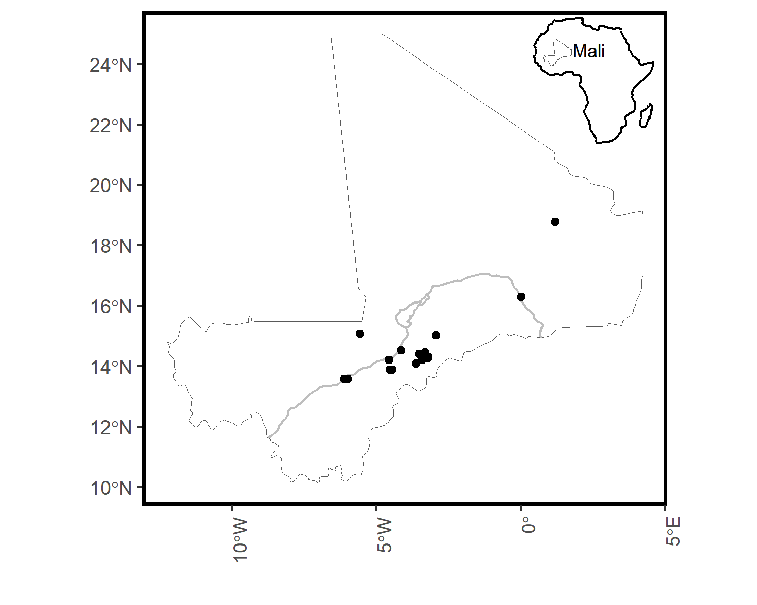

Figure 2.1: location of sites in the analysis

## 2.2 Network construction

## 2.3 Data Quality

#> Compare 16 assemblages with Hill number order q = 0.  
#> $class: iNEXT  
#>   
#> $DataInfo: basic data information  
#> Assemblage n S.obs SC f1 f2 f3 f4 f5 f6 f7 f8 f9 f10  
#> 1 Akumbu12 133 5 1.0000 1 0 0 0 0 0 0 0 0 1  
#> 2 Ambere-Dougon 33 4 1.0000 1 0 1 0 0 0 0 0 0 0  
#> 3 Damassogou 179 6 1.0000 0 0 1 1 0 0 0 0 0 0  
#> 4 Doupwil 34 7 0.9429 2 1 0 0 1 0 1 1 0 1  
#> 5 Essouk 363 8 1.0000 0 1 0 0 0 1 0 0 0 0  
#> 6 Galia 130 9 1.0000 0 2 0 1 0 1 0 0 1 0  
#> 7 Gao12 1045 7 1.0000 0 0 0 0 1 0 0 0 0 0  
#> 8 Jenne-jeno12 178 11 0.9945 1 2 1 1 0 1 0 1 0 0  
#> 9 Kokolo 119 4 1.0000 0 1 0 1 0 0 0 0 0 0  
#> 10 Mara12 307 7 1.0000 0 0 2 0 1 0 0 0 0 0  
#> 11 Ounjougou12 23 4 0.9203 2 0 0 0 0 0 0 1 0 0  
#> 12 Sadia12 3336 5 1.0000 0 0 0 0 0 0 0 0 0 0  
#> 13 Shoma12 583 7 0.9966 2 0 0 0 0 0 0 0 0 0  
#> 14 TMD12 188 11 1.0000 1 0 1 2 0 0 0 1 0 0  
#> 15 Togu 126 8 0.9844 2 0 2 1 0 0 0 1 0 0  
#> 16 Sanga D 95 10 0.9897 1 1 3 0 0 0 1 0 0 0  
#>   
#> $iNextEst: diversity estimates with rarefied and extrapolated samples.  
#> $size_based (LCL and UCL are obtained for fixed size.)  
#>   
#> Assemblage m Method Order.q qD qD.LCL qD.UCL  
#> 1 Akumbu12 1 Rarefaction 0 1.000000 1.000000 1.000000  
#> 10 Akumbu12 66 Rarefaction 0 4.495506 3.818722 5.172289  
#> 20 Akumbu12 133 Observed 0 5.000000 4.049666 5.950334  
#> 30 Akumbu12 196 Extrapolation 0 5.000000 4.049666 5.950334  
#> 40 Akumbu12 266 Extrapolation 0 5.000000 4.049666 5.950334  
#> 41 Ambere-Dougon 1 Rarefaction 0 1.000000 1.000000 1.000000  
#> 50 Ambere-Dougon 16 Rarefaction 0 3.360151 2.590806 4.129497  
#> 60 Ambere-Dougon 33 Observed 0 4.000000 2.952355 5.047645  
#> 70 Ambere-Dougon 49 Extrapolation 0 4.000000 2.865667 5.134333  
#> 80 Ambere-Dougon 66 Extrapolation 0 4.000000 2.820103 5.179897  
#> 81 Damassogou 1 Rarefaction 0 1.000000 1.000000 1.000000  
#> 90 Damassogou 89 Rarefaction 0 5.813188 5.150932 6.475444  
#> 100 Damassogou 179 Observed 0 6.000000 5.406041 6.593959  
#> 110 Damassogou 264 Extrapolation 0 6.000000 5.365770 6.634230  
#> 120 Damassogou 358 Extrapolation 0 6.000000 5.334529 6.665471  
#> 121 Doupwil 1 Rarefaction 0 1.000000 1.000000 1.000000  
#> 130 Doupwil 17 Rarefaction 0 5.730235 4.311247 7.149222  
#> 140 Doupwil 34 Observed 0 7.000000 4.699267 9.300733  
#> 150 Doupwil 50 Extrapolation 0 7.737180 4.648738 10.825621  
#> 160 Doupwil 68 Extrapolation 0 8.237690 4.531187 11.944193  
#> 161 Essouk 1 Rarefaction 0 1.000000 1.000000 1.000000  
#> 170 Essouk 181 Rarefaction 0 7.733618 7.099393 8.367844  
#> 180 Essouk 363 Observed 0 8.000000 7.179849 8.820151  
#> 190 Essouk 535 Extrapolation 0 8.000000 7.179849 8.820151  
#> 200 Essouk 726 Extrapolation 0 8.000000 7.179849 8.820151  
#> 201 Galia 1 Rarefaction 0 1.000000 1.000000 1.000000  
#> 210 Galia 65 Rarefaction 0 8.428941 7.476961 9.380921  
#> 220 Galia 130 Observed 0 9.000000 7.970471 10.029529  
#> 230 Galia 192 Extrapolation 0 9.000000 7.760417 10.239583  
#> 240 Galia 260 Extrapolation 0 9.000000 7.609510 10.390490  
#> 241 Gao12 1 Rarefaction 0 1.000000 1.000000 1.000000  
#> 250 Gao12 522 Rarefaction 0 6.968872 6.786013 7.151731  
#> 260 Gao12 1045 Observed 0 7.000000 7.000000 7.000000  
#> 270 Gao12 1540 Extrapolation 0 7.000000 7.000000 7.000000  
#> 280 Gao12 2090 Extrapolation 0 7.000000 7.000000 7.000000  
#> 281 Jenne-jeno12 1 Rarefaction 0 1.000000 1.000000 1.000000  
#> 290 Jenne-jeno12 89 Rarefaction 0 9.801895 8.506319 11.097470  
#> 300 Jenne-jeno12 178 Observed 0 11.000000 9.340691 12.659309  
#> 310 Jenne-jeno12 262 Extrapolation 0 11.210555 8.942008 13.479102  
#> 320 Jenne-jeno12 356 Extrapolation 0 11.243940 8.311277 14.176604  
#> 321 Kokolo 1 Rarefaction 0 1.000000 1.000000 1.000000  
#> 330 Kokolo 59 Rarefaction 0 3.686461 3.017280 4.355641  
#> 340 Kokolo 119 Observed 0 4.000000 3.313013 4.686987  
#> 350 Kokolo 175 Extrapolation 0 4.000000 3.203055 4.796945  
#> 360 Kokolo 238 Extrapolation 0 4.000000 3.130102 4.869898  
#> 361 Mara12 1 Rarefaction 0 1.000000 1.000000 1.000000  
#> 370 Mara12 153 Rarefaction 0 6.719272 6.089208 7.349336  
#> 380 Mara12 307 Observed 0 7.000000 6.612028 7.387972  
#> 390 Mara12 452 Extrapolation 0 7.000000 6.600528 7.399472  
#> 400 Mara12 614 Extrapolation 0 7.000000 6.570881 7.429119  
#> 401 Ounjougou12 1 Rarefaction 0 1.000000 1.000000 1.000000  
#> 410 Ounjougou12 11 Rarefaction 0 2.955512 2.238282 3.672743  
#> 420 Ounjougou12 23 Observed 0 4.000000 3.043089 4.956911  
#> 430 Ounjougou12 34 Extrapolation 0 4.589222 3.582376 5.596068  
#> 440 Ounjougou12 46 Extrapolation 0 4.827234 3.797302 5.857165  
#> 441 Sadia12 1 Rarefaction 0 1.000000 1.000000 1.000000  
#> 450 Sadia12 1668 Rarefaction 0 5.000000 5.000000 5.000000  
#> 460 Sadia12 3336 Observed 0 5.000000 5.000000 5.000000  
#> 470 Sadia12 4916 Extrapolation 0 5.000000 5.000000 5.000000  
#> 480 Sadia12 6672 Extrapolation 0 5.000000 5.000000 5.000000  
#> 481 Shoma12 1 Rarefaction 0 1.000000 1.000000 1.000000  
#> 490 Shoma12 291 Rarefaction 0 5.998285 5.417258 6.579311  
#> 500 Shoma12 583 Observed 0 7.000000 6.313013 7.686987  
#> 510 Shoma12 859 Extrapolation 0 7.610980 6.923994 8.297967  
#> 520 Shoma12 1166 Extrapolation 0 7.863182 7.176195 8.550169  
#> 521 TMD12 1 Rarefaction 0 1.000000 1.000000 1.000000  
#> 530 TMD12 94 Rarefaction 0 10.252117 9.346632 11.157602  
#> 540 TMD12 188 Observed 0 11.000000 9.960619 12.039381  
#> 550 TMD12 277 Extrapolation 0 11.000000 9.749973 12.250027  
#> 560 TMD12 376 Extrapolation 0 11.000000 9.568662 12.431338  
#> 561 Togu 1 Rarefaction 0 1.000000 1.000000 1.000000  
#> 570 Togu 63 Rarefaction 0 6.693404 5.500127 7.886681  
#> 580 Togu 126 Observed 0 8.000000 6.403784 9.596216  
#> 590 Togu 186 Extrapolation 0 8.609312 6.442330 10.776293  
#> 600 Togu 252 Extrapolation 0 8.857808 6.226325 11.489291  
#> 601 Sanga D 1 Rarefaction 0 1.000000 1.000000 1.000000  
#> 610 Sanga D 47 Rarefaction 0 8.860278 7.345142 10.375415  
#> 620 Sanga D 95 Observed 0 10.000000 8.237589 11.762411  
#> 630 Sanga D 140 Extrapolation 0 10.302904 8.241204 12.364604  
#> 640 Sanga D 190 Extrapolation 0 10.427786 8.047636 12.807937  
#> SC SC.LCL SC.UCL  
#> 1 0.2871953 0.2551365 0.3192540  
#> 10 0.9923715 0.9852370 0.9995060  
#> 20 1.0000000 1.0000000 1.0000000  
#> 30 1.0000000 1.0000000 1.0000000  
#> 40 1.0000000 1.0000000 1.0000000  
#> 41 0.3996212 0.2876069 0.5116355  
#> 50 0.9476615 0.9137920 0.9815309  
#> 60 1.0000000 0.9773851 1.0000000  
#> 70 1.0000000 0.9914270 1.0000000  
#> 80 1.0000000 0.9969413 1.0000000  
#> 81 0.3331869 0.2822732 0.3841005  
#> 90 0.9930815 0.9879344 0.9982286  
#> 100 1.0000000 0.9966040 1.0000000  
#> 110 1.0000000 0.9986863 1.0000000  
#> 120 1.0000000 0.9995404 1.0000000  
#> 121 0.1871658 0.1202157 0.2541158  
#> 130 0.9039093 0.8314225 0.9763961  
#> 140 0.9429066 0.8729783 1.0000000  
#> 150 0.9645883 0.9166427 1.0000000  
#> 160 0.9793092 0.9462859 1.0000000  
#> 161 0.3530889 0.3142463 0.3919315  
#> 170 0.9967146 0.9940539 0.9993754  
#> 180 1.0000000 1.0000000 1.0000000  
#> 190 1.0000000 1.0000000 1.0000000  
#> 200 1.0000000 1.0000000 1.0000000  
#> 201 0.2019082 0.1626721 0.2411443  
#> 210 0.9795811 0.9700399 0.9891223  
#> 220 1.0000000 0.9892680 1.0000000  
#> 230 1.0000000 0.9949639 1.0000000  
#> 240 1.0000000 0.9974515 1.0000000  
#> 241 0.2909971 0.2744514 0.3075427  
#> 250 0.9997019 0.9991308 1.0000000  
#> 260 1.0000000 1.0000000 1.0000000  
#> 270 1.0000000 1.0000000 1.0000000  
#> 280 1.0000000 1.0000000 1.0000000  
#> 281 0.2595696 0.2178434 0.3012959  
#> 290 0.9750859 0.9646068 0.9855649  
#> 300 0.9945062 0.9811602 1.0000000  
#> 310 0.9991593 0.9889301 1.0000000  
#> 320 0.9998971 0.9925243 1.0000000  
#> 321 0.7048853 0.5929537 0.8168170  
#> 330 0.9874958 0.9793908 0.9956009  
#> 340 1.0000000 0.9917938 1.0000000  
#> 350 1.0000000 0.9967983 1.0000000  
#> 360 1.0000000 0.9988895 1.0000000  
#> 361 0.2438313 0.2282355 0.2594271  
#> 370 0.9941321 0.9902505 0.9980137  
#> 380 1.0000000 0.9976549 1.0000000  
#> 390 1.0000000 0.9991825 1.0000000  
#> 400 1.0000000 0.9997190 1.0000000  
#> 401 0.4189723 0.2598769 0.5780678  
#> 410 0.9123704 0.8668564 0.9578845  
#> 420 0.9202899 0.9048272 0.9357525  
#> 430 0.9693917 0.9634541 0.9753293  
#> 440 0.9892260 0.9871360 0.9913160  
#> 441 0.3861407 0.3754511 0.3968304  
#> 450 1.0000000 1.0000000 1.0000000  
#> 460 1.0000000 1.0000000 1.0000000  
#> 470 1.0000000 1.0000000 1.0000000  
#> 480 1.0000000 1.0000000 1.0000000  
#> 481 0.4166622 0.3780232 0.4553013  
#> 490 0.9965695 0.9953164 0.9978225  
#> 500 0.9965812 0.9965812 0.9965812  
#> 510 0.9986736 0.9986736 0.9986736  
#> 520 0.9995373 0.9995373 0.9995373  
#> 521 0.1959836 0.1609258 0.2310415  
#> 530 0.9852558 0.9771276 0.9933841  
#> 540 1.0000000 0.9921672 1.0000000  
#> 550 1.0000000 0.9960349 1.0000000  
#> 560 1.0000000 0.9976286 1.0000000  
#> 561 0.3799365 0.3228197 0.4370533  
#> 570 0.9683378 0.9545520 0.9821236  
#> 580 0.9843770 0.9664767 1.0000000  
#> 590 0.9939724 0.9829272 1.0000000  
#> 600 0.9978857 0.9909518 1.0000000  
#> 601 0.1742441 0.1336149 0.2148733  
#> 610 0.9544792 0.9353455 0.9736129  
#> 620 0.9896930 0.9698239 1.0000000  
#> 630 0.9960035 0.9826794 1.0000000  
#> 640 0.9986052 0.9899654 1.0000000  
#>   
#> NOTE: The above output only shows five estimates for each assemblage; call iNEXT.object$iNextEst$size_based to view complete output.  
#>   
#> $coverage_based (LCL and UCL are obtained for fixed coverage; interval length is wider due to varying size in bootstraps.)  
#>   
#> Assemblage SC m Method Order.q qD qD.LCL  
#> 1 Akumbu12 0.2871958 1 Rarefaction 0 1.000002 0.9500968  
#> 5 Akumbu12 0.9856756 30 Rarefaction 0 4.155595 3.5819850  
#> 10 Akumbu12 0.9923715 66 Rarefaction 0 4.495506 3.7495128  
#> 15 Akumbu12 0.9924812 102 Rarefaction 0 4.766917 3.9380297  
#> 20 Akumbu12 1.0000000 133 Observed 0 5.000000 4.0496659  
#> 21 Ambere-Dougon 0.3996258 1 Rarefaction 0 1.000010 0.8431844  
#> 25 Ambere-Dougon 0.8967790 7 Rarefaction 0 2.694153 1.9413107  
#> 30 Ambere-Dougon 0.9476615 16 Rarefaction 0 3.360151 2.3660790  
#> 35 Ambere-Dougon 0.9658480 25 Rarefaction 0 3.747312 2.6482626  
#> 40 Ambere-Dougon 1.0000000 33 Observed 0 4.000000 2.7924306  
#> 41 Damassogou 0.3331869 1 Rarefaction 0 1.000000 0.9257909  
#> 45 Damassogou 0.9760347 40 Rarefaction 0 5.141042 4.3833699  
#> 50 Damassogou 0.9930815 89 Rarefaction 0 5.813188 5.1354542  
#> 55 Damassogou 0.9989313 138 Rarefaction 0 5.986210 5.3153181  
#> 59 Damassogou 1.0000000 179 Observed 0 6.000000 5.3147331  
#> 60 Doupwil 0.1871658 1 Rarefaction 0 1.000000 0.8763597  
#> 69 Doupwil 0.9039093 17 Rarefaction 0 5.730234 2.6255175  
#> 79 Doupwil 0.9429066 34 Observed 0 7.000000 3.0755832  
#> 89 Doupwil 0.9645883 50 Extrapolation 0 7.737180 3.3632353  
#> 99 Doupwil 0.9793092 68 Extrapolation 0 8.237690 3.5736041  
#> 100 Essouk 0.3530889 1 Rarefaction 0 1.000000 0.9446558  
#> 104 Essouk 0.9868791 81 Rarefaction 0 7.087694 6.5313368  
#> 109 Essouk 0.9967146 181 Rarefaction 0 7.733618 7.0102275  
#> 114 Essouk 0.9987588 281 Rarefaction 0 7.949339 7.1242328  
#> 118 Essouk 1.0000000 363 Observed 0 8.000000 7.1798492  
#> 119 Galia 0.2019082 1 Rarefaction 0 1.000000 0.9086516  
#> 123 Galia 0.9370161 29 Rarefaction 0 7.102770 6.0854557  
#> 128 Galia 0.9795811 65 Rarefaction 0 8.428941 7.2970260  
#> 133 Galia 0.9927411 100 Rarefaction 0 8.893730 7.5481543  
#> 137 Galia 1.0000000 130 Observed 0 9.000000 7.4196366  
#> 138 Gao12 0.2910015 1 Rarefaction 0 1.000014 0.9668036  
#> 142 Gao12 0.9977942 232 Rarefaction 0 6.691934 6.3739282  
#> 147 Gao12 0.9997019 522 Rarefaction 0 6.968872 6.9363864  
#> 152 Gao12 0.9999886 812 Rarefaction 0 6.999467 6.9603080  
#> 156 Gao12 1.0000000 1045 Observed 0 7.000000 7.0000000  
#> 157 Jenne-jeno12 0.2595696 1 Rarefaction 0 1.000000 0.8713490  
#> 166 Jenne-jeno12 0.9750859 89 Rarefaction 0 9.801894 7.7397056  
#> 176 Jenne-jeno12 0.9945062 178 Observed 0 11.000000 6.9481629  
#> 186 Jenne-jeno12 0.9991593 262 Extrapolation 0 11.210555 6.4722940  
#> 196 Jenne-jeno12 0.9998971 356 Extrapolation 0 11.243940 6.3906528  
#> 197 Kokolo 0.7048853 1 Rarefaction 0 1.000000 0.9301715  
#> 201 Kokolo 0.9684976 27 Rarefaction 0 3.030606 2.2768893  
#> 206 Kokolo 0.9874958 59 Rarefaction 0 3.686461 2.8754403  
#> 211 Kokolo 0.9959694 92 Rarefaction 0 3.947797 3.0973830  
#> 215 Kokolo 1.0000000 119 Observed 0 4.000000 3.0867092  
#> 216 Mara12 0.2438313 1 Rarefaction 0 1.000000 0.9752449  
#> 220 Mara12 0.9822612 68 Rarefaction 0 5.775701 4.7489445  
#> 225 Mara12 0.9941321 153 Rarefaction 0 6.719272 6.2332014  
#> 230 Mara12 0.9990089 238 Rarefaction 0 6.977546 6.5668510  
#> 234 Mara12 1.0000000 307 Observed 0 7.000000 6.5508399  
#> 235 Ounjougou12 0.4189723 1 Rarefaction 0 1.000000 0.8416652  
#> 244 Ounjougou12 0.9123704 11 Rarefaction 0 2.955513 2.0921885  
#> 254 Ounjougou12 0.9269324 24 Extrapolation 0 4.079710 3.1651956  
#> 264 Ounjougou12 0.9719424 35 Extrapolation 0 4.619830 3.6227040  
#> 273 Ounjougou12 0.9892260 46 Extrapolation 0 4.827234 3.8059820  
#> 1100 Sadia12 1.0000000 3336 Observed 0 5.000000 5.0000000  
#> 610 Sadia12 1.0000000 3336 Observed 0 5.000000 5.0000000  
#> 1101 Shoma12 0.4166622 1 Rarefaction 0 1.000000 0.9420798  
#> 1010 Shoma12 0.9965695 291 Rarefaction 0 5.998285 5.5442521  
#> 2010 Shoma12 0.9965812 583 Observed 0 7.000000 6.5451799  
#> 301 Shoma12 0.9986736 859 Extrapolation 0 7.610980 7.0059804  
#> 401 Shoma12 0.9995373 1166 Extrapolation 0 7.863182 7.2025120  
#> 1102 TMD12 0.1959836 1 Rarefaction 0 1.000000 0.8985290  
#> 511 TMD12 0.9479987 42 Rarefaction 0 8.786234 7.8014981  
#> 1011 TMD12 0.9852558 94 Rarefaction 0 10.252118 9.1575825  
#> 1511 TMD12 0.9934345 145 Rarefaction 0 10.755052 9.3185493  
#> 2011 TMD12 1.0000000 188 Observed 0 11.000000 9.1507192  
#> 1103 Togu 0.3799385 1 Rarefaction 0 1.000004 0.9191125  
#> 1012 Togu 0.9683378 63 Rarefaction 0 6.693404 4.8876207  
#> 2012 Togu 0.9843770 126 Observed 0 8.000000 5.5061001  
#> 302 Togu 0.9939724 186 Extrapolation 0 8.609312 5.5711584  
#> 402 Togu 0.9978857 252 Extrapolation 0 8.857808 5.5195052  
#> 1104 Sanga D 0.1742441 1 Rarefaction 0 1.000000 0.8874942  
#> 1013 Sanga D 0.9544792 47 Rarefaction 0 8.860278 6.9569466  
#> 2013 Sanga D 0.9896930 95 Observed 0 10.000000 7.3986497  
#> 303 Sanga D 0.9960035 140 Extrapolation 0 10.302904 7.4122728  
#> 403 Sanga D 0.9986052 190 Extrapolation 0 10.427786 7.4066890  
#> qD.UCL  
#> 1 1.049906  
#> 5 4.729204  
#> 10 5.241499  
#> 15 5.595805  
#> 20 5.950334  
#> 21 1.156835  
#> 25 3.446995  
#> 30 4.354224  
#> 35 4.846361  
#> 40 5.207569  
#> 41 1.074209  
#> 45 5.898714  
#> 50 6.490922  
#> 55 6.657102  
#> 59 6.685267  
#> 60 1.123640  
#> 69 8.834950  
#> 79 10.924417  
#> 89 12.111124  
#> 99 12.901776  
#> 100 1.055344  
#> 104 7.644051  
#> 109 8.457009  
#> 114 8.774446  
#> 118 8.820151  
#> 119 1.091348  
#> 123 8.120085  
#> 128 9.560856  
#> 133 10.239306  
#> 137 10.580363  
#> 138 1.033223  
#> 142 7.009939  
#> 147 7.001358  
#> 152 7.038626  
#> 156 7.000000  
#> 157 1.128651  
#> 166 11.864083  
#> 176 15.051837  
#> 186 15.948816  
#> 196 16.097228  
#> 197 1.069829  
#> 201 3.784323  
#> 206 4.497481  
#> 211 4.798211  
#> 215 4.913291  
#> 216 1.024755  
#> 220 6.802458  
#> 225 7.205342  
#> 230 7.388240  
#> 234 7.449160  
#> 235 1.158335  
#> 244 3.818837  
#> 254 4.994225  
#> 264 5.616957  
#> 273 5.848486  
#> 1100 5.000000  
#> 610 5.000000  
#> 1101 1.057920  
#> 1010 6.452317  
#> 2010 7.454820  
#> 301 8.215980  
#> 401 8.523852  
#> 1102 1.101471  
#> 511 9.770970  
#> 1011 11.346653  
#> 1511 12.191554  
#> 2011 12.849281  
#> 1103 1.080896  
#> 1012 8.499187  
#> 2012 10.493900  
#> 302 11.647465  
#> 402 12.196111  
#> 1104 1.112506  
#> 1013 10.763609  
#> 2013 12.601350  
#> 303 13.193536  
#> 403 13.448884  
#>   
#> NOTE: The above output only shows five estimates for each assemblage; call iNEXT.object$iNextEst$coverage_based to view complete output.  
#>   
#> $AsyEst: asymptotic diversity estimates along with related statistics.  
#> Assemblage Diversity Observed Estimator s.e. LCL  
#> 1 Akumbu12 Species richness 5.000000 5.000000 0.48783173 5.000000  
#> 2 Akumbu12 Shannon diversity 3.697871 3.756474 0.17774825 3.408094  
#> 3 Akumbu12 Simpson diversity 3.418164 3.481952 0.16726507 3.154118  
#> 4 Ambere-Dougon Species richness 4.000000 4.000000 0.62269043 4.000000  
#> 5 Ambere-Dougon Shannon diversity 2.775328 2.914474 0.33829837 2.251421  
#> 6 Ambere-Dougon Simpson diversity 2.393407 2.502370 0.32382567 1.867683  
#> 7 Damassogou Species richness 6.000000 6.000000 0.25951200 6.000000  
#> 8 Damassogou Shannon diversity 3.669273 3.722144 0.20241506 3.325418  
#> 9 Damassogou Simpson diversity 2.968133 3.001319 0.20144706 2.606490  
#> 10 Doupwil Species richness 7.000000 8.941176 2.48333055 7.000000  
#> 11 Doupwil Shannon diversity 5.375036 6.120295 0.89871589 4.358845  
#> 12 Doupwil Simpson diversity 4.737705 5.342857 0.77516781 3.823556  
#> 13 Essouk Species richness 8.000000 8.000000 0.37650340 8.000000  
#> 14 Essouk Shannon diversity 3.865230 3.903506 0.21735342 3.477501  
#> 15 Essouk Simpson diversity 2.817925 2.832148 0.17531192 2.488543  
#> 16 Galia Species richness 9.000000 9.000000 0.84641843 9.000000  
#> 17 Galia Shannon diversity 6.007968 6.202348 0.39738759 5.423483  
#> 18 Galia Simpson diversity 4.806598 4.952747 0.43409220 4.101942  
#> 19 Gao12 Species richness 7.000000 7.000000 0.00000000 7.000000  
#> 20 Gao12 Shannon diversity 4.093966 4.105843 0.08437905 3.940463  
#> 21 Gao12 Simpson diversity 3.428467 3.436461 0.08236110 3.275036  
#> 22 Jenne-jeno12 Species richness 11.000000 11.248596 1.95082704 11.000000  
#> 23 Jenne-jeno12 Shannon diversity 5.347695 5.513958 0.46280273 4.606881  
#> 24 Jenne-jeno12 Simpson diversity 3.791766 3.852531 0.36915659 3.128998  
#> 25 Kokolo Species richness 4.000000 4.000000 0.45174823 4.000000  
#> 26 Kokolo Shannon diversity 1.799606 1.823468 0.14321268 1.542776  
#> 27 Kokolo Simpson diversity 1.413697 1.418670 0.09168193 1.238977  
#> 28 Mara12 Species richness 7.000000 7.000000 0.44344585 7.000000  
#> 29 Mara12 Shannon diversity 4.481057 4.526183 0.15861072 4.215312  
#> 30 Mara12 Simpson diversity 4.060182 4.101196 0.13328109 3.839970  
#> 31 Ounjougou12 Species richness 4.000000 4.956522 0.64781312 4.000000  
#> 32 Ounjougou12 Shannon diversity 2.618119 2.902346 0.35206700 2.212307  
#> 33 Ounjougou12 Simpson diversity 2.251064 2.386792 0.33144994 1.737163  
#> 34 Sadia12 Species richness 5.000000 5.000000 0.00000000 5.000000  
#> 35 Sadia12 Shannon diversity 3.176027 3.177933 0.03887123 3.101747  
#> 36 Sadia12 Simpson diversity 2.588496 2.589729 0.03377860 2.523524  
#> 37 Sanga D Species richness 10.000000 10.494737 1.79505409 10.000000  
#> 38 Sanga D Shannon diversity 6.683657 7.051515 0.61920308 5.837899  
#> 39 Sanga D Simpson diversity 5.466384 5.739075 0.55223590 4.656712  
#> 40 Shoma12 Species richness 7.000000 7.998285 0.37752517 7.258349  
#> 41 Shoma12 Shannon diversity 3.223166 3.244714 0.12499995 2.999718  
#> 42 Shoma12 Simpson diversity 2.394276 2.400025 0.11473295 2.175153  
#> 43 TMD12 Species richness 11.000000 11.000000 0.90286783 11.000000  
#> 44 TMD12 Shannon diversity 6.629250 6.814567 0.47409574 5.885357  
#> 45 TMD12 Simpson diversity 4.993501 5.102467 0.46820705 4.184798  
#> 46 Togu Species richness 8.000000 8.992063 1.96550300 8.000000  
#> 47 Togu Shannon diversity 3.449197 3.573540 0.33563875 2.915701  
#> 48 Togu Simpson diversity 2.598363 2.632019 0.21456796 2.211473  
#> UCL  
#> 1 5.956133  
#> 2 4.104854  
#> 3 3.809785  
#> 4 5.220451  
#> 5 3.577526  
#> 6 3.137056  
#> 7 6.508634  
#> 8 4.118870  
#> 9 3.396148  
#> 10 13.808415  
#> 11 7.881746  
#> 12 6.862158  
#> 13 8.737933  
#> 14 4.329511  
#> 15 3.175753  
#> 16 10.658950  
#> 17 6.981213  
#> 18 5.803552  
#> 19 7.000000  
#> 20 4.271222  
#> 21 3.597885  
#> 22 15.072146  
#> 23 6.421034  
#> 24 4.576065  
#> 25 4.885410  
#> 26 2.104160  
#> 27 1.598364  
#> 28 7.869138  
#> 29 4.837054  
#> 30 4.362422  
#> 31 6.226212  
#> 32 3.592385  
#> 33 3.036422  
#> 34 5.000000  
#> 35 3.254119  
#> 36 2.655934  
#> 37 14.012978  
#> 38 8.265131  
#> 39 6.821437  
#> 40 8.738220  
#> 41 3.489709  
#> 42 2.624898  
#> 43 12.769588  
#> 44 7.743778  
#> 45 6.020136  
#> 46 12.844379  
#> 47 4.231380  
#> 48 3.052564

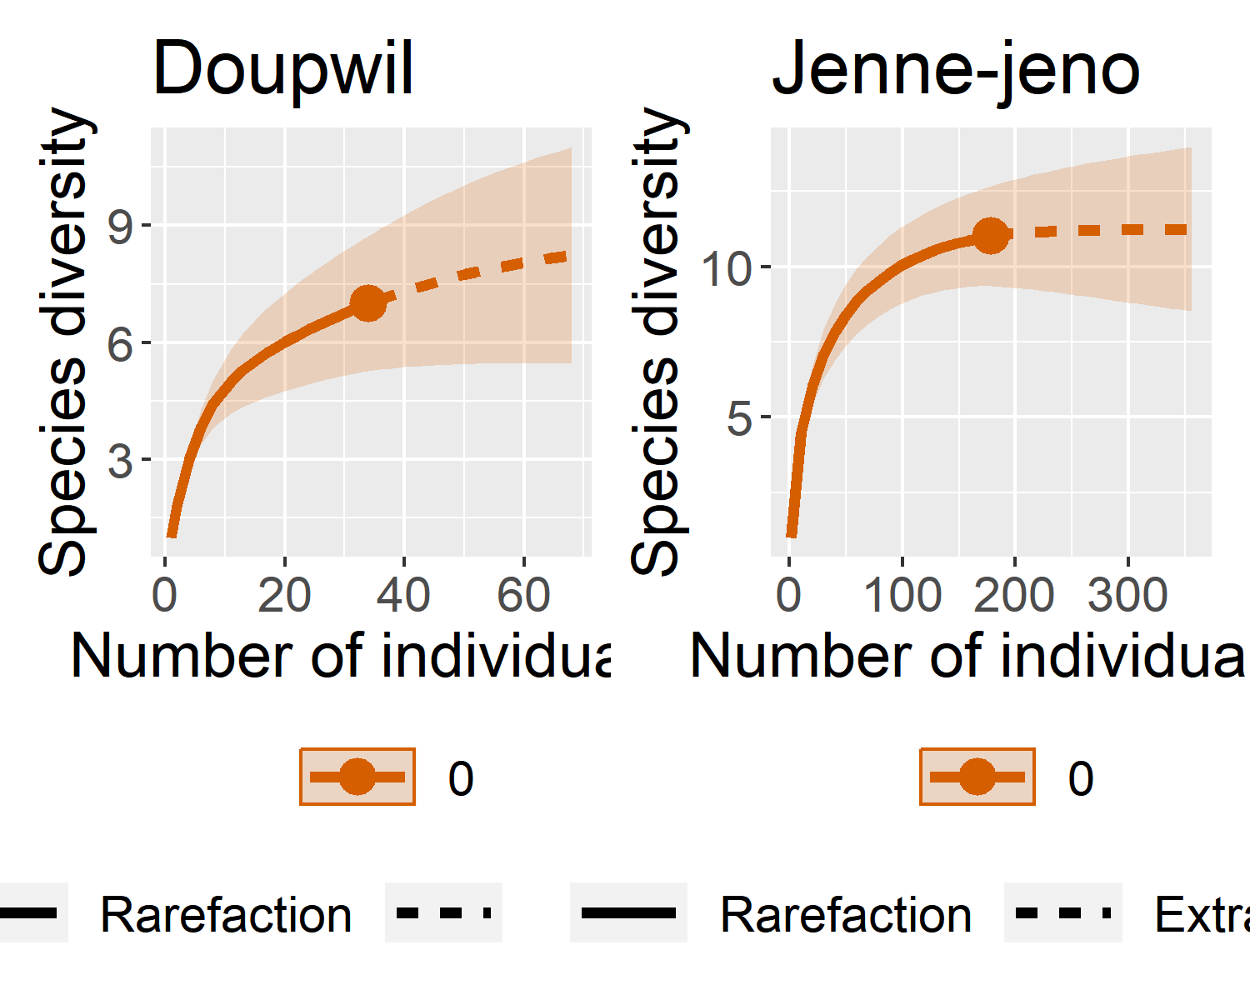

#> Compare 8 assemblages with Hill number order q = 0.  
#> $class: iNEXT  
#>   
#> $DataInfo: basic data information  
#> Assemblage n S.obs SC f1 f2 f3 f4 f5 f6 f7 f8 f9 f10  
#> 1 Akumbu9 278 4 1.0000 0 0 0 0 0 2 0 0 0 0  
#> 2 Gao9 376 7 1.0000 0 0 0 0 0 0 1 0 0 0  
#> 3 Jenne-jeno9 536 12 0.9907 5 1 0 0 0 1 0 0 0 0  
#> 4 Mara9 234 12 0.9872 3 1 0 0 0 0 0 0 1 0  
#> 5 Nin_Bere 26 2 1.0000 0 0 0 1 0 0 0 0 0 0  
#> 6 Sadia9 645 5 1.0000 0 0 0 0 0 0 0 0 0 0  
#> 7 TMD9 92 10 0.9894 1 1 0 2 0 1 1 1 0 1  
#> 8 Marakaduguba 37 6 0.9757 1 2 1 0 1 0 0 0 0 0  
#>   
#> $iNextEst: diversity estimates with rarefied and extrapolated samples.  
#> $size_based (LCL and UCL are obtained for fixed size.)  
#>   
#> Assemblage m Method Order.q qD qD.LCL qD.UCL  
#> 1 Akumbu9 1 Rarefaction 0 1.000000 1.000000 1.000000  
#> 10 Akumbu9 139 Rarefaction 0 3.970424 3.543076 4.397772  
#> 20 Akumbu9 278 Observed 0 4.000000 3.722819 4.277181  
#> 30 Akumbu9 410 Extrapolation 0 4.000000 3.722819 4.277181  
#> 40 Akumbu9 556 Extrapolation 0 4.000000 3.722819 4.277181  
#> 41 Gao9 1 Rarefaction 0 1.000000 1.000000 1.000000  
#> 50 Gao9 188 Rarefaction 0 6.992619 6.905185 7.080054  
#> 60 Gao9 376 Observed 0 7.000000 7.000000 7.000000  
#> 70 Gao9 554 Extrapolation 0 7.000000 7.000000 7.000000  
#> 80 Gao9 752 Extrapolation 0 7.000000 7.000000 7.000000  
#> 81 Jenne-jeno9 1 Rarefaction 0 1.000000 1.000000 1.000000  
#> 90 Jenne-jeno9 268 Rarefaction 0 9.235063 7.068414 11.401711  
#> 100 Jenne-jeno9 536 Observed 0 12.000000 8.197633 15.802367  
#> 110 Jenne-jeno9 790 Extrapolation 0 14.157279 8.994235 19.320323  
#> 120 Jenne-jeno9 1072 Extrapolation 0 16.118310 9.529095 22.707525  
#> 121 Mara9 1 Rarefaction 0 1.000000 1.000000 1.000000  
#> 130 Mara9 117 Rarefaction 0 10.249026 8.649618 11.848435  
#> 140 Mara9 234 Observed 0 12.000000 9.210149 14.789851  
#> 150 Mara9 345 Extrapolation 0 13.217754 9.308263 17.127245  
#> 160 Mara9 468 Extrapolation 0 14.184644 9.143479 19.225810  
#> 161 Nin_Bere 1 Rarefaction 0 1.000000 1.000000 1.000000  
#> 170 Nin_Bere 13 Rarefaction 0 1.952174 1.534845 2.369503  
#> 180 Nin_Bere 26 Observed 0 2.000000 1.612028 2.387972  
#> 190 Nin_Bere 38 Extrapolation 0 2.000000 1.612028 2.387972  
#> 200 Nin_Bere 52 Extrapolation 0 2.000000 1.612028 2.387972  
#> 201 Sadia9 1 Rarefaction 0 1.000000 1.000000 1.000000  
#> 210 Sadia9 322 Rarefaction 0 4.999987 4.998875 5.001099  
#> 220 Sadia9 645 Observed 0 5.000000 5.000000 5.000000  
#> 230 Sadia9 951 Extrapolation 0 5.000000 5.000000 5.000000  
#> 240 Sadia9 1290 Extrapolation 0 5.000000 5.000000 5.000000  
#> 241 TMD9 1 Rarefaction 0 1.000000 1.000000 1.000000  
#> 250 TMD9 46 Rarefaction 0 9.113328 7.967326 10.259331  
#> 260 TMD9 92 Observed 0 10.000000 8.209784 11.790216  
#> 270 TMD9 136 Extrapolation 0 10.304547 7.945141 12.663953  
#> 280 TMD9 184 Extrapolation 0 10.427638 7.647141 13.208136  
#> 281 Marakaduguba 1 Rarefaction 0 1.000000 1.000000 1.000000  
#> 290 Marakaduguba 18 Rarefaction 0 4.821587 3.673546 5.969627  
#> 300 Marakaduguba 37 Observed 0 6.000000 4.262678 7.737322  
#> 310 Marakaduguba 55 Extrapolation 0 6.206734 3.999084 8.414384  
#> 320 Marakaduguba 74 Extrapolation 0 6.238311 3.612076 8.864547  
#> SC SC.LCL SC.UCL  
#> 1 0.7061787 0.6286222 0.7837352  
#> 10 0.9987233 0.9959258 1.0000000  
#> 20 1.0000000 1.0000000 1.0000000  
#> 30 1.0000000 1.0000000 1.0000000  
#> 40 1.0000000 1.0000000 1.0000000  
#> 41 0.2202128 0.1958074 0.2446181  
#> 50 0.9997252 0.9985578 1.0000000  
#> 60 1.0000000 1.0000000 1.0000000  
#> 70 1.0000000 1.0000000 1.0000000  
#> 80 1.0000000 1.0000000 1.0000000  
#> 81 0.2394546 0.2248750 0.2540342  
#> 90 0.9884598 0.9809822 0.9959373  
#> 100 0.9906786 0.9844872 0.9968700  
#> 110 0.9922903 0.9862881 0.9982925  
#> 120 0.9937554 0.9882078 0.9993030  
#> 121 0.1756355 0.1500769 0.2011942  
#> 130 0.9827566 0.9711828 0.9943304  
#> 140 0.9872161 0.9756171 0.9988150  
#> 150 0.9906904 0.9799956 1.0000000  
#> 160 0.9934490 0.9844187 1.0000000  
#> 161 0.7292308 0.5124796 0.9459819  
#> 170 0.9852843 0.9589692 1.0000000  
#> 180 1.0000000 1.0000000 1.0000000  
#> 190 1.0000000 1.0000000 1.0000000  
#> 200 1.0000000 1.0000000 1.0000000  
#> 201 0.3593047 0.3327835 0.3858259  
#> 210 0.9999994 0.9999709 1.0000000  
#> 220 1.0000000 1.0000000 1.0000000  
#> 230 1.0000000 1.0000000 1.0000000  
#> 240 1.0000000 1.0000000 1.0000000  
#> 241 0.1734353 0.1327479 0.2141226  
#> 250 0.9649698 0.9433255 0.9866141  
#> 260 0.9893642 0.9674630 1.0000000  
#> 270 0.9959136 0.9818077 1.0000000  
#> 280 0.9985607 0.9895302 1.0000000  
#> 281 0.4369369 0.2920948 0.5817791  
#> 290 0.8922078 0.8370336 0.9473820  
#> 300 0.9756757 0.9260175 1.0000000  
#> 310 0.9963490 0.9596389 1.0000000  
#> 320 0.9995068 0.9740834 1.0000000  
#>   
#> NOTE: The above output only shows five estimates for each assemblage; call iNEXT.object$iNextEst$size_based to view complete output.  
#>   
#> $coverage_based (LCL and UCL are obtained for fixed coverage; interval length is wider due to varying size in bootstraps.)  
#>   
#> Assemblage SC m Method Order.q qD qD.LCL  
#> 1 Akumbu9 0.7061787 1 Rarefaction 0 1.000000 0.9369404  
#> 5 Akumbu9 0.9879556 62 Rarefaction 0 3.566760 3.0424986  
#> 10 Akumbu9 0.9987233 139 Rarefaction 0 3.970424 3.6165478  
#> 15 Akumbu9 0.9999787 215 Rarefaction 0 3.999776 3.6367197  
#> 19 Akumbu9 1.0000000 278 Observed 0 4.000000 3.7228192  
#> 20 Gao9 0.2202166 1 Rarefaction 0 1.000016 0.9577778  
#> 24 Gao9 0.9959037 84 Rarefaction 0 6.831645 6.6658272  
#> 29 Gao9 0.9997252 188 Rarefaction 0 6.992619 6.9909743  
#> 34 Gao9 0.9999980 291 Rarefaction 0 6.999975 6.9999631  
#> 38 Gao9 1.0000000 376 Observed 0 7.000000 7.0000000  
#> 39 Jenne-jeno9 0.2394546 1 Rarefaction 0 1.000000 0.9734103  
#> 48 Jenne-jeno9 0.9884598 268 Rarefaction 0 9.235062 1.8086994  
#> 58 Jenne-jeno9 0.9906786 536 Observed 0 12.000000 2.5416839  
#> 68 Jenne-jeno9 0.9922903 790 Extrapolation 0 14.157279 3.3303641  
#> 78 Jenne-jeno9 0.9937554 1072 Extrapolation 0 16.118310 4.2914406  
#> 79 Mara9 0.1756360 1 Rarefaction 0 1.000003 0.9364566  
#> 88 Mara9 0.9827566 117 Rarefaction 0 10.249026 4.9644242  
#> 98 Mara9 0.9872161 234 Observed 0 12.000000 5.4741468  
#> 108 Mara9 0.9906904 345 Extrapolation 0 13.217754 5.7723609  
#> 118 Mara9 0.9934490 468 Extrapolation 0 14.184644 6.0833012  
#> 119 Nin_Bere 0.7292316 1 Rarefaction 0 1.000001 0.6543754  
#> 123 Nin_Bere 0.9351840 6 Rarefaction 0 1.675920 1.2552439  
#> 127 Nin_Bere 0.9756522 11 Rarefaction 0 1.908696 1.4769109  
#> 132 Nin_Bere 0.9976588 18 Rarefaction 0 1.995318 1.5193004  
#> 135 Nin_Bere 1.0000000 22 Rarefaction 0 1.999959 1.5217978  
#> 136 Nin_Bere 1.0000000 26 Observed 0 2.000000 1.6120277  
#> 137 Sadia9 0.3593047 1 Rarefaction 0 1.000000 0.9590244  
#> 141 Sadia9 0.9994462 143 Rarefaction 0 4.982736 4.9758295  
#> 145 Sadia9 0.9999968 286 Rarefaction 0 4.999927 4.9999142  
#> 149 Sadia9 1.0000000 429 Rarefaction 0 5.000000 5.0000000  
#> 153 Sadia9 1.0000000 645 Observed 0 5.000000 5.0000000  
#> 154 TMD9 0.1734353 1 Rarefaction 0 1.000000 0.8916349  
#> 163 TMD9 0.9649699 46 Rarefaction 0 9.113329 7.3035140  
#> 173 TMD9 0.9893642 92 Observed 0 10.000000 7.0201386  
#> 183 TMD9 0.9959136 136 Extrapolation 0 10.304547 6.9607228  
#> 193 TMD9 0.9985607 184 Extrapolation 0 10.427638 6.9261336  
#> 194 Marakaduguba 0.4369369 1 Rarefaction 0 1.000000 0.7789677  
#> 203 Marakaduguba 0.8922077 18 Rarefaction 0 4.821585 2.9052466  
#> 213 Marakaduguba 0.9756757 37 Observed 0 6.000000 2.9217962  
#> 223 Marakaduguba 0.9963490 55 Extrapolation 0 6.206734 2.6450038  
#> 233 Marakaduguba 0.9995068 74 Extrapolation 0 6.238311 2.5974268  
#> qD.UCL  
#> 1 1.063060  
#> 5 4.091022  
#> 10 4.324300  
#> 15 4.362833  
#> 19 4.277181  
#> 20 1.042254  
#> 24 6.997462  
#> 29 6.994264  
#> 34 6.999987  
#> 38 7.000000  
#> 39 1.026590  
#> 48 16.661425  
#> 58 21.458316  
#> 68 24.984194  
#> 78 27.945180  
#> 79 1.063549  
#> 88 15.533628  
#> 98 18.525853  
#> 108 20.663147  
#> 118 22.285988  
#> 119 1.345626  
#> 123 2.096596  
#> 127 2.340481  
#> 132 2.471335  
#> 135 2.478120  
#> 136 2.387972  
#> 137 1.040976  
#> 141 4.989643  
#> 145 4.999940  
#> 149 5.000000  
#> 153 5.000000  
#> 154 1.108365  
#> 163 10.923143  
#> 173 12.979861  
#> 183 13.648371  
#> 193 13.929143  
#> 194 1.221032  
#> 203 6.737924  
#> 213 9.078204  
#> 223 9.768464  
#> 233 9.879196  
#>   
#> NOTE: The above output only shows five estimates for each assemblage; call iNEXT.object$iNextEst$coverage_based to view complete output.  
#>   
#> $AsyEst: asymptotic diversity estimates along with related statistics.  
#> Assemblage Diversity Observed Estimator s.e. LCL  
#> 1 Akumbu9 Species richness 4.000000 4.000000 0.14070529 4.000000  
#> 2 Akumbu9 Shannon diversity 1.786693 1.796554 0.10527151 1.590226  
#> 3 Akumbu9 Simpson diversity 1.413956 1.416072 0.06716725 1.284427  
#> 4 Gao9 Species richness 7.000000 7.000000 0.00000000 7.000000  
#> 5 Gao9 Shannon diversity 5.351863 5.395063 0.16545267 5.070781  
#> 6 Gao9 Simpson diversity 4.498695 4.541063 0.19714172 4.154672  
#> 7 Jenne-jeno9 Species richness 12.000000 24.476679 8.06342138 12.000000  
#> 8 Jenne-jeno9 Shannon diversity 4.731440 4.831217 0.17392332 4.490334  
#> 9 Jenne-jeno9 Simpson diversity 4.151556 4.176157 0.10837732 3.963741  
#> 10 Mara9 Species richness 12.000000 16.480769 3.78344061 12.000000  
#> 11 Mara9 Shannon diversity 6.980336 7.227197 0.44875515 6.347653  
#> 12 Mara9 Simpson diversity 5.581651 5.693609 0.42602847 4.858609  
#> 13 Marakaduguba Species richness 6.000000 6.243243 1.80692972 6.000000  
#> 14 Marakaduguba Shannon diversity 3.215473 3.478219 0.72440358 2.058414  
#> 15 Marakaduguba Simpson diversity 2.211632 2.288660 0.50166382 1.305417  
#> 16 Nin_Bere Species richness 2.000000 2.000000 0.00000000 2.000000  
#> 17 Nin_Bere Shannon diversity 1.536217 1.567329 0.15607508 1.261427  
#> 18 Nin_Bere Simpson diversity 1.352000 1.371308 0.15429667 1.068892  
#> 19 Sadia9 Species richness 5.000000 5.000000 0.00000000 5.000000  
#> 20 Sadia9 Shannon diversity 3.321323 3.331686 0.10773676 3.120526  
#> 21 Sadia9 Simpson diversity 2.775480 2.783153 0.10033018 2.586509  
#> 22 TMD9 Species richness 10.000000 10.494565 1.52220548 10.000000  
#> 23 TMD9 Shannon diversity 6.951994 7.345744 0.70987737 5.954409  
#> 24 TMD9 Simpson diversity 5.481865 5.765840 0.73824945 4.318898  
#> UCL  
#> 1 4.275777  
#> 2 2.002883  
#> 3 1.547717  
#> 4 7.000000  
#> 5 5.719344  
#> 6 4.927453  
#> 7 40.280695  
#> 8 5.172101  
#> 9 4.388573  
#> 10 23.896177  
#> 11 8.106740  
#> 12 6.528609  
#> 13 9.784760  
#> 14 4.898024  
#> 15 3.271903  
#> 16 2.000000  
#> 17 1.873230  
#> 18 1.673724  
#> 19 5.000000  
#> 20 3.542846  
#> 21 2.979796  
#> 22 13.478033  
#> 23 8.737078  
#> 24 7.212783

# 3 Analysis

## 3.1 Multiplex structure

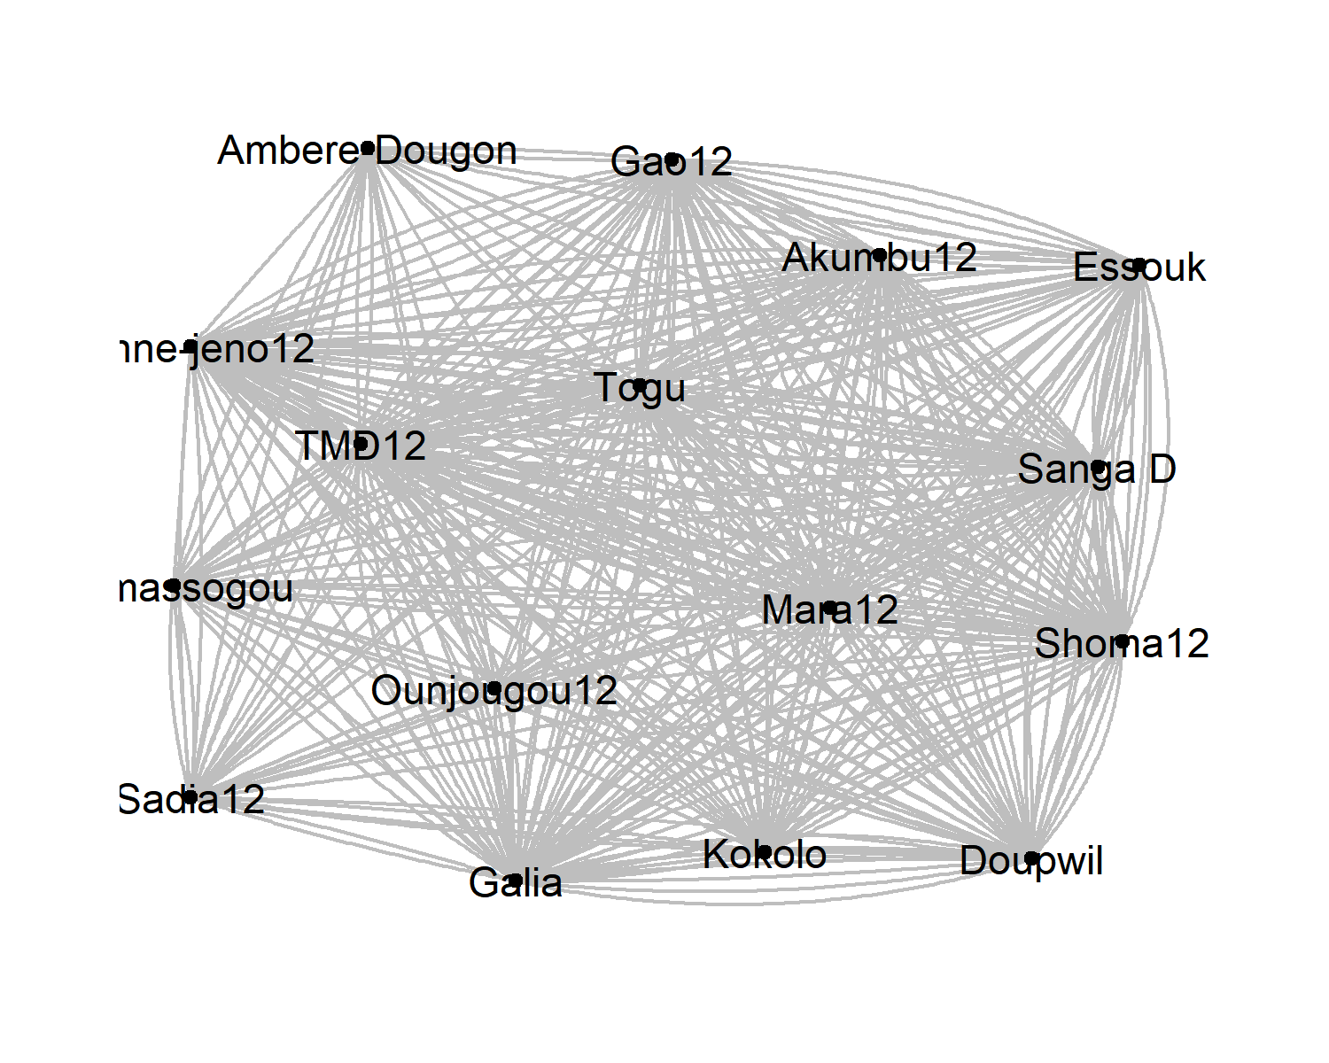

Figure 3.1: Plot of 11th century AD network of decorative practices. The plot shows the very strongly connected structure of the network.

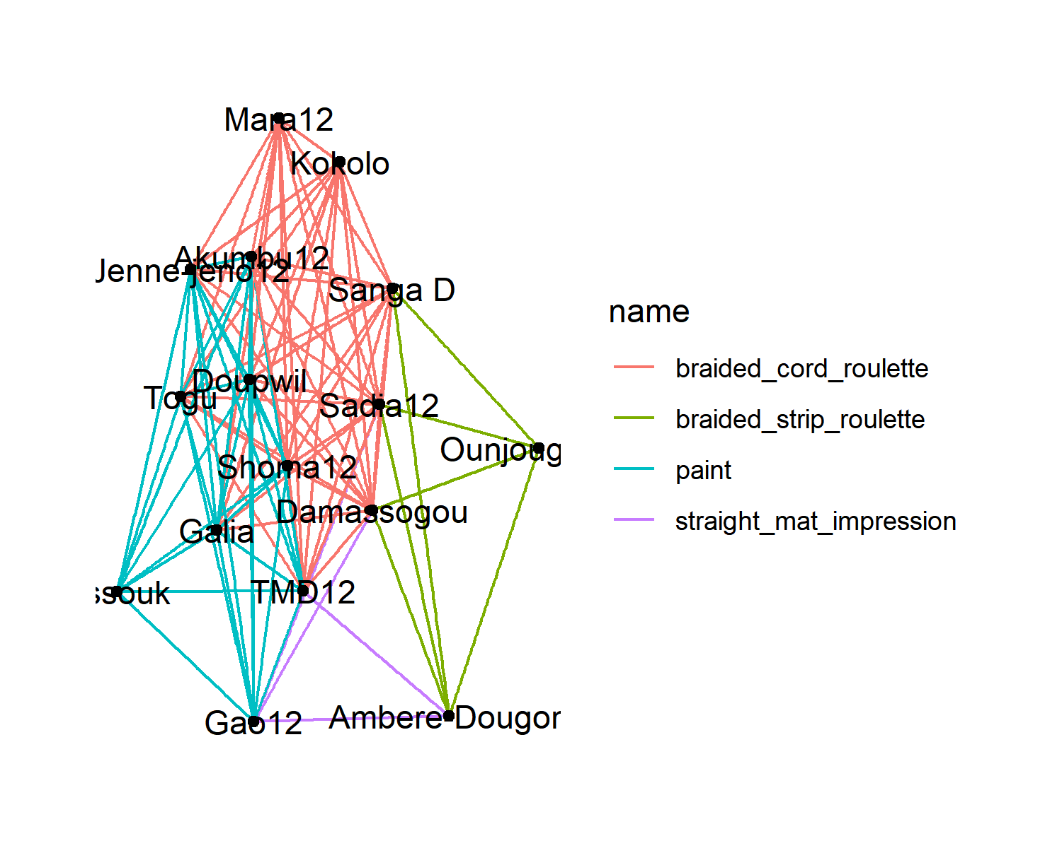

Figure 3.2: Partially overlapping networks of four decorative practices

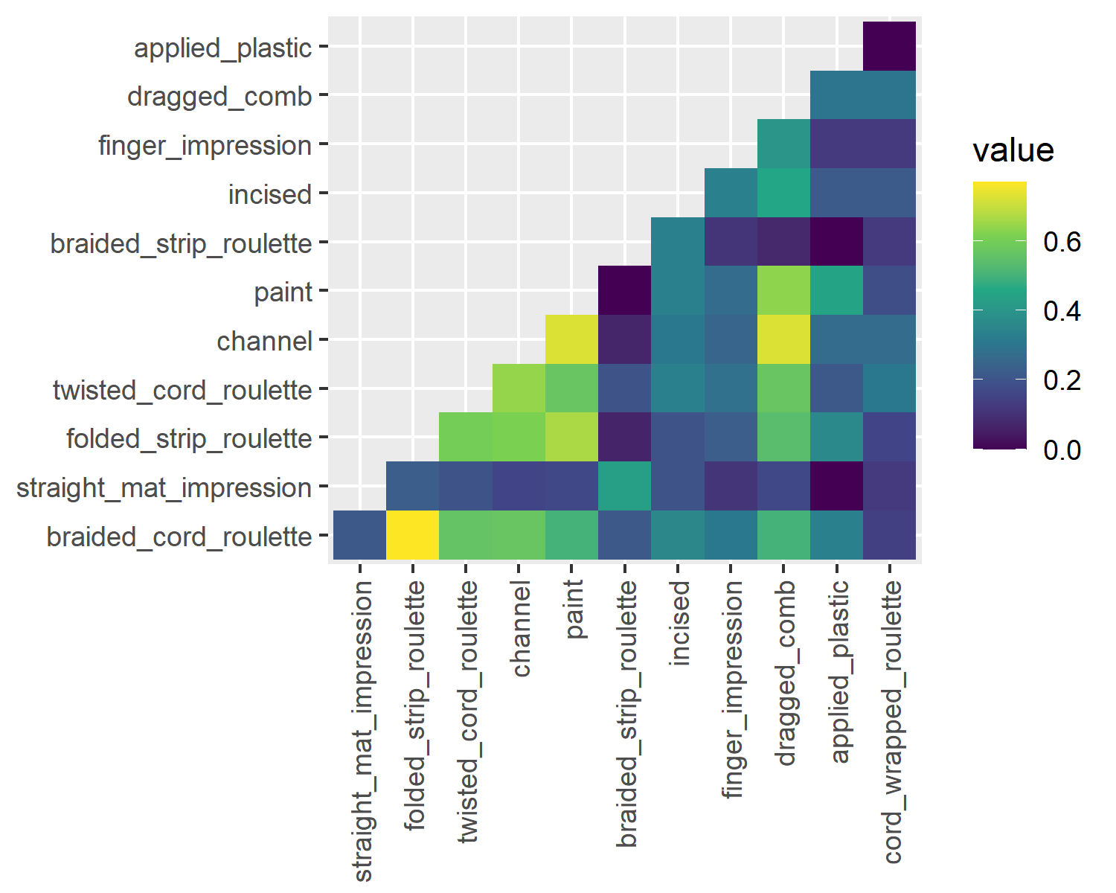

Figure 3.3: Jaccard similarity of nodes present in the networks of individual decorative practices

## 3.2 Sparsification

### 3.2.1 Simplified network backbone

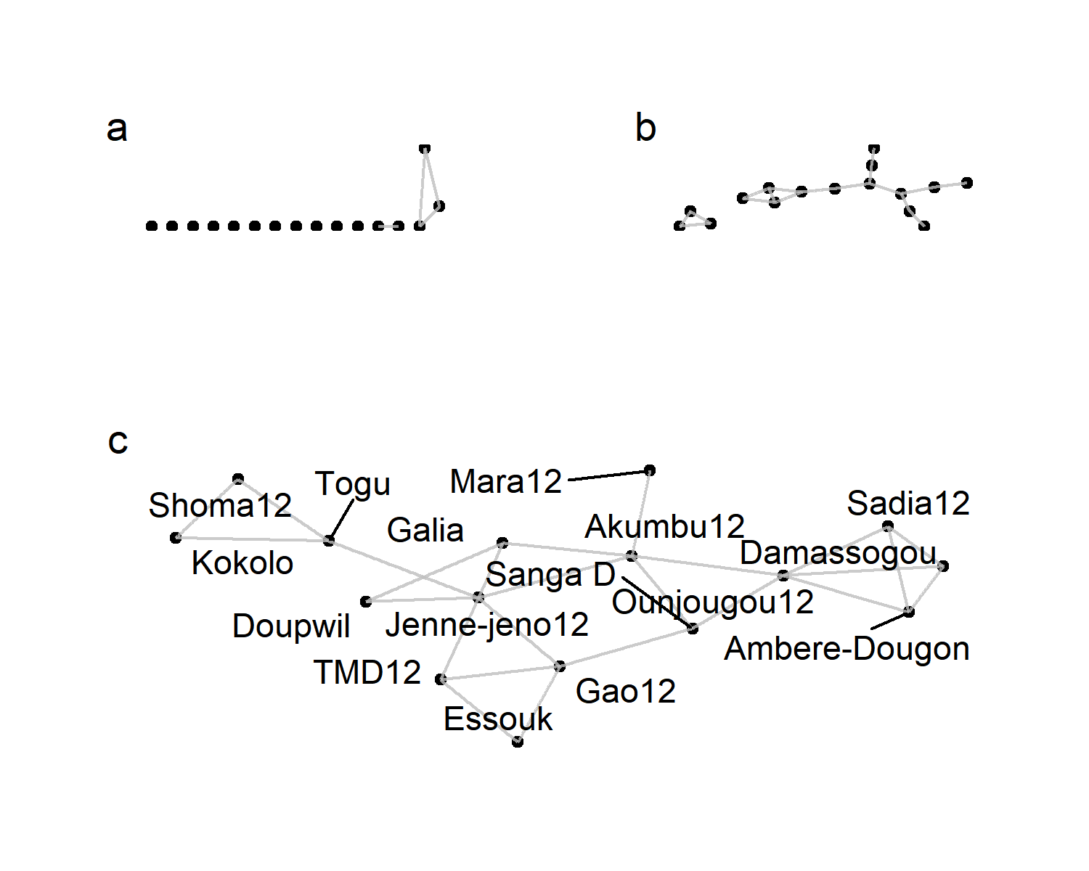

Figure 3.4: Extraction of binary backbones at decreasing significance levels: a) 0.05, b) 0.15, c) 0.18

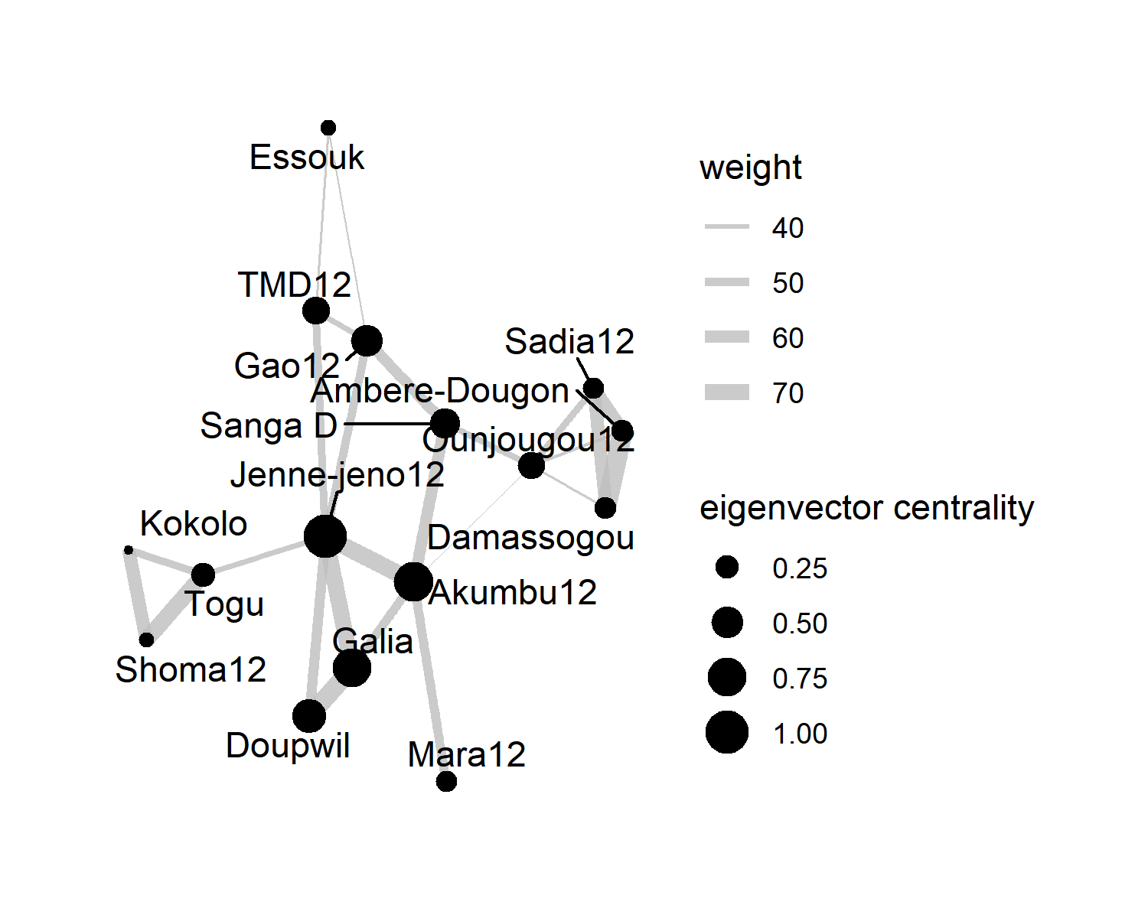

### 3.2.2 Influential nodes

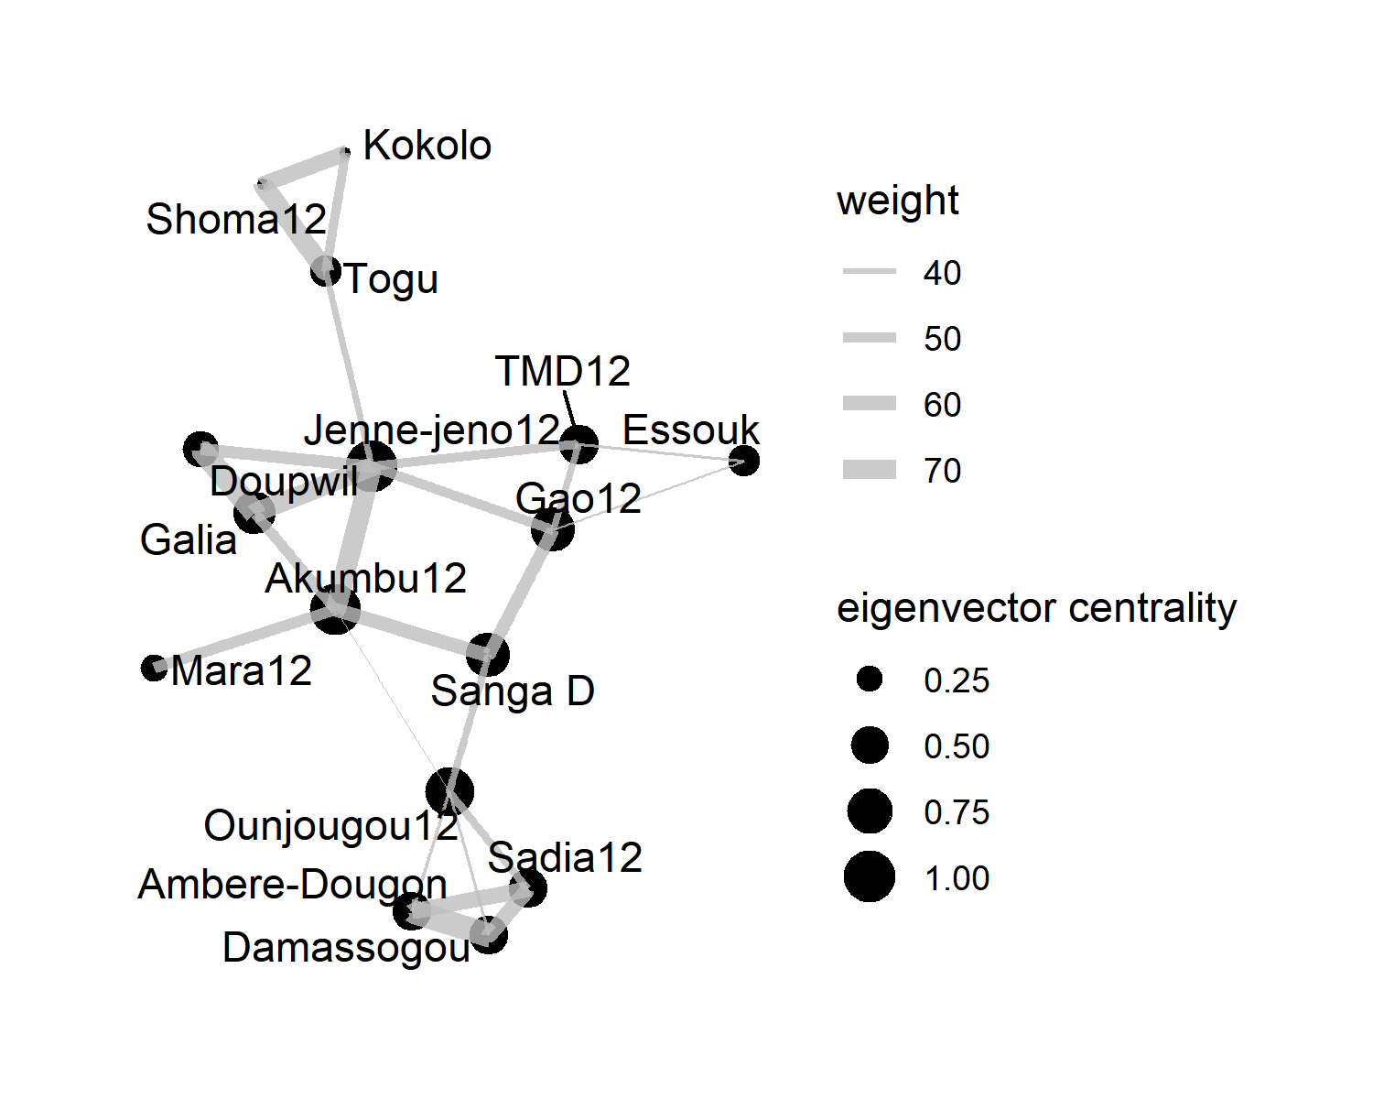

Figure 3.5: Binary backbone at alpha = 0.15 showing eigenvector centralities

### 3.2.3 Brokers

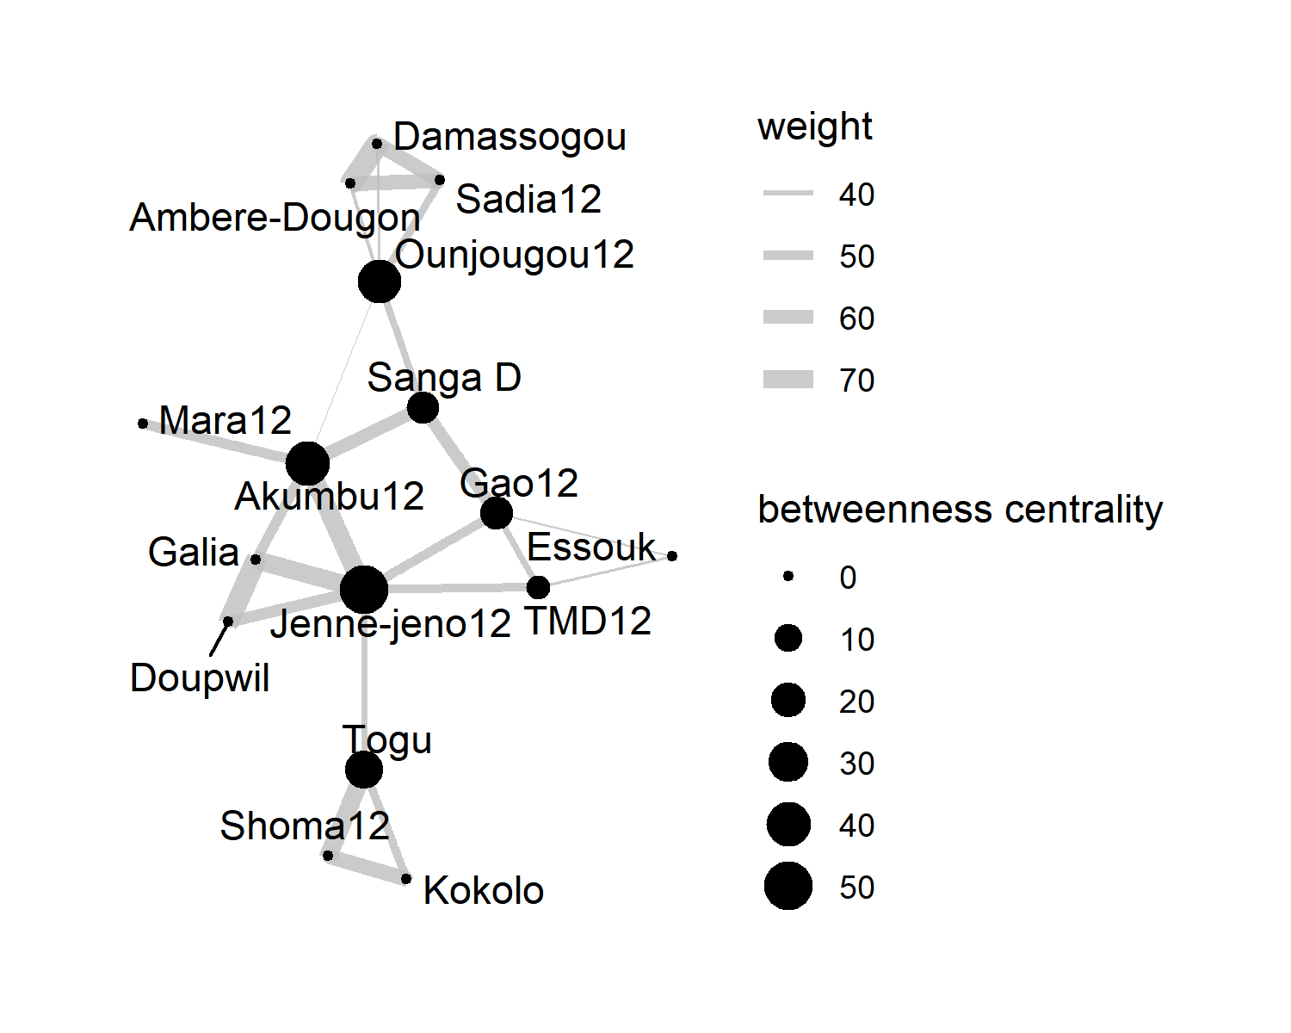

Figure 3.6: Binary backbone at alpha = 0.15 showing betweenness centralities

### 3.2.4 Evaluating measurements

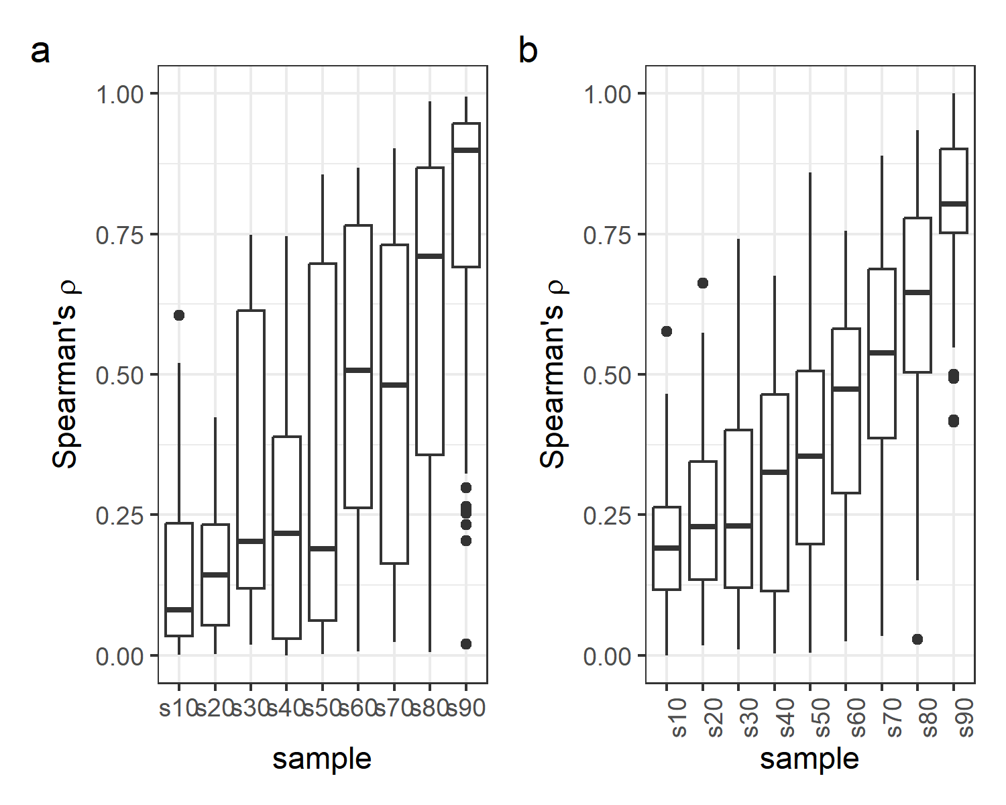

Figure 3.7: Testing the robustness of the bb-network by comparing its centralities to the original graph

## 3.3 Community detection

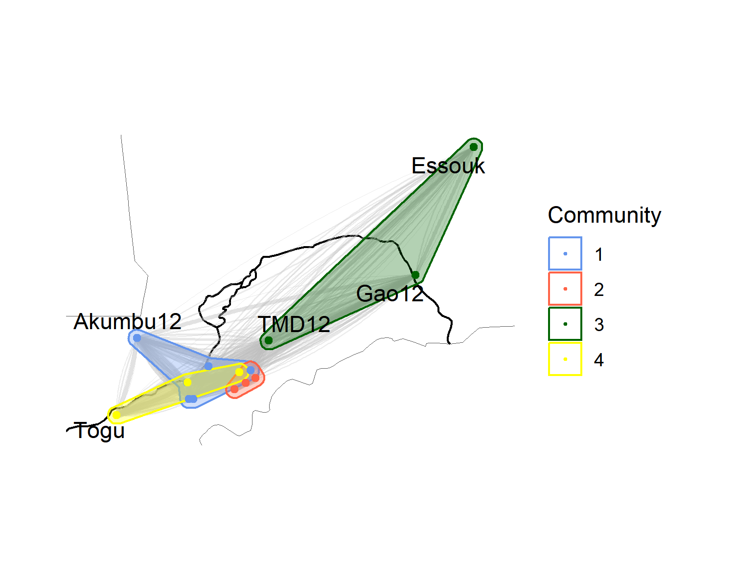

Figure 3.8: Louvain communities within the decor network

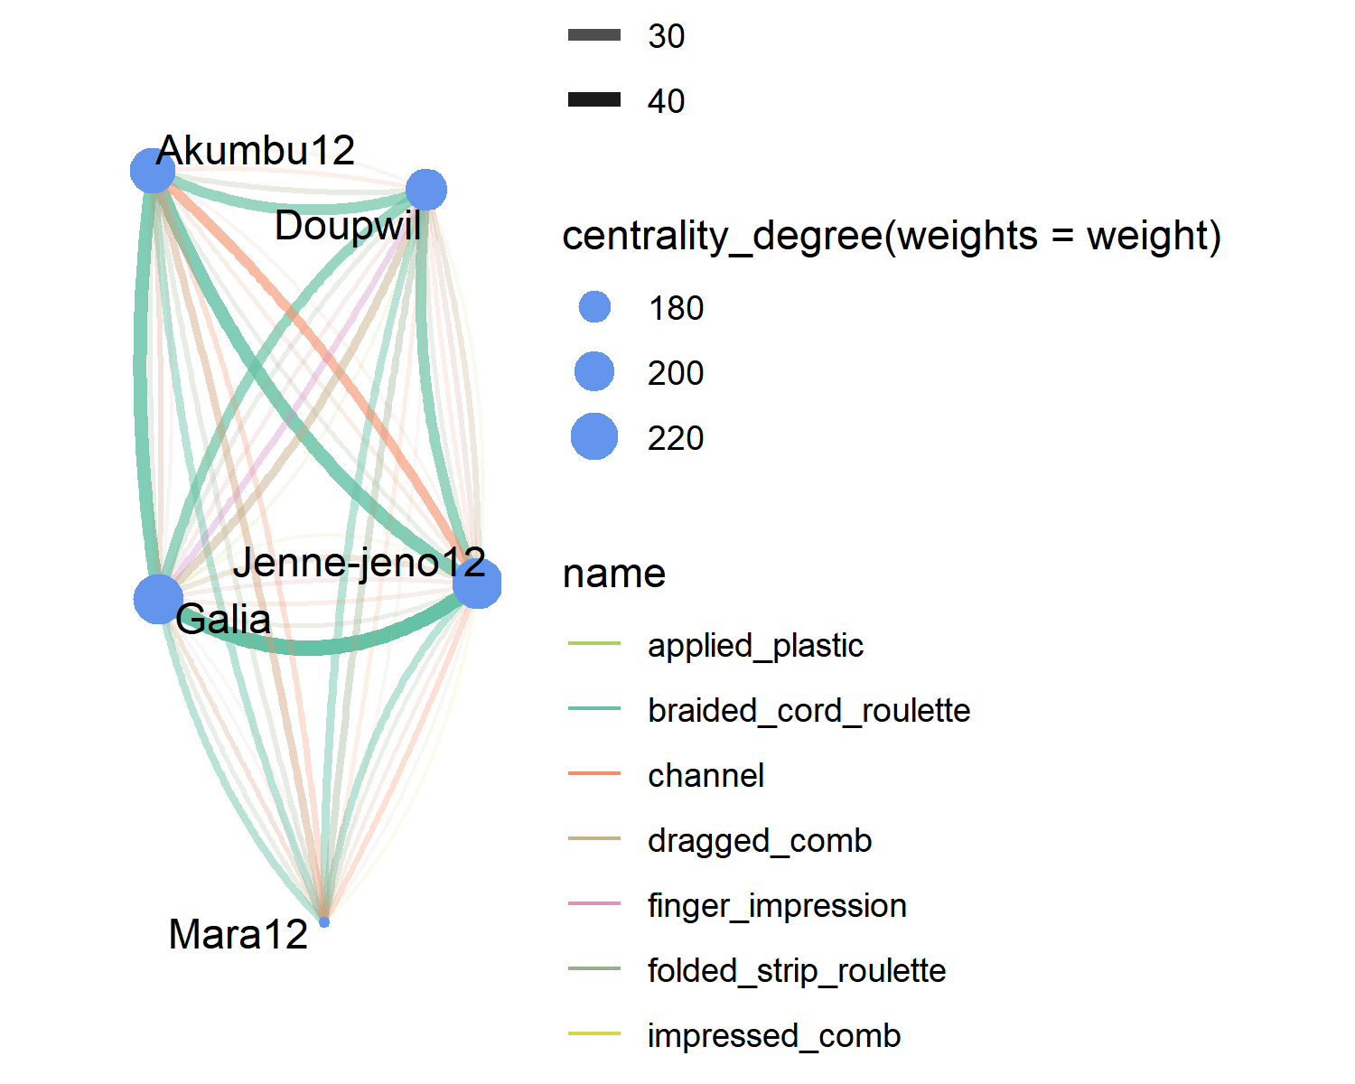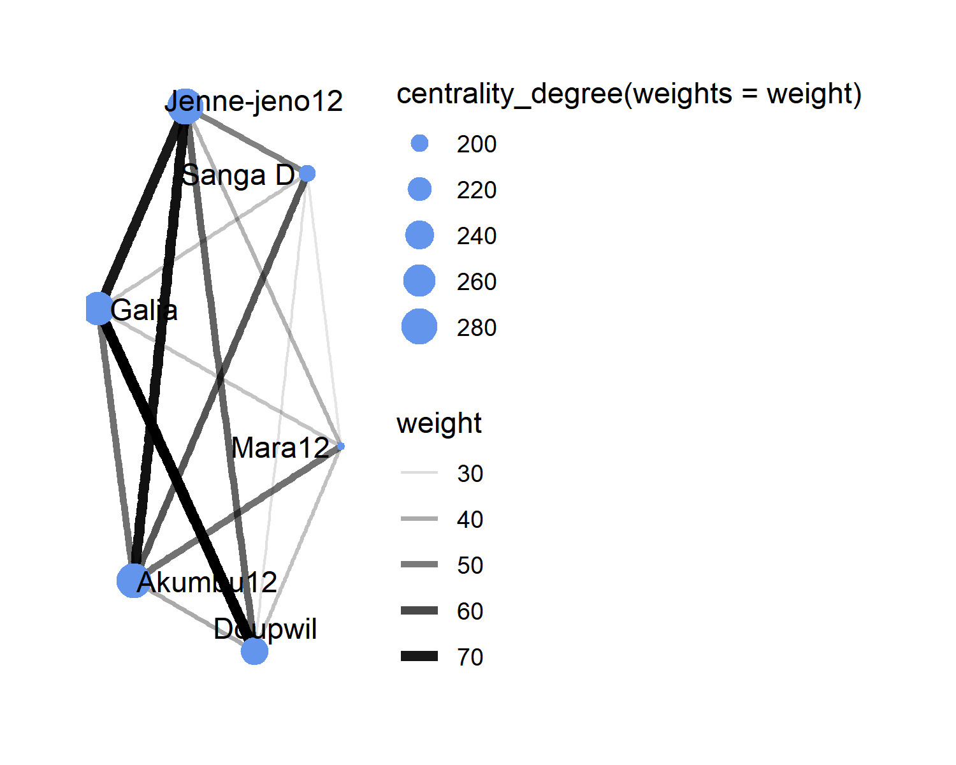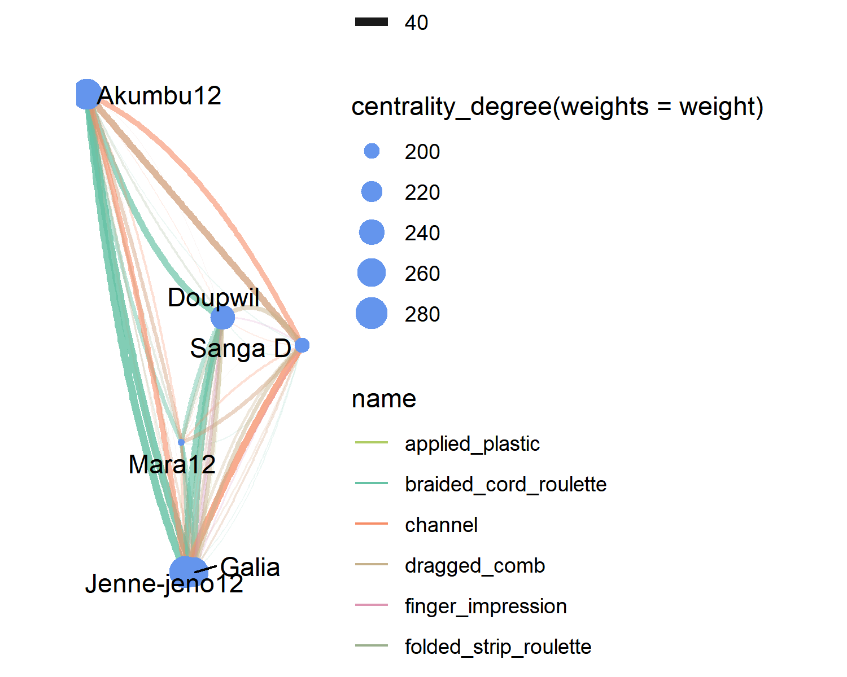

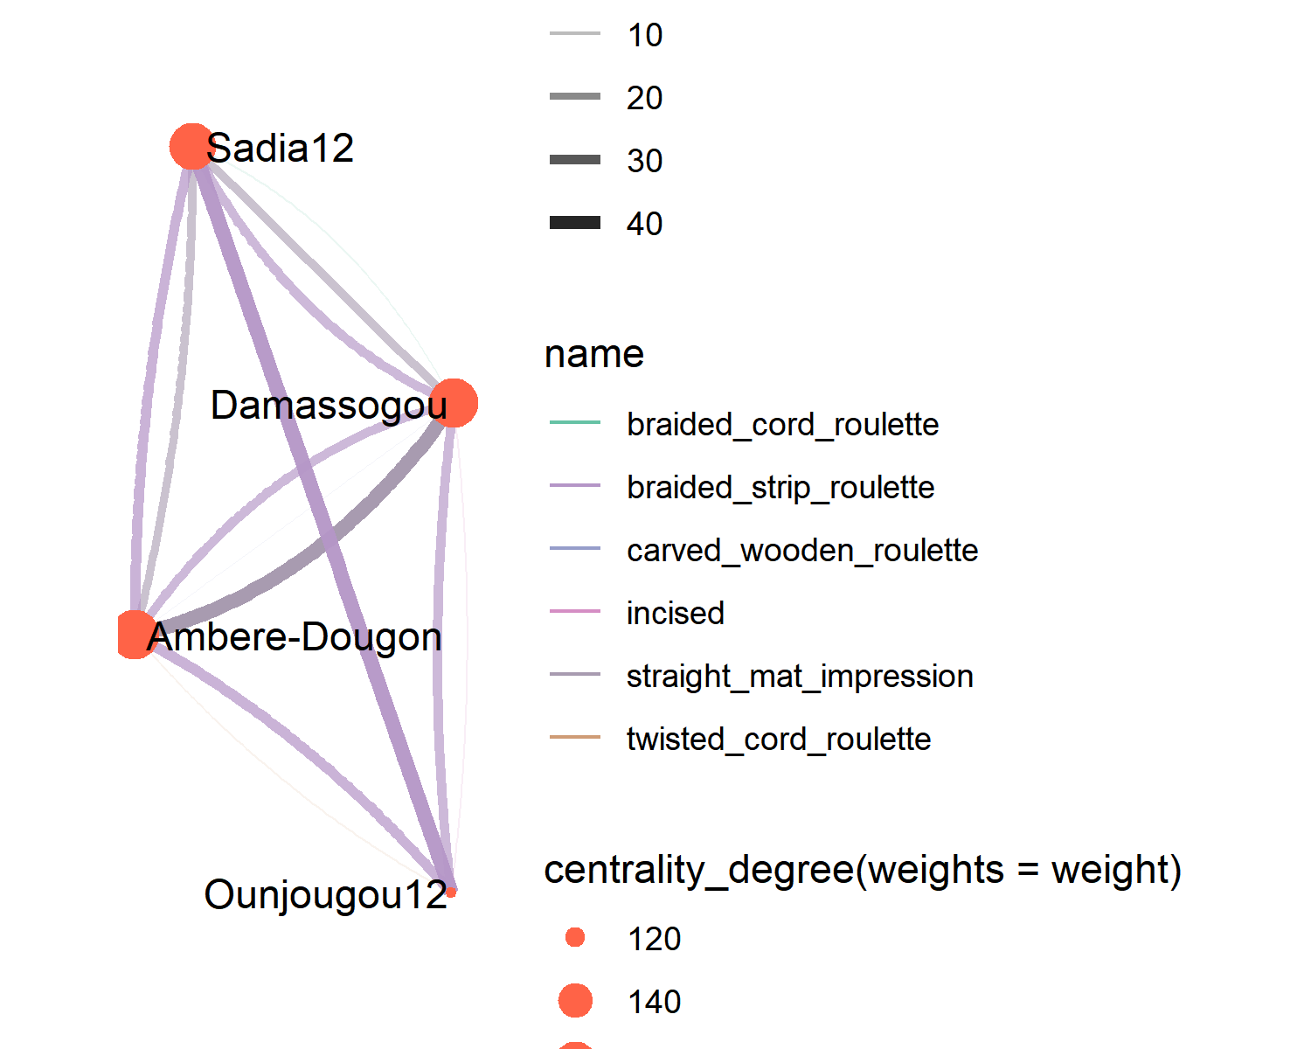

Figure 3.12: Internal connections within community 2

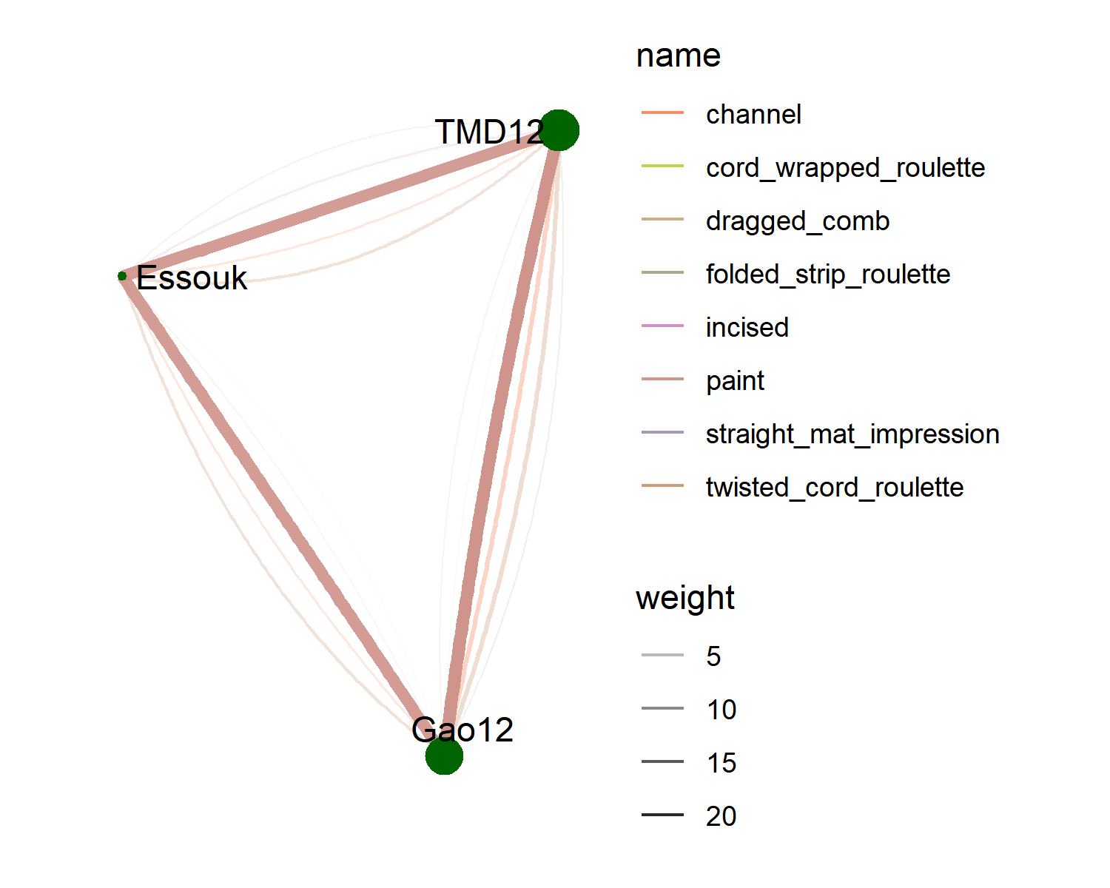

Figure 3.13: Internal connections within community 3

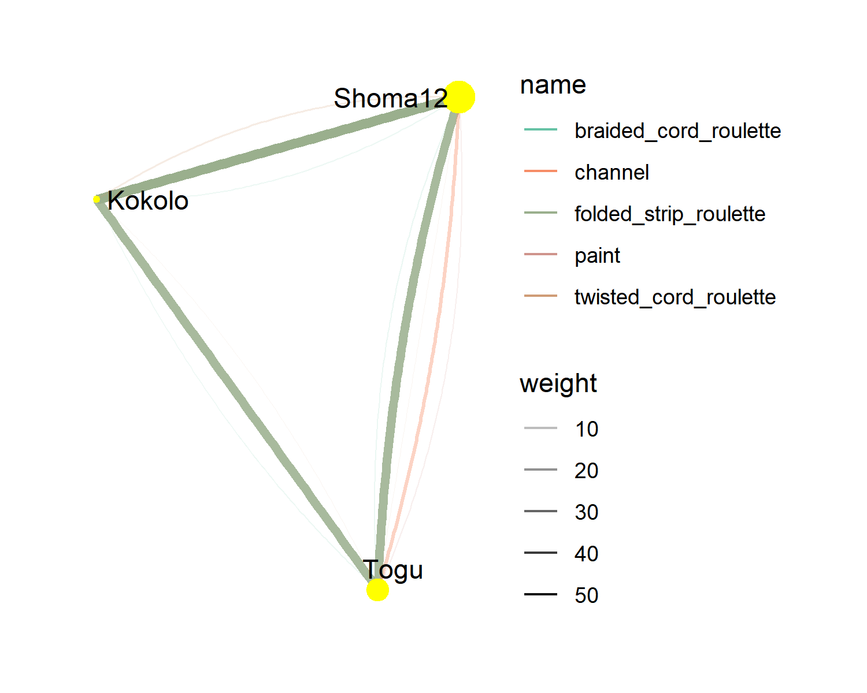

Figure 3.14: Internal connections within community 3

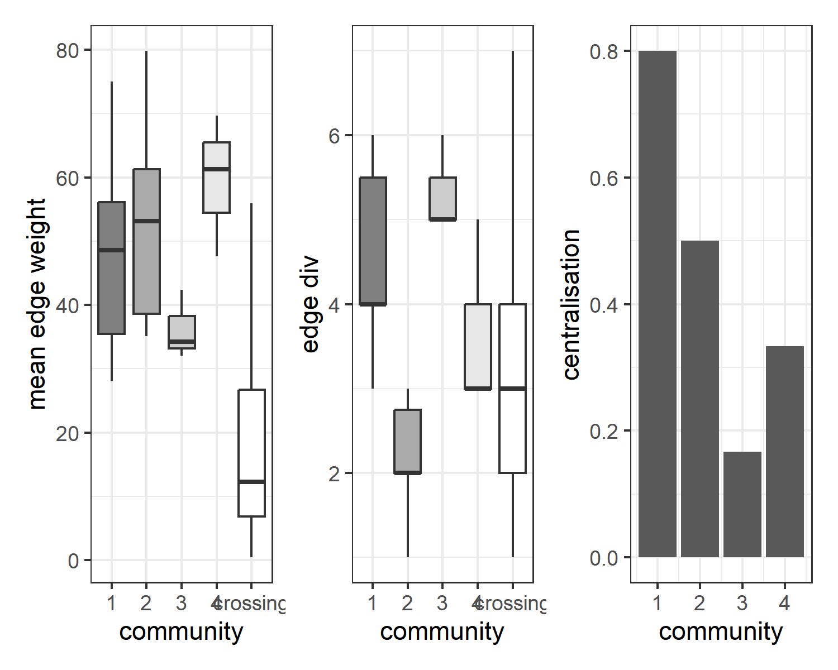

Figure 3.15: Relative edge weights, edge diversity and centralization by cluster

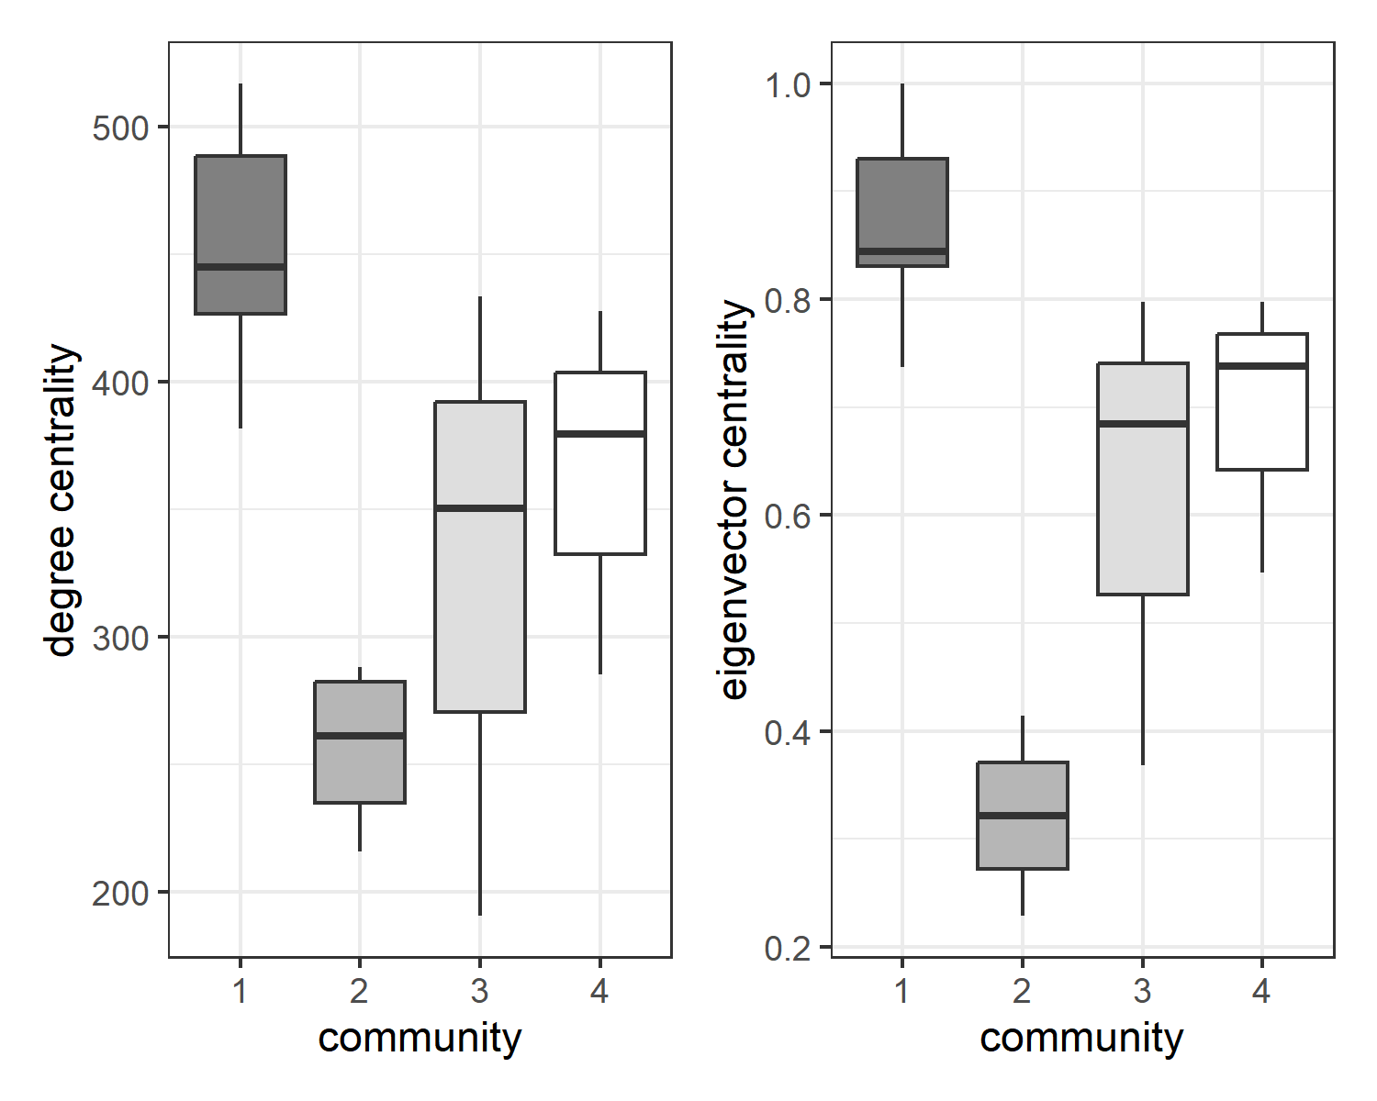

(#fig:cluster_centralities)Distribution of weighted degree and eigenvector centralities by community.

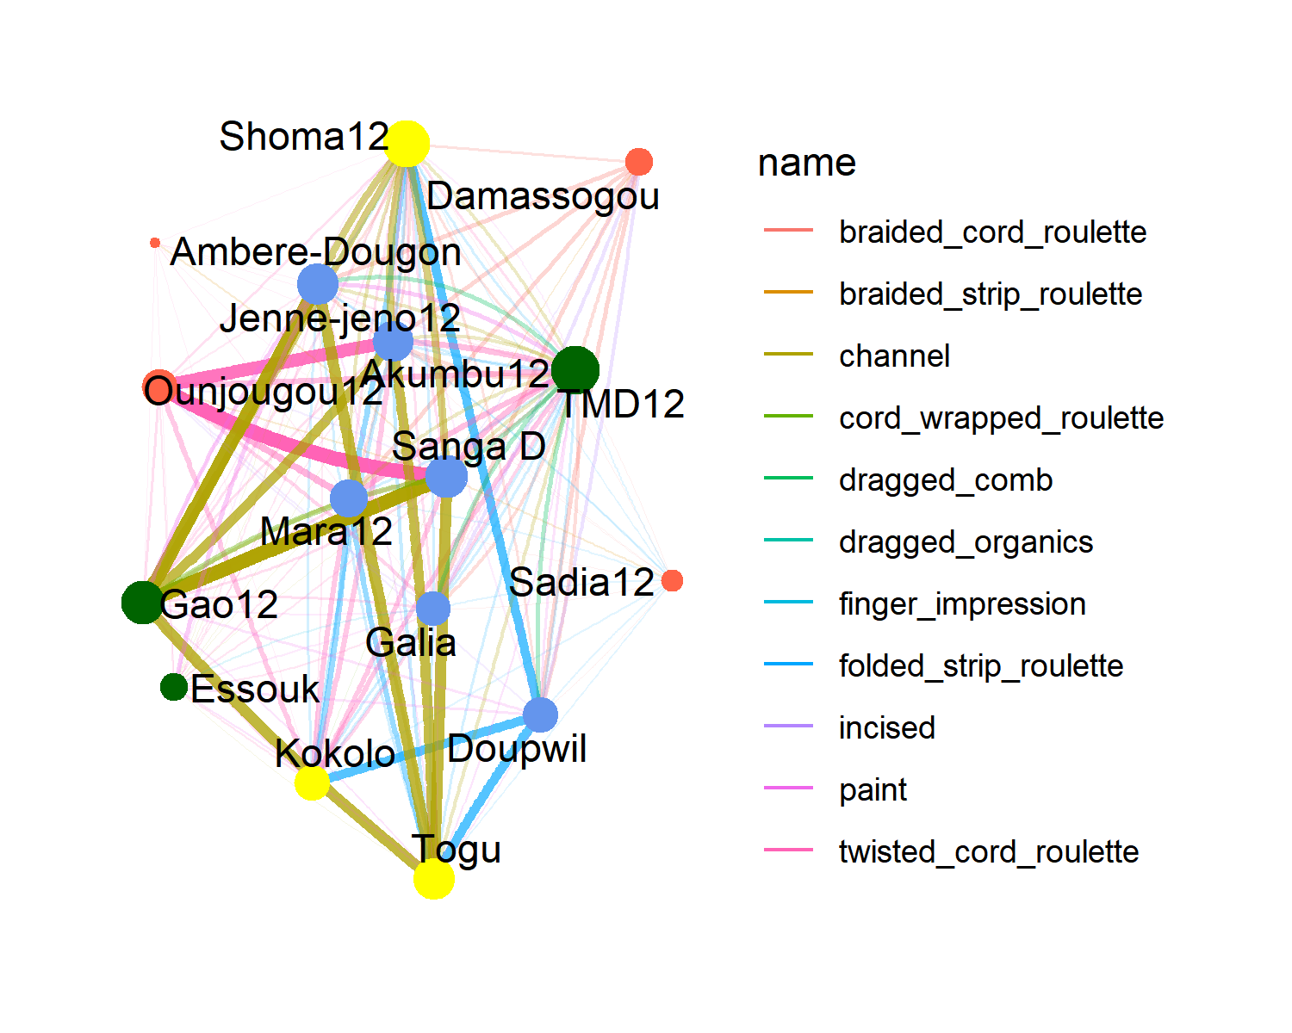

Figure 3.16: Network of edges which cross between clusters

## 3.4 Diachronic analysis

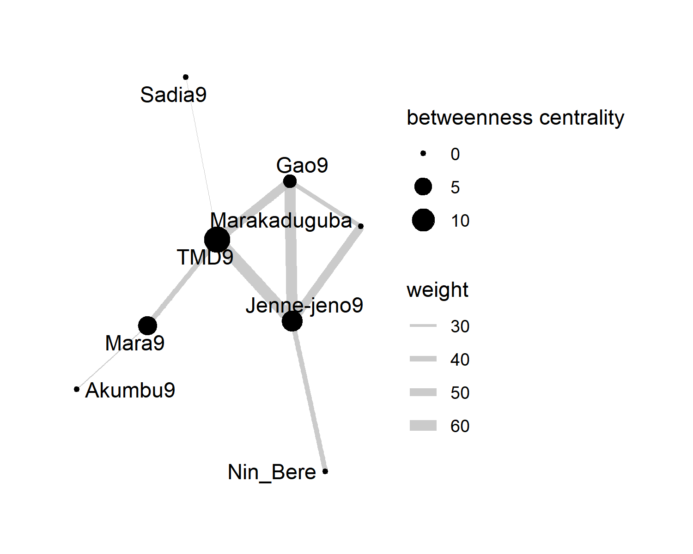

Figure 3.17: early backbone

# 4 Discussion

# 5 Conclusion

# 6 Acknowledgements

The work presented here was undertaken as part of the project “Borrowed words and shared objects” within the German Research Foundation’s (DFG) Priority Programme “Entangled Africa”. Nikolas Gestrich was responsible for the research design and implementation. He is the main author of the analysis code and the manuscript. Juan-Marco Puerta Schardt aided in collating the data and co-authored the analysis code, particularly the section on community detection. He also contributed to the draft versions of the manuscript. The authors wish to thank the Institut des Sciences Humaines du Mali, the Musée National du Mali, and the Rijksmuseum voor Volkenkunde in Leiden for access to their pottery collections, and Susan McIntosh and Douglas Post Park for providing primary data. The R compendium for this article was created using the rrtools package.

### 6.0.1 Colophon

This report was generated on 2024-07-01 09:59:47 using the following computational environment and dependencies:

The current Git commit details are:

#> Local: master U:/github projects/pottery_decor_as_networks  
#> Remote: master @ origin (https://github.com/AHWA-Lab-Frankfurt/pottery_decor_as_networks.git)  
#> Head: [f27a1b2] 2024-06-10: paper correct