**FLEXMONEY INTERNSHIP ASSIGNMENT**

**Hadassah Amarthaluri**

**Mahindra University**

**hadassahamarthaluri@gmail.com**

React app frontend :

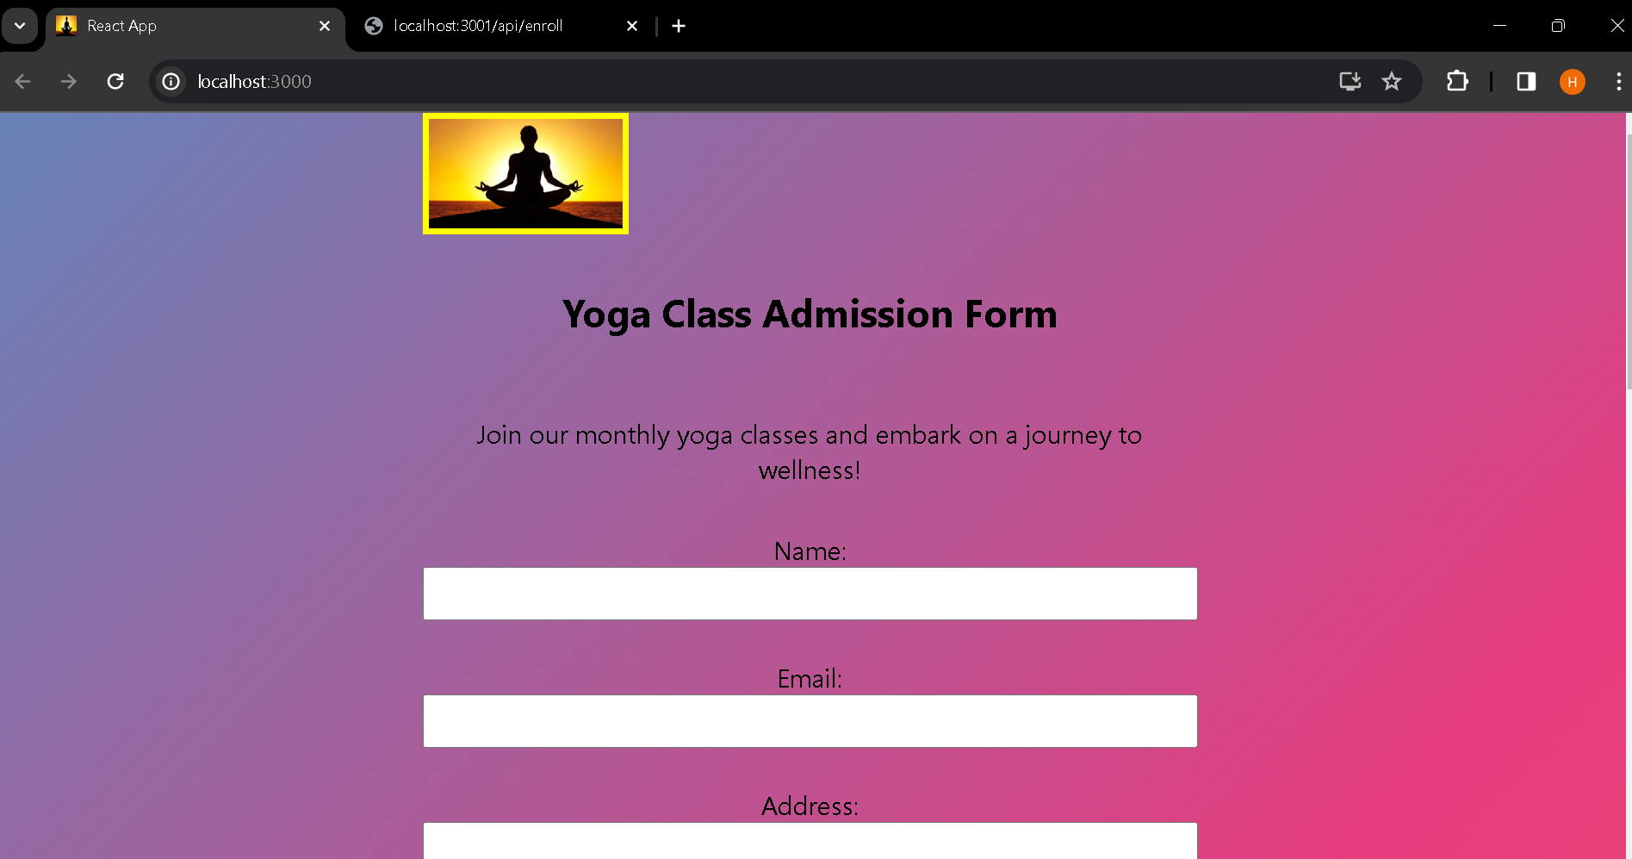

React app and console after successful enrollment : 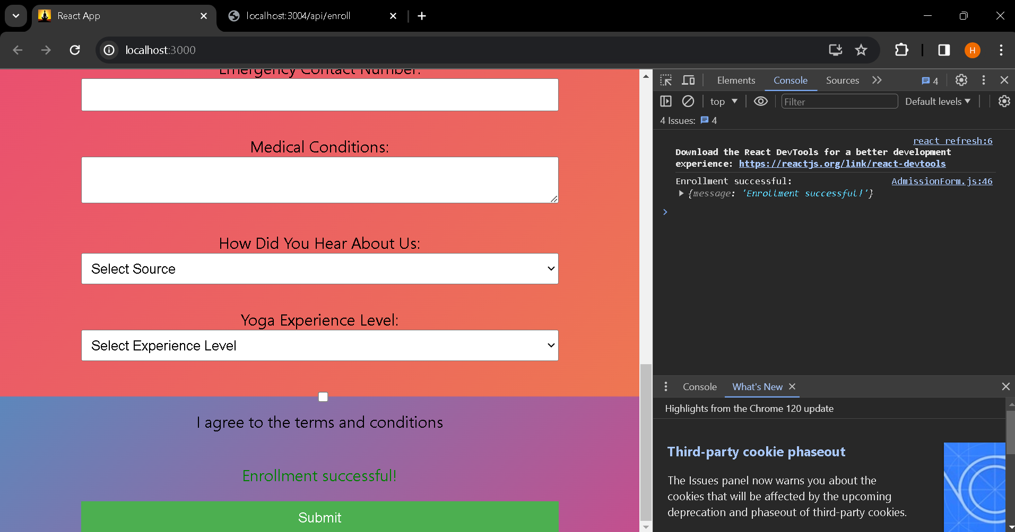

Localhost 3001:

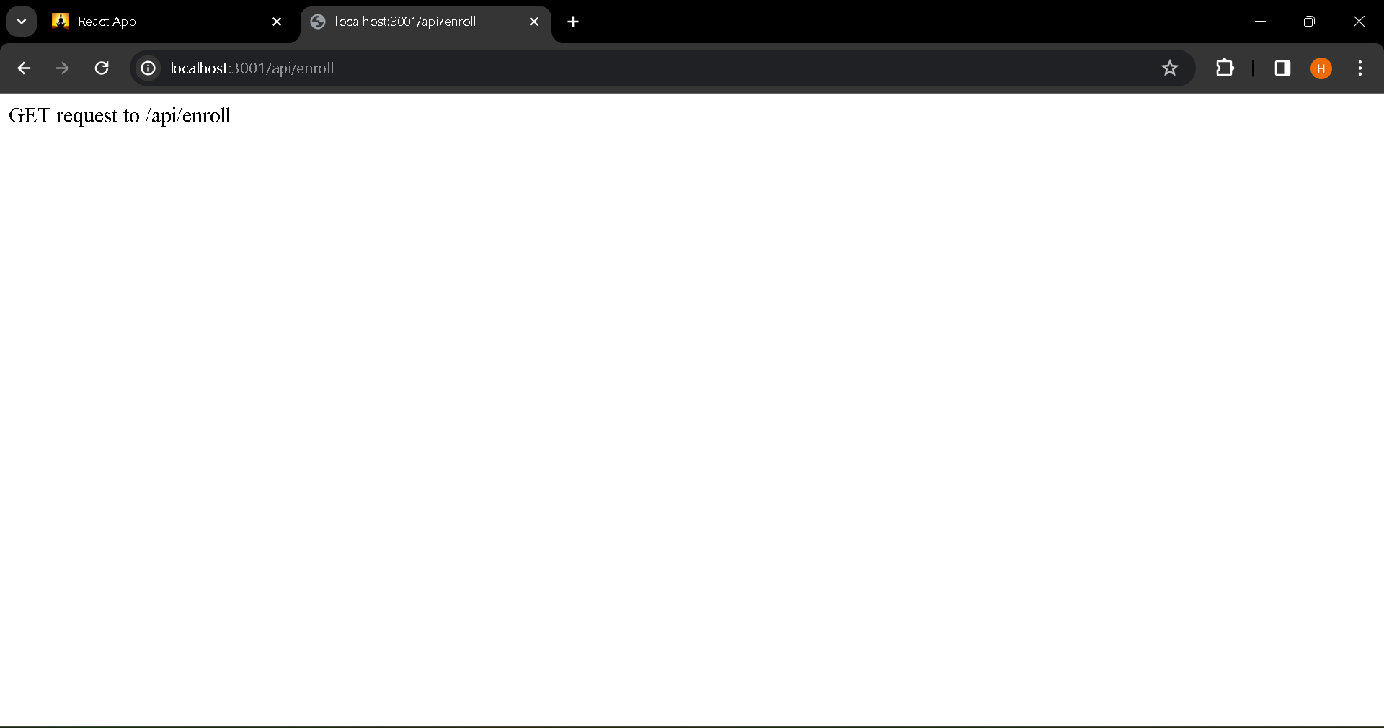

Mongodb database :

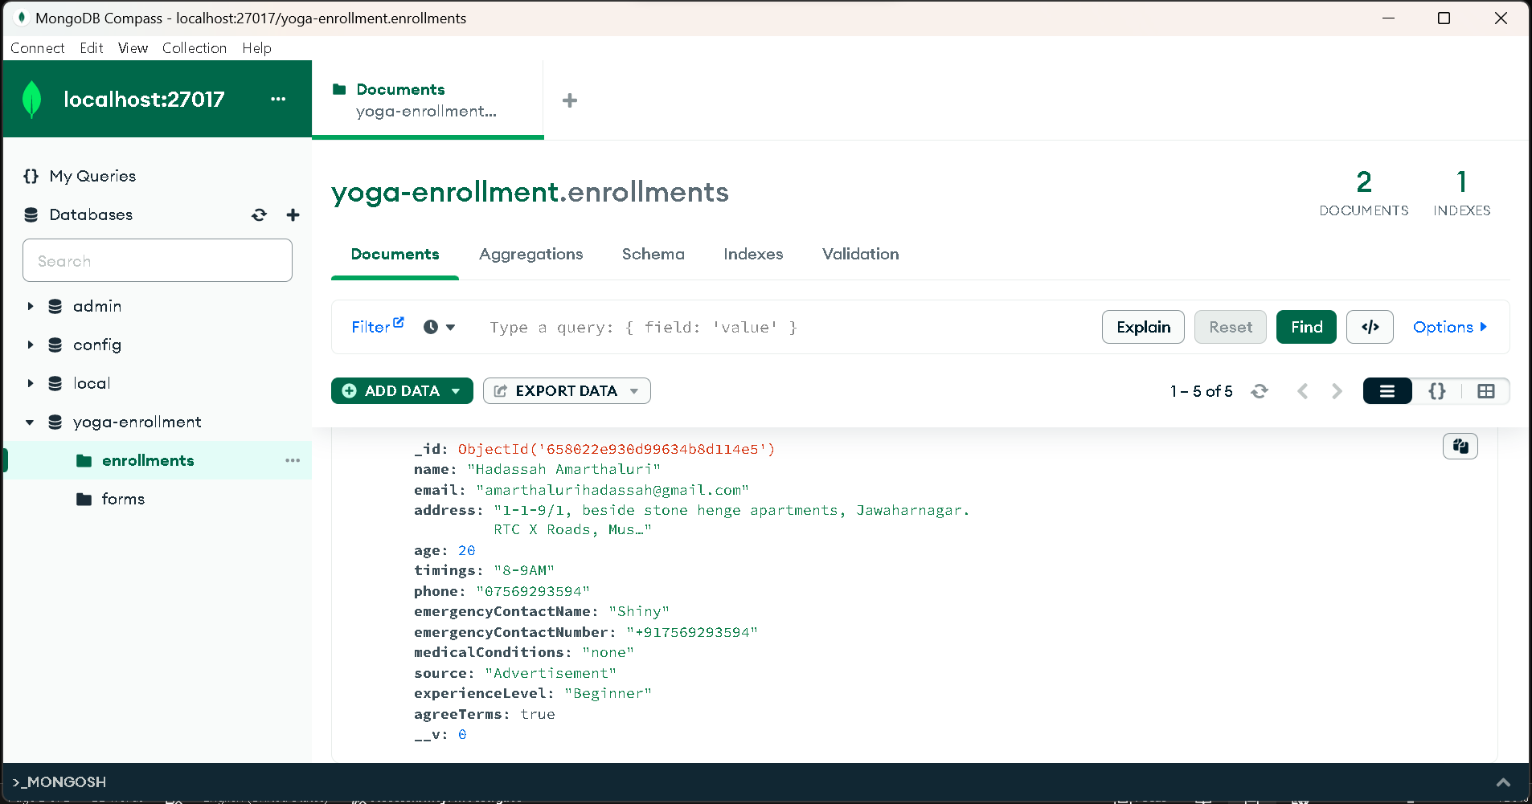

Vs codeterminal :

