**Project Title: Student Record System**

**Functional Requirements Document**



**Submitted To: Sir Umer Khattak (Snr. Lecturer)**

**Submitted By**

**Adeel ur Rehman**

**Enroll : 01-235192-106**

**Bs IT 1B**

TABLE OF CONTENTS

1 INTRODUCTION 3

2 PURPOSE OF THE SYSTEM 3

3 FUNCTIONAL REQUIREMENTS 3

3.1 USE CASE DIAGRAMS………………………………………………………...4

4 GRAPHICAL USER INTERFACE REQUIREMENTS……………………………………..4

* **INTRODUCTION**

A student record system with a GPA calculator providing various functions.

# PURPOSE OF THE SYSTEM

The system can be used to store the record of many students , store it in external files & display it. The record can also be modified or deleted depending on users choice.

1. **FUNCTIONAL REQUIREMENTS**

The system will ask the user for username and password and after that user will be given choice to select from menu : Calculate gpa , create new record , see old record , modify record , delete record.

After the user enters the option for create new record the console asks for name of student , date of birth , gpa , enrollment and grade. And by selecting the old record the last recorded record is shown. If delete record is selected so the last saved record is deleted.

**3.1 USE CASE DIAGRAMS**

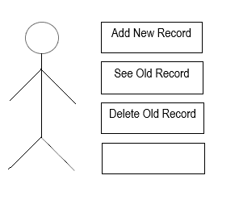

1. **GRAPHICAL USER INTERFACE REQUIREMENTS**

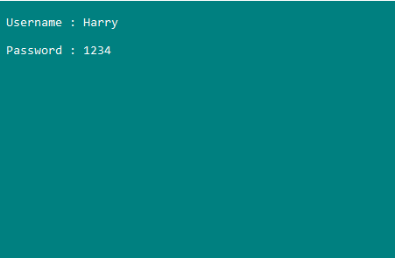

Login Screen

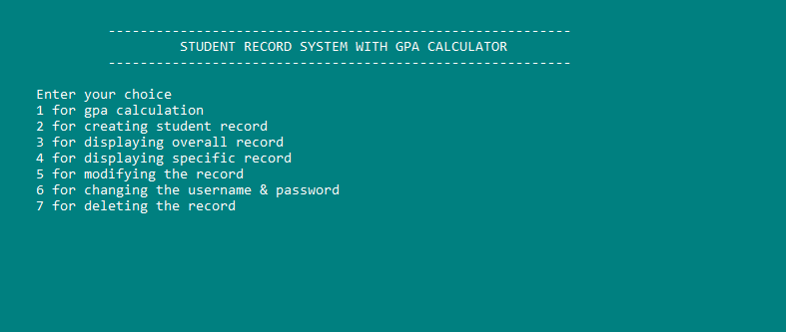

Main Screen

**Project Code**

#include <iostream>

#include <istream>

#include <stdio.h>

#include <conio.h>

#include <string>

#include <fstream>

void login();

void main_menu();

void gpa(float *, char *, float, float, float, float, float);

void create_record();

void display_record();

void display_specific();

void modify_record();

void change_pass();

void delete_record();

using namespace std;

char grade;

float cp_marks, calculus_marks, english_marks, ict_marks, physics_marks ;

float cgpa, percentage;

float totalmarks = 500;

int n;

struct birthday

{

int day;

int month;

int year;

};

struct student

{

char name[50], Class[40]; // cstring , character array used //

char grade;

birthday b;

int enroll;

float cgpa;

} s, *ptr = &s;

int main()

{

system("color 3f");

login();

_getch();

}

void main_menu()

{

int op;

char x;

do

{

cout << " \n \n \n ";

cout << " \t \t ";

cout << " ----------------------------------------------------------" << endl;

cout << " \t \t ";

cout << "\t STUDENT RECORD SYSTEM WITH GPA CALCULATOR " << endl;

cout << " \t \t ";

cout << " ----------------------------------------------------------" << endl;

cout << "\n \t Enter your choice \n";

cout << "\t 1 for gpa calculation \n";

cout << "\t 2 for creating student record \n";

cout << "\t 3 for displaying overall record \n";

cout << "\t 4 for displaying specific record \n";

cout << "\t 5 for modifying the record \n";

cout << "\t 6 for changing the username & password \n";

cout << "\t 7 for deleting the record \n";

cout << " \t ";

cin >> op;

switch (op)

{

case 1:

fflush(stdin);

cout << "\n Enter the marks in Computer out of 100 : ";

cin >> cp_marks;

cout << " \n Enter the marks in Calculus out of 100 : ";

cin >> calculus_marks;

cout << "\n Enter the marks in English out of 100 : ";

cin >> english_marks;

cout << "\n Enter the marks in ICT out of 100 : ";

cin >> ict_marks;

cout << "\n Enter the marks in Physics out of 100 : ";

cin >> physics_marks;

fflush(stdin);

gpa(&cgpa, &grade, cp_marks, calculus_marks, english_marks, ict_marks, physics_marks);

cout << "\n cgpa : " << cgpa;

cout << "\n grade : " << grade;

break;

case 2:

create_record();

break;

case 3:

display_record();

break;

case 4:

display_specific();

break;

case 5:

modify_record();

break;

case 6:

change_pass();

break;

case 7:

delete_record();

break;

default: cout << "\n Invalid choice \n";

}

cout << "\n do you want to continue ? \n \n";

cout << " Press y or Y for yes & n or N for No \n";

cin >> x;

if (x == 'y' || x == 'Y')

{

system("cls");

}

else if (x == 'n' || x == 'N')

{

exit(0);

}

} while (x == 'y' || x == 'Y');

}

void gpa(float *ptr, char *pt, float a, float b, float c, float d, float e)

{

float totalmarks = 500, cgpa;

char grade;

float percentage;

percentage = (a + b + c + d + e) / totalmarks;

*ptr = percentage * 4;

if (*ptr >= 3.5)

{

*pt = 'A';

}

else if (*ptr >= 3 && *ptr < 3.5)

{

*pt = 'B+';

}

else if (*ptr >= 2.5 && *ptr < 3)

{

*pt = 'B';

}

else if (*ptr >= 2 && *ptr < 2.5)

{

*pt = 'C';

}

else if (*ptr >= 1.5 && *ptr < 2)

{

*pt = 'D';

}

else

{

*pt = 'F';

}

}

void login()

{

string username, uname;

int pass, pass1;

char x = 'y';

while (x == 'y' || x == 'Y')

{

cout << "\n Username : ";

cin >> username;

cout << "\n Password : ";

cin >> pass;

ifstream read;

read.open("user_name.txt");

getline(read, uname);

read.close();

ifstream password;

password.open("pass.txt");

password >> pass1;

password.close();

if (username == uname && pass == pass1)

{

system("cls");

main_menu();

}

else {

cout << " \n Inavlid login \n";

cout << " do you want to continue ? \n";

cout << " press Y or y for yes & n or N for No : \n";

cin >> x;

}

if (x == 'y' || x == 'Y')

{

system("cls");

}

else

{

exit(0);

}

}

}

void create_record()

{

cout << "\n for how many students you want to create a record ? \n";

cin >> n;

for (int i = 1; i <= n; i++)

{

fflush(stdin);

cout << "\n Enter the name of student : ";

cin.get(s.name, 50);

fflush(stdin);

cout << " \n Enter the class & section : ";

cin.get(s.Class, 40);

fflush(stdin);

cout << "\n Enter the enrollment of the student : ";

cin >> ptr->enroll;

fflush(stdin);

cout << "\n Enter date of birth : ";

cin >> ptr->b.day >> s.b.month >> ptr->b.year;

fflush(stdin);

cout << "\n Enter the cgpa : ";

cin >> ptr->cgpa;

fflush(stdin);

cout << "\n Enter the grade : ";

cin >> ptr->grade;

cout << endl;

ofstream write;

write.open("student_record.txt", ios::app);

write << "\n Name of the student : " << s.name << endl;

write << " Class of the student : " << s.Class << endl;

write << " Enrollment of the student : " << ptr->enroll << endl;

write << " Date of Birth of the student : " << ptr->b.day << "/" << s.b.month << "/" << s.b.year << endl;

write << " CGPA of student : " << ptr->cgpa << endl;

write << " Grade of student : " << ptr->grade << endl << endl;

write.close();

}

}

void display_record()

{

string name;

ifstream read;

read.open("student_record.txt");

if (read.is_open())

{

while (!read.eof())

{

getline(read, name);

cout << name << endl;

}

read.close();

}

else

cout << "\n Unable to open file " << endl;

}

void delete_record()

{

ofstream del;

string s = "";

del.open("student_record.txt");

if (del.is_open())

{

del << s;

cout << "\n Record deleted \n";

}

else

cout << "\n Unable to open the file \n";

}

void modify_record()

{

int id;

cout << "\n Enter the id you want to modify : ";

cin >> id;

if (id == s.enroll)

{

cout << " \n id found : \n";

cout << " Name of the student : ";

cin >> s.name;

cout << "\n Class of the student : ";

cin >> s.Class;

cout << "\n Enrollment of the student : ";

cin >> ptr->enroll;

cout << "\n Date of Birth of the student : ";

cin >> ptr->b.day >> s.b.month >> s.b.year ;

cout << "\n CGPA of student : ";

cin >> ptr->cgpa;

cout << " Grade of student : ";

cin >> ptr->grade;

}

}

void change_pass()

{

string username, uname;

int pass, pass1;

cout << "\n Enter the current username : ";

cin >> username;

cout << "\n Enter current password : ";

cin >> pass;

ifstream read;

read.open("user_name.txt");

if (read.is_open())

{

getline(read, uname);

read.close();

}

else

{

cout << "\n Unable to open the file \n";

}

ifstream reead;

reead.open("pass.txt");

if (reead.is_open())

{

reead >> pass1;

reead.close();

}

else

{

cout << "\n Unable to open the file \n";

}

if (uname == username && pass == pass1)

{

ofstream write;

string user;

write.open("user_name.txt");

if (write.is_open())

{

cout << "\n Enter the new username : ";

cin >> user;

write << user;

write.close();

cout << "\n username successfully changed \n";

}

else

{

"\n Unable to open the file \n";

}

int passw;

ofstream wriite;

cout << "\n Enter the new password : ";

cin >> passw;

wriite.open("pass.txt");

if (wriite.is_open())

{

wriite << passw;

wriite.close();

cout << "\n password successfully changed \n";

}

else

{

cout << "\n Unable to open the file \n";

}

}

else

{

cout << "\n Incorrect username or password! Try Again : ";

}

}

void display_specific()

{

int id;

cout << "\n Enter the id you want to search : ";

cin >> id;

if (id == s.enroll)

{

cout << " \n id found : \n";

cout << " Name of the student : " << s.name << endl;

cout << " Class of the student : " << s.Class << endl;

cout << " Enrollment of the student : " << ptr->enroll << endl;

cout << " Date of Birth of the student : " << ptr->b.day << "/" << s.b.month << "/" << s.b.year << endl;

cout << " CGPA of student : " << ptr->cgpa << endl;

cout << " Grade of student : " << ptr->grade << endl << endl;

}

}