**[Q]** 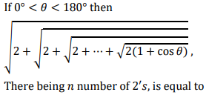

(a) 

(b) 

(c) 

(d) 

[qtype] mcq

[ans] a

[Marks]4,1

[sortid] 1

[soln] 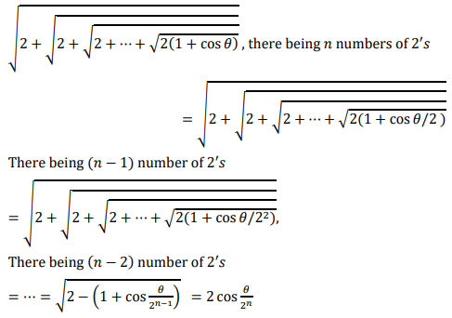

**[Q]** 

(a) 

(b) 

(c) 

(d) 

[qtype] msq

[ans] b,c

[Marks]4,1

[sortid] 2

[soln] 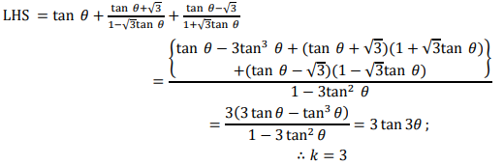

**[Q]** 

(a) 

(b) 

(c) 

(d) 

[qtype] mcq

[ans] b

[Marks]4,1

[sortid] 3

[soln] 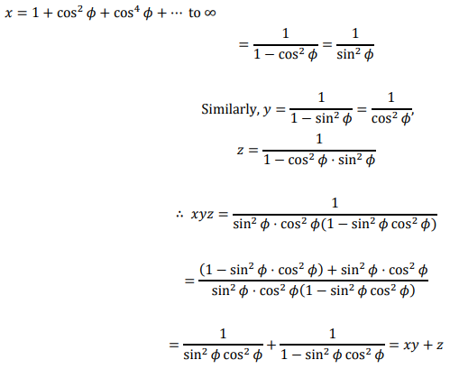

**[Q]** 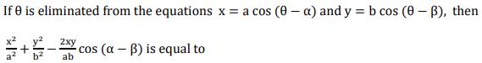

(a) 

(b) 

(c) 

(d) 

[qtype] msq

[ans] a,d

[Marks]4,1

[sortid] 4

[soln] 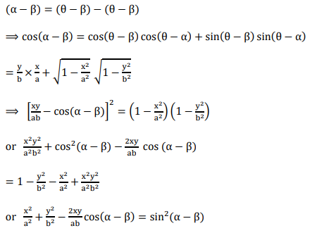

**[Q]** 

(a) 

(b) 

(c) 

(d) 

[qtype] mcq

[ans]a

[Marks]4,1

[sortid] 5

[soln] 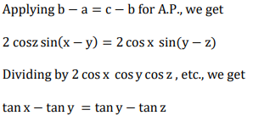

**[Q]** 

(a) 

(b) 

(c) 

(d)

[qtype] msq

[ans] a,c

[Marks]4,1

[sortid] 6

[soln] 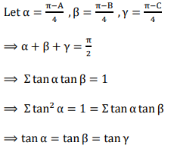

**[Q]** 

(a) 

(b) 

(c) 

(d) 

[qtype] msq

[ans] a,d

[Marks]4,1

[sortid] 7

[soln] 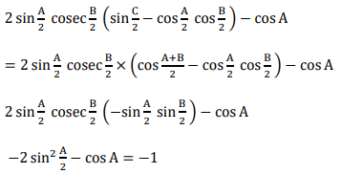

**[Q]** 

(a) 

(b) 

(c) 

(d) 

[qtype] mcq

[ans] c

[Marks]4,1

[sortid] 8

[soln] 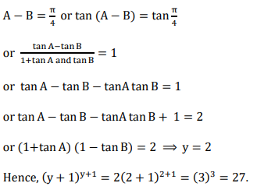

**[Q]** 

(a) 

(b) 

(c) 

(d) 

[qtype] mcq

[ans] b

[Marks]4,1

[sortid] 9

[soln] 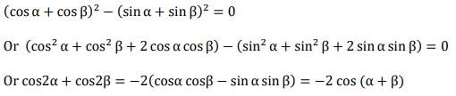

**[Q]** 

(a) 

(b) 

(c) 

(d) 

[qtype] msq

[ans] c,d

[Marks]4,1

[sortid] 10

[soln] 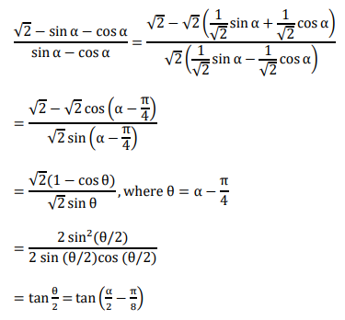

**[Q]** 

(a) 

(b) 

(c) 

(d) 

[qtype] mcq

[ans] a

[Marks]4,1

[sortid] 11

[soln] 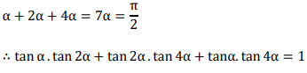

**[Q]** 

(a) 

(b) 

(c) 

(d) 

[qtype] mcq

[ans] a

[Marks]4,1

[sortid] 12

[soln] 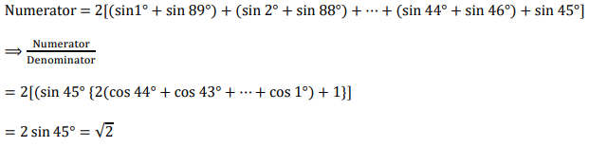

**[Q]** 

(a) 

(b) 

(c) 

(d) 

[qtype] msq

[ans] b,d

[Marks]4,1

[sortid] 13

[soln] 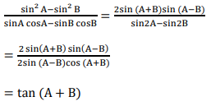

**[Q]** 

(a) 

(b) 

(c) 

(d) 

[qtype] mcq

[ans] b

[Marks]4,1

[sortid] 14

[soln] 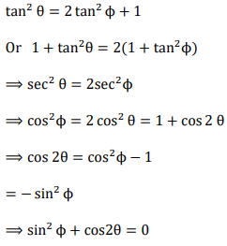

**[Q]** 

(a) 

(b) 

(c) 

(d) 

[qtype] mcq

[ans] d

[Marks]4,1

[sortid] 15

[soln] 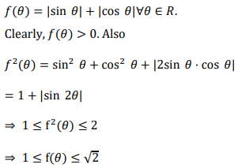

**[Q]** 

(a) 

(b) 

(c) 

(d) 

[qtype] mcq

[ans] b

[Marks]4,1

[sortid] 16

[soln] 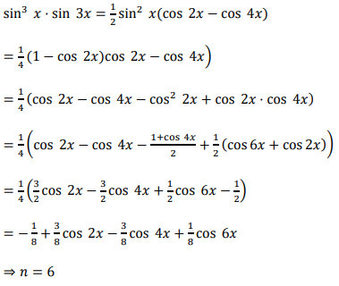

**[Q]** 

(a) 

(b) 

(c) 

(d) 

[qtype] mcq

[ans] b

[Marks]4,1

[sortid] 17

[soln] 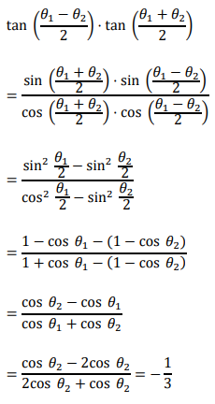

**[Q]** 

(a) 

(b) 

(c) 

(d) 

[qtype] mcq

[ans] a

[Marks]4,1

[sortid] 18

[soln] 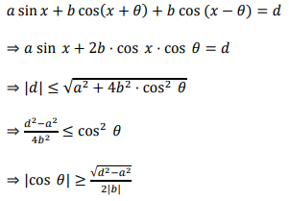

**[Q]** 

(a) 

(b) 

(c) 

(d) 

[qtype] mcq

[ans] b

[Marks]4,1

[sortid] 19

[soln] 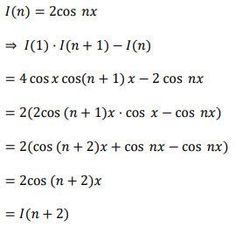

**[Q]** 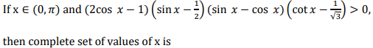

(a) 

(b) 

(c) 

(d) 

[qtype] msq

[ans] a,d

[Marks]4,1

[sortid] 20

[soln] 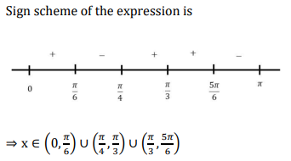

**[Q]** 

[qtype] nat

[ans] 4

[Marks]4,1

[sortid] 21

[soln] 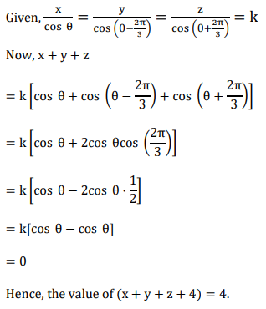

**[Q]** 

[qtype] nat

[ans] 5

[Marks]4,1

[sortid] 22

[soln] 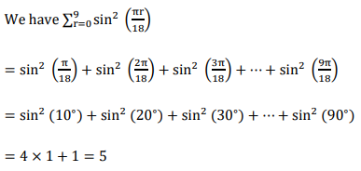

**[Q]** 

[qtype] nat

[ans] 3

[Marks]4,1

[sortid] 23

[soln] 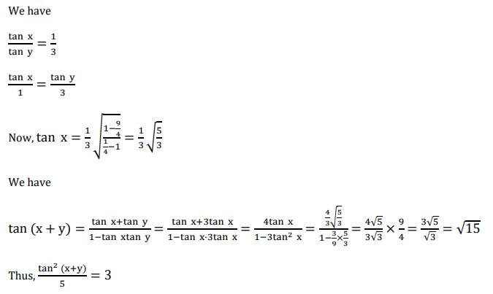

**[Q]** 

[qtype] nat

[ans] 4

[Marks]4,1

[sortid] 24

[soln] 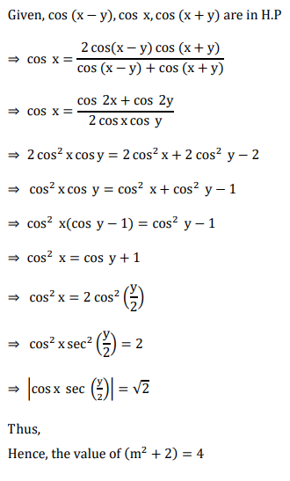

**[Q]** 

[qtype] nat

[ans] 3

[Marks]4,1

[sortid] 25

[soln] 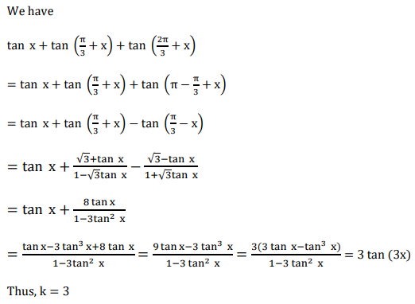

**[Q]** 

[qtype] nat

[ans] 3

[Marks]4,1

[sortid] 26

[soln] 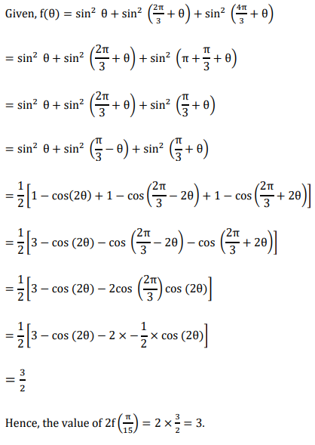

**[Q]** 

[qtype] nat

[ans] 7

[Marks]4,1

[sortid] 27

[soln] 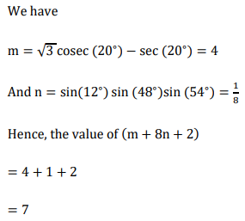

**[Q]** 

[qtype] nat

[ans] 3

[Marks]4,1

[sortid] 28

[soln] 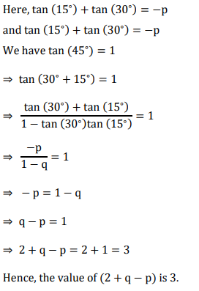

**[Q]** 

[qtype] nat

[ans] 5

[Marks]4,1

[sortid] 29

[soln] 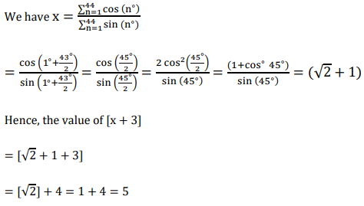

**[Q]** 

[qtype] nat

[ans] 2

[Marks]4,1

[sortid] 30

[soln] 