Alex Hasty

This report briefly covers the included web applications purpose and also gives reasoning to certain design choices

Portfolio Report

Web Application

Portfolio Report

Contents

Overview 1

Navigation 1

Header and Footer 2

Home 3

Previous Work 3

About 5

Contact 6

Summary/Self-evaluation 7

Bibliography 7

# Overview

The included web application is a design for an online portfolio, specifically catered towards people with a career in an artistic industry. There are multiple pages within the web application including: ‘home’, ‘previous work’, ‘about’ and ‘contact’. The portfolio showcases art in three different ways: a large background image covering the ‘home’ page, this makes the art feel more incorporated into the website while simultaneously allowing viewers to see details clearer; a large, centred slideshow on the ‘previous work’ page so that the viewer can inspect multiple pieces of art closely and flick through several slides at their own pace; finally, under the slideshow, each image will be laid out separately with large blocks of text adjacent describing the piece and giving a brief self-evaluation of how the piece helped me to improve or even what I would do differently if I revisited the piece. A variation of display helps to keep the viewer interested and have a refreshing and interactive time while viewing the web pages. The ‘about’ page of the web application describes my background, education and goals in detail as well as showing a small, centred portrait. The final page is the ‘contact’ page which will display multiple ways for the viewers to contact me about my work.

## Navigation

For the navigation of the website I decided to opt for a navigation bar positioned at the top of each page. The bar displays each page’s title with a divider to separate them. When the viewer hovers over one of the titles it will change to a darker grey so that it is easier for the viewer to understand that they are links. When the viewer clicks on one of the links it will take them to the corresponding page, once they are on that page the background of the title on the navigation bar will turn green to indicate which page they are on.

I decided to choose this layout for my navigation bar as it is very simplistic and very easy to understand, making the viewers experience of navigating around the website a lot easier. Giving the viewer a lot of visual hints such as the colour change on hover and background colour change on each web page helps the viewer to conote that it is a navigation bar and not just text on the screen.

To make the navigation bar I used code from W3schools.com and changed the style to fit my site.



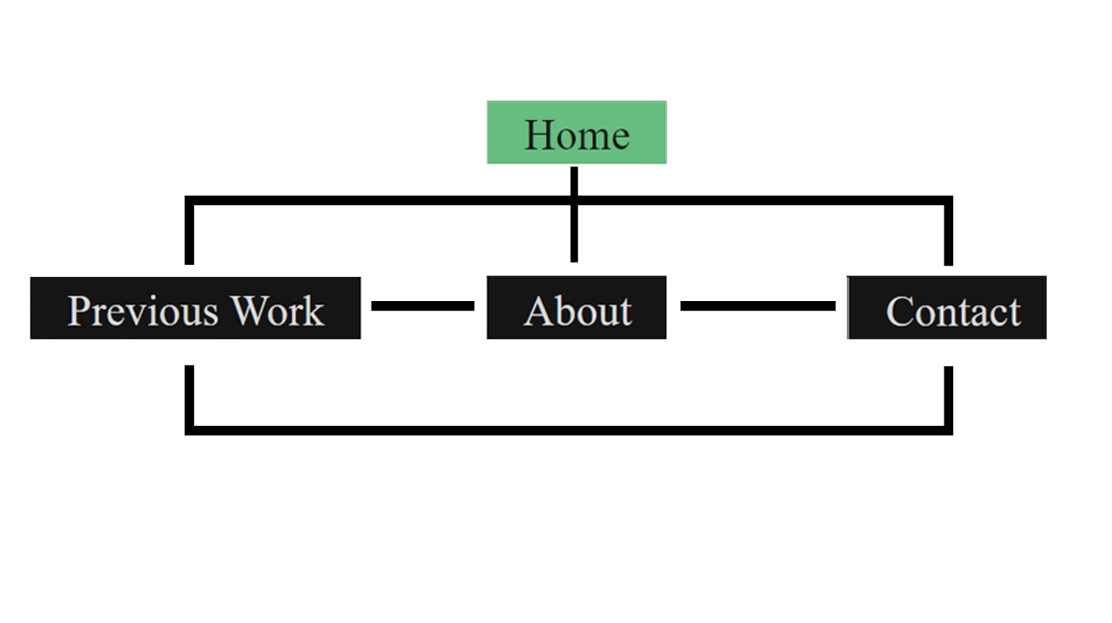

## Header and Footer

The header and footer appear on every page other than the home page. This is because the home page is the first thing people see when entering the website and I didn’t want it to look too cluttered. Both the header and footer follow the simple design of the rest of the website, making use of blank space surrounding white text to make the important information stand out and give the page more of a minimalistic feel. The header simply displays the title of the page in a large font, the footer is currently just a copyright notice with a lot of blank space for future additions.





# Home

When designing the home page, I wanted to make it as visually appealing as I could to give a good first impression. The first thing I created on the page was the title division. I decided not to go with the conventional position for a title at the top of the page and instead positioned it about 3/4 of the way down the page. Because of the positioning of the title, I included a full background image that brought the title forward and made it pop out from the page, drawing the viewers eye. The vertical lines of the buildings contrasted with the horizontal lines of the division further enforcing this effect. Due to this once the image is replaced with my personal artwork, I will keep this in mind and include a piece of art with a lot of verticality.

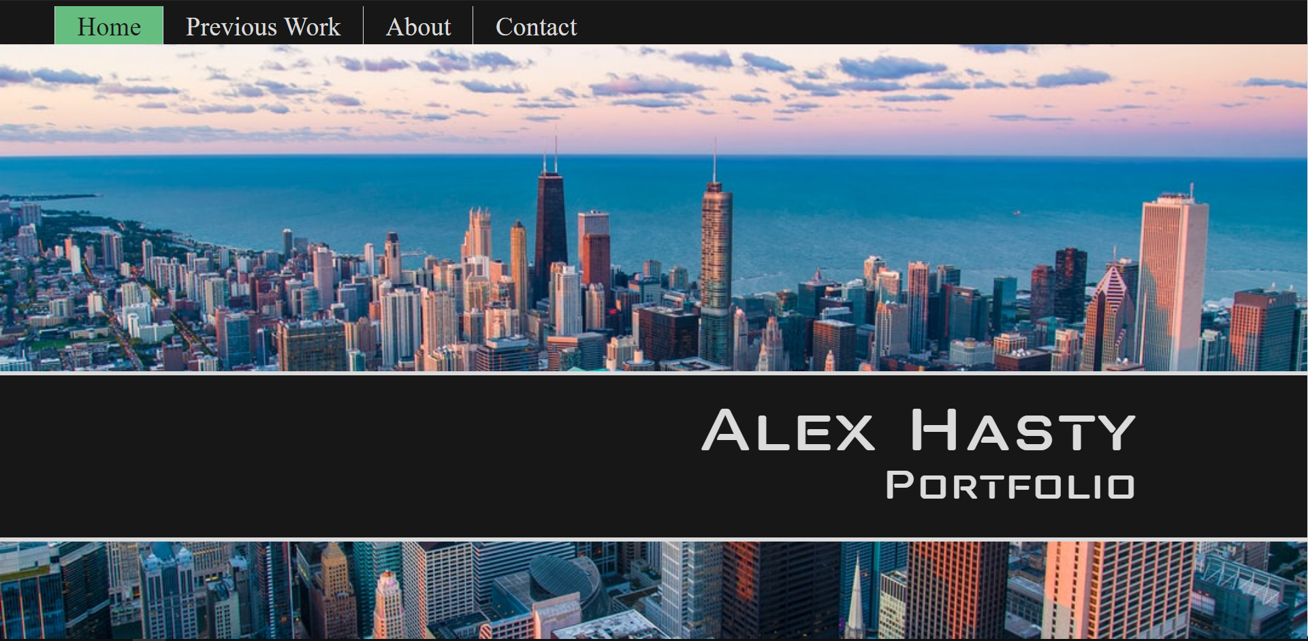

# Previous Work

On the ‘previous work’ page I opted for a very clear layout, using blank space and text to divide sections and attract attention to the most important detail on the page, the images. When loading the page, the first thing that the viewer is met with is a slideshow showcasing every piece of work on the website. I created the slideshow with a mix of html, java script and CSS. Html was used to add: the images, captions, next arrows, clickable dots and image number in the top left of the slideshow; CSS to style and add hover functions and the java script to set the functionality of the slideshow itself. For the slideshow I once again used W3schools.com as a reference.

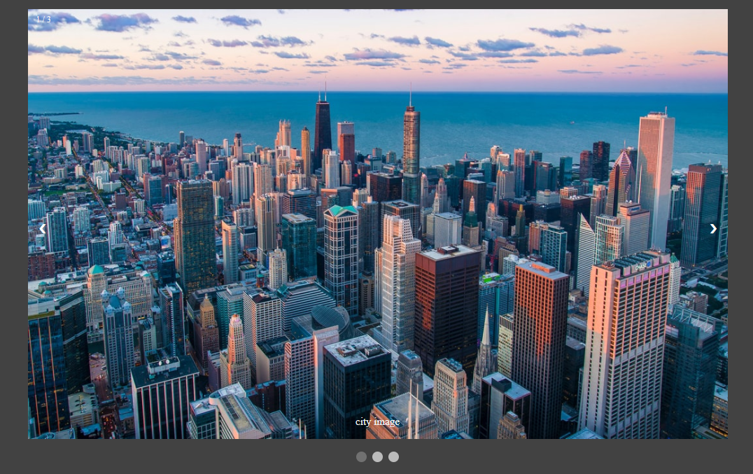

Under the slideshow is some text, not only to describe what is on the page but also to split up the page before moving on to the second section.

In the second section of the page every piece of art is displayed vertically down the left side of the page with large blocks of text to go into detail about each piece. This is very convenient for the viewer, if they see a piece of art they like in the slideshow, they can then scroll down and read into it more.

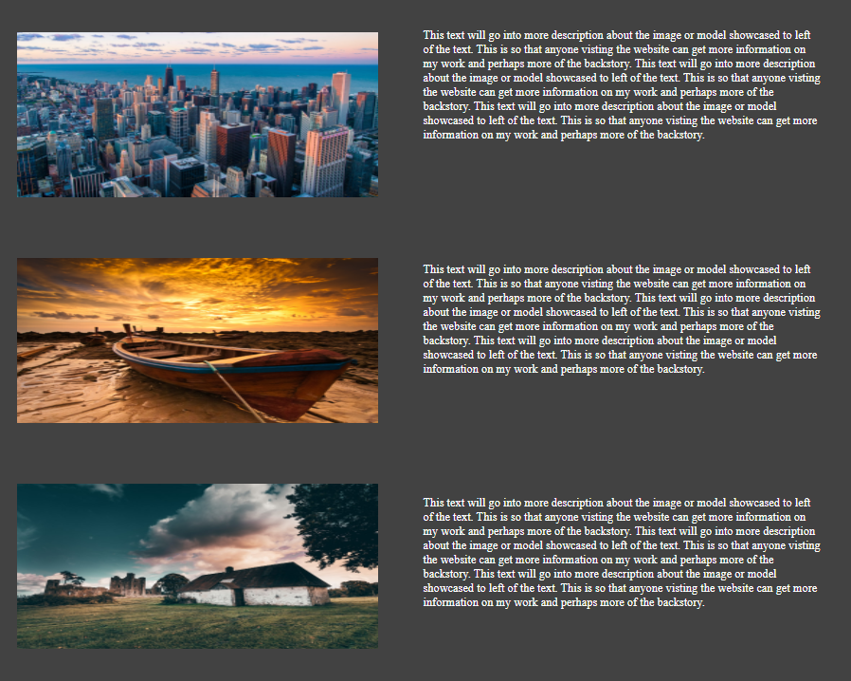

# About

The about section is very simple, displaying a portrait that will be replaced by a picture of myself in the future and brief description of my background, education and goals in a centred, cleanly laid out format.

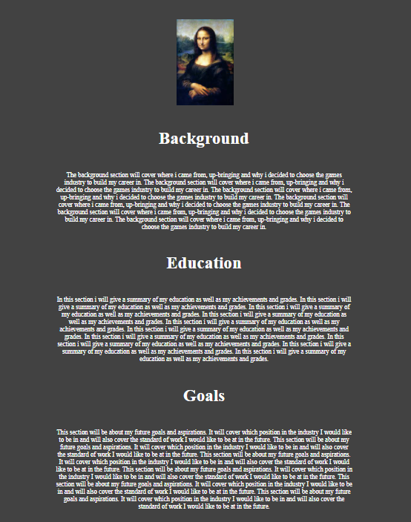

# Contact

The contact page will hold all of the information needed for people to reach out to me, once again in a very clean, centred format with a graphic of a smartphone which matches the colour palette.

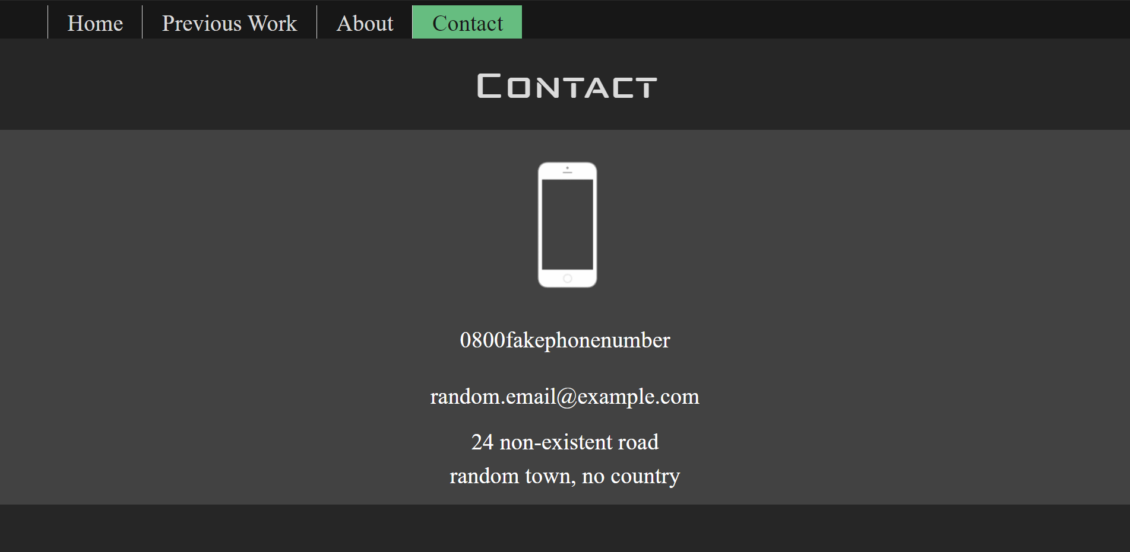

# Summary/Self-evaluation

Overall, I am quite pleased with what I managed to create with very little prior knowledge of html, CSS and java script. One thing that I think could have improved my website is model viewers however at the time I was not able to access the models and scenes referenced by Pete in his video and didn’t have any of my own to display. This is certainly an addition I will be adding in the future, as well as other minor changes to the style and layout as I get better at coding with html, CSS and java script.

# Bibliography

* W3schools, 2020. How to create a top navigation bar [online]. Refsnes Data. Available from: https://www.w3schools.com/howto/howto_js_topnav.asp [Accessed 16 December 2020]
* W3schools, 2020. How to create a slideshow [online]. Refsnes Data. Available from: <https://www.w3schools.com/howto/howto_js_slideshow.asp> [Accessed 16 December 2020]
* W3schools, 2020. HTML Links [online]. Refsnes Data. Available from: https://www.w3schools.com/html/html_links.asp [Accessed 16 December 2020]