The **Angle Tracking Observer** is a robust method to determine the angle of a space phasor or the rotor position from the signal of a sin/cos-resolver.

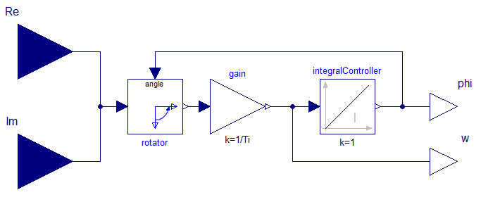

Turning a phasor by an angle $-φ^{'}$:

$$e^{jφ}∙e^{-jφ^{'}}=e^{j\left(φ-φ^{'}\right)}=\left(cosφ+jsinφ\right)∙\left(cosφ^{'}-jsinφ^{'}\right)= \\ \left(cosφ∙cosφ^{'}+sinφ∙sinφ^{'}\right)+j\left(-cosφ∙sinφ^{'}+sinφ∙cosφ^{'}\right)$$

The controller drives the imaginary part of the rotated phasor to zero:

$$Im=\sin\left(φ-φ^{'}\right)=-cosφ∙sinφ^{'}+sinφ∙cosφ^{'}→0$$

Linearization for small deviations (control error): $φ≈φ^{'}: Im≈φ-φ^{'}$

Transfer function of the closed loop using an integral controller:

$$φ^{'}=\left(φ-φ^{'}\right)∙\frac{1}{sT_{i}}$$

$$φ^{'}=\frac{φ}{1+sT_{i}}$$

Additionally the phasor’s angular velocity $ω=\frac{dφ}{dt}$ is determined at the integral controller’s input.