A single-axis bike trailer with two wheel hub motors shall be investigated.  
In the drawbar, a traction force sensor is integrated.

For the beginning, only straight-line driving should be considered. For turns, the torque must be distributed to the two wheel hub motors in such a way that neither oversteer nor understeer occurs. Additional sensors are required to achieve this goal.

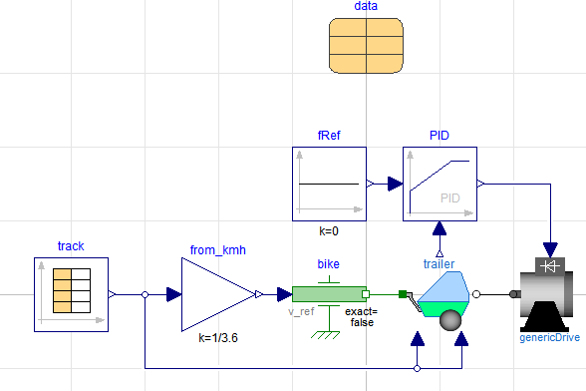

The bicycle is modeled in a simplified way using a specified riding speed. Speed, gradient and wind speed are specified by a time-dependent table:  
Modelica.Mechanics.Translational.Sources.Speed  
Modelica.Blocks.Sources.CombiTimeTable

The trailer is implemented as a separate model:

* Modelica.Mechanics.Translational.Components.Vehicle describing:
  + Mass of trailer
  + Wheels
  + Moment of inertia of wheels
  + Resistances (can be specified constant or by an input):
    - Air drag resistance $$F_{Drag}=c_{W}∙A∙ρ∙\frac{{\left(v-v_{Wind}\right)}^{2}}{2}$$
    - Rolling resistance $$F_{Roll}=c_{R}∙m∙g∙sin\left(α\right)$$
    - Inclination resistance $$F_{Grav}= m∙g∙cos\left(α\right)$$ 
      Note: Inclination is the tangent of $α$.
* Translational multi-sensor, providing traction force, speed and power

The drives are summarized in one external generic drive model:

* Limiter for maximum and minimum achievable torque  
  Modelica.Blocks.Nonlinear.Limiter
* Second-Order (Reference transfer function for an optimal designed current controller)   
  Modelica.Blocks.Continuous.TransferFunction
* Gesteuertes Drehmoment  
  Modelica.Mechanics.Rotational.Sources.Torque

**Control** oft the two wheel hub drives to achieve zero traction force at the drawbar.

Proportional gain can be calculated from the relationship between force and torque:

$$τ=F∙\frac{D_{wheel}}{2}$$

The reference transfer function for an optimal designed current controller can be written as:

$$\frac{τ}{τ_{Ref}}=\frac{I}{I_{Ref}}=\frac{1}{1+sT_{sub}+s^{2}\frac{T_{sub}^{2}}{2}}$$

$T_{sub}=2T_{σ}$ is the substitute time constant. $T_{σ}$ is the sum of small time constants on the current control loop (dead time respectively delay of the power converter as well as current measurement).

A PID-controller with ideal differential part cannot be achieved. Therefore a PIDT1-controller is choosen:

$$1+\frac{1}{sT_{i}}+\frac{sT_{d}}{1+skT_{d}}=\frac{1+s\left(T_{i}+kT_{d}\right)+s^{2}T_{i}T_{d}\left(1+k\right)}{sT_{i}\left(1+skT_{d}\right)}$$

$k<1$ determines how near the behaviour of the DT1-term approximates the ideal differentiator,

The transfer function of the open loop can be written as:

$$\frac{1+s\left(T_{i}+kT_{d}\right)+s^{2}T_{i}T_{d}\left(1+k\right)}{sT_{i}\left(1+skT_{d}\right)}∙\frac{1}{1+sT_{sub}+s^{2}\frac{T_{sub}^{2}}{2}}$$

Compensation of the denominator of the plant using the numerator of the controller delivers:

$$T_{i}+kT_{d}=T_{sub}$$

$$T_{i}T_{d}\left(1+k\right)=\frac{T_{sub}^{2}}{2}$$

Therefor we can derive the parameterization oft he controller:

$$\frac{T_{i}}{T_{sub}}=\frac{1}{2}±\sqrt{\frac{1}{4}-\frac{k}{2\left(1+k\right)}}=\frac{1}{2}\left[1±\sqrt{\frac{1-k}{1+k}}\right]$$

$$\frac{T_{d}}{T_{sub}}=\frac{T_{sub}}{T_{i}}\frac{1}{2\left(1+k\right)}=\frac{1}{1+k±\sqrt{1-k^{2}}}$$

To get only real solutions, $k$ is limited:

$$k≤1$$

Thus we get the transfer function of the open loop:

$$\frac{1}{sT_{i}\left(1+skT_{d}\right)}$$

The reference transfer function shows second order behaviour: $$\frac{\frac{1}{sT_{i}\left(1+skT_{d}\right)}}{1+\frac{1}{sT_{i}\left(1+skT_{d}\right)}}=\frac{1}{1+sT_{i}+s^{2}T_{i}kT_{d}}=\frac{1}{1+2ϑTs+T^{2}s^{2}}$$

Compariosn of coefficients reveals:

$$T_{i}=2ϑT$$

$$T_{i}kT_{d}=T^{2}$$

$$T=\sqrt{kT_{i}T_{d}} → \frac{T}{T_{sub}}=\sqrt{\frac{k}{2\left(1+k\right)}}$$

$$ϑ=\frac{T_{i}}{2T}=\frac{\sqrt{2}}{4}∙\left[\sqrt{\frac{1}{k}+1}±\sqrt{\frac{1}{k}-1}\right]≥1$$

The aperiodic borderline case is achieved for damping $ϑ=1$:

$$k≤\frac{8}{17}$$

For all solutions of quadratic equations the positive sign of the root is taken.

Comparison of PID – controller Modelica – Simulink (ideal)

$$k_{p}∙\left(1+\frac{1/{T_{i}}}{s}+\frac{T_{d}∙s}{1+s∙k∙T_{d}}\right)=P∙\left(1+\frac{I}{s}+\frac{D∙s}{1+s∙1/N}\right)$$

Conversion of the parameters:

$$P=k_{p}$$

$$I=1/{T_{i}}$$

$$D=T_{d}$$

$$N=\frac{1}{k∙T_{d}}$$