The kinetic energy of rotating masses is converted to electric energy using an electric machine   
and subsequently dissipated in the internal resistance and the external braking resistance to heat.

**DC-Machine with Permanentmagnet Excitation**

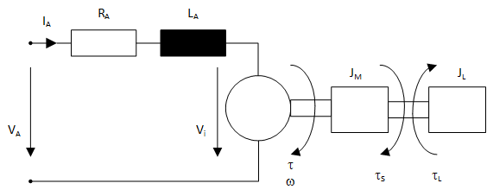

Farady’s Law:

Lorentz‘ Law:

These two basic equations get implemented in the „electro-mechanical converter“.

Kirchhoff’s voltage law:

Equation of Motion:

**Parameter sets**:



**Synchronous Machine with Permanentmagnet Excitation**

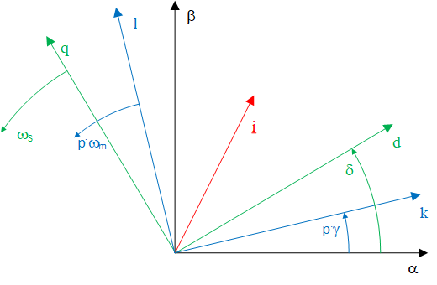Stator fixed frame

Rotor fixed frame

Field fixed frame

For synchronous machines the field fixed frame and the rotor fixed frame are the same.

is the mechanical angle of the rotor (with respect to the stator).

For this machine Clarke and Park transform for voltages and currents are implemented in the corresponding electro-mechanical converter:

The zero components fulfills the following equation:

**Set of Equations**:

Due to magnetic saliency and the permanent magnets acting in one foxed direction with respect to the rotor the equations have to be implemented in the rotor fixed frame:

**Parameter sets**:



The machines have stator phases, the windings are star-connected.

Stator frequency is strictly related to mechanical shaft speed:

Flux linkage space phasor of stator due to permanent magnets can be calculated from open circuit voltage at nominal speed: